BCMS Incident Management iPhone Application 1.0 Requirements Specification

This document outlines the Application Scope and Requirements for
BCMS Incident Management iPhone Application 1.0.

PRESENTED TO:  <Client Names> | <CLIENT LOGO>
PRESENTED BY:  <TopCoder Names> | 

Revision History
Author | Revision Number | Date
MiG-29 | 1.0 | 10/15/2011

Application Requirements Specification 5
1. Scope 5
1.1 Overview 5
1.2 Objectives 7
1.3 Limitations & Assumptions 7
2. Logic Requirements 8
2.1 Login 9
2.2 Logout 13
2.3 View Homepage 14
2.4 Navigate through Pages 17
2.5 Expand Large Panel to Full Screen 19
2.6 Collapse Large Panel from Full Screen 20
2.7 Change Device Orientation 21
2.8 View Incidents List 22
2.9 Filter and Sort Incidents 25
2.10 View Incident Details 29
2.11 Update Incident Details 34
2.12 Edit Checklist 37
2.13 View Incident's Attachments 39
2.14 View Incident's Notes 40
2.15 View Incident's Note Details 43
2.16 Email Incident's Note 45
2.17 Add Incident's Note 47
2.18 Delete Incident's Note 50
2.19 View Contact Options List 52
2.20 View Contacts List 54
2.21 View Call Trees 61
2.22 View Direct Reports 68
2.23 View Direct Report Details 71
2.24 Send Alert to Chosen User(s) 72
2.25 Call Chosen User 77
2.26 Send SMS to Chosen User 79
2.27 Email Chosen User 82
2.28 View "More" List 84
2.29 View Area Office Data 86
2.30 View Plans Data 90
2.31 View Twitter Data 91
2.32 View Facebook Data 92
2.33 View List of Settings 92
2.34 Get Information About Application 94
2.35 Get Help Data 97
2.36 Create New Incident 100
2.37 Update Incident's Additional Information 106
2.38 Upload Incident's Attachment 111
2.39 Delete Incident's Attachment 115
2.40 Perform Logging 117
2.41 Perform Auditing 118
3. General Requirements 120
3.1 Graphical User Interface Requirements 120
3.2 Performance Constraints 122
3.3 Security 123
4. Required Documentation 125
4.1 Specification Documentation 125
5. Help / User Documentation 125
6. Notes 125
7. Future Enhancements 125
8. Glossary 125
8.1 Definitions 125
8.2 Acronyms 126

Application Requirements Specification

Scope

Overview
The client is looking for a solution for key teams within their company to keep critical services working in the event of a major disaster (ranging from major technical infrastructure failures to fires and other local environmental disasters). The Business Continuity Mobility Solution should allow us to manage at least three key functions:
- Incident alert and notification
- Contact information
- Business continuity plans and checklists
- Details

The resulting technical solution will eventually need to be usable from a variety of devices - including Smartphones (e.g., Blackberry & iPhone), as well as tablet (like iPad) & notebook PCs.

Please note, this contest will focus on just the iPhone functionality. Wireframes are provided for just the iPhone based solution. The specification is based on iPhone wireframes and on the client’s design/conceptualization document (EDES) with requirements. The web functionality has been covered, and the iPad will be completed in a separate contest.

The point of this contest is to generate an ARS in the normal format that covers all the requirements, but also expands on them in detail.

Of particular importance is anything that is not feasible on the device due to its limitations. The specification clarifies if any functionality will be markedly different from the web version (already having an ARS) to the iPhone, because it is important to maintain close consistency between the different platforms.

The close attention is paid to the following topics:
- Form validation
- Flow of data in the application
- Screens shown in the wireframe but not documented in the project document
- Security, namely authentication and authorization
- Any differences in flow or data between the mobile devices and the web
- Any backend service structure (covered by other contests)
- Attaching files from the device - what is in the wireframe likely won't work, but it is needed to know what is feasible here. The application will support attaching a video or picture taken on an iPhone device.

The Business Continuity Mobility solution will consist of three key functional areas:
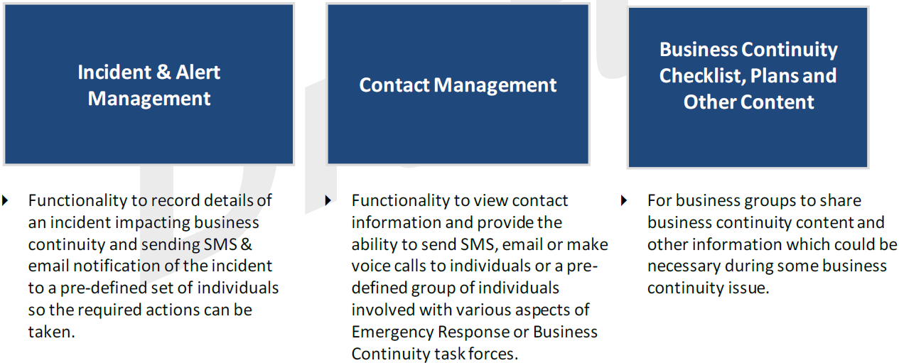

The context diagram explains a proposed backend server structure, but this has not been
finalized yet and, therefore, is provided as-is – just for information.

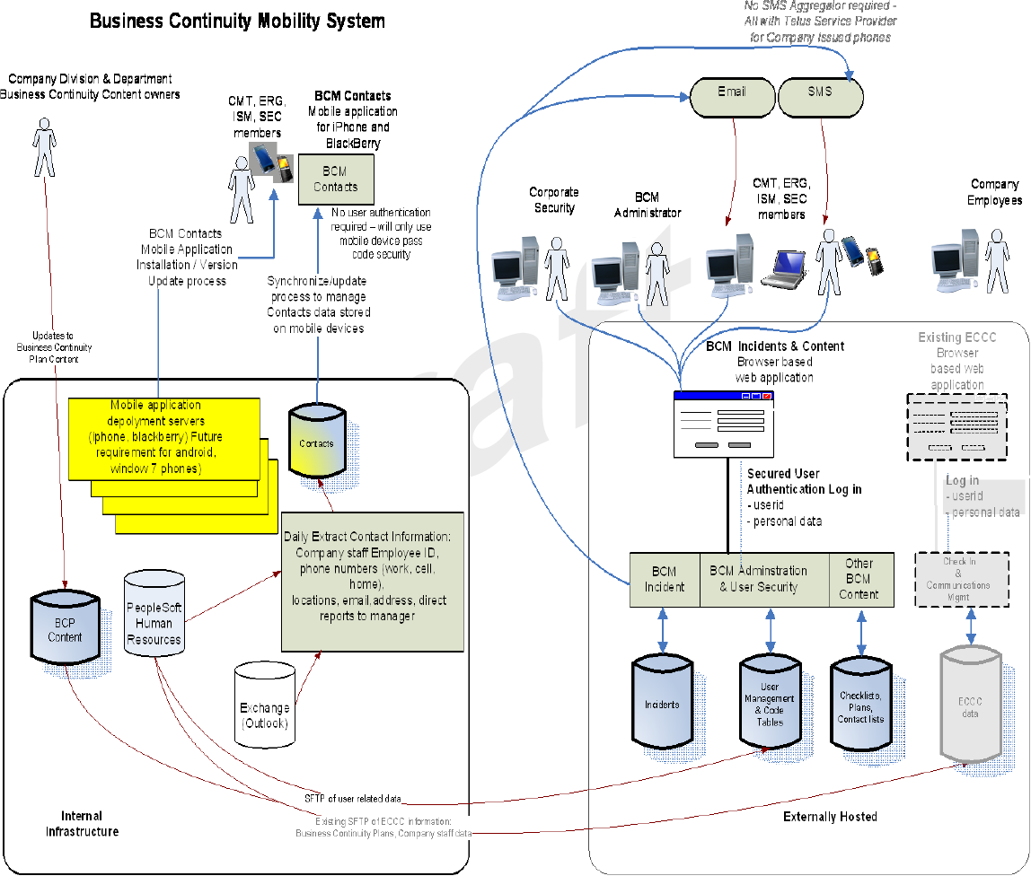

Objectives
The objectives of this application are:
- The objective of this project is to retire the current unsupported MS Access based application and provide a solution for managing incidents that impact the business operations and issuing alert notifications to key individuals in the organization.
- This system will provide authorized users with access to the incident, contacts and important business continuity content to facilitate communication and information sharing.
- Centralized management of incidents has to be implemented.

Project Return on Investment (ROI Metrics):
- No ROI metrics were provided by the client. This application will greatly improve efficiency of the entire business process of incidents management.

General Capacity Metrics:
- The maximum expected count of unique users of the application is 1,000.
- The maximum expected count of concurrent users of the application is 100+. Please note, the application’s frontend is natively executed on the mobile devices (usually by a single user per device).

General Usability Metrics:
- The application will be for iPhone and the related GUI guidelines will apply.
- Landscape and portrait device orientations will be supported.
- The application GUI will be user friendly.

Limitations & Assumptions
Assumptions critical to the success of this application are listed below:
- The application will be a native iPhone application.
- Backend services will be RESTful and their data will be exposed through JSON.
- Another contest is responsible for defining those services: http://apps.topcoder.com/wiki/display/docs/Business+Continuity+Mobility+System+REST+Services+Architecture
- The current specification does not specify backend services. This specification just defines data formats, which can be re-used for those services later.
- This specification greatly re-use data from the previous specification (web application ARS). The same data formats are used when possible.
- Please note, there are some differences between the data formats from the previous specification (web application ARS) and the iPhone application wireframes. The information from the iPhone wireframes is used in those cases. So, the iPhone wireframes have higher priority.

The limitations of the application are listed below:
- Only video or picture attachments will be supported for iPhone application.

Environment and technology requirements:
- The application will be written in Objective-C and run on iOS 4+.
- iPhone versions 3GS and newer will be supported.
- iPod Touch versions 3G and newer will be supported.

Logic Requirements
Use case diagrams are shown below:
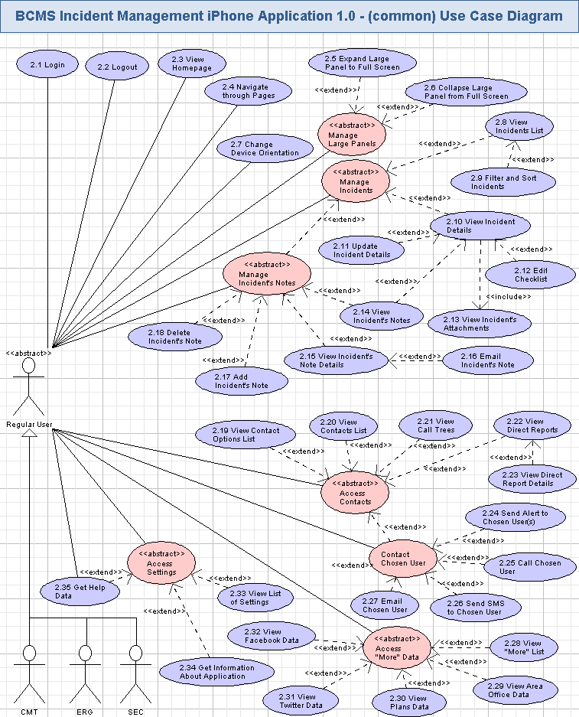
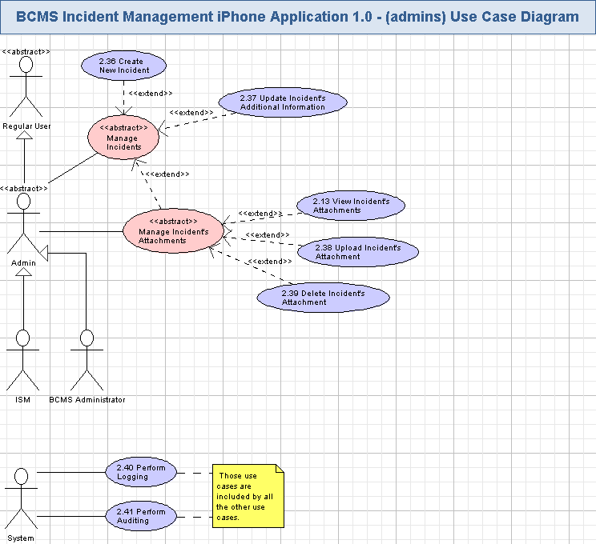

Login
The application will allow registered users to login by entering their credentials and choosing privileges. The application validates user credentials and performs authentication/authorization. If there is no cached password on the application/device (i.e. first time the user accesses the application from the iPhone), the application will ask the user to enter the credentials. The application will automatically cache the user password upon first time the user authenticates so the user will not be asked to re-login again. If authentication fails after 5 consecutive attempts, the user account will be locked for 30 minutes. The account will be automatically unlocked after 30 minutes or if an administrator unlocks the account manually. It will be possible to start the web-based application from this page. This use case includes use case 3.3 “View Homepage” (that include link was not shown on the use case diagram for clarity).
Wireframe page: “Login_Landscape”, “Login_Portrait”.
Related use case from EDES document: 1.17 Logon.
- Pre-conditions: the non logged-in user opened any page of the application.
- Post-conditions: the user was successfully logged in if failed login attempts is less than 5 tries and can access application functionality.

Login Activity
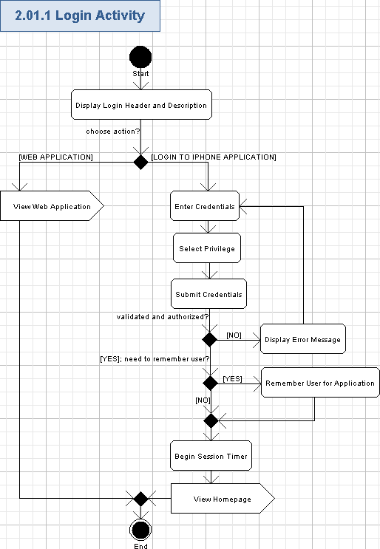

Display Login Header and Description
- The application will show the header on the top of the screen – i.e. the name of the BCMS Incident Management iPhone application:
Business Continuity Mobile
- The application will show the name of the page just below the header:
LOGIN
- The application will show the brief description of the page (String, max 256 chars, non empty) below the “Done” button.

View Web Application
- The user can open the BCMS Incident Management Web application by pressing “View the web version of this app” hyperlink.
- The web application will be started on the mobile device and the user will externally work with it (out of scope for this specification).

Enter Credentials
- In order to login into the application, the user will enter their user ID and password on the login page if it is the first time accessing the application from the mobile device or use existing cached password (see description in section 2.1)
- The user name and password are according to the following table:
Data Element | Description | Format | R?
Username | The unique username (handle) for the user account on the application. | String, max 50 chars, non empty.  The default value is “Username” and it has to be replaced by the actual user name. | Y
Password | The password of the user | String, min 8 chars, max 15 chars, case sensitive, complex combination of ASCII characters (must consist of at least 1 uppercase, 1 lowercase, and 1 numeric/special character)..  Displayed with ‘*’ chars when entering. | Y
- The screen shot example for login to the application is like following:
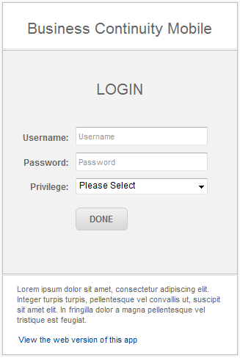

Select Privilege
- The user will select his/her privilege for the application as following:
Data Element | Description | Format | R?
Privilege | The Privileges (use role) of the user | Single item selection drop down, following values are possible:  Business Continuity Mobility  Incident Situation Manager,  Crisis Management Team,  Emergency Response Group,  Senior Executive Committee. | Y
- Please note, “Privilege” drop down has “Please Select” value by default, and the user is required to choose one of the values, from the table above.

Submit Credentials
- The user presses “DONE” button to perform login to the system.
- The system will validate the user credentials and authenticate/authorize the user.
- There will be an own authentication/authorization sub-system to perform that action.
- In case of successful login the user will get access to BCMS Incident Management iPhone Application functionality according to the access rights of his/her user role (like Crisis Management Team, Business Mobile Continuity System Administration, etc.).

Display Error Message
- If the user credentials was wrong (invalid format) then the application will show:
  - The validation error icon (simply red “*” character) nearby the wrong field.
  - One or several of the following red messages (there can be more error message according to validation rules), informing the user about the problem:
Username is required,
Password is required,
Password has to be from <N> to <M> chars,
Please type the correct username/password,
No privilege has been selected,
// etc…
  - Where <N> is a lowest possible count of chars in the password, and <M> is the greatest possible count of chars in the password. <N> and <M> values are as defined in tables from chapters 3.1.1.3 and 3.1.1.4.
- If the authentication failed, a message will be displayed to inform the user that the user name or password is invalid. A user will not be able to infer if the password is wrong or the user id is invalid from the error text. The message is like:
The username or password you provided is wrong. Authentication failed.
- The user has to re-enter his/her credentials to login.

Remember User for Application
- There will be a “remember me” checkbox, so BCMS Incident Management iPhone Application will allow to remember the logged in user.
- If the user turned On the “Remember Me” checkbox, then he/she will be specially remembered by the application:
  - The application will ask the user to login just once – after that the user will stay logged in until he/she specially asks the application to logout or session expires.
  - The user login will be stored between closing BCMS Incident Management iPhone application for the user.
  - The application will not require the user to login again each time he/she opens BCMS Incident Management iPhone Application.
- Please note, the user will be able to forget the login through the settings application on the device.

Begin Session Timer
- The login information will be stored in the application to make the login persist. It is up-to the Architect to determine how the user’s session is stored and processed in this iPhone native application.
- The session will by default expire when the user closes this application and if the “remember me” feature was not requested.
- The session will at minimum maintain the username and the role name of the current logged in user.
- The default user session is 15 minutes (configurable).
- It starts after successful login.
- If the user performs no actions in 15 minutes, he/she is automatically timed out.
- If the user performs any action (clicks any feature on any site page), the session timer is restarted.

View Homepage
- The application will redirect the user to view the homepage (with navigation menu) – please refer to the chapter 3.3 for more details.

Logout
The user can logout at any time from the application to ensure high security. Most pages (except the login page) of the application will display the button for logout (like “Logout”). The logout can be also performed automatically due to user’s session expiration.
Wireframe page: “Login_Portrait->BCMSA->Incidents” and many other pages.
Related use case from EDES document: none.
- Pre-conditions: the logged in user pressed “Logout” button or the user session has expired.
- Post-conditions: the user was logged out from the application and cannot work with his/her profile until login again. The login page was displayed.

Logout Activity
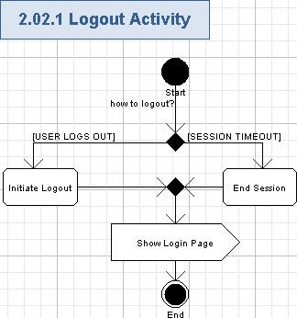

Initiate Logout
- The “Logout” button will be displayed in the footer on most page of the application (when the user is logged in).
- The logged in user can logout from BCMS Incident Management iPhone Application at any time.
- If a logout command is issued, the user’s session will be terminated and they will not be able to perform any functions of a logged in user.
- Logout will be used to improve security when the user has no more needs to use BCMS Incident Management iPhone Application.

End Session
- If the session timeout expires (i.e. the user is inactive with BCMS Incident Management iPhone Application for quite a long time) then the user will be automatically logged out and required to re-login (if performed some operation, available only for the logged-in user).
- The session timeout will be set to 15 minutes by default, but it will be configurable.

Show Login Page
- The application will show the Login page (as described in chapter 3.1), so the user can login again.
- The logged out user will lose access to his/her previously available functionality in BCMS Incident Management iPhone Application and has to login again to access BCMS Incident Management iPhone Application.

Show my Cached Password
The application will reveal the user’s cached password in plain text to the authenticated user upon request. This will remind users who might have forgotten their password for the purpose of logging into the web application.
- Pre-conditions: The user has to be logged in to the application to perform this action. The user’s password has been cached from previous authentication.
- Post-conditions: The user can choose the action to reveal the cached password in plain text.

View Homepage
The application will show a home page for the user after he/she has just logged in. It will show the header, the main area, the footer, and the bottom navigation menu. This page is like a template for displaying most the other web-pages of the application and it will allow to navigate through the most important parts of the application. The user can get help and perform logout from this page. Content of the main area in the homepage will depend on the currently performed feature of the application. This use case is included by use case 3.1 “Login”.
Wireframe page: “Login_Portrait->BCMSA->Incidents”, “Login_Landscape->BCMSA->Incidents” and many other pages.
Related use case from EDES document: a part of 1.18 Incidents.
- Pre-conditions: the user has just logged in to the application or returned back to the top screen of the application. The user has to be logged in to the application to perform this action.
- Post-conditions: the homepage (template) of the application was displayed, and the user can choose some actions on that page or navigate to some other features of the application.

View Homepage Activity
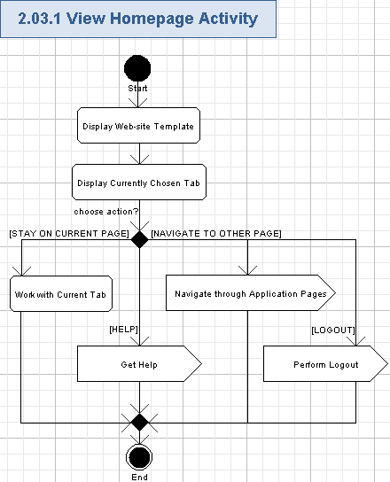

Display Web-site Template
- The application will display the template of the web-site.
- The template will be shown on any page of the application, so it will be described just once below.
- The template has a heading part, a main middle/center area, footer, and a bottom navigation menu.
- The application displays its name in the header:
Business Continuity Mobile
- The application will display the name of the page below the application name. The name depends on which page is shown on the screen. Please note, the “Contacts” page does not have a name in the wireframes – it is like a bug and it suggested to show “Contacts” string as that page’s name.
- The application will use the main area below the page name for displaying the main data, which the user works with (for example, list of Incidents, etc.). So, it can be recognized as a content area.
- The application will show the “Welcome, <username> (<user role)” message in the footer.
Data Element | Description | Format | R?
<Username> | The unique username (handle) for the user account on the application. | String, max 50 chars, non empty. | Y
<user role> | The user role of the user | Single item selection drop down, following values are possible:  Business Continuity Mobility  Incident Situation Manager,  Crisis Management Team,  Emergency Response Group,  Senior Executive Committee. | Y
- The application will display “Help” hyperlink near the welcome message, so the user can always easily access help – please refer to the chapter 3.4.1.5 for more details.
- The application will display the “Logout” button near the welcome message, so the user can always easily logout from the application – please refer to the chapter 3.4.1.6 for more details.
- The application will display the bottom navigation menu (below the “welcome” message – in portrait mode, or together with welcome message – in landscape mode) . The bottom navigation menu will have options to quickly open the related parts of the application – please refer chapter 3.5 for more details.
- The screen shot example of the homepage of the application is as following:
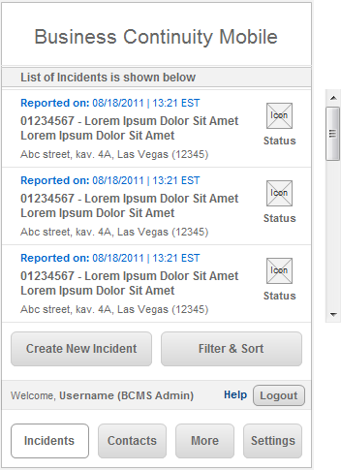

Display Currently Chosen Tab
- The application will show the page in the main area for the currently chosen tab.
- Please refer to the following chapters for the information about top level pages, related to the bottom navigation menu tabs: 3.9, 3.20, 3.29, 3.34.
- The list of incidents (use case 3.9) is shown by default on the homepage.

Work with Current Tab
- The user can stay on the current web-page and perform actions, related to the currently shown tab. Please refer to the following chapters for details: 3.9, 3.20, 3.29, 3.34.

Navigate through Application Pages
- The user can navigate to other page of the application by using the bottom navigation menu, various data entries on the screen, “>” button, “Back” buttons, etc. Please refer to the chapter 3.5 for more details.

Get Help
- The user can get help information on the application usage by pressing “Help” hyperlink.
- The help page will be shown as described in the chapter 3.36.

Perform Logout
- The user can logout from the application by pressing “Logout” button from the footer.
- Logout will be performed as described in the chapter 3.2.

Navigate through Pages
The user can use bottom navigation menu (tabs) to navigate through the various pages of the application.
Wireframe page: “Login_Portrait->BCMSA->Incidents”, “Login_Landscape->BCMSA->Incidents” and many other pages.
Related use case from EDES document: none.
- Pre-conditions: the new user pressed the “Incidents”, “Contacts”, “More”, (etc...) tab in the bottom navigation menu. The user has to be logged in to the application to perform this action.
- Post-conditions: the related chosen page was displayed.

Navigate through Pages Activity
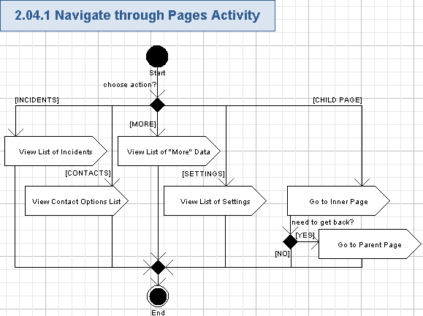

View List of Incidents
- The user can view the list of incidents in the main area of the screen by pressing “Incidents” tab from the bottom navigation menu.
- The list of incidents will be shown as described in the chapter 3.9.

View Contact Options List
- The user can view the list of contact options in the main area of the screen by pressing “Contacts” tab from the bottom navigation menu.
- The list of contact options will be shown as described in the chapter 3.20.

View List of "More" Data
- The user can view “More” list in the main area of the screen by pressing “More” tab from the bottom navigation menu.
- The list of “More” data will be shown as described in the chapter 3.29.

View List of Settings
- The user can view the list of settings in the main area of the screen by pressing “Settings” tab from the bottom navigation menu.
- The list of settings will be shown as described in the chapter 3.34.

Go to Inner Page
- The user can go to the inner (child) page from the top level pages by pressing some clickable data entry on the screen or “>” button:
- The user will be redirected to the related child page.

Go to Parent Page
- The user will be able to return back by pressing “Back” button.

Expand Large Panel to Full Screen
Some panels of the application GUI are quite large and supports expanding/collapsing. This allows for a better management of the user interface and better usage of the display real estate by expanding the large panel to the entire screen of the mobile device. This use case represents the function for expanding the panel to make better use of display real estate. Please note that this functionality is not considered pervasive as logging and as such dependencies to it are not shown explicitly in other activity and use case diagrams.
Wireframe page: “Login_Portrait->BCMSA->Incidents->Incident_Report”, “Login_Portrait->BCMSA->Incidents->Update”, etc.
Related use case from EDES document: none.
- Pre-conditions: the user has accessed a panel which supports expansion functionality and was previously compressed. The user has to be logged in to the application to perform this action.
- Post-conditions: the chosen panel was expanded to full screen.

Expand Large Panel Activity
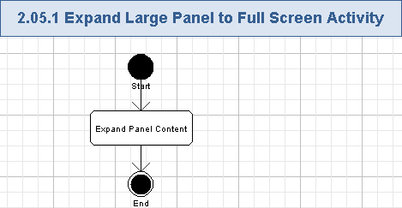

Expand Panel Content
- The user can press “>” button (at the right side of the panel title) of the collapsed panel to open it. The example of the button is as following:
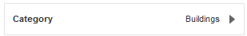
- The application will expand the related panel by opening data entries of that panel to the entire screen – it will be shown like a new page.
- The entire content of the expanded panel will be shown, the title of the panel (String, max 50 chars, non empty) is shown in the header of that page.
- The expanding button (“>”) will be hidden.
- The “Back” button will be shown in the header of the page.
- The example of the expanded panel is as following:
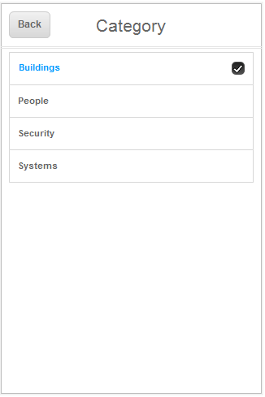

Collapse Large Panel from Full Screen
Some panels of the application GUI are quite large and supports expanding/collapsing. This allows for a better management of the user interface and better usage of the display real estate. This use case represents the function for collapsing the panel from full screen to make better use of display real estate. Please note that this functionality is not considered pervasive as logging and as such dependencies to it are not shown explicitly in other activity and use case diagrams.
Wireframe page: “Login_Portrait->BCMSA->Incidents->Incident_Report”, “Login_Portrait->BCMSA->Incidents->Update”, etc.
Related use case from EDES document: none.
- Pre-conditions: the user has accessed a panel which supports collapsing functionality and was previously expanded. The user has to be logged in to the application to perform this action.
- Post-conditions: the chosen full screen panel was collapsed.

Collapse Large Panel Activity
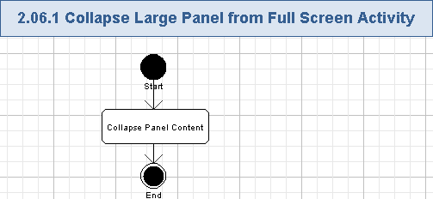

Collapse Panel Content
- The user can press “Back” button (at the left side of the panel title) of the expanded panel to close it.
- The application will collapse the related full screen panel.
- The entire content of the expanded panel will be hidden – so just the header of the panel will be shown, the title of the panel (String, max 50 chars, non empty) is also kept shown.
- The collapsing button (“Back”) will be hidden. And the application will show the expanding button (“>”) on the collapsed panel.
- The value, chosen on the full screen panel, will be shown on the collapsed panel header (like String, max 100 chars, non empty).
- The example of the collapsed panel is as following:

Change Device Orientation
The application supports both portrait and landscape orientation of the mobile device. The user can freely rotate the mobile device and get the application screen rotated according to the current physical orientation of the mobile device.
Wireframe page: “Login_Landscape” and all children pages support landscape orientation, “Login_Portrait” and all children pages support portrait orientation.
Related use case from EDES document: none.
- Pre-conditions: the user rotated the mobile device with the running application.
- Post-conditions: the GUI screen of the current page of the application was rotated accordingly.

Change Device Orientation Activity
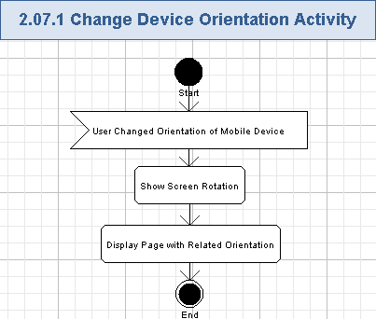

User Changed Orientation of Mobile Device
- The user can freely rotation the mobile device as needed.
- The information about the changed physical orientation of the mobile device will be provided to the application.

Show Screen Rotation
- The application will show the screen rotation visual transition – the standard feature for iPhone devices.

Display Page with Related Orientation
- The application will display the current page in the new physical orientation – according to the new orientation of the mobile device.
- The application will have two sets of GUI screens – for landscape and portrait modes.
- Flipping of landscape and portrait screens will support two more orientations of the mobile devices.
- Therefore, the application will support all 4 possible orientations of the mobile device, so the application GUI will be also shown according to how the user is actually holding the mobile device in his/her hands.

View Incidents List
The application will allow the user to view the list of incidents. The list of incidents will be shown and the application will allow the user to perform further actions with incidents – like filtering and sorting incidents, viewing incident details, creating a new incident.
Wireframe page: “Login_Portrait->BCMSA->Incidents”, “Login_Landscape->BCMSA->Incidents” and similar pages for ISM, CMT, ERG, and SEC user roles.
Related use case from EDES document: 1.18 Incidents.
- Pre-conditions: the user press the “Incidents” tab in the bottom menu or returned back to this page from some other screen. The user has to be logged in to the application to perform this action.
- Post-conditions: the list of incidents was displayed.

View Incidents List Activity
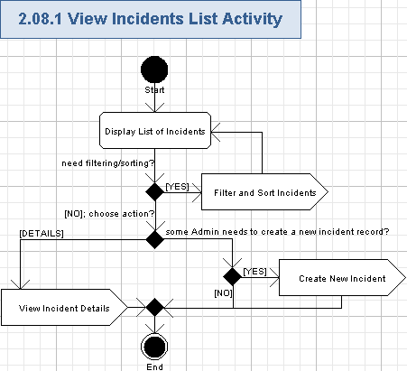

Display List of Incidents
- The application will show the header of the list like following:
List of Incidents is shown below
- The incident entries will be shown on the list with the following fields for each entry:
Data Element | Description | Format | R?
Reported on | The Date and Time stamp when the incident was reported. The name and value for this field will be specially highlighted by the color. The name of the field will be in bold font. | String, max 25 chars, date/time format “MM/DD/YYYY | HH:MM <timezone>”, like “08/18/2011, 08:23 EST”, non empty | Y
<Incident Number> | The number of the Incident. The value of this field will be in bold font. | Positive Integer number, greater than 0. max 9 chars. | Y
<separator> | A simple text separator between the incident number and incident title fields | String, constant value: “ – “, non empty | Y
<Incident Title> | The title of the Incident. The value of this field will be in bold font. | String, max 50 chars, non empty | Y
Location | The location of the Incident. It is like a street address, city name and ZIP code. | String, max 100 chars, non empty | Y
<icon> | An icon representing the current status of the incident. Each icon will be colored according to the status:  New – blue color,  Pending – orange color,  Active – green color,  Closed – red color. | One of the icons with the incident status. The following statuses are supported:  New,  Pending,  Active,  Closed. | Y
<Status> | The name of the current status of the incident. | String, max 7 chars, non empty.  The possible values:  New,  Pending,  Active,  Closed. | Y
- The list rows will be separated – like by lines.
- The list can occupy more than one screen, so the user will be able to scroll the screen with the incident list data. Scrolling of the screen will be possible either up or down.
- Lazy loading of more entries for the incidents list can be supported when the user scrolls the screen to view more incidents – this is just a suggestion (up-to the Architect).
- The screen example of the incidents list is like following (please note, “Create New Incident” button is only shown for BCMS Administrator and ISM user roles):
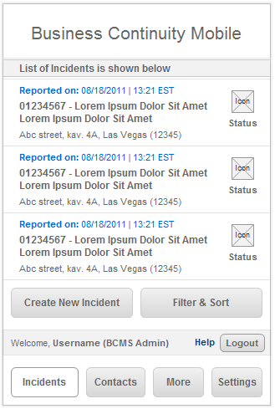

Filter and Sort Incidents
- The user can press “Filter & Sort” button to choose filtering and sorting options and apply then to the list of incidents.
- Please refer to the chapter 3.10 for more details.

View Incident Details
- The user can view details of the incident (and then update it if needed) by pressing the related incident’s entry row on the list of incidents. Any part of the row can be pressed to get redirected to the incident details page.
- Please refer to the chapter 3.11 for more information on the incident details to be shown.

Create New Incident
- If the user role is Admin (i.e. either BCMS Administrator ISM), then there will be “Create New Incident” button on the screen.
- The administrator can press “Create New Incident” button to create a new incident entry in the application – please refer to the chapter 3.37 for more details.

Filter and Sort Incidents
The user can filter the list of displayed incidents by incident status and location. It will be possible to sort the list of incidents by date, incident status or location.
Wireframe page: “Set Filter & Sort Options” page, shown after pressing “Filter & Sort” button on “Login_Portrait->BCMSA->Incidents”, “Login_Landscape->BCMSA->Incidents” and similar pages for ISM, CMT, ERG, and SEC user roles.
Related use case from EDES document: 1.25 Filter and Sort.
- Pre-conditions: the user pressed “Filter & Sort” button. The user has to be logged in to the application to perform this action.
- Post-conditions: the needed filtering and sorting options were chosen, and the application filtered and sorted the list of incidents according to the user’s choice.

Filter and Sort Incidents Activity
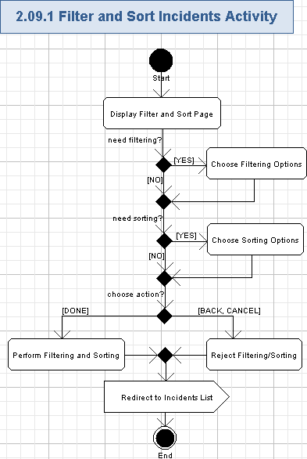

Display Filter and Sort Page
- The application will show the “Set Filter & Sort Options” page, and the page name will be shown in the header:
Set Filter & Sort Options
- The page will show the currently used filtering and sorting options for the list of incidents.
- The filtering options are shown as described in the chapter 3.10.1.2.
- The sorting options are shown as described in the chapter 3.10.1.3.
- The screen example of filtering and sorting of incidents is as following:
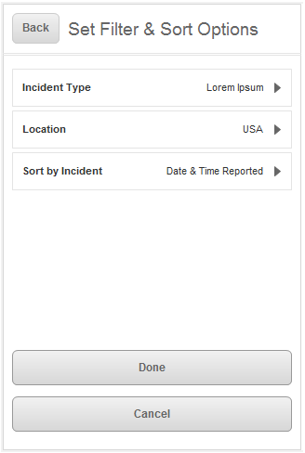

Choose Filtering Options
- The application will show the currently chosen value of the “Incident Status” filtering option. Please note, “Incident Type” option in the wireframes is like a bug and has to be change to “Incident Status”.
Data Element | Description | Format | R?
Incident Status | The name of the current status of the incident. | String, max 7 chars, non empty.  The possible values:  New,  Pending,  Active,  Closed. | Y
- The application will allow the user to choose one or many types of the incidents on “Incident Status” page – it will be open when the user presses the “Incident Status” row. Please note, the wireframes page “Incident Type” has to be renamed to “Incident Status”.
  - The application will show the page name (“Incident Status”) in the header.
  - There will be “Back” button allowing to return to the parent “Set Filter & Sort Options” page.
  - The allowed Incident Status types are shown on the page. They are check boxes (boolean, On/Off values)
    - Active
    - Closed
    - Pending – to be added (it was absent in wireframes)
    - New.
  - Turning On an incident status from that group means the user wants to show incidents of that type on the list. Turning Off an incident status from that group means the user wants to hide incidents of that type from the list.
  - The user choice of needed statuses is automatically remembered by the application and it will be shown on the “Set Filter & Sort Options” page when the user return’s back to it (i.e. pressing “Back” button).
- The application will show the currently chosen value of the “Location” filtering option.
Data Element | Description | Format | R?
Location | The location of the incident | String, max 100 chars, non empty | Y
- The application will allow the user to choose one or many locations of the incidents on “Location” page – it will be open when the user presses the “Location” row.
  - The application will show the page name (“Location”) in the header.
  - There will be “Back” button allowing to return to the parent “Set Filter & Sort Options” page.
  - The list with all possible locations will be shown. They will be checkboxes.
Data Element | Description | Format | R?
<checkbox> | The control allowing to choose the location of incidents | Checkbox control, boolean, On/Off values. | Y
<Location> | The location of the incident | String, max 100 chars, non empty | Y
  - Turning On a location from that group means the user wants to show incidents with that location on the list. Turning Off a location from that group means the user wants to hide incidents with that location from the list.
  - The user choice of needed locations is automatically remembered by the application and it will be shown on the “Set Filter & Sort Options” page when the user return’s back to it (i.e. pressing “Back” button).

Choose Sorting Options
- The application will show the currently chosen value of the “Sort by Incident” sorting option.
Data Element | Description | Format | R?
Sort by Incident | The sorting option | String, max 16 chars, non empty. The possible values are:  Date of Incident,  Location,  Status. | Y
- The user can choose sorting options from the “Sort by Incident” page – it will be open when the user presses the “Sort by Incident” row.
  - The application will show the page name (“Sort by Incident”) in the header.
  - There will be “Back” button allowing to return to the parent “Set Filter & Sort Options” page.
  - The sorting page contains the following sorting options, represented as radio buttons:
    - Date of Incident,
    - Location,
    - Status.
  - The user can select only one of those sorting options.
  - “Date of Incident” sorting option is initially chosen by default.
  - If “Date of Incident” sorting option is chosen, then it means the list of incidents will be sorted by incidents’ dates (descending).
  - If “Location” sorting option is chosen, then it means the list of incidents will be sorted by the locations of the incidents (ascending).
  - If “Status” sorting option is chosen, then it means the list of incidents will be sorted by the titles of the incidents (ascending).
  - The user choice of needed sorting is automatically remembered by the application and it will be shown on the “Set Filter & Sort Options” page when the user return’s back to it (i.e. pressing “Back” button).

Perform Filtering and Sorting
- The user can apply chosen filtering and/or sorting options to the list of incidents by pressing “Done” button.
- The application will keep the user choice of filtering options and sorting options for the list of incidents.
- The list of incidents will be filtered and sorted accordingly. Please note, sorting by Date of Incident is performed in descending order, but sorting by Incident Status or Location is always performed in ascending order.
- The application will store the currently chosen filtering and sorting options for the list of incidents for that user.

Reject Filtering/Sorting
- The user can cancel filtering/sorting process by pressing “Cancel” button or by pressing “Done”.
- No of just changes filtering or sorting of incidents will be applied in this case.
- The filtering and sorting options on the page will be returned to the previous value (just after the previous pressing “Done” button on that page).

Redirect to Incidents List
- The application will redirect the user back to the list of incidents page. Please refer to the chapter 3.9 for more details.

View Incident Details
The user can view the details of the chosen incident. The application will display the summary, details, and additional comments, and attachments. The user can view and edit checklist for that incident. It will be possible to view notes and add new notes, remove existing note, view note details and send notes by e-mail. The user can view attachments and the Admin-related user roles can manage attachments. This use case includes the following use case: 3.14 “View Incident’s Attachments”.
Wireframe page: “Login_Portrait->BCMSA->Incidents->Incidents_Details”, “Login_Landscape->BCMSA->Incidents->Incidents_Details” and similar pages for ISM, CMT, ERG, and SEC user roles.
Related use case from EDES document: 1.19 Incident Detail.
- Pre-conditions: the user chose the needed incident from the list or returned back to the incident details page from the other page. The user has to be logged in to the application to perform this action.
- Post-conditions: the details of the chosen incident were displayed and the user may be (optionally) chose some actions with them.

View Incident Details Activity
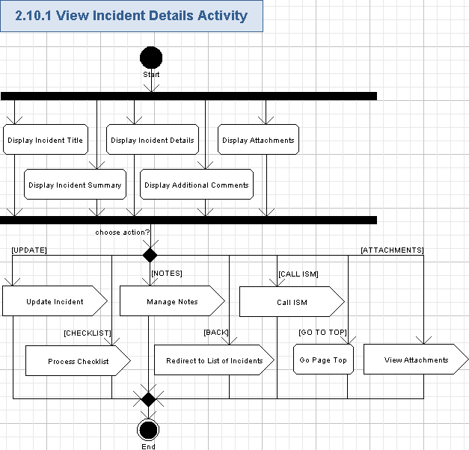

Display Incident Title
- The application will show the title of the incident in the header (instead of the application name).
Data Element | Description | Format | R?
<incident title> | The title of the Incident | String, max 50 chars, non empty | Y
- The application will show “Back” button in the header – so the user can easily return back to the previous page.
- Please note, the incident details page can be quite long and, therefore, the user has to scroll it up/down to view all the information.
- The screen example of the entire incident details page (scrolled to the top and to the bottom) is as following:
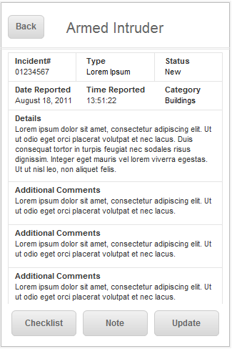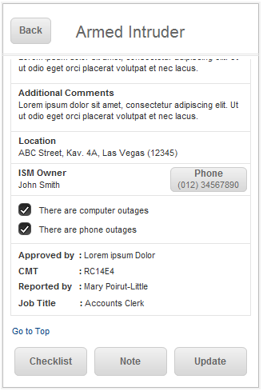

Display Incident Summary
- The application will show the following data in the “Summary” panel:
Data Element | Description | Format | R?
Incident# | The number of the Incident | Positive Integer number, greater than 0. max 9 chars. | Y
Type | The type of the incident | String, max 100 chars, non empty | Y
Status | The status of the incident | String, max 7 chars, non empty. The following values are possible:  New,  Active.  Pending – (it was absent in wireframes, but should be added)  Closed. | Y
Date Reported | The date when the incident was reported | String, max 18 chars, date format “Month DD, YYYY” – like “July 24, 2011”, non empty. | Y
Time Reported | The time when the incident was reported | String, max 8 chars, time format “HH:MM:SS” – like “08:14:32”, non empty | Y
Category | The category of the incident | String, max 100 chars, non empty | Y
Location | The location of the Incident. It is like a street address with the city name and the ZIP code | String, max 100 chars, non empty | Y
ISM Owner | The name of the Incident Situation Manager, owning this incident | String, max 100 chars, non empty | Y
Phone | The phone number of ISM owner. It is displayed on the clickable button – the user can call the related ISM by pressing it – please refer to the chapter 3.11.1.10 for more details. | String, max 18 chars, non empty, phone format with country code and area code: xxx (xxx) xxx-xxxx, where “x” is a digit from 0 to 9. Please note, the country code can be from 1 to 3 digits.  It looks wireframes had a bug with the phone number – wrong number of digits is present and there was no country code. | Y
Approved by | The user who approved the incident | String, max 100 chars, non empty. | Y
CMT | The name of Crisis Management Team, related to this incident | String, max 100 chars, non empty. | Y
Reported by | The name of the user, created this incident | String, max 100 chars, non empty. | Y
Job Title | The name of the job for user, reported the incident | String, max 50 chars, non empty. | Y
- Field values on “Summary” panel will be specially highlighted – like by a visually attractive color (up-to the Studio designer).

Display Incident Details
- The application will show the details of the incident in the “Details” text area – free form text, String, max 1,000 chars, non empty.
- The application will show several turned On checkboxes, describing problems, related to this incident.
- One or many checkboxes is turned On, indicating that the related problems were occurred during the incident.
- Only turned On checkboxes will be shown.
- The problem names (checkboxes names) are as following (up-to 6 of them can be present on this page):
  - There are deaths
  - There are injuries
  - Building(s) have been evacuated
  - Emergency services have been notified
  - There are computer outages
  - There are phone outages

Display Additional Comments
- The application will show “Additional Comments” list. Please note, more data was added to this list – like from iPad wireframes. The iPhone wireframes did not show very important data (username and date), so it was like a bug.
- Each list entry will have the following fields:
Data Element | Description | Format | R?
<comment> | The comment on the incident | String, max 400 chars, non empty | Y
<username> | The handle of the user, commented on the incident | String, max 50 chars, non empty. | Y
<date of comment> | The date, when the comment was added to the incident | String, max 18 chars, date format “Month-DD, YYYY” – like “July-24, 2011”, non empty. | Y
- The user name and date of comment creation are shown in a different color (up-to the Studio designer).
- List entries will be visually separated (like by lines).
- The list will be automatically sorted by date/time of adding a comment (descending).

Display Attachments
- The application will display the “Attachments” button or a collapsed large panel, so the user will be able to press it to view and manage attachments – please refer to the chapter 3.11.1.12 for more details.

Update Incident
- The user can update some data of the incident by pressing “Update” button.
- If the user is not an Admin (i.e. not BCMS Administrator, and not ISM), then he/she will be allowed to update just basic data – as described in the chapter 3.12.
- Else (if the user is BCMS Administrator or ISM), then he/she will be allowed to update basic data and additional information – so, features from the chapter 3.38 will be provided.

Process Checklist
- The user can view and/or edit the checklist by pressing “Checklist” button.
- Please refer to the chapter 3.13 for more details.

Manage Notes
- The user can view the list of notes by pressing “Note” button – please refer to the chapter 3.15 for more details. Then, on the page of shown notes, the user will be able to add a new note, e-mail the note or delete.

Redirect to List of Incidents
- The user can return back to the list of incidents by pressing “Back” button.
- The user will be redirect to the incidents list page – please refer to the chapter 3.9 for more details.

Call ISM
- The user can press “Phone” button to contact the ISM owner of the current incident by a phone call. Please refer to the chapter 3.26 for more details.

Go Page Top
- The user can press “Go to Top” hyperlink at the bottom of the scrolled page and the page will be automatically scrolled to its top position.

View Attachments
- The user can view attachments for the incident – by pressing the “Attachments” button (or header – up-to the Architect). The list of attachments will be shown as described in the chapter 3.14. The Admin-related user will be able to manage attachments on that page.

Update Incident Details
Any regular user can update the basic data of the chosen incident. A free form comment data can be entered by the user and stored to the incident.
Wireframe page: “Login_Portrait->CMT->Incidents->Update”, “Login_Landscape->CMT->Incidents->Update”, and similar pages for ERG and SEC user roles.
Related use case from EDES document: 1.24 Update.
- Pre-conditions: the user pressed “Update” button when viewing details of the incident. The user has to be logged in to the application to perform this action.
- Post-conditions: the basic data of the incident was updated, and changes were saved or cancelled.

Update Incident Details Activity
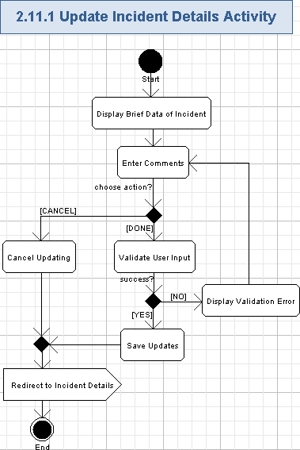

Display Brief Data of Incident
- The application will show the title of the incident on the top of the incident’s data.:
Data Element | Description | Format | R?
<incident title> | The title of the Incident | String, max 50 chars, non empty | Y
- The application will show “Back” button in the header, so the user can easily return to the previous page.
- The application will show the following (read-only) fields with the basic information about the incident.
Data Element | Description | Format | R?
<Date/Time Reported> | The date and time when the incident was reported | String, max 35 chars, date/time format “Month DD, YYYY | HH:MM:SS <timezone>” – like “July 24, 2011 | 08:14:32 EST”, non empty. | Y
Type | The Type of the incident | String, max 100 chars, non empty | Y
Status | The status of the incident | String, max 7 chars, non empty. The following values are possible:  New,  Active.  Closed.  Pending – (it was absent in wireframes, but should be added) | Y
Category | The category of the incident | String, max 100 chars, non empty | Y
ISM Owner | The name of the Incident Situation Manager, owning this incident | String, max 100 chars, non empty | Y
Location | The location of the incident | String, max 100 chars, non empty | Y
Approved by | The user who approved the incident | String, max 100 chars, non empty. | Y
CMT | The name of Crisis Management Team, related to this incident | String, max 100 chars, non empty. | Y
Reported by | The name of the user, created this incident | String, max 100 chars, non empty. | Y
Job Title | The name of the job for user, reported the incident | String, max 50 chars, non empty. | Y
- The application will show checkboxes (read-only) with information about problems, related to this incident.
- One or many checkboxes is turned On, indicating that the related problems were occurred during the incident.
- Only turned On checkboxes will be shown.
- The problem names (checkboxes names) are as following (up-to 6 of them can be present on this page):
  - There are deaths
  - There are injuries
  - Building(s) have been evacuated
  - Emergency services have been notified
  - There are computer outages
  - There are phone outages
- Please note, the page is quite long and the user has to scroll it up/down to see all the data
- The screen example of updating incident details is as following:
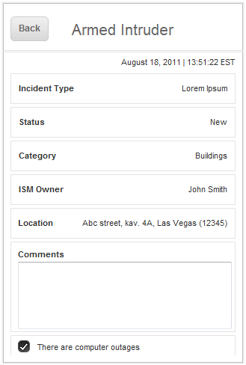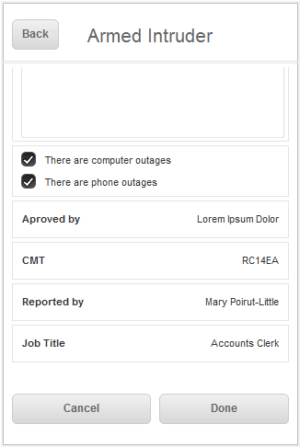

Enter Comments
- The application will ask the user to enter the following data for the currently chosen incident:
Data Element | Description | Format | R?
Comment | The comment on the incident | String, max 400 chars, non empty | Y
- The user will enter the comment by standard virtual keyboard of the device.

Validate User Input
- The application will automatically validate all the user input for all the required fields according to table 3.12.1.2.
- The user can not proceed until providing the correct data.

Display Validation Error
- If the validation failed, then the validation icon (or just “*” character) will be displayed nearby the wrong field and there will be validation message like this (concrete validation error relates to the failed field):
Field <FieldName> is required.
Etc.

Save Updates
- The user can add a newly entered comment to the incident by pressing “Done” button.
- The comment will be stored by the application and appended to the incident.
- The newly stored comment will be later shown on the incident details (on the top of “Additional Comments” list).

Cancel Updating
- The user can cancel updating of the incident details by pressing “Cancel” button.
- No comment is added to the incident in this case.

Redirect to Incident Details
- The user will be redirected back – to the page with incident’s details. Please refer to the chapter 3.11 for more details.

Edit Checklist
The user can edit his/her checklist as needed. It has just several groups of checkboxes, located by categories. The user can freely turn on/off items on the checklist. The checklist data is managed individually per each user.
Wireframe page: “Login_Portrait->BCMSA->Incidents->Checklist”, “Login_Landscape->BCMSA->Incidents->Checklist” and similar pages for ISM, CMT, ERG, and SEC user roles.
Related use case from EDES document: 1.20 Checklist.
- Pre-conditions: the user pressed “Checklist” button when viewing details of the incident. The user has to be logged in to the application to perform this action.
- Post-conditions: the checklist options were displayed, the user edited them and the application automatically stored changes.

Edit Checklist Activity
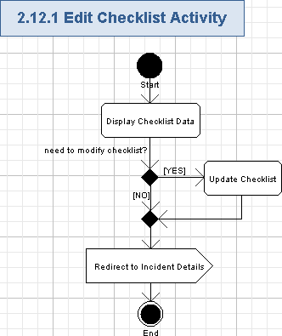

Display Checklist Data
- The application will show a new page.
- The application will display the page name in the header (instead of application name):
Checklist
- The application will show the “Back” button – it will allow to easily return to the previous page.
- The application will show the list of checkbox items.
- This is a list of things the user will need to reference, undertake, complete, etc. whenever an incident occurs.
- The items on this screen are static and are not specific to the incident but could be applied to all incidents.
- Checklist items are grouped by categories (like “1. Buildings”, “2. Staff”, “3. People”, “4. Security”, “5. Systems”, etc.). The checklist category name (String, max 50 chars, non empty) is shown as the header of the group and has an order number prefix (positive integer number, incrementing from 1).
- Each group on the checklist can have one or multiple checkbox entries.
- Each checkbox entry has a checkbox (boolean, On/Off values) and name (String, max 50 chars, non empty).
- The screen example of the checklist is as following:
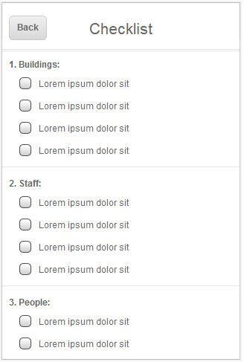

Update Checklist
- The user can set any one or many checkboxes to On value in the checklist.
- The user can reset any one or many checkboxes to Off value in the checklist.
- The checklist is automatically updated and stored by the application.

Redirect to Incident Details
- The user can press “Back” button to redirect back – to the page with incident’s details.
- The user will be redirected to the incident’s details page – please refer to the chapter 3.11 for more details.

View Incident's Attachments
The user can view the attachments for the chosen incident. The icons of the attached files will be shown on the incident details page and the user can view/open any of those attachments. BCMS Administrator or ISM can upload or remove attachments, if needed.
This use case is included by use case 3.11 “View Incident Details”.
Wireframe page: absent.
Related use case from EDES document: 1.11.3.7 Attachments.
- Pre-conditions: the incident’s details page was shown and the user pressed “Attachments” button (or panel header). The user has to be logged in to the application to perform this action.
- Post-conditions: the attached files of the incident were displayed to the user and the user optionally updated them (if he/she is BCMS Administrator or ISM).

View Incident's Attachments Activity
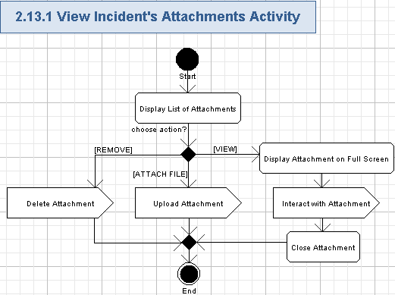

Display List of Attachments
- The application will show the new page.
- The application will display the page name in the header (instead of application name):
Attachments
- The application will show the “Back” button – it will allow to easily return to the previous page.
- The application will show all the attachments of the incident on the “Attachments”.
- Each entry will have the following data:
Data Element | Description | Format | R?
<thumbnail> | The very small picture of the attachment file data (i.e. greatly zoomed out photograph or video attachment) | Picture, dimensions and format are up-to the Studio designer.  It will be clickable object – allowing to view the attachment on full screen | Y
Date | The Date/time, when the attachment was added to the incident | String, max 20 chars, date/time format “MON-DD-YYYY HH:MM:SS” – like “Oct-26-2011 08:00:00”. | Y
Added by | The user who Added the attachment | String, max 100 chars | Y
Name | The name of the attachment | String, max 50 chars | Y
View | The button allowing to view the attachment in full screen mode | A button control. | Y
Remove | The button allowing to delete the attachment from the incident | A button control, red colored. | Y

Delete Attachment
- The Admin-related user (BCMS Administrator or ISM) can remove attachment from the incident by pressing “Remove” button nearby that attachment – please refer to the chapter 3.40 for more details.

Upload Attachment
- The Admin-related user (BCMS Administrator or ISM) can upload a file as an attachment to the incident by pressing “Attach File” button – please refer to the chapter 3.39 for more details.

Display Attachment on Full Screen
- The user can press the attachment thumbnail or “View” button and the application will show the chosen attachment file on the full screen.
- The following attachment types are supported in the first version of the application:
  - The picture attachment will be automatically scaled to fit into the page.
  - The video attachment file will be also automatically scaled to fit into the page.
- The entire screen of the mobile device will be used to show the chosen attachment.

Interact with Attachment
- The user can interact with the displayed attachment as it is allowed by default by the mobile device with that type of file – i.e. the user can zoom in/out or scroll the picture, play/pause the video, etc.
- The user can go forward/backward through attachments of the incident in full screen mode – like by swiping the attachments on the screen.

Close Attachment
- The user can close the attachment like by zooming it out, so it becomes much smaller than the screen of the mobile device.
- In this case the attachment full screen mode is closed.

View Incident's Notes
The user can view the list of notes for the chosen incident. Brief information about notes will be shown on the notes page and the user can add a new note, remove any existing note, view details of any note, or send a note by e-mail (after opening note details).
This use case is included by use case 3.11 “View Incident Details”.
Wireframe page: “Login_Portrait->BCMSA->Incidents->Note”, “Login_Landscape->BCMSA->Incidents->Note” and similar pages for ISM, CMT, ERG, and SEC user roles.
Related use case from EDES document: 1.21 Note.
- Pre-conditions: the incident’s details page was shown and the user pressed “Note” button on that page. The user has to be logged in to the application to perform this action.
- Post-conditions: the attached notes were displayed and the user may be (optionally) performed some actions with them.

View Incident's Notes Activity
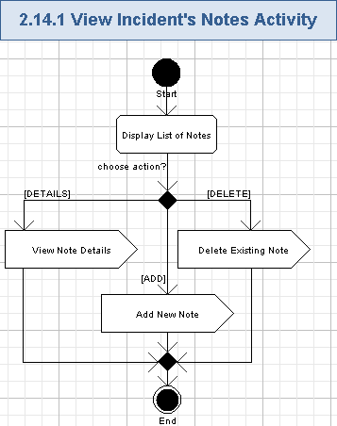

Display List of Notes
- The application will show a new page.
- The application will show the incident number in the header (instead of the application name):
Data Element | Description | Format | R?
<Incident number> | The number of the Incident | Positive Integer number, greater than 0. max 9 chars. | Y
- The application will show the “Back” button – it will allow to easily return to the previous page.
- Please note, only BCMS Administrator user will view and manage all the notes for any incident (according to EDES requirements).
- Other users, will be able to view/manage only their own notes (according to EDES requirements).
- The application will show the list of notes, which are accessible by the current user.
- Please note, the list can be quite long, so the user have to scroll the page up/down to view all the notes.
- Each list entry will have the following fields:
Data Element | Description | Format | R?
“x” icon | The icon, allowing to remove the related note from the incident. Please note, this icon will be hidden and it becomes open only when the user slides the related note entry. Then, the user can use it to remove the related note. | Icon, dimensions are up-to the Studio designer. | Y
Reported on | The date/time, when the note was added to the incident | String, max 25 chars, date/time format “MM/DD/YYYY | HH:MM <timezone>”, like “08/18/2011, 08:23 EST”, non empty | Y
<note abstract> | The truncated note data | String, max 50 chars, non empty. It is a hyperlink to view details of the note. | Y
- <reported on> values on the list of notes will be specially highlighted – like by a visually attractive color (up-to the Studio designer).
- <note abstract> will be shown in bold font.
- List entries will be visually separated (like by lines).
- The list will be automatically sorted by date/time of adding a note (descending).
- The screen example of the list of notes is as following:
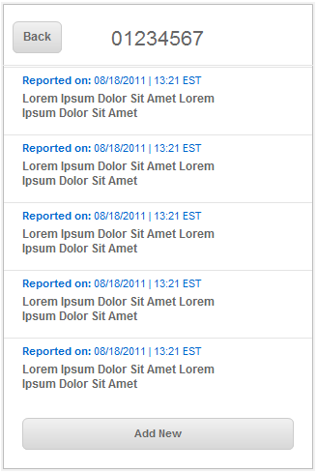

View Note Details
- The user can press the hyperlink of the note entry (any part of the shown note data) and view the detailed information about the note (it will be also possible to e-mail note there) – please refer to the chapter 3.16 for more details.

Add New Note
- The user can press “Add New” button to add a new note to the current incident – please refer to the chapter 3.18 for more details.

Delete Existing Note
- The user can delete the existing note by pressing “x” icon, but that icon will be hidden for all the notes and it only becomes open when the user slides the related note entry. Then, the user can use shown “x” button to remove the related note.
- The user can press “x” button for the related note to delete it from the incident – please refer to the chapter 3.19 for more details.
- Or the user can press another note, or return back, or go to the inner page – then the “x” icon will be hidden.

View Incident's Note Details
The user can view details of the chosen note for the given incident. Full description of the note will be shown and the user can e-mail that note or remove it from the related incident.
Wireframe page: “Login_Portrait->BCMS->Incidents->Note->Note_Details”, “Login_Landscape->BCMS->Incidents->Note->Note_Details” and similar pages for ISM, CMT, ERG, and SEC user roles.
Related use case from EDES document: 1.22 Note Detail.
- Pre-conditions: the user pressed the note row on the notes page. The user has to be logged in to the application to perform this action.
- Post-conditions: the detailed information about the note was displayed and the user may be (optionally) performed some actions this that note.

View Incident's Note Details Activity
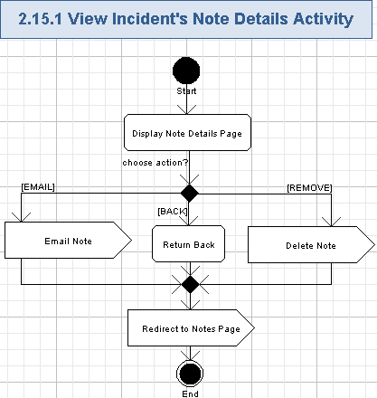

Display Note Details Page
- The application will show a new page.
- The application will show the incident number in the header (instead of the application name):
Data Element | Description | Format | R?
<Incident number> | The number of the Incident | Positive Integer number, greater than 0. max 9 chars. | Y
- The application will show the “Back” button – it will allow to easily return to the previous page.
- Please note, only BCMS Administrator user will view and manage all the notes for any incident (according to EDES requirements).
- Other users, will be able to view/manage only their own notes (according to EDES requirements).
- The application will display the detailed information for the note.
- The following fields will be shown for the chosen note:
Data Element | Description | Format | R?
Date & Time reported | The date/time, when the note was added to the incident | String, max 25 chars, date/time format “Mon DD, YYYY | HH:MM:SS” – like “Aug 24, 2011 | 08:14:32”, non empty. | Y
<Mail icon> | The icon, allowing to send the note by e-mail | Icon, dimensions are up-to the Studio designer. | Y
<Trash icon> | The icon, allowing to remove the related note from the incident | Icon, dimensions are up-to the Studio designer. | Y
<note details> | The full data of the note | String, max 1,000 chars, non empty. | Y
- The date/time of note creation are shown in bold font.
- The <note details> data will be separated from the other fields by the line.
- The screen example of note details is as following:
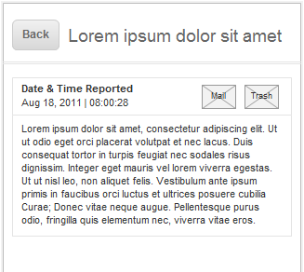

Email Note
- The user can press “Mail” icon to send the displayed note to some other user – please refer to the chapter 3.17 for more details.

Return Back
- The user can press “Back” button to simply return to the previous page – please refer to the chapter 3.16.1.5 for more details.

Delete Note
- The user can press “Trash” icon to remove the displayed note from the incident – please refer to the chapter 3.19 for more details (the “Note Details” page is closed after user deletes the note).

Redirect to Notes Page
- The user can press “Back” button to redirect back to the page with a list of notes.
- The user will be also redirected back after the user deleted or e-mailed the note.
- Please refer to the chapter 3.15 for more details.

Email Incident's Note
The user can e-mail the chosen incident’s note to other users. It will be performed by the e-mail client application on the mobile device.
Wireframe page: the screen of external e-mail client, shown after pressing “Mail” icon on the “Login_Portrait->BCMSA->Incidents->Note->Note_Details”, “Login_Landscape->BCMSA->Incidents->Note->Note_Details” and similar pages for ISM, CMT, ERG, and SEC user roles.
Related use case from EDES document: a part of 1.22 Note Detail.
- Pre-conditions: the user pressed “Mail” icon on the “Notes Details” page. The user has to be logged in to the application to perform this action.
- Post-conditions: the default e-mail client application of the mobile device was opened with the data of the current note.

Email Incident's Note Activity
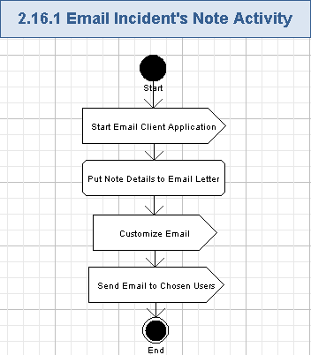

Start Email Client Application
- The user presses e-mail icon and the application will open the external application – a default e-mail client application on the mobile device.
- Please note, only BCMS Administrator user can email the note for any incident (according to EDES requirements).
- Other users, will be able to email only their own notes (according to EDES requirements).

Put Note Details to Email Letter
- The application will create a new e-mail letter in the external e-mail client application.
- The application will copy the following data of the note to the e-mail body:
Data Element | Description | Format | R?
Date and time reported | The date/time, when the note was added to the incident | String, max 36 chars, date/time format “Month-DD, YYYY | HH:MM:SS <timezone>” – like “July-24, 2011 | 08:14:32 EST”, non empty. | Y
<note details> | The full data of the note | String, max 1,000 chars, non empty. | Y
<quote> | The last sentence in the e-mail body. It will be in bold font | String, max 19 chars, non empty. It’s like “Send from my iPhone”. | Y
- The application will put the following message to the subject of the e-mail message (String, max 100 chars, non empty):
A note for the <Incident Title> incident from BCMS Incident Management iPhone application
- Where <Incident Title> is as following:
Data Element | Description | Format | R?
<Incident Title> | The title of the Incident | String, max 50 chars, non empty | Y

Customize Email
- The user will be able to enter target e-mail addresses to the e-mail letter.
- The user will be able to edit subject and body data of the e-mail letter.
- E-mail will be customized externally – through the e-mail client application on the mobile device.

Send Email to Chosen Users
- The user can send the prepared e-mail by the external e-mail client application.
- The e-mail will be sent to the chosen e-mail addresses through some e-mail server.

Add Incident's Note
The user can add a new note to the currently chosen incident. The free form text information can be entered as a note and added to the incident’s details.
Wireframe page: “Add Notes” page displayed after the user pressed “Add New” button on the “Login_Portrait->BCMS->Incidents->Note”, “Login_Landscape->BCMS->Incidents->Note” and similar pages for ISM, CMT, ERG, and SEC user roles.
Related use case from EDES document: a part of 1.21 Note.
- Pre-conditions: the user pressed “Add New” button on the “Notes” page. The user has to be logged in to the application to perform this action.
- Post-conditions: the new note was added (or addition of a note was cancelled) to the given incident.

Add Incident's Note Activity
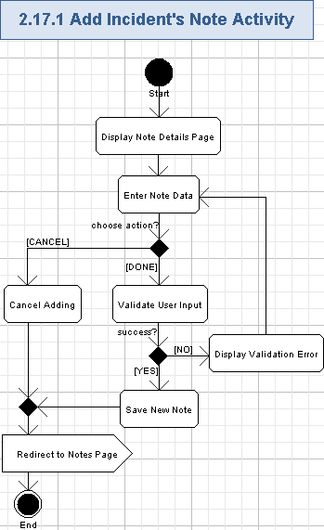

Display Note Details Page
- The application will show a new page, which allows the user to add a new note to the currently chosen incident.
- The application will show the name of the page (instead of the application name):
Add New Note
- The application will show the “Cancel” button – it will allow to easily return to the previous page.
The application will show the current date/time – it will be a date/timestamp for newly added note:
Data Element | Description | Format | R?
<Date & Time reported> | The date/time, when the note will be added to the incident. It’s a current date/time stamp. | String, max 35 chars, date/time format “Month DD, YYYY | HH:MM:SS <timezone>” – like “August 24, 2011 | 08:14:32 EST”, non empty. | Y
- The screen example of the page for adding notes is as following:
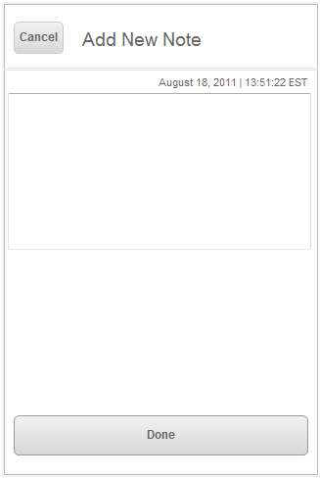

Enter Note Data
- The user will enter the free form text data for the note:
Data Element | Description | Format | R?
<note details> | The full data of the note | String, max 1,000 chars, non empty. | Y

Validate User Input
- The application will automatically validate all the user input for all the required fields according to table 3.18.1.2.
- The user can not proceed until providing the correct data.

Display Validation Error
- If the validation failed, then the validation icon (or just “*” character) will be displayed nearby the wrong field and there will be validation message like this (concrete validation error relates to the failed field):
Field <FieldName> is required.
Etc.

Save New Note
- The user can add a newly entered note to the incident by pressing “Done” button.
- The note will be stored by the application and appended to the incident.
- Additionally, the following data will be stored with the note:
Data Element | Description | Format | R?
<username> | The handle of the user, added the note for the incident | String, max 50 chars, non empty. | Y
Date and time reported | The date/time, when the note was added to the incident | String, max 35 chars, date/time format “Month DD, YYYY | HH:MM:SS <timezone>” – like “July 24, 2011 | 08:14:32 EST”, non empty. | Y
- The newly stored note will be later shown on the list of notes (on the top of “Notes” list).

Cancel Adding
- The user can cancel adding a note to the incident by pressing “Cancel” button.
- No note is added to the incident in this case.

Redirect to Notes Page
- The user can press “Cancel” button to redirect back to the page with a list of notes.
- The user will be also redirected back after the user added a new note.
- Please refer to the chapter 3.15 for more details.

Delete Incident's Note
The user can delete any existing note from the currently chosen incident. There will be a confirmation popup before actual removal of the note.
Wireframe page: “Do you really want to remove this note to trash?” popup on the “Login_Portrait->BCMSA->Incidents->Note->Note_Details”, “Login_Landscape->BCMSA->Incidents->Note->Note_Details” and similar pages for ISM, CMT, ERG, and SEC user roles.
Related use case from EDES document: a part of 1.22 Note Detail.
- Pre-conditions: the user pressed a “Trash” icon on the “Note Details” page. The user has to be logged in to the application to perform this action.
- Post-conditions: the chosen note was removed from the list of notes or the user cancelled the removal process.

Delete Incident's Note Activity
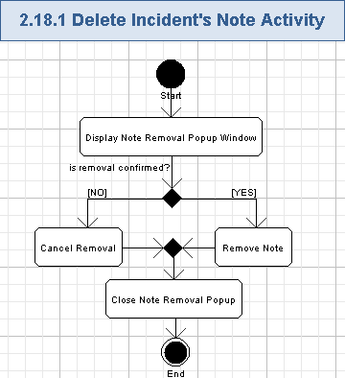

Display Note Removal Popup Window
- The application will display the confirmation popup window with the following message on the removal of the chosen note.
Do you really want to remove this note to trash

<Remove>, <Cancel>
- Please note, only BCMS Administrator user can delete the note for any incident (according to EDES requirements).
- Other users, will be able to delete only their own notes (according to EDES requirements).
- The screen example of note removal window is as following:
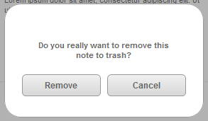

Cancel Removal
- The user can press “Cancel” button to cancel removal of the chosen note.
- No note is removed in this case.

Remove Note
- The user can press “Remove” button to confirm removal of the chosen note.
- The application will remove the related note from the incident – the data for that note will be no more shown on the Notes list page for the incident.

Close Note Removal Popup
- The confirmation popup window will be closed regardless if the user confirmed or rejected removal of the note.

View Contact Options List
The user can view various contact options by pressing “Contacts” tab in the bottom navigation menu. Those options will be: Contact List, Call Trees, and Direct Reports. Then, the user can choose one option from that list to get actual contact data.
Wireframe page: “Login_Portrait->BCMSA->Contacts”, “Login_Landscape->BCMSA->Contacts” and similar pages for ISM, CMT, ERG, and SEC user roles.
Related use case from EDES document: 1.26 Contacts.
- Pre-conditions: the user pressed “Contacts” tab in the bottom navigation menu or returned back to this page from some other page. The user has to be logged in to the application to perform this action.
- Post-conditions: all the contact options were displayed and the user chose which list to show (contact list, or call trees, or direct reports).

View Contact Options List Activity
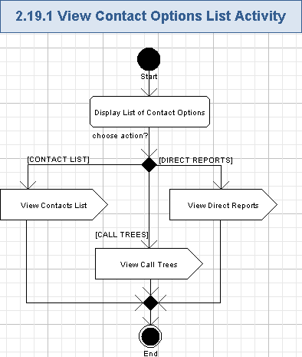

Display List of Contact Options
- The application will show the new page with all the available contact options.
- It is suggested, that the application will show the header of the list like following (just to have a similar header, naming the page, as “Incidents”, “More”, and “Settings” pages):
Contacts
- Each contact option will have the following fields:
Data Element | Description | Format | R?
<contact option> | The name of the contact option | String, max 20 chars, non empty.  At least the following entries will be supported:  Contact List,  Call Trees,  Direct Reports. | Y
“>” icon | The icon allowing to view the list of contacts for the chosen contact option | Icon, dimensions are up-to the Studio designer. | Y
- The following contact options will be supported:
  - Contact List,
  - Call Trees,
  - Direct Reports.
- The list entries will be separated (like by lines).
- The screen example of contact options list is as following:
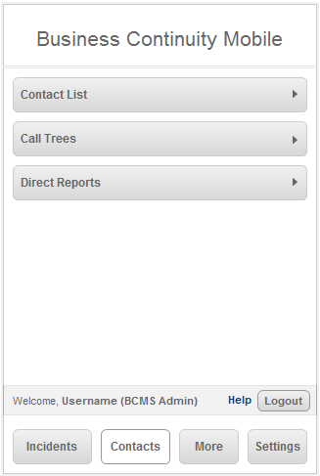

View Contacts List
- The user can press “Contact List” option (either the name or its icons) to view the contacts list – please refer to the chapter 3.21 for more details.

View Call Trees
- The user can press “Call Trees” option (either the name or its icons) to view the contacts for call trees – please refer to the chapter 3.22 for more details.

View Direct Reports
- The user can press “Direct Report” option (either the name or its icons) to view the contacts for direct reports – please refer to the chapter 3.23 for more details.

View Contacts List
The user can get the list of contacts from the application. The actual contact data is grouped by Crisis Management Team, Emergency Response Group, Incident Situation Manager, and Senior Executive groups. The user can choose any of those groups and view the list of the related persons and the contacts data for them. It will be possible to send an alert to the currently chosen group of users, send an e-mail or SMS message, or perform a phone call to the chosen user too.
Wireframe page: “Login_Portrait->BCMSA->Contacts->Contact Groups”, “Login_Landscape->BCMSA->Contacts->Contact Groups” and similar pages for ISM, CMT, ERG, and SEC user roles.
Related use case from EDES document: 1.26 Contacts, 1.27 Crisis Management Team, 1.28 Member Detail.
- Pre-conditions: the user chose “Contact List” option from the contact list options page. The user has to be logged in to the application to perform this action.
- Post-conditions: the list of contacts was displayed and the user may be (optionally) sent an alert, e-mail, or SMS message, or performed a phone call to the chosen user(s).

View Contacts List Activity
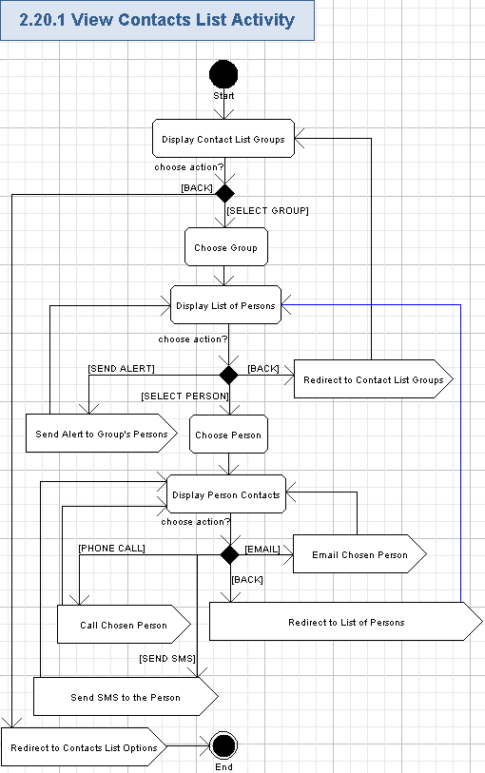

Display Contact List Groups
- The application will show the new page with all the available contact groups.
- The application will show the name of the page:
Contact List
- The application will show the “Back” button – it will allow to easily return to the previous page.
- The application will show the list of contact groups.
- Each contact group will have the following fields:
Data Element | Description | Format | R?
<contact group> | The name of the contact group | String, max 50 chars, non empty.  At least the following entries will be supported:  Crisis Management Team,  Emergency Response Group,  Incident Situation Manager,  Senior Executive. | Y
“>” icon | The icon allowing to view the list of persons for the chosen contact group | Icon, dimensions are up-to the Studio designer. | Y
- The following contact groups will be supported:
  - Crisis Management Team,
  - Emergency Response Group,
  - Incident Situation Manager,
  - Senior Executive.
- The list entries will be separated (like by lines).
- The screen example of the contact list is as following:
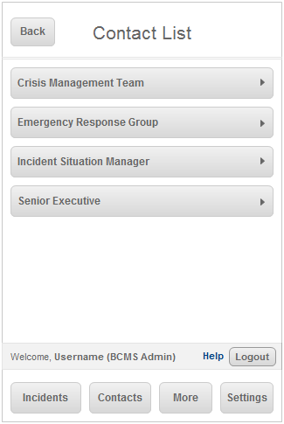

Redirect to Contacts List Options
- The user can press “Back” button to get back to the “Contacts” page – the user will be redirected to the previous page (please refer to the chapter 3.20 for more details).

Choose Group
- The user can choose any contact group from the “Contact List” by pressing the name or the icon of the contact group.

Display List of Persons
- The application will show a new page on the screen.
- The application will display the group name in the header (instead of the application name).
Data Element | Description | Format | R?
<contact group> | The name of the contact group | String, max 50 chars, non empty.  At least the following entries will be supported:  Crisis Management Team,  Emergency Response Group,  Incident Situation Manager,  Senior Executive. | Y
- The application will show the “Back” button – it will allow to easily return to the previous page.
- The application will show the “Alert <XYZ>” button allowing to send alerts to all the persons of the currently chosen group.
- The application will show the list of persons – it will provide brief information about persons, related to the currently chosen contact group.
- Each entry in the list will have the following fields:
Data Element | Description | Format | R?
Name | The name of the person in the currently chosen contact group | String, max 100 chars, non empty. | Y
Title | The name of the job for the person | String, max 50 chars, non empty. | Y
“>” icon | The icon allowing to view the detailed contacts data for the chosen person. It was absent in wireframes (like a bug), but have to be provided according to EDES document. | Icon, dimensions are up-to the Studio designer. | Y
- The list entries will be separated (like by lines).
- The screen example of the persons list is as following:
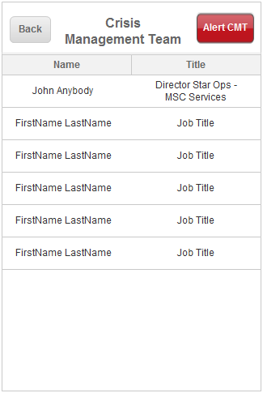

Redirect to Contact List Groups
- The user can press “Back” button to get back to the contact list groups page – the user will be redirected to the previous page (please refer to the chapter 3.21.1.1 for more details).

Send Alert to Group's Persons
- The user can send an alert to all the persons in the currently chosen contact group by pressing “Alert <XYZ>” button, where <XYZ” is one of the following abbreviations (it depends on the currently chosen contact group):
  - CMT – for Crisis Management Team,
  - ERG – for Emergency Response Group,
  - ISM – for Incident Situation Manager,
  - SE – for Senior Executive.
- Please refer to the chapter 3.25 for more details.

Choose Person
- The user can choose the needed person from the list of persons by pressing the entry of that person (i.e. its name, or job title, or “>” icon).

Display Person Contacts
- The application will show the new page for displaying contacts of the chosen person.
- The application will show the page name as following:
Data Element | Description | Format | R?
<Person Name> | The name of the person in the currently chosen contact group | String, max 100 chars, non empty. | Y
<Job Title> | The name of the job for the person | String, max 50 chars, non empty. | Y
- The application will show the “Back” button – it will allow to easily return to the previous page.
- The application will show the “Contact Information” data for the currently chosen person. That detailed contact data will have the following fields:
Data Element | Description | Format | R?
Mobile | The mobile phone number of the person | String, max 18 chars, non empty, phone format with country code and area code: xxx (xxx) xxx-xxxx, where “x” is a digit from 0 to 9. Please note, the country code can be from 1 to 3 digits. It is a clickable button.  It looks wireframes had a bug with count of digits in the phone number. | Y
Business | The office phone number of the person |  | Y
Home | The home phone number of the person |  | Y
Text | The text messages phone number of the user |  | Y
Email | The e-mail address of the user | String, max 50 chars, non empty, it will be case insensitive. This field must be a valid e-mail address.  It is clickable and allows to send an e-mail to the related person. | Y
- The contact fields will be separated (like by lines).
- Each field data will be shown on a button.
- Buttons for phone numbers can be used to perform a phone call to the chosen person – please refer to the chapter 3.21.1.10 for more details. Please note, if the application works on the iPod Touch device, then there will be NO phone call functionality and, therefore, phone buttons will not be workable.
- “Text” button can be used to send SMS to the chosen person – please refer to the chapter 3.21.1.11 for more details.
- “Email” button can be used to send an e-mail to the chosen person – please refer to the chapter 3.21.1.12 for more details.
- The screen example of displaying person contacts is as following:
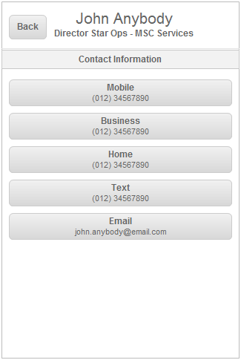

Redirect to List of Persons
- The user can press “Back” button to get back to the list of persons page – the user will be redirected to the previous page (please refer to the chapter 3.21.1.4 for more details).

Call Chosen Person
- The user can press “Mobile”, or “Business”, or “Home” button for the chosen person and the application will automatically perform a phone call to the chosen phone number of the given person – please refer to the chapter 3.26 for more details.

Send SMS to the Person
- The user can press “Text” button for the chosen person and the application will proceed to send SMS to the chosen phone number of the given person – please refer to the chapter 3.27 for more details.

Email Chosen Person
- It will be possible to send an e-mail to the currently chosen person by pressing his/her “Email” button. Please refer to the chapter 3.28 for more details.

View Call Trees
The user can get the list of call trees from the application. The actual trees data is grouped by Board of Directors, Corporate Affairs, Finance Information, HR Facilities, Legal Services, Office of the President, and Worker Employer Services groups. The user can choose any of those groups and view the list of the related persons and the contacts data for them. It will be possible to send an alert to the currently chosen group of users, send an e-mail or SMS message, or perform a phone call to the chosen user too.
Wireframe page: “Login_Portrait->BCMSA->Contacts->Call Trees”, “Login_Landscape->BCMSA->Contacts->Call Trees” and similar pages for ISM, CMT, ERG, and SEC user roles.
Related use case from EDES document: 1.29 Call trees.
- Pre-conditions: the user chose “Call Trees” option from the contact list options page. The user has to be logged in to the application to perform this action.
- Post-conditions: the list of call trees was displayed and the user may be (optionally) sent an alert, e-mail, SMS message, or performed a phone call to the chosen user(s).

View Call Trees Activity
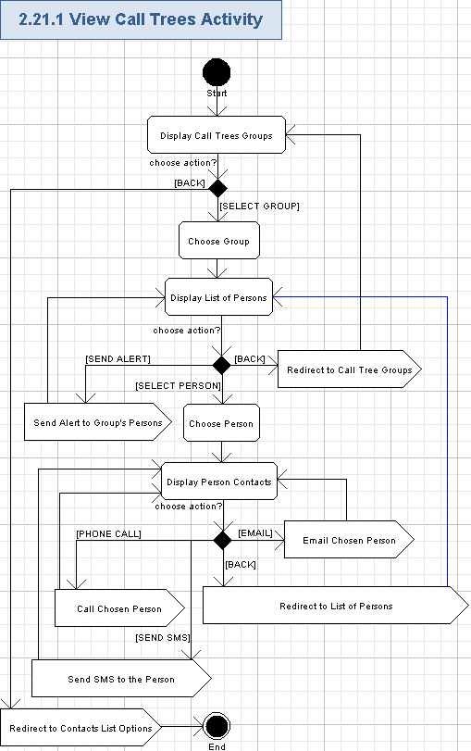

Display Call Trees Groups
- The application will show the new page with all the available call tree groups.
- The application will show the name of the page:
Call Trees
- The application will show the “Back” button – it will allow to easily return to the previous page.
- The application will show the list of call tree groups.
- Each call tree group will have the following fields:
Data Element | Description | Format | R?
<call trees group> | The name of the call trees group | String, max 50 chars, non empty.  At least the following entries will be supported:  Board of Directors,  Corporate Affairs,  Finance Information,  HR Facilities,  Legal Services,  Office of the President,  Worker Employer Services. | Y
“>” icon | The icon allowing to view the list of persons for the chosen call trees group | Icon, dimensions are up-to the Studio designer. | Y
- The following call tree groups will be supported:
  - Board of Directors,
  - Corporate Affairs,
  - Finance Information,
  - HR Facilities,
  - Legal Services,
  - Office of the President,
  - Worker Employer Services.
- The list entries will be separated (like by lines).
- The screen example of the call trees list is as following:
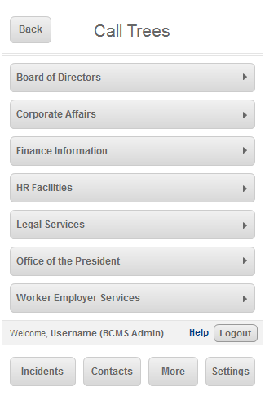

Redirect to Contacts List Options
- The user can press “Back” button to get back to the “Contacts” page – the user will be redirected to the previous page (please refer to the chapter 3.20 for more details).

Choose Group
- The user can choose any call trees group from the “Call Trees” list by pressing the name or the icon of the call trees group.

Display List of Persons
- The application will show a new page on the screen.
- The application will display the group name in the header (instead of the application name).
Data Element | Description | Format | R?
<call trees group> | The name of the contact group | String, max 50 chars, non empty.  At least the following entries will be supported:  Board of Directors,  Corporate Affairs,  Finance Information,  HR Facilities,  Legal Services,  Office of the President,  Worker Employer Services. | Y
- The application will show the “Back” button – it will allow to easily return to the previous page.
- The application will show the “Alert <XYZ>” button allowing to send alerts to all the persons of the currently chosen group.
- The application will show the list of persons – it will provide brief information about persons, related to the currently chosen call tree group.
- Each entry in the list will have the following fields:
Data Element | Description | Format | R?
<Person Name> | The name of the person in the currently chosen call trees group | String, max 100 chars, non empty. | Y
<Job Title> | The name of the job for the person | String, max 50 chars, non empty. | Y
“>” icon | The icon allowing to view the detailed contacts data for the chosen person. It was absent in wireframes (like a bug), but have to be provided according to EDES document. | Icon, dimensions are up-to the Studio designer. | Y
- The list entries will be separated (like by lines).
- The screen example of the persons list is as following:
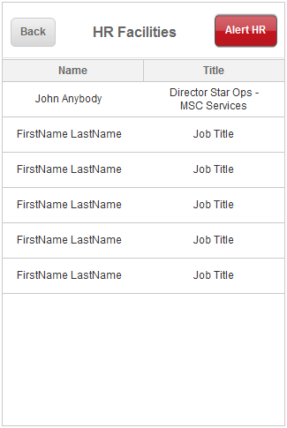

Redirect to Call Tree Groups
- The user can press “Back” button to get back to the call tree groups page – the user will be redirected to the previous page (please refer to the chapter 3.22.1.1 for more details).

Send Alert to Group's Persons
- The user can send an alert to all the persons in the currently chosen call trees group by pressing “Alert <XYZ>” button, where <XYZ” is one of the following abbreviations (it depends on the currently chosen call trees group):
  - BOD – for Board of Directors,
  - CA – for Corporate Affairs,
  - FI – for Finance Information,
  - HR – for HR Facilities,
  - LS – for Legal Services,
  - OP – for Office of the President,
  - WES – for Worker Employer Services.
- Please refer to the chapter 3.25 for more details.

Choose Person
- The user can choose the needed person from the list of persons by pressing the entry of that person (i.e. its name, or job title, or “>” icon).

Display Person Contacts
- The application will show the new page for displaying contacts of the chosen person.
- The application will show the page name as following:
Data Element | Description | Format | R?
<Person Name> | The name of the person in the currently chosen contact group | String, max 100 chars, non empty. | Y
<Job Title> | The name of the job for the person | String, max 50 chars, non empty. | Y
- The application will show the “Back” button – it will allow to easily return to the previous page.
- The application will show the “Contact Information” data for the currently chosen person. That detailed contact data will have the following fields:
Data Element | Description | Format | R?
Mobile | The mobile phone number of the person | String, max 18 chars, non empty, phone format with country code and area code: xxx (xxx) xxx-xxxx, where “x” is a digit from 0 to 9. Please note, the country code can be from 1 to 3 digits. It is a clickable button.  It looks wireframes had a bug with count of digits in the phone number. | Y
Business | The office phone number of the person |  | Y
Home | The home phone number of the person |  | Y
Text | The text messages phone number of the user |  | Y
Email | The e-mail address of the user | String, max 50 chars, non empty, it will be case insensitive. This field must be a valid e-mail address.  It is clickable and allows to send an e-mail to the related person. | Y
- The contact fields will be separated (like by lines).
- Each field data will be shown on a button.
- Buttons for phone numbers can be used to perform a phone call to the chosen person – please refer to the chapter 3.22.1.10 for more details. Please note, if the application works on the iPod Touch device, then there will be NO phone call functionality and, therefore, phone buttons will not be workable.
- “Text” button can be used to send SMS to the chosen person – please refer to the chapter 3.22.1.11 for more details.
- “Email” button can be used to send an e-mail to the chosen person – please refer to the chapter 3.22.1.12 for more details.
- The screen example of displaying person contacts is as following:

Redirect to List of Persons
- The user can press “Back” button to get back to the list of persons page – the user will be redirected to the previous page (please refer to the chapter 3.22.1.4 for more details).

Call Chosen Person
- The user can press “Mobile”, or “Business”, or “Home” button for the chosen person and the application will automatically perform a phone call to the chosen phone number of the given person – please refer to the chapter 3.26 for more details.

Send SMS to the Person
- The user can press “Text” button for the chosen person and the application will proceed to send SMS to the chosen phone number of the given person – please refer to the chapter 3.27 for more details.

Email Chosen Person
- It will be possible to send an e-mail to the currently chosen person by pressing his/her “Email” button. Please refer to the chapter 3.28 for more details.

View Direct Reports
The user can get the list of contacts for direct reports from the application. The person’s entries are grouped by location sections. The user can choose any of the users and view the detailed information about him/her. It will be possible to send an alert to the currently chosen group of users or send an e-mail message to the chosen user too. Viewing the direct report details is also allowed.
Wireframe page: “Direct Reports” option on “Contacts(BCS Admin)-P”, “Contacts(BCS Admin)-L” and similar pages for ISM, CMT, ERG, and SEC user roles.
Related use case from EDES document: 1.30 Direct reports.
- Pre-conditions: the user chose “Direct Reports” option from the “Content List”. The user has to be logged in to the application to perform this action.
- Post-conditions: the list of contacts for direct reports was displayed and the user may be (optionally) displayed the direct report and sent an alert or e-mail message to the chosen user(s).

View Direct Reports Activity
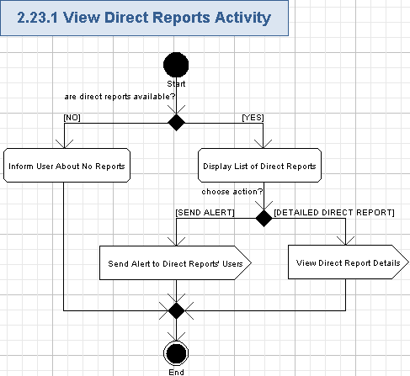

Display List of Direct Reports
- The application will show the new page for showing direct reports.
- The application will show the name of the page:
Direct Reports
- The application will show the “Back” button – it will allow to easily return to the previous page.
- Please note, the user can view only his/her own direct reports.
- The application will display the “Direct Reports” list.
- The list will be grouped by Location data. Each group will have the following name:
Data Element | Description | Format | R?
<Location> | The location of the direct reports | String, max 100 chars, non empty | Y
- Each group represents a collapsible/expandable panel (which can be controlled as described in chapters 3.6, 3.7).
- Each group will have the list of direct report entries. Each entry will have the following fields:
Data Element | Description | Format | R?
Name | The name of the person for the direct report | String, max 100 chars, non empty. | Y
<Job Title> | The name of the job for the person of the direct report. It was absent in wireframes (like a bug), but have to be provided according to EDES document. | String, max 50 chars, non empty. | Y
“>” icon | The icon allowing to view the detailed direct report data for the chosen person. It was absent in wireframes (like a bug), but have to be provided according to EDES document. | Icon, dimensions are up-to the Studio designer. | Y
- Each entry will be specially highlighted and selectable – to view direct report details (please refer to the chapter 3.23.1.4)
- Location groups will be specially separated – like by lines.
- The screen example of viewing the list of direct reports is as following:
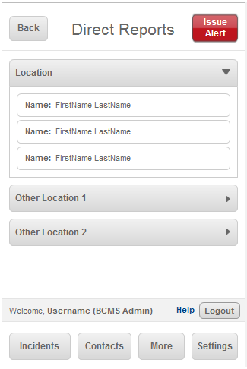

Redirect to Contacts List Options
- The user can press “Back” button to get back to the “Contacts” page – the user will be redirected to the previous page (please refer to the chapter 3.20 for more details).

Send Alert to Direct Reports' Users
- The user can send an alert to all the persons in the direct reports list by pressing “Issue Alert” button.
- Please refer to the chapter 3.25 for more details.

View Direct Report Details
- The user can view the detailed data about the direct report by pressing the person name or job title entry of the direct report on the screen.
- The detailed report will be shown as described in the chapter 3.24.
- Sending a direct report by e-mail will be also allowed on that detailed page.

View Direct Report Details
The user can view the direct report by pressing the entry of any user, related to the direct reports. The data of the direct report will be displayed and the user can reply to that user through SMS.
Wireframe page: a special page, displayed after the user presses any direct report entry on the direct reports list.
Related use case from EDES document: none.
- Pre-conditions: the user pressed the entry (i.e. name, or job title, or icon) of the direct report-related user on the list of direct reports. The user has to be logged in to the application to perform this action.
- Post-conditions: the data of the direct report was displayed and the user may be (optionally) replied by SMS to the chosen user, assigned with the direct reports.

View Direct Report Details Activity
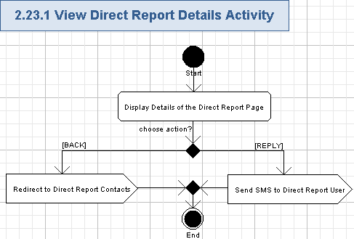

Display Details of the Direct Report Page
- The application will show the new page the detailed information about the currently chosen note.
- The application will show the following as the page name:
Data Element | Description | Format | R?
<Name> | The name of the person for the direct report | String, max 100 chars, non empty. | Y
- The application will show the “Back” button – it will allow to easily return to the previous page.
- The application will show the “Reply” button, so the user can easily send SMS message to the direct report-related person.
- Please note, the user can view only details for his/her own direct reports.
- The following fields will be shown for the direct report:
Data Element | Description | Format | R?
<direct report details> | The full data of the direct report | String, max 1000 chars, non empty. | Y
- The screen example of direct report details is as following:
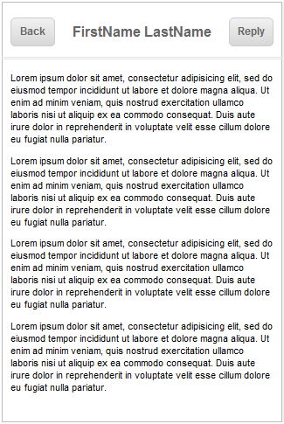

Redirect to Direct Report Contacts
- The user can press “Back” button to get back to the direct reports page – the user will be redirected to the previous page (please refer to the chapter 3.23 for more details).

Send SMS to Direct Report User
- The user can press “Reply” button and the application will proceed to send SMS to the chosen phone number of the given person (related to the direct report) – please refer to the chapter 3.27 for more details.

Send Alert to Chosen User(s)
The user can send the alert message to the chosen group of users from the contacts lists, or from the call trees, or from the direct reports. The user will enter the free form text alert message. Then the user either sends the alert or cancels that.
Wireframe page: “Alert <some group>” page, shown after pressing “Alert …” button from the page of contact groups, or from the page of call tree, or from the page of direct reports.
Related use case from EDES document: a part of 1.27.1 and 1.30.1.
- Pre-conditions: the user pressed “Alert <some group>” red button (for contacts list or call trees); or the user pressed “Issue Alert” red button (for direct reports). The user has to be logged in to the application to perform this action.
- Post-conditions: the alert message was sent to the chosen group of users, or the user cancelled sending an alert.

Send Alert to Chosen User(s) Activity
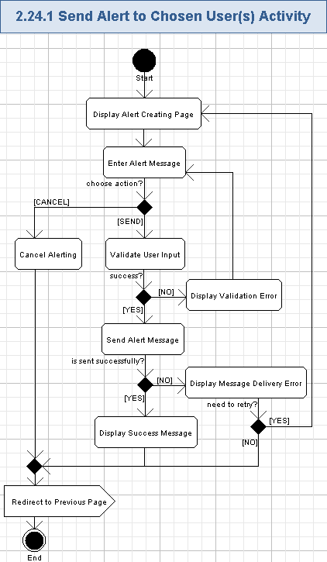

Display Alert Creating Page
- The application will show the “<alert group>” page, which allows the user to enter the alert message and send it to the chosen group of users, where <user group> depends on which alert button the user pressed. It also defines which group of users will be notified by this alert. The cross reference table for <user group> text is as following:
Pressed Button | <alert group> Text | <To> message
Alert CMT | Alert Crisis Management Team | Crisis Management Team group
Alert ERG | Alert Emergency Response Group | Emergency Response Group
Alert ISM | Alert Incident Situation Manager | Incident Situation Manager group
Alert SE | Alert Senior Executive | Senior Executive group
Alert BOD | Alert Board of Directors | Board of Directors group
Alert CA | Alert Corporate Affairs | Corporate Affairs group
Alert FI | Alert Finance Information | Finance Information group
Alert HR | Alert HR Facilities | HR Facilities group
Alert LS | Alert Legal Services | Legal Services group
Alert OP | Alert Office of the President | Office of the President group
Alert WES | Alert Worker Employer Services | Worker Employer Services group
Issue Alert | Issue Alert | Direct Reports group
- The application will show the name of the page <alert group>.
- The application will show the “Cancel” button – it will allow to easily return to the previous page.
- The application will show “To” message (String, max 50 chars, non empty) according to the <To> values from the table above.
- The screen example of the page for sending the alert message is as following:
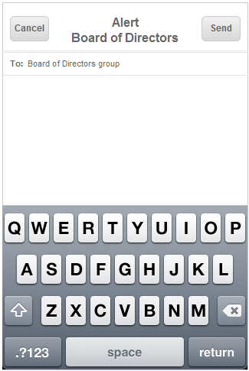

Enter Alert Message
- The user will enter the free form text data for the alert message (it will be performed by the virtual keyboard of the mobile device):
Data Element | Description | Format | R?
<Alert Message> | The message text for the alert | String, max 400 chars, non empty. | Y
- Please note, the long text message will be automatically split by several shorter SMS messages by the application when sending it by SMS.

Validate User Input
- The application will automatically validate all the user input for all the required fields according to table 3.25.1.2.
- The user can not proceed until providing the correct data.

Display Validation Error
- If the validation failed, then the validation icon (or just “*” character) will be displayed nearby the wrong field and there will be validation message like this (concrete validation error relates to the failed field):
Field <FieldName> is required.
Etc.

Send Alert Message
- The user will send entered alert message by pressing “Send” button.
- The alert message will be sent to all the chosen users. Recipient users are just determined by the related group of persons, displayed on the page where alert button was pressed. Recipient users can be from various groups of contacts list, or call trees, or direct reports.
- The iPhone mobile device can directly send SMS messages, so the alert will be automatically sent by the application as one or multiple SMS message to the recipients.
- The application will try to deliver the alert message, entered by the user, to recipients.
- Please note, if the application works on the iPod Touch device, then there will be NO internal SMS functionality, so the application will send SMS through the application backend on the server side – i.e. through some SMS gateway.

Display Success Message
- If the alert message was successfully sent, then the application will display the success message on the popup window:
The alert message has been successfully sent
to all members of this group.
- The user can close the popup window by pressing “OK” button.

Display Message Delivery Error
- If sending of the alert message was failed, then the application will show the error message on the popup window:
An error occurred while sending the alert.

<Try Again>, <Cancel>
- The user will be able to edit and re-send the alert message by pressing “Try Again” button. In this case the popup window is closed and the user can re-try.
- Or the user can cancel sending of the alert by pressing “Cancel” button. In this case the popup window is closed and no alert is sent.

Cancel Alerting
- The user can cancel sending an alert by pressing “Cancel” button.
- No alert message is sent in this case.

Redirect to Previous Page
- The application will redirect from the Alert page to the page where the related “Alert …” button was pressed – so the user will be redirected to the previous page.

Call Chosen User
The user can perform a phone call to the chosen user from the contacts lists, or area office, or call trees. The application will display the standard phone calling popup on the iPhone mobile device. This use case relates to the situation when the user presses some button with phone number (except “Text” button) in contact information for some person.
Please note, this use case is only for the iPhone device. If the application is running on the iPod Touch, then no phone call functionality will be available, because that mobile device does not allow to perform phone calls.
Wireframe page: a phone calling popup page shown when the user presses “Mobile”, “Business”, or “Home” on the person’s contact page – it can be reached by drilling down from “Login_Portrait->BCMSA->Contacts->Contact Groups”, or “Login_Portrait->BCMSA->Contacts->Call Trees”, or “Login_Portrait->BCMSA->Area_Office_Information->Abbotsford”, or “Login_Landscape->BCMSA->Contacts->Contact Groups”, or “Login_Landscape->BCMSA->Contacts->Call Trees”, or “Login_Landscape->BCMSA->Area_Office_Information->Abbotsford” and similar pages for ISM, CMT, ERG, and SEC user roles.
Related use case from EDES document: 1.28.2, field #3 in the table.
- Pre-conditions: the user pressed the “Mobile”, “Business”, “Home”, etc. (except “Text”) button with the person’s phone number (for contacts list, or for area offices, or for call trees). The user has to be logged in to the application to perform this action.
- Post-conditions: the chosen person was called from the iPhone.

Call Chosen User Activity
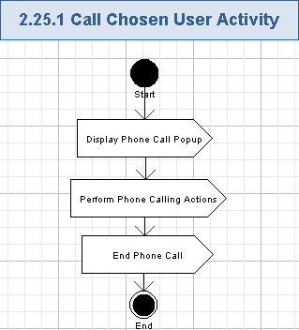

Display Phone Call Popup
- The application will show the standard phone calling popup on the iPhone mobile device.
- The application will show the target phone number:
Data Element | Description | Format | R?
To | The phone number of person, which will receive the phone call. That phone number relates to the data from contact button, pressed by the user for the related person on some contacts page | String, max 18 chars, non empty, phone format with country code and area code: xxx (xxx) xxx-xxxx, where “x” is a digit from 0 to 9. Please note, the country code can be from 1 to 3 digits.  Please note, the phone number in the wireframe has a wrong count of digits. | Y
- The iPhone will automatically start calling the recipient.
- All actions on this popup panel will be performed externally to this application. The existing phone calling functionality of the iPhone is fully re-used.
- The screen example of a phone call popup is as following:
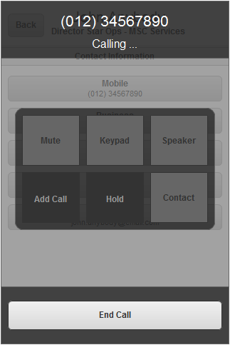

Perform Phone Calling Actions
- The user will be able to perform standard iPhone actions during the phone call – like Mute, Keypad, Speaker, Add Call, Hold, Contact.
- They will be performed externally to the application – the existing phone calling functionality of the iPhone is fully re-used.

End Phone Call
- The user can press “End Call” button and the phone call with the recipient person will be finished.
- The Phone Call popup is closed and the user is stayed on the previous page (where he/she initiated a phone call).

Send SMS to Chosen User
The user can send text message (SMS) to the chosen user from the contacts lists or call trees. The user will enter the free form text message. Then the user either sends the SMS message or cancels that.
This use case relates to the situation when the user presses “Text” button in contact information for some person. It was directly required by EDES, but wireframes did not implement that and mistakenly start a phone call instead of sending an SMS. That absent wireframe feature is fully covered by this use case.
Wireframe page: just a “Text” button with a phone number on the page of contact groups, or on the page of call tree, but pressing that button mistakenly performed a phone call instead of sending SMS message.
Related use case from EDES document: 1.28.2, field #3 in the table.
- Pre-conditions: the user pressed the “Text” button with the person’s phone number (for contacts list, or for call trees). The user has to be logged in to the application to perform this action.
- Post-conditions: the SMS message was sent to the chosen person, or sending process was cancelled.

Send SMS to Chosen User Activity
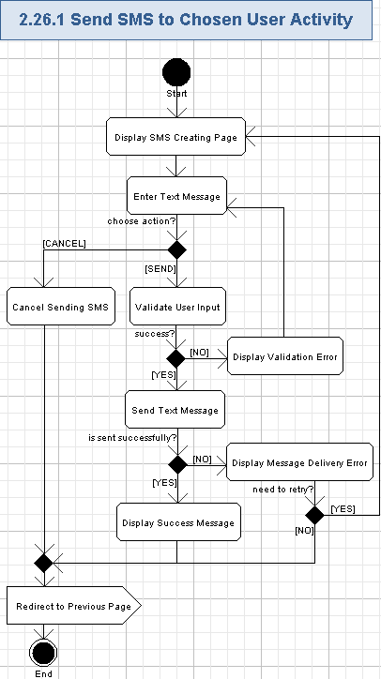

Display SMS Creating Page
- The application will show the new page, which allows the user to enter the text message and send it to the chosen user as SMS
- The application will show the name of the page:
Send SMS
- The application will show the “Cancel” button – it will allow to easily return to the previous page.
- The application will show “To” field with information about target phone number as following:
Data Element | Description | Format | R?
To | The phone number of person, which will receive the SMS text. That phone number relates to the data from contact button, pressed by the user for the related person on some contacts page | String, max 18 chars, non empty, phone format with country code and area code: xxx (xxx) xxx-xxxx, where “x” is a digit from 0 to 9. Please note, the country code can be from 1 to 3 digits. | Y
- The screen example of the page for sending the SMS message is absent in wireframes.

Enter Text Message
- The user will enter the free form text data for the SMS message (it will be performed by the virtual keyboard of the mobile device):
Data Element | Description | Format | R?
<Text Message> | The message text to be sent by SMS | String, max 400 chars, non empty. | Y
- Please note, the long text message will be automatically split by several shorter SMS messages by the application when sending it by SMS.

Validate User Input
- The application will automatically validate all the user input for all the required fields according to table 3.27.1.2.
- The user can not proceed until providing the correct data.

Display Validation Error
- If the validation failed, then the validation icon (or just “*” character) will be displayed nearby the wrong field and there will be validation message like this (concrete validation error relates to the failed field):
Field <FieldName> is required.
Etc.

Send Text Message
- The user will send entered text message by pressing “Send” button.
- The text message will be sent to the related target person. Recipient user is determined by the related phone number (from “To” field).
- The iPhone mobile device can directly send SMS messages, so the alert will be automatically sent by the application as one or multiple SMS message to the recipient.
- The application will try to deliver the text message, entered by the user, to target recipient.
- Please note, if the application works on the iPod Touch device, then there will be NO internal SMS functionality, so the application will send SMS through the application backend on the server side – i.e. through some SMS gateway.

Display Success Message
- If the text message was successfully sent, then the application will display the success message on the popup window:
The text message has been successfully sent
to the chosen person.
- The user can close the popup window by pressing “OK” button.

Display Message Delivery Error
- If sending of the text message was failed, then the application will show the error message on the popup window:
An error occurred while sending the text message.

<Try Again>, <Cancel>
- The user will be able to edit and re-send the text message by pressing “Try Again” button. In this case the popup window is closed and the user can re-try.
- Or the user can cancel sending of the alert by pressing “Cancel” button. In this case the popup window is closed and no text message is sent.

Cancel Sending SMS
- The user can cancel sending a text message by pressing “Cancel” button.
- No text message is sent in this case.

Redirect to Previous Page
- The application will redirect from the Send SMS page to the page where the related phone calling button was pressed – so the user will be redirected to the previous page.

Email Chosen User
The user can send an e-mail message to the chosen user from the contacts’ lists, or from call trees. The e-mail message will be sent externally – by the e-mail client application from the mobile device.
Wireframe page: “Email” button with e-mail address on the page of contact groups, or on the page of call tree.
Related use case from EDES document: a part of 1.28 Member detail.
- Pre-conditions: the user pressed the button with the e-mail address (for contacts list, or for call trees). The user has to be logged in to the application to perform this action.
- Post-conditions: the e-mail message was sent to the chosen user by the default e-mail client application.

Email Chosen User Activity
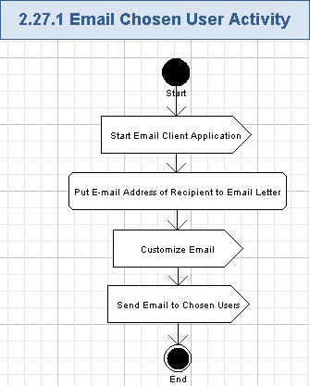

Start Email Client Application
- The user presses the button with the e-mail address and the application will open the external application – a default e-mail client application on the mobile device.

Put E-mail Address of Recipient to Email Letter
- The application will create a new e-mail letter in the external e-mail client application.
- The application will place the recipient’s e-mail address from the pressed button to the “To:” field of the e-mail address:
Data Element | Description | Format | R?
<To> | The e-mail address of the recipient’s user | String, max 50 chars, non empty, it will be case insensitive. This field must be a valid e-mail address. | Y
- It is suggested that the application can put the following message to the subject of the e-mail message (String, max 100 chars, non empty), or it can be left empty – up-to the Architect:
Data message from BCMS Incident Management iPhone application

Customize Email
- The user will be able to add/edit target e-mail addresses to the e-mail letter.
- The user will be able to edit subject and enter the body data for the e-mail letter.
- E-mail will be customized externally – through the e-mail client application on the mobile device.

Send Email to Chosen Users
- The user can send the prepared e-mail by the external e-mail client application.
- The e-mail will be sent to the chosen e-mail addresses through some e-mail server.

View "More" List
The user can get more contacts data (information about area office, related users and their contacts) by pressing “More” tab in the bottom navigation menu. The options will be Area Office Information, Plans, Social Media Links (Twitter feeds, and Facebook page). Then, the user can choose one option from that list to get the related data.
Wireframe page: “Login_Portrait->BCMSA->More”, “Login_Landscape->BCMSA->More” and similar pages for ISM, CMT, ERG, and SEC user roles.
Related use case from EDES document: 1.31 More.
- Pre-conditions: the user pressed “More” tab in the bottom navigation menu or returned back to this page from some other page. The user has to be logged in to the application to perform this action.
- Post-conditions: all the options for more data were displayed and the user chose what data to show (area office information, or plans, or Twitter feeds, or Facebook page).

View "More" List Activity
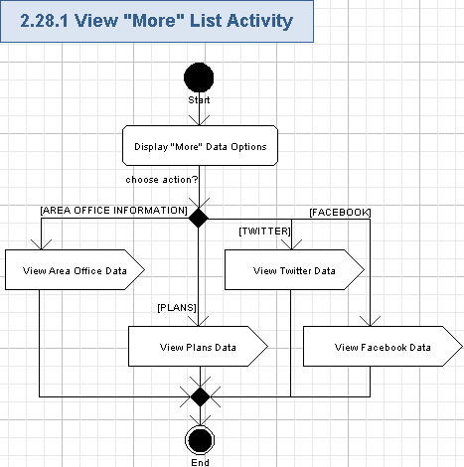

Display "More" Data Options
- The application will show the new page with all the available “More” data options.
- The application will show the header of the list like following:
More
- Each “More” data option will have the following fields:
Data Element | Description | Format | R?
<icon> | The icon, representing the “More” data option. It is absent in wireframes, but should be present according to EDES document. | Icon, dimensions are up-to the Studio designer. | Y
<contact option> | The name of the “More” data option | String, max 20 chars, non empty.  At least the following entries will be supported:  Area Office Information,  Plans,  Twitter. | Y
“>” icon | The icon allowing to view the data page for the chosen “More” data option | Icon, dimensions are up-to the Studio designer. | Y
- The following “More” data options will be supported:
  - Area Office Information,
  - Plans,
  - Social Media Links:
    - Twitter,
    - Facebook .
- The list entries will be separated (like by lines).
- The screen example of “More” data options list is as following (Social Media Links was absent in wireframes, but has to be added; Facebook option was absent in wireframes, but has to be added):
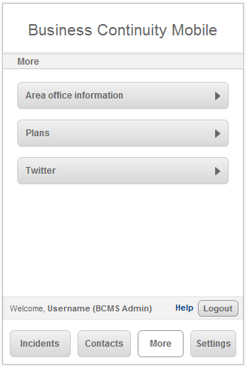

View Area Office Data
- The user can press “Area Office Information” option (either the name or its icons) to view the area office data – please refer to the chapter 3.30 for more details.

View Plans Data
- The user can press “Plans” option (either the name or its icons) to view the plans data – please refer to the chapter 3.31 for more details.

View Twitter Data
- The user can press “Social Media Links -> Twitter” option (either the name or its icons) to view the Twitter feeds of his/her account – please refer to the chapter 3.32 for more details.

View Facebook Data
- The user can press “Social Media Links ->Facebook” option (either the name or its icons) to view the Facebook data of his/her account – please refer to the chapter 3.33 for more details. This option was absent in wireframes, but has to be added.

View Area Office Data
The user can get the list of contacts from the application. The actual persons data is grouped by area of office sections. The user can choose any of the office area and view the list of the related persons and the contacts data for them. Each area office will provide contact information for fire, police, hospitals, and taxis. The user will be able to perform a phone call to the chosen person.
Wireframe page: “Login_Portrait->BCMSA->Area_Office_Information”, “Login_Portrait->BCMSA->Area_Office_Information->Abbotsford”, “Login_Landscape->BCMSA->Area_Office_Information”, “Login_Landscape->BCMSA->Area_Office_Information->Abbotsford” and similar pages for ISM, CMT, ERG, and SEC user roles.
Related use case from EDES document: 1.32 Area office information, 1.33 Abbotsford.
- Pre-conditions: the user chose “Area Office Information” option from the “More” page and then – the needed section from the Area Office Information. The user has to be logged in to the application to perform this action.
- Post-conditions: the list of persons for the chosen area office was displayed and the user may be (optionally) performed a phone call to the chosen person.

View Area Office Data Activity
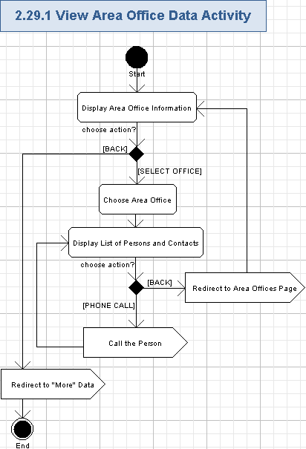

Display Area Office Information
- The application will show the new page with all the available area offices.
- The application will show the name of the page:
Area Office Information
- The application will show the “Back” button – it will allow to easily return to the previous page.
- The application will show the list of area offices.
- Each area office entry will have the following fields:
Data Element | Description | Format | R?
<area office> | The name of the area office | String, max 50 chars, non empty. | Y
“>” icon | The icon allowing to view the list of persons for the chosen area office | Icon, dimensions are up-to the Studio designer. | Y
- The list entries will be separated (like by lines).
- The screen example of the area office information is as following:
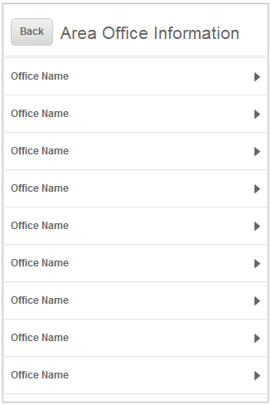

Redirect to "More" Data
- The user can press “Back” button to get back to the “More” page – the user will be redirected to the previous page (please refer to the chapter 3.29 for more details).

Choose Area Office
- The user can choose any area office from the “Area Office Information” list by pressing the name or the icon of the area office entry in that list.

Display List of Persons and Contacts
- The application will show a new page on the screen.
- The application will display the area office name in the header (instead of the application name).
Data Element | Description | Format | R?
<area office> | The name of the area office | String, max 50 chars, non empty. | Y
- The application will show the “Back” button – it will allow to easily return to the previous page.
- The application will show the list of persons and their contact information.
- Each list entry will have the following fields:
  - The application will display the brief information about the person from the chosen area office in the header as following:
Data Element | Description | Format | R?
<Person Name> | The name of the person in the currently chosen area office | String, max 100 chars, non empty. | Y
<Job Title> | The name of the job for the person | String, max 50 chars, non empty. | Y
  - The application will show the detailed contact data for the person from the chosen area office like following:
Data Element | Description | Format | R?
Primary Contact# | The main phone number for the person | String, max 18 chars, non empty, phone format with country code and area code: xxx (xxx) xxx-xxxx, where “x” is a digit from 0 to 9. Please note, the country code can be from 1 to 3 digits.  It looks wireframes had a bug with count of digits in the phone number and formatting. | Y
Secondary Contact# | The additional phone number for the person |  | Y
- The list entries will be separated (like by lines).
- Each phone field data will be shown on a button. Buttons for phone numbers can be used to perform a phone call to the chosen person – please refer to the chapter 3.30.1.6 for more details.
- Please note, if the application works on the iPod Touch device, then there will be NO phone call functionality and, therefore, phone buttons will not be workable.
- The screen example of displaying list of persons and person contacts is as following:
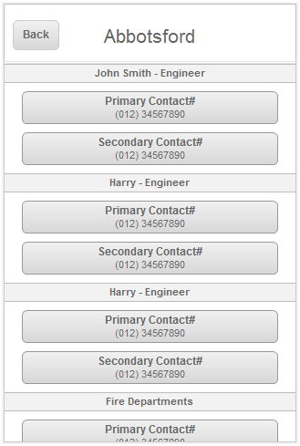

Redirect to Area Offices Page
- The user can press “Back” button to redirect back to the list of area offices – please refer to the chapter 3.30.1.1 for more details.

Call the Person
- The user can press “Primary Contact#” or “Secondary Contact#” button for the chosen person and the application will automatically perform a phone call to the chosen phone number of the given person – please refer to the chapter 3.26 for more details.

View Plans Data
The user can retrieve the plans data from the application. It will be retrieved externally and provided to the application as-is. The external web application will be a repository of Business Continuity Plans, contact lists, etc.
Wireframe page: “Plans” option on “Login_Portrait->BCMSA->More”, “Login_Landscape->BCMSA->More” and similar pages for ISM, CMT, ERG, and SEC user roles. Please note, the actual page with plans data is absent in the wireframes.
Related use case from EDES document: a part of 1.31 More.
- Pre-conditions: the user chose “Plans” option from the “Content List”. The user has to be logged in to the application to perform this action.
- Post-conditions: plans data was displayed.

View Plans Data Activity
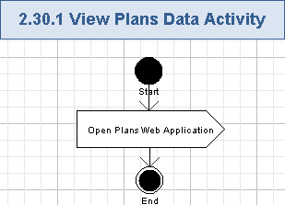

Open Plans Web Application
- The application will externally open the web application for plan documents.
- The external “Plans” web application will be just a repository of various plan documents.
- The application will show information of the Continuity Plans, contact lists, etc. on the page.
- The user will be able to access plan documents according to functionality of the external “Plans” application.

View Twitter Data
The user can get Twitter feeds data for his/her account from the application. Those feeds are retrieved externally and presented to the user.
Wireframe page: “Twitter” option on “Login_Portrait->BCMSA->More”, “Login_Landscape->BCMSA->More” and similar pages for ISM, CMT, ERG, and SEC user roles. Please note, the actual page with Twitter data is absent in the wireframes.
Related use case from EDES document: a part of 1.31 More.
- Pre-conditions: the user chose “Twitter” option from the “More” page. The user has to be logged in to the application to perform this action.
- Post-conditions: Twitter feeds of the user’s account were displayed.

View Twitter Data Activity
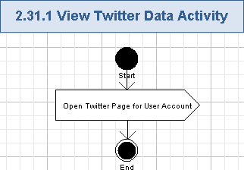

Open Twitter Page for User Account
- The application will externally open the Twitter page for the user’s account.
- The application will show Twitter feeds on the page according to the user’s account.
- The user will be able to access his/her Twitter page according to functionality of the external Twitter application.

View Facebook Data
The user can get Facebook page for his/her account from the application. That page is retrieved externally and presented to the user.
Wireframe page: “Facebook” option on “Login_Portrait->BCMSA->More”, “Login_Landscape->BCMSA->More” and similar pages for ISM, CMT, ERG, and SEC user roles. Please note, the actual page with Facebook data is absent in the wireframes.
Related use case from EDES document: a part of 1.31 More.
- Pre-conditions: the user chose “Facebook” option from the “More” page. The user has to be logged in to the application to perform this action.
- Post-conditions: Facebook page of the user’s account was displayed.

View Facebook Data Activity
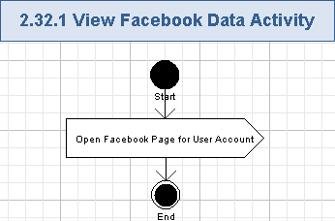

Open Facebook Page for User Account
- The application will externally open the Facebook page for the user’s account.
- The application will show the data according to the user’s Facebook page.
- The user will be able to access his/her Facebook page according to functionality of the external Facebook application.

View List of Settings
The user can get helpful information about the BCMS application by pressing “Settings” tab in the bottom navigation menu. The options will be About This App, and Help. Then, the user can choose one option from that list to get the related data. The content is retrieved dynamically – through some URL.
Wireframe page: “Login_Portrait->BCMSA->Settings”, “Login_Landscape->BCMSA->Settings” and similar pages for ISM, CMT, ERG, and SEC user roles.
Related use case from EDES document: 1.34 Settings.
- Pre-conditions: the user pressed “Settings” tab in the bottom navigation menu. The user has to be logged in to the application to perform this action.
- Post-conditions: all the options for helpful information on the application were displayed and the user chose what data to show (about this application, or help).

View List of Settings Activity
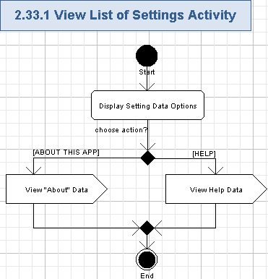

Display Setting Data Options
- The application will show the new page with all the available Setting options.
- The application will show the header of the list like following:
Settings
- Each top-level setting option is like a header of the sub-options page. The hierarchy of pages for settings menu at least as following (the content is retrieved dynamically – through some URL):
  - About This App
    - Terms of Use
    - Privacy Policies
    - Legal Notices
  - Help
    - <Help topic AAA>
    - <Help topic BBB>
    - etc.
- Each top level setting option will have the following fields:
Data Element | Description | Format | R?
<contact option> | The name of the Setting option | String, max 20 chars, non empty.  At least the following entries will be supported:  About This App,  Help. | Y
“>” icon | The icon allowing to view the data page for the chosen Setting option | Icon, dimensions are up-to the Studio designer. | Y
- The following top level setting options will be supported at least (the content is retrieved dynamically – through some URL.):
  - About This App
  - Help
- The list entries will be separated (like by lines).
- The screen example of Settings options list is as following:
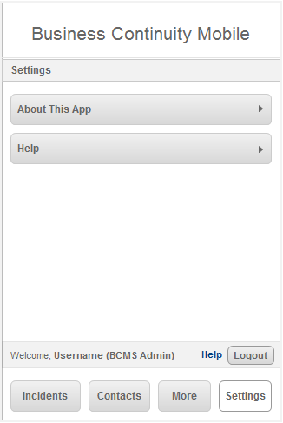

View "About" Data
- The user can press “About This App” option either the name or its icons) to view the useful data about the application – please refer to the chapter 3.35 for more details.

View Help Data
- The user can press “Help” option either the name or its icons) to view the help data – please refer to the chapter 3.36 for more details.

Get Information About Application
The user can get various topics about the application. The following articles are provided: About This Application, Terms of Use, Privacy Policies. The user can choose any of the “about” topic and view the related article. Each article will be simply shown on the screen as free form text data. The content is retrieved dynamically – through some URL.
Wireframe page: “About This App” and children options on “Login_Portrait->BCMS->Settings”, “Login_Landscape->BCMS->Settings” and similar pages for ISM, CMT, ERG, and SEC user roles.
Related use case from EDES document: 1.35 About This App.
- Pre-conditions: the user chose “About This App” or children options from the “Settings” page. The user has to be logged in to the application to perform this action.
- Post-conditions: the chosen article about the application was displayed.

Get Information About Application Activity
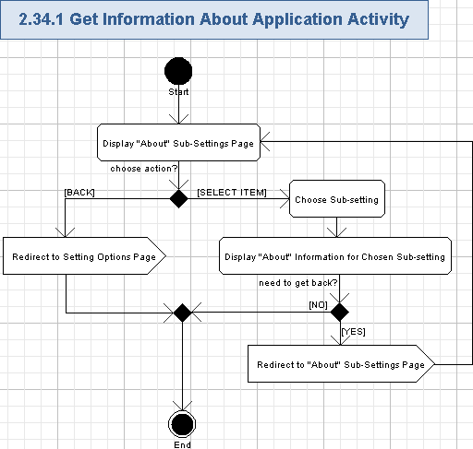

Display "About" Sub-Settings Page
- The application will display the page with sub-settings in the menu.
- The application will show the header of the list like following:
About This App
- The application will show the “Back” button – it will allow to easily return to the previous page.
- At least the following sub-settings will be supported (the content is retrieved dynamically – through some URL.):
  - Terms of Use
  - Privacy Policies
  - Legal Notices
- The name and the “>” icon will be shown for each entry.
- All sub-settings will be clickable.
- The sub-settings will be separated (like by lines).
- The screen example of the sub-setting for information about the application is as following:
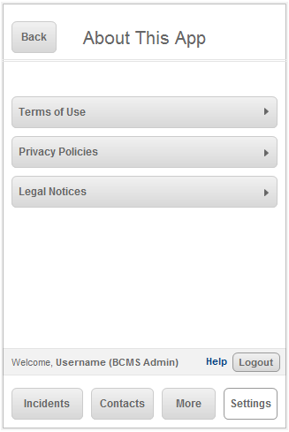

Redirect to Setting Options Page
- The user can press “Back” button and redirect back to view the Settings options menu – please refer to the chapter 3.34 for more details.

Choose Sub-setting
- The user can choose any entry from the “About This App” sub-settings page by pressing the name or the icon of the sub-setting entry in that list.

Display "About" Information for Chosen Sub-setting
- The application will show the application about page, related to the chosen sub-setting on the screen.
- The page will have a header (String, max 50 chars, non empty), equal to the name of the chosen sub-setting from the menu (like Terms of User, Privacy Policies, Legal Notices, etc.).
- The application will show the “Back” button – it will allow to easily return to the previous page.
- The application will show the related data on the page (the content is retrieved dynamically – through some URL.):
Data Element | Description | Format | R?
<sub-setting data> | The free form text data for the chosen sub-setting. It can be information about Terms of User, about Privacy Policies, or Legal Notices. | String, max 10,000 chars, non empty. | Y
- The screen example of displaying the data about the application on the page is as following:
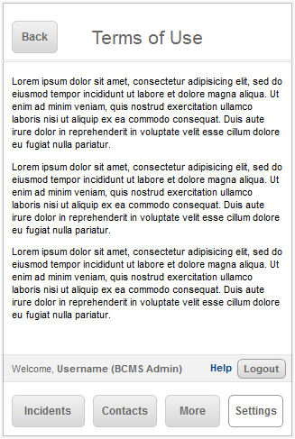

Redirect to "About" Sub-Settings Page
- The user can press “Back” button and redirect back to view the “About” sub-setting options menu – please refer to the chapter 3.35.1.1 for more details.

Get Help Data
The user can get various topics with the application help. Several help articles are provided. The user can choose any of the “help” topic and view the related article. Each article will be simply shown on the screen as free form text data. The content is retrieved dynamically – through some URL.
Wireframe page: “Help” and children options on “Login_Portrait->BCMS->Settings”, “Login_Landscape->BCMS->Settings” and similar pages for ISM, CMT, ERG, and SEC user roles.
Related use case from EDES document: 1.36 Help.
- Pre-conditions: the user chose “Help” (and all children entries) options from the “Settings” page. The user has to be logged in to the application to perform this action.
- Post-conditions: the chosen article with the application help was displayed.

Get Help Data Activity
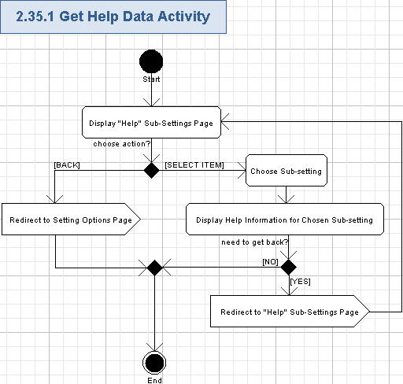

Display "Help" Sub-Settings Page
- The application will display the page with sub-settings in the menu.
- The application will show the header of the list like following:
Help
- The application will show the “Back” button – it will allow to easily return to the previous page.
- At least the following sub-settings will be supported (please note, concrete names of help topics are up-to the Architect or Studio Designer; the content is retrieved dynamically – through some URL):
  - <Help Topic AAA>
  - <Help Topic BBB>
  - etc.
- The name and the “>” icon will be shown for each entry.
- All sub-settings will be clickable.
- The sub-settings will be separated (like by lines).
- The screen example of the sub-setting for help information is as following:
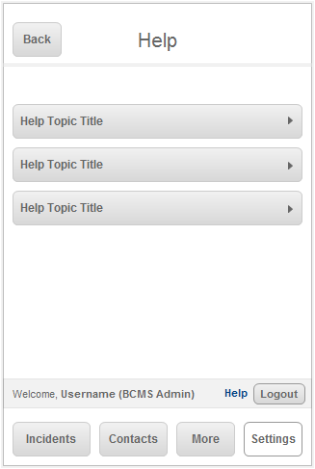

Redirect to Setting Options Page
- The user can press “Back” button and redirect back to view the Settings options menu – please refer to the chapter 3.34 for more details.

Choose Sub-setting
- The user can choose any entry from the “Help” sub-settings page by pressing the name or the icon of the sub-setting entry in that list.

Display Help Information for Chosen Sub-setting
- The application will show the application help page, related to the chosen sub-setting on the screen.
- The page will have a header (String, max 50 chars, non empty), equal to the name of the chosen sub-setting from the menu (like <Help Topic AAA>, <Help Topic BBB>, etc. – concrete names of help topics are up-to the Architect or Studio Designer).
- The application will show the “Back” button – it will allow to easily return to the previous page.
- The application will show the related data on the page (the content is retrieved dynamically – through some URL):
Data Element | Description | Format | R?
<sub-setting data> | The free form text data for the chosen sub-setting. It can be a help information related to the given topic | String, max 10,000 chars, non empty. | Y
- The screen example of displaying the help data on the page is as following:
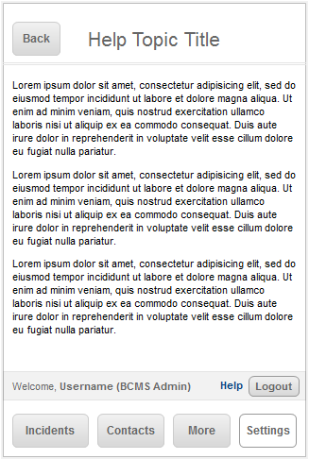

Redirect to "Help" Sub-Settings Page
- The user can press “Back” button and redirect back to view the “Help” sub-setting options menu – please refer to the chapter 3.36.1.1 for more details.

Create New Incident
The user can add a new incident to the application. He/she will enter the general information about the incident, incident title, details, choose its category, type, status, additional information, reported by, etc. data. Then, it will be possible to attach a video or picture file to the incident.
Wireframe page: “Login_Portrait->BCMSA->Incidents->Incident_Report”, or “Login_Landscape->BCMSA->Incidents->Incident_Report” and similar pages for ISM user role.
Related use case from EDES document: 1.1 Incident report.
- Pre-conditions: BCMS Administrator or ISM pressed “Create New Incident” button on the list of incidents page. The user has to be logged in to the application to perform this action.
- Post-conditions: the new incident data was created and saved, or new incident creation process was cancelled.

Create New Incident Activity
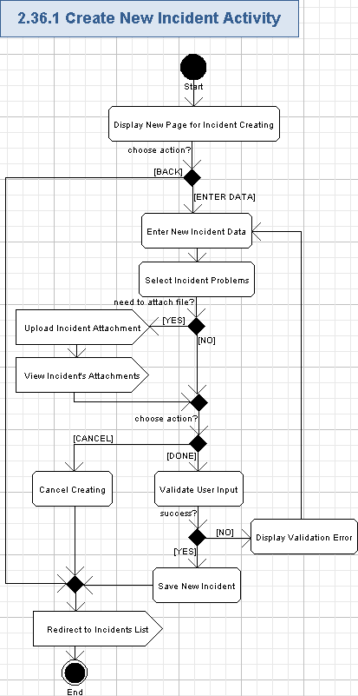

Display New Page for Incident Creating
- The application will display the page name in the header (instead of application name) and the bottom navigation menu is removed:
Add New Incident
- The application will show the “Back” button – it will allow to easily return to the previous page.
- The application will show the “Cancel” button – it will allow to reject creating of a new incident and easily return to the previous page.
- The page will be quite long and the user has to scroll it up/down to access all the data fields on the page.
- There are many large expandable panels on this page. Those pages are expanded/collapsed as described in the chapters 3.6 and 3.7 . For simplicity, this specification simply mentions fields to be entered and it is implicitly assumed that the user has to first expand the related large panel for entering data to that field. Entering of the data on the expanded large panel actually means filling fields on a new page and then returning back to the current page by pressing “Back” button.
- The screen example of a page for creating a new incident is as following (all fields are shown on several differently scrolled examples of the page):
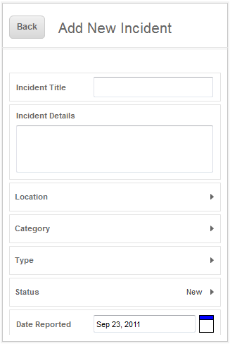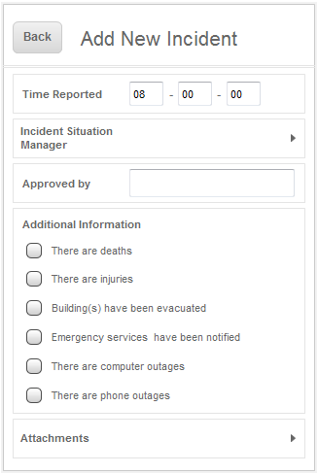
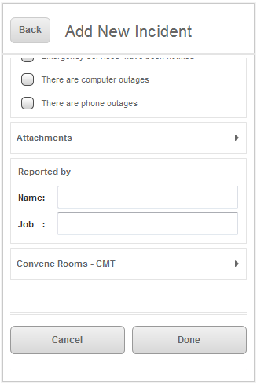

Enter New Incident Data
- The application will display the common incident data to be entered in the following fields.:
Data Element | Description | Format | R?
Incident Title | The title of the Incident | String, max 50 chars, non empty | Y
Incidents details | The Incident details | String, max 1,000 chars | Y
- The Admin-related user can simply choose Location value from the “Location” list (on expandable panel), or select “Other” item and enter Location value to the “Other” text field.
Data Element | Description | Format | R?
Location | The location of the incident – like office location. | Single item selection list, each item is String, max 100 chars, non empty. | Required if “Other” item is not selected.
<Other> item | A special item allowing to manually enter location value to the text box | List item, string, max 5 chars, non empty. The list item is “Other”. | Y
<text box> Other | The textbox for entering Location value (i.e. the office location of the incident) | String, max 100 chars, non empty. | Required if “Other” item is selected.
- The following data can be also entered to the fields of the related large panels:
Data Element | Description | Format | R?
Category | The category of the incident | Single item selection list. Each item is String, max 100 chars, non empty.  At least the following values will be supported:  Buildings,  People,  Security,  Systems. | Y
Type | The type of the incident | Single item selection list. Each item is String, max 100 chars, non empty. | Y
Status | The status of the incident | Single item selection list. Each item is String, max 7 chars, non empty. The following values are possible:  New,  Active.  Closed.  Pending – (it was absent in wireframes, but should be added) | Y
- The user can enter the date/time data to the following fields:
Data Element | Description | Format | R?
Date Reported | The date when the incident was reported. It is a text box and a date picker control. | String, max 12 chars, date format “Mon DD, YYYY” – like “Sep 23, 2011”, non empty. | Y
Time Reported | The time when the incident was reported | It is represented by 3 text boxes. Each text box holds 2 digits (each digit from 0 to 9).  First text box contains hours (from 0 to 23).  Second text box contains minutes (from 0 to 59).  Third text box contains seconds (from 0 to 59) | Y
- The user will enter information about ISM on the related large panel:
Data Element | Description | Format | R?
Incident Situation Manager | The name of the Incident Situation Manager, owning this incident | Single item selection list. Each item is String, max 100 chars, non empty | Y
- The user will enter the approval and creator information for the following fields:
Data Element | Description | Format | R?
Approved by | The user who approved the incident | String, max 100 chars, non empty. | Y
Name | The name of the user, created this incident | String, max 100 chars, non empty. | Y
Job Title | The name of the job for user, reported the incident | String, max 50 chars, non empty. | Y
- Please note, attachments are managed as described in the chapter 3.37.1.4.
- The information about CMT to be related with the incident can be entered to the “Convene Rooms - CMT” large panel.
  - The Admin-related user can simply choose CMT value from the “CMT” list on the expandable panel, or select the “Other” item and enter CMT value to the “Other” text field.
Data Element | Description | Format | R?
CMT | The name of Crisis Management Team, related to this incident | Single item selection list, each item is String, max 100 chars, non empty. | Required if “Other” item is not selected.
<Other> item | List item allowing to manually enter CMT value to the text box | List item, string, max 5 chars, non empty. The list item is “Other”. | Y
<text box> Other | The textbox for entering CMT value (i.e. the name of the Crisis Management Team, related to this incident) | String, max 100 chars, non empty. | Required if “Other” item is selected.
- The user can freely enter data to the fields, described in tables above.

Select Incident Problems
- The application will show checkboxes (clickable) with information about problems, which can be related to this incident, on the “Additional Information” group.
- One or many checkboxes is turned On, indicating that the related problems were occurred during the incident.
- The problem names (checkboxes names) are as following (they are Off by default):
  - There are deaths
  - There are injuries
  - Building(s) have been evacuated
  - Emergency services have been notified
  - There are computer outages
  - There are phone outages
- The BCMS Administrator or ISM can freely turn On or Off checkboxes of the incident problems.
- Turning a checkbox On means the chosen problem becomes related to the given incident.
- Turning a checkbox Off means the chosen problem is irrelevant to the given incident.

Upload Incident Attachment
- The Admin-related user can upload an attachment to the incident by pressing “Attachments” icon – please refer to the chapter 3.38 for more details.

View Incident's Attachments
- The application will display the uploaded attachments for the Admin-related user – please refer to the chapter 3.14 for more details.

Validate User Input
- The application will automatically validate all the Admin-related user input for all the required fields according to tables and rules from 3.37.1.2 and 3.37.1.3.
- The Admin-related user can not proceed until providing the correct data.

Display Validation Error
- If the validation failed, then the validation icon (or just “*” character) will be displayed nearby the wrong field and there will be validation message like this (concrete validation error relates to the failed fields):
Validation Error: Please complete all fields marked by * below.
Etc.

Save New Incident
- The Admin-related user can create a new incident with entered and validated data by pressing “Done” button.
- The incident will be created by the application and all the entered data will be stored for that incident.
- The newly created incident will be later shown on the list of incidents.

Cancel Updating
- The Admin-related user can cancel updating of the incident details by pressing “Cancel” button.
- No incident is created in this case.

Redirect to Incidents List
- The Admin-related user will be redirected back – to the page with incidents list. Please refer to the chapter 3.9 for more details.

Update Incident's Additional Information
Any Admin user (i.e. BCMS Administrator, or ISM) can update the additional data of the chosen incident. That data contains types of problems during the incident, status, type, CMT, category, and ISM of the incident.
Wireframe page: “Login_Portrait->BCMSA->Incidents->Update”, “Login_Landscape->BCMSA->Incidents->Update” and similar pages for ISM user role.
Related use case from EDES document: 1.24 Update.
- Pre-conditions: the BCMS Administrator or ISM pressed “Update” button when viewing details of the incident. The user has to be logged in to the application to perform this action.
- Post-conditions: the additional data of the incident was updated, and changes were saved or cancelled.

Update Incident's Additional Information Activity
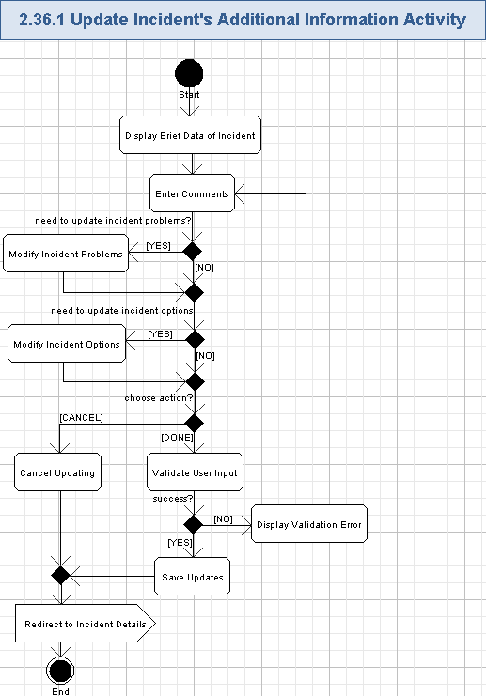

Display Brief Data of Incident
- The application will show the title of the incident on the top of the incident’s data.:
Data Element | Description | Format | R?
<incident title> | The title of the Incident | String, max 50 chars, non empty | Y
- The application will show “Back” button in the header, so the user can easily return to the previous page.
- The application will show the following fields (read-only) with the basic information about the incident.
Data Element | Description | Format | R?
Date/Time Reported | The date and time when the incident was reported | String, max 35 chars, date/time format “Month DD, YYYY | HH:MM:SS <timezone>” – like “July 24, 2011 | 08:14:32 EST”, non empty. | Y
Location | The location of the incident | String, max 100 chars, non empty | Y
Reported by | The name of the user, created this incident | String, max 100 chars, non empty. | Y
Job Title | The name of the job for user, reported the incident | String, max 50 chars, non empty. | Y
- The application will show the current values for the incident’s editable fields. Those value will be shown mostly in the large expandable panels:
Data Element | Description | Format | R?
Incident Type | The Type of the incident | String, max 100 chars, non empty | Y
Status | The status of the incident | String, max 7 chars, non empty. The following values are possible:  New,  Active.  Closed.  Pending – (it was absent in wireframes, but should be added) | Y
Category | The category of the incident | String, max 100 chars, non empty | Y
ISM Owner | The name of the Incident Situation Manager, owning this incident | String, max 100 chars, non empty | Y
Approved by | The user who approved the incident | String, max 100 chars, non empty. | Y
CMT | The name of Crisis Management Team, related to this incident | String, max 100 chars, non empty. | Y
- The application will show checkboxes (clickable) with information about problems, related to this incident.
- One or many checkboxes is turned On, indicating that the related problems were occurred during the incident.
- The problem names (checkboxes names) are as following:
  - There are deaths
  - There are injuries
  - Building(s) have been evacuated
  - Emergency services have been notified
  - There are computer outages
  - There are phone outages
- The page will be quite long and the user has to scroll it up/down to access all the data fields on the page.
- There are many large expandable panels on this page. Those pages are expanded/collapsed as described in the chapters 3.6 and 3.7 . For simplicity, this specification simply mentions fields to be entered and it is implicitly assumed that the user has to first expand the related large panel for entering data to that field. Entering of the data on the expanded large panel actually means filling fields on a new page and then returning back to the current page by pressing “Back” button.
- The screen example of updating incident details by BCMS Administrator or ISM is as following (all fields are shown on several differently scrolled examples of the page):
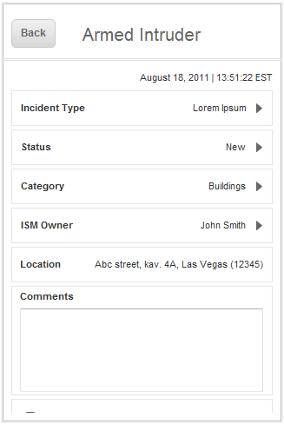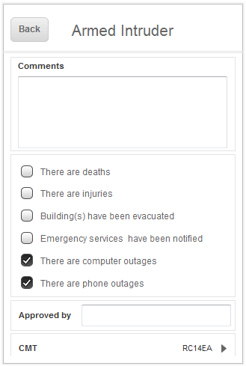

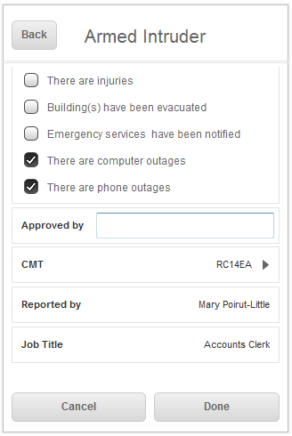

Enter Comments
- The application will ask the user to enter the following data for the currently chosen incident:
Data Element | Description | Format | R?
Comments | The comment on the incident | String, max 400 chars, non empty | Y

Modify Incident Problems
- The BCMS Administrator or ISM can freely turn On or Off checkboxes of the incident problems.
- Turning a checkbox On means the chosen problem is related to the given incident.
- Turning a checkbox Off means the chosen problem is irrelevant to the given incident.
- The problem names of the clickable checkboxes are as following:
  - There are deaths
  - There are injuries
  - Building(s) have been evacuated
  - Emergency services have been notified
  - There are computer outages
  - There are phone outages

Modify Incident Options
- There are several changeable options of the incident. They are shown as expandable long panels:
Data Element | Description | Format | R?
Incident Type | The Type of the incident | Single item selection list. Each item is String, max 100 chars, non empty | Y
Status | The status of the incident | Single item selection list. Each item is String, max 7 chars, non empty. The following values are possible:  New,  Active.  Closed.  Pending – (it was absent in wireframes, but should be added) | Y
Category | The category of the incident | Single item selection list. Each item is String, max 100 chars, non empty | Y
ISM Owner | The name of the Incident Situation Manager, owning this incident | Single item selection list. Each item is String, max 100 chars, non empty | Y
CMT | The name of Crisis Management Team, related to this incident | Single item selection list. Each item is String, max 100 chars, non empty. | Y
- The application can edit the following value as a simple text box:
Data Element | Description | Format | R?
Approved by | The user who approved the incident | String, max 100 chars, non empty. | Y
- The Admin-related user can freely edit those values.

Validate User Input
- The application will automatically validate all the Admin-related user input for all the required fields according to tables and rules from 3.38.1.2, 3.38.1.3, and 3.38.1.4.
- The Admin-related user can not proceed until providing the correct data.

Display Validation Error
- If the validation failed, then the validation icon (or just “*” character) will be displayed nearby the wrong field and there will be validation message like this (concrete validation error relates to the failed field):
Field <FieldName> is required.
Etc.

Save Updates
- The user can add a newly entered comment, updated incident problems and options to the incident by pressing “Done” button.
- The comment will be stored by the application and appended to the incident.
- The updated set of incident problems will be applied to the incident.
- The updated values of incident options will be applied to the incident.
- The newly stored comment, incident problems and options will be later shown on the incident details.

Cancel Updating
- The Admin-related user can cancel updating of the incident details by pressing “Cancel” or “Back” button.
- No comment is added, and no problems/options are changed to the incident in this case.

Redirect to Incident Details
- The Admin-related user will be redirected back – to the page with incident’s details. Please refer to the chapter 3.11 for more details.

Upload Incident's Attachment
The BCMS Administrator and ISM user can upload video or picture files as attachments to the incident. He/she will choose the related file from the list of photographs or from the video list. The files will be from the user’s mobile device. Then, the user will upload them to the application.
Wireframe page: “Attach File – Select Folder” page, shown after pressing “Attachments” expandable panel and then “Attach File” button on “Login_Portrait->BCMSA->Incidents->Incident_Report”, “Login_Landscape->BCMSA->Incidents->Incident_Report” and similar pages for ISM user role. Please note, the wireframes page has bugs and the functionality was re-designed in this specification.
Related use case from EDES document: part of 1.1 Incident report, 1.3 Incident update.
- Pre-conditions: the BCMS Administrator or ISM pressed “Attachments” and then “Attach File” button on the new incident creation page or during updating the incident details. The user has to be logged in to the application to perform this action.
- Post-conditions: the chosen picture or video file was uploaded and attached to the given incident, or the user cancelled uploading process.

Upload Incident's Attachment Activity
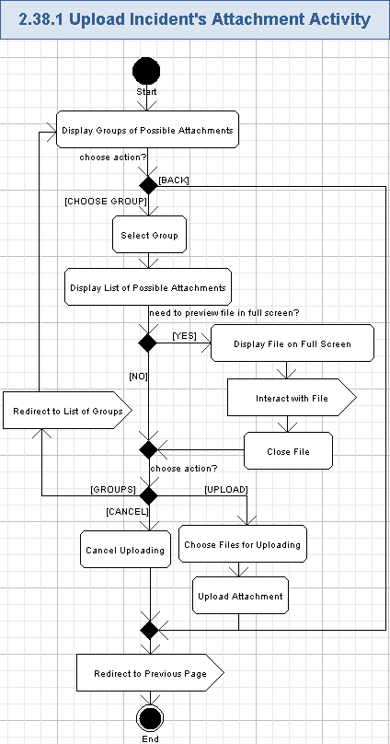

Display Groups of Possible Attachments
- The application will display the page name in the header (instead of application name) and the bottom navigation menu is removed:
Attach File – Select Group
- Please note, there are no “Folder” on iPhone, so they were renamed to “Groups”.
- The application will find the pictures and video files from the user’s mobile device.
- The application will logically group them – like by albums, by photographs, by video files.
- The application will show the list of groups for the possible attachments as a “Folders” menu. The name is like a bug in wireframes (there are no folders on the iPhone), so it is better to rename to “Groups”.
- Each list entry will have the following data:
Data Element | Description | Format | R?
<thumbnail> | The very small picture of the file data (i.e. greatly zoomed out first photograph or video file in the album, or a predefined pictogram for Pictures and Videos groups) | Picture, dimensions and format are up-to the Studio designer.  It will be clickable object – allowing to view the file on full screen | Y
<group name> | The name of the group, logically containing found files | String, max 50 chars, non empty.  At least the following entries will be supported:  Pictures,  Videos,  Albums. | Y
“>” icon | The icon allowing to view the list of files for the chosen group | Icon, dimensions are up-to the Studio designer. | Y
- The screen example of uploading the attachments is as per wireframes (not fully finished and actually have some bugs):
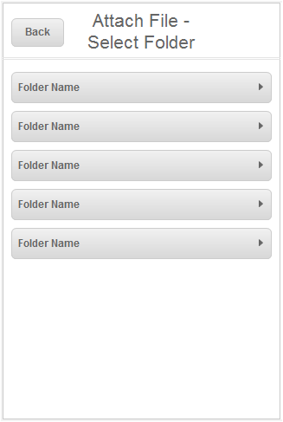

Select Group
- The user can select the needed group of files by pressing it’s thumbnail, name or “>” icon.
- The chosen group of possible attachments will be selected and visually highlighted.

Display List of Possible Attachments
- The application will display the list of possible attachments from the chosen group.
- It will be shown on a new page with the name:
Attach File
- There will be a “Cancel” button, which allows to cancel uploading process and return to the page of already uploaded attachments
- There will be a “Groups” button (renamed from “Folders” button in wireframes) – it will allow to return to the previous page with the list of groups.
- Each file entry will have the following data:
Data Element | Description | Format | R?
<thumbnail> | The very small picture of the file data (i.e. greatly zoomed out photograph or video file) | Picture, dimensions and format are up-to the Studio designer.  It will be clickable object – allowing to view the file on full screen | Y
Name | The name of the file | String, max 50 chars | Y
View | The button allowing to view the file in full screen mode | A button control. | Y

Display File on Full Screen
- The user can press the file thumbnail picture or “View” button and the application will show the chosen file on the full screen.
- The following file types are supported as possible attachments in the first version of the application:
  - The picture attachment will be automatically scaled to fit into the page.
  - The video attachment file will be also automatically scaled to fit into the page.
- The entire screen of the mobile device will be used to show the chosen file.

Interact with File
- The user can interact with the displayed file as it is allowed by default by the mobile device with that type of file – i.e. the user can zoom in/out or scroll the picture, play/pause the video, etc.
- The user can go forward/backward through files of the currently chosen group in full screen mode – like by swiping the files on the screen.

Close File
- The user can close the file like by zooming it out, so it becomes much smaller than the screen of the mobile device.
- In this case the file full screen mode is closed.

Redirect to List of Groups
- The user can press “Groups” button (it was “Folders” in the wireframes) to get back to the list of groups – please refer to the chapter 3.39.1.1.

Choose Files for Uploading
- The user can select the file from the list of the currently chosen group by simply pressing it’s thumbnail or name.
- The chosen file will be visually highlighted (up-to the Studio designer) and becomes ready for uploading.
- Multiple files can be selected – just press them one-by-one.
- The user can unselect any of the selected files by pressing it again.

Upload Attachment
- The user can upload the chosen files as attachments to the incident by pressing “Upload” button.
- A single uploading action allows to attach one or multiple files to the incident.
- The application will upload the attachments and attach them to the given incident.
- The attached files will be later available on the list of attachments for that incident.

Cancel Uploading
- The user can reject uploading of the attachment to the incident by pressing “Cancel” button.
- No files will be attached to the incident in this case.

Redirect to Previous Page
- The user can get back to the previous page by pressing “Cancel” button.
- He/she will be returned to the page, from which the user initiated uploading of the attachment – like to the add new incident page, or to the incident details page, etc.

Delete Incident's Attachment
The BCMS Administrator and ISM user can delete any existing attachment from the given incident. There will be a confirmation popup before actual removal of the attachment. Please note, the wireframes were redesigned for this use case, because wireframes did not have a confirmation, and it was inconvenient.
Wireframe page: absent.
Related use case from EDES document: none.
- Pre-conditions: the BCMS Administrator or ISM user pressed a trash can icon for the given attachment. The user has to be logged in to the application to perform this action.
- Post-conditions: the chosen attachment was removed from the incident’s details or the user cancelled the removal process.

Delete Incident's Attachment Activity
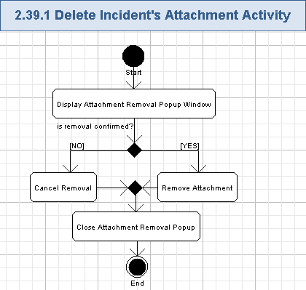

Display Attachment Removal Popup Window
- The application will display the confirmation popup window with the following message on the removal of the chosen attachment.
Are you sure to delete?

<Cancel>, <Remove>
- The “Remove” button will be highlighted by default.
- The screen example of attachment removal window is as following:
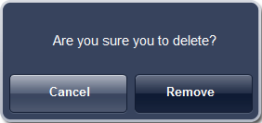

Cancel Removal
- The user can press “Cancel” button to cancel removal of the chosen attachment.
- No attachment is removed in this case.

Remove Attachment
- The user can press “Remove” button to confirm removal of the chosen attachment.
- The application will remove the related attachment from the incident – the data for that attachment will be no more shown on the attachments list of the incident.

Close Attachment Removal Popup
- The confirmation popup window will be closed regardless if the user confirmed or rejected removal of the attachment.

Perform Logging
The application will automatically log errors, exceptions, warnings and debug information during its execution. Information about users, tried to login to the application will be logged as well. Logging information will be stored to some logging system (like files on the server side). This use case is included by most of other user cases.
Related use case from EDES document: none.
- Pre-conditions: the application was started and it will constantly log all problems during its execution.
- Post-conditions: all errors, exceptions, warnings and debug information was logged to logging system (like log files).

Perform Logging Activity
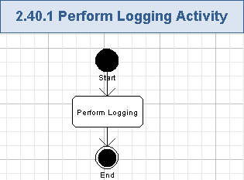

Perform Logging
- The system will log all the errors, exceptions, warning and debug information during the application execution.
- For this iPhone native application, all logging data will be stored to the mobile device itself.
- Please note, logging functionality will be configurable through the build property of the application – logging can be turned On, or Off.
- The following data will be logged in each method of the application:
  - Method name (String, max 100 chars, non empty),
  - Description of problem (String, max 1024 chars, non empty),
  - Input arguments (if any, String, max 4096 chars, can be empty),
  - Output results (if any, String, max 4096 chars, can be empty),
  - Date and timestamp (String, full date/time format, max 30 chars, non empty),
  - Etc. – up-to Architect.
- Additionally, the application will log all successful and failed login attempts for all the users. It is needed to determine how many and which users accessed BCMS Incident Management iPhone Application. The following data will be logged in addition to the regular logging information:
  - Username (String, max 50 chars, non empty),
  - Login result (String, max 7 chars, non empty: “success” or “fail”).
- The logged information must not contain user passwords.

Perform Auditing
All the user actions will be audited by the application. All the data/actions will be audited to the database, so it can be easily retrieved and evaluated in the future by some application management/support staff. This use case is included by most the other use cases.
Related use case from EDES document: none.
- Pre-conditions: some user action has occurred or some data has changed.
- Post-conditions: the user action was audited.

Perform Auditing Activity
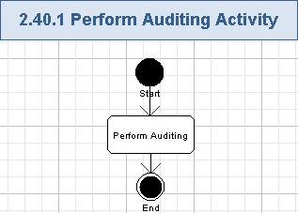

Perform Auditing
- All the user actions will be audited by the application – including viewing any page, entering new data, editing existing data, removing data.
- Auditing will be performed on the server-side – through the application backend.
- The next data of each action will be audited to the database:
  - User ID (it will allow to precisely get user name and so on information).
  - Action name.
  - Date/time.
  - Field or attribute changed.
  - Previous value (if the action was a change to something or removal).
  - New value (if the action was a change to something or creation).
- The type of the values to be audited are like following:
Data Element | Description | Format | R?
User ID | The unique e-mail address of the user. It will be a user ID. This is a primary user’s e-mail. | String, max 50 chars, non empty, it will be case insensitive. This field must be a valid e-mail address. | Y
Action Name | The name of the audited user action | String, max 100 chars, non empty | Y
Field changed | The name of the field changed. | String, max 50 chars, non empty. | Y
Previous value | The previous data of the audited value (if any) | String, max 2000 chars, can be empty.  It will be a serialized data | N
New value | The new data of the audited value (if any) | String, max 2000 chars, can be empty.  It will be a serialized data | N
Date/time | The timestamp of the auditing moment | String, date/time format like DD/MM/YYYY hh:mm:ss, non empty | Y

General Requirements

Graphical User Interface Requirements

Main GUI Goal
The new application’s GUI will be user friendly and provide a simplified interface for BCMS Incident Management iPhone Application functionality.

The GUI will follow the wireframes attached to the wiki page: http://apps.topcoder.com/wiki/display/docs/BCMS+Incident+Management+iPhone+Application+Specification

Resolution
The application has to support the standard resolution for iPhone 3GS and iPod Touch 3G devices: 480 x 320.

The application has to support the standard resolution for iPhone 4 and 4S, and iPod Touch 4G devices: 960 x 640.

Basic GUI Requirements
- Fonts
The fonts (styles, sizes and colors) displayed in the EDES will not necessarily be the same as those used in the application. All the fonts used in the application should follow the standards set for the various styles (skin IDs). This applies to everything, including: headers, paragraphs, grouping text, labels data, footers, etc.
- Alignment
All labels, display only text, text boxes, drop down lists, etc. will be left aligned on the page. The data is the second column should be left aligned to the longest label on that page or modal.
- Drop down lists
If a drop down list is a required field on the add page/modal, and there is a default selection, then the “Select” option should be removed. No point in allowing the user to select it only to get an error. Likewise, on the edit page/modal, the “Select” should also be removed for the same reason.
- Grid views
The following standards will be applied to all grids within the application:
  - All grids (except Comments) will have 50 lines maximum and will page for greater than 50 lines, unless otherwise noted. Comments grids will have a max. of 10 lines.
  - Columns and column headings: Column headings will have the same alignment as the data in the columns. All data with a decimal (including money and percentages), will be right justified in the column. All other data (including text, dates, and non-decimal numeric date (such as ID numbers, etc) will be left justified in the columns. *
  - * The exception to this rule is if a left justified column follows a right justified column. In this case, to avoid crowding and difficulty reading the data, the column will be centre justified.

Color Palette
The client suggested the following color palette.

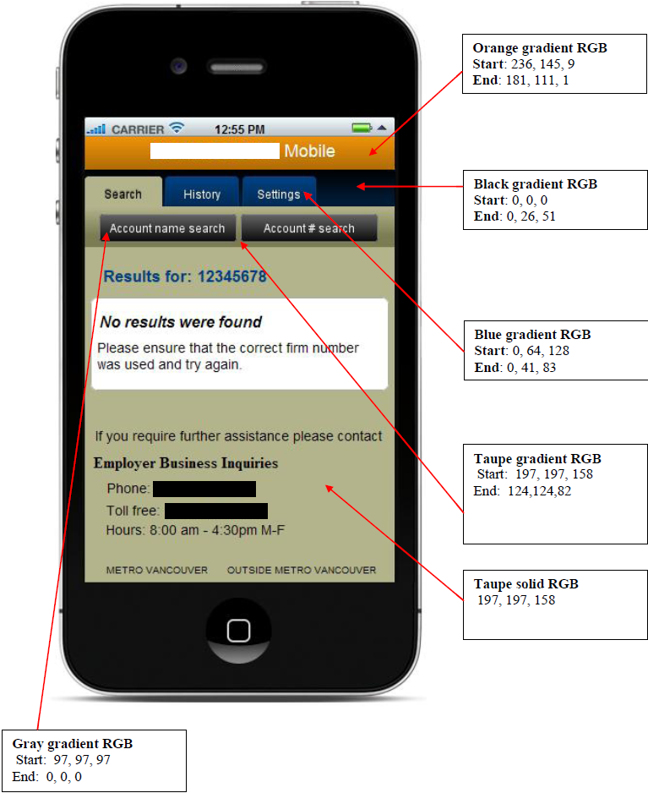

Performance Constraints
User Metrics Requirements:
- The maximum expected count of unique users of the application is 1,000.
- The maximum expected count of concurrent users of the application is 100+. Please note, the application’s frontend is natively executed on the mobile devices (usually by a single user per device).

Performance Requirements:
- The system will be available 24x7 and it will achieve 99.0% uptime (or greater). Please note, this requirement is mostly for the application’s backend. The application frontend will be an iPhone native application and can be called by the user from the mobile device as needed.
- The application screens will load in 2 seconds (or less) after initial hit (including access to the application backend).
- The application users prefer to get results from the application immediately, but a performance of output report generation can be up-to 10-20 seconds and it is acceptable.

Security

Security Roles

Permissions
All security checks will occur against permissions. Each function in the system will validate a user’s permission against the required permission for the task.

Roles
One or more permissions will be assigned to roles. A user may have more than one role. Below is a list of roles and permissions. The System user role was added just for clarity.

 | CMT | ERG | SEC | ISM | BCMS Administrator | System
Login | X | X | X | X | X
Logout | X | X | X | X | X
View Homepage | X | X | X | X | X
Navigate through Pages | X | X | X | X | X
Expand Large Panel to Full Screen | X | X | X | X | X
Collapse Large Panel from Full Screen | X | X | X | X | X
Change Device Orientation | X | X | X | X | X
View Incidents List | X | X | X | X | X
Filter and Sort Incidents | X | X | X | X | X
View Incident Details | X | X | X | X | X
Update Incident Details | X | X | X | X | X
Edit Checklist | X | X | X | X | X
View Incident's Attachments | X | X | X | X | X
View Incident's Notes | X | X | X | X | X
View Incident's Note Details | X | X | X | X | X
Email Incident's Note | X | X | X | X | X
Add Incident's Note | X | X | X | X | X
Delete Incident's Note | X | X | X | X | X
View Contact Options List | X | X | X | X | X
View Contacts List | X | X | X | X | X
View Call Trees | X | X | X | X | X
View Direct Reports | X | X | X | X | X
View Direct Report Details | X | X | X | X | X
Send Alert to Chosen User(s) | X | X | X | X | X
Call Chosen User | X | X | X | X | X
Send SMS to Chosen User | X | X | X | X | X
Email Chosen User | X | X | X | X | X
View "More" List | X | X | X | X | X
View Area Office Data | X | X | X | X | X
View Plans Data | X | X | X | X | X
View Twitter Data | X | X | X | X | X
View Facebook Data | X | X | X | X | X
View List of Settings | X | X | X | X | X
Get Information About Application | X | X | X | X | X
Get Help Data | X | X | X | X | X
Create New Incident |  |  |  | X | X
Update Incident's Additional Information |  |  |  | X | X
Upload Incident's Attachment |  |  |  | X | X
Delete Incident's Attachment |  |  |  | X | X
Perform Logging |  |  |  |  |  | X
Perform Auditing |  |  |  |  |  | X

Administrators
BCMS Administrator and ISM user roles can perform actions of regular users and additionally – can create and fully update incidents, manage any notes and attachments of incidents in the application.

Password Logic

Password Rules
For security reasons passwords must meet a minimum criteria. To be consistent with standards the following rules for passwords have been defined.
- Password must be complex set of ASCII characters consist of at least 1 lowercase, 1 uppercase, and 1 numeric/special character. \.
- Passwords must be a minimum of 8 characters and maximum of 15 characters.
- Password matching will be case sensitive.

Password Expiration Rules
There are no password expiration rules.

Password Storage
Passwords stored in the data store must be encrypted (like stored as hashed in the database). This will prevent unauthorized users from viewing the passwords.

Forget Password
There is no “forget password” feature.

Password caching
The application will cache the user’s password to the application or device so the user will not be require to enter the password after the first logon. (See section 2.3 for description)

Failed login attempt lockout
User account will be automatically locked if the user fails to authenticate after 5 consecutive attempts. The user account will be locked for 30 minutes or when an administrator unlocks the user account manually.

Required Documentation

Specification Documentation
- Requirements Specification (this document)
- High Level Use Case Diagrams
- Activity Diagrams
- Logical data model (as needed)
- Quality Assurance Plan (out of scope for this competition)

Help / User Documentation
- None at this time.

Notes
- None at this time.

Future Enhancements
- None at this time.

Glossary

Definitions
Definition | Description
iPhone | A smartphone implemented by Apple
Incident | A problem, that has occurred during the business process. An incident impacts the business operations.
Company Security | It consists of head office and area office on-site security officers who will be responsible to create new incidents since they will likely be the first point of contact.
Business Continuity Mobility System Administration | It consists of the Business Continuity Management department resources that will be responsible for managing user security, BCM system content (plans, checklists), general administration in the system and will also be able to create and manage incidents.
Incident Situation Manager | He/she selects individuals for each the incident type who will be accountable for the overall incident management and providing regular progress updates on the incident resolution.
Crisis Management Team | It consists of individuals representing key departments of the organization who are responsible with situation assessment, defining steps to maintain business continuity and providing incident updates as required.
Emergency Response Group | It consists of individuals who are responsible for ensuring the required emergency, medical and other support services are called, safety of any on-site individuals and providing incident updates as required.
Senior Executive Committee | This is a senior management with access to incident status and would available for issue escalation and decision making if required.

Acronyms
Definition | Description
ARS | Application Requirements Specification
BCM | Business Continuity Mobility
BCMS | Business Continuity Mobility Solution, Business Continuity Mobility System
BOD | Board of Directors
CA | Corporate Affairs
CMT | Crisis Management Team
CS | Company Security
EDES | External DESign – it’s a client provided requirements document
ERG | Emergency Response Group
FI | Finance Information
GUI | Graphical User Interface
HR | Human Resources
ISM | Incident Situation Manager
JSON | JavaScript Object Notation
LS | Legal Services
OP | Office of the President
RESTful | REpresentational State Transfer services
SE | Senior Executive
SEC | Senior Executive Committee
SMS | Short Message Service
URL | Uniform Resource Locator
WES | Worker Employer Services

