**Group: Luan Trinh Khoi**

**Online bookstore – User Guide**

**Việt Book**



Online shop virtual guide:

* Administrator-side
* Client-side

ADMINISTRATOR-SIDE

# 1. Login the admin account:

1/If you have already received the admin’s username and password from the website administrator. Through your web browser, go to the admin website of Viet Book to login.

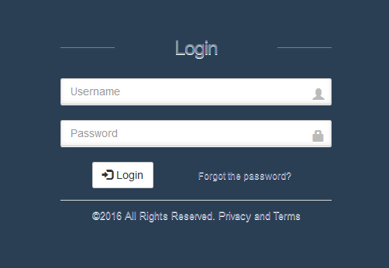

Figure : Login page

2/Enter your username and password. Click login button. The home page is showed as below. (Figure 2)

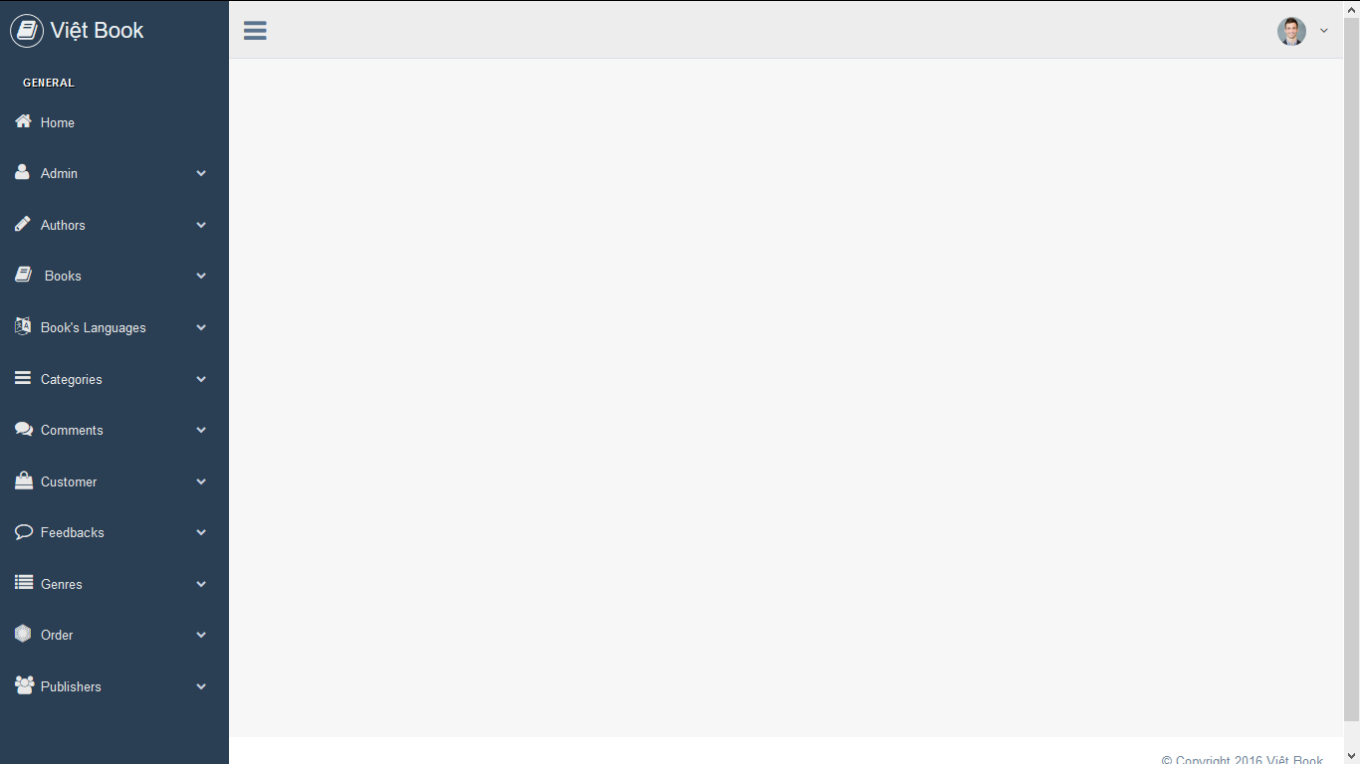

Figure 2: Home page

# 2. View profile:

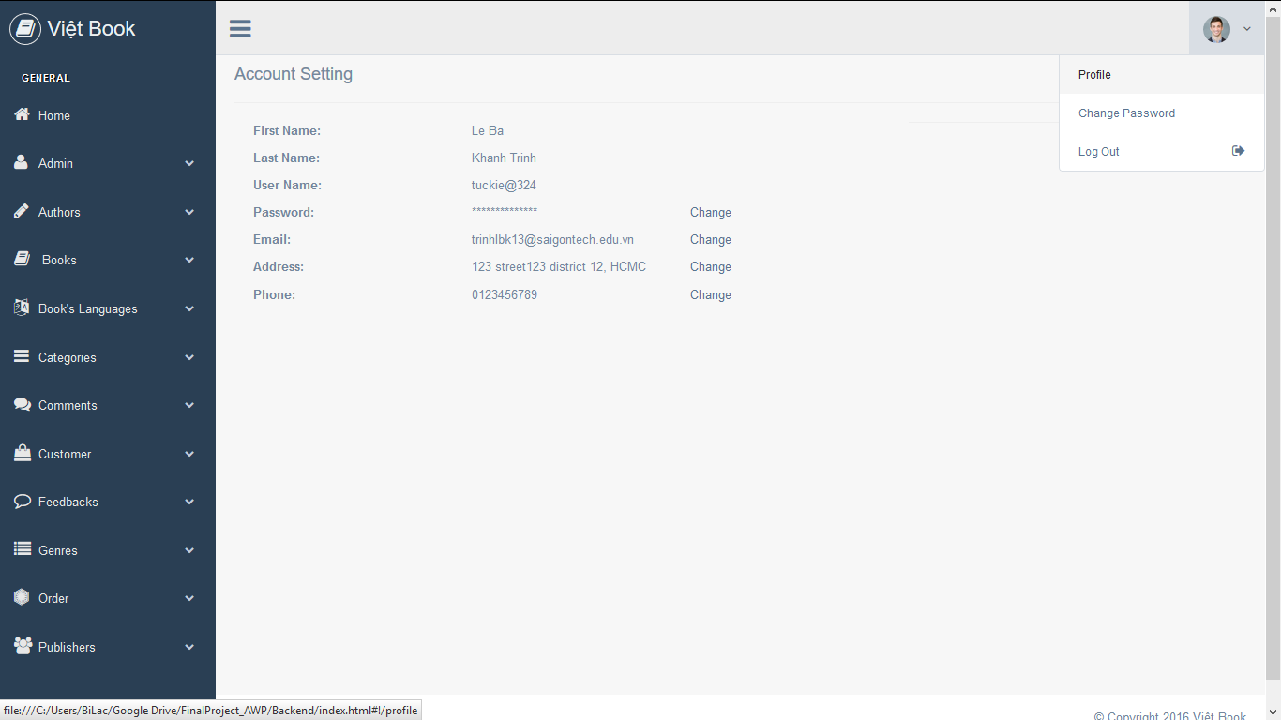1/Click on the image icon on the upper-right corner of the scene. A new popover window will appear. Click on the link “Profile”.

Figure : Profile page

2/If you want to change any of the setting, click at any of the word “Change” and you can edit the information on the same row.

**\*Note**: the account showed in the figure 3 is an example and doesn’t relate to any real life individual.

# 3. Change the password:

1/You want to change the account password? Click on the link “Change Password”, which is under the link “Profile”, to go to the Change Pass page.

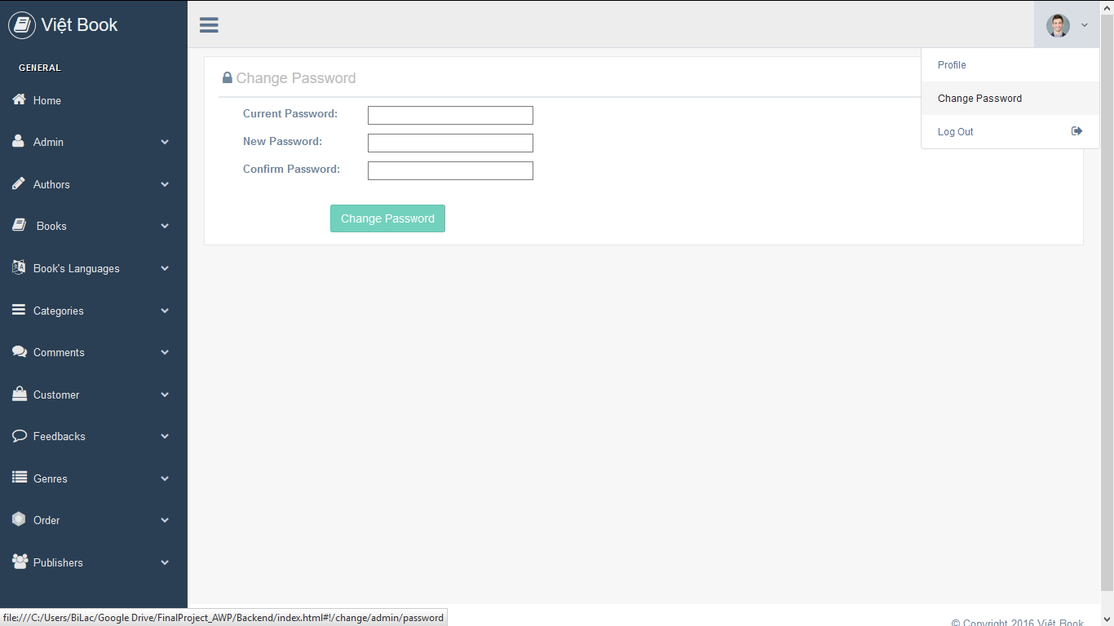

Figure 4: Change Pass page

2/To change the current password of your account, proceed to enter the current password and the new one that you desire into the blank. Enter the new password again for confirmation. Then, click “Change Password”.

# 4. Add data to the Admin database:

1/ In the Home page, click on the Admin tag in the left menu to see the “Add Admin” link. Click it.

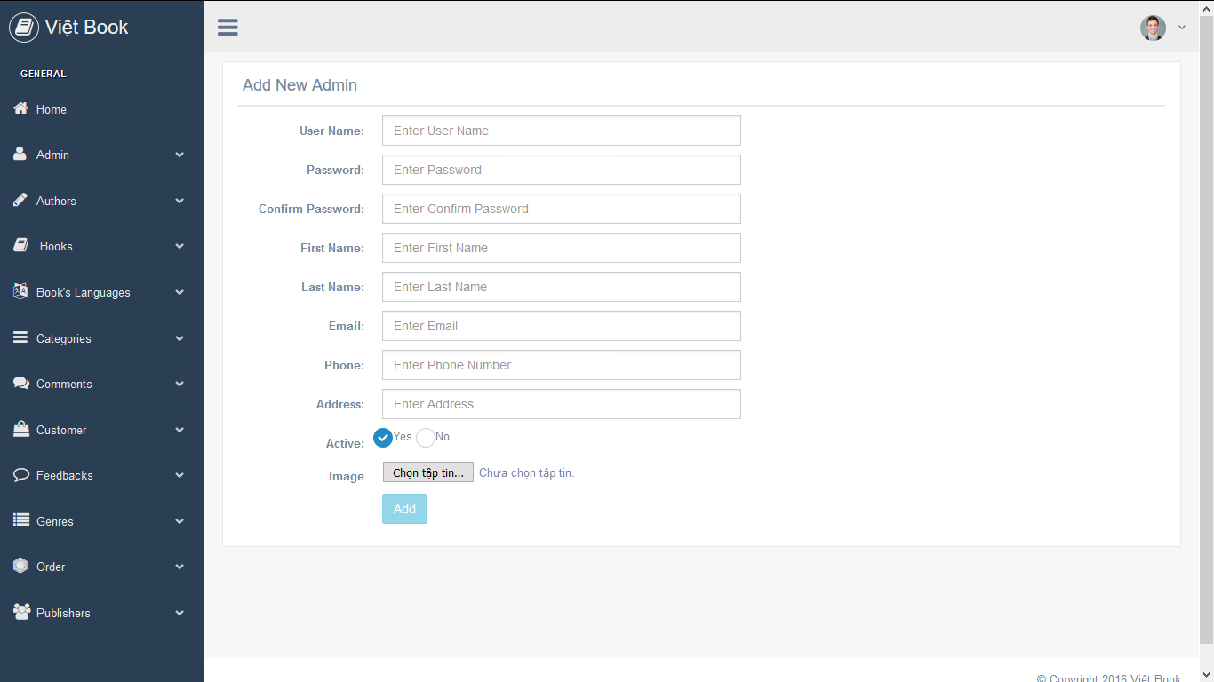

Figure 5: Add Admin page

2/In the Admin page, input all the required info into the form. Click “Add” button.

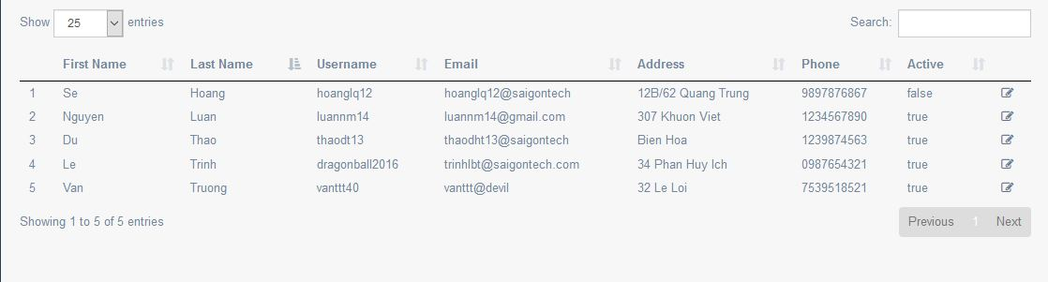

Figure 6: Admin data table

3/The system has successfully added the input data into the database. (Figure 6)

# 5. Edit the Admin database:

1/In the Admin data table list, click on the edit icon ( ).

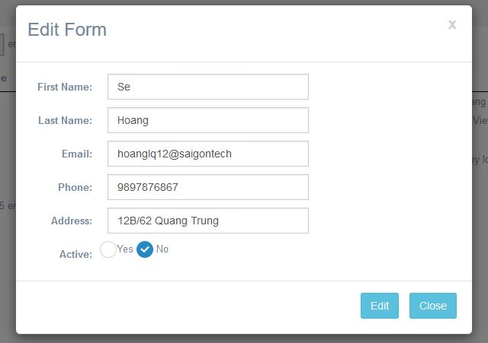

Figure 7: Admin Edit Panel

2/Edit the data you want to change then click “Edit”. You will see an announcement “Update Successfully” on the top when the system save the new info into the database.

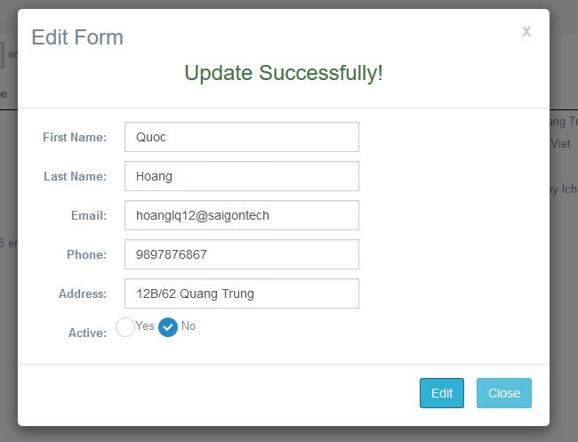

Figure 8: Update Successfully

3/You have updated the admin data in the database. Close the panel to see the change.

# 6. Add the data into the Author database:

1/In the Home page, click on the Author tag to find the “Add Author” link. Click on the link.

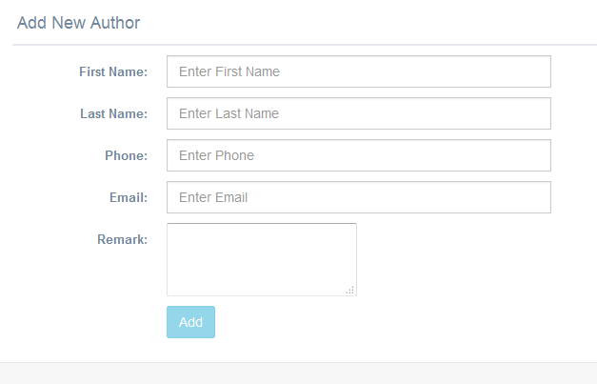

Figure :Add Author page

2/Enter the info of the new author then click “Add” button. You will see the newly added data in the author data table list.

# 7. Edit the Author database:

1/In the Author data table list, click on the edit icon () at any row you want to update the info.

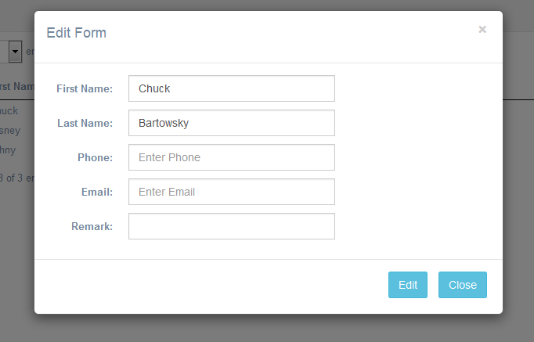

Figure : Author Edit form

2/In the edit form, edit the data you want to change and click the “Edit” button to update the data. The system saves the newly updated data into the Author database.

# 8. Add the data into the Book database:

1/In the Home page, click on the Book tag to see the “Add Book” link. Click it.

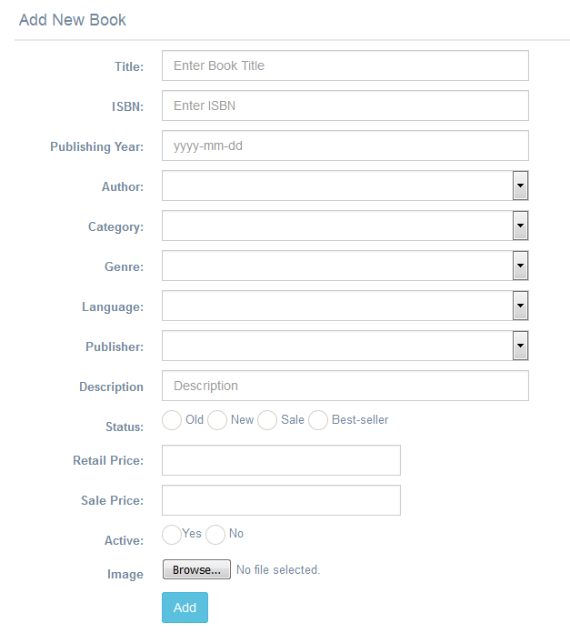

Figure : Add Book page

2/Enter the info of the new book. Click “Add” button. The new book data will be saved into the Book database.

# 9. Edit the Book database:

1/If you are in the Book data table list page, click on the edit icon at the end of any row to see the edit data panel. Otherwise, click on the “Book” tag again to find the “Book List” link.

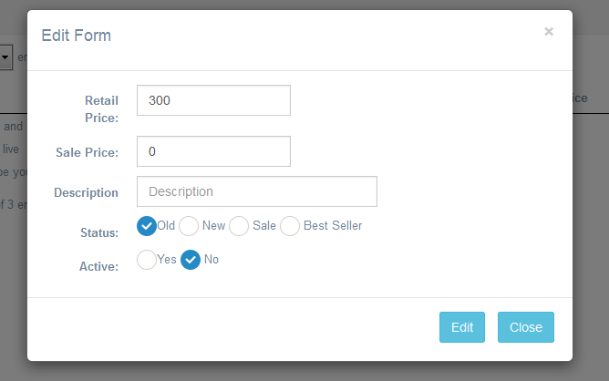

Figure : Book Edit page

2/In the edit form, edit the data you want to update and click on “Edit” button. The info has been updated in the database.

# 10. Add the data into the Language database:

1/Click on the “Book’s Language” tag to find the “Add Language” link. Click it.

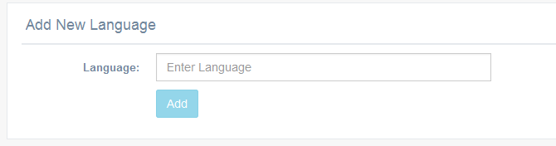

Figure : Add Language page

2/Enter the new language. Click “Add”.

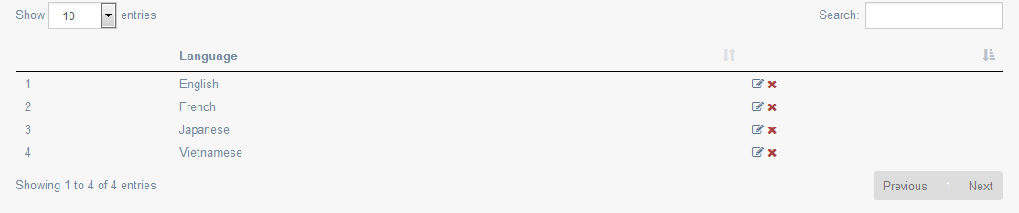

Figure : Language database

3/The new language has been saved in the database.

# 11. Edit the Book’s Language database:

1/Click on the “Add Language” link in the “Book’s Language” tag. After you access to the data table list, click on the edit icon at the end of the row that contains the data you want to update.

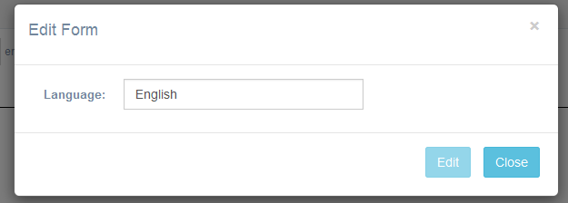

Figure : Language Edit form

2/In the newly opened panel, edit the language data you want to change and click “Edit” button. The edited data has been updated in the database.

# 11. Add the data into the Categories database:

1/Click on the “Add Category” link in the “Categories” tag.

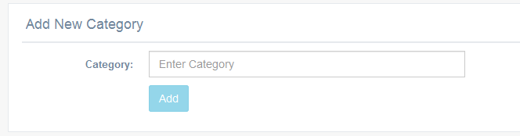

Figure : Add Category page

2/Enter the new category of the book into the input field. Click “Add”.

3/The new book category has been added into the database.

# 12. Edit the Category database:

1/In the Category data table list page, click on the edit icon of the row contains the data you want to update.

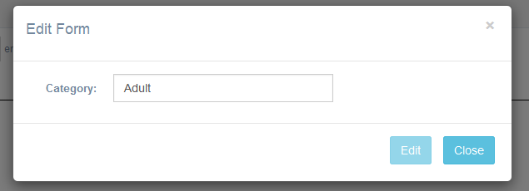

Figure : Category Edit form

2/In the edit panel, edit the category and click “Edit”. The edited category data has been updated in the database.

# 13. Add the data into the Genres database:

1/Go to the “Genres” tag to see the “Add Genre” link. Click it to access to the add genre page.

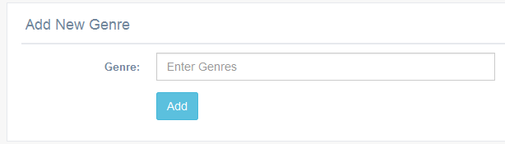

Figure : Add Genre page

2/Enter the new genre to the input field. Click “Add” button to store it in the database.

3/The new genre has been added to the genre database.

# 14. Edit the Genre database:

1/In the Genre data table list page, click on the edit icon of the row contains the genre data you want to change.

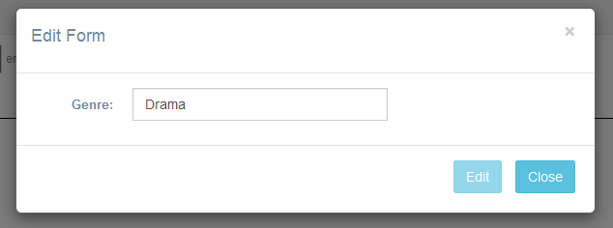

Figure : Genre Edit form

2/In the opened edit panel, edit the genre data in the input field and click “Edit”. The edited genre data has been updated in the database.

# 15. Add the data into the Publisher database:

1/Click on the “Publishers” tag to find the “Add Publisher” link.

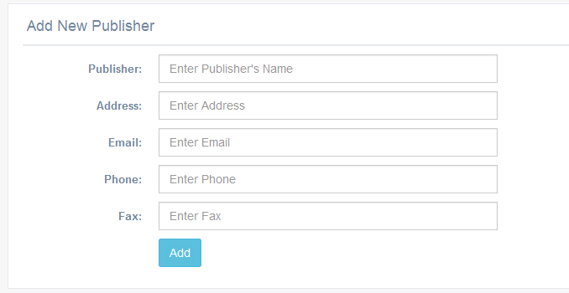

Figure : Add Publisher page

2/Enter the new publisher’s information in the form. Click “Add” button to save it in the database. The new publisher has been added to the publisher database.

# 16. Edit the Publisher database:

1/Click on the “Publisher List” link to go to the Publisher data table list display webpage. Click the edit icon.

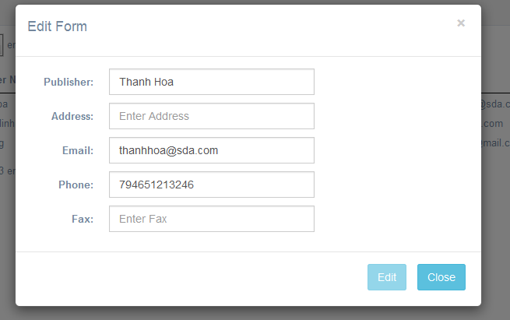

Figure : Publisher Edit form

2/Edit the publisher info in the edit form. Click “Edit” button. The updated info of the publisher has been updated in the database.

# 17. Input data rules:

When you want to enter the data in the input field of any form, please follow the text message display next to each field when an error occur during your input. (Figure 22, 23)

* For the required input data: the message “Please enter the (first name, last name, phone, address, etc)”will display if you leave the field blank.
* For the input data that relies on pattern: the message “This (email, date, etc) is invalid” will display if the data you enter doesn’t satisfy the pattern.
* For the input data that must be the numbers only: the message “’Please enter the numbers only” will display if you enter the wrong pattern. (Phone, Publishing Year, Price, etc)

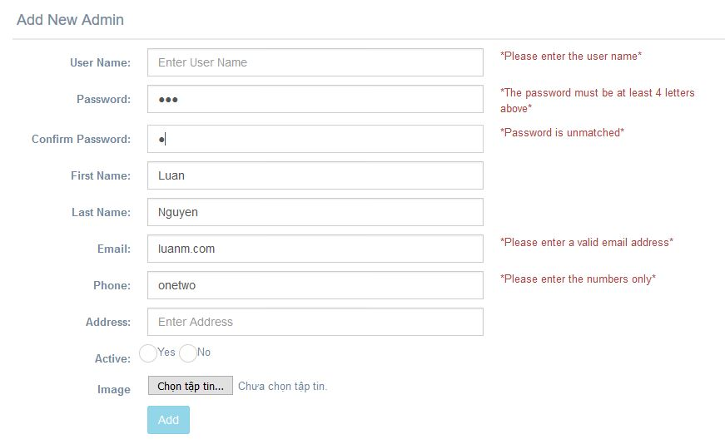

Figure : Error Message

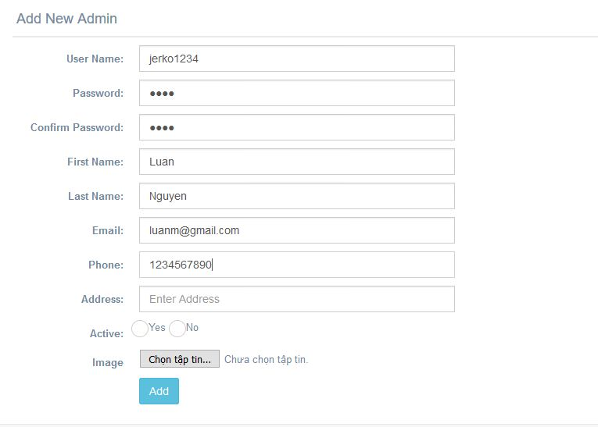

Figure : Corrected Input

# 18. Check the data from the Client-side:

1/ If you need to check the data that server get from the client-side. Click on any of the tag showed below to see the link leads to the data table lists that stores the data from the clients:

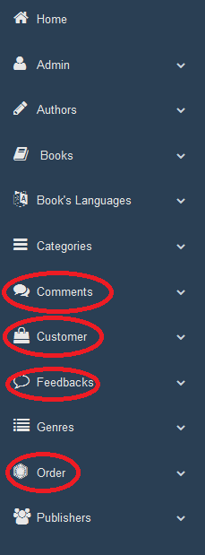

Figure 24: Client-side Relate database link

2/ Click on the link to go to the database that stores the data from the client-side.

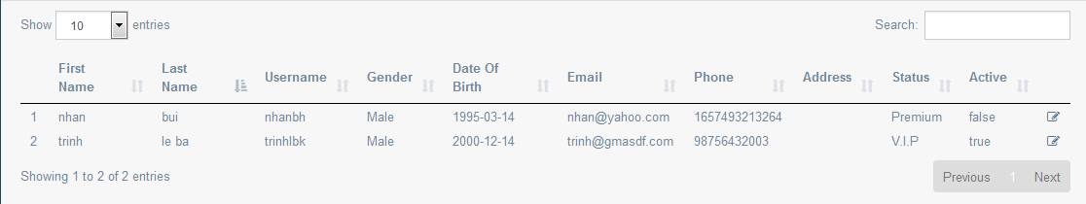

Figure :Customer data

**\*Note**: From the data table list above, you can view and edit the data from the client-side accordingly. However, only edit the data from the client-side if necessary.

# 19. Search function:

Looking for some info in the database? Go to the data table list that contains the info you are searching for and enter the information in the Search box.

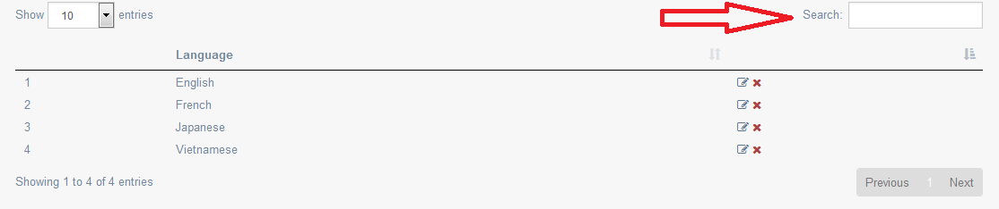

Figure : Search box

CLIENT-SIDE

**What is the Viet Book online bookstore?**

A commercial website that sells books. An online shop where customer can buy or order the books with agreed sale prices.

Provides customer with many helpful services:

* Feedback
* Detailed book info
* Add to cart function
* Ordering books
* Review ordered list through login account

**How can I find the Online Bookstore?**

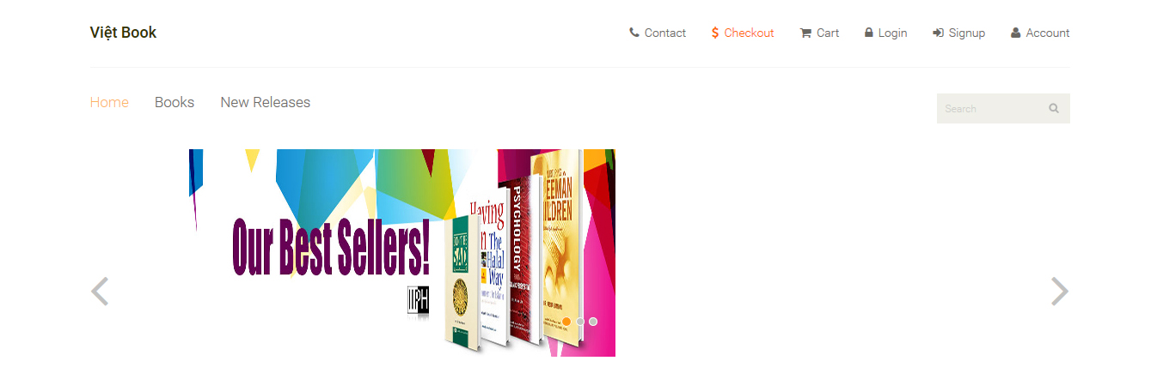Visit [www.vietbook.com](http://www.vietbook.com)

(1)On the Homepage under the online bookstore, you see the following links:

* **Contact**
* **Checkout**
* **Cart**
* **….**

(2)The top menu features the quick links to the most important feature of the website.

# 1. First time visit here? Register on the Việt Book bookstore:

1/If you want to create an account of the website, go to signup page by clicking the Signup link featured in the top menu.

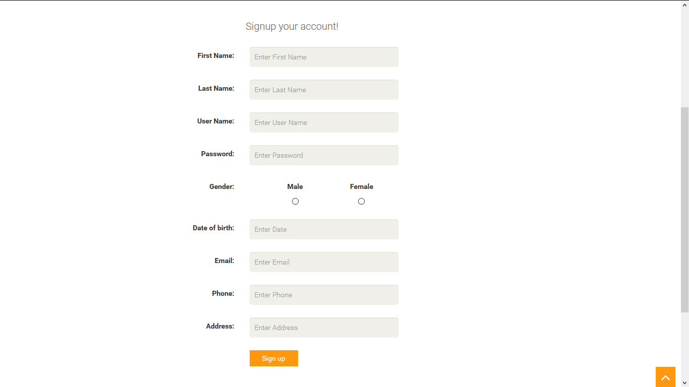

Figure 27: Signup Page

**\*Note**: the Address is optional.

2/If you don’t fill in the blank correctly, an error message will display to alert as showed below in figure 28 and the signup button will remain hidden from view.

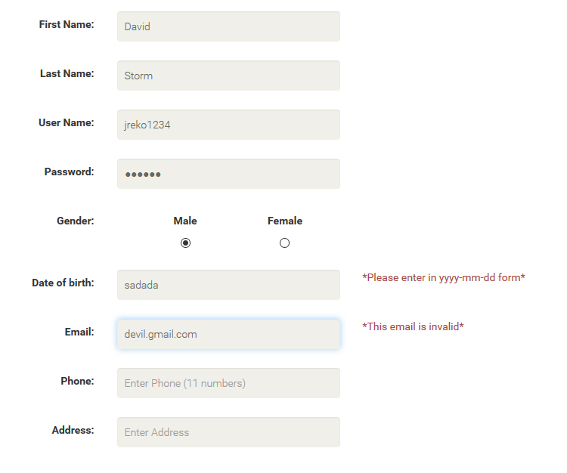

Figure 28: Error Message

3/Fill out the registration form (Figure 27) and click “Sign up”. A message will appear on top the form to inform you that your have signed up successful.

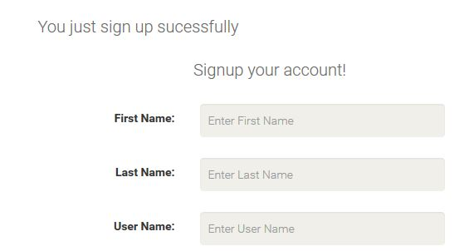

Figure 29: Sign up successful

4/ Your information in the registration form will be processed and a confirmation of your account creation will be mailed to your email address.

# 2. Login the account:

1/To login your account on the Việt Book website, go to the Login link on the top menu and click it.

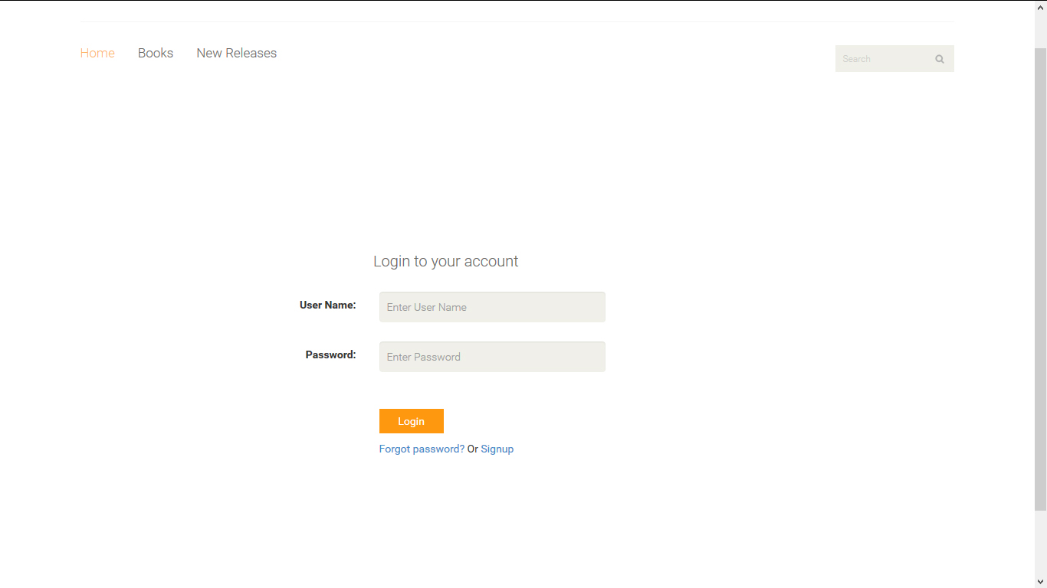

Figure 30: Login Page

2/Fill in the login form with your user name and password. Then, click the login button. You have successfully logged in the account.

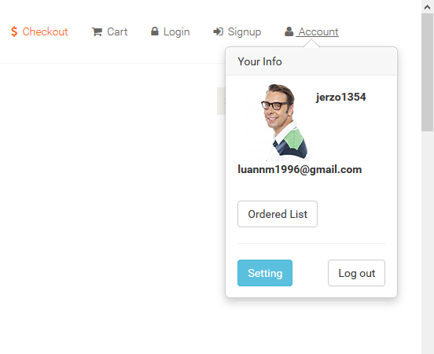

Figure : Account Login Successfully

**\*Note**: the account showed in this document is an example and doesn’t relate to any real life individual.

# 3. Forgot your password?

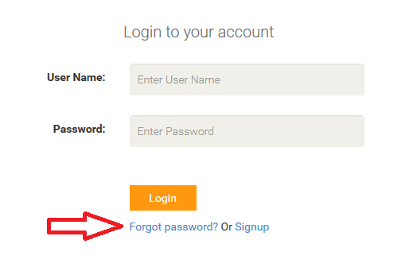1/In the login page, click on “Forgot password?” link.

Figure : Forgot Pass link

2/When access to the forgotten password form, you will need to enter the email address and click “send”.

Figure : Forgot Pass page

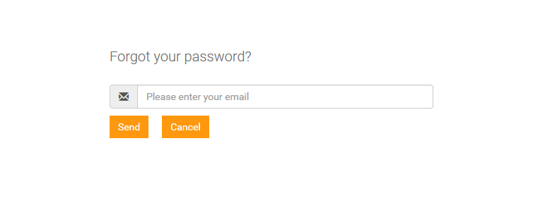

3/An email will be mailed to your email address with a temporary password that you can change if you wish to by clicking the Setting button found in the popover panel of the account link on top the menu. (Figure 30)

## 4. Change your account setting:

1/To change the account setting. First, click on the Account link to see the popover panel (Figure 4) then click on the Setting button.

Figure : Account Setting page

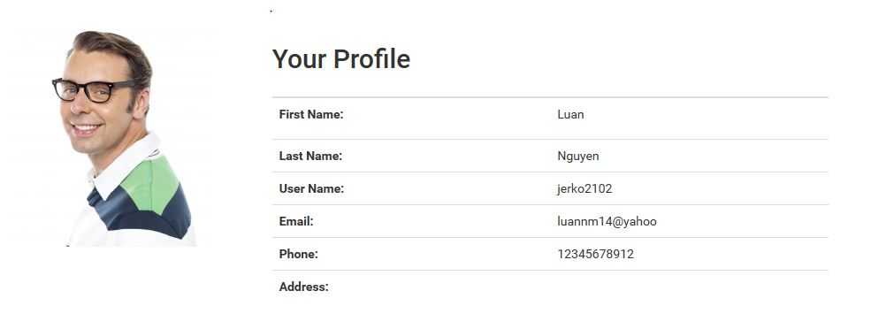

2/Click at the link “change” of any info you want to change. Proceed to enter the value in the newly open frame and click “save”.

# 5. Add To Cart Function:

1/ To Buy a book on the website, you can click on the button to add the book to shopping cart.



Figure : Add the book to cart

2/Go to the cart link on the top menu, you will see the book you just selected listed in the shopping list section.

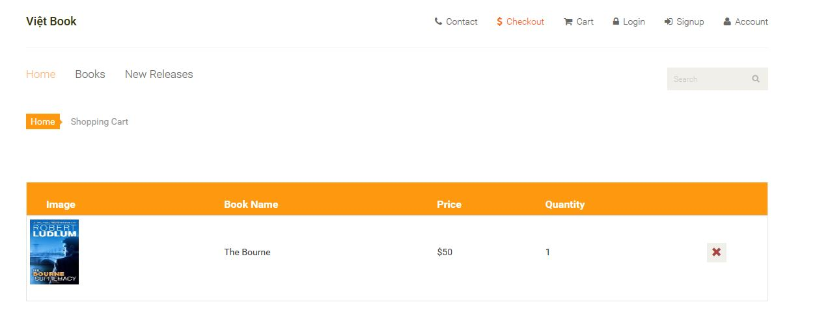

Figure : Cart Page

3/ You can increase the quantity of the book by pressing the button repeatedly to raise up the number of book you want to buy.

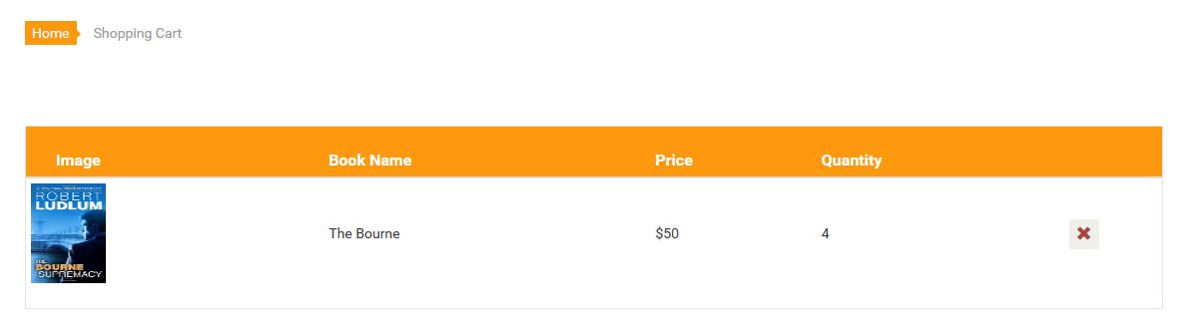

Figure : Change the quantity

4/If you change your mind and want to remove your earlier choice of books, click on the button to remove the book from the shopping cart.



Figure : Remove the book

# 6. Checkout the books:

1/ For the final process of buying the book on the website, you need to click on the “checkout” link which is also located on the top menu.



Figure : Checkout

2/In the checkout page, the total price of all the books you have included in the shopping cart will be showed on top the form for you to know.

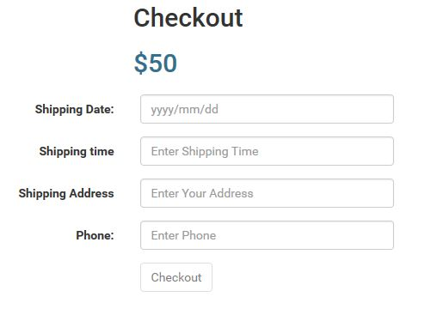

Figure : Total price of the shopping cart

3/Fill in the shipping date, time and address that you want to receive the ordered book. Click “Checkout”. A message will appear right after to inform you that the order has been received.

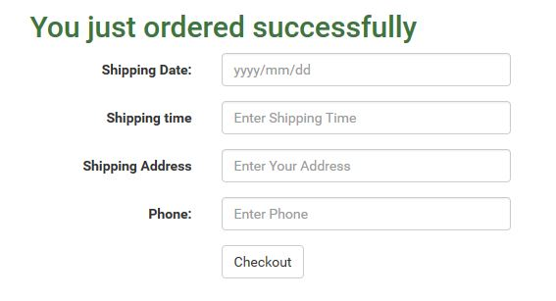

Figure : Success Message

# 7. Feedback Function:

1/ If you want to give some feedback for the website, please do so by clicking the Contact link on the top menu.

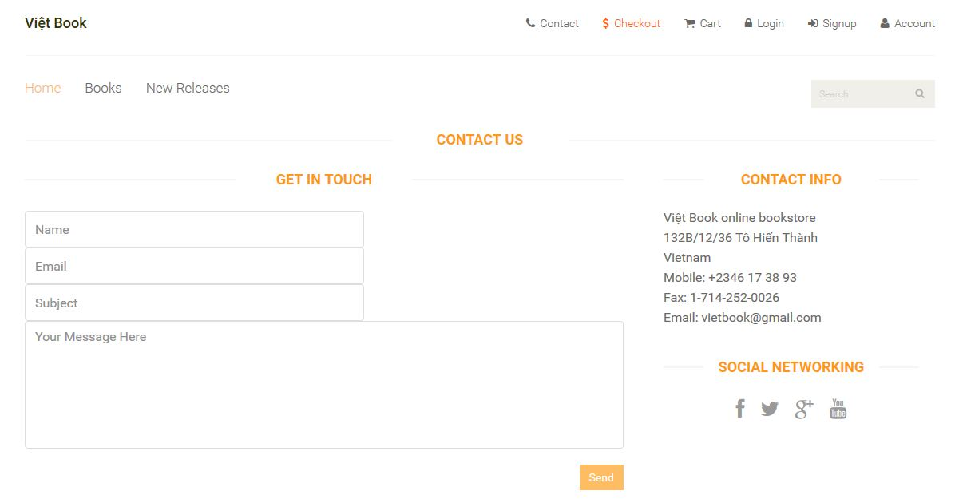

Figure : Contact page

2/In the Contact page, filled in the “Get In Touch” form and click Send. Then, a message to alert that you have successfully sent us your feedback will appear on top the name input field.

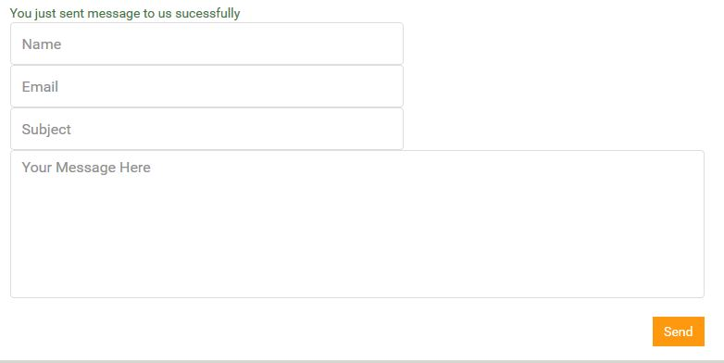

Figure 43: Success Message

# 8. Ordered List:

To view the history of the books you had bought from the website. In the account popover panel. Click “Ordered List”.

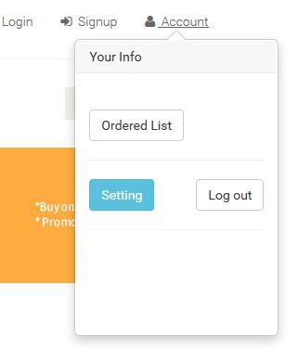

Figure 44: Ordered List

The End