|  |  |
| --- | --- |
|  | **MINISTRY OF EDUCATION AND TRAINING** |

FPT UNIVERSITY

**DOCUMENT REPORT**

**Camera Data Analysis System**

|  |  |
| --- | --- |
| **Group** | |
| **Group members** | Thân Nhật Trường - SE130426  Đỗ Ngọc Hữu - SE130557  Nguyễn Minh Luận - SE62431  Trịnh Phúc Lộc - SE130101 |
| **Supervisor** | Phạm Công Thành |
| **Ext. Supervisor** | Đoàn Nguyễn Thành Hòa |
| **Project Code** | N/A |

# Table of Contents

Table of Contents 2

Definitions, Acronyms, and Abbreviations 2

A. Introduction 3

1. Project Information 3

2. Introduction 4

3. Current Situation 4

4. Problem Definition 4

5. Proposed Solution 4

5.1. Feature functions 4

5.2. Advantages and Disadvantages 5

6. Functional Requirements 5

7. Role and Responsibility 5

B. Software Requirements Specification 6

1. System Overview Use Case 6

2. List of Use Case 7

2.1 <Quest> Overview Use Case 7

2.2 <Customer> Overview Use Case 11

2.3 <Admin> Overview Use Case 50

2.4 <Authorized user> Overview Use Case 52

# Definitions, Acronyms, and Abbreviations

|  |  |
| --- | --- |
| **Name** | **Definition** |
| CDAS | Camera Data Analysis System |

# A. Introduction

## Project Information

* Project name:  **Camera Data Analysis System**
* Start Date: **March 01st, 2021**
* End Date: **--**

## Introduction

In this document, we introduce a solution that helps suppliers know the level of customer interest in each of the products on display and where is the "hot spot" in the store that suitable for displaying products.

Today, we meet a lot of products on display everywhere. However, as providers, knowing their products get customers interested or not or where the product display is reasonable is very important. Understanding those things, we have created the "Camera Data Analysis System".

In the " Camera Data Analysis System", we will analyze customers' emotions and identify “hot spots” to help suppliers modify their business strategy and tactics.

The system will produce a detailed analysis for each product as well as each required time frame.

## Current Situation

Today, there are many ways to analyze whether a product is popular or not such as sales analysis, surveys, feedback ... However, it all has to rely on people and it is very time-consuming.

Besides, where to display products in the store to attract the attention of customers is very interested. Most of them are based on knowledge and experience but there is no basis.

## Problem Definition

Below are disadvantages of the current situation:

* It costs a lot of money and time: Data collection is very costly and time-consuming.
* Data does not guarantee correctness: The data may be faked by data collectors.
* Need knowledge and experience: Only people who have knowledge and experience can analyze the collected data.
* No objective view.

## Proposed Solution

### Feature functions

* Generate the report: Customers can generate reports about their customers' feelings and know what is the "hot spot" in their store for the period of their choice.

### Advantages and Disadvantages

* **Advantages:**
* Objective analysis.
* Data cannot be falsified.
* Easy to analyze and have the right strategy.
* The analysis makes automatically.
* Analysis can be classified by hour, day, week, month, year.
* **Disadvantages:**
* High installation cost.
* The emotional analysis is not 100% accurate.
* Analyzing customers' emotions needs their consent.

## Functional Requirements

Function requirements of the system are listed as below:

* Quest component:
* Login by account
* Register an account
* Customer component:
* Manage the video
* Generate a report
* Manage the shelf
* Manage the stack
* Manage the camera
* Manage the product
* Admin component:
* Manage the user
* Authorized user component:
  + Logout

## Role and Responsibility

|  |  |  |  |  |
| --- | --- | --- | --- | --- |
| **No** | **Full Name** | **Role** | **Position** | **Contact** |
| 1 | Phạm Công Thành | Project Supervisor | Supervisor | thanhpc@fe.edu.vn |
| 2 | Đoàn Nguyễn Thành Hòa | Project Supervisor | Ext. Supervisor | hoadnt@fpt.edu.vn |
| 3 | Thân Nhật Trường | Developer | Leader | truongtnse130426@fpt.edu.vn |
| 4 | Đỗ Ngọc Hữu | Developer | Member | huudnse130557@fpt.edu.vn |
| 5 | Nguyễn Minh Luận | Developer | Member | luannmse62431@fpt.edu.vn |
| 6 | Trịnh Phúc Lộc | Developer | Member | loctpse130101@fpt.edu.vn |

*Table 1: Roles and Responsibilities*

# B. Software Requirements Specification

## 1. System Overview Use Case

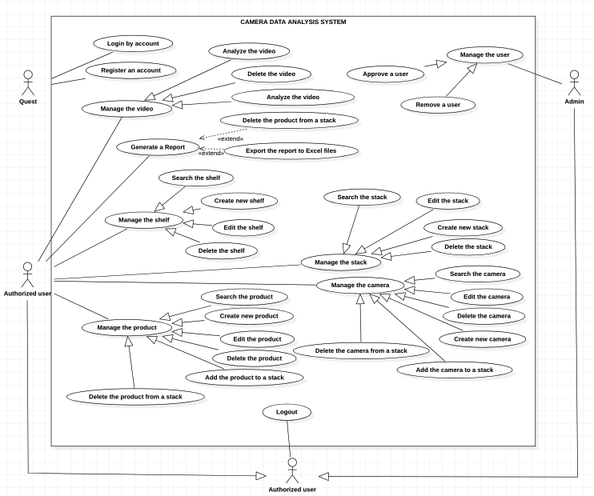

*Figure 1 - System Overview Use Case Diagram*

## 2. List of Use Case

### 2.1 <Quest> Overview Use Case

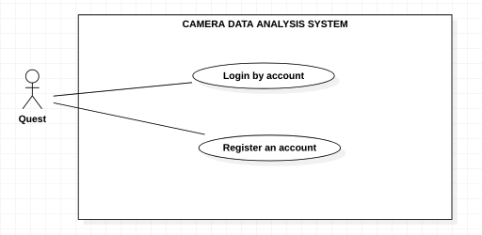

*Figure 2 - <Quest> Overview Use Case*

#### 2.1.1 <Quest>Login by account

**Use case diagram**

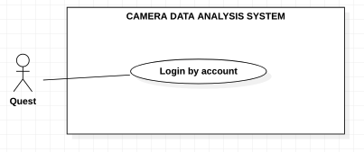

*Figure 3 - <Quest> Login by account*

**Use Case Specification**

|  |  |  |  |
| --- | --- | --- | --- |
| **USE CASE – CDAS** | | | |
| **Use Case No.** | CDAS-01 | **Use Case Version** | 1.0 |
| **Use Case Name** | Login by account | | |
| **Author** | Than Nhat Truong | | |
| **Date** | 02/01/2021 | **Priority** | Normal |
| **Actor:**  - Guest.  **Summary:**  - This use case allows the guest to login the system by account.  **Goal:**  - Guest can login into the system by account.  **Triggers:**  - Guest clicks on the “Login” button.  **Preconditions:**  - Guest is on the Home page.  **Postconditions:**  - **Success**: Guest logins to the system successfully.  - **Fail**: System shows the error message.  **Main Success Scenarios:**   |  |  |  | | --- | --- | --- | | **Step** | **Actor Action** | **System Response** | | 1 | Guest clicks on the “Login” button on the navigation menu. | System shows the form:  + Username: input.  + Password: input. | | 2 | Guest inputs the fields. |  | | 3 | Guest clicks on the “Login” button. | System shows the message: “Login successful”.  [Exception 1, 2, 3] |   **Alternative Scenarios:** N/A  **Exceptions:**   |  |  |  | | --- | --- | --- | | **No** | **Actor Action** | **System Response** | | 1 | The username is blank. | System shows the message: “The username is required”. | | 2 | The password is blank. | System shows the message: “The password is required”. | | 3 | The account is not available. | System shows the message: “Invalid username or password”. | | 4 | Internet problem. | System shows the message:" The system is busy" when the internet is lost. |   **Relationships:** N/A  **Business Rules:**  - Password was converted before being sent to server.  - After login to the system, guest will be redirected to Home page. | | | |

*Table 2 - <Quest> Login*

#### 2.1.2 <Quest>Register an account

**Use Case Diagram**

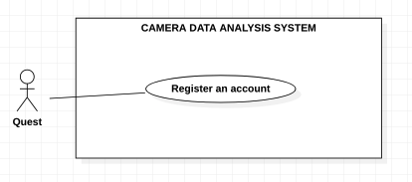

*Figure 4 - <Quest> Register an account*

**Use Case Specification**

|  |  |  |  |
| --- | --- | --- | --- |
| **USE CASE – CDAS** | | | |
| **Use Case No.** | CDAS-02 | **Use Case Version** | 1.0 |
| **Use Case Name** | Register an account | | |
| **Author** | Than Nhat Truong | | |
| **Date** | 20/02/2020 | **Priority** | Normal |
| **Actor:**  - Guest.  **Summary:**  - This use case allows the guest to register an account.  **Goal:**  - Guest can register an account.  **Triggers:**  - Guest clicks on the “Register an account” button.  **Preconditions:**  - Guest is on the login page.  **Postconditions:**  - **Success**: Guest registers successfully.  - **Fail**: System shows the error message.  **Main Success Scenarios:**   |  |  |  | | --- | --- | --- | | **Step** | **Actor Action** | **System Response** | | 1 | Guest clicks on the “Register an account” button. | System shows the form that includes:  + Username: input.  + Fullname: input  + Phone: input  + Email: input  + Gender: check box  + Address: input  + City: combobox  + District: combobox  + Identify card: image  + Password: input  + Re-type password: input | | 2 | Guest inputs the fields. |  | | 3 | Guest clicks on the “Register” button. | System shows a dialog: “A verification code has been sent to your email address” and enter code field.  [Exception 1, 2, 3, 4, 5, 6, 7, 8, 9, 10, 11, 12] | | 4 | Quest input verification code into the field. | System shows the message: “Register successful.”.  [Exception 13] |   **Alternative Scenarios:** N/A  **Exceptions:**   |  |  |  | | --- | --- | --- | | **No** | **Actor Action** | **System Response** | | 1 | The username existed. | System shows the message: “The username existed”. | | 2 | The username includes 6 – 30 characters. | System shows the message: “The username includes 6 - 30 characters.” | | 3 | The full name includes 6 – 50 characters. | System shows the message: “The full name includes 6 - 50 characters.” | | 4 | The gender is not selected. | System shows the message: “The gender must be selected”. | | 5 | The requestor’s phone includes 10 – 12 digits. | System shows the message: “The requestor’s phone includes 10 – 12 digits.” | | 6 | The identify card is empty. | System shows the message: “The identify card is required”. | | 7 | Email does not follow format form: ^[^\s@]+@[^\s@]+\.[^\s@]+$ | Email must follow format: ^[^\s@]+@[^\s@]+\.[^\s@]+$ | | 8 | The address is blank. | System shows the message: “The address is required”. | | 9 | The district is not selected. | System shows the message: “The district must be selected.” | | 10 | The city is not selected. | System shows the message: “The city must be selected”. | | 11 | The password includes 6 – 30 characters | System shows the message: “The password includes 6 - 30 characters.” | | 12 | The re-type password does not match password. | System shows the message: “The re-type password does not match password.” | | 13 | The verification code is wrong. | System shows the message: “The verification code is wrong.” | | 14 | Internet problem. | System shows message "The system is busy" when the internet is lost. |   **Relationships:** N/A  **Business Rules:**  - Password was converted before being sent to server.  - A new account has “pending” status.  - After the register successful, system redirects to the login page. | | | |

*Table 3 - <Quest> Register an account*

### 2.2 <Customer> Overview Use Case

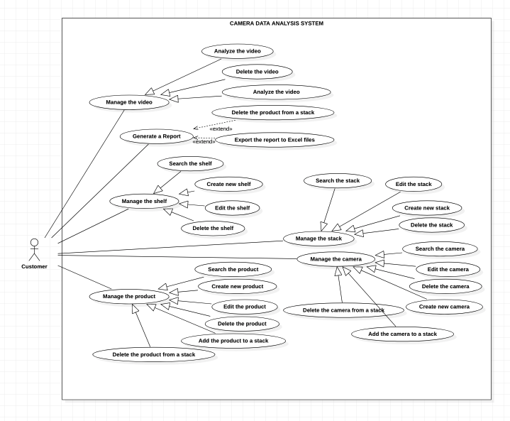

*Figure 5 - <* *Customer> Overview Use Case*

#### 2.2.1 <Customer> Watch the video

**Use Case Diagram**

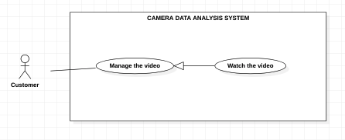

*Figure 6 - <Customer> Watch the video*

**Use Case Specification**

|  |  |  |  |
| --- | --- | --- | --- |
| **USE CASE – CDAS** | | | |
| **Use Case No.** | CDAS-03 | **Use Case Version** | 1.0 |
| **Use Case Name** | Watch the video | | |
| **Author** | Than Nhat Truong | | |
| **Date** | 02/02/2021 | **Priority** | Normal |
| **Actor:**  - Customer.  **Summary:**  - This use case allows the customer to watch the video.  **Goal:**  - Customer can watch the video.  **Triggers:**  - Customer clicks on the “Play” button or choose start time.  **Preconditions:**  - Customer must login into the system.  - Customer is on the videos page.  **Postconditions:**  - **Success**: Customer watches the video successfully.  - **Fail**: System shows the error message.  **Main Success Scenarios:**   |  |  |  | | --- | --- | --- | | **Step** | **Actor Action** | **System Response** | | 1 | Customer clicks on the “Play” button to watch the live video or choose start time to watch the video. | System shows the video.  [Exception 1] |   **Alternative Scenarios:** N/A  **Exceptions:**   |  |  |  | | --- | --- | --- | | **No** | **Actor Action** | **System Response** | | 1 | The start time of video is invalid. | System shows the nearest time video with start time that was chosen by user. | | 2 | Internet problem. | System shows message "The system is busy" when the internet is lost. |   **Relationships:** N/A  **Business Rules:**  - The customer can stop or back to the video while watching the video. | | | |

*Table 4 - <Customer> Watch the video*

#### 2.2.2 <Customer> Delete the video

**Use Case Diagram**

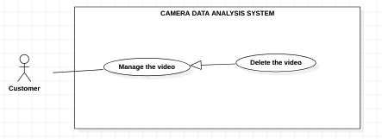

*Figure 7 - <Customer> Delete the video*

**Use Case Specifications**

|  |  |  |  |
| --- | --- | --- | --- |
| **USE CASE – CDAS** | | | |
| **Use Case No.** | CDAS-04 | **Use Case Version** | 1.0 |
| **Use Case Name** | Delete the video | | |
| **Author** | Than Nhat Truong | | |
| **Date** | 02/02/2021 | **Priority** | Normal |
| **Actor:**  - Customer.  **Summary:**  - This use case allows the customer to delete the video.  **Goal:**  - Customer can delete the video.  **Triggers:**  - Customer clicks on the “Delete” button.  **Preconditions:**  - Customer must login into the system.  - Customer is on the video list page.  **Postconditions:**  - **Success**: Customer deletes the video successfully.  - **Fail**: System shows the error message.  **Main Success Scenarios:**   |  |  |  | | --- | --- | --- | | **Step** | **Actor Action** | **System Response** | | 1 | Customer clicks on the “Delete” button on the video. | System shows confirm message dialog. | | 2 | Customer clicks on the “Yes” button in confirm message dialog. | The system shows the message: “Delete the video successful”.  [Exception 1] |   **Alternative Scenarios:** N/A  **Exceptions:**   |  |  |  | | --- | --- | --- | | **No** | **Actor Action** | **System Response** | | 1 | The chosen video is invalid. | System shows the message: “The video is invalid.” | | 2 | Internet problem. | System shows message "The system is busy" when the internet is lost. |   **Relationships:** N/A  **Business Rules:**  - After authorized had deleted the video, system redirects to video list page. | | | |

*Table 5 - <Customer> Delete the video*

#### 2.2.3 <Customer> Analyze the video

**Use Case Diagram**

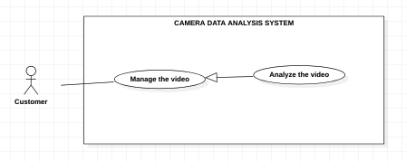

*Figure 8 - <Customer> Analyze the video*

**Use Case Specifications**

|  |  |  |  |
| --- | --- | --- | --- |
| **USE CASE – CDAS** | | | |
| **Use Case No.** | CDAS-05 | **Use Case Version** | 1.0 |
| **Use Case Name** | Analyze the video | | |
| **Author** | Than Nhat Truong | | |
| **Date** | 02/02/2021 | **Priority** | Normal |
| **Actor:**  - Customer.  **Summary:**  - This use case allows the customer to analyze the video.  **Goal:**  - Customer can analyze the video.  **Triggers:**  - Customer clicks on the “Analyze” button.  **Preconditions:**  - Authorized user must login into the system.  - Authorized user is on the video page.  **Postconditions:**  - **Success**: Authorized user analyze the video successfully.  - **Fail**: System shows the error message.  **Main Success Scenarios:**   |  |  |  | | --- | --- | --- | | **Step** | **Actor Action** | **System Response** | | 1 | Authorized user clicks on the “Analyze” button on the video page. | System shows analyze form:  + From time: datetime  + To time: datetime  + Auto analyze: combobox | | 2 | Authorized user clicks on the “Start” button. | The system shows the message: “Analyze the video successful”.  [Exception 1, 2] |   **Alternative Scenarios:** N/A  **Exceptions:**   |  |  |  | | --- | --- | --- | | **No** | **Actor Action** | **System Response** | | 1 | From time is invalid. | System shows the message: “The from time video is invalid.” | | 2 | To time is invalid. | System shows the message: “The to time video is invalid.” | | 3 | Internet problem. | System shows message "The system is busy" when the internet is lost. |   **Relationships:** N/A  **Business Rules:**  - After authorized had analyzed the video, system redirects to result page.  - Video analysis time must be stored. | | | |

*Table 6 - <Customer> Analyze the video*

#### 2.2.4 <Customer> Generate a report

**Use Case Diagram**

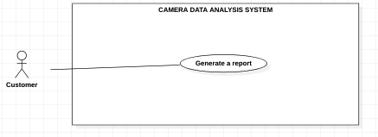

*Figure 9 - <Customer> Generate a report*

**Use Case Specifications**

|  |  |  |  |
| --- | --- | --- | --- |
| **USE CASE – CDAS** | | | |
| **Use Case No.** | CDAS-06 | **Use Case Version** | 1.0 |
| **Use Case Name** | Generate a report | | |
| **Author** | LocTP | | |
| **Date** | 3/02/2021 | **Priority** | High |
| **Actor:**  - Customer.  **Summary:**  - This use case allows the customer to generate a report.  **Goal:**  - Customer can create a report in the indicated time.  **Triggers:**  - Customer clicks on the “Generate” button.  **Preconditions:**  - Customer must login to the system.  - Customer is on the generating report page.  **Postconditions:**  - **Success**: Customer generates a report successfully.  - **Fail**: System shows the error message.  **Main Success Scenario:**   |  |  |  | | --- | --- | --- | | **Step** | **Actor Action** | **System Response** | | 1 | Customer clicks on the “Generate the report” button on the navigation menu. | System shows the form that includes:  - Month From: combobox  - Month To: combobox  - Date From: combobox  - Date To: combobox  - Hour From: combobox  - Hour To: combobox  - Analysis results: label  + Hour: combobox  + Day: combobox  + Month: combobox  + Year: combobox  + Shelf: combobox  + Stack: combobox  + Product: combobox | | 2 | Customer selects the options. |  | | 4 | Customer clicks on the “Generate” button | System shows the results based on the request. |   **Alternative Scenarios:** N/A  **Exceptions:**   |  |  |  | | --- | --- | --- | | **No** | **Actor Action** | **System Response** | | 1 | Internet problem. | System shows the message: "The system is busy" when the internet is lost. |   **Relationships:** N/A  **Business Rules:**  - After generated successfully, system redirects to the result screen. | | | |

*Table 7 - <Customer> Generate the video*

#### 2.2.5 <Customer> Export the report to PDF files

**Use Case Diagram**

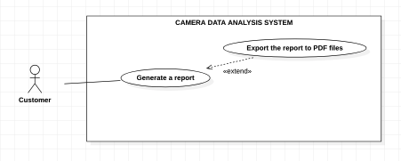

*Figure 10 - <Customer > Export the report to PDF files*

**Use Case Specifications**

|  |  |  |  |
| --- | --- | --- | --- |
| **USE CASE – CDAS** | | | |
| **Use Case No.** | CDAS-07 | **Use Case Version** | 1.0 |
| **Use Case Name** | Export the report to PDF files | | |
| **Author** | LocTP | | |
| **Date** | 3/02/2021 | **Priority** | Normal |
| **Actor:**  - Customer.  **Summary:**  - This use case allows the customer to export a report to PDF file.  **Goal:**  - Customer can to export a report to PDF file.  **Triggers:**  - Customer clicks on the “Export PDF” button.  **Preconditions:**  - Customer must login to the system.  - Customer is on the report page.  **Postconditions:**  - **Success**: Customer exports a report successfully.  - **Fail**: System shows the error message.  **Main Success Scenario:**   |  |  |  | | --- | --- | --- | | **Step** | **Actor Action** | **System Response** | | 1 | Customer clicks on the “Export PDF” button. | System downloads the report in pdf format. |   **Alternative Scenarios:** N/A  **Exceptions:**   |  |  |  | | --- | --- | --- | | **No** | **Actor Action** | **System Response** | | 1 | Internet problem. | System shows the message: "The system is busy" when the internet is lost. |   **Relationships:** N/A  **Business Rules:** N/A | | | |

*Table 8 - <Customer> Export the report to PDF files*

#### 2.2.6 <Customer> Export the report to Excel files

**Use Case Diagram**

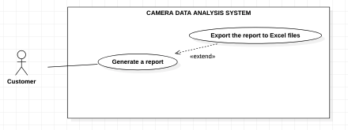

*Figure 11 - <Customer> Export the report to Excel files*

**Use Case Specifications**

|  |  |  |  |
| --- | --- | --- | --- |
| **USE CASE – CDAS** | | | |
| **Use Case No.** | CDAS-08 | **Use Case Version** | 1.0 |
| **Use Case Name** | Export the report to Excel files | | |
| **Author** | LocTP | | |
| **Date** | 03/02/2021 | **Priority** | Normal |
| **Actor:**  - Customer.  **Summary:**  - This use case allows the customer to export a report to excel file.  **Goal:**  - Customer can to export a report to excel file.  **Triggers:**  - Customer clicks on the “Export Excel” button.  **Preconditions:**  - Customer must login to the system.  - Customer is on the report page.  **Postconditions:**  - **Success**: Customer exports a report successfully.  - **Fail**: System shows the error message.  **Main Success Scenario:**   |  |  |  | | --- | --- | --- | | **Step** | **Actor Action** | **System Response** | | 1 | Customer clicks on the “Export Excel” button. | System downloads the report in excel format. |   **Alternative Scenarios:** N/A  **Exceptions:**   |  |  |  | | --- | --- | --- | | **No** | **Actor Action** | **System Response** | | 1 | Internet problem. | System shows the message: "The system is busy" when the internet is lost. |   **Relationships:** N/A  **Business Rules:** N/A | | | |

*Table 9 - <Customer> Export the report to Excel files*

#### 2.2.7 <Customer> Search the shelf

**Use Case Diagram**

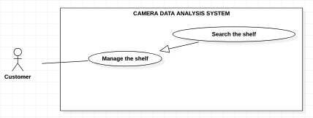

*Figure 12 - <Customer> Search the shelf*

**Use Case Specifications**

|  |  |  |  |
| --- | --- | --- | --- |
| **USE CASE – CDAS** | | | |
| **Use Case No.** | CDAS-09 | **Use Case Version** | 1.0 |
| **Use Case Name** | Search the shelfs | | |
| **Author** | LocTP | | |
| **Date** | 03/02/2021 | **Priority** | Normal |
| **Actor:**  - Customer.  **Summary:**  - This use case allows the customer to search the shelfs in the system.  **Goal:**  - Customer can search the shelfs.  **Triggers:**  - Customer inputs on the “Search” button.  **Preconditions:**  - Customer must login to the system.  - Customer is on the shelf managing page.  **Postconditions:**  - **Success**: Customer view shelfs with indicated condition.  - **Fail**: System shows the error message.  **Main Success Scenario:**   |  |  |  | | --- | --- | --- | | **Step** | **Actor Action** | **System Response** | | 1 | Customer clicks on the “Search” button. | System shows the list of suitable shelf that includes:  + Position  + Type  + Status  + Stack |   **Alternative Scenarios:** N/A  **Exceptions:**   |  |  |  | | --- | --- | --- | | **No** | **Actor Action** | **System Response** | | 1 | Internet problem. | System shows the message: "The system is busy" when the internet is lost. |   **Relationships:** N/A  **Business Rules:**  - If the resulting list is empty, display "No shelf". | | | |

*Table 10 - <Customer> Search the shelf*

#### 2.2.8 <Customer> Create new shelf

**Use Case Diagram**

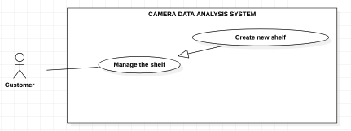

*Figure 13 - <Customer> Create new shelf*

**Use Case Specifications**

|  |  |  |  |
| --- | --- | --- | --- |
| **USE CASE – CDAS** | | | |
| **Use Case No.** | CDAS-10 | **Use Case Version** | 1.0 |
| **Use Case Name** | Create new shelf | | |
| **Author** | LocTP | | |
| **Date** | 03/02/2021 | **Priority** | Normal |
| **Actor:**  - Customer  **Summary:**  - This use case allows the customer to create new shelf in the system.  **Goal:**  - Customer can create a new shelf.  **Triggers:**  - Customer clicks on the “Create new shelf” button.  **Preconditions:**  - Customer must login to the system.  - Customer is on the creating shelf page.  **Postconditions:**  - **Success**: Customer create a shelf successfully.  - **Fail**: System shows the error message.  **Main Success Scenario:**   |  |  |  | | --- | --- | --- | | **Step** | **Actor Action** | **System Response** | | 1 | Customer clicks on the “Create new shelf” button | System shows the form that includes:  - Position: input  - Type: input  - Image: images  - Total stack: input | | 2 | Customer inputs or selected the fields |  | | 3 | Customer clicks on the “Create” button | System shows the message that the shelf created succesfully.  [Exception 1, 2, 3, 4, 5] |   **Alternative Scenarios:** N/A  **Exceptions:**   |  |  |  | | --- | --- | --- | | **No** | **Actor Action** | **System Response** | | 1 | The position is empty | System shows the message: “The shelf’s position is required.” | | 2 | The type is empty | System shows the message: “The shelf’s type is required.” | | 3 | The shelf's position is identical to the other. | System shows the message: “The shelf already exists.”. | | 4 | The image is empty. | System shows the message: “The image must be chosen.” | | 5 | The total stack is not a numeric. | System shows the message: “The total stack is numeric.” | | 6 | Internet problem. | System shows the message: "The system is busy" when the internet is lost. |   **Relationships:** N/A  **Business Rules:**  - After created successfully, system redirects to the shelf page. | | | |

*Table 11 - <Customer> Create new shelf*

#### 2.2.9 <Customer> Edit the shelf

**Use Case Diagram**

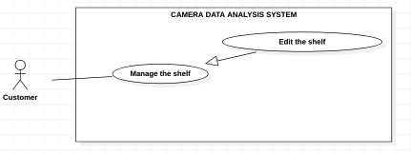

*Figure 14 - <Customer> Edit the shelf*

**Use Case Specifications**

|  |  |  |  |
| --- | --- | --- | --- |
| **USE CASE – CDAS** | | | |
| **Use Case No.** | CDAS-11 | **Use Case Version** | 1.0 |
| **Use Case Name** | Edit the shelf | | |
| **Author** | LocTP | | |
| **Date** | 03/02/2021 | **Priority** | Normal |
| **Actor:**  - Customer  **Summary:**  - This use case allows the customer to create new shelf in the system.  **Goal:**  - Customer can edit the shelf.  **Triggers:**  - Customer clicks on the “Edit” button.  **Preconditions:**  - Customer must login to the system.  - Customer is on the shelf detail page.  **Postconditions:**  - **Success**: Customer edit the shelf successfully.  - **Fail**: System shows the error message.  **Main Success Scenario:**   |  |  |  | | --- | --- | --- | | **Step** | **Actor Action** | **System Response** | | 1 | Customer clicks on the “Edit” button | System shows the form that includes:  - Shelf position: input  - Type: input  - Position on camera: label  - Image: image  - Total stack: input  - isActive: combobox | | 2 | Customer inputs or sleectes the fields |  | | 3 | Customer clicks on the “Edit” button | System shows the message that the shelf edited succesfully.  [Exception 1, 2, 3, 4, 5, 6] |   **Alternative Scenarios:** N/A  **Exceptions:**   |  |  |  | | --- | --- | --- | | **No** | **Actor Action** | **System Response** | | 1 | The position is empty | System shows the message: “The shelf’s position is required.” | | 2 | The type is empty | System shows the message: “The shelf’s type is required.” | | 3 | The shelf's position is identical to the other. | System shows the message: “The shelf already exists.”. | | 4 | The image is empty. | System shows the message: “The image must be chosen.” | | 5 | The total stack is not a numeric. | System shows the message: “The total stack is a numeric.” | | 6 | The status is empty. | System shows the message: “The shelf’s status must be chosen.” | | 7 | Internet problem. | System shows the message: "The system is busy" when the internet is lost. |   **Relationships:** N/A  **Business Rules:**  - After edited successfully, system redirects to the main view screen.  - Last edited time must be stored. | | | |

*Table 12 - <Customer> Edit the shelf*

#### 2.2.9 <Customer> Delete the shelf

**Use Case Diagram**

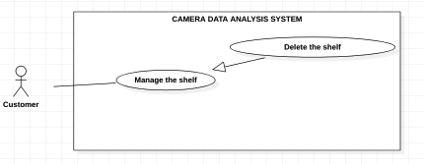

*Figure 15 - <Customer> Delete the shelf*

**Use Case Specifications**

|  |  |  |  |
| --- | --- | --- | --- |
| **USE CASE – CDAS** | | | |
| **Use Case No.** | CDAS-12 | **Use Case Version** | 1.0 |
| **Use Case Name** | Delete the shelf | | |
| **Author** | LocTP | | |
| **Date** | 03/02/2021 | **Priority** | Normal |
| **Actor:**  - Customer  **Summary:**  - This use case allows the customer to delete the shelf in the system.  **Goal:**  - Customer can delete the shelf.  **Triggers:**  - Customer clicks on the “Delete” button.  **Preconditions:**  - Customer must login to the system.  - Customer is on the shelf detail page.  **Postconditions:**  - **Success**: Customer delete the shelf successfully.  - **Fail**: System shows the error message.  **Main Success Scenario:**   |  |  |  | | --- | --- | --- | | **Step** | **Actor Action** | **System Response** | | 1 | Customer clicks on the “Delete” button | System asks customer to confirm the action | | 2 | Customer clicks “Ok” button. | System shows the message that the shelf is removed. |   **Alternative Scenarios:** N/A  **Exceptions:**   |  |  |  | | --- | --- | --- | | **No** | **Actor Action** | **System Response** | | 1 | Internet problem. | System shows the message: "The system is busy" when the internet is lost. |   **Relationships:** N/A  **Business Rules:**   * After deleted successfully, the shelf has “Deleted” active and system redirects to the main view screen. | | | |

*Table 13 - <Customer> Delete the shelf*

#### 2.2.10 <Customer> Search the stack

**Use Case Diagram**

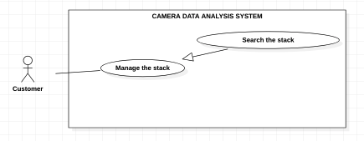

*Figure 16 - <Customer> Search the stack*

**Use Case Specifications**

|  |  |  |  |
| --- | --- | --- | --- |
| **USE CASE – CDAS** | | | |
| **Use Case No.** | CDAS-12 | **Use Case Version** | 1.0 |
| **Use Case Name** | Search the stack | | |
| **Author** | LuanNM | | |
| **Date** | 03/02/2021 | **Priority** | Normal |
| **Actor:**  - Customer  **Summary:**  - This use case allows the customer to search the stacks in the system.  **Goal:**  - Customer can search the stacks.  **Triggers:**  - Customer clicks on the “Search” button.  **Preconditions:**  - Customer must login to the system.  - Customer is on the stack managing page.  **Postconditions:**  - **Success**: Customer views the stacks with indicated condition.  - **Fail**: System shows the error message.  **Main Success Scenario:**   |  |  |  | | --- | --- | --- | | **Step** | **Actor Action** | **System Response** | | 1 | Customer clicks on the “Search” button. | System shows the list stacks that includes:  + Shelf position  + Stack position  + Position on camera  + Image  + Product  + Type  + Status  + isActive |   **Alternative Scenarios:** N/A  **Exceptions:**   |  |  |  | | --- | --- | --- | | **No** | **Actor Action** | **System Response** | | 1 | Internet problem. | System shows the message: "The system is busy" when the internet is lost. |   **Relationships:** N/A  **Business Rules:**  - If the resulting list is empty, display "No stack".  - The list stack must be paging.  - The list stack must be sorted by descending created time. | | | |

*Table 14 - <Customer> Search the stack*

#### 2.2.11 <Customer> Create new stack

**Use Case Diagram**

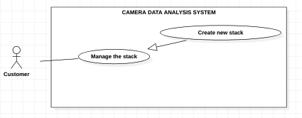

*Figure 17 - <Customer> Create new stack*

**Use Case Specifications**

|  |  |  |  |
| --- | --- | --- | --- |
| **USE CASE – CDAS** | | | |
| **Use Case No.** | CDAS-13 | **Use Case Version** | 1.0 |
| **Use Case Name** | Create new stack | | |
| **Author** | LuanNM | | |
| **Date** | 03/02/2021 | **Priority** | Normal |
| **Actor:**  - Customer  **Summary:**  - This use case allows the customer to create new stack in the system.  **Goal:**  - Customer can create a new stack.  **Triggers:**  - Customer clicks on the “Create new stack” button.  **Preconditions:**  - Customer must login to the system.  - Customer is on the creating stack page.  **Postconditions:**  - **Success**: Customer creates a stack successfully.  - **Fail**: System shows the error message.  **Main Success Scenario:**   |  |  |  | | --- | --- | --- | | **Step** | **Actor Action** | **System Response** | | 1 | Customer clicks on the “Create new stack” button | System shows the form that includes:  - Shelf position: combobox  - Stack position: combobox  - Type: input  - Image: image | | 2 | Customer inputs or selects fields |  | | 3 | Customer clicks on the “Create” button | System shows the message that the stack created succesfully.  [Exception 1, 2, 3, 4] |   **Alternative Scenarios:** N/A  **Exceptions:**   |  |  |  | | --- | --- | --- | | **No** | **Actor Action** | **System Response** | | 1 | The shelf is empty. | System shows the message: “The shelf must be chosen.”. | | 2 | The position is empty. | System shows the message: “The position must be chosen.”. | | 3 | The position is identical to the other. | System shows the message: “The position already exists.”. | | 4 | The type is empty. | System shows the message: “The type is required.”. | | 5 | Internet problem. | System shows the message: "The system is busy" when the internet is lost. |   **Relationships:** N/A  **Business Rules:**  - After created successfully, system shows the stack newly created one that includes:  + Shelf position  + Stack position  + Position on the camera: Not added yet  + Type  + Image  + Camera: Not added yet  + Product: Not added yet  + Status: available  + Active: active | | | |

*Table 14 - <Customer> Create new stack*

#### 2.2.12 <Customer> Edit the stack

**Use Case Diagram**

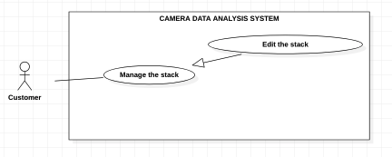

*Figure 18 - <Customer> Edit the stack*

**Use Case Specifications**

|  |  |  |  |
| --- | --- | --- | --- |
| **USE CASE – CDAS** | | | |
| **Use Case No.** | CDAS-14 | **Use Case Version** | 1.0 |
| **Use Case Name** | Edit the stack | | |
| **Author** | LuanNM | | |
| **Date** | 03/02/2021 | **Priority** | Normal |
| **Actor:**  - Customer  **Summary:**  - This use case allows the customer to edit the stack in the system.  **Goal:**  - Customer can edit the stack.  **Triggers:**  - Customer clicks on the “Edit” button.  **Preconditions:**  - Customer must login to the system.  - Customer is on the stack detail page.  **Postconditions:**  - **Success**: Customer edits a stack successfully.  - **Fail**: System shows the error message.  **Main Success Scenario:**   |  |  |  | | --- | --- | --- | | **Step** | **Actor Action** | **System Response** | | 1 | Customer clicks on the “Edit” button | System shows the form that includes:  - Shelf position: combo box  - Stack position: combo box  - Position on the camera: label  - Type: input  - Image: image  - Camera: combo box  - Product: combo box  - Status: label  - Active: combo box | | 2 | Customer inputs or selects fields |  | | 3 | Customer clicks on the “Edit” button | System shows the message that the stack created succesfully.  [Exception 1, 2, 3, 4, 5] |   **Alternative Scenarios:** N/A  **Exceptions:**   |  |  |  | | --- | --- | --- | | **No** | **Actor Action** | **System Response** | | 1 | The shelf is empty. | System shows the message: “The shelf must be chosen.”. | | 2 | The position is empty. | System shows the message: “The position must be chosen.”. | | 3 | The position is identical to the other. | System shows the message: “The position already exists.”. | | 4 | The type is empty. | System shows the message: “The type is required.”. | | 5 | The active is empty. | System shows the message: “The active is required.”. | | 6 | Internet problem. | System shows the message: "The system is busy" when the internet is lost. |   **Relationships:** N/A  **Business Rules:**  - After edited successfully, system shows the stack information that includes:  + Shelf position  + Stack position  + Position on the camera  + Type  + Image  + Camera  + Product  + Status  + Active | | | |

*Table 15 - <Customer> Edit the stack*

#### 2.2.12 <Customer> Delete the stack

**Use Case Diagram**

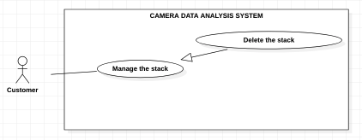

*Figure 19 - <Customer> Delete the stack*

**Use Case Specifications**

|  |  |  |  |
| --- | --- | --- | --- |
| **USE CASE – CDAS** | | | |
| **Use Case No.** | CDAS-15 | **Use Case Version** | 1.0 |
| **Use Case Name** | Delete the stack | | |
| **Author** | LuanNM | | |
| **Date** | 03/02/2021 | **Priority** | Normal |
| **Actor:**  - Customer  **Summary:**  - This use case allows the customer to delete the stack in the system.  **Goal:**  - Customer can delete the stack.  **Triggers:**  - Customer clicks on the “Delete” button.  **Preconditions:**  - Customer must login to the system.  - Customer is on the stack detail page.  **Postconditions:**  - **Success**: Customer deletes a stack successfully.  - **Fail**: System shows the error message.  **Main Success Scenario:**   |  |  |  | | --- | --- | --- | | **Step** | **Actor Action** | **System Response** | | 1 | Customer clicks on the “Delete” button | System asks customer to confirm the action. | | 2 | Customer clicks on the “Ok” button | System shows the message that the stack deleted succesfully. |   **Alternative Scenarios:** N/A  **Exceptions:**   |  |  |  | | --- | --- | --- | | **No** | **Actor Action** | **System Response** | | 1 | Internet problem. | System shows the message: "The system is busy" when the internet is lost. |   **Relationships:** N/A  **Business Rules:**  - The stack’s status is changed to “Inactive”.  - The stack’s product is removed.  - The stack’s camera is removed.  - After deleted successfully, system redirects to the stack page. | | | |

*Table 16 - <Customer> Delete the stack*

#### 2.2.12 <Customer> Search the camera

**Use Case Diagram**

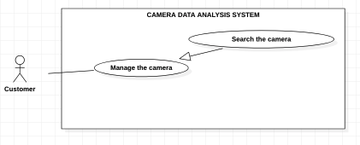

*Figure 20 - <Customer> Search the camera*

**Use Case Specifications**

|  |  |  |  |
| --- | --- | --- | --- |
| **USE CASE – CDAS** | | | |
| **Use Case No.** | CDAS-16 | **Use Case Version** | 1.0 |
| **Use Case Name** | Search the Camera | | |
| **Author** | HuuDN | | |
| **Date** | 04/02/2020 | **Priority** | Normal |
| **Actor:**  - Customer.  **Summary:**  - This use case allows the customer to search the camera.  **Goal:**  - Customer can search the camera.  **Triggers:**  - Customer clicks on the “Search” button.  **Preconditions:**  - Customer must login to the system.  - Customer is on the manage camera page.  **Postconditions:**  - **Success**: System shows the available camera successfully.  - **Fail**: System shows error message.  **Main Success Scenarios:**   |  |  |  | | --- | --- | --- | | **Step** | **Actor Action** | **System Response** | | 1 | Customer inputs information into the “Search” box. |  | | 2 | Customer presses the “Enter” key or clicks on the “Search” button. | System shows the list of the available request’s details that includes:  + Camera code  + Brand  + Position on shelf  + Position on stack  + Image  + Status  + Active |   **Alternative Scenarios:** N/A  **Exceptions:**   |  |  |  | | --- | --- | --- | | **No** | **Actor Action** | **System Response** | | 1 | Internet problem. | System shows the message "The system is busy" when the internet is lost. |   **Relationships:** N/A.  **Business Rules:**  - If the list of the available products is empty, System displays “No result”.  - The cameras must be sorted by descending created time.  - The cameras must be paging. | | | |

*Table 17 - <Customer> Search the camera*

#### 2.2.13 <Customer> Create new camera

**Use Case Diagram**

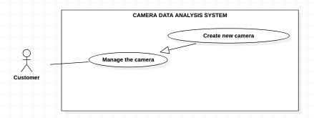

*Figure 21 - <Customer> Create new camera*

**Use Case Specifications**

|  |  |  |  |
| --- | --- | --- | --- |
| **USE CASE – CDAS** | | | |
| **Use Case No.** | CDAS-17 | **Use Case Version** | 1.0 |
| **Use Case Name** | Create new camera | | |
| **Author** | LuanNM | | |
| **Date** | 03/02/2021 | **Priority** | Normal |
| **Actor:**  - Customer  **Summary:**  - This use case allows the customer to create new camera in the system.  **Goal:**  - Customer can create a new camera.  **Triggers:**  - Customer clicks on the “Create new camera” button.  **Preconditions:**  - Customer must login to the system.  - Customer is on the creating camera page.  **Postconditions:**  - **Success**: Customer create a camera successfully.  - **Fail**: System shows the error message.  **Main Success Scenario:**   |  |  |  | | --- | --- | --- | | **Step** | **Actor Action** | **System Response** | | 1 | Customer clicks on the “Create new camera” button | System shows the form that includes:  + Camera code: input  + Brand: input  + Position on shelf: combo box  + Position on stack: combo box  + Camera IP  + Image: image | | 2 | Customer inputs or selects fields |  | | 3 | Customer clicks on the “Create” button | System shows the message that the camera created succesfully.  [Exception 1, 2, 3] |   **Alternative Scenarios:** N/A  **Exceptions:**   |  |  |  | | --- | --- | --- | | **No** | **Actor Action** | **System Response** | | 1 | The camera code is empty. | System shows the message: “The camera code is required.” | | 2 | The brand is empty. | System shows the message: “The brand is required.” | | 3 | The camera IP is empty. | System shows the message: “The camera IP is required.” | | 4 | Internet problem. | System shows the message: "The system is busy" when the internet is lost. |   **Relationships:** N/A  **Business Rules:**  - If the position on shelf and stack is chosen, the status is changed to “unavailable”.  - After created successfully, system shows the camera information that includes:  + Camera code  + Brand  + Position on shelf  + Position on stack  + Camera IP  + Status  + Active | | | |

*Table 18 - <Customer> Create new camera*

#### 2.2.14 <Customer> Edit the camera

**Use Case Diagram**

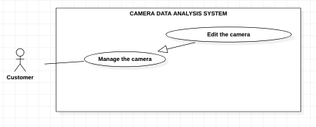

*Figure 22 - <Customer> Edit the camera*

**Use Case Specifications**

|  |  |  |  |
| --- | --- | --- | --- |
| **USE CASE – CDAS** | | | |
| **Use Case No.** | CDAS-18 | **Use Case Version** | 1.0 |
| **Use Case Name** | Edit the camera | | |
| **Author** | LuanNM | | |
| **Date** | 03/02/2021 | **Priority** | Normal |
| **Actor:**  - Customer  **Summary:**  - This use case allows the customer to edit the camera in the system.  **Goal:**  - Customer can edit the camera.  **Triggers:**  - Customer clicks on the “Edit” button.  **Preconditions:**  - Customer must login to the system.  - Customer is on the camera detail page.  **Postconditions:**  - **Success**: Customer edits the camera successfully.  - **Fail**: System shows the error message.  **Main Success Scenario:**   |  |  |  | | --- | --- | --- | | **Step** | **Actor Action** | **System Response** | | 1 | Customer clicks on the “Edit” button | System shows the form that includes:  + Camera code: input  + Brand: input  + Position on shelf: combo box  + Position on stack: combo box  + Camera IP  + Image: image  + Status: label  + Active: combo box | | 2 | Customer inputs or selects fields |  | | 3 | Customer clicks on the “Edit” button | System shows the message that the camera edited succesfully.  [Exception 1, 2, 3, 4] |   **Alternative Scenarios:** N/A  **Exceptions:**   |  |  |  | | --- | --- | --- | | **No** | **Actor Action** | **System Response** | | 1 | The camera code is empty. | System shows the message: “The camera code is required.”. | | 2 | The brand is empty. | System shows the message: “The brand is required.”. | | 3 | The camera IP is empty. | System shows the message: “The camera IP is required.”. | | 4 | The active is not selected. | System shows the message: “The active must be chosen.”. | | 5 | Internet problem. | System shows the message: "The system is busy" when the internet is lost. |   **Relationships:** N/A  **Business Rules:**  - If the position on shelf and stack is chosen, the status is changed to “unavailable”.  - After edited successfully, system shows the camera information that includes:  + Camera code  + Brand  + Position on shelf  + Position on stack  + Camera IP  + Status  + Active | | | |

*Table 20 - <Customer> Edit the camera*

#### 2.2.15 <Customer> Delete the camera

**Use Case Diagram**

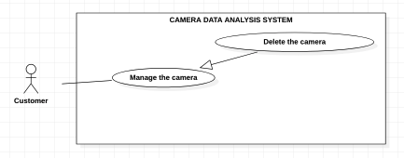

*Figure 23 - <Customer> Delete the camera*

**Use Case Specifications**

|  |  |  |  |
| --- | --- | --- | --- |
| **USE CASE – CDAS** | | | |
| **Use Case No.** | CDAS-19 | **Use Case Version** | 1.0 |
| **Use Case Name** | Delete the camera | | |
| **Author** | LuanNM | | |
| **Date** | 03/02/2021 | **Priority** | Normal |
| **Actor:**  - Customer.  **Summary:**  - This use case allows the customer to delete the camera in the system.  **Goal:**  - Customer can delete the camera.  **Triggers:**  - Customer clicks on the “Delete” button.  **Preconditions:**  - Customer must login to the system.  - Customer is on the camera detail page.  **Postconditions:**  - **Success**: Customer edits the camera successfully.  - **Fail**: System shows the error message.  **Main Success Scenario:**   |  |  |  | | --- | --- | --- | | **Step** | **Actor Action** | **System Response** | | 1 | Customer clicks on the “Delete” button | System asks the customer to confirm this actition. | | 2 | Customer clicks on the “Ok” button | System shows the message that the camera deleted succesfully. |   **Alternative Scenarios:** N/A  **Exceptions:**   |  |  |  | | --- | --- | --- | | **No** | **Actor Action** | **System Response** | | 1 | Internet problem. | System shows the message: "The system is busy" when the internet is lost. |   **Relationships:** N/A  **Business Rules:**  - After deleted successfully,  + The camera’s status is changing “available”.  + The camera’s active is changing “inactive”.  + The camera’s position on the shelf and the stack is removed.  + The stack’s camera is removed and the stack’s status is changing “available”.  + System redirects to managing camera page. | | | |

*Table 21 - <Customer> Delete the camera*

#### 2.2.15 <Customer> Delete the camera from a stack

**Use Case Diagram**

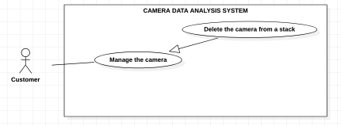

*Figure 24 - <Customer> Delete the camera from a stack*

**Use Case Specifications**

|  |  |  |  |
| --- | --- | --- | --- |
| **USE CASE – CDAS** | | | |
| **Use Case No.** | CDAS-20 | **Use Case Version** | 1.0 |
| **Use Case Name** | Delete the camera from a stack | | |
| **Author** | LuanNM | | |
| **Date** | 03/02/2021 | **Priority** | Normal |
| **Actor:**  - Customer.  **Summary:**  - This use case allows the customer to delete the camera from a stack in the system.  **Goal:**  - Customer can delete the camera from a stack.  **Triggers:**  - Customer clicks on the “Remove this camera” button.  **Preconditions:**  - Customer must login to the system.  - Customer is on the stack detail page.  **Postconditions:**  - **Success**: Customer removes the camera successfully.  - **Fail**: System shows the error message.  **Main Success Scenario:**   |  |  |  | | --- | --- | --- | | **Step** | **Actor Action** | **System Response** | | 1 | Customer clicks on the “Remove this camera” button. | System asks the customer to confirm this actition. | | 2 | Customer clicks on the “Ok” button. | System shows the message that the camera removed succesfully. |   **Alternative Scenarios:** N/A  **Exceptions:**   |  |  |  | | --- | --- | --- | | **No** | **Actor Action** | **System Response** | | 1 | Internet problem. | System shows the message: "The system is busy" when the internet is lost. |   **Relationships:** N/A  **Business Rules:**  - After deleted successfully,  + The camera’s status is changing “available”.  + The stack’s status is changing “available”.  + System redirects to stack detail page. | | | |

*Table 22 - <Customer> Delete the camera from a stack*

#### 2.2.15 <Customer> Add the camera to a stack

**Use Case Diagram**

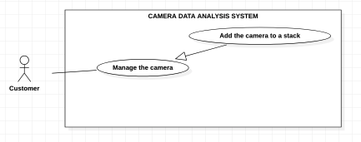

*Figure 25 - <Customer> Add the camera to a stack*

**Use Case Specifications**

|  |  |  |  |
| --- | --- | --- | --- |
| **USE CASE – CDAS** | | | |
| **Use Case No.** | CDAS-20 | **Use Case Version** | 1.0 |
| **Use Case Name** | Add the camera to a stack | | |
| **Author** | LuanNM | | |
| **Date** | 03/02/2021 | **Priority** | Normal |
| **Actor:**  - Customer.  **Summary:**  - This use case allows the customer to add the camera to a stack in the system.  **Goal:**  - Customer can add the camera to a stack.  **Triggers:**  - Customer clicks on the “Add” button.  **Preconditions:**  - Customer must login to the system.  - Customer is on the stack detail page.  **Postconditions:**  - **Success**: Customer removes the camera successfully.  - **Fail**: System shows the error message.  **Main Success Scenario:**   |  |  |  | | --- | --- | --- | | **Step** | **Actor Action** | **System Response** | | 1 | Customer clicks on the “Add” button. | System asks the customer to confirm this actition. | | 2 | Customer clicks on the “Ok” button. | System shows the message that the camera added succesfully. |   **Alternative Scenarios:** N/A  **Exceptions:**   |  |  |  | | --- | --- | --- | | **No** | **Actor Action** | **System Response** | | 1 | Internet problem. | System shows the message: "The system is busy" when the internet is lost. |   **Relationships:** N/A  **Business Rules:**  - After added successfully,  + The camera’s position on the shelf and the stack is changing base on the stack.  + The camera’s status is changing “unavailable”.  + The stack’s status is changing “unavailable”.  + System redirects to stack detail page. | | | |

*Table 23 - <Customer> Add the camera to a stack*

#### 2.2.16 <Customer> Search the product

**Use Case Diagram**

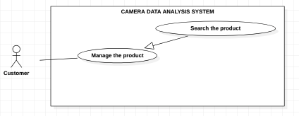

*Figure 25 - <Customer> Add the camera to a stack*

**Use Case Specifications**

|  |  |  |  |
| --- | --- | --- | --- |
| **USE CASE – CDAS** | | | |
| **Use Case No.** | CDAS-21 | **Use Case Version** | 1.0 |
| **Use Case Name** | Search the product | | |
| **Author** | HuuDN | | |
| **Date** | 04/02/2020 | **Priority** | Normal |
| **Actor:**  - Customer.  **Summary:**  - This use case allows the customer to search the product.  **Goal:**  - Customer can search the product.  **Triggers:**  - Customer clicks on the “Search” button.  **Preconditions:**  - Customer must login to the system.  - Customer is on the managing product page.  **Postconditions:**  - **Success**: System shows the available products successfully.  - **Fail**: System shows error message.  **Main Success Scenarios:**   |  |  |  | | --- | --- | --- | | **Step** | **Actor Action** | **System Response** | | 1 | Customer inputs information into the “Search” box. |  | | 2 | Customer presses the “Enter” key or clicks on the “Search” button. | System shows the list of the available product’s details that includes:  + Title  + Description  + Created Time  + Price  + Position on shelf  + Position on stack  + Image  + Product code  + Active |   **Alternative Scenarios:** N/A  **Exceptions:**   |  |  |  | | --- | --- | --- | | **No** | **Actor Action** | **System Response** | | 1 | Internet problem. | System shows the message "The system is busy" when the internet is lost. |   **Relationships:** N/A.  **Business Rules:**  - If the list product is empty, system displays “No result”.  - The products that have “active” and “inactive” active.  - The products must be sorted by descending created time.  - The products must be paging. | | | |

*Table 24 - <Customer> Search the product*

#### 2.2.17 <Customer> Create new product

**Use Case Diagram**

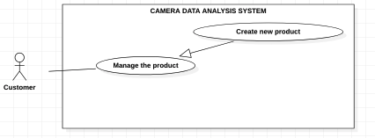

*Figure 26 - <Customer> Create new product*

**Use Case Specifications**

|  |  |  |  |
| --- | --- | --- | --- |
| **USE CASE – CDAS** | | | |
| **Use Case No.** | CDAS-22 | **Use Case Version** | 1.0 |
| **Use Case Name** | Create new product | | |
| **Author** | HuuDN | | |
| **Date** | 04/02/2020 | **Priority** | Normal |
| **Actor:**  - Customer.  **Summary:**  - This use case allows the customer to create new product.  **Goal:**  - Customer can create a new product.  **Triggers:**  - Customer clicks on the “Create a product” button.  **Preconditions:**  - Customer must log in the system.  **Postconditions:**  - **Success**: Customer create new product successfully.  - **Fail**: System shows the error message.  **Main Success Scenarios:**   |  |  |  | | --- | --- | --- | | **Step** | **Actor Action** | **System Response** | | 1 | Customer clicks on the “Create a product” button on navigation menu. | System shows the form that includes:  + Title: input  + Description: input  + Price: input  + Type: combo box  + Image: image  + Product code: input | | 2 | Customer inputs or selects the fields. |  | | 3 | Customer clicks on the “Create” button. | System shows the message created successfully.  [Exception 1, 2, 3, 4, 5, 6, 7] |   **Alternative Scenarios:** N/A  **Exceptions:**   |  |  |  | | --- | --- | --- | | **No** | **Actor Action** | **System Response** | | 1 | The title includes 50 – 200 characters. | System shows the message: “The title includes 50 – 200 characters.” | | 2 | The description is blank. | System shows the message: “The description is required”. | | 3 | The images are empty. | System shows the message: “The images are required”. | | 4 | The product’s price is a double. | System shows the message: “The product’s price must be number.” | | 5 | The product’s type is blank. | System shows the message: “The product’s type must be chosen”. | | 6 | The product code is blank. | System shows the message: “The product code is required”. | | 7 | The product code already exists. | System shows the message: “The product code already exists.”. | | 8 | Internet problem. | System shows message "System is busy" when the internet is lost. |   **Relationships:** N/A  **Business Rules:**  - After created successfully, system shows the product information that includes:  + Title  + Description  + Price  + Type  + Image  + Product code  + Active: active | | | |

*Table 25 - <Customer> Create new product*

#### 2.2.18 <Customer> Edit the product

**Use Case Diagram**

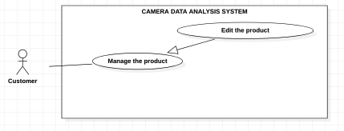

*Figure 27 - <Customer> Edit the product*

**Use Case Specifications**

|  |  |  |  |
| --- | --- | --- | --- |
| **USE CASE – CDAS** | | | |
| **Use Case No.** | CDAS-23 | **Use Case Version** | 1.0 |
| **Use Case Name** | Edit the product | | |
| **Author** | HuuDN | | |
| **Date** | 04/02/2020 | **Priority** | Normal |
| **Actor:**  - Customer.  **Summary:**  - This use case allows the Customer to edit the product.  **Goal:**  - Customer can edit own request.  **Triggers:**  - Customer clicks on the “Edit” button.  **Preconditions:**  - Customer must log in the system.  - Customer is on the product details page.  **Postconditions:**  - **Success**: Customer edits the product successfully.  - **Fail**: System shows the error message.  **Main Success Scenarios:**   |  |  |  | | --- | --- | --- | | **Step** | **Actor Action** | **System Response** | | 1 | Customer clicks on the “Edit” button. | System shows the form that includes:  + Title: input  + Description: input  + Price: input  + Type: combo box  + Image: image  + Position on shelf: combo box  + Position on stack: combo box  + Active: combo box  [Exception 1] | | 2 | Customer inputs or selects the fields. |  | | 3 | Customer clicks on the “Save” button. | System shows the message:” Edit successfully”.  [Exception 1, 2, 3, 4, 5, 6, 7, 8, 9] |   **Alternative Scenarios:** N/A  **Exceptions:**   |  |  |  | | --- | --- | --- | | **No** | **Actor Action** | **System Response** | | 1 | The product is not available. | System shows the message: “The product is not available”. | | 2 | The title includes 50 – 200 characters. | System shows the message: “The title includes 50 – 200 characters.” | | 3 | The description is blank. | System shows the message: “The description is required”. | | 4 | The images are empty. | System shows the message: “The images are required”. | | 5 | The product’s price is a double. | System shows the message: “The product’s price must be number.” | | 6 | The product’s type is blank. | System shows the message: “The product’s type must be chosen”. | | 7 | The product’s active is blank. | System shows the message: “The product’s active must be chosen”. | | 8 | Internet problem. | System shows message "System is busy" when the internet is lost. |   **Relationships:** N/A  **Business Rules:**  - If the product’s active is changing “unactive”, the stack’s product is removed.  - The products’ update time must be updated after editing.  - After created successfully, system shows the product information that includes:  + Title  + Description  + Price  + Type  + Image  + Product code  + Active: active | | | |

*Table 26 - <Customer> Edit the product*

#### 2.2.18 <Customer> Delete the product

**Use Case Diagram**

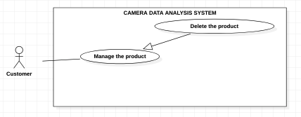

*Figure 28 - <Customer> Delete the product*

**Use Case Specifications**

|  |  |  |  |
| --- | --- | --- | --- |
| **USE CASE – CDAS** | | | |
| **Use Case No.** | CDAS-24 | **Use Case Version** | 1.0 |
| **Use Case Name** | Delete the product | | |
| **Author** | HuuDN | | |
| **Date** | 04/02/2020 | **Priority** | Normal |
| **Actor:**  - Customer.  **Summary:**  - This use case allows the customer to delete the product.  **Goal:**  - Customer can delete the product.  **Triggers:**  - Customer clicks on the “Delete” button.  **Preconditions:**  - Customer must log in the system.  - Customer is on the product detail page.  **Postconditions:**  - **Success**: Customer deletes the product successfully.  - **Fail**: System shows the error message.  **Main Success Scenarios:**   |  |  |  | | --- | --- | --- | | **Step** | **Actor Action** | **System Response** | | 1 | Customer clicks on the “Delete” button. | System ask user to confirm the action | | 2 | Customer chooses to confirm the action. | System show message that product is deleted. |   **Alternative Scenarios:** N/A  **Exceptions:**   |  |  |  | | --- | --- | --- | | **No** | **Actor Action** | **System Response** | | 1 | Internet problem. | System shows message "System is busy" when the internet is lost. |   **Relationships:** N/A  **Business Rules:**  - After deleted successfully,  + The product’s active is changing “inactive”.  + The product of the stacks that were added is removed.  + System redirects to managing product page. | | | |

*Table 27 - <Customer> Delete the product*

#### 2.2.19 <Customer> Add the product to a stack

**Use Case Diagram**

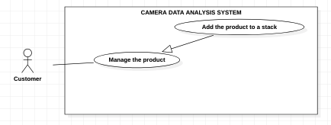

*Figure 29 - <Customer> Add the product to a stack*

**Use Case Specifications**

|  |  |  |  |
| --- | --- | --- | --- |
| **USE CASE – CDAS** | | | |
| **Use Case No.** | CDAS-25 | **Use Case Version** | 1.0 |
| **Use Case Name** | Add the product to a stack | | |
| **Author** | HuuDN | | |
| **Date** | 04/02/2020 | **Priority** | Normal |
| **Actor:**  - Customer.  **Summary:**  - This use case allows the customer to add the product to a stack.  **Goal:**  - Customer can add the product to a stack.  **Triggers:**  - Customer clicks on the “Add” button.  **Preconditions:**  - Customer must log in the system.  - Customer is on the stack detail page.  **Postconditions:**  - **Success**: Customer adds the product to stack successfully.  - **Fail**: System shows the error message.  **Main Success Scenarios:**   |  |  |  | | --- | --- | --- | | **Step** | **Actor Action** | **System Response** | | 1 | Customer clicks on the “Add a product” button. | System shows list of products that has form:  + Title  + Image  + Description  + Update time  + Price  + Product code | | 2 | Customer clicks “Add” button. | System shows the message: “The product is added successfully”. |   **Alternative Scenarios:**   |  |  |  | | --- | --- | --- | | **Step** | **Actor Action** | **System Response** | | 1 | Customer clicks “Edit” button on the product detail page. | System shows the form that includes:  + Title: input  + Description: input  + Price: input  + Type: combo box  + Images: image  + Position on shelf: combo box  + Position on stack: combo box  + Active: combo box | | 2 | Customer selects “Position on shelf” combo box. | System shows the form that includes:  + Shelf’s column  + Shelf’s row  + Shelf’s type | | 3 | Customer selects “Position on stack” combo box. | System shows the form that includes:  + Stack’s position | | 4 | Customer clicks “Save” button. | System shows the message: “The product is edited successfully”. |   **Exceptions:**   |  |  |  | | --- | --- | --- | | **No** | **Actor Action** | **System Response** | | 1 | Internet problem. | System shows message "System is busy" when the internet is lost. |   **Relationships:** N/A  **Business Rules:**  - A stack contains only one product.  - After added successfully,  + The stack’s status is changing “unavailable”.  + System redirects to the stack detail page. | | | |

*Table 28 - <Customer> Add the product to a stack*

#### 2.2.20 <Customer> Delete the product from a stack

**Use Case Diagram**

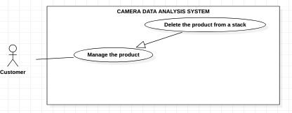

*Figure 30 - <Customer> Delete the product from a stack*

**Use Case Specifications**

|  |  |  |  |
| --- | --- | --- | --- |
| **USE CASE – CDAS** | | | |
| **Use Case No.** | CDAS-26 | **Use Case Version** | 1.0 |
| **Use Case Name** | Delete the product from a stack | | |
| **Author** | HuuDN | | |
| **Date** | 04/02/2020 | **Priority** | Normal |
| **Actor:**  - Customer.  **Summary:**  - This use case allows the customer to delete the product from a stack.  **Goal:**  - Customer can delete the product from a stack.  **Triggers:**  - Customer clicks on the “Delete” button.  **Preconditions:**  - Customer must log in the system.  - Customer is on the stack details page.  **Postconditions:**  - **Success**: Customer delete the product from a stack successfully.  - **Fail**: System shows the error message.  **Main Success Scenarios:**   |  |  |  | | --- | --- | --- | | **Step** | **Actor Action** | **System Response** | | 1 | Customer clicks on the “Delete the product” button. | System ask user to confirm the action | | 2 | Customer clicks “Yes” button. | System show message that product is deleted. |   **Alternative Scenarios:**   |  |  |  | | --- | --- | --- | | **Step** | **Actor Action** | **System Response** | | 1 | Customer clicks “Edit” button on the product detail page. | System shows the form that includes:  + Title: input  + Description: input  + Price: input  + Type: combo box  + Images: image  + Position on shelf: combo box  + Position on stack: combo box  + Active: combo box | | 2 | Customer selects “Position on shelf” combo box. | System shows the form that includes:  + Shelf’s column  + Shelf’s row  + Shelf’s type | | 3 | Customer selects “Position on stack” combo box. | System shows the form that includes:  + Stack’s position | | 4 | Customer clicks “Save” button. | System shows the message: “The product is edited successfully”. |   **Exceptions:**   |  |  |  | | --- | --- | --- | | **No** | **Actor Action** | **System Response** | | 1 | Internet problem. | System shows message "System is busy" when the internet is lost. |   **Relationships:** N/A  **Business Rules:**  - After deleting the product from a stack, the stack’s status is “available”.  - After the customer had edited, system redirects to this stack details page. | | | |

*Table 29 - <Customer> Delete the product from a stack*

### 2.3 <Admin> Overview Use Case

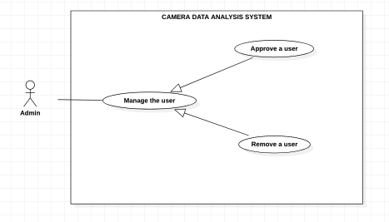

*Figure 31 - <Admin> Overview Use Case*

#### 2.3.1 <Admin> Approve a user

**Use Case Diagram**

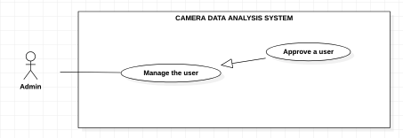

*Figure 32 - <Admin> Approve a user*

**Use Case Specifications**

|  |  |  |  |
| --- | --- | --- | --- |
| **USE CASE - CDAS** | | | |
| **Use Case No.** | CDAS-27 | **Use Case Version** | 1.0 |
| **Use Case Name** | Approve a user | | |
| **Author** | HuuDN | | |
| **Date** | 23/02/2021 | **Priority** | Normal |
| **Actor:**  - Admin.  **Summary:**  - This use case allows the admin to approve a user.  **Goal:**  - Admin can allows the user to use the system.  **Triggers:**  - Admin clicks on the “Approve” button.  **Preconditions:**  - Admin must login to the system.  - Admin must be on the user detail page.  **Postconditions:**  - **Success**: Admin approves a user successfully.  - **Fail**: System shows the error message.  **Main Success Scenario:**   |  |  |  | | --- | --- | --- | | **Step** | **Actor Action** | **System Response** | | 1 | Admin clicks on the “Approve” button. | System asks the admin to confirm this action. | | 2 | Admin clicks on the “Yes” button. | System shows the message approved user successfully. |   **Alternative Scenarios:** N/A  **Exception**s**:**   |  |  |  | | --- | --- | --- | | **No** | **Actor Action** | **System Response** | | 1 | Internet problem | System shows the message: "System is busy" when the internet is lost. |   **Relationships:** N/A  **Business Rules:**  - After approved successfully,  + The user’s status is changing “available”.  + System redirects to managing user page. | | | |

*Table 30 - <Admin > Approve a user*

#### 2.3.2 <Admin> Remove a user

**Use Case Diagram**

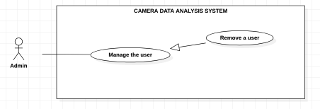

*Figure 33 - <Admin> Remove a user*

**Use Case Specifications**

|  |  |  |  |
| --- | --- | --- | --- |
| **USE CASE - CDAS** | | | |
| **Use Case No.** | CDAS-28 | **Use Case Version** | 1.0 |
| **Use Case Name** | Remove a user | | |
| **Author** | HuuDN | | |
| **Date** | 23/02/2021 | **Priority** | Normal |
| **Actor:**  - Admin.  **Summary:**  - This use case allows the admin to remove a user.  **Goal:**  - Admin can allows the user to use the system.  **Triggers:**  - Admin clicks on the “Remove” button.  **Preconditions:**  - Admin must login to the system.  - Admin must be on the user detail page.  **Postconditions:**  - **Success**: Admin approves a user successfully.  - **Fail**: System shows the error message.  **Main Success Scenario:**   |  |  |  | | --- | --- | --- | | **Step** | **Actor Action** | **System Response** | | 1 | Admin clicks on the “Remove” button. | System asks the admin to confirm this action. | | 2 | Admin clicks on the “Yes” button. | System shows the message removed user successfully. |   **Alternative Scenarios:** N/A  **Exception**s**:**   |  |  |  | | --- | --- | --- | | **No** | **Actor Action** | **System Response** | | 1 | Internet problem | System shows the message: "System is busy" when the internet is lost. |   **Relationships:** N/A  **Business Rules:**  - After removed successfully,  + The user’s status is changing “unavailable”.  + System redirects to managing user page. | | | |

*Table 31 - <Admin> Remove a user*

### 2.4 <Authorized user> Overview Use Case

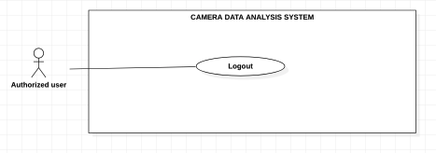

*Figure 34 - <Authorized user> Overview Use Case*

#### 2.4.1 <Authorized user> Logout

**Use Case Diagram**



*Figure 35 - <Authorized user> Logout*

**Use Case Specifications**

|  |  |  |  |
| --- | --- | --- | --- |
| **USE CASE – CDAS** | | | |
| **Use Case No.** | CDAS-29 | **Use Case Version** | 1.0 |
| **Use Case Name** | Logout | | |
| **Author** | Than Nhat Truong | | |
| **Date** | 02/01/2021 | **Priority** | Normal |
| **Actor:**  - Authorized user.  **Summary:**  - This use case allows the authorized user to logout the system.  **Goal:**  - Authorized user can logout from the system.  **Triggers:**  - Authorized user clicks on the “Logout” button.  **Preconditions:**  - Authorized user must login to the system.  **Postconditions:**  - **Success**: Authorized user logout from the system successfully.  - **Fail**: System shows the error message.  **Main Success Scenarios:**   |  |  |  | | --- | --- | --- | | **Step** | **Actor Action** | **System Response** | | 1 | Authorized user clicks on the “Logout” button on navigation menu. | System shows Logout dialog with message:” Do you want to logout? ”. | | 2 | Authorized user clicks on the “Yes” button. | Authorized user logout the system. |   **Alternative Scenarios:** N/A  **Exceptions:**   |  |  |  | | --- | --- | --- | | **No** | **Actor Action** | **System Response** | | 1 | Internet problem. | System shows message: "The system is busy" when the internet is lost. |   **Relationships:** N/A.  **Business Rules:**  - After Authorized user logout from the system, system redirects to the home page. | | | |

*Table 32 - <* *Authorized user> Logout*

### 3. Detail Description

#### 3.1 Class Diagram

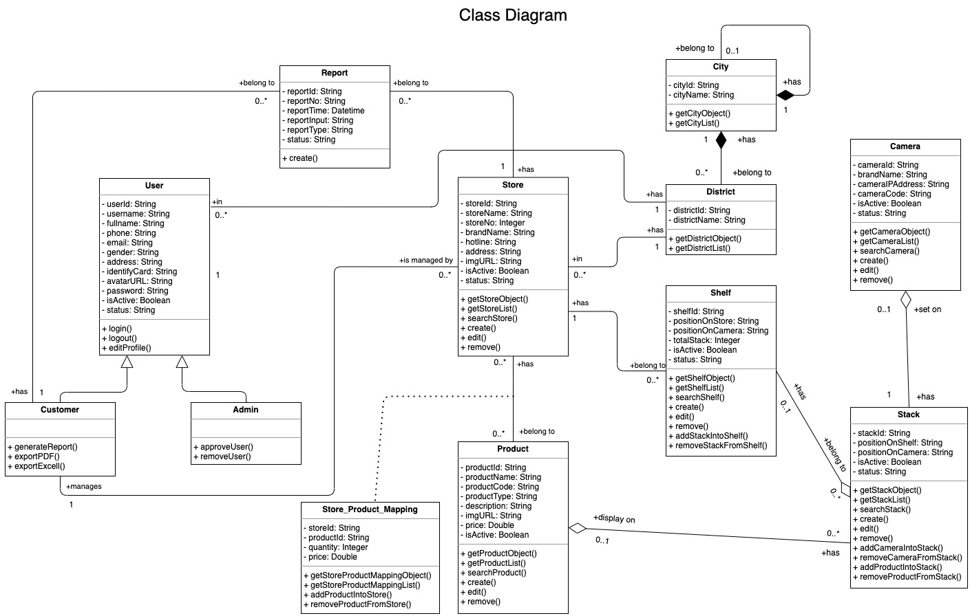

|  |  |  |
| --- | --- | --- |
| **CLASS DICTIONARY: DESCRIBE CLASS** | | |
| ***Class Name*** | ***Mapping column with Conceptual diagram*** | ***Description*** |
| **User** | User | Contains the user information |
| **Admin** | N/A | Not exist in conceptual diagram, but needed in class diagram to contain the admin information |
| **Customer** | N/A | Not exist in conceptual diagram, but needed in class diagram to contain the customer information |
| **Store** | Store | Contains the store information |
| **Shelf** | Shelf | Contains the shelf information |
| **Stack** | Stack | Contains the stack information |
| **Product** | Product | Contains the product information |
| **Camera** | Camera | Contains the camera information |
| **Store_Product_Mapping** | N/A | Not exist in conceptual diagram, but needed in class diagram to contain the store_product_mapping information |
| **City** | N/A | Not exist in conceptual diagram, but needed in class diagram to contain the city information |
| **District** | N/A | Not exist in conceptual diagram, but needed in class diagram to contain the district information |
| **Report** | Report | Contains the report information |

#### 3.2 Class Diagram Explanation

#### 3.2.1 User

* **Attributes**

|  |  |  |  |
| --- | --- | --- | --- |
| **Attribute** | **Type** | **Visibility** | **Description** |
| userId | String | private | Unique identifier of the user |
| username | String | private | Username of the user |
| fullname | String | private | Fullname of the user |
| phone | String | private | Phone of the user |
| email | String | private | Email of the user |
| gender | String | private | Gender of the user |
| address | String | private | Address of the user |
| identify Card | String | private | Identify card of the user |
| avatarURL | String | private | Avatar URL of the user |
| password | String | private | Password of the user |
| isActive | Boolean | private | Active of the user |
| status | String | private | Status of the user |

* **Methods**

|  |  |  |  |
| --- | --- | --- | --- |
| **Method** | **Return Type** | **Visibility** | **Description** |
| login() | resultObject | public | Login into system |
| logout() | void | public | Logout from system |
| editProfile() | resultObject | public | Edit the user's profile |

#### 3.2.2 Admin

* **Methods**

|  |  |  |  |
| --- | --- | --- | --- |
| **Method** | **Return Type** | **Visibility** | **Description** |
| approveUser() | resultObject | public | Accept the user to use system |
| removeUser() | resultObject | public | Remove the user from system |

#### 3.2.3 Customer

* **Methods**

|  |  |  |  |
| --- | --- | --- | --- |
| **Method** | **Return Type** | **Visibility** | **Description** |
| generateReport() | resultObject | public | Generate a report |
| exportPDF() | resultObject | public | Export the report to PDF files. |
| exportExcell() | resultObject | public | Export the report to Excell files. |

#### 3.2.4 Store

* **Attributes**

|  |  |  |  |
| --- | --- | --- | --- |
| **Attribute** | **Type** | **Visibility** | **Description** |
| storeId | String | private | Unique identifier of the store |
| storeName | String | private | Name of the store |
| storeNo | Integer | private | No of the store |
| brandName | String | private | Brand of the store |
| hotline | String | private | Hotline of the store |
| address | String | private | Address of the store |
| imgURL | String | private | ImageURL of the store |
| isActive | Boolean | private | Active of the store |
| status | String | private | Status of the store |

* **Methods**

|  |  |  |  |
| --- | --- | --- | --- |
| **Method** | **Return Type** | **Visibility** | **Description** |
| getStoreObject() | resultObject | public | Get the store information |
| getStoreList() | resultObject | public | Get the store information list |
| searchStore() | resultObject | public | Search the stores |
| create() | resultObject | public | Create a store |
| edit() | resultObject | public | Edit the store information |
| remove() | resultObject | public | Remove the store |

#### 3.2.5 Shelf

* **Attributes**

|  |  |  |  |
| --- | --- | --- | --- |
| **Attribute** | **Type** | **Visibility** | **Description** |
| shelfId | String | private | Unique identifier of the shelf |
| positionOnStore | String | private | Position on the store |
| positionOnCamera | String | private | Position on the camera |
| totalStack | Integer | private | Total stack in the shelf |
| isActive | Boolean | private | Active of shelf |
| status | String | private | Status of shelf |

* **Methods**

|  |  |  |  |
| --- | --- | --- | --- |
| **Method** | **Return Type** | **Visibility** | **Description** |
| getShelfObject() | resultObject | public | Get the shelf information |
| getShelfList() | resultObject | public | Get the shelf information list |
| searchShelf() | resultObject | public | Search the shelfs |
| create() | resultObject | public | Create a shelf |
| edit() | resultObject | public | Edit the shelf information |
| remove() | resultObject | public | Remove the shelf |
| addStackIntoShelf() | resultObject | public | Add a stack into the shelf |
| removeStackFromShelf() | resultObject | pubic | Remove a stack from the shelf |

#### 3.2.6 Stack

* **Attributes**

|  |  |  |  |
| --- | --- | --- | --- |
| **Attribute** | **Type** | **Visibility** | **Description** |
| stackId | String | private | Unique identifier of the stack |
| positionOnShelf | String | private | Position on the shelf |
| positionOnCamera | String | private | Position on the camera |
| isActive | Boolean | private | Active of stack |
| status | String | private | Status of stack |

* **Methods**

|  |  |  |  |
| --- | --- | --- | --- |
| **Method** | **Return Type** | **Visibility** | **Description** |
| getStackObject() | resultObject | public | Get the stack information |
| getStackList() | resultObject | public | Get the stack information list |
| searchStack() | resultObject | public | Search the stacks |
| create() | resultObject | public | Create a stack |
| edit() | resultObject | public | Edit the stack information |
| remove() | resultObject | public | Remove the stack |
| addCameraIntoStack() | resultObject | public | Add a camera into the stack |
| removeCameraFromStack() | resultObject | pubic | Remove a camera from the stack |
| addProductIntoStack() | resultObject | public | Add a product into the stack |
| removeProductFromStack() | resultObject | public | Remove a product from the stack |

#### 3.2.7 Product

* **Attributes**

|  |  |  |  |
| --- | --- | --- | --- |
| **Attribute** | **Type** | **Visibility** | **Description** |
| productId | String | private | Unique identifier of the product |
| productName | String | private | Name of the product |
| productCode | String | private | Code of the product |
| productType | String | private | Type of the product |
| description | String | private | Description of the product |
| imgURL | String | private | ImageURL of the product |
| price | Double | private | Price of the product |
| isActive | Boolean | private | Active of the product |

* **Methods**

|  |  |  |  |
| --- | --- | --- | --- |
| **Method** | **Return Type** | **Visibility** | **Description** |
| getProductObject() | resultObject | public | Get the product information |
| getProductList() | resultObject | public | Get the product information list |
| searchProduct() | resultObject | public | Search the products |
| create() | resultObject | public | Create a product |
| edit() | resultObject | public | Edit the product information |
| remove() | resultObject | public | Remove the product |

#### 3.2.8 Camera

* **Attributes**

|  |  |  |  |
| --- | --- | --- | --- |
| **Attribute** | **Type** | **Visibility** | **Description** |
| cameraId | String | private | Unique identifier of the camera |
| brandName | String | private | Brand name of the camera |
| cameraIPAddress | String | private | IP address of the camera |
| cameraCode | String | private | Code of the camera |
| isActive | Boolean | private | Active of the camera |
| status | String | private | Status of the camera |

* **Methods**

|  |  |  |  |
| --- | --- | --- | --- |
| **Method** | **Return Type** | **Visibility** | **Description** |
| getCameraObject() | resultObject | public | Get the camera information |
| getCameraList() | resultObject | public | Get the camera information list |
| searchCamera() | resultObject | public | Search the cameras |
| create() | resultObject | public | Create a camera |
| edit() | resultObject | public | Edit the camera information |
| remove() | resultObject | public | Remove the camera |

#### 3.2.9 Store_Product_Mapping

* **Attributes**

|  |  |  |  |
| --- | --- | --- | --- |
| **Attribute** | **Type** | **Visibility** | **Description** |
| storeId | String | private | Unique identifier of the store |
| productId | String | private | Unique identifier of the product |
| quantity | Integer | private | Quantity of product |
| price | Double | private | Price of product |

* **Methods**

|  |  |  |  |
| --- | --- | --- | --- |
| **Method** | **Return Type** | **Visibility** | **Description** |
| getStoreProductMappingObject() | resultObject | public | Get the store_product_mapping information |
| getStoreProductMappingList() | resultObject | public | Get the store_product_mapping list |
| addProductIntoStore() | resultObject | public | Add a product into the store |
| removeProductFromStore() | resultObject | public | Remove a product from the store |

#### 3.2.10 City

* **Attributes**

|  |  |  |  |
| --- | --- | --- | --- |
| **Attribute** | **Type** | **Visibility** | **Description** |
| cityId | String | private | Unique identifier of the city |
| cityName | String | private | Name of the city |

* **Methods**

|  |  |  |  |
| --- | --- | --- | --- |
| **Method** | **Return Type** | **Visibility** | **Description** |
| getCityObject() | resultObject | public | Get the city information |
| getCityList() | resultObject | public | Get the city list |

#### 3.2.11 District

* **Attributes**

|  |  |  |  |
| --- | --- | --- | --- |
| **Attribute** | **Type** | **Visibility** | **Description** |
| districtId | String | private | Unique identifier of the district |
| districtName | String | private | Name of the district |

* **Methods**

|  |  |  |  |
| --- | --- | --- | --- |
| **Method** | **Return Type** | **Visibility** | **Description** |
| getDistrictObject() | resultObject | public | Get the district information |
| getDistrictList() | resultObject | public | Get the district list |

#### 3.2.12 Report

* **Attributes**

|  |  |  |  |
| --- | --- | --- | --- |
| **Attribute** | **Type** | **Visibility** | **Description** |
| reportId | String | private | Unique identifier of the report |
| reportNo | String | private | No of the report |
| reportTime | Datetime | private | Time of the report generation |
| reportInput | String | pirvate | Chosen options for the report |
| status | String | private | Status of the report |

* **Methods**

|  |  |  |  |
| --- | --- | --- | --- |
| **Method** | **Return Type** | **Visibility** | **Description** |
| create() | resultObject | public | Create the report |

#### 3.3 Sequence Diagram