|  |  |
| --- | --- |
|  | **MINISTRY OF EDUCATION AND TRAINING** |

FPT UNIVERSITY

**Capstone Project Document**

**Engineer Grab System**

|  |  |
| --- | --- |
| **Group** | |
| **Group members** | Đỗ Ngọc Hữu - SE130557  Từ Quang Huy - SE130537  Thân Nhật Trường - SE130426 |
| **Supervisor** | Lại Đức Hùng |
| **Ext. Supervisor** | N/A |
| **Project Code** | N/A |

# Table of Contents

Table of Contents 2

A. Introduction 3

1. Project Information 3

2. Introduction 3

3. Current Situation 3

4. Problem Definition 3

5. Proposed Solution 3

6. Definitions, Acronyms, and Abbreviations 3

B. Functional Requirements 4

1. <Use Case Diagram Main> 4

2. <Use Case Make A Deal With The Engineer> 4

3. <Use Case Feedback> 6

4. <Use Case View Own Request> 7

5. <Use Case View The Promotion> 9

6. <Use Case Add A New Request> 10

7. <Use Case View Profile> 12

8. <Use Case Search the Available Request> 14

9. <Use Case Submit The Profile> 16

10. <Use Case Add An Engineer> 17

C. Database Design 19

1. Entity relationship diagram (ERD) 19

2. Database diagram 20

3. Query command 20

3.1 Query command 1 20

3.2 Query command 2 21

3.3 Query command 3 21

3.4 Query command 4 22

3.5 Query command 5 22

D. Survey information 23

1. Customer survey 23

2. Engineer survey 27

# A. Introduction

## Project Information

* Project name:  **Engineer grab system**
* Start Date: **March 20th, 2020**
* End Date: **--**

## Introduction

In this document, we introduce a solution for you about finding an engineer. Today, finding workers is no longer difficult but there are still some problems such as quality, prestige, price or inconvenience in traveling. Understanding those things, we have created "Engineer grab system". So what is the "Engineer grab system"? The "Engineer grab system" is the most convenient and efficient way to connect engineers and technicians.

In the "Engineer grab system", we build a standardized community of technicians to provide our customers with the best service, ensuring the rights of engineers and customers.

A team of qualified technicians from the style, behavior to the code of conduct are always ready to serve you anytime, anywhere.

We provide technician services to meet most of your needs of utilities, installation, maintenance, repair and recruitment.

## Current Situation

To find an engineer, customers often come to the store, so sometimes customers have to go very far and take time. Moreover, they do not know how skilled workers. Because hiring a bad engineer will affect equipment as well as losing money. With the application, the amount of time spent traveling is greatly reduced, avoiding unexpected risks.

## Problem Definition

After doing some research, we can see some disadvantages still exist:

+ The standard repair cost cannot be calculated.

+ No guarantee all requests are completed.

+ Does not guarantee the requirements are real.

## Proposed Solution

To solve these problems, our proposed solution is to build a system called the “Engineer grab system”. The system that helps users find engineers by linking with users through the application. The system helps reduce time as well as increase efficiency in repair problems.

## Definitions, Acronyms, and Abbreviations

|  |  |
| --- | --- |
| **Name** | **Definition** |
| CV | Curriculum Vitae |
| URL | Uniform Resource Locator |

# B. Functional Requirements

## 1. <Use Case Diagram Main>

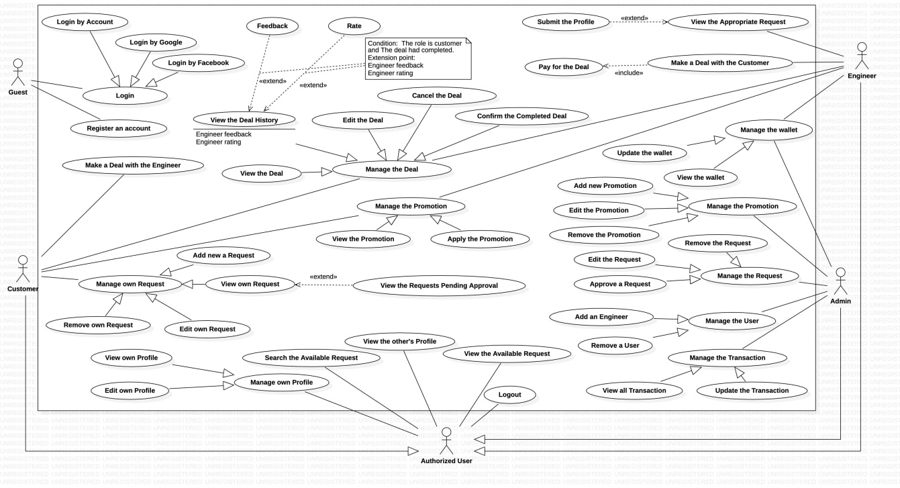

## 2. <Use Case Make A Deal With The Engineer>

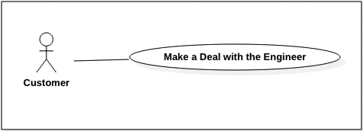

|  |  |  |  |
| --- | --- | --- | --- |
| **USE CASE – Engineer Grab System** | | | |
| **Use Case No.** | EGS-01 | **Use Case Version** | 1.0 |
| **Use Case Name** | Make a deal with the engineer | | |
| **Author** | Do Ngoc Huu | | |
| **Date** | 30/03/2020 | **Priority** |  |
| **Actor:**  - Customer.  **Summary:**  - This use case allows the customer to make a deal with the Engineer.  **Goal:**  - The customer makes a deal.  **Triggers:**  - The customer clicks on the “Make a deal” button.  **Preconditions:**  - The customer must login to the system.  - The customer must post the request for what they have a problem that needs fixing.  - The customer’s request must be approved by the Admin and posted on the system.  - The customer's request has submitted the profile of the engineers who want to repair the customer’s problem.  - The customer is on the request page.  **Post conditions:**  - **Success**: The system will notify the customer that the deal is successful.  - **Fail**: The system will show the error message.  **Main Success Scenarios:**   |  |  |  | | --- | --- | --- | | **Step** | **Actor Action** | **System Response** | | 1 | The customer clicks on the request details page. | The system will show the Request details and all submitted the profile of the engineers who wants to repair the customer’s problem. | | 2 | The customer clicks on the “Make a deal” button with the appropriate engineer profile. | The system will notify the customer that the deal is successful.  [Exception 1] |   **Alternative Scenarios:** N/A  **Exceptions:**   |  |  |  | | --- | --- | --- | | **No** | **Actor Action** | **System Response** | | 1 | The engineer is not available. | The system shows the message: “The engineer is not available.” | | 2 | Internet problem. | The system shows the message: "The system is busy" when the internet is lost. |   **Relationships:** N/A  **Business Rules:**  - The request’s status must be changed to "in repair".  - The status of other submitted engineer’s profiles must be changed to "cancel".  - The system must notify the engineer that they have a deal with the customer.  - The status of engineer’s deal must be changed to "pending repair". At the require time, this status must be changed to "in repaire". | | | |

## 3. <Use Case Feedback>

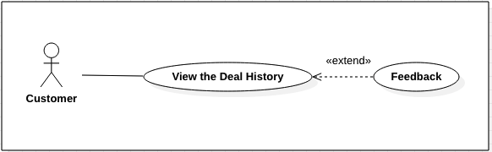

|  |  |  |  |
| --- | --- | --- | --- |
| **USE CASE – Engineer Grab System** | | | |
| **Use Case No.** | EGS-02 | **Use Case Version** | 1.0 |
| **Use Case Name** | Feedback | | |
| **Author** | Do Ngoc Huu | | |
| **Date** | 30/03/2020 | **Priority** |  |
| **Actor:**  - Customer.  **Summary:**  - This use case allows the customer to feedback on the completed deal.  **Goal:**  - The customer feedbacks to the engineers.  **Triggers:**  - The customer clicks on the “Submit” button.  **Preconditions:**  - The customer must login to the system.  - The deal of the customer and the engineer must be completed.  - The customer is on the deal history page.  **Post conditions:**  - **Success**: The system will show the successful message.  - **Fail**: The system will show the error message.  **Main Success Scenarios:**   |  |  |  | | --- | --- | --- | | **Step** | **Actor Action** | **System Response** | | 1 | The customer clicks on the deal details page. | The system will show a form:  + Feedback the engineer: text input  + Submit: button | | 2 | The customer inputs the feedback text. |  | | 3 | The customer clicks on the “Submit” button. | The system shows the message: “Thanks for your feedback.” |   **Alternative Scenarios:** N/A  **Exceptions:**   |  |  |  | | --- | --- | --- | | **No** | **Actor Action** | **System Response** | | 1 | Internet problem. | The system shows the message: "The system is busy" when the internet is lost. |   **Relationships:** This use case extends from the “View the Deal History” use case.  **Business Rules:**   * The only customer can feedback to the engineers. | | | |

## 4. <Use Case View Own Request>

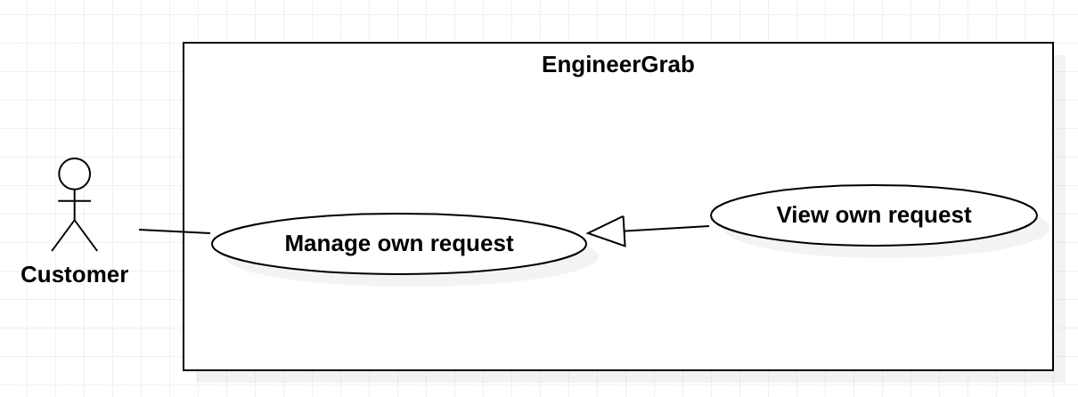

|  |  |  |  |
| --- | --- | --- | --- |
| **USE CASE – Engineer Grab System** | | | |
| **Use Case No.** | EGS-03 | **Use Case Version** | 1.0 |
| **Use Case Name** | View own request | | |
| **Author** | Than Nhat Truong | | |
| **Date** | 23/02/2020 | **Priority** | Normal |
| **Actor:**   * Customer   **Summary:**   * This use case allows cutstomer to view own request.   **Goal:**   * The customer can view own request infomation.   **Triggers:**   * The customer sends view own request command to the system.   **Preconditions:**   * The customer must login to the system.   **Post conditions:**   * Success: The customer can view own request details. * Fail: The system shows the error message.   **Main Success Scenario:**   |  |  |  | | --- | --- | --- | | **Step** | **Actor Action** | **System Response** | | 1 | The customer clicks “View own request” on navigation menu. | The system redirects to view own request screen with list of the requests.  [Exception 1] | | 2 | The customer clicks on a request. | The system redirects to view own request details screen. The customer can view information of the request. |   **Alternative Scenarios:** N/A  **Exception:**   |  |  |  | | --- | --- | --- | | **No** | **Actor Action** | **System Response** | | 1 | The customer does not have requests. | The system shows the message “You have no the request.” | | 2 | Internet problem. | The system shows the message: "The system is busy" when the internet is lost. |   **Relationships:** N/A  **Business Rules:**   * Display list of request base on customer’s id. * The requests will be paging. * A view own request screen must have:  1. Title. 2. Content. 3. Status. 4. Created time 5. Requestor phone. 6. Requestor name. 7. Requestor address. 8. Request time. 9. Service name. 10. Promotion details. | | | |

## 5. <Use Case View The Promotion>

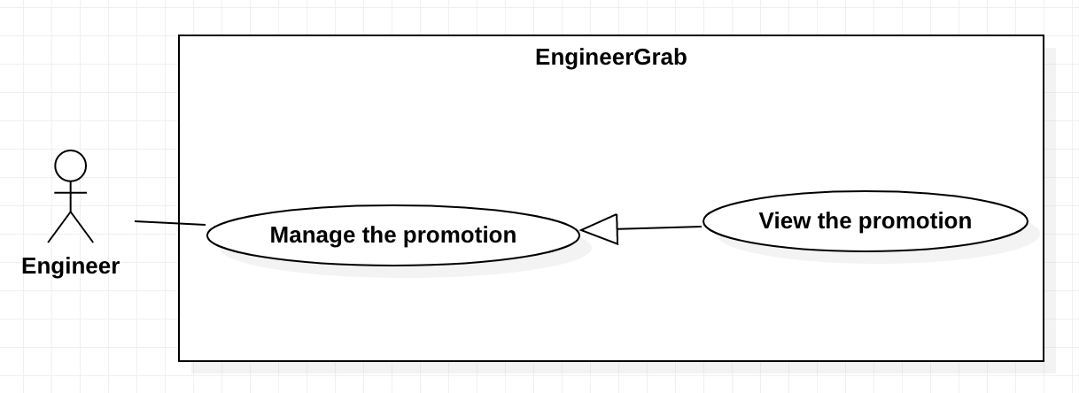

|  |  |  |  |
| --- | --- | --- | --- |
| **USE CASE - Engineer Grab System** | | | |
| **Use Case No.** | EGS-04 | **Use Case Version** | 1.0 |
| **Use Case Name** | View the promotion | | |
| **Author** | Than Nhat Truong | | |
| **Date** | 23/02/2020 | **Priority** | Normal |
| **Actor:**   * Engineer   **Summary:**   * This use case allows the engineer to view the promotion.   **Goal:**   * The engineer can view the promotion.   **Triggers:**   * The engineer sends view the promotion command to the system.   **Preconditions:**   * The engineer must login to the system.   **Post conditions:**   * Success: The system shows the promotion details. * Fail: The system shows the error message.   **Main Success Scenario:**   |  |  |  | | --- | --- | --- | | **Step** | **Actor Action** | **System Response** | | 1 | The engineer clicks “View the promotion” on navigation menu. | The system redirects to view the promotion screen with list of the promotions.  [Exception 1] | | 2 | The engineer clicks on a promotion. | The system redirects to view promtion details screen. The customer can view information of the promotion. |   **Alternative Scenarios:** N/A  **Exception:**   |  |  |  | | --- | --- | --- | | **No** | **Actor Action** | **System Response** | | 1 | The engineer does not have a promotion. | System show message “You have no the promotion.” | | 2 | Internet problem. | The system shows the message: "The system is busy" when the internet is lost. |   **Relationships:** N/A  **Business Rules:**   * The promotions will be paging. * The promotion details screen must have:  1. Name of the promotion 2. Amount discount 3. Percent discount 4. Started date 5. Ended date 6. Status | | | |

## 6. <Use Case Add A New Request>

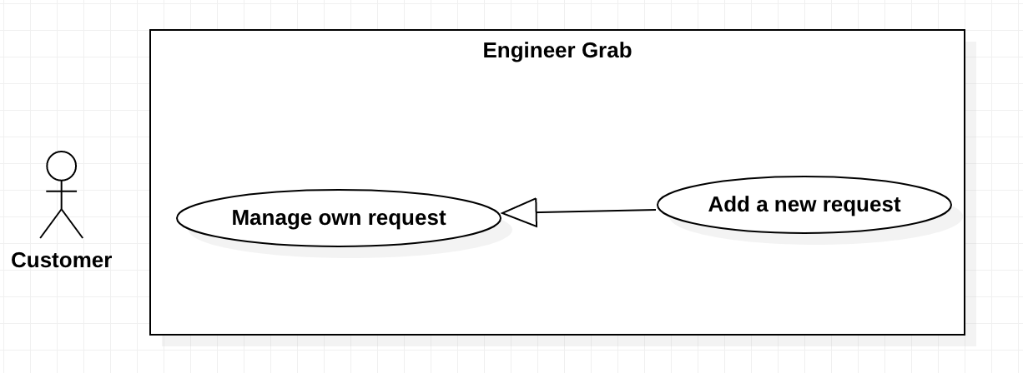

|  |  |  |  |
| --- | --- | --- | --- |
| **USE CASE - Engineer Grab System** | | | |
| **Use Case No.** | EGS-05 | **Use Case Version** | 1.0 |
| **Use Case Name** | Add a new request | | |
| **Author** | Than Nhat Truong | | |
| **Date** | 23/02/2020 | **Priority** | Normal |
| **Actor:**   * Customer   **Summary:**   * This use case allows the customer to add a new request.   **Goal:**   * The customer can add a new request.   **Triggers:**   * The customer clicks on the “Add a new request” button.   **Preconditions:**   * The customer must login to the system.   **Post conditions:**   * Success: The system shows the successful message. * Fail: The system shows the error message.   **Main Success Scenario:**   |  |  |  | | --- | --- | --- | | **Step** | **Actor Action** | **System Response** | | 1 | The customer clicks on the “Add a new request” button. | The system redirects to add a new request screen. | | 2. | The customer inputs the fields. | The system shows the message : “ Your request has been sent to the admin and awaits approval.”.  [Exception 1] |   **Alternative Scenarios:** N/A  **Exception**s**:**   |  |  |  | | --- | --- | --- | | **No** | **Actor Action** | **System Response** | | 1 | User inputs invalid fields. | System shows message with correspoding fields:  Title: must be inputted from 6 to 200 characters.  Content: must be inputted.  Requestor name: must be inputted from 2 to 50 charactes.  Requestor address: must be inputted.  Requestor phone: must be inputted from 10 to 12 numbers.  Request time: must be inputted.  Service name: must be chosen. | | 2 | Internet problem | The system shows the message: "The system is busy" when the internet is lost. |   **Relationships:** N/A  **Business Rules:**   * The customer can view the details of the request before clicking the “Add a new request” button. * After the added a new request is successful, the system redirects to the “View the request” screen. * The customer can apply the promotion in the request. | | | |

## 7. <Use Case View Profile>

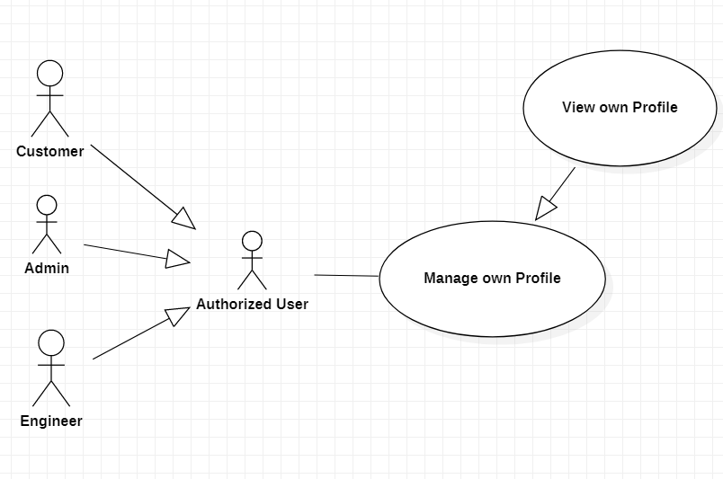

|  |  |  |  |
| --- | --- | --- | --- |
| **USE CASE – Engineer Grab System** | | | |
| **Use Case No.** | EGS-06 | **Use Case Version** | 1.0 |
| **Use Case Name** | View Profile | | |
| **Author** | Tu Quang Huy | | |
| **Date** | 20/03/2020 | **Priority** |  |
| **Actor:**  - Admin, Customer, Engineer.  **Summary:**  - This use case allows the admin to view own profile.  - This use case allows the customer to view own profile.  - This use case allows the engineer to view own profile.  **Goal:**   * The admin can view own profile. * The customer can view own profile. * The engineer can view own profile.   **Triggers:**   * The admin, the customer, the engineer clicks on the “Your Profile” button.   **Preconditions:**   * The admin, the customer, the engineer must login to the system.   **Post conditions:**  - Success: The system shows the profile.  - Fail: The system shows the error message.  **Main Success Scenarios:**   |  |  |  | | --- | --- | --- | | **Step** | **Actor Action** | **System Response** | | 1 | The admin or the customer or the engineer clicks on the “Your Profile” button. | The system shows Profile information:  + User ID  + Full name  + Sex  + Phone  + Identity Car  + Avatar  + Email  + Address  + Curriculum Vitae  + Status  + Role name  + District name |   **Alternative Scenarios:** N/A  **Exceptions:**   |  |  |  | | --- | --- | --- | | **No** | **Actor Action** | **System Response** | | 1 | Internet problem. | The system shows the message "The system is busy" when the internet is lost. |   **Relationships:**   * Generalization from the “Manage own Profile” use case.   **Business Rules:**  - If actor is an Engineer. The system will show more information such as: The CV, The wallet details, education, work experience, career. | | | |

## 8. <Use Case Search the Available Request>

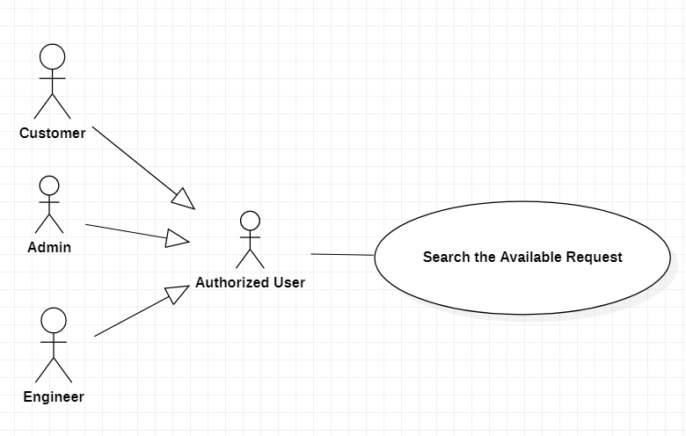

|  |  |  |  |
| --- | --- | --- | --- |
| **USE CASE – Engineer Grab System** | | | |
| **Use Case No.** | EGS-07 | **Use Case Version** | 1.0 |
| **Use Case Name** | Search the Available Request | | |
| **Author** | Tu Quang Huy | | |
| **Date** | 20/03/2020 | **Priority** |  |
| **Actor:**  - Admin, Customer, Engineer.  **Summary:**   * This use case allows the admin to search the available requests. * This use case allows the customer to search the available requests. * This use case allows the engineer to search the available requests.   **Goal:**   * The admin can search the available requests. * The customer can search the available requests. * The engineer can search the available requests.   **Triggers:**   * The admin clicks on the “Search” button. * The customer clicks on the “Search” button. * The engineer clicks on the “Search” button.   **Preconditions:**   * The admin must login to the system. * The customer must login to the system. * The engineer must login to the system. * The admin or the customer or the engineer is on the home page.   **Post conditions:**  - Success: The system shows the available requests.  - Fail: The system shows the error message.  **Main Success Scenarios:**   |  |  |  | | --- | --- | --- | | **Step** | **Actor Action** | **System Response** | | 1 | The admin or the customer or the engineer inputs information. |  | | 2 | The admin or the customer or the engineer presses the “Enter” key or clicks on the “Search” button. | The system will be showed request with search value:  + Title  + Content  + Created Time  + Requestor Name  + Requestor Phone  + Requestor Address  + Request Time  + District name  + Service Details  + Promotion Details |   **Alternative Scenarios:** N/A  **Exceptions:**   |  |  |  | | --- | --- | --- | | **No** | **Actor Action** | **System Response** | | 1 | Internet problem. | The system shows the message "The system is busy" when the internet is lost. |   **Relationships:**   * N/A.   **Business Rules:**   * If there is no matching request, the system will show message:” No result”. * If the role is admin, the admin can view more information such as status and request ID. * The requests will be paging. | | | |

## 9. <Use Case Submit The Profile>

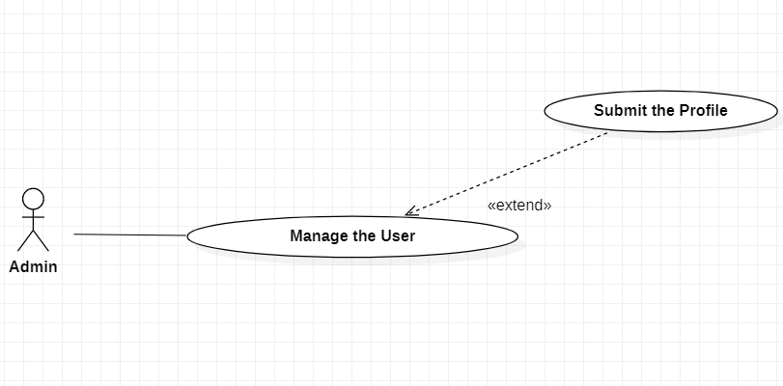

|  |  |  |  |
| --- | --- | --- | --- |
| **USE CASE – Engineer Grab System** | | | |
| **Use Case No.** | EGS-08 | **Use Case Version** | 1.0 |
| **Use Case Name** | Submit the Profile | | |
| **Author** | Tu Quang Huy | | |
| **Date** | 20/03/2020 | **Priority** |  |
| **Actor:**  - Engineer.  **Summary:**  - This use case allows the engineer to submit the Profile.  **Goal:**  - The engineer can submit the Profile.  **Triggers:**  - The engineer clicks on the “Submit” button.  **Preconditions:**   * The engineer must login the system. * The request had uploaded on the system. * The engineer is on the request page.   **Post conditions:**  - Success: The system shows the successful message.  - Fail: The system shows the error message.  **Main Success Scenarios:**   |  |  |  | | --- | --- | --- | | **Step** | **Actor Action** | **System Response** | | 1 | The engineer clicks on the” Submit” button below the request. | The system shows the message” Submitted successfully”. |   **Alternative Scenarios:** N/A  **Exceptions:**   |  |  |  | | --- | --- | --- | | **No** | **Actor Action** | **System Response** | | 1 | Internet problem. | The system shows the message "The system is busy" when the internet is lost. |   **Relationships:**   * This use case extends from the “Manager the User” use case.   **Business Rules:**   * The engineers' career must be match to the request. * The system will show notify the message to the customer:” There is a submitted profile”. | | | |

## 10. <Use Case Add An Engineer>

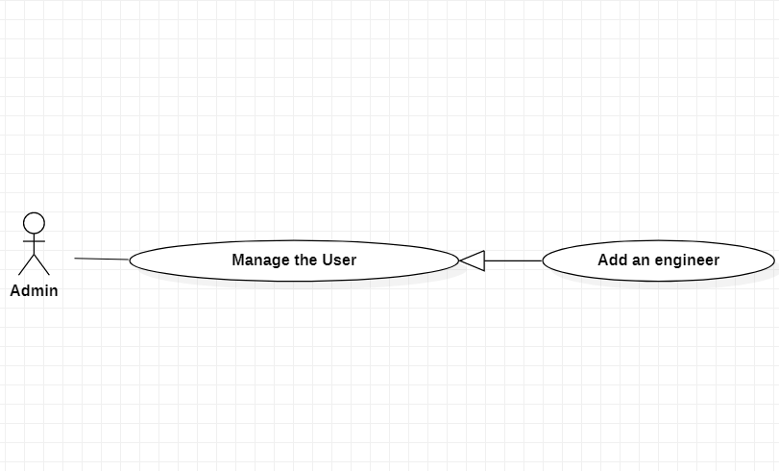

|  |  |  |  |
| --- | --- | --- | --- |
| **USE CASE – Engineer Grab System** | | | |
| **Use Case No.** | EGS-09 | **Use Case Version** | 1.0 |
| **Use Case Name** | Add an Engineer | | |
| **Author** | Tu Quang Huy | | |
| **Date** | 20/03/2020 | **Priority** |  |
| **Actor:**   * Admin.   **Summary:**   * This use case allows the admin to add an engineer.   **Goal:**   * The engineer will have an account that allows use on the application.   **Triggers:**   * The admin clicks on the “Confirm” button.   **Preconditions:**   * The admin must login to the system.   **Post conditions:**  - Success: The system will show the successful message.  - Fail: The system will show the error message.  **Main Success Scenarios:**   |  |  |  | | --- | --- | --- | | **Step** | **Actor Action** | **System Response** | | 1 | The admin clicks on the “Confirm” button. | The system will be showed the message:” The engineer’s account is created successfully”. |   **Alternative Scenarios:** N/A  **Exceptions:**   |  |  |  | | --- | --- | --- | | **No** | **Actor Action** | **System Response** | | 1 | Internet problem. | The system shows the message: "The system is busy" when the internet is lost. |   **Relationships:**   * Generalization from use case “Manage the user”.   **Business Rules:**  - Only admin can approve an Engineer.  - If the engineer is added, an account and a wallet will be created and stored in the system. | | | |

# C. Database Design

## 1. Entity relationship diagram (ERD)

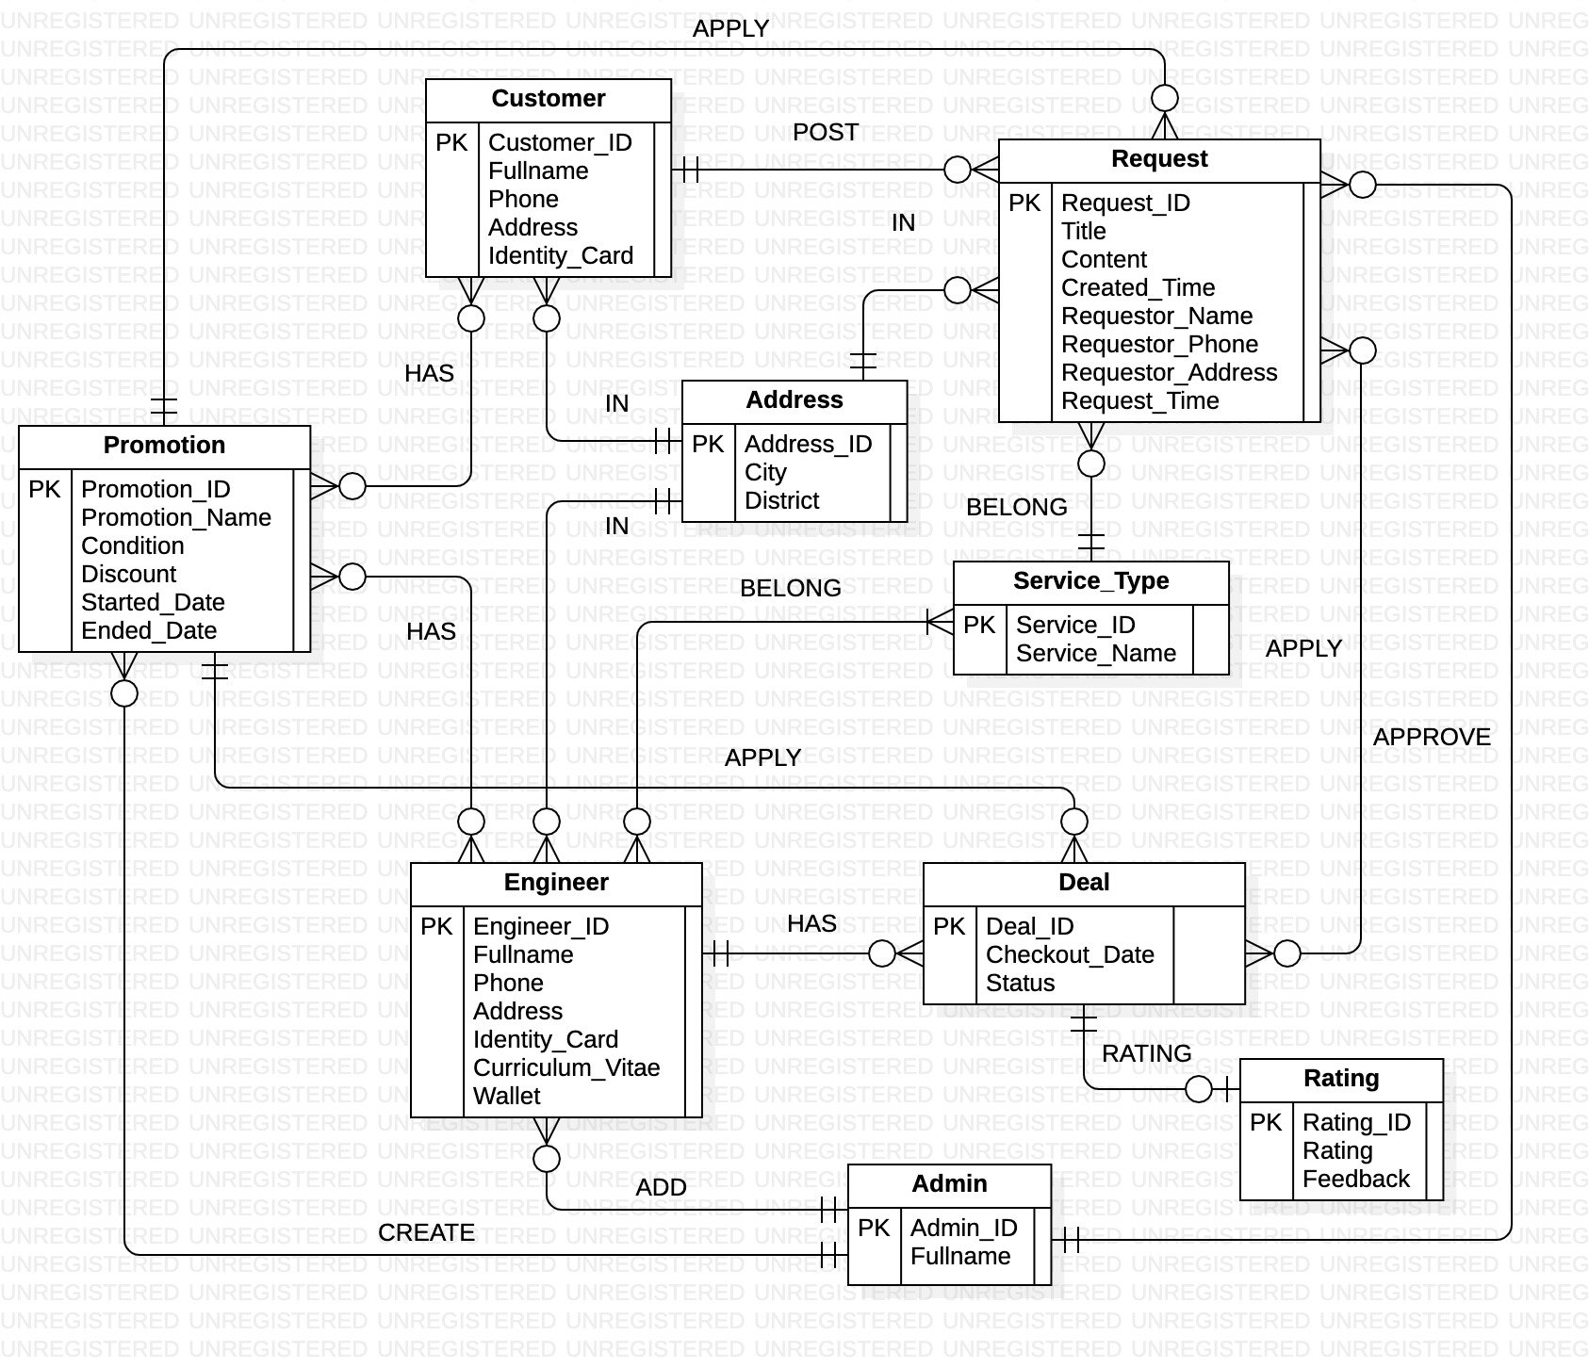

## 2. Database diagram

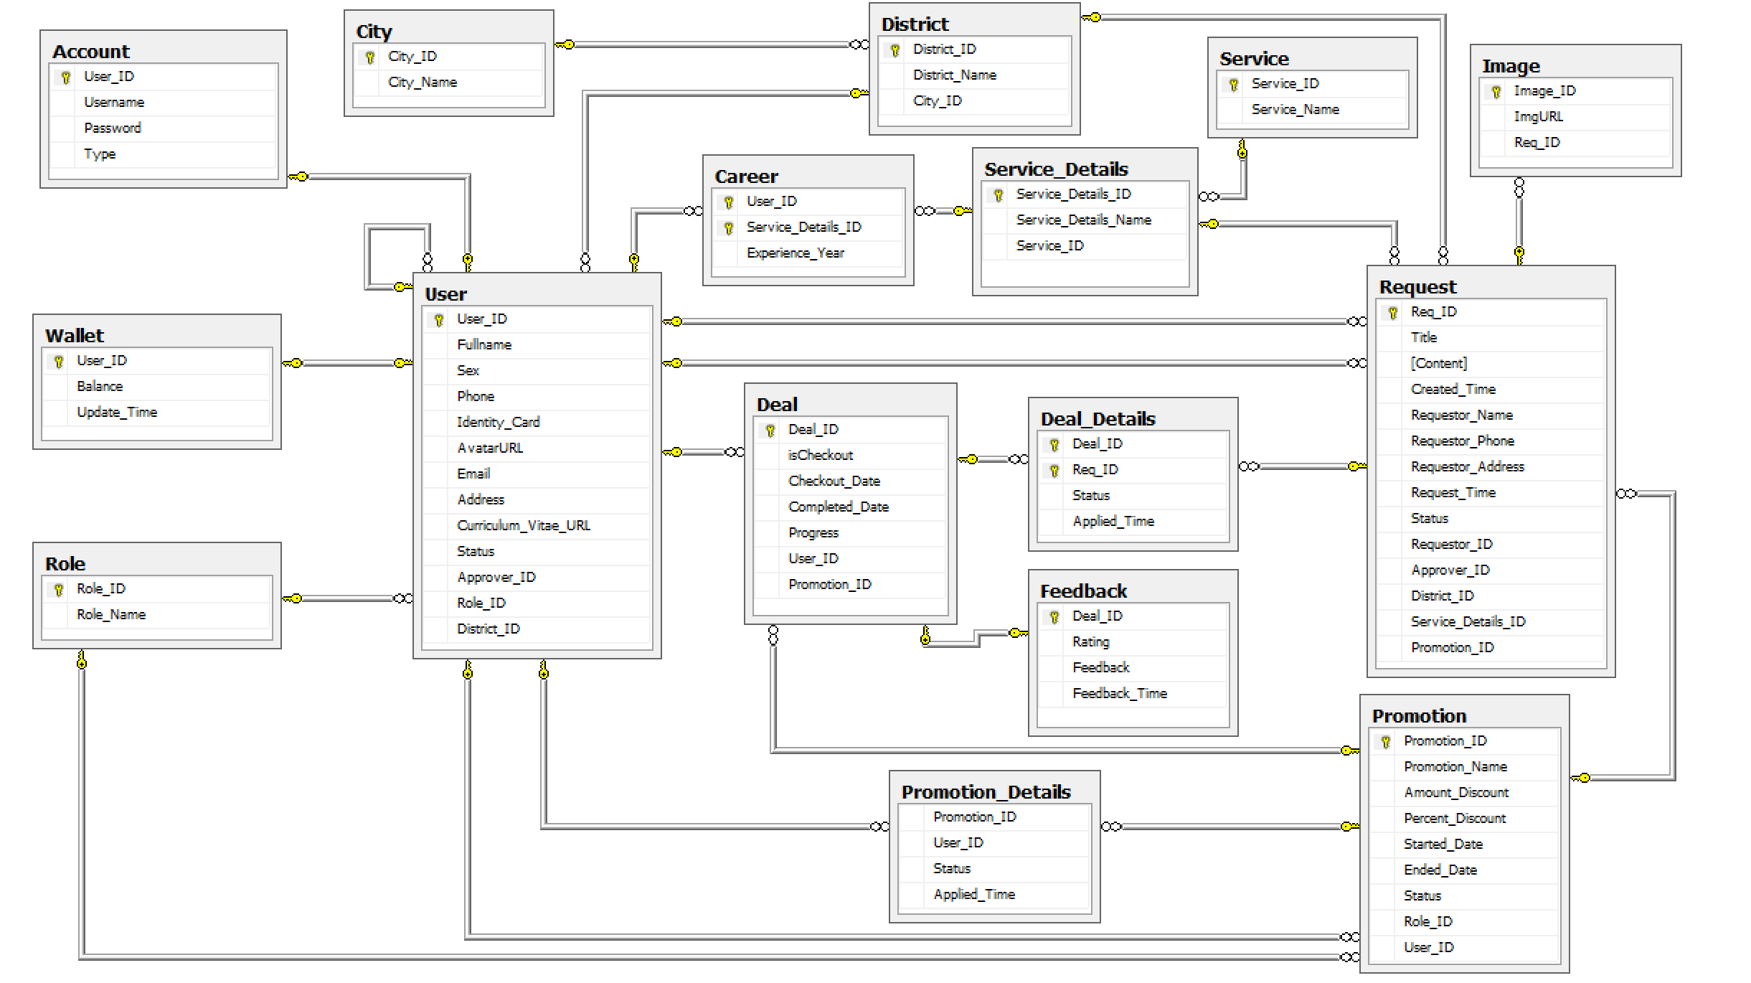

## 3. Query command

### 3.1 Query command 1

Query commands use to show the list of engineers with a rating of 9 or more in the first quarter of 2019.

(The engineers’ information include: USER_ID, Fullname, Sex, Phone, Identity_Card, Email).

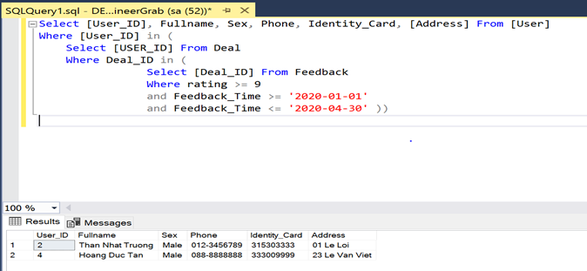

### 3.2 Query command 2

Query commands use to show the list of customers who are eligible for the promotion but have not used the promotion.

(The customers’ information include: USER_ID, Fullname, Sex, Phone, Identity_Card, Address).

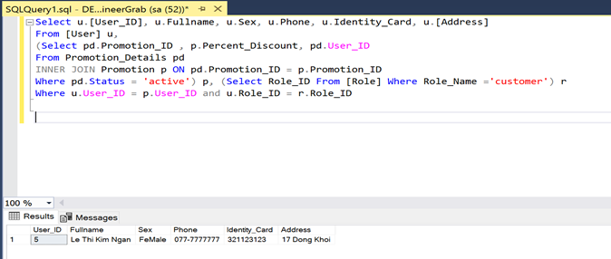

### 3.3 Query command 3

Query commands use to show the list of repair requests from customers name is "Le Thi Kim Ngan".

(The customer’s information includes: title, content, created-time, requestor_Name, Requestor_Address, Request_Time, service_Name).

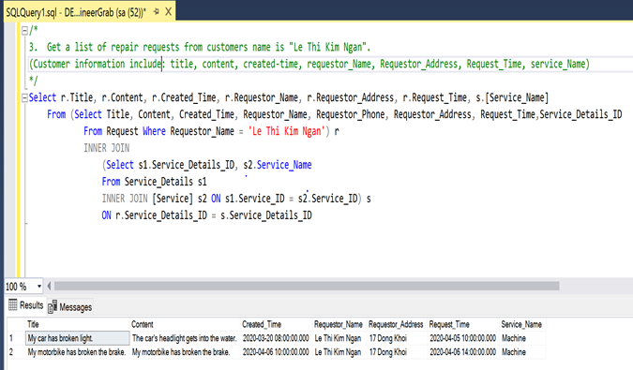

### 3.4 Query command 4

Query commands use to show the list of areas with the most customer in HCM City.

(The areas’ information include: District_ID, District_Name, NumberOfUser)

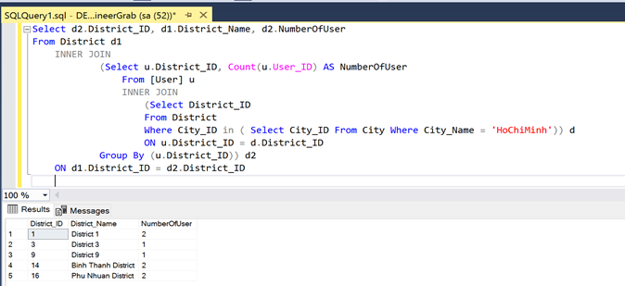

### 3.5 Query command 5

Query commands use to show the list of accounts is not activated.

(The accounts’ information include: USER_ID, Fullname, Sex, Phone, Identity_Card, Email).

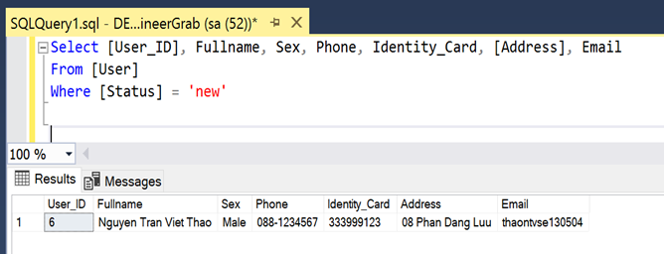

# D. Survey information

## Customer survey

**Link to the customer survey form:** <https://docs.google.com/forms/d/1yR75Qs7M1HVNjyZfeRPFKl_Teol3T_QIM-nA7-Mdtt4/edit>

**Survey results:**

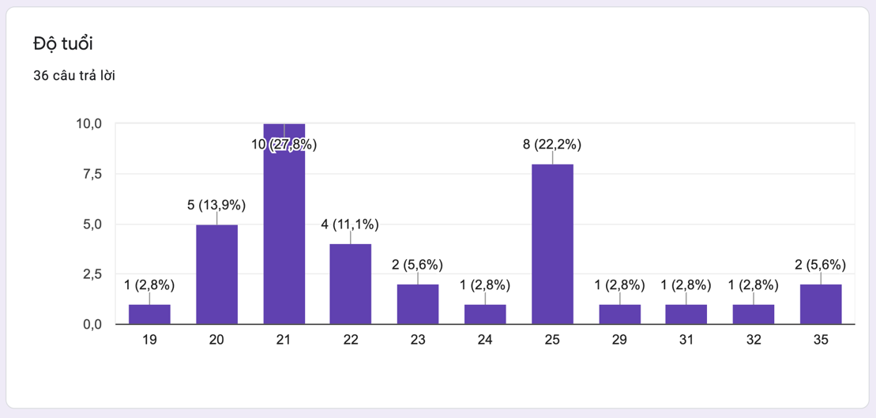

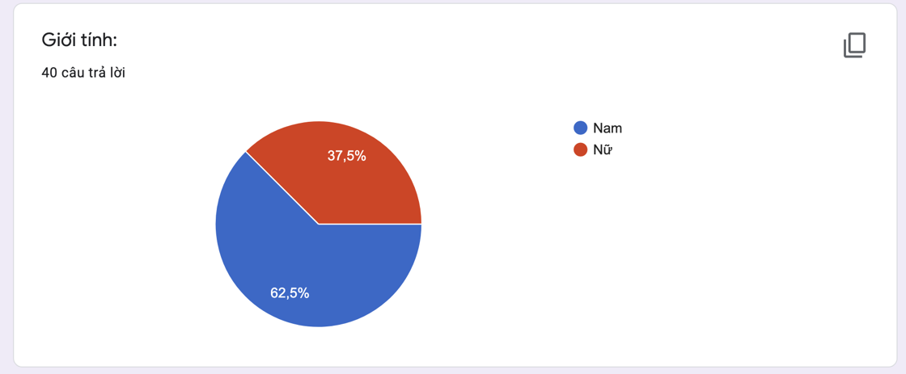

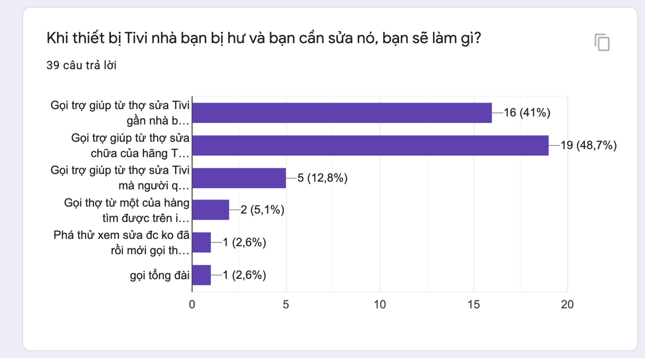

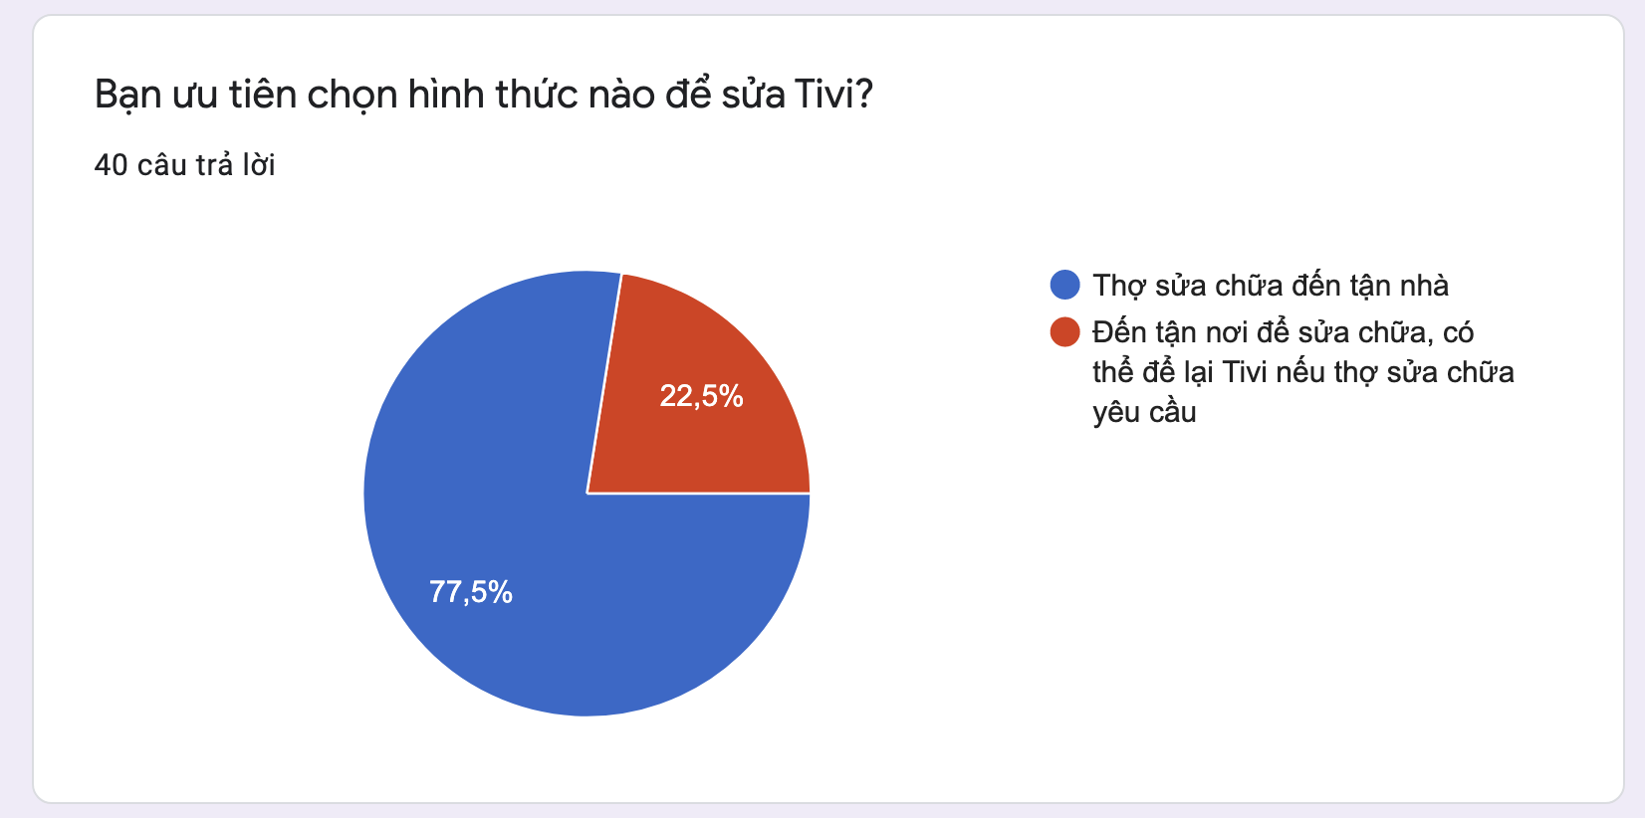

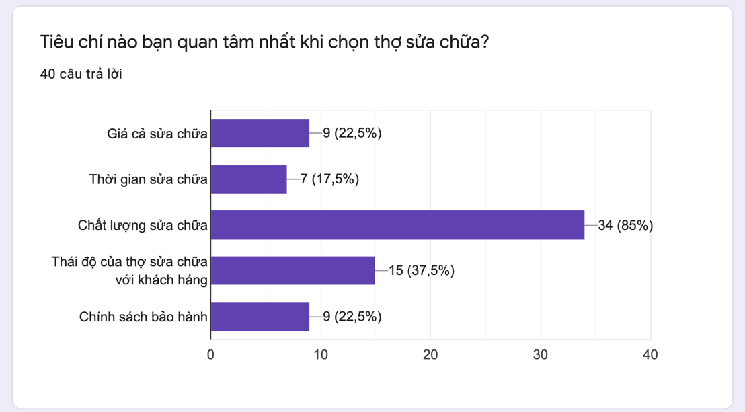

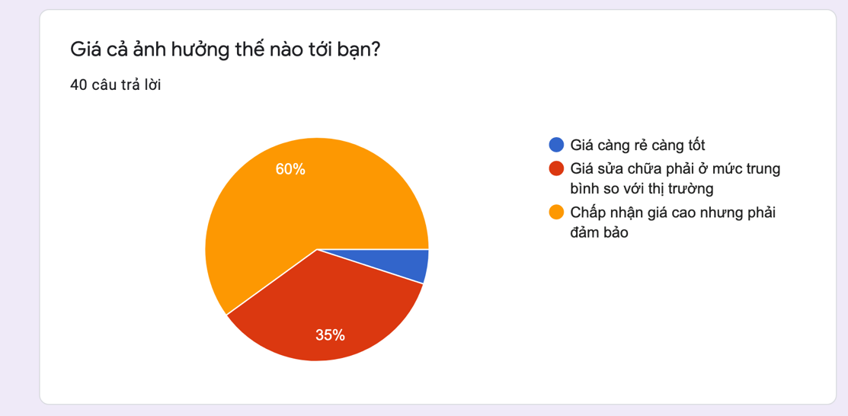

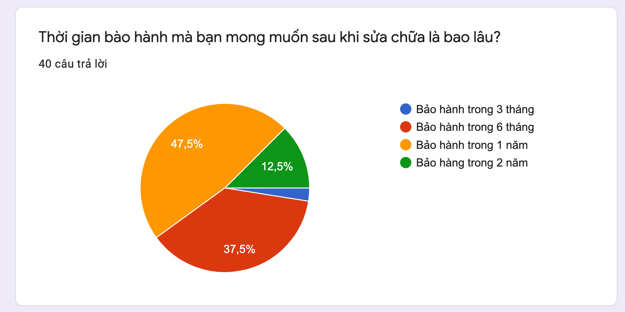

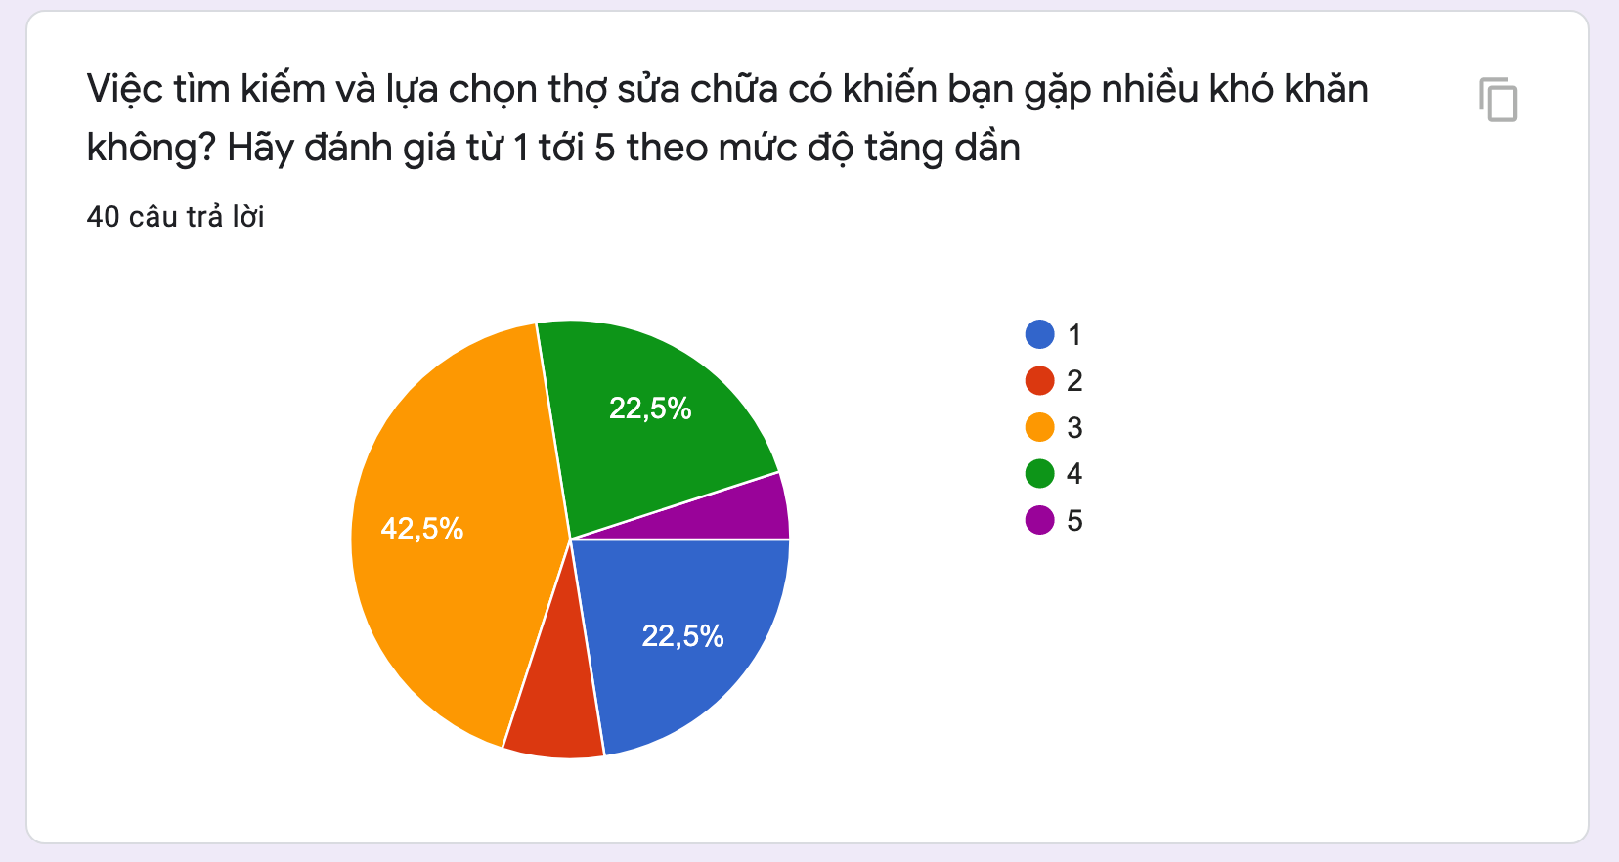



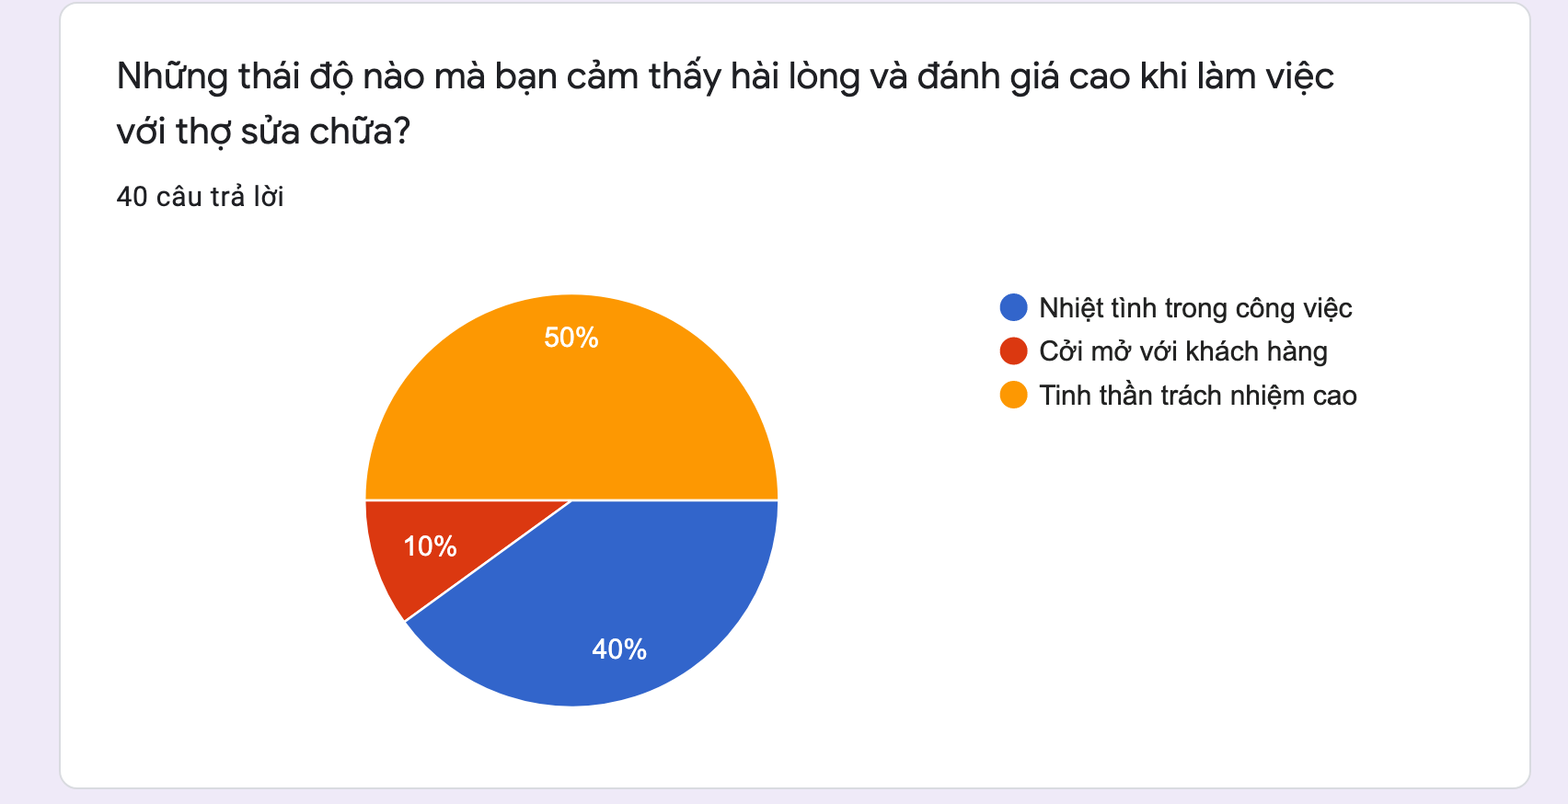

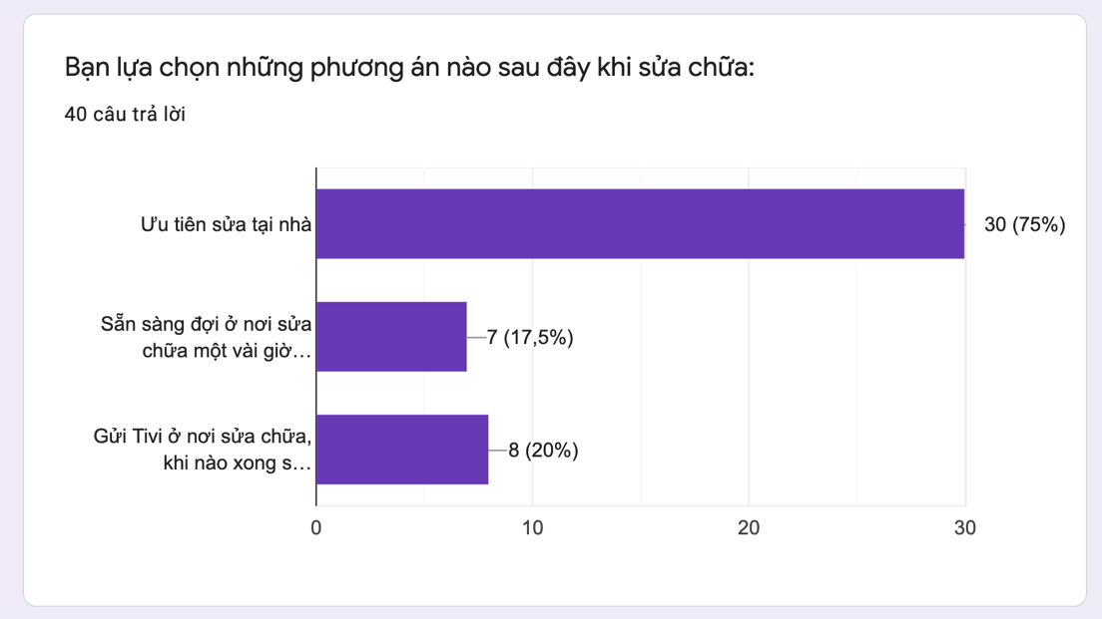

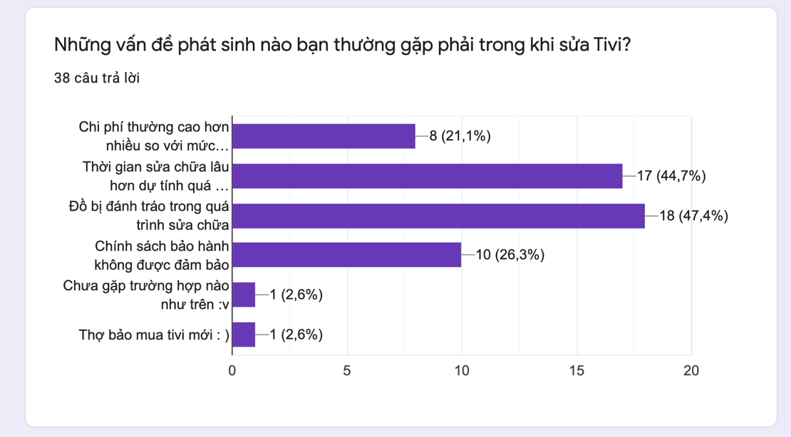

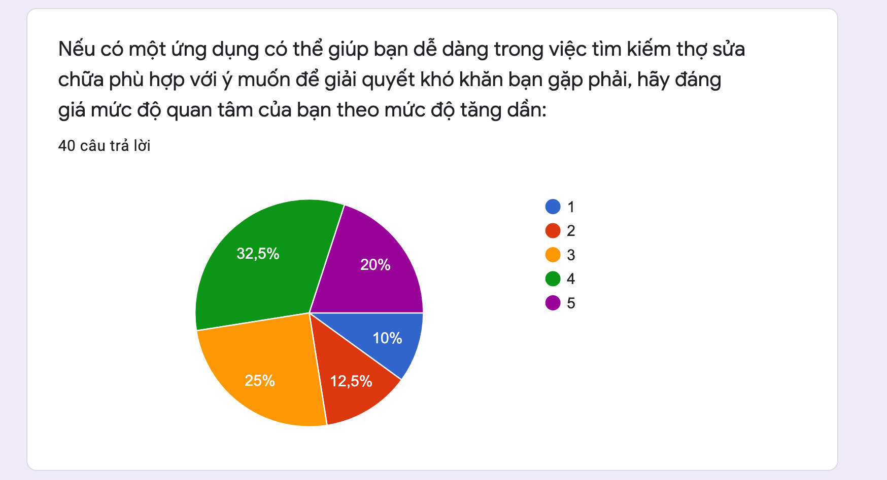

## Engineer survey

**Link to the engineer survey form:** [https://docs.google.com/forms/d/1v-n5-kPYoHOs071aUZBPxDxz-hx6HWck29oasSomamE/edit](https://meet.google.com/linkredirect?authuser=2&dest=https%3A%2F%2Fdocs.google.com%2Fforms%2Fd%2F1v-n5-kPYoHOs071aUZBPxDxz-hx6HWck29oasSomamE%2Fedit)

**Survey result:**

