

**Capstone Project Report**

**Report 1 – Project Introduction**

– Ho Chi Minh, January 2021 –

**Table of Contents**

I. Project Report 3

1. Status Report 3

2. Team Involvements 3

3. Issues/Suggestions 3

II. Project Introduction 4

1. Overview 4

1.1 Project Information 4

1.2 Project Team 4

2. Product Background 4

3. Existing Systems 5

3.1 Manual Solution 5

4. Business Opportunity 5

5. Software Product Vision 5

6. Project Scope & Limitations 5

6.1 Major Features 5

6.2 Limitations & Exclusions 8

# I. Project Report

## 1. Status Report

|  |  |  |  |
| --- | --- | --- | --- |
| **#** | **Work Item** | **Status** | **Notes (Work Item in Details)** |
| 1 | Overview | Completed |  |
| 2 | Product Background | Completed |  |
| 3 | Existing Systems | Completed |  |
| 4 | Business Opportunity | Completed |  |
| 5 | Software Product Vision | Completed |  |
| 6 | Project Scope & Limitations | Completed |  |

## 2. Team Involvements

|  |  |  |  |
| --- | --- | --- | --- |
| **#** | **Task** | **Member** | **Notes (Task Details, etc.)** |
| 1 | Overview |  |  |
| 2 | Product Background |  |  |
| 3 | Existing Systems |  |  |
| 4 | Business Opportunity |  |  |
| 5 | Software Product Vision |  |  |
| 6 | Project Scope & Limitations |  |  |

## 3. Issues/Suggestions

|  |  |  |  |
| --- | --- | --- | --- |
| **#** | **Issue** | **Status** | **Notes (Solution, Suggestion, etc.)** |
|  |  |  |  |

# II. Project Introduction

## 1. Overview

### 1.1 Project Information

* Project name: <<Book Library Management With Flycam And Code Bar>>
* Project code: <<PAPV>>
* Group name: <<GSP21SE05>>
* Software type: <<Software Type: Web, Mobile App>>

### 1.2 Project Team

#### a. Supervisor

|  |  |  |  |
| --- | --- | --- | --- |
| **Full Name** | **Email** | **Phone Number** | **Title** |
| Phạm Công Thành | ThanhPC3@fe.edu.vn |  | Lecturer |
| Đoàn Nguyễn Thành Hòa | HoaDNT@fpt.edu.vn |  | Lecturer |

#### b. Team Members

|  |  |  |  |
| --- | --- | --- | --- |
| **Full Name** | **Email** | **Mobile** | **Role** |
| Nguyễn Huỳnh Phú | PhuNHSE130571@fpt.edu.vn |  | Leader |
| Nguyễn Hữu Linh | LinhNHSE130563@fpt.edu.vn |  | Member |
| Trần Đăng Khánh | KhanhTDSE130585@fpt.edu.vn |  | Member |
| Trịnh Tiến Hoàng | HoangTTSE63415@fpt.edu.vn |  | Member |

## 2. Product Background

In every extensive library, manual management like checking, inspecting, or looking over books can be time-consuming and requires lots of effort. Periodically, librarians have to go through every aisle and section to check whether there is a missing of books or not, and it is a challenge to determine the reason for missing books. Taking a consideration of large libraries with the vast area of sections and many enormous bookshelves, the manual inventory is definitely laborious and can be quite dangerous working environment for librarians (taking into consideration they might hurt themselves from climbing up to the high place).

Meanwhile, the office hours of libraries are limited. The inventory requires time, and other problems arise from it, such as employees having to work overtime, temporarily shut down, or defer the libraries' opening hours. This problem can make a severe impact on the library's activities.

Moreover, in every traditional library, the most common problem is the loss of library borrowing/returning card templates. Libraries manage books borrowing or returning by using borrowing card templates always face problems like the card is damaged or loss of card. It takes time and money to register the card over again.

Clients always face trouble searching and finding books in large libraries. Asking for the assistance of librarians might also take lots of time.

## 3. Existing Systems

### 3.1 Manual Solution

Nowadays, there are still many libraries using manual inventory. Employees are facing lots of problems in book managing. They have to do the inventory manually, check every bookshelf one by one. This manual operation is laborious and time-consuming. Besides, when facing the problem like high bookshelves, employees have to climb up and working at the high ground, which can be dangerous, especially for older employees. Moreover, missing or loss of data is relatively a common problem for managing information manually.

It isn't easy for clients (borrowing books) to know the category or what books the library has, which book is the most favorite, and they can't view all the feedback and comments about the book from other people.

## 4. Business Opportunity

Our system is not a new face in the library managing system, but still, it can solve many fundamental problems and automate a lot of work. Throughout conducting many surveys about managing systems from many libraries, our team has realized some limits are still not fully optimized in terms of time and human resources. By that, we will come with the idea to optimize the managing system through this project.

## 5. Software Product Vision

For the library's activities, managing information will be more effective.

For librarians, it will save more time. With the help of a flycam, it can instigate the books from the high shelf. Better vision, the flycam is able to capture the whole picture of the library from high ground. It can be a useful tool for detecting any missing books or misplacement of books and, therefore, a proper investigation on the reason for that. Also, it can provide a safe working environment for librarians, minimizing the risk of working at high ground, avoid potential serve injuries especially for employees with ages.

For clients, borrowing/returning activities will become easier. For example, clients can choose the list of books they want to borrow before coming to the library. So when they come to the library, it is easier to check whether the books from that list are available in the library or not. It will save time for clients and also for librarians. Clients will receive a reminder about the date of returning the books when it is coming closer. It helps clients to stay alert when the books need to be returned

## 6. Project Scope & Limitations

The project is unique because there is a presence of a flycam. It is more versatile. It functions as a civilian mobile camera to detect books from high ground and can also play an essential role in others, such as monitoring the whole library or detecting faces. But there is also a challenge to face. Only large libraries can use this because the price of a flycam is expensive, the maintenance is difficult. Moreover, it requires the right environment to function correctly, such as providing enough light for the camera to detect the code.

### 6.1 Major Features

FE-01: Librarian can view position tracking of books

FE-02: Librarian can view schedule of borrowing book

FE-03: Librarian can get notification of book’s position tracking

FE-04: Librarian can scan QR code to get customer’s wish list of book

FE-05: Customer can choose wish list to borrow books

FE-06: Customer can search location of book

FE-07: Customer can view history of borrowing books

FE-08: Customer can get notification from library

FE-09: Customer can view book detail

FE-10: Customer can view suggestion book base on often reading category

FE-11: Customer can add book feedback

FE-12: Customer can view feedbacks of book

FE-13: Customer can view profile

FE-14: Customer can update profile

FE-15: Customer can view campaign

FE-16: Customer can scan QR code to check in

FE-17: Customer can pick favorite type of book

FE-18: Drone can send video to server

FE-19: System can detect Barcode, QR code and character

FE-20: System can check out customer

FE-21: System can send notification

FE-22: Admin can view book group detail

FE-23: Admin can view all book group

FE-24: Admin can create book group

FE-25: Admin can update book group information

FE-26: Admin can delete group

FE-27: Admin can find book by category

FE-28: Admin can find book by location

FE-29: Admin can find book by name

FE-30: Admin can view all category

FE-31: Admin can create category

FE-32: Admin can update category

FE-33: Admin can delete category

FE-34: Admin can view all bookshelf

FE-35: Admin can view bookshelf detail

FE-36: Admin can create shelf

FE-37: Admin can update shelf

FE-38: Admin can delete shelf

FE-39: Admin can add book to shelf

FE-40: Admin can view all campaigns

FE-41: Admin can campaign detail

FE-42: Admin can create campaign

FE-43: Admin can update campaign

FE-44: Admin can delete campaign

FE-45: Admin can view event

FE-46: Admin can create event

FE-47: Admin can update event

FE-48: Admin can delete event

FE-49: Admin can add book to campaign

FE-50: Admin can view all locations

FE-51: Admin can view location detail

FE-52: Admin can create location

FE-53: Admin can update location

FE-54: Admin can delete location

FE-55: Admin can view all customer

FE-56: Admin can view all customer detail

FE-57: Admin can update customer detail

FE-58: Admin can de-active customer

FE-59: Admin can view all librarian

FE-60: Admin can create librarian

FE-61: Admin can update librarian

FE-62: Admin can de-active librarian

FE-63: Admin can view feedback of customer

FE-64: Admin delete feedback of customer

FE-65: Admin can add borrow fee

FE-66: Admin can update borrow fee

FE-67: Admin can view schedule of borrowing book

[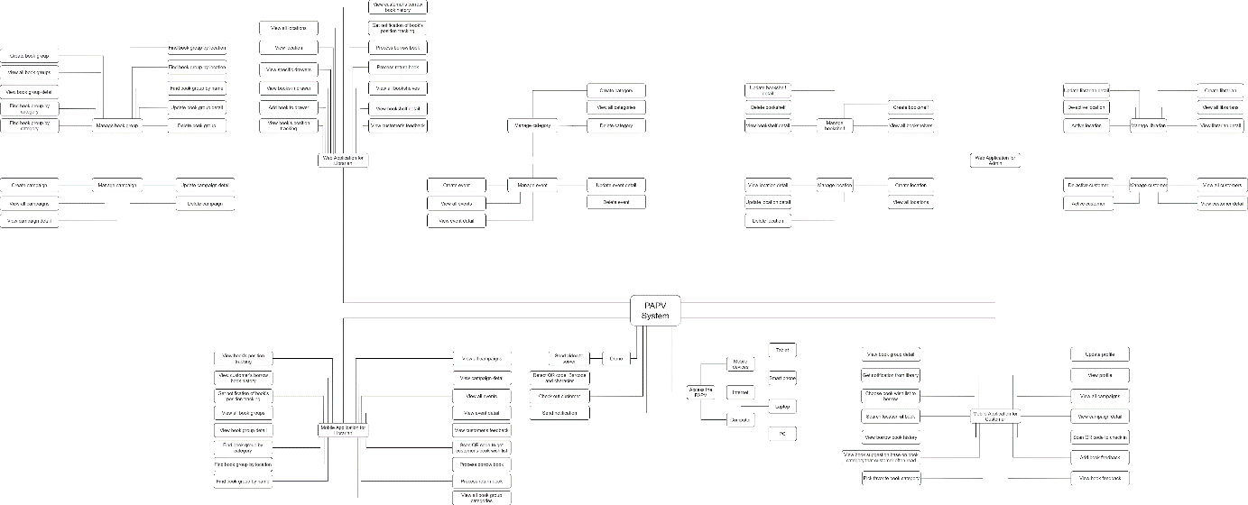](https://drive.google.com/file/d/1_oStltBa08doOQ-zsMmUHFOAT9iHoYCT/view?usp=sharing)

[Figure 1- PAPV Major Features](https://drive.google.com/file/d/1_oStltBa08doOQ-zsMmUHFOAT9iHoYCT/view?usp=sharing)

### 6.2 Limitations & Exclusions

LI-01: The use of flycam requires the right environment to function correctly, like the brightness, spacious environment, separation between bookshelves for the flycam to move freely and safely.

LI-02: Books have to be organized, barcodes must face outside so flycam can capture the codes.

LI-03: The PAPV system can’t completely replace humans. It can’t automate some procedures.

LI-04: Flycam can’t use waypoint automatically

EX-01: PAPV system does not include manage import/ export books in library’s warehouse.