

**Capstone Project Report**

**Report 2 – Project Management Plan**

– Ho Chi Minh, January 2021 –

**Table of Contents**

I. Project Report 3

1. Status Report 3

2. Team Involvements 3

3. Issues/Suggestions 3

II. Project Management Plan 4

1. Overview 4

1.1 WBS & Estimation 4

1.2 Project Objectives 7

1.3 Project Risks 8

2. Management Approach 8

2.1 Project Process 8

2.2 Quality Management 8

2.3 Training Plan 9

3. Master Schedule 9

4. Project Organization 10

4.1 Team & Structures 10

4.2 Roles & Responsibilities 10

5. Project Communication 11

5.1 Communication Plan 11

5.2 External Interface 11

6. Configuration Management 11

6.1 Tools & Infrastructures 11

6.2 Document Management 12

6.3 Source Code Management 12

# I. Project Report

## 1. Status Report

|  |  |  |  |
| --- | --- | --- | --- |
| **#** | **Work Item** | **Status** | **Notes (Work Item in Details)** |
| 1 | Overview | Completed |  |
| 2 | Management Approach | Completed |  |
| 3 | Master Schedule | Completed |  |
| 4 | Project Organization | Completed |  |
| 5 | Project Communication | Completed |  |
| 6 | Configuration Management | Completed |  |

## 2. Team Involvements

|  |  |  |  |
| --- | --- | --- | --- |
| **#** | **Task** | **Member** | **Notes (Task Details, etc.)** |
| 1 | Overview |  |  |
| 2 | Management Approach |  |  |
| 3 | Master Schedule |  |  |
| 4 | Project Organization |  |  |
| 5 | Project Communication |  |  |
| 6 | Configuration Management |  |  |

## 3. Issues/Suggestions

|  |  |  |  |
| --- | --- | --- | --- |
| **#** | **Issue** | **Status** | **Notes (Solution, Suggestion, etc.)** |
| 1 |  |  |  |

# II. Project Management Plan

## 1. Overview

### 1.1 WBS & Estimation

|  |  |  |  |  |
| --- | --- | --- | --- | --- |
| **#** | **WBS Item** | **Complexity** | **Est. Effort** | |
| ***1*** | ***Web Application for Admin*** |  |  | |
| 1.1 | Create bookshelf | Simple | 1 | |
| 1.2 | View all bookshelves | Simple | 1 | |
| 1.3 | View bookshelf detail | Simple | 1 | |
| 1.4 | Update bookshelf detail | Complex | 5 | |
| 1.5 | Delete bookshelf | Medium | 3 | |
| 1.6 | Create location | Simple | 1 | |
| 1.7 | View all locations | Simple | 1 | |
| 1.8 | View location detail | Simple | 1 | |
| 1.9 | Update location detail | Simple | 1 | |
| 1.10 | Delete location | Complex | 5 | |
| 1.11 | View all customers | Simple | 1 | |
| 1.12 | View customer detail | Simple | 1 | |
| 1.13 | De-active customer | Simple | 1 | |
| 1.14 | Active customer | Simple | 1 | |
| 1.15 | Create librarian | Simple | 1 | |
| 1.16 | View all librarians | Simple | 1 | |
| 1.17 | View librarian detail | Simple | 1 | |
| 1.18 | Update librarian | Simple | 1 | |
| 1.19 | De-active librarian | Simple | 1 | |
| 1.20 | Active librarian | Simple | 1 | |
| 1.21 | View customer’s feedback | Simple | 1 | |
| 1.22 | Delete customer’s feedback | Simple | 1 | |
| ***2*** | ***Web Application for Librarian*** |  |  | |
| 2.1 | View book’s position tracking | Medium | 3 | |
| 2.2 | View customer’s borrow book history | Medium | 3 | |
| 2.3 | Get notification of book’s position tracking | Complex | 10 | |
| 2.4 | Process borrow book | Medium | 5 | |
| 2.5 | Process return book | Medium | 5 | |
| 2.6 | View all bookshelves | Simple | 1 | |
| 2.7 | View bookshelf detail | Simple | 1 | |
| 2.8 | View all locations | Simple | 1 | |
| 2.9 | View location detail | Simple | 1 | |
| 2.10 | Create book group | Medium | 3 | |
| 2.11 | View all book groups | Simple | 1 | |
| 2.12 | View book group detail | Simple | 1 | |
| 2.13 | Find book group by category | Simple | 1 | |
| 2.14 | Find book group by location | Simple | 1 | |
| 2.15 | Find book group by name | Simple | 1 | |
| 2.16 | Update book group detail | Medium | 3 | |
| 2.17 | Delete book group | Simple | 1 | |
| 2.18 | Create category | Simple | 1 | |
| 2.19 | View all categories | Simple | 1 | |
| 2.20 | Delete category | Simple | 1 | |
| 2.21 | View specific drawers | Medium | 3 | |
| 2.22 | View books in drawer | Medium | 3 | |
| 2.23 | Add book to drawer | Medium | 3 | |
| 2.24 | Create campaign | Medium | 3 | |
| 2.25 | View all campaigns | Simple | 1 | |
| 2.26 | View campaign detail | Simple | 1 | |
| 2.27 | Update campaign detail | Medium | 3 | |
| 2.28 | Delete campaign | Simple | 1 | |
| 2.29 | View customer’s feedback | Simple | 1 | |
| 2.30 | Create event | Simple | 1 | |
| 2.31 | View all events | Simple | 1 | |
| 2.32 | View event detail | Simple | 1 | |
| 2.33 | Update event detail | Simple | 1 | |
| 2.34 | Delete event | Simple | 1 | |
| ***3*** | ***Mobile Application for Librarian*** |  |  | |
| 3.1 | View book’s position tracking | Medium | 3 | |
| 3.2 | View customer’s borrow book history | Medium | 5 | |
| 3.3 | Get notification of book’s position tracking | Complex | 15 | |
| 3.4 | View all book groups | Simple | 1 | |
| 3.5 | View book group detail | Simple | 1 | |
| 3.6 | Find book group by category | Simple | 1 | |
| 3.7 | Find book group by location | Simple | 1 | |
| 3.8 | Find book group by name | Simple | 1 | |
| 3.9 | View all book group categories | Simple | 1 | |
| 3.10 | View all campaigns | Simple | 1 | |
| 3.11 | View campaign detail | Simple | 1 | |
| 3.12 | View all events | Simple | 1 | |
| 3.13 | View event detail | Simple | 1 | |
| 3.14 | View customer’s feedback | Simple | 1 | |
| 3.15 | Scan QR code to get customer’s book wish list | Complex | 10 | |
| 3.16 | Process borrow book | Medium | 5 | |
| 3.17 | Process return book | Medium | 5 | |
| ***4*** | ***Mobile Application for Customer*** |  |  | |
| 4.1 | Choose book wish list to borrow | Medium | 5 | |
| 4.2 | Search location of book | Medium | 3 | |
| 4.3 | View borrow book history | Simple | 1 | |
| 4.4 | Get notification from library | Medium | 5 | |
| 4.5 | View book group detail | Simple | 1 | |
| 4.6 | View book suggestion base on category that customer often read | Complex | 15 | |
| 4.7 | Add book feedback | Simple | 1 | |
| 4.8 | View book feedback | Simple | 1 | |
| 4.9 | View profile | Simple | 1 | |
| 4.10 | Update profile | Simple | 1 | |
| 4.11 | View campaigns | Simple | 1 | |
| 4.12 | View campaign detail | Simple | 1 | |
| 4.13 | Scan QR code to check in | Medium | 5 | |
| 4.14 | Pick favorite type of book | Simple | 1 | |
| ***5*** | ***PAPV System*** |  |  | |
| 5.1 | Checkout customer | Medium | 5 | |
| 5.2 | Send notification | Medium | 5 | |
| 5.3 | Detect Barcode, QR code and character | Complex | 20 | |
| ***6*** | ***Drone*** |  |  | |
| 6.1 | Send video to server | Complex | 10 | |
| ***Total Estimated Effort (man-days)*** | | | | ***237*** | |

### 1.2 Project Objectives

|  |  |  |  |  |
| --- | --- | --- | --- | --- |
| **#** | **Quality Stage** | **No. of Defects** | **% of Defect** | **Notes** |
| 1 | Reviewing | 7 | 14.58 |  |
| 2 | Unit Test | 30 | 62.50 |  |
| 3 | Integration Test |  |  |  |
| 4 | System Test | 5 | 10.42 |  |
| 5 | User Acceptance Test | 6 | 12.50 |  |
| ***Total*** | | ***48*** | ***100%*** |  |

### 1.3 Project Risks

|  |  |  |  |  |
| --- | --- | --- | --- | --- |
| **#** | **Risk Description** | **Impact** | **Possibility** | **Response Plans** |
| 1 | Team member drop out | Critical | Medium | Reduce scope |
| 2 | Supervisors get sick | Critical | Low | Request other lecture for guidance |

## 2. Management Approach

Implementing Scrum as an Agile methodology enables PAPV team under a common organization for decision making, allows to see product evolve in real time as we build and adjust them.

### 2.1 Project Process

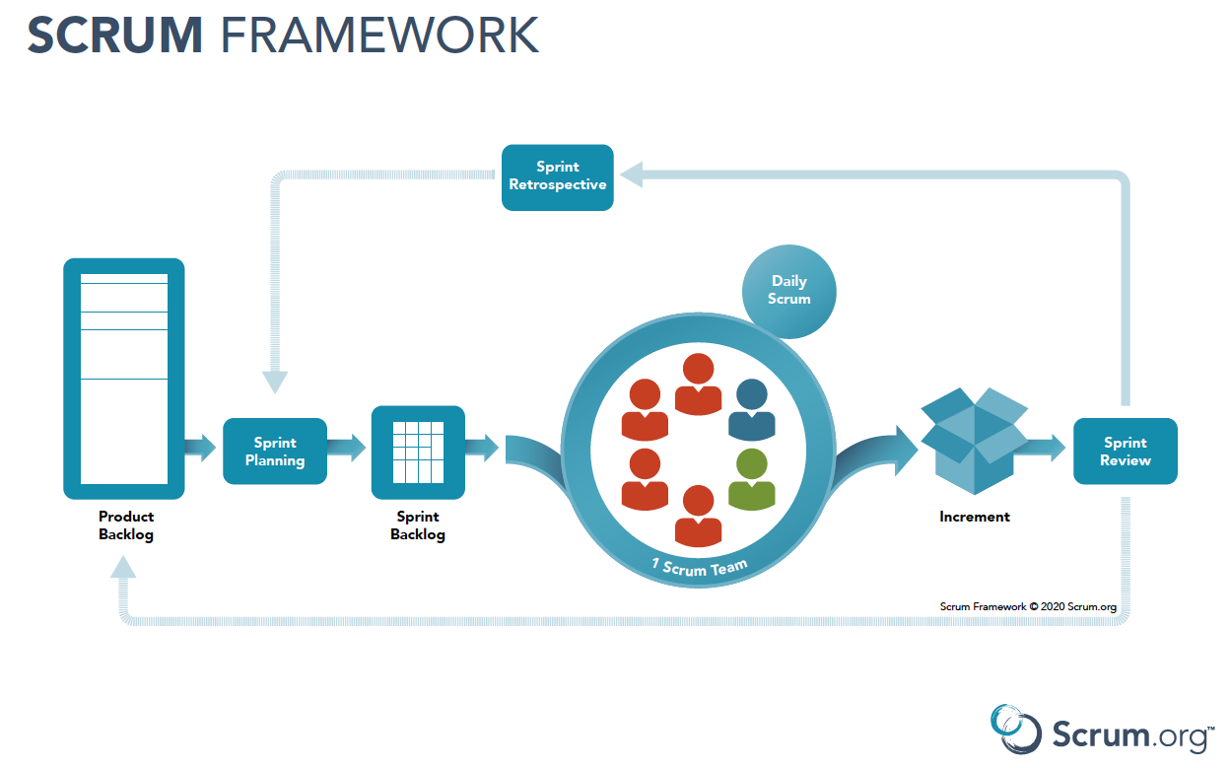

[Figure 2 - Scrum Framework](https://www.scrum.org/resources/scrum-framework-poster)

PAPV team apply Scrum Framework for managing project process for the following reasons:

* It’s suitable for small or medium size project as PAPV System.
* Project processes are done by the development team simultaneously, that help everything to be flexible and changeable during the life of the project and even after.
* Better visibility into project and minimize risks.

### 2.2 Quality Management

To improve the project quality, PAPV team apply the following schemes:

* Following available application’s design.
* Cohering FU HCM Library information, supervisors’ guidance and researching to achieve the best solution.
* Holding daily meeting to follow project’s tasks and support each other.

### 2.3 Training Plan

|  |  |  |  |
| --- | --- | --- | --- |
| Training Area | Participants | When, Duration | Waiver Criteria |
| .Net Core | Everyone | 3 days | Mandatory |
| ReactJS | Everyone | 3 days | Mandatory |
| Dart, Flutter | Everyone | 3 days | Mandatory |
| Microsoft SQL Server | Everyone | 1 day | Mandatory |
| Git, Github | Everyone | 1 day | Mandatory |
| Draw.io | Everyone | 1 day | Mandatory |

## 3. Master Schedule

|  |  |  |  |  |
| --- | --- | --- | --- | --- |
| **#** | **Deliverable** | **Effort** | **Due Date** | **Deliverable Scope** |
| 1 | Project Plan |  |  | Make project goal plan |
| 2 | Report 1 |  |  | Project introduction |
| 3 | Report 2 |  |  | Project management plan |
| 4 | Report 3 |  |  | Software requirement specification |
| 5 | Report 4 |  |  | Software design document |
| 6 | Report 5 |  |  | Test case document, test documentation |
| 7 | Report 6 |  |  | Software user guides |
| 8 | Report 7 |  |  | Final project final |
| 9 | Code package 1 |  |  | Code, Unit test, System test case |
| 10 | Code package 2 |  |  | Code, Unit test, System test case |
| 11 | Code package 3 |  |  | Code, Unit test, System test case |
| 12 | Code font-end 1 |  |  | Code, design screen |
| 13 | Code font-end 2 |  |  | Code, design screen |
| 14 | Code font-end 3 |  |  | Code, design screen |
| 15 | Final package |  |  | Final code package and documents |

## 4. Project Organization

### 4.1 Team & Structures

[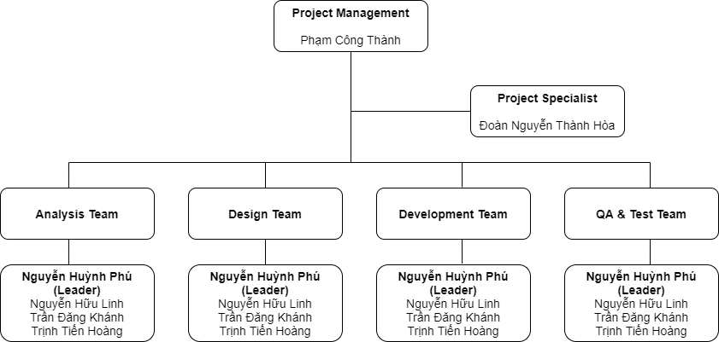](https://drive.google.com/file/d/1uy-qd-hA4KFLONwhTkYpvA24mdx9usTV/view?usp=sharing)

[Figure 3 - Project Organization](https://drive.google.com/file/d/1uy-qd-hA4KFLONwhTkYpvA24mdx9usTV/view?usp=sharing)

### 4.2 Roles & Responsibilities

|  |  |
| --- | --- |
| **Role** | **Responsibility** |
| Project Manager | Give guidance, monitoring and manage the project to be right direction. |
| Project Specialist | Give guidance, support project’s solution. |
| Analysis Leader | Give guidance, adjust project’s requirements. |
| Analysis Member | Analyze, update project’s requirements. |
| Design Leader | Give guidance, control user interface design. |
| Design Member | Design, implement user interface. |
| Technical Leader | Give guidance, discuss about technical solution and design. |
| Test Leader | Give guidance, write test cases and test plan. |
| Test Member | Write test cases and update. |

## 5. Project Communication

### 5.1 Communication Plan

|  |  |  |  |  |
| --- | --- | --- | --- | --- |
| **Communication Item** | **Who/ Target** | **Purpose** | **When, Frequency** | **Type, Tool, Method(s)** |
| Daily Meeting | Team Members | Internal Communication | Always | Meeting |
| Weekly Report | Supervisors and Team Members | Discuss project’s status, solution, next target | Weekly | Google Meet |
| Division of duties | Team Members | Control project status | Always | Trello |

### 5.2 External Interface

#### a. FU Contacts

|  |  |  |  |
| --- | --- | --- | --- |
| Function | Contact Person  (name, position) | Contact address  (email, telephone) | Responsibility |
| Supervisor | Phạm Công Thành | ThanhPC3@fe.edu.vn | - Provide document template - Give instruction to project team - Review deliverables - Supervise project status |
| Supervisor | Đoàn Nguyễn Thành Hòa | HoaDNT@fpt.edu.vn | - Provide document template  - Receive report project  - Answer questions about the project |

#### b. Customer Contacts

|  |  |  |  |
| --- | --- | --- | --- |
| Function | Contact Person  (name, position) | Contact address  (email, telephone) | Responsibility |
| Supervisor | Phạm Công Thành | ThanhPC3@fe.edu.vn | - Provide document template - Give instruction to project team - Review deliverables - Supervise project status |
| Supervisor | Đoàn Nguyễn Thành Hòa | HoaDNT@fpt.edu.vn | - Provide document template  - Receive report project  - Answer questions about the project |

## 6. Configuration Management

### 6.1 Tools & Infrastructures

|  |  |
| --- | --- |
| **Programming languages** | C#, TypeScript, Dart |
| **Framework** | .NET Core 3.1, Entity Framework 5.0, Flutter, ReactJS |
| **API** | API |
| **DBMS** | Microsoft SQL Server |
| **IDEs/Editors** | Visual Studio Code |
| **UML tools** | Draw.io |
| **Version Control** | Git hub |
| **Deployment server** | IIS |
| **Project management tool** | Google Drive, Trello |

### 6.2 Document Management

Google Drive is used to manage project’s documents.

### 6.3 Source Code Management

Github is used to manage project’s source code.