

**Capstone Project Report**

**Report 2 – System Requirement Specification**

– Ho Chi Minh, January 2021 –

**Table of Contents**

I. Project Report 3

1. Status Report 3

2. Team Involvements 3

3. Issues/Suggestions 3

II. System Requirement Specification 4

1. Overall Description 4

1.1 Product Overview 4

1.2 Business Rules 6

2. User Requirements 8

2.1 Overview 8

2.2 Web Application 10

2.3 Mobile Application 34

2.4 Drone 36

2.5 PAPV System 36

3. Functional Requirements 36

3.1 System Functional Overview 36

4. Non-Functional Requirements 39

4.1 External Interfaces 39

4.2 Quality Attributes 40

5. Other Requirements 41

5.1 Messages List 41

# I. Project Report

## 1. Status Report

|  |  |  |  |
| --- | --- | --- | --- |
| **#** | **Work Item** | **Status** | **Notes (Work Item in Details)** |
| 1 | Overall Description | Completed |  |
| 2 | User Requirements | Completed |  |
| 3 | Functional Requirements | Completed |  |
| 4 | Non-Functional Requirements | Completed |  |
| 5 | Others Requirements | Completed |  |

## 2. Team Involvements

|  |  |  |  |
| --- | --- | --- | --- |
| **#** | **Task** | **Member** | **Notes (Task Details, etc.)** |
| 1 | Overall Description |  |  |
| 2 | User Requirements |  |  |
| 3 | Functional Requirements |  |  |
| 4 | Non-Functional Requirements |  |  |
| 5 | Others Requirements |  |  |

## 3. Issues/Suggestions

|  |  |  |  |
| --- | --- | --- | --- |
| **#** | **Issue** | **Status** | **Notes (Solution, Suggestion, etc.)** |
| 1 |  |  |  |

# II. System Requirement Specification

## 1. Overall Description

### 1.1 Product Overview

#### Unauthenticated User Requirements

Unauthenticated User who has not been identified by PAPV system. Unauthenticated User has limited access to the system with the following feature:

* Login the system

#### Customer Requirements

Customer is a person who accesses to the system as customer role. Customer can use the following functions:

* Choose book wish list to borrow
* Search location of book
* View borrow book history
* Get notification from library
* View book group detail
* View book suggestion book (base on category that customer often read)
* Add book feedback
* View book feedback
* View profile
* Update profile
* View all campaigns
* View campaign detail
* Scan QR code to check in
* Pick favourite book category

#### Librarian Requirements

Librarian is a person who accesses to the system as librarian role. Librarian can use the following functions:

* View book’s position tracking
* View customer’s borrow book history
* Get notification of book’s position tracking
* Process borrow book
* Process return book
* View all bookshelves
* View bookshelf detail
* View all locations
* View location detail
* Create book group
* View all book groups
* View book group detail
* Find book group by category
* Find book group by location
* Find book group by name
* Update book group detail
* Delete book group
* Create category
* View all categories
* Delete category
* View specific drawers
* View book in drawer
* Add book to drawer
* Create campaign
* View all campaigns
* View campaign detail
* Update campaign detail
* Delete campaign
* View customer’s feedback
* Create event
* View all events
* View event detail
* Delete event
* Scan QR code to get customer’s book wish list

#### Admin Requirements

Admin is a person who accesses to the system as admin role. Admin can use the following functions:

* Create bookshelf
* View all bookshelves
* View bookshelf detail
* Update bookshelf detail
* Delete bookshelf
* Create location
* View all locations
* View location detail
* Update location detail
* Delete location
* View all customers
* View customer detail
* De-active customer
* Active customer
* Create librarian
* View all librarians
* View librarian detail
* De-active librarian
* Active librarian
* View customer’s feedback
* Delete customer’s feedback

#### Drone Requirements

Drone is an actor which can do:

* Send video to server

#### PAPV System Requirements

PAPV System is an actor which can do:

* Check out customer
* Send notification
* Detect Barcode, QR code and character

### 1.2 Business Rules

|  |  |
| --- | --- |
| ID | Rule Definition |
| BR-01 | User logs in using username and password are registered. If the username and password are correct, PAPV redirect users to corresponding home page:   * User logs in as role “librarian”, the system will display librarian home page * User logs in as role “admin”, the system will display librarian home page * User logs in as role “customer”, the system will display librarian home page |
| BR-02 | After logout successfully, user become the “Unauthenticated User” and PAPV will direct to login page |
| BR-03 | A bookshelf requires fields:   * Book shelf name: between 1-50 characters * Row number: between 1-100 * Column number: between 1-100 |
| BR-04 | Admin or librarian can view all of bookshelves in system  Admin or librarian can search by name with search bar on top  Tables contains max 10 items per page |
| BR-05 | Admin can edit bookshelf information |
| BR-06 | If one bookshelf has been removed, all drawers in bookshelf are also removed |
| BR-07 | A bookshelf requires fields:   * Location name: between 1-50 characters |
| BR-08 | Admin or librarian can view all of locations in system  Admin or librarian can search by name with search bar on top  Tables contains max 10 items per page |
| BR-09 | If one location has been removed, all bookshelves in location are also removed |
| BR-10 | Admin can view all of customer in system  Admin can search by name with search bar on top  Tables contains max 10 items per page |
| BR-11 | A book group requires fields:   * Book group name: between 1-250 characters * Author: between 1-100 characters * Page Number: between 1-1000 * Width: between 1-100 * Height: between 1-100 * Quantity: between 1-100 * Fee: between 1-5 * Punish Fee: between 1-5 * Publishing Company: between 1-250 characters * Publishing Number: between 1-100 * Publishing Date: must be smaller than current time * Publishing Palace: between 1-250 characters   After a book group is added, PAPV will automatically add the number of books to the book group equal to the number of librarians just imported.  Librarian need to prepare books before creating a book group |
| BR-12 | Librarian can view all of book groups in system  Librarian can search by name with search bar on top  Tables contains max 10 items per page |
| BR-13 | Librarian can edit book group information |
| BR-14 | After search book group by location, librarian can edit book group information details |
| BR-15 | After search book group by name, librarian can edit book group information details |
| BR-16 | A book group requires fields:   * Book group name: between 1-250 characters * Author: between 1-100 characters * Page Number: between 1-1000 * Width: between 1-100 * Height: between 1-100 * Quantity: between 1-100 * Fee: between 1-5 * Punish Fee: between 1-5 * Publishing Company: between 1-250 characters * Publishing Number: between 1-100 * Publishing Date: must be smaller than current time * Publishing Palace: between 1-250 characters |
| BR-17 | If one book group has been removed, all book in this book group are also removed |
| BR-18 | A category requires fields:   * Category name: between 1-50 characters |
| BR-19 | Librarian can view all of book in a specific drawer  Librarian can search by book name with search bar on top  Tables contains max 20 items per page |

## 2. User Requirements

### 2.1 Overview

#### Use Case Diagram

##### Web Application

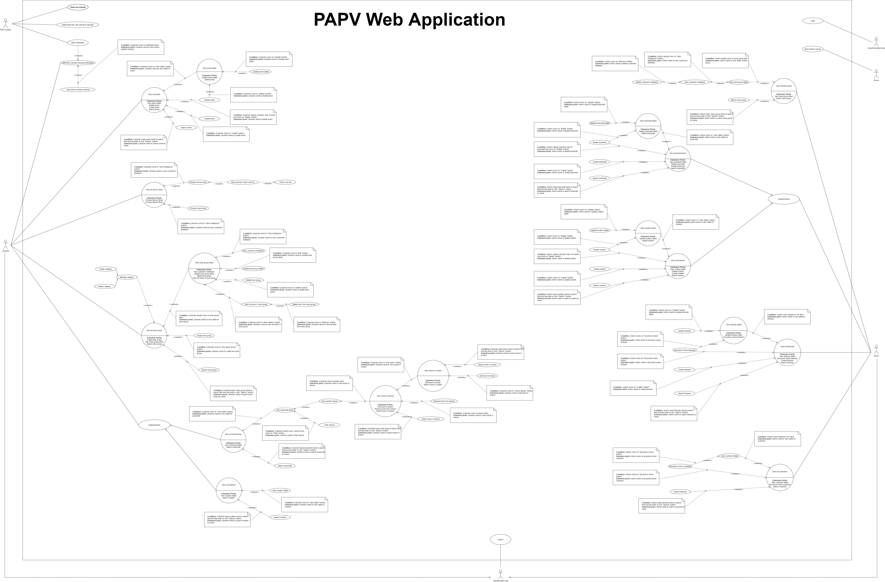

[*Figure 1 - <Use Case Overview> PAPV Web Application*](https://drive.google.com/file/d/1Ylnq4nvsIdiXuldDagrgbIvoW_oBMjVH/view?usp=sharing)

##### Mobile Application

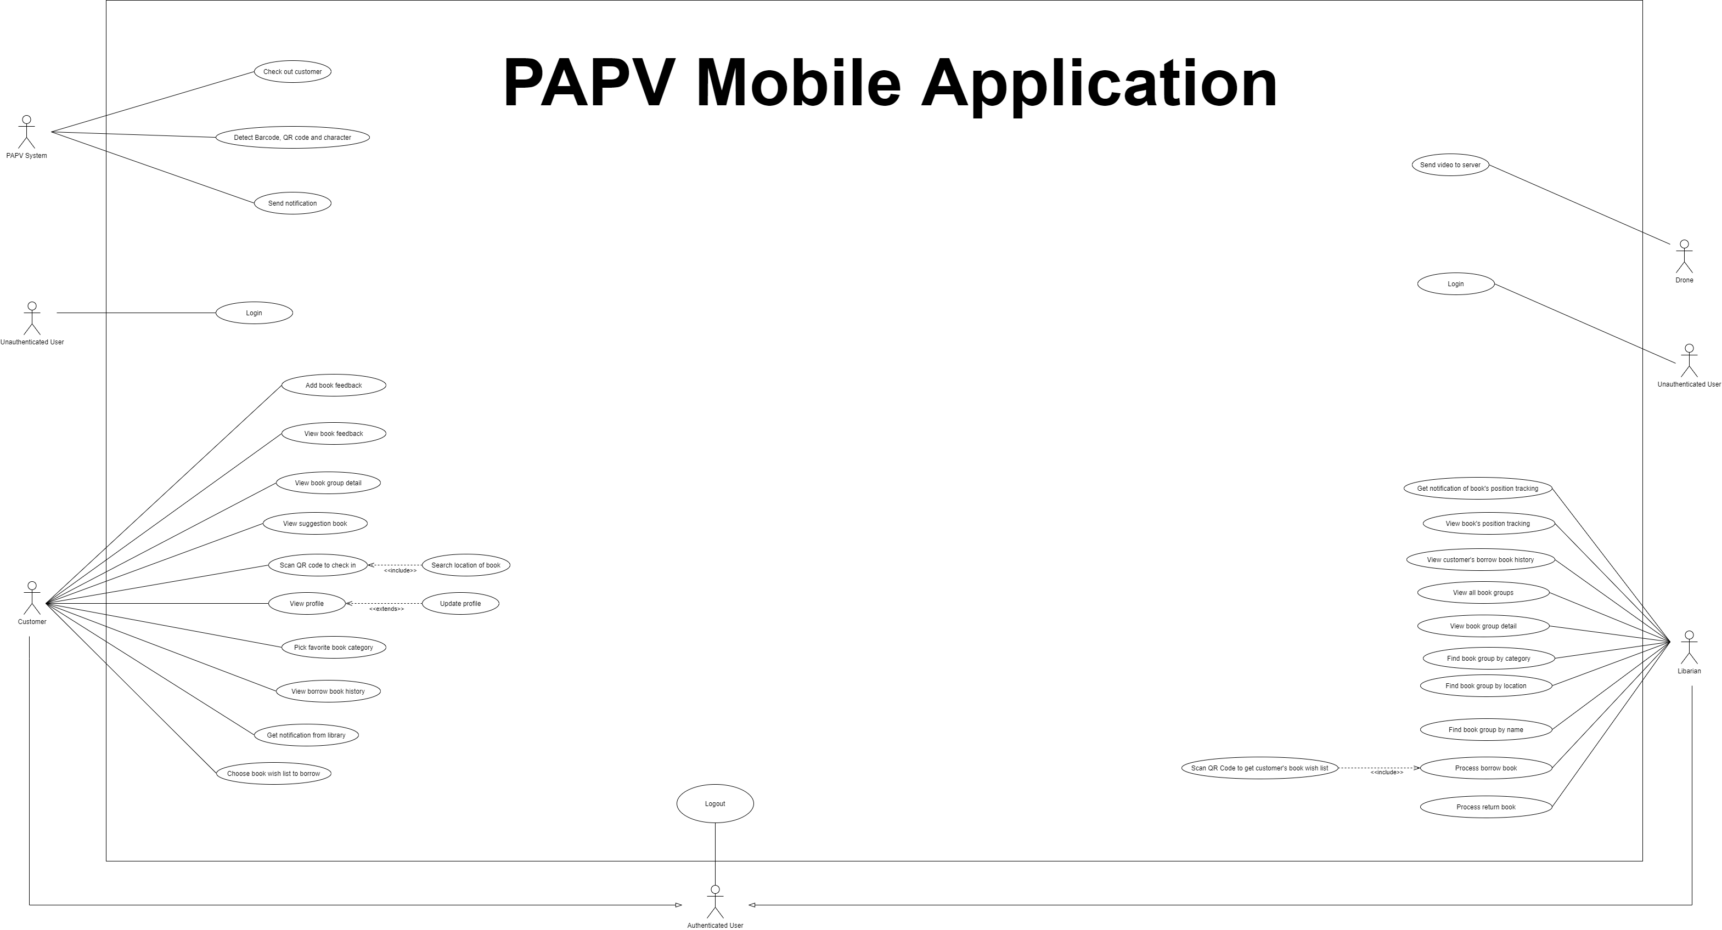

[*Figure 2 - <Use Case Overview> PAPV Mobile Application*](https://drive.google.com/file/d/15zlF2ZuvwpdlTkIa2HK82uo9HgiAtnZJ/view?usp=sharing)

#### System Actors

|  |  |  |
| --- | --- | --- |
| **#** | **Actor** | **Description** |
| 1 | Unauthenticated User | Unauthenticated User is person who has no account |
| 2 | Authenticated User | Authenticated User is person who has account in system (admin, librarian, customer) |
| 3 | Customer | Customer borrows and returns book of library |
| 4 | Librarian | Librarian manages books in library |
| 5 | Admin | Admin manages location, bookshelf, librarian and customer |
| 6 | Drone | Drone sends video to system’s server |
| 7 | PAPV System | PAPV System deals with internal processes |

#### Use Cases List

|  |  |  |  |
| --- | --- | --- | --- |
| **ID** | **Use Case** | **Primary Actors** | **Secondary Actors** |
| UC1 | **Login** | Unauthenticated User | N/A |
| UC2 | **Logout** | Authenticated User | N/A |
| UC3 | **Create bookshelf** | Admin | N/A |
| UC4 | **Get all bookshelves** | Admin | N/A |
| UC5 | **Get bookshelf detail** | Admin | N/A |
| UC6 | **Update bookshelf detail** | Admin | N/A |
| UC7 | **Delete bookshelf** | Admin | N/A |
| UC8 | **Create a location** | Admin | N/A |
| UC9 | **Get all bookshelves** | Admin | N/A |
| UC10 | **Update location detail** | Admin | N/A |
| UC11 | **Delete location** | Admin | N/A |
| UC12 | **Get all customers** | Admin | N/A |
| UC13 | **Get customer detail** | Admin | N/A |
| UC24 | **View book’s position tracking** | Librarian | Drone |
| UC25 | **Get customer’s borrow book history** | Librarian | N/A |
| UC27 | **Process borrow book** | Librarian | Customer |
| UC28 | **Process return book** | Librarian | Customer |
| UC30 | **Create book group** | Librarian | N/A |
| UC31 | **Get all book groups** | Librarian | N/A |
| UC32 | **Get book group detail** | Librarian | N/A |
| UC33 | **Find book group by location** | Librarian | N/A |
| UC34 | **Find book group by name** | Librarian | N/A |
| UC35 | **Update book group detail** | Librarian | N/A |
| UC36 | **Delete book group** | Librarian | N/A |
| UC37 | **Create category** | Librarian | N/A |
| UC38 | **Get all categories** | Librarian | N/A |
| UC39 | **Delete category** | Librarian | N/A |
| UC40 | **View specific drawers** | Librarian | N/A |
| UC41 | **View books in drawer** | Librarian | N/A |
| UC42 | **Add books into a drawer** | Librarian | N/A |
| UC43 | **Create Event** | Librarian | N/A |
| UC44 | **View All Events** | Librarian | N/A |
| UC45 | **View Event Detail** | Librarian | N/A |
| UC46 | **Update Event Detail** | Librarian | N/A |
| UC47 | **Delete Event** | Librarian | N/A |
| UC48 | **Find Book Group By Category** | Librarian | N/A |

### Web Application



#### 2.2.1 <Admin> Overview Use Case

##### 2.2.1.1 <Admin> Create bookshelf

|  |  |  |  |
| --- | --- | --- | --- |
| ID and Name: | **UC-3 Create bookshelf** | | |
| Created By: | PhuNH | Date Created: | 25/01/2021 |
| Primary Actor: | Admin | Secondary Actors: | N/A |
| Description: | This feature allows admin to create a bookshelf | | |
| Trigger: | Admin send request to create bookshelf | | |
| Pre-conditions: | PRE-01. User has logged in the web as Admin role.  PRE-02. Admin in “Organize Books” page. | | |
| Post-conditions: | POST-01. PAPV return a message that bookshelf has been created successfully. PAPV stores bookshelf detail. | | |
| Normal Flow: | **3.0 Create a bookshelf**  1. Admin click “New book shelf” to send request to create a bookshelf.  2. PAPV will show a form requires identity information of bookshelf:  - “Book shelf name”: text input, blank  - “Row number”: text input, blank  - “Column number”: text input, blank  - “Location”: dropdown, blank  3. Admin fills in the book shelf information (see 3.0.E1)  4. Admin click “Submit” button to send request to create bookshelf.  5. PAPV validates the bookshelf information and stores them | | |
| Alternative Flows: | N/A | | |
| Exceptions: | **3.0.E1 Admin fails to fill in all the requires fields**   1. PAPV returns to admin to fill in the missing fields | | |
| Priority: | Simple. | | |
| Frequency of Use: | Often. | | |
| Business Rules: | BR-03 | | |
| Other Information: | In case of internet connection failure, Admin cannot create bookshelf | | |
| Assumptions: | N/A | | |

##### 2.2.1.2 <Admin> Get all bookshelves

|  |  |  |  |
| --- | --- | --- | --- |
| ID and Name: | **UC-4 Get all bookshelves.** | | |
| Created By: | PhuNH | Date Created: | 25/01/2021 |
| Primary Actor: | Admin, Librarian | Secondary Actors: | N/A |
| Description: | This feature allows admin and librarian to get all bookshelves that they manage | | |
| Trigger: | Admin/Librarian send request to get bookshelves list | | |
| Pre-conditions: | PRE-01. User has logged in the web as Admin/Librarian role  PRE-02. Admin/Librarian in “Organize Books” page | | |
| Post-conditions: | POST-01. PAPV return bookshelves list | | |
| Normal Flow: | **4.0 Get all bookshelves**  1. Admin or librarian send request to get all bookshelves  2. PAPV return list bookshelves (see 4.0.E1) | | |
| Alternative Flows: | N/A | | |
| Exceptions: | **4.0.E1 Admin or librarian has no bookshelf to manage**   1. PAPV returns message: MSG10 | | |
| Priority: | Simple. | | |
| Frequency of Use: | Often. | | |
| Business Rules: | BR-04 | | |
| Other Information: | In case of internet connection failure, Admin/ Librarian cannot view all bookshelf. | | |
| Assumptions: | N/A | | |

##### 2.2.1.3 <Admin> Get bookshelf detail

|  |  |  |  |
| --- | --- | --- | --- |
| ID and Name: | **UC-5 Get bookshelf detail** | | |
| Created By: | PhuNH | Date Created: | 25/01/2021 |
| Primary Actor: | Admin, Librarian | Secondary Actors: | N/A |
| Description: | This feature allows Admin/Librarian view a bookshelf information detail. | | |
| Trigger: | Admin/Librarian send request to view bookshelf detail | | |
| Pre-conditions: | PRE-01. User has logged in the web as Admin/Librarian role  PRE-02. Admin/Librarian in “Organize Books” page. | | |
| Post-conditions: | POST-01. PAPV returns bookshelf information details | | |
| Normal Flow: | **5.0 Get bookshelf information detail**  1. Admin/Librarian click “Edit” button on specific bookshelf  2. PAPV will redirect to view bookshelf information details | | |
| Alternative Flows: | N/A | | |
| Exceptions: | N/A | | |
| Priority: | Simple. | | |
| Frequency of Use: | Often. | | |
| Business Rules: | BR-05 | | |
| Other Information: | In case of internet connection failure, Admin/ Librarian cannot view bookshelf detail. | | |
| Assumptions: | N/A | | |

##### 2.2.1.4 <Admin> Update bookshelf detail

|  |  |  |  |
| --- | --- | --- | --- |
| ID and Name: | **UC-6 Update bookshelf detail** | | |
| Created By: | PhuNH | Date Created: | 25/01/2021 |
| Primary Actor: | Admin | Secondary Actors: | N/A |
| Description: | This feature allows admin to update bookshelf information. | | |
| Trigger: | Admin send request to update bookshelf information. | | |
| Pre-conditions: | PRE-01. User has logged in the web as Admin role.  PRE-02. Admin in “Organize Books” page.  PRE-03. Admin view “Books Shelf Detail” page. | | |
| Post-conditions: | POST-01. New bookshelf information had been updated. | | |
| Normal Flow: | |  |  |  | | --- | --- | --- | | Step | Actor Action | System Response | | 1 | Admin send request to update bookshelf detail. |  | |  |  | PAPV return list bookshelves.  [Exception 1] | | | |
| Alternative Flows: | N/A | | |
| Exceptions: | |  |  |  | | --- | --- | --- | | No | Cause | System Response | | 1 | PAPV has no bookshelves | PAPV returns message: [MSG010] | | | |
| Priority: | Simple. | | |
| Frequency of Use: | Often. | | |
| Business Rules: | N/A | | |
| Other Information: | In case of internet connection failure, Admin/ Librarian cannot view all bookshelf. | | |
| Assumptions: | N/A | | |

##### 2.2.1.5 <Admin> Delete bookshelf

|  |  |  |  |
| --- | --- | --- | --- |
| ID and Name: | **UC-07 Delete bookshelf** | | |
| Created By: | LinhNH | Date Created: | 18/01/2021 |
| Primary Actor: | Admin | Secondary Actors: | N/A |
| Description: | This feature allows admin to delete a bookshelf | | |
| Trigger: | Admin send request to delete a bookshelf | | |
| Preconditions: | PRE-01. User has logged in web as Librarian Role  PRE-02 Admin in “Organize Books” page | | |
| Post-conditions: | POST-1. PAPV removes the bookshelf | | |
| Normal Flow: | **7.0 Delete a bookshelf**  1. Admin clicks on “Delete” button on tables  2. System show delete story popup with two buttons for admin can select:  - “Yes” button  - “No” button  3. User clicks on “Yes” button, PAPV remove bookshelf  4. User clicks on “No” button, close popup and nothing change | | |
| Alternative Flows: | N/A | | |
| Exceptions: | N/A | | |
| Priority: | Medium | | |
| Frequency of Use: | Approximately 10 usages per day. | | |
| Business Rules: | Br-06 | | |
| Other Information: | 1. In case of internet connection failure, librarian cannot finish this use case properly | | |
| Assumptions: | N/A | | |

##### 2.2.1.6 <Admin> Create location

|  |  |  |  |
| --- | --- | --- | --- |
| ID and Name: | **UC-8 Create a location** | | |
| Created By: | PhuNH | Date Created: | 25/01/2021 |
| Primary Actor: | Admin | Secondary Actors: | N/A |
| Description: | This feature allows admin to create a location | | |
| Trigger: | Admin send request to create location | | |
| Pre-conditions: | PRE-01. User has logged in the web as Admin role.  PRE-02. Admin in “Organize Books” page. | | |
| Post-conditions: | POST-01. PAPV return a message that location has been created successfully. PAPV stores location detail. | | |
| Normal Flow: | **8.0 Create a location**  1. Admin click “New Location” to send request to create a location.  2. PAPV will show a form requires identity information of bookshelf:  - “Location”: text input, blank  - “Color”: dropdown, blank  3. Admin fills in the location information (see 3.0.E1)  4. Admin click “Submit” button to send request to create bookshelf.  5. PAPV validates the bookshelf information and stores them | | |
| Alternative Flows: | N/A | | |
| Exceptions: | **3.0.E1 Admin fails to fill in all the requires fields**   1. PAPV returns to admin to fill in the missing fields | | |
| Priority: | Simple. | | |
| Frequency of Use: | Often. | | |
| Business Rules: | BR-07 | | |
| Other Information: | In case of internet connection failure, Admin cannot create bookshelf | | |
| Assumptions: | N/A | | |

##### 2.2.1.7 <Admin> Get all locations

|  |  |  |  |
| --- | --- | --- | --- |
| ID and Name: | **UC-9 Get all locations** | | |
| Created By: | PhuNH | Date Created: | 25/01/2021 |
| Primary Actor: | Admin, Librarian | Secondary Actors: | N/A |
| Description: | This feature allows admin and librarian to get all location that they manage | | |
| Trigger: | Admin/Librarian send request to get location list | | |
| Pre-conditions: | PRE-01. User has logged in the web as Admin/Librarian role  PRE-02. Admin/Librarian in “Organize Books” page | | |
| Post-conditions: | POST-01. PAPV return location list | | |
| Normal Flow: | **9.0 Get all bookshelves**  1. Admin or librarian send request to get all locations  2. PAPV return list locations (see 4.0.E1) | | |
| Alternative Flows: | N/A | | |
| Exceptions: | **9.0.E1 Admin or librarian has no location to manage**   1. PAPV returns message: MSG10 | | |
| Priority: | Simple. | | |
| Frequency of Use: | Often. | | |
| Business Rules: | BR-08 | | |
| Other Information: | In case of internet connection failure, Admin/ Librarian cannot view all bookshelf. | | |
| Assumptions: | N/A | | |

##### 2.2.1.8 <Admin> View location detail

|  |  |  |  |
| --- | --- | --- | --- |
| ID and Name: | **UC-10 View location detail** | | |
| Created By: | LinhNH | Date Created: | 18/01/2021 |
| Primary Actor: | Librarian | Secondary Actors: | N/A |
| Description: | This feature allows to get detailed location information in library | | |
| Trigger: | Librarian send request to get detailed of a location | | |
| Preconditions: | PRE-01. User has logged in web as Librarian Role | | |
| Post-conditions: | POST-01. Location information is returned to Librarian | | |
| Normal Flow: | |  |  |  | | --- | --- | --- | | Step | Actor Action | System Response | | 1 | Librarian send request to get detail of a locations. |  | |  |  | PAPV returns details of a location | | | |
| Alternative Flows: | N/A | | |
| Exceptions: | |  |  |  | | --- | --- | --- | | No | Cause | System Response | | 1 | PAPV has no location | PAPV returns message: [MSG10] | | | |
| Priority: | High | | |
| Frequency of Use: | Approximately 2 usages per week. | | |
| Business Rules: | N/A | | |
| Other Information: | 1. In case of internet connection failure, librarian cannot finish this use case properly | | |
| Assumptions: | N/A | | |

##### 2.2.1.9 <Admin> Update location detail

|  |  |  |  |
| --- | --- | --- | --- |
| ID and Name: | **UC-10 Update location detail** | | |
| Created By: | PhuNH | Date Created: | 25/01/2021 |
| Primary Actor: | Admin | Secondary Actors: | N/A |
| Description: | This feature allows admin to update bookshelf information. | | |
| Trigger: | Admin send request to update bookshelf information. | | |
| Pre-conditions: | PRE-01. User has logged in the web as Admin role.  PRE-02. Admin in “Organize Books” page.  PRE-03. Admin view “Books Shelf Detail” page. | | |
| Post-conditions: | POST-01. New bookshelf information had been updated. | | |
| Normal Flow: | |  |  |  | | --- | --- | --- | | Step | Actor Action | System Response | | 1 | Admin send request to update bookshelf detail. |  | |  |  | PAPV return list bookshelves.  [Exception 1] | | | |
| Alternative Flows: | N/A | | |
| Exceptions: | |  |  |  | | --- | --- | --- | | No | Cause | System Response | | 1 | PAPV has no bookshelves | PAPV returns message: [MSG010] | | | |
| Priority: | Simple. | | |
| Frequency of Use: | Often. | | |
| Business Rules: | N/A | | |
| Other Information: | In case of internet connection failure, Admin/ Librarian cannot view all bookshelf. | | |
| Assumptions: | N/A | | |

##### 2.2.1.10 <Admin> Delete location

|  |  |  |  |
| --- | --- | --- | --- |
| ID and Name: | **UC-11 Delete location** | | |
| Created By: | LinhNH | Date Created: | 18/01/2021 |
| Primary Actor: | Admin | Secondary Actors: | N/A |
| Description: | This feature allows admin to delete one or more location | | |
| Trigger: | Admin send request to delete one or more book groups | | |
| Preconditions: | PRE-01. User has logged in web as Librarian Role  PRE-02 Admin in “Organize Books” page | | |
| Post-conditions: | POST-01. PAPV removes the bookshelf | | |
| Normal Flow: | **11.0 Delete one or more bookshelf**  1. Admin clicks to choices location want to delete  2. System show delete story popup with two buttons for admin can select:  - “Delete” button  - “Cancel” button  3. User clicks on “Yes” button, PAPV remove one more bookshelf selected location  4. User clicks on “No” button, close popup and nothing change | | |
| Alternative Flows: | N/A | | |
| Exceptions: | N/A | | |
| Priority: | Medium | | |
| Frequency of Use: | Approximately 10 usages per day. | | |
| Business Rules: | BR-09 | | |
| Other Information: | 1. In case of internet connection failure, librarian cannot finish this use case properly | | |
| Assumptions: | N/A | | |

##### 2.2.1.11 <Admin> Get all customers

|  |  |  |  |
| --- | --- | --- | --- |
| ID and Name: | **UC-12 Get all customers** | | |
| Created By: | PhuNH | Date Created: | 25/01/2021 |
| Primary Actor: | Admin | Secondary Actors: | N/A |
| Description: | This feature allows admin to get all customers that they manage | | |
| Trigger: | Admin send request to get customers list | | |
| Pre-conditions: | PRE-01. User has logged in the web as Admin/Librarian role  PRE-02. Admin/Librarian in “Customer” page | | |
| Post-conditions: | POST-01. PAPV return customers list | | |
| Normal Flow: | **12.0 Get all customers**  1. Admin send request to get all customers  2. PAPV return list customers (see 4.0.E1) | | |
| Alternative Flows: | N/A | | |
| Exceptions: | **4.0.E1 Admin has no customer to manage**   1. PAPV returns message: MSG10 | | |
| Priority: | Simple. | | |
| Frequency of Use: | Often. | | |
| Business Rules: | BR-10 | | |
| Other Information: | In case of internet connection failure, Admin/ Librarian cannot view all bookshelf. | | |
| Assumptions: | N/A | | |

##### 2.2.1.12 <Admin> Get customer detail

|  |  |  |  |
| --- | --- | --- | --- |
| ID and Name: | **UC-13 Get customer detail** | | |
| Created By: | PhuNH | Date Created: | 25/01/2021 |
| Primary Actor: | Admin | Secondary Actors: | N/A |
| Description: | This feature allows Admin view a customer information detail. | | |
| Trigger: | Admin send request to view bookshelf detail | | |
| Pre-conditions: | PRE-01. User has logged in the web as Admin/Librarian role  PRE-02. Admin/Librarian in “Organize Books” page. | | |
| Post-conditions: | POST-01. PAPV returns bookshelf information details | | |
| Normal Flow: | **5.0 Get bookshelf information detail**  1. Admin/Librarian click “Edit” button on specific bookshelf  2. PAPV will redirect to view bookshelf information details | | |
| Alternative Flows: | N/A | | |
| Exceptions: | N/A | | |
| Priority: | Simple. | | |
| Frequency of Use: | Often. | | |
| Business Rules: | BR-05 | | |
| Other Information: | In case of internet connection failure, Admin/ Librarian cannot view bookshelf detail. | | |
| Assumptions: | N/A | | |

#### 2.2.2 <Librarian> Overview Use Case

##### 2.2.2.1 <Librarian> View all book’s position tracking

|  |  |  |  |
| --- | --- | --- | --- |
| ID and Name: | **UC-24 View book’s position tracking** | | |
| Created By: | LinhNH | Date Created: | 18/01/2021 |
| Primary Actor: | Librarian | Secondary Actors: | Drone |
| Description: | Librarian use drone to fly over a specific bookshelf, thereby tracking where the books are in the bookshelf | | |
| Trigger: | Librarian send request to get book’s position tracking of specific bookshelf | | |
| Preconditions: | PRE-01. User has logged in as Librarian Role | | |
| Post-conditions: | POST-01. Notification list about book’s position is returned to librarian | | |
| Normal Flow: | **24.0 View book’s position tracking using drone**  1.   |  |  |  | | --- | --- | --- | | Step | Actor Action | System Response | | 1 | Librarian request to tracking book’s position |  | |  |  | PAPV returns a message: [MSG03] | | 2 | Librarian use drone to fly over a specific bookshelf |  | | 3 | Librarian request to finish tracking |  | |  |  | PAPV returns a notification with message: [MSG06], [MSG07], [MSG08] | | | |
| Alternative Flows: | N/A | | |
| Exceptions: | N/A | | |
| Priority: | High | | |
| Frequency of Use: | Librarian will do in the weekend, once pre week | | |
| Business Rules: | N/A | | |
| Other Information: | 1. Drone needs 7-9s to send video to server 2. In case of internet connection failure, drone cannot send video to server 3. In the case drone out of power, librarian cannot finish this use case properly | | |
| Assumptions: | Library must have drone | | |

##### 2.2.2.2 <Librarian> Get customer’s borrow book history

|  |  |  |  |
| --- | --- | --- | --- |
| ID and Name: | **UC-25 Get customer’s borrow book history** | | |
| Created By: | LinhNH | Date Created: | 18/01/2021 |
| Primary Actor: | Librarian | Secondary Actors: | N/A |
| Description: | This feature allows librarian to get list of borrow book | | |
| Trigger: | Librarian send request to get list of borrow book | | |
| Preconditions: | PRE-01. User has logged in as Librarian Role | | |
| Post-conditions: | POST-01. List of borrow book are returned for librarian | | |
| Normal Flow: | **25.0 Get all customer’s borrow book history**  1. Librarian send request to get all customer’s list borrow book  2. PAPV returns list of borrow book (see 25.0.E1) | | |
| Alternative Flows: | N/A | | |
| Exceptions: | **25.0.E1 PAPV has no customer’s borrow book history**  1. PAPV returns message: | | |
| Priority: | High | | |
| Frequency of Use: | Approximately 15 usages per day. | | |
| Business Rules: | N/A | | |
| Other Information: | 1. In case of internet connection failure, librarian cannot finish this use case properly | | |
| Assumptions: | N/A | | |

##### 2.2.2.3 <Librarian> Process borrow book

|  |  |  |  |
| --- | --- | --- | --- |
| ID and Name: | **UC-27 Process borrow book** | | |
| Created By: | LinhNH | Date Created: | 18/01/2021 |
| Primary Actor: | Librarian | Secondary Actors: | Customer |
| Description: | This feature allows librarian to accept borrow request from user at the library | | |
| Trigger: | Librarian send request to start process borrow book | | |
| Preconditions: | PRE-01. User has logged in web and mobile as Librarian Role  PRE-02. Customer already have wish list want to borrow | | |
| Post-conditions: | POST-01. PAPV stores customer’s borrow book and the borrow, the return date time | | |
| Normal Flow: | |  |  |  | | --- | --- | --- | | Step | Actor Action | System Response | | 1 | Librarian send request to start process borrow book |  | | 2 | Librarian scan QR code to get wish list want to borrow of customer [Exception 1] |  | |  |  | PAPV returned message on mobile app: [MSG]  PAPV return wish list on web | | 3 | Librarian fill return date on borrow form(required) [Exception 2] |  | | 4 | Librarian click “Confirm” to finish borrow process |  | |  |  | PAPV return a message that customer has borrowed successfully | | | |
| Alternative Flows: | N/A | | |
| Exceptions: | |  |  |  | | --- | --- | --- | | No | Cause | System Response | | 1 | One or more book in wish list not enough quantity for borrow | PAPV returns to librarian that book is not available | | 2 | The return date time is 7 days greater than the borrow date time | PAPV returns to librarian that the return date time must be less than 7 days after the borrow date time | | | |
| Priority: | High | | |
| Frequency of Use: | On average on librarian is used 15 times per day | | |
| Business Rules: | N/A | | |
| Other Information: | 1. In case of internet connection failure, librarian cannot finish this use case properly 2. In the case internet connection failure, librarian cannot scan QR | | |
| Assumptions: | Librarian’s phone must have camera that is able to scan QR | | |

##### 2.2.2.4 <Librarian> Process return book

|  |  |  |  |
| --- | --- | --- | --- |
| ID and Name: | **UC-28 Process return book** | | |
| Created By: | LinhNH | Date Created: | 18/01/2021 |
| Primary Actor: | Librarian | Secondary Actors: | Customer |
| Description: | This feature allows librarian to accept borrow request from user at the library | | |
| Trigger: | Librarian send request to start process borrow book | | |
| Preconditions: | PRE-01. User has logged in web and mobile as Librarian Role  PRE-02. Customer already have wish list want to borrow | | |
| Post-conditions: | POST-01. PAPV stores customer’s borrow book and the borrow, the return date time | | |
| Normal Flow: | |  |  |  | | --- | --- | --- | | Step | Actor Action | System Response | | 1 | Librarian send request to start process borrow book |  | | 2 | Librarian scan QR code to get wish list want to borrow of customer [Exception 1] |  | |  |  | PAPV returned message on mobile app: [MSG]  PAPV return wish list on web | | 3 | Librarian fill return date on borrow form(required) [Exception 2] |  | | 4 | Librarian click “Confirm” to finish borrow process |  | |  |  | PAPV return a message that customer has borrowed successfully | | | |
| Alternative Flows: | N/A | | |
| Exceptions: | |  |  |  | | --- | --- | --- | | No | Cause | System Response | | 1 | One or more book in wish list not enough quantity for borrow | PAPV returns to librarian that book is not available | | 2 | The return date time is 7 days greater than the borrow date time | PAPV returns to librarian that the return date time must be less than 7 days after the borrow date time | | | |
| Priority: | High | | |
| Frequency of Use: | Approximately 15 usages per day. | | |
| Business Rules: | N/A | | |
| Other Information: | 1. In case of internet connection failure, librarian cannot finish this use case properly 2. In the case internet connection failure, librarian cannot scan QR | | |
| Assumptions: | Librarian’s phone must have camera that is able to scan QR | | |

##### 2.2.2.5 <Librarian> Create book group

|  |  |  |  |
| --- | --- | --- | --- |
| ID and Name: | **UC-30 Create book group** | | |
| Created By: | LinhNH | Date Created: | 18/01/2021 |
| Primary Actor: | Librarian | Secondary Actors: | N/A |
| Description: | This feature allows librarian to create a book group | | |
| Trigger: | Librarian send request to get detailed of a location | | |
| Preconditions: | PRE-01. User has logged in web as Librarian Role  PRE-02. Librarian in “Manage Book” page | | |
| Post-conditions: | POST-01. PAPV stores book group details | | |
| Normal Flow: | **30.1 Create a book group**  1. Admin click “New Book” to send request to create a location.  2. PAPV will show a form requires identity information of bookshelf:  - “Book Group Name”: text input, blank  - “Author”: text input, blank  - “Page Number”: text input, blank  - “Width”: text input, blank  - “Height”: text input, blank  - “Quantity”: text input, blank  - “Fee”: text input, blank  - “Punish Fee”: text input, blank  - “Category”: text input, blank  - “Publishing Company”: text input, blank  - “Upload”: button  - “Publishing Date”: date picker  - “Publishing Number”: text input, blank  - “Publishing Palace”: text input, blank  - “Publishing Description”: text input, blank  3. Admin fills in the location information (see 30.0.E1)  4. Admin click “Add Book” button to send request to create book group.  5. PAPV validates the book group information and stores them | | |
| Alternative Flows: | N/A | | |
| Exceptions: | **30.0.E1 Librarian fails to fill in all the required fields**  1. PAPV returns to librarian to fill in the missing fields | | |
| Priority: | High | | |
| Frequency of Use: | Approximately 2 usages per week. | | |
| Business Rules: | BR-11 | | |
| Other Information: | 1. In case of internet connection failure, librarian cannot finish this use case properly | | |
| Assumptions: | The library must import the books into the store to create a book group | | |

##### 2.2.2.6 <Librarian> Get all book groups

|  |  |  |  |
| --- | --- | --- | --- |
| ID and Name: | **UC-31 Get all book groups.** | | |
| Created By: | PhuNH | Date Created: | 25/01/2021 |
| Primary Actor: | Librarian | Secondary Actors: | N/A |
| Description: | This feature allows admin and librarian to get all book groups that they manage | | |
| Trigger: | Librarian send request to get book groups list | | |
| Pre-conditions: | PRE-01. User has logged in the web as Librarian role  PRE-02. Librarian in “Manage Book” page | | |
| Post-conditions: | POST-01. PAPV return book groups list | | |
| Normal Flow: | **31.0 Get all book groups**  1. Librarian send request to get all book groups  2. PAPV return list book groups (see 31.0.E1) | | |
| Alternative Flows: | N/A | | |
| Exceptions: | **31.0.E1 Admin or librarian has no bookshelf to manage**   1. PAPV returns message: MSG10 | | |
| Priority: | Simple. | | |
| Frequency of Use: | Often. | | |
| Business Rules: | BR-12 | | |
| Other Information: | In case of internet connection failure, Admin/ Librarian cannot view all bookshelf. | | |
| Assumptions: | N/A | | |

##### 2.2.2.7 <Librarian> Get book group detail

|  |  |  |  |
| --- | --- | --- | --- |
| ID and Name: | **UC-32 Get book group detail** | | |
| Created By: | PhuNH | Date Created: | 25/01/2021 |
| Primary Actor: | Librarian | Secondary Actors: | N/A |
| Description: | This feature allows Librarian view a book group information detail. | | |
| Trigger: | Librarian send request to view book group detail | | |
| Pre-conditions: | PRE-01. User has logged in the web as Librarian role  PRE-02. Librarian in “Manage Books” page. | | |
| Post-conditions: | POST-01. PAPV returns bookshelf information details | | |
| Normal Flow: | **32.0 Get book group information detail**  1. Librarian double click on specific book group on tables  2. PAPV will redirect to view book group information details | | |
| Alternative Flows: | N/A | | |
| Exceptions: | N/A | | |
| Priority: | Simple. | | |
| Frequency of Use: | Often. | | |
| Business Rules: | BR-13 | | |
| Other Information: | In case of internet connection failure, Admin/ Librarian cannot view bookshelf detail. | | |
| Assumptions: | N/A | | |

##### 2.2.2.8 <Librarian> Find book group by location

|  |  |  |  |
| --- | --- | --- | --- |
| ID and Name: | **UC-33 Find book group by location** | | |
| Created By: | LinhNH | Date Created: | 18/01/2021 |
| Primary Actor: | Librarian | Secondary Actors: | N/A |
| Description: | This feature allows librarian to search book group by location | | |
| Trigger: | Librarian send request to find out about a book group | | |
| Preconditions: | PRE-01. User has logged in web as Librarian Role  PRE-02. Librarian in “Manage Books” page. | | |
| Post-conditions: | POST-01. PAPV returns all book group in specific location | | |
| Normal Flow: | **33.0 Look up book group detail by location**  1. Librarian input requested location want to find book group (see 33.0.E1)  2. Librarian clicks on “Search” button  3. PAPV returns all book group in the requested location | | |
| Alternative Flows: | N/A | | |
| Exceptions: | **33.0.E1 PAPV has no book group in requested location**  1. PAPV returns message: [MSG10] | | |
| Priority: | Medium | | |
| Frequency of Use: | Approximately 10 usages per day. | | |
| Business Rules: | BR-14 | | |
| Other Information: | 1. In case of internet connection failure, librarian cannot finish this use case properly | | |
| Assumptions: | N/A | | |

##### 2.2.2.9 <Librarian> Find book group by name

|  |  |  |  |
| --- | --- | --- | --- |
| ID and Name: | **UC-34 Find book group by name** | | |
| Created By: | LinhNH | Date Created: | 18/01/2021 |
| Primary Actor: | Librarian | Secondary Actors: | N/A |
| Description: | This feature allows librarian to search book group by name | | |
| Trigger: | Librarian send request to find out about a book group | | |
| Preconditions: | PRE-01. User has logged in web as Librarian Role  PRE-02. Librarian in “Manage Books” page. | | |
| Post-conditions: | POST-01. PAPV returns book group | | |
| Normal Flow: | **34.0 Look up book group detail by NAME**  1. Librarian input requested name of book group want to find in PAPV (see 34.0.E1)  2. Librarian clicks on “Search” button  3. PAPV returns all book group has the same name with the requested name | | |
| Alternative Flows: | N/A | | |
| Exceptions: | **34.0.E1 PAPV has no book group has the same name with requested name**  1. PAPV returns message: [MSG10] | | |
| Priority: | Medium | | |
| Frequency of Use: | Approximately 10 usages per day. | | |
| Business Rules: | BR-15 | | |
| Other Information: | 1. In case of internet connection failure, librarian cannot finish this use case properly | | |
| Assumptions: | N/A | | |

##### 2.2.2.10 <Librarian> Update book group detail

|  |  |  |  |
| --- | --- | --- | --- |
| ID and Name: | **UC-35 Update book group detail** | | |
| Created By: | LinhNH | Date Created: | 18/01/2021 |
| Primary Actor: | Librarian | Secondary Actors: | N/A |
| Description: | This feature allows librarian to update book group information | | |
| Trigger: | Librarian send request to update book group information | | |
| Preconditions: | PRE-01. User has logged in web as Librarian Role  PRE-02. Librarian in “Manage Books” page. | | |
| Post-conditions: | POST-01. PAPV stores the updated book group details | | |
| Normal Flow: | **35.0 Update book group information detail**  1. Librarian clicks on “Edit” button on pop up of book group detail  2. PAPV will show pop up for edit information detail  3. Librarian fills in the book group information detail form(see 35.0.E1)  4a. Librarian clicks on “Save” button  4a.1. PAPV validates the updated book group information and stores them  4b. Librarian clicks on “Cancel” button  4b.1. PAPV close the pop up, nothing changes | | |
| Alternative Flows: | N/A | | |
| Exceptions: | **35.0.E1 Librarian fails to fill in all the required fields**  1. PAPV returns message: | | |
| Priority: | Medium | | |
| Frequency of Use: | Approximately 10 usages per day. | | |
| Business Rules: | BR-16 | | |
| Other Information: | 1. In case of internet connection failure, librarian cannot finish this use case properly | | |
| Assumptions: | N/A | | |

##### 2.2.2.11 <Librarian> Delete book group

|  |  |  |  |
| --- | --- | --- | --- |
| ID and Name: | **UC-36 Delete book group** | | |
| Created By: | LinhNH | Date Created: | 18/01/2021 |
| Primary Actor: | Librarian | Secondary Actors: | N/A |
| Description: | This feature allows librarian to delete one or more book groups | | |
| Trigger: | Librarian send request to delete one or more book groups | | |
| Preconditions: | PRE-01. User has logged in web as Librarian Role  PRE-02. Librarian in “Manage Books” page. | | |
| Post-conditions: | POST-01. PAPV removes the book group | | |
| Normal Flow: | **36.0 Delete a book group in system**  1. Librarian clicks on “Delete” button on pop up of book group detail  2. PAPV show delete story popup with two buttons for admin can select:  - “Yes” button  - “No” button  3a. Librarian clicks on “Save” button  3a.1. PAPV remove the book group and returns to librarian that book group has been deleted  3b. Librarian clicks on “Cancel” button  3b.1. PAPV close the pop up, nothing changes | | |
| Alternative Flows: | N/A | | |
| Exceptions: | N/A | | |
| Priority: | Medium | | |
| Frequency of Use: | Approximately 10 usages per day. | | |
| Business Rules: | BR-17 | | |
| Other Information: | 1. In case of internet connection failure, librarian cannot finish this use case properly | | |
| Assumptions: | N/A | | |

##### 2.2.2.12 <Librarian> Create category

|  |  |  |  |
| --- | --- | --- | --- |
| ID and Name: | **UC-37 Create category** | | |
| Created By: | LinhNH | Date Created: | 18/01/2021 |
| Primary Actor: | Librarian | Secondary Actors: | N/A |
| Description: | This feature allows librarian to create a category | | |
| Trigger: | Librarian send request to create category | | |
| Preconditions: | PRE-01. User has logged in web as Librarian Role  PRE-02. Librarian in “Manage Books” page. | | |
| Post-conditions: | POST-01. PAPV stores category details | | |
| Normal Flow: | **37.0 Create a category**  1. Librarian clicks on “Manage Categories” button  2. PAPV will show pop up to create a category  3. Librarian input the category name (see 37.0.E1)  4. Librarian clicks on “Add item” button  5. PAPV validates the category information and stores them | | |
| Alternative Flows: | N/A | | |
| Exceptions: | **37.0.E1 Librarian fails to fill in all the required fields**  1. PAPV returns message: | | |
| Priority: | Medium | | |
| Frequency of Use: | Approximately 10 usages per day. | | |
| Business Rules: | BR-18 | | |
| Other Information: | 1. In case of internet connection failure, librarian cannot finish this use case properly | | |
| Assumptions: | N/A | | |

##### 2.2.2.13 <Librarian> Get all categories

|  |  |  |  |
| --- | --- | --- | --- |
| ID and Name: | **UC-38 Get all categories** | | |
| Created By: | LinhNH | Date Created: | 18/01/2021 |
| Primary Actor: | Librarian | Secondary Actors: | N/A |
| Description: | This feature allows librarian to get list of categories | | |
| Trigger: | Librarian send request to retrieve list categories | | |
| Preconditions: | PRE-01. User has logged in web as Librarian Role  PRE-02. Librarian in “Manage Books” page. | | |
| Post-conditions: | POST-01. PAPV returns categories list | | |
| Normal Flow: | **38.0 View all categories in system**  1. 1. Librarian clicks on “Manage Categories” button (see 38.0.E1)  2. PAPV will show pop up with categories list | | |
| Alternative Flows: | N/A | | |
| Exceptions: | **380.E1 PAPV has no category in system**  1. PAPV returns message: [MSG10] | | |
| Priority: | Medium | | |
| Frequency of Use: | Approximately 10 usages per day. | | |
| Business Rules: | N/A | | |
| Other Information: | 1. In case of internet connection failure, librarian cannot finish this use case properly | | |
| Assumptions: | N/A | | |

##### 2.2.2.14 <Librarian> Delete category

|  |  |  |  |
| --- | --- | --- | --- |
| ID and Name: | **UC-39 Delete category** | | |
| Created By: | LinhNH | Date Created: | 18/01/2021 |
| Primary Actor: | Librarian | Secondary Actors: | N/A |
| Description: | This feature allows librarian to delete one or more categories | | |
| Trigger: | Librarian send request to delete one or more categories | | |
| Preconditions: | PRE-01. User has logged in web as Librarian Role | | |
| Post-conditions: | POST-01. PAPV removes the category | | |
| Normal Flow: | |  |  |  | | --- | --- | --- | | Step | Actor Action | System Response | | 1 | Librarian sends request to delete category |  | |  |  | PAPV returns to librarian that category has been deleted | | | |
| Alternative Flows: | N/A | | |
| Exceptions: | N/A | | |
| Priority: | Medium | | |
| Frequency of Use: | Approximately 10 usages per day. | | |
| Business Rules: | N/A | | |
| Other Information: | 1. In case of internet connection failure, librarian cannot finish this use case properly | | |
| Assumptions: | N/A | | |

##### 2.2.2.15 <Librarian> View specific drawers

|  |  |  |  |
| --- | --- | --- | --- |
| ID and Name: | **UC-40 View specific drawers** | | |
| Created By: | LinhNH | Date Created: | 18/01/2021 |
| Primary Actor: | Librarian | Secondary Actors: | N/A |
| Description: | This feature allows to get details of a drawers that librarian manage | | |
| Trigger: | Librarian send request to get drawers details | | |
| Preconditions: | PRE-01. User has logged in web as Librarian Role | | |
| Post-conditions: | POST-01. PAPV returns drawers details | | |
| Normal Flow: | |  |  |  | | --- | --- | --- | | Step | Actor Action | System Response | | 1 | Librarian sends request to get the details of a drawers that they manage |  | |  |  | PAPV returns the requested drawers details | | | |
| Alternative Flows: | N/A | | |
| Exceptions: | N/A | | |
| Priority: | Medium | | |
| Frequency of Use: | Approximately 10 usages per day. | | |
| Business Rules: | N/A | | |
| Other Information: | 1. In case of internet connection failure, librarian cannot finish this use case properly | | |
| Assumptions: | N/A | | |

##### 2.2.2.16 <Librarian> View books in drawer

|  |  |  |  |
| --- | --- | --- | --- |
| ID and Name: | **UC-41 View books in drawer** | | |
| Created By: | LinhNH | Date Created: | 18/01/2021 |
| Primary Actor: | Librarian | Secondary Actors: | N/A |
| Description: | This feature allows to get all book in a specific drawer that they manage | | |
| Trigger: | Librarian send request to get book in a drawer | | |
| Preconditions: | PRE-01. User has logged in web as Librarian Role  PRE-02. Librarian in “Organize Books” page. | | |
| Post-conditions: | POST-01. PAPV returns book in drawer | | |
| Normal Flow: | **41.0 Get all book in a drawer**  1. Librarian double clicks on a specific drawer (see 41.0.E1)  2. PAPV shows a popup and returns book list in requested drawer | | |
| Alternative Flows: | N/A | | |
| Exceptions: | **41.0.E1 PAPV has no book in requested drawer**  1. PAPV returns messages: [MSG10] | | |
| Priority: | Medium | | |
| Frequency of Use: | Approximately 10 usages per day. | | |
| Business Rules: | BR-19 | | |
| Other Information: | 1. In case of internet connection failure, librarian cannot finish this use case properly | | |
| Assumptions: | N/A | | |

##### 2.2.2.17 <Librarian> Add books into a drawer

|  |  |  |  |
| --- | --- | --- | --- |
| ID and Name: | **UC-42 Add books into a drawer** | | |
| Created By: | LinhNH | Date Created: | 18/01/2021 |
| Primary Actor: | Librarian | Secondary Actors: | N/A |
| Description: | This feature allows to add one or more book into a specific drawer that they manage | | |
| Trigger: | Librarian send request to add one or more book into a drawer | | |
| Preconditions: | PRE-01. User has logged in web as Librarian Role  PRE-02. Librarian in “Organize Books” page. | | |
| Post-conditions: | POST-01. PAPV returns book in drawer | | |
| Normal Flow: | **42.0 Add book into a specific drawer**  1. Librarian clicks to selected one or more book on popup drawer detail to add into drawer  2. PAPV clicks “Add books” button on popup drawer detail  3. PAPV stores selected books has been added to the drawer | | |
| Alternative Flows: | N/A | | |
| Exceptions: | **42.0.E1 PAPV has no book in requested drawer**  1. PAPV returns messages: [MSG10] | | |
| Priority: | Medium | | |
| Frequency of Use: | Approximately 10 usages per day. | | |
| Business Rules: | BR-20 | | |
| Other Information: | 1. In case of internet connection failure, librarian cannot finish this use case properly | | |
| Assumptions: | N/A | | |

##### 2.2.2.18 <Librarian> Find book group by category

|  |  |  |  |
| --- | --- | --- | --- |
| ID and Name: | **UC-48 Find Book Group By Category** | | |
| Created By: | HoangTT | Date Created: | 25/01/21 |
| Primary Actor: | Librarian | Secondary Actors: | N/A |
| Description: | This use case allows librarian to find book group by category | | |
| Trigger: | Librarian sends request to find book group by category | | |
| Preconditions: | PRE-01. User has logged in the system as Librarian  PRE-02. Librarian in “Manage Books” page. | | |
| Post-conditions: | POST-01. PAPV returns book group list by category | | |
| Normal Flows: | |  |  |  | | --- | --- | --- | | Step | Actor Action | System Response | | 1 | Librarian sends request to find book group by category [Exception 1] |  | |  |  | PAPV returns book group list by category | | | |
| Alternative Flows: | N/A | | |
| Exceptions: | |  |  |  | | --- | --- | --- | | No | Cause | System Response | | 1 | PAPV has no book group | PAPV returns message: [MSG] | | | |
| Priority: | Medium | | |
| Frequency of Use: | Usually | | |
| Business Rules: |  | | |
| Other Information: | Librarian cannot find book group by category when internet has no connection | | |
| Assumptions: | N/A | | |

### 2.3 Mobile Application

#### 2.3.1 <Unauthenticated User> Overview Use Case

##### 2.3.1.1 <Unauthenticated User> Login

|  |  |  |  |
| --- | --- | --- | --- |
| ID and Name: | **UC-1 Login** | | |
| Created By: | PhuNH | Date Created: | 25/01/2021 |
| Primary Actor: | Unauthenticated User | Secondary Actors: | N/A |
| Description: | Unauthenticated User login to PAPV to verify role, give them access to more features in the system | | |
| Trigger: | Unauthenticated User request login into PAPV | | |
| Pre-conditions: | PRE-01. User is not logged in | | |
| Post-conditions: | POST-01. Screen redirect to “Home Page”. | | |
| Normal Flow: | 1. **Login into PAPV System** 2. Unauthenticated User access web admin 3. PAPV requires information from Unauthenticated User:   - “Username”: text input, blank  - “Password”: text input, blank  3. Unauthenticated User input to login form: username, password  4. Unauthenticated User click to “Login” button.  5. PAPV validate the username, password  6. PAPV determines user’s identity, role and permission then redirects user to home page (see 1.0.E1, 1.0.E2) | | |
| Alternative Flows: | N/A | | |
| Exceptions: | 1. **E1 Unauthenticated User fails to fill in all the required fields** 2. PAPV returns to unauthenticated user to fill in the missing fields   2a. If unauthenticated user input again username and password, return to step 4 of normal flow  2b. Else if unauthenticated user cancels the login process, then PAPV terminates use case  **1.0.E2 Unauthenticated User enters wrong password with entered username**  1. PAPV returns to unauthenticated user to fill the password again  2a. If unauthenticated user input password again, return to step 4 of normal flow  2b. Else if unauthenticated user cancels the login process, then PAPV terminates use case | | |
| Priority: | Medium. | | |
| Frequency of Use: | Usually. | | |
| Business Rules: | BR-1 | | |
| Other Information: | In case of internet connection failure, Unauthenticated User cannot login into PAPV | | |
| Assumptions: | N/A | | |

#### 2.3.2 <Authenticated User> Overview Use Case

##### 2.3.2.1<Authenticated User> Logout

|  |  |  |  |
| --- | --- | --- | --- |
| ID and Name: | **UC-2 Logout** | | |
| Created By: | PhuNH | Date Created: | 25/01/2021 |
| Primary Actor: | Authenticated User | Secondary Actors: | N/A |
| Description: | Authenticated User log out PAPV. | | |
| Trigger: | Authenticated User send request to log out PAPV | | |
| Pre-conditions: | PRE-01. User has logged in | | |
| Post-conditions: | POST-01. PAPV delete their login cookie.  POST-02. User is navigated to “Login” page. | | |
| Normal Flow: | **2.0 Logout the PAPV System**  1. Authenticated User click “Logout” button.  2. PAPV delete their cookie.  3. PAPV navigates user to login page. | | |
| Alternative Flows: | N/A | | |
| Exceptions: | N/A | | |
| Priority: | Simple. | | |
| Frequency of Use: | Often. | | |
| Business Rules: | BR-2 | | |
| Other Information: | In case of internet connection failure, Authenticated User cannot log out PAPV. | | |
| Assumptions: | N/A | | |

#### 2.3.3 <Customer> Overview Use Case

##### 2.3.3.1 <Customer>

##### <Customer>

#### 2.3.4 <Librarian> Overview Use Case

##### 2.3.4.1 <Librarian>

### Drone

#### <Drone> Overview Use Case

##### 2.4.1.1 <Drone> Send video to server

### PAPV System

#### <PAPV System> Overview Use Case

##### 2.5.1.1 <PAPV System> Check out customer

##### 2.5.1.2 <PAPV System> Send notification

##### 2.5.1.3 <PAPV System> Detect Barcode, QR code and character

## 3. Functional Requirements

### 3.1 System Functional Overview

#### 3.1.1 Screen Flow

##### <Admin> Web Application Screen Flow

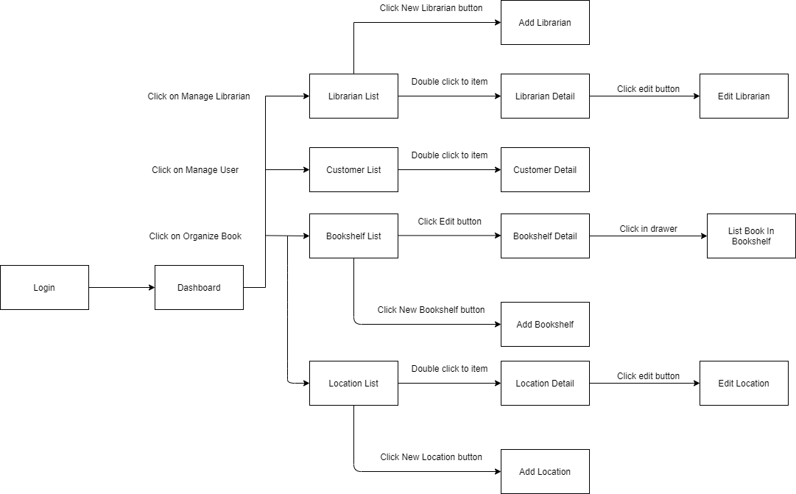

[*Figure 3 - <Admin> Web Application Screen Flow*](https://drive.google.com/file/d/1Ed1ol9jqNSSn5GLb2yABKotTkOdpD3no/view?usp=sharing)

##### <Librarian> Web Application Screen Flow

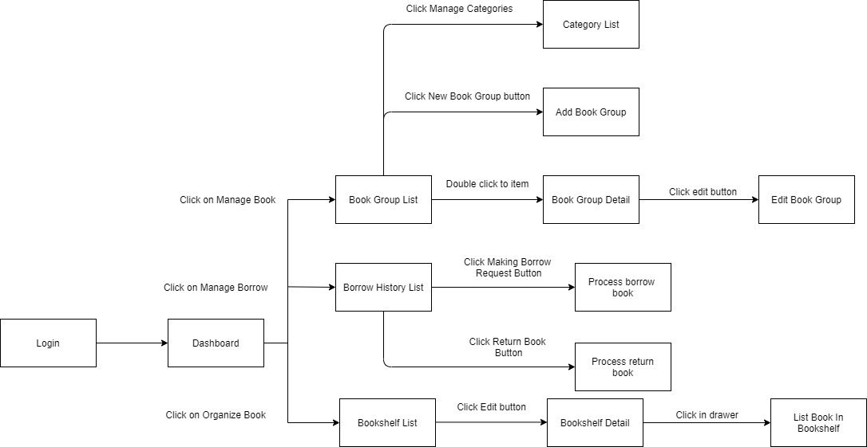

[*Figure 4 - <Librarian> Web Application Screen Flow*](https://drive.google.com/file/d/1WSxn9fGcdB9q74ah3C1KsZIked6oGvch/view?usp=sharing)

##### <Librarian> Mobile Application Screen Flow

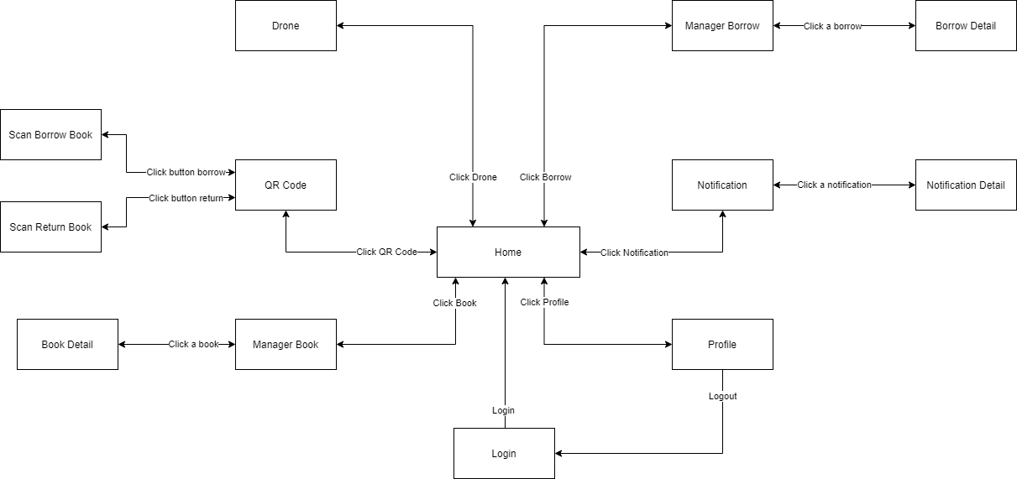

[*Figure 5 - <Librarian> Mobile Application Screen Flow*](https://drive.google.com/file/d/1pXos9aJCquZ1aiMbf5GTqOIv312BATcl/view?usp=sharing)

##### <Customer> Web Application Screen Flow

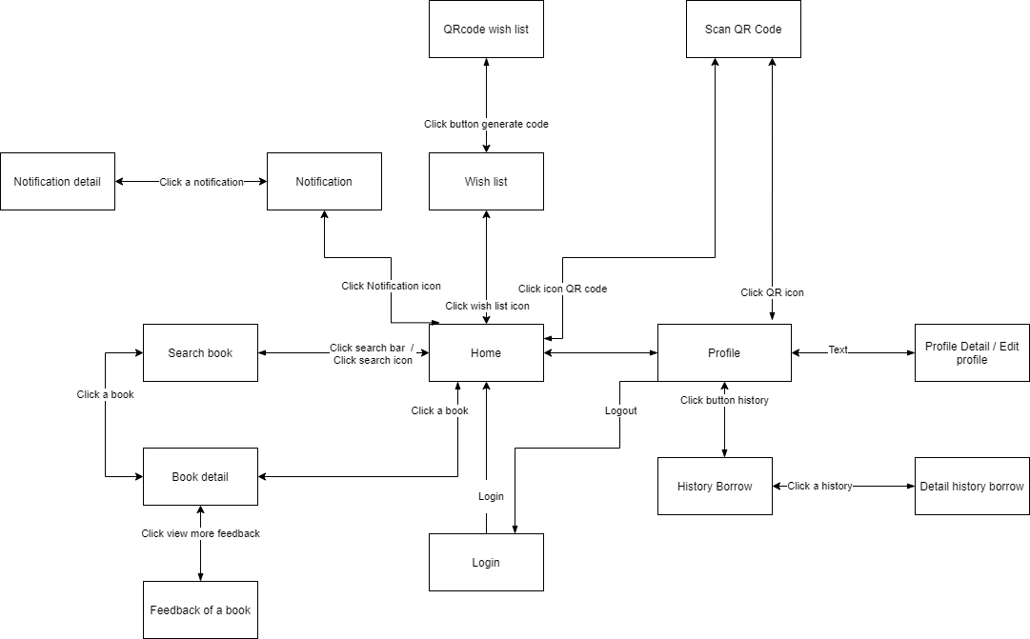

[*Figure 6 - <Customer> Mobile Application Screen Flow*](https://drive.google.com/file/d/1ZZBwSD1SDKMCjoQcQJ4fH0qZ6HqiEMu6/view?usp=sharing)

#### 3.1.2 Screen Details

##### 3.1.2.1 Web Application Admin Screen Details

|  |  |  |  |
| --- | --- | --- | --- |
| **Id** | **Feature** | **Screen** | **Description** |
|  |  |  |  |
|  |  |  |  |
|  |  |  |  |

##### 3.1.2.2 Web Application Librarian Screen Details

|  |  |  |  |
| --- | --- | --- | --- |
| **Id** | **Feature** | **Screen** | **Description** |
|  |  |  |  |
|  |  |  |  |
|  |  |  |  |

##### 3.1.2.3 Mobile Application Librarian Screen Details

|  |  |  |  |
| --- | --- | --- | --- |
| **Id** | **Feature** | **Screen** | **Description** |
|  |  |  |  |
|  |  |  |  |
|  |  |  |  |

##### 3.1.2.4 Mobile Application

|  |  |  |  |
| --- | --- | --- | --- |
| **Id** | **Feature** | **Screen** | **Description** |
|  |  |  |  |
|  |  |  |  |
|  |  |  |  |

#### Screen Authorization

|  |  |  |  |  |  |
| --- | --- | --- | --- | --- | --- |
| **Screen** | **Unauthenticated User** | **Authenticated User** | **Admin** | **Librarian** | **Customer** |
|  |  |  |  |  |  |
|  |  |  |  |  |  |
|  |  |  |  |  |  |
|  |  |  |  |  |  |
|  |  |  |  |  |  |
|  |  |  |  |  |  |
|  |  |  |  |  |  |
|  |  |  |  |  |  |
|  |  |  |  |  |  |
|  |  |  |  |  |  |
|  |  |  |  |  |  |
|  |  |  |  |  |  |

In which:

* Unauthenticated User: The user has no account or has not logged in system
* Authenticated User: The user who has logged in system successfully
* Admin: The user who manages location, bookshelf, librarian and customer
* Librarian: The user who manages books in library
* Customer: The user who borrows and returns book of library

#### Non-Screen Functions

|  |  |  |
| --- | --- | --- |
| **#** | **System Function** | **Description** |
| 1 | Check out customer | PAPV automatically checks out customer has checked-in in day at 00:00:00 AM every day |
| 2 | Detect Barcode, QR Code and character | PAPV detects Barcode, QR Code and character |
| 3 | Send notification | PAPV sends notification to customer when their borrow book is expiring before one day |
| 4 | Send video to server | Drone sends video to server |

#### Entity Relationship Diagram

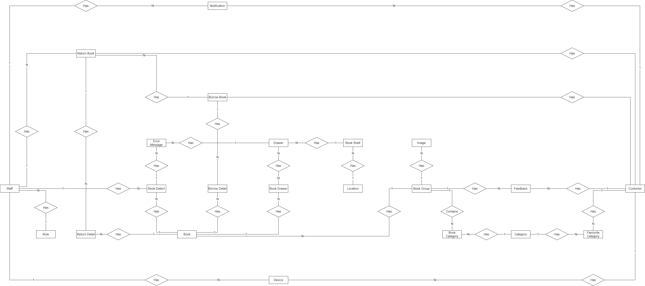

[*Figure 7 - Entity Relationship Diagram (without attributes)*](https://drive.google.com/file/d/1-cYZpe9ZTD95S4HrL3RUBlyRJSBxcRlp/view?usp=sharing)

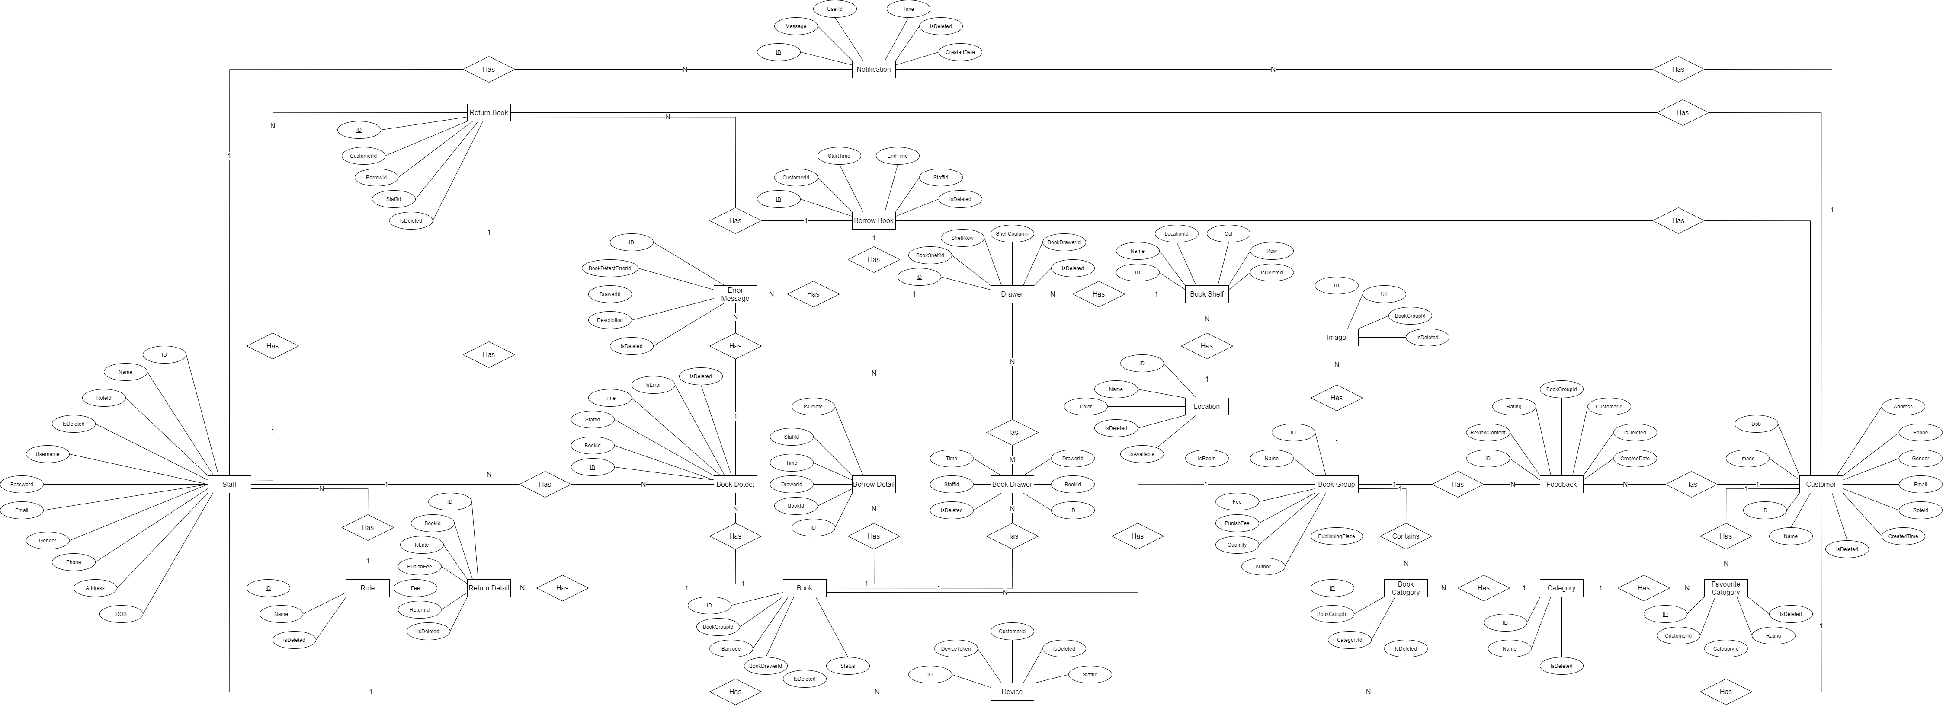

[*Figure 8 - Entity Relationship Diagram (with attributes)*](https://drive.google.com/file/d/1N2tnKgZQWCzH2v-niody4OtYY-jBaEXx/view?usp=sharing)

|  |  |  |
| --- | --- | --- |
| **#** | **Entity** | **Description** |
| 1 | Staff | Staff is an entity represents staff information that includes admin and librarian |
| 2 | Role | Role is an entity represents role information |
| 3 | Notification | Notification is an entity represents notification information |
| 4 | Customer | Customer is an entity represents customer information |
| 5 | Device | Device is an entity represents device information of user in the system |
| 6 | Return Book | Return book is an entity represents return book information |
| 7 | Return Detail | Return detail is an entity represents return book detail information |
| 8 | Borrow Book | Borrow book is an entity represents borrow book information |
| 9 | Book Detect | Borrow detect is an entity represents book detect information |
| 10 | Error Message | Error message is an entity represents error message information |
| 11 | Drawer | Drawer is an entity represents drawer information |
| 12 | Book Drawer | Book drawer is an entity represents book drawer information |
| 13 | Book Shelf | Book shelf is an entity represents book shelf information |
| 14 | Location | Location is an entity represents location information |
| 15 | Book | Book is an entity represents book information |
| 16 | Book Detail | Book detail is an entity represents book detail information |
| 17 | Book Group | Book group is an entity represents book group information |
| 18 | Image | Image is an entity represents image information |
| 19 | Feedback | Feedback is an entity represents feedback information |
| 20 | Book Category | Book category is an entity represents book category information |
| 21 | Category | Category is an entity represents category information |
| 22 | Favourite Category | Favourite Category is an entity represents favourite category information |

## 4. Non-Functional Requirements

### 4.1 External Interfaces

#### 4.1.1 User Interfaces

UI-1: GUI has to be friendly to use

UI-2: Language used in application is English

UI-3: UI can be responsive on multiple screen size

UI-4: Mobile application follow Material-UI design

UI-5: Web application follow Ant Design

#### 4.1.2 Software Interfaces

SI-1: File Storage Service

SI-1.1: PAPV can integrate with Firebase Storage Service and use its upload file API

SI-2: Real-time Message Transform Service

SI-2.1: PAPV can integrate with SignalR Real-time Message Transform Service to transform message between web application and mobile application

#### 4.1.3 Hardware Interfaces

PAPV System requires Drone to send video to system. Like other system, PAPV just requires basic devices for input, output as personal computer or laptop and smartphone. All of devices must have internet permission and camera permission for smartphone.

#### 4.1.4 Communications Interfaces

PAPV System’s communication interfaces depend on sending and retrieving data through online protocol to connect between applications.

### Quality Attributes

#### Usability

* Mobile UI/UX follows Material Design to be friendly with users
* Web Application follows Ant Design which is clear and easy to use
* Admin and librarian can use PAPV with less than a day of guidance
* Customer does not require to have technical knowledge before using.

#### Reliability

* PAPV failure is less than 5% and availability of the system is over 80%
* Mean time to hotfix and deploy is less than 6 hours

#### Performance

* Librarian’s mobile application scan QR Code to get customer’s book wish list with real time message transform SignalR needs under 5 seconds
* Customer’s mobile application scan QR Code to check-in needs under 3 seconds
* PAPV needs under 5 minutes to detect and notify book position tracking
* All common response time is under 3 seconds

#### 4.2.4 Dependability

##### 4.2.4.1 Security

* PAPV always checks authorization
* Each role can only access its own functions
* Account must be unique, password must be encrypted

##### 4.2.4.2 Safety

* Librarian cannot change borrow fee of borrowing book

#### 4.2.3 Supportability

* Beside web application for Librarian, PAPV support a group of functions to Librarian on mobile application

#### Design Constraints

* Application language is English
* Application uses TypeScripts to increase maintainability

#### Support Documents

* PAPV does not support o-line user documentation

#### Purchased Components

* IIS Server
* Firebase Storage
* Firebase Notification
* Google Colab

## 5. Other Requirements

### 5.1 Messages List

|  |  |  |  |  |
| --- | --- | --- | --- | --- |
| **#** | **Message code** | **Message Type** | **Context** | **Content** |
| 1 | MSG01 | In line, under input form, red text | "Username" input field and "Password" input field is empty | Username and Password must not empty |
| 2 | MSG02 | In line, under input form, red text | Account with user name and password not exist in PAPV | Username and Password not correct |
| 3 | MSG03 | in line, popup, black text | Librarian request to tracking | Use drone to start tracking |
| 4 | MSG04 | in line, popup, black text | Admin successful create bookshelf | Successful created bookshelf |
| 5 | MSG05 | in line, popup, black text | Required field in input form is empty | Required must not empty |
| 6 | MSG06 | in line, text field, green text | All book in book shelf are correct position | All book are correct position |
| 7 | MSG07 | in line, text field, red text | One book in book shelf are wrong position | The book with {id} is wrong position |
| 8 | MSG08 | in line, text field, red text | One book in book shelf was lost | The book with {id} was lost |
| 9 | MSG09 | in line, text field, red text | Row or Column in create bookshelf form is less than 0 | Row and Column must be upper than 0 |
| 10 | MSG10 | in line, text field, grey text | No data in PAPV | No data |