# III. System Requirement Specification

## 1. Overall Description

## 2. User Requirements

### Overview

### User case specification

### 2.3 User case specification (Mobile)

#### 2.3.1 <Unauthenticated User> Overview Use Case

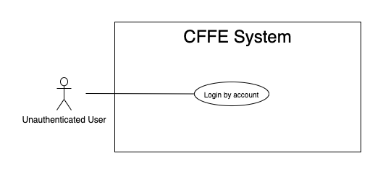

*Figure 2 - <Overview Use Case> Unauthenticated User*

##### 2.3.1.1 <Unauthenticated User> Login by account



*Figure 3 - <Use Case> Login by account*

|  |  |  |  |
| --- | --- | --- | --- |
| ID and Name: | **UC-01 Login by account** | | |
| Created By: | TruongTN | Date Created: | 25/06/2021 |
| Primary Actor: | Unauthenticated User | Secondary Actors: | N/A |
| Description: | This feature allows the unauthenticated user to login to CFFE system to verify the role and gives them access to more features. | | |
| Trigger: | Unauthenticated User sends a request to login to CFFE system. | | |
| Pre-conditions: | PRE-01. User's account has been created.  PRE-02. User's account has been authorized as Admin or Manager role.  PRE-03. User has not logged in to CFFE system. | | |
| Post-conditions: | POST-01:   * Success: User logins to CFFE system with own role successfully and redirect to "Dashboard" page. * Fail: CFFE system shows error message. | | |
| Normal Flow: | **1.0 Login by account**   1. Unauthenticated User send a request to login to the CFFE system. 2. CFFE system shows required form that includes:  * “Username”: input text * “Password”: input text * “Login”: button  1. Unauthenticated User inputs the required fields. 2. Unauthenticated User clicks on “Login” button. 3. CFFE system validates the username and password. (Exception 1.0.E1, 1.0.E2) 4. CFFE system determines the user’s identity, role, and permission then redirects to the manager page. | | |
| Alternative Flows: | N/A | | |
| Exceptions: | **1.0.E1 Unauthenticated User does not enter the required fields**   1. CFFE system returns to Unauthenticated User to fill the required fields again (MSG-001, MSG-002). 2. If Unauthenticated User inputs the required fields again, CFFE system returns to step 3 of the normal flow. 3. Else if Unauthenticated User cancels the login process, then CFFE system terminates this use case.   **1.0.E2 Unauthenticated User enters wrong username or password.**   1. CFFE system returns to Unauthenticated User to fill the required fields again (MSG-003). 2. If Unauthenticated User inputs username and password again, CFFE system returns to step 3 of the normal flow. 3. Else if Unauthenticated User cancels the login process, then CFFE system terminates this use case. | | |
| Priority: | High | | |
| Frequency of Use: | Always | | |
| Business Rules: | BR-001, BR-002, BR-007 | | |
| Other Information: | In case of internet connection failure, Unauthenticated User cannot finish this use case. | | |
| Assumptions: | N/A | | |

*Table 4 - <Use Case> Login by account*

#### 2.3.2 <Authenticated User> Overview Use Case

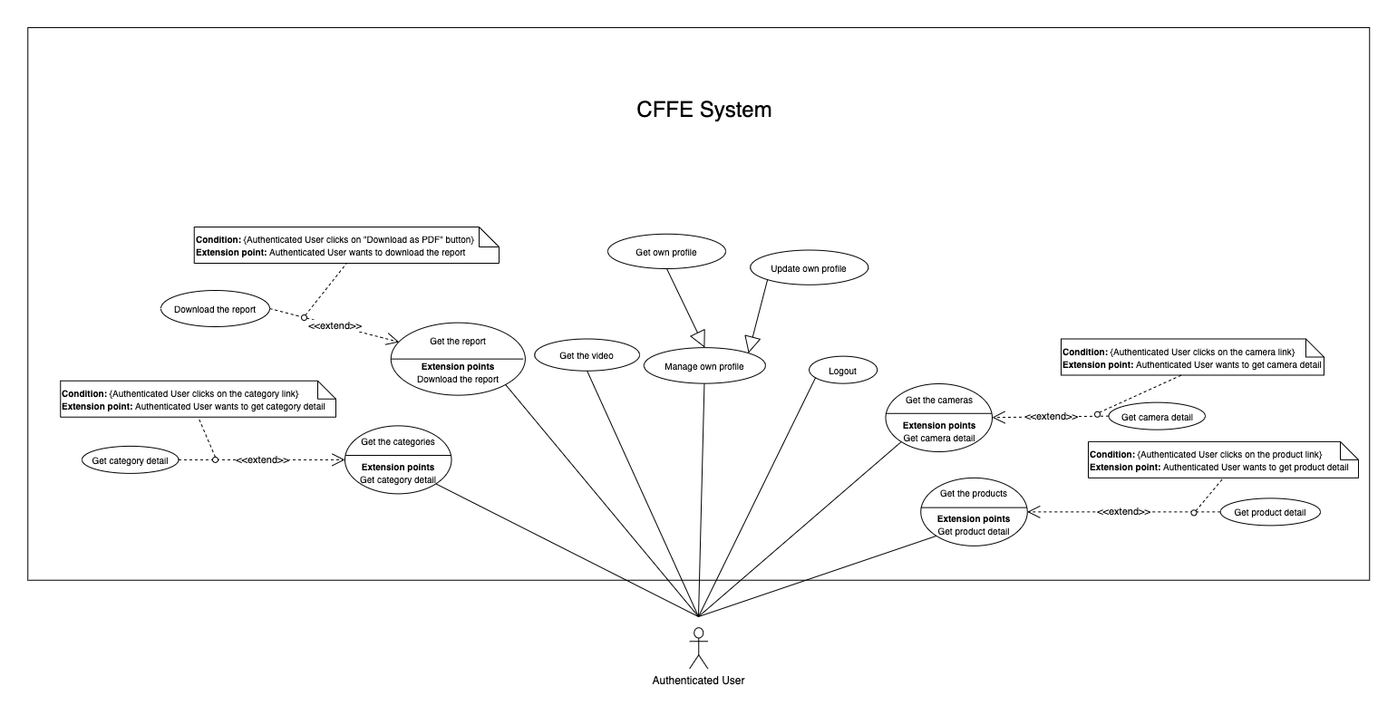

*Figure 4 - <Overview Use Case> Authenticated User*

##### 2.3.2.1 <Authenticated User> Logout

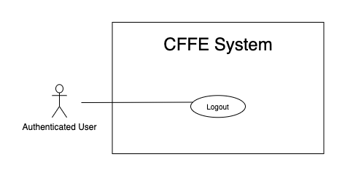

*Figure 5 - <Use Case> Logout*

|  |  |  |  |
| --- | --- | --- | --- |
| ID and Name: | **UC-02 Logout** | | |
| Created By: | TruongTN | Date Created: | 25/06/2021 |
| Primary Actor: | Authenticated User | Secondary Actors: | N/A |
| Description: | This feature allows the authenticated user to log out from CFFE system. | | |
| Trigger: | Authenticated user sends a request to log out from CFFE system. | | |
| Pre-conditions: | PRE-01. User has logged into CFFE system. | | |
| Post-conditions: | POST-01. User has successfully logged out CFFE system. | | |
| Normal Flow: | **2.0 Logout**   1. Authenticated user clicks on “Logout” button of the navigation bar. 2. CFFE system deletes information on their local storage and cookie. 3. CFFE system redirects to the login page. | | |
| Alternative Flows: | N/A | | |
| Exceptions: | N/A | | |
| Priority: | Medium | | |
| Frequency of Use: | Usually | | |
| Business Rules: | BR-004, BR-005, BR-006 | | |
| Other Information: | In case of internet connection failure, Authenticated User cannot finish this use case. | | |
| Assumptions: | N/A | | |

*Table 5 - <Use Case> Logout*

##### 2.3.2.2 <Authenticated User> Get own profile

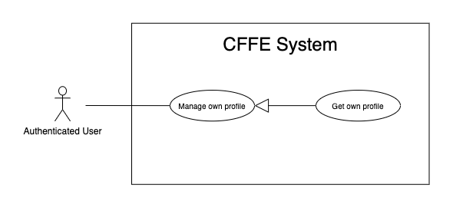

*Figure 43 - <Use Case> Get own profile*

|  |  |  |  |
| --- | --- | --- | --- |
| ID and Name: | **UC-03 Get own profile** | | |
| Created By: | HuuDN | Date Created: | 17/06/2021 |
| Primary Actor: | Authenticated User | Secondary Actors: | N/A |
| Description: | This feature allows the authenticated user to get own profile. | | |
| Trigger: | Authenticated User sends a request to get own profile. | | |
| Preconditions: | PRE-01. User has logged into CFFE system. | | |
| Post-conditions: | POST-01:   * Success: CFFE system redirects to own profile page. * Fail: CFFE system shows error message. | | |
| Normal Flow: | **3.0 Get own profile**   1. Authenticated User clicks on "Profile" button of the navigation bar. 2. CFFE system returns own information and redirects to the profile page. (Exception 3.0.E1) | | |
| Alternative Flows: | N/A | | |
| Exceptions: | **3.0.E1 Authenticated User does not exist.**  1. CFFE system returns the message (MSG-041) and terminates this use case. | | |
| Priority: | Normal | | |
| Frequency of Use: | Sometime | | |
| Business Rules: | N/A | | |
| Other Information: | In case of internet connection failure, Authenticated User cannot finish this use case properly. | | |
| Assumptions: | N/A | | |

*Table 42 - <Use Case> Get own profile*

##### 2.3.2.3 <Authenticated User> Update own profile

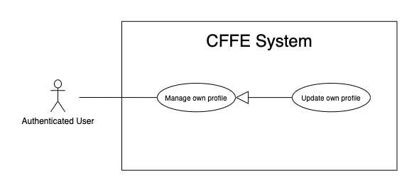

*Figure 44 - <Use Case> Update own profile*

|  |  |  |  |
| --- | --- | --- | --- |
| ID and Name: | **UC-04 Update own profile** | | |
| Created By: | HuuDN | Date Created: | 17/06/2021 |
| Primary Actor: | Authenticated User | Secondary Actors: | N/A |
| Description: | This feature allows the authenticated user to update own profile. | | |
| Trigger: | Authenticated User sends a request to update own profile. | | |
| Preconditions: | PRE-01. User has logged in CFFE system.  PRE-02. User is on “Profile” page. | | |
| Post-conditions: | POST-01:   * Success: CFFE system shows success message and reloads "Profile" page. * Fail: CFFE system shows error message. | | |
| Normal Flow: | **4.0 Update information** (Alternative 4.0, 4.1)   1. Authenticated User clicks on "Update Information" button. 2. CFFE system redirects to the update information page and shows required form that includes:  * “Full name”: input text * “Gender”: radio button * “Birthday”: date picker * “Identity card”: input text * “Phone number”: input text * “Email”: input text * “Address”: input text * “City”: select box * “District”: select box * “Back”: button * “Save”: button  1. Authenticated User inputs the required fields. 2. Authenticated User clicks on “Save” button. (Alternative 4.2) 3. CFFE system validates the fields (Exception 4.0.E1, 4.0.E2) 4. CFFE system updates own information and redirects to the profile page with the success message (MSG-013). | | |
| Alternative Flows: | **4.0 Update Avatar**   1. Authenticated User clicks on "Change avatar" button. 2. CFFE system redirects to the change avatar page and shows required form that includes:    * "Choose": button    * "Save": button    * "Back": button 3. Authenticated User clicks on "Choose" button and selects an image. 4. Authenticated User clicks on "Save" button. (Alternative 4.2) 5. CFFE system validates the image (Exception 4.0.E3, 4.0.E4, 4.0.E7) 6. CFFE system updates own avatar and redirects to the profile page with the success message (MSG-013).   **4.1 Update password**   1. Authenticated User clicks on "Change password" button. 2. CFFE system redirects to change password page requires form that includes:    * "Old password": input text    * "New password": input text    * "Retype password": input text    * "Update": button    * "Back": button 3. Authenticated User inputs/selects the fields. 4. Authenticated User clicks on "Update" button. (Alternative 4.2) 5. CFFE system validates the image (Exception 4.0.E5, 4.0.E6) 6. CFFE system updates own password and redirects to the profile page with the success message (MSG-013).   **4.2 Authenticated User cancels the updating process.**   1. Authenticated User clicks on "Back" button. 2. CFFE system redirects to the profile page and terminates this use case. | | |
| Exceptions: | **4.0.E1 Authenticated User does not input/select the required fields**   1. CFFE system returns to Authenticated User to input/select the required fields again (MSG-014, MSG-036, MSG-038, MSG-039, MSG-049, MSG-044, MSG-047, MSG-051, MSG-054). 2. If Authenticated User inputs/selects the required fields again, CFFE system returns to step 3 of the normal flow. 3. Else if Authenticated User cancels the updating process, then CFFE system terminates this use case.   **4.0.E2 Authenticated User inputs/selects the fields that are not valid**   1. CFFE system returns to Authenticated Users to input/select the fields again (MSG-015, MSG-037, MSG-042, MSG-045, MSG-052, MSG-073). 2. If Authenticated User inputs/selects the fields again, CFFE system returns to step 3 of the normal flow. 3. Else if Authenticated User cancels the updating process, then CFFE system terminates this use case.   **4.0.E3 Authenticated User does not select an image**   1. CFFE system will not show “Save” button until User select an image. 2. If Authenticated User click on “Choose” button, CFFE system returns to step 4 of the alternative flow 4.0. 3. Else if Authenticated User cancels the updating process, then CFFE system terminates this use case.   **4.0.E4 Image is not png/jpg/jpeg format.**   1. CFFE system shows message (MSG-027) and terminates this use case.   **4.0.E5 Authenticated User does not input the required fields**   1. CFFE system returns to Authenticated User to input/select the required fields again (MSG-004, MSG-005, MSG-006). 2. If Authenticated User inputs/selects the required fields again, CFFE system returns to step 3 of the alternative flow 4.1. 3. Else if Authenticated User cancels the updating process, then CFFE system terminates this use case.   **4.0.E6 Authenticated User inputs the fields that are not valid**   1. CFFE system returns to Authenticated Users to input/select the fields again (MSG-007, MSG-008, MSG-068). 2. If Authenticated User inputs/selects the fields again, CFFE system returns to step 3 of the alternative flow 4.1. 3. Else if Authenticated User cancels the updating process, then CFFE system terminates this use case.   **4.0.E7 CFFE system cannot upload the image.**   1. CFFE system shows error message (MSG-114) and terminates this use case. | | |
| Priority: | Medium | | |
| Frequency of Use: | Often | | |
| Business Rules: | BR-032, BR-034, BR-060 | | |
| Other Information: | In case of internet connection failure, Authenticated User cannot finish this use case properly. | | |
| Assumptions: | N/A | | |

*Table 37 - <Use Case> Update own profile*

##### 2.3.2.4 <Authenticated User> Get the report

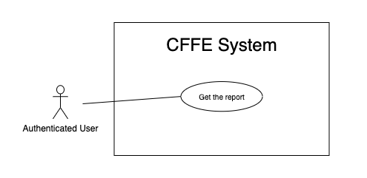

*Figure 7 - <Use Case> Get the report*

|  |  |  |  |
| --- | --- | --- | --- |
| ID and Name: | **UC-05 Get the report** | | |
| Created By: | HuuDN | Date Created: | 15/06/2021 |
| Primary Actor: | Authenticated User | Secondary Actors: | N/A |
| Description: | This feature allows the Authenticated User to get the report. | | |
| Trigger: | Authenticated User sends a request to get the report. | | |
| Preconditions: | PRE-01. User has logged into CFFE system as admin or manager role. | | |
| Post-conditions: | POST-01. Authenticated User has successfully got the report. | | |
| Normal Flow: | **5.0 Get the facial expression analysis report** (Alternative 5.0)   1. Authenticated User clicks on "Dashboard" button on the navigation bar. 2. CFFE system requires the report's information from Authenticated User:  * “Product name”: select box * “Store name”: select box * “Date rage”: date range picker  1. Authenticated User selects the fields. 2. CFFE system returns the reports (Exception 5.0.E1). | | |
| Alternative Flows: | **5.0 Get the counting customer report**   1. Authenticated User clicks on "Dashboard" button of the navigation bar. 2. Authenticated User clicks on "Counting customer" button on the left-bottom navigation bar of the frame. 3. CFFE system requires the report's information from Authenticated User:  * “Store name”: select box * “Shelf name”: select box * “Date rage”: date range picker  1. Authenticated User selects the fields. 2. CFFE system returns the reports (Exception 5.0.E1). | | |
| Exceptions: | **5.0.E1 The report has no data.**   1. CFFE system returns the message (MSG-009). | | |
| Priority: | High | | |
| Frequency of Use: | Often | | |
| Business Rules: | BR-013, BR-014, BR-016 | | |
| Other Information: | In case of internet connection failure, Authenticated User cannot finish this use case properly. | | |
| Assumptions: | N/A | | |

*Table 7 - <Use Case> Get the report*

##### 2.3.2.5 <Authenticated User> Download the report

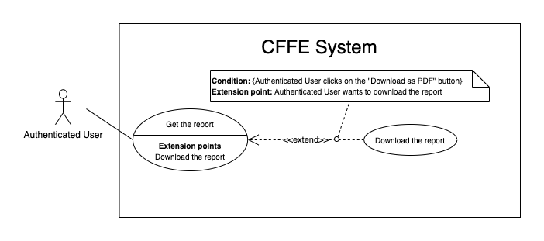

*Figure 8 - <Use Case> Download the report*

|  |  |  |  |
| --- | --- | --- | --- |
| ID and Name: | **UC-06 Download the report** | | |
| Created By: | HuuDN | Date Created: | 18/06/2021 |
| Primary Actor: | Authenticated User | Secondary Actors: | N/A |
| Description: | This feature allows Authenticated User to download the report. | | |
| Trigger: | Authenticated User sends a request to download the report. | | |
| Preconditions: | PRE-01. User has logged into CFFE system as admin or manager role.  PRE-02. Authenticated User on "Dashboard" page. | | |
| Post-conditions: | POST-01. Authenticated User has successfully downloaded the report. | | |
| Normal Flow: | **6.0 Download the report**   1. Authenticated User right clicks on "Dashboard" page. 2. Authenticated User clicks on "Download as PDF" 3. CFFE system shows the popup that includes:    * "All pages": radio button    * "Select pages": radio button    * "Additional Options": dropdown list      + "Ignore custom background color": check box      + "Add a link back to report": check box      + "Password protect report": check box    * "Download": button    * "Cancel": button 4. Authenticated User selects that fields 5. Authenticated User clicks on "Download" button. (Alternative 6.0, 6.1) 6. CFFE system downloads this report on client-side. | | |
| Alternative Flows: | **6.0 Authenticated User cancels the downloading process.**   1. Authenticated User clicks on "Cancel" button. 2. CFFE system closes this popup and terminates this use case.   **6.1 Authenticated User clicks outside of popup.**   1. Authenticated User clicks outside of popup. 2. CFFE system closes this popup and terminates this use case. | | |
| Exceptions: | N/A | | |
| Priority: | High | | |
| Frequency of Use: | Often | | |
| Business Rules: | BR-008, BR-009. | | |
| Other Information: | In case of internet connection failure, Authenticated User cannot finish this use case properly. | | |
| Assumptions: | N/A | | |

*Table 8 - <Use Case> Download the report*

##### 2.3.2.6 <Authenticated User> Get the video

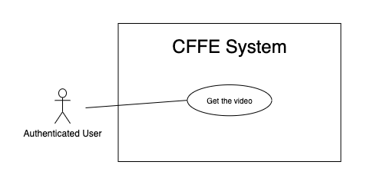

*Figure 9 - <Use Case> Get the video*

|  |  |  |  |
| --- | --- | --- | --- |
| ID and Name: | **UC-07 Get the video** | | |
| Created By: | HuuDN | Date Created: | 11/06/2021 |
| Primary Actor: | Authenticated User | Secondary Actors: | N/A |
| Description: | This feature allows Authenticated User to get the video. | | |
| Trigger: | Authenticated User sends a request to get the video. | | |
| Preconditions: | PRE-01. User has logged into CFFE system as admin or manager role. | | |
| Post-conditions: | POST-01. Authenticated User has successfully got the video. | | |
| Normal Flow: | **7.0 Get the video**   1. Authenticated User clicks on "Video" button on the navigation bar. 2. CFFE system requires the video's information from Authenticated User:  * “Start Date”: text input * “End Date”: text input * “Counting”: check box * “Emotion”: check box * “Store”: select box * “Shelf”: select box * “Product”: select box  1. Authenticated User inputs/selects the fields. 2. CFFE system returns the corresponding videos (Exception 7.0.E1). | | |
| Alternative Flows: | N/A | | |
| Exceptions: | **7.0.E1 The video list has no data.**   1. CFFE system returns the message (MSG-009). | | |
| Priority: | High | | |
| Frequency of Use: | Often | | |
| Business Rules: | BR-010, BR-011, BR-021 | | |
| Other Information: | In case of internet connection failure, Authenticated User cannot finish this use case properly. | | |
| Assumptions: | N/A | | |

*Table 9 - <Use Case> Get the video*

##### 2.3.3.7 <Authenticated User> Get the products

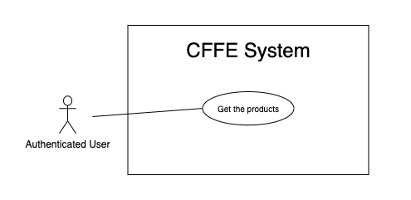

*Figure 22 - <Use Case> Get the products*

|  |  |  |  |
| --- | --- | --- | --- |
| ID and Name: | **UC-08 Get the products** | | |
| Created By: | HieuNT | Date Created: | 08/05/2021 |
| Primary Actor: | Authenticated User | Secondary Actors: | N/A |
| Description: | This feature allows authenticated user to get the products. | | |
| Trigger: | Authenticated user sends a request to get the products. | | |
| Pre-conditions: | PRE-01. User has logged into the system as admin or manager role. | | |
| Post-conditions: | POST-01. CFFE system returns the list of products. | | |
| Normal Flow: | **8.0 Get the products**   1. Authenticated User clicks on "Product" button on the navigation bar. 2. CFFE system requires the product information:  * “Product name”: input text * “Status”: select box  1. Authenticated user inputs/selects the fields: product name, status. 2. CFFE system returns the list of products based on below conditions and display them (Exception 8.0.E1). | | |
| Alternative Flows: | N/A | | |
| Exceptions: | **8.0.E1 The list of product has no data.**   1. CFFE system returns the message (MSG-009). | | |
| Priority: | High | | |
| Frequency of Use: | Usually | | |
| Business Rules: | BR-044, BR-045 | | |
| Other Information: | In case of internet connection failure, authenticated user cannot finish this use case properly. | | |
| Assumptions: | N/A | | |

*Table 21 - <Use Case> Get the products*

##### 2.3.3.8 <Authenticated User> Get product detail

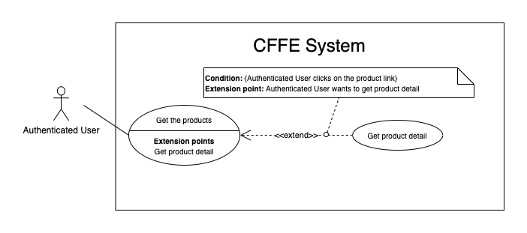

*Figure 23 - <Use Case> Get product detail*

|  |  |  |  |
| --- | --- | --- | --- |
| ID and Name: | **UC-09 Get product detail** | | |
| Created By: | HieuNT | Date Created: | 10/05/2021 |
| Primary Actor: | Authenticated User | Secondary Actors: | N/A |
| Description: | This feature allows the authenticated user to getproductdetail. | | |
| Trigger: | Authenticated user sends a request to get product detail. | | |
| Preconditions: | PRE-01. User has logged in the system as admin or manager role.  PRE-02. There is at least one product link. | | |
| Post-conditions: | POST-01:   * Success: CFFE system redirects to "Product Detail" page. * Fail: CFFE system shows error message. | | |
| Normal Flow: | **9.0 Get product detail**   1. Authenticated user clicks on the product item. 2. CFFE system validates the product exists (Exception 19.0.E1) 3. CFFE system returns the product information and redirects to product detail page. | | |
| Alternative Flows: | N/A | | |
| Exceptions: | **9.0.E1 The product does not exist.**  1. CFFE system returns the message (MSG-023) and terminates this use case. | | |
| Priority: | High | | |
| Frequency of Use: | Usually | | |
| Business Rules: | BR-046 | | |
| Other Information: | In case of internet connection failure, Authenticated user cannot finish this use case properly. | | |
| Assumptions: | N/A | | |

*Table 22 - <Use Case> Get product detail*

##### 2.3.3.9 <Authenticated User> Get the categories

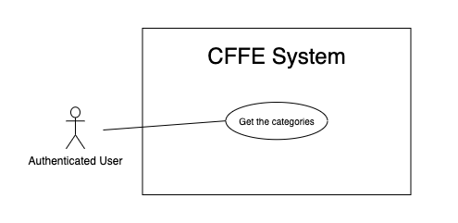

*Figure 32 - <Use Case> Get the categories*

|  |  |  |  |
| --- | --- | --- | --- |
| ID and Name: | **UC-10 Get the categories** | | |
| Created By: | TruongTN | Date Created: | 08/05/2021 |
| Primary Actor: | Authenticated user | Secondary Actors: | N/A |
| Description: | This feature allows manager to get the categories. | | |
| Trigger: | Authenticated user sends a request to get the categories. | | |
| Pre-conditions: | PRE-01. User has logged into the system as admin or manager role. | | |
| Post-conditions: | POST-01. CFFE system returns the list of categories. | | |
| Normal Flow: | **10.0 Get the categories**   1. Authenticated user clicks on "Category" button on the navigation bar. 2. CFFE system requires the category information:  * “Category name”: input text * “Status”: select box  1. Authenticated user inputs/selects the fields 2. CFFE system returns the list of categories based on below conditions and display them (Exception 10.0.E1). | | |
| Alternative Flows: | N/A | | |
| Exceptions: | **10.0.E1 The list of categories has no data.**   1. CFFE system returns the message (MSG-009). | | |
| Priority: | High | | |
| Frequency of Use: | Usually | | |
| Business Rules: | BR-013, BR-062 | | |
| Other Information: | In case of internet connection failure, authenticated user cannot finish this use case properly. | | |
| Assumptions: | N/A | | |

*Table 31 - <Use Case> Get the categories*

##### 2.3.3.10 <Authenticated User> Get category detail

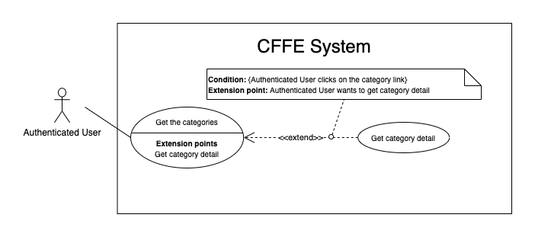

*Figure 33 - <Use Case> Get category detail*

|  |  |  |  |
| --- | --- | --- | --- |
| ID and Name: | **UC-11 Get category detail** | | |
| Created By: | HuuDN | Date Created: | 10/05/2021 |
| Primary Actor: | Authenticated User | Secondary Actors: | N/A |
| Description: | This feature allows the authenticated user to getcategorydetail. | | |
| Trigger: | Authenticated user sends a request to get categorydetail. | | |
| Preconditions: | PRE-01. User has logged in the system as admin or manager role.  PRE-02. User is on "Category" page. | | |
| Post-conditions: | POST-01:   * Success: CFFE system returns category detail successfully. * Fail: CFFE system shows error message. | | |
| Normal Flow: | **11.0 Get category detail**   1. Authenticated user clicks on the category item. 2. CFFE system validates the categoryexists (Exception 11.0.E1) 3. CFFE system returns the category information and redirects to “Category Detail” page. | | |
| Alternative Flows: | N/A | | |
| Exceptions: | **11.0.E1 The category does not exist.**  1. CFFE system returns the message (MSG-029) and terminates this use case.  **11.0.E2 The list of products that belong to this category has no data.**  1. CFFE system returns the message (MSG-009). | | |
| Priority: | High | | |
| Frequency of Use: | Usually | | |
| Business Rules: | BR-062 | | |
| Other Information: | In case of internet connection failure, Authenticated User cannot finish this use case properly. | | |
| Assumptions: | N/A | | |

*Table 32 - <Use Case> Get category detail*

##### 2.3.3.11 <Authenticated User> Get the cameras

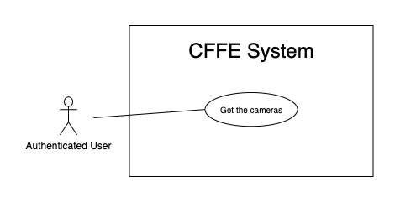

*Figure 27 - <Use Case> Get the cameras*

|  |  |  |  |
| --- | --- | --- | --- |
| ID and Name: | **UC-12 Get the cameras** | | |
| Created By: | HuuDN | Date Created: | 08/05/2021 |
| Primary Actor: | Authenticated user | Secondary Actors: | N/A |
| Description: | This feature allows authenticated user to get the cameras. | | |
| Trigger: | Authenticated user sends a request to get the cameras. | | |
| Pre-conditions: | PRE-01. User has logged into the system as admin or manager role. | | |
| Post-conditions: | POST-01. CFFE system returns the list of cameras. | | |
| Normal Flow: | **12.0 Get the cameras**   1. Authenticated user clicks on "Camera" button on the navigation bar. 2. CFFE system requires the camera information:  * “Camera name”: input text * “Status”: select box  1. Authenticated user inputs/selects the fields. 2. CFFE system returns the list of cameras based on below conditions and display them (Exception 12.0.E1). | | |
| Alternative Flows: | N/A | | |
| Exceptions: | **12.0.E1 The list of cameras has no data.**   1. CFFE system returns the message (MSG-009). | | |
| Priority: | High | | |
| Frequency of Use: | Usually | | |
| Business Rules: | BR-052, BR-053, BR-056 | | |
| Other Information: | In case of internet connection failure, authenticated user cannot finish this use case properly. | | |
| Assumptions: | N/A | | |

*Table 26 - <Use Case> Get the cameras*

##### 2.3.3.11 <Authenticated User> Get camera detail

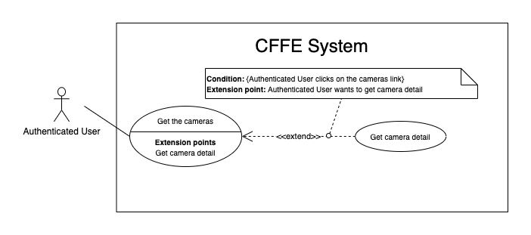

*Figure 28 - <Use Case> Get camera detail*

|  |  |  |  |
| --- | --- | --- | --- |
| ID and Name: | **UC-13 Get camera detail** | | |
| Created By: | HuuDN | Date Created: | 10/05/2021 |
| Primary Actor: | Authenticated User | Secondary Actors: | N/A |
| Description: | This feature allows the authenticated user to getcameradetail. | | |
| Trigger: | Authenticated User sends a request to get camera detail. | | |
| Preconditions: | PRE-01. User has logged in the system as admin or manager role.  PRE-02. There is at least one camera link. | | |
| Post-conditions: | POST-01:   * Success: CFFE system returns camera detail successfully and redirects to "Camera Detail" page. * Fail: CFFE system shows error message. | | |
| Normal Flow: | **13.0 Get camera detail**   1. Authenticated User clicks on the camera item. 2. CFFE system validates the camera exists (Exception 13.0.E1, 13.1.E1). 3. CFFE system returns the camera information and redirects to ”Camera Detail” page. | | |
| Alternative Flows: | N/A | | |
| Exceptions: | **13.0.E1 The camera does not exist.**  1. CFFE system returns the message (MSG-009) and terminates this use case.  **13.1.E1 The camera access is not allowed.**  1. CFFE system returns the message (MSG-120) and terminates this use case. | | |
| Priority: | High | | |
| Frequency of Use: | Usually | | |
| Business Rules: | BR-022, BR-054, BR-056 | | |
| Other Information: | In case of internet connection failure, Authenticated User cannot finish this use case properly. | | |
| Assumptions: | N/A | | |

*Table 27 - <Use Case> Get camera detail*

#### 2.3.3 <Manager> Overview Use Case

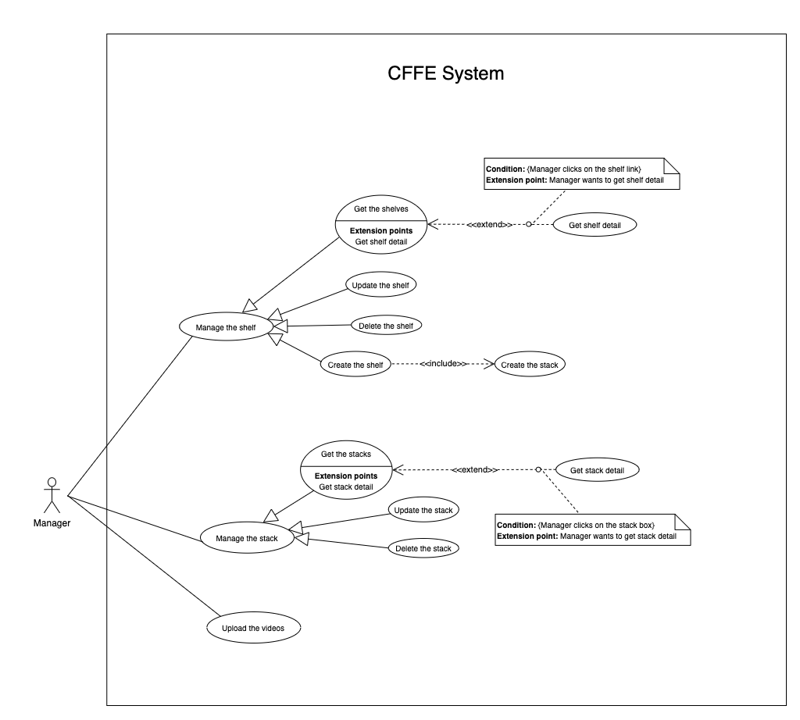

*Figure 11 - <Overview Use Case> Manager*

##### 2.3.3.1 <Manager> Get the shelves

*Figure 12 - <Use Case> Get the shelves*

|  |  |  |  |
| --- | --- | --- | --- |
| ID and Name: | **UC-14 Get the shelves** | | |
| Created By: | TruongTN | Date Created: | 08/05/2021 |
| Primary Actor: | Manager | Secondary Actors: | N/A |
| Description: | This feature allows the manager to get the shelves. | | |
| Trigger: | Manager sends a request to get the shelves. | | |
| Pre-conditions: | PRE-01. User has logged into the system as manager role.  PRE-02. Manager is managing a store. | | |
| Post-conditions: | POST-01. CFFE system returns the list of shelves. | | |
| Normal Flow: | **14.0 Get the shelves**   1. Manager clicks on "Shelf" button on the navigation bar. 2. CFFE system requires the shelf information:  * “Shelf name”: input text * “Status”: select box  1. Manager inputs/selects the fields. 2. CFFE system returns the shelves based on below conditions and display them (Exception 14.0.E1). | | |
| Alternative Flows: | N/A | | |
| Exceptions: | **14.0.E1 The list of shelves has no data.**   1. CFFE system returns the message (MSG-009). | | |
| Priority: | High | | |
| Frequency of Use: | Usually | | |
| Business Rules: | BR-026, BR-027, BR-048 | | |
| Other Information: | In case of internet connection failure, Manager cannot finish this use case properly. | | |
| Assumptions: | N/A | | |

*Table 11 - <Use Case> Get the shelves*

##### 2.3.3.2 <Manager> Get shelf detail

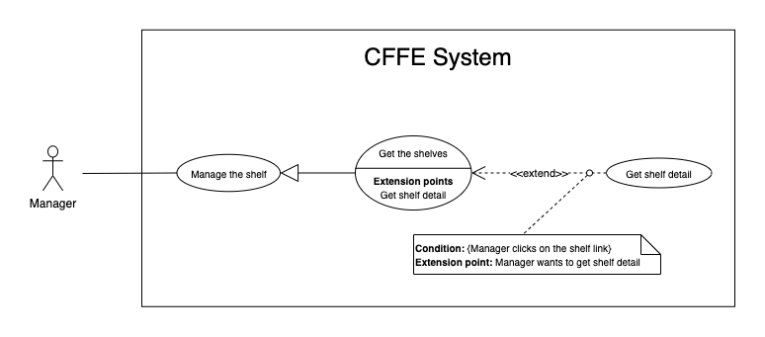

*Figure 13 - <Use Case> Get shelf detail*

|  |  |  |  |
| --- | --- | --- | --- |
| ID and Name: | **UC-15 Get shelf detail** | | |
| Created By: | TruongTN | Date Created: | 10/05/2021 |
| Primary Actor: | Manager | Secondary Actors: | N/A |
| Description: | This feature allows the Manager to get shelf detail. | | |
| Trigger: | Manager sends a request to get shelf detail. | | |
| Preconditions: | PRE-01. User has logged in the system as manager role.  PRE-02. There is at least one shelf link. | | |
| Post-conditions: | POST-01:   * Success: CFFE system returns shelf detail successfully and redirects to "Shelf Detail" page. * Fail: CFFE system shows error message. | | |
| Normal Flow: | **15.0 Get shelf detail**   1. Manager clicks on the shelf item. 2. CFFE system validates the shelf exists (Exception 15.0.E1) 3. CFFE system returns the shelf information and redirects to “Shelf Detail” page. | | |
| Alternative Flows: | N/A | | |
| Exceptions: | **15.0.E1 The shelf does not exist.**  1. CFFE system returns the message (MSG-009) and terminates this use case. | | |
| Priority: | High | | |
| Frequency of Use: | Usually | | |
| Business Rules: | BR-028, BR-048 | | |
| Other Information: | In case of internet connection failure, Manager cannot finish this use case properly. | | |
| Assumptions: | N/A | | |

*Table 12 - <Use Case> Get shelf detail*

##### 2.3.3.3 <Manager> Update the shelf

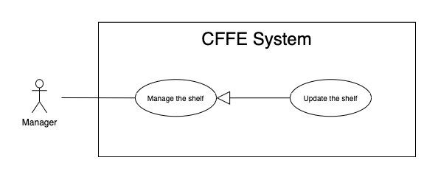

*Figure 14 - <Use Case> Update the shelf*

|  |  |  |  |
| --- | --- | --- | --- |
| ID and Name: | **UC-16 Update the shelf** | | |
| Created By: | TruongTN | Date Created: | 18/06/2021 |
| Primary Actor: | Manager | Secondary Actors: | N/A |
| Description: | This feature allows Manager to update shelf in CFFE system. | | |
| Trigger: | Manager sends a request to update the shelf. | | |
| Preconditions: | PRE-01. User has logged in the system as manager role.  PRE-02. Manager is on “Shelf detail” page. | | |
| Post-conditions: | POST-01:   * Success: CFFE system shows success message and reloads "Shelf Detail" page. * Fail: CFFE system shows error message. | | |
| Normal Flow: | **16.0 Update the shelf information** (Alternative 16.0, 16.1, 16.2)   1. Manager clicks on "Update Information". 2. CFFE system redirects to “Update Shelf” page and shows required form that includes:  * “Shelf name”: input text * “Description”: input text * “Save”: button * “Back”: button  1. Manager inputs all required fields. 2. Manager clicks on “Save” button. (Alternative 16.3) 3. CFFE system validates the required fields (Exception 16.0.E1, 16.0.E2) 4. CFFE system updates shelf information and redirects to ”Shelf Detail” page with the success message (MSG-013). | | |
| Alternative Flows: | **16.0 Adding the camera to the shelf**   1. Manager clicks on "Add camera" button on the camera box. 2. CFFE system redirects to “Choose Camera” page and shows:    * "Camera": list box 3. Manager clicks on the Camera item. 4. CFFE system shows confirm popup with message "Are you sure to add this camera?" and two buttons for Manager selecting:    * "Yes": button    * "No": button 5. Manager clicks on "Yes" button. (Alternative 16.3) 6. CFFE system validates the chosen camera and shelf. (Exception 16.0.E3, 16.0.E4, 16.0.E5) 7. CFFE system adds the camera to the shelf and redirects to “Shelf Detail” page with the success message (MSG-013).   **16.1 Removing the camera from the shelf**   1. Manager clicks on "Remove camera" button on the camera box. 2. CFFE system shows confirm popup with message "Are you sure to remove this camera" and two buttons for Manager selecting:    * "Yes" button    * "No" button 3. Manager clicks on "Yes" button. (Alternative 16.3) 4. CFFE system validates the camera and shelf. (Exception 16.0.E6) 5. CFFE system remove the camera from the shelf and returns the success message (MSG-013).   **16.2 Reactivate the inactive shelf.**   1. Manager clicks on "Change to Pending" button. 2. CFFE system shows confirm popup with message "The status will change to Pending. Are you sure?" and two buttons for Manager select:    * "Yes" button    * "No" button 3. Manager clicks on "Yes" button. (Alternative 16.3) 4. CFFE system validates the shelf. (Exception 16.0.E7) 5. CFFE system updates the shelf's status and returns the success message (MSG-013).   **16.3 Manager cancels the updating process.**   1. Manager clicks on "No" button. 2. CFFE system closes this popup and terminates this use case. | | |
| Exceptions: | **16.0.E1 Manager does not input the required fields**   1. CFFE system returns to Manager to fill the required fields again (MSG-079, MSG-016). 2. If Manager inputs the required fields again, CFFE system returns to step 3 of the normal flow. 3. Else if Manager cancels the updating process, then CFFE system terminates this use case.   **16.0.E2 Manager inputs the required fields that are not valid**   1. CFFE system returns to Manager to fill the required fields again (MSG-080, MSG-017). 2. If Manager inputs the required fields again, CFFE system returns to step 3 of the normal flow. 3. Else if Manager cancels the updating process, then CFFE system terminates this use case.   **16.0.E3 Shelf does not exist or is active.**   1. CFFE system returns error message (MSG-085) and terminates this use case.   **16.0.E4 Camera does not exist or is active.**   1. CFFE system returns the error message (MSG-086) and terminates this use case.   **16.0.E5 Shelf does not exist.**   1. CFFE system returns the error message (MSG-012) and terminates this use case.   **16.0.E6 Camera on the shelf is full.**   1. CFFE system returns the error message (MSG-128) and terminates this use case.   **16.0.E7 Camera is not on the shelf.**   1. CFFE system returns the error message (MSG-088) and terminates this use case. | | |
| Priority: | High | | |
| Frequency of Use: | Usually | | |
| Business Rules: | BR-024, BR-031, BR-032, BR-039, BR-048, BR-051 | | |
| Other Information: | In case of internet connection failure, Manager cannot finish this use case properly. | | |
| Assumptions: | N/A | | |

*Table 13 - <Use Case> Update the shelf*

##### 2.3.3.4 <Manager> Delete the shelf

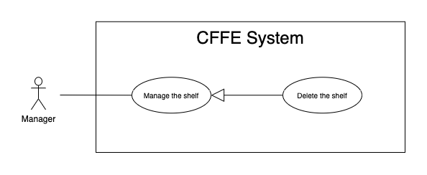

*Figure 15 - <Use Case> Delete the shelf*

|  |  |  |  |
| --- | --- | --- | --- |
| ID and Name: | **UC-17 Delete the shelf** | | |
| Created By: | TruongTN | Date Created: | 18/06/2021 |
| Primary Actor: | Manager | Secondary Actors: | N/A |
| Description: | This feature allows Manager to delete the shelf. | | |
| Trigger: | Manager sends a request to delete the shelf. | | |
| Preconditions: | PRE-01. User has logged in the system as manager role.  PRE-02. Manager is on “Shelf detail” page. | | |
| Post-conditions: | POST-01:   * Success: CFFE system shows success message and reloads "Shelf Detail" page. * Fail: CFFE system shows error message. | | |
| Normal Flow: | **17.0 Delete the shelf**   1. Manager clicks on "Change to Inactive" button. 2. CFFE system redirects to “Inactive” page and shows required form:  * "Reason": text area * "Save": button * "Back": button  1. Manager inputs the fields. 2. Manager clicks on "Save" button. (Alternative 17.0) 3. CFFE system validates the required field and the shelf. (Exception 17.0.E1, 17.0.E2, 17.0.E3) 4. CFFE system updates the shelf's status and redirects to “Shelf Detail” page with the success message (MSG-040). | | |
| Alternative Flows: | **17.0 Manager cancels the deleting process.**   1. Manager clicks on "Back" button. 2. CFFE system redirects to “Shelf Detail” page and terminates this use case. | | |
| Exceptions: | **17.0.E1 The shelf does not exist**   1. CFFE system returns error message (MSG-012) and terminates this use case.   **17.0.E2 Manager does not input the inactive reason and remove all stacks, cameras.**   1. CFFE system returns error message (MSG-066) and terminates this use case.   **17.0.E3 Manager inputs the inactive reason fields that are not valid**   1. CFFE system returns error message (MSG-067) and terminates this use case. | | |
| Priority: | Medium | | |
| Frequency of Use: | Often | | |
| Business Rules: | BR-030, BR-032, BR-033, BR-048 | | |
| Other Information: | In case of internet connection failure, Manager cannot finish this use case properly. | | |
| Assumptions: | N/A | | |

*Table 14 - <Use Case> Delete the shelf*

##### 2.3.3.5 <Manager> Create the shelf

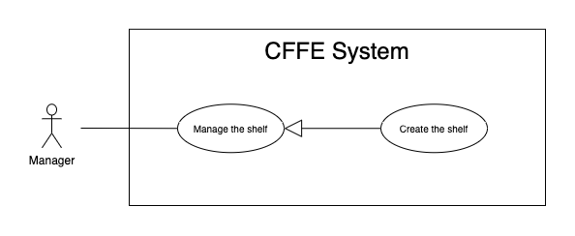

*Figure 16 - <Use Case> Create the shelf*

|  |  |  |  |
| --- | --- | --- | --- |
| ID and Name: | **UC-18 Create the shelf** | | |
| Created By: | TruongTN | Date Created: | 10/05/2021 |
| Primary Actor: | Manager | Secondary Actors: | N/A |
| Description: | This feature allows Manager to create the shelf. | | |
| Trigger: | Manager sends a request to create the shelf. | | |
| Preconditions: | PRE-01. User has logged in the system as manager role.  PRE-02. Manager is on “Manage Shelf” page. | | |
| Post-conditions: | POST-01:   * Success: CFFE system shows success message and reloads "Shelf" page. * Fail: CFFE system shows error message. | | |
| Normal Flow: | **18.0 Create the** **shelf**   1. Manager clicks on "New" button. 2. CFFE system redirect to create shelf page and shows required form that includes:  * “Shelf name”: input text * “Description”: input text * “Number of stacks”: drop down list * “Create”: button * “Back”: button  1. Manager inputs the fields. 2. Manager clicks on “Create” button. (Alternative 18.0) 3. CFFE system validates the required fields. (Exception 18.0.E1, 18.0.E2) 4. CFFE system creates newly shelf and redirects to “Shelf” page with the success message (MSG-011). | | |
| Alternative Flows: | **18.0 Manager cancels the creating process.**   1. Manager clicks on "Back" button. 2. CFFE system closes this popup and terminates this use case. | | |
| Exceptions: | **18.0.E1 Manager does not input the required fields**   1. CFFE system returns to Manager to fill the required fields again (MSG-079, MSG-016). 2. If Manager inputs the required fields again, CFFE system returns to step 3 of the normal flow. 3. Else if Manager cancels the creating process, then CFFE system terminates this use case.   **18.0.E2 Manager inputs the required fields that are not valid**   1. CFFE system returns to Manager to fill the required fields again (MSG-080, MSG-017, MSG-019). 2. If Manager inputs the required fields again, CFFE system returns to step 3 of the normal flow. 3. Else if Manager cancels the creating process, then CFFE system terminates this use case. | | |
| Priority: | Medium | | |
| Frequency of Use: | Often | | |
| Business Rules: | BR-025, BR-031, BR-035, BR-048, BR-070 | | |
| Other Information: | In case of internet connection failure, Manager cannot finish this use case properly. | | |
| Assumptions: | N/A | | |

*Table 15 - <Use Case> Create the shelf*

##### 2.3.3.6 <Manager> Get the stacks

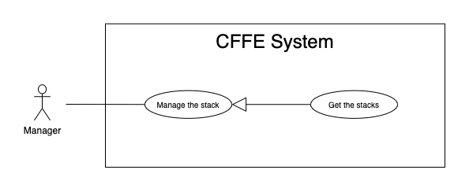

*Figure 17 - <Use Case> Get the stacks*

|  |  |  |  |
| --- | --- | --- | --- |
| ID and Name: | **UC19- Get the stacks** | | |
| Created By: | LuanNM | Date Created: | 08/05/2021 |
| Primary Actor: | Manager | Secondary Actors: | N/A |
| Description: | This feature allows manager to get the stacks. | | |
| Trigger: | Manager sends a request to get the stacks. | | |
| Pre-conditions: | PRE-01. User has logged into the system as manager role.  PRE-02. Manager is managing a store.  PRE-03. There is at least one shelf link. | | |
| Post-conditions: | POST-01. CFFE system returns the list of stacks. | | |
| Normal Flow: | **19.0 Get the stacks**   1. Manager clicks on the shelf item. 2. CFFE system validates the shelf exists (Exception 19.0.E1, 19.0.E2) 3. CFFE system returns the stack list and redirects to “Shelf Detail” page. | | |
| Alternative Flows: | N/A | | |
| Exceptions: | **19.0.E1 The shelf does not exist.**  1. CFFE system returns the message (MSG-009) and terminates this use case.  **19.0.E2 The list of stacks has no data.**   1. CFFE system returns the message (MSG-009) and terminates this use case. | | |
| Priority: | High | | |
| Frequency of Use: | Usually | | |
| Business Rules: | BR-009, BR-037 | | |
| Other Information: | In case of internet connection failure, Manager cannot finish this use case properly. | | |
| Assumptions: | N/A | | |

*Table 16 - <Use Case> Get the stacks*

##### 2.3.3.7 <Manager> Get stack detail

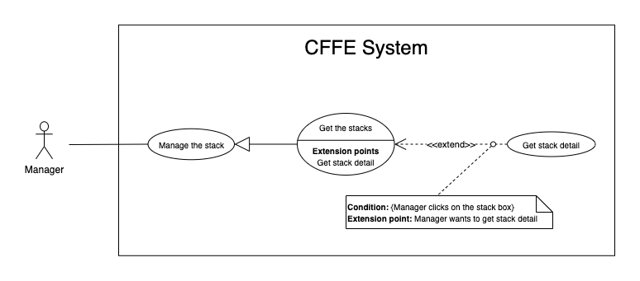

*Figure 18 - <Use Case> Get stack detail*

|  |  |  |  |
| --- | --- | --- | --- |
| ID and Name: | **UC-20 Get stack detail** | | |
| Created By: | LuanNM | Date Created: | 10/05/2021 |
| Primary Actor: | Manager | Secondary Actors: | N/A |
| Description: | This feature allows the Manager to getstackdetail. | | |
| Trigger: | Manager sends a request to get stack detail. | | |
| Preconditions: | PRE-01. User has logged in the system as manager role.  PRE-02. Manager is on "Shelf Detail" page. | | |
| Post-conditions: | POST-01. CFFE system returns stack information. | | |
| Normal Flow: | **20.0 Get stack detail**   1. Manager clicks on the stack item. 2. CFFE system validates the stack exists (Exception 20.0.E1) 3. CFFE system returns the stack information and redirects to “Stack Detail” page. | | |
| Alternative Flows: | N/A | | |
| Exceptions: | **20.0.E1 The stack does not exist.**  1. CFFE system returns the message (MSG-022) and terminates this use case. | | |
| Priority: | High | | |
| Frequency of Use: | Usually | | |
| Business Rules: | BR-009, BR-038 | | |
| Other Information: | In case of internet connection failure, Manager cannot finish this use case properly. | | |
| Assumptions: | N/A | | |

*Table 17 - <Use Case> Get stack detail*

##### 2.3.3.8 <Manager> Update the stack

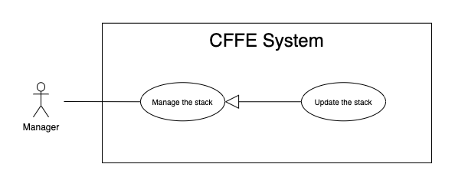

*Figure 19 - <Use Case> Update the stack*

|  |  |  |  |
| --- | --- | --- | --- |
| ID and Name: | **UC-21 Update the stack** | | |
| Created By: | LuanNM | Date Created: | 18/06/2021 |
| Primary Actor: | Manager | Secondary Actors: | N/A |
| Description: | This feature allows Manager to update stack in CFFE system. | | |
| Trigger: | Manager sends a request to update the stack. | | |
| Preconditions: | PRE-01. User has logged in the system as manager role.  PRE-02. Manager is on “Stack detail” page. | | |
| Post-conditions: | POST-01:   * Success: CFFE system shows success message and reloads "Shelf Detail" page. * Fail: CFFE system shows error message. | | |
| Normal Flow: | **21.0 Reactive the inactive stack.** (Alternative 21.0, 21.1, 21.2, 21.3)   1. Manager "Change to Pending" button. 2. CFFE system shows confirm popup with message "The status will change to Pending. Are you sure?" and two buttons for Manager selecting:  * “Yes” button * “No” button  1. Manager clicks on "Yes" button. (Alternative 21.4) 2. CFFE system validates the stack. (Exception 21.0.E1) 3. CFFE system updates stack information and returns the success message (MSG-013). | | |
| Alternative Flows: | **21.0 Adding the product to the stack**   1. Manager clicks on "Add product" button on the product box. 2. CFFE system redirects to “Choose Product” page and shows:    * "Product": list box 3. Manager clicks on the product item. 4. CFFE system shows confirm popup with message "Are you sure to add this product?" and two buttons for Manager selecting:    * "Yes": button    * "No": button 5. Manager clicks on "Yes" button. (Alternative 21.4) 6. CFFE system validates the chosen product and stack (Exception 21.0.E1, 21.0.E2, 21.0.E3, 21.0.E4) 7. CFFE system adds the product to the stack and redirects to “Stack Detail” page with the success message (MSG-013).   **21.1 Removing the product from the stack**   1. Manager clicks on "Remove product" button on the product box. 2. CFFE system shows confirm popup with message "Are you sure to remove this product?" and two buttons for Manager selecting:    1. "Yes" button    2. "No" button 3. Manager clicks on "Yes" button. (Alternative 21.4) 4. CFFE system validates the product and stack. (Exception 21.0.E1, 21.0.E5) 5. CFFE system remove the product from the shelf and return the success message (MSG-013).   **21.2 Adding the camera to the stack**  Manager clicks on "Add camera" button on the camera box.   1. CFFE system redirects to “Choose Camera” page and shows:    1. "Camera": list box 2. Manager clicks on the camera item. 3. CFFE system shows confirm popup with message "Are you sure to add this camera?" and two buttons for Manager selecting:    1. "Yes": button    2. "No": button 4. Manager clicks on "Yes" button. (Alternative 21.4, 21.5) 5. CFFE system validates the chosen camera and stack. (Exception 21.0.E1, 21.0.E6, 21.0.E7, 21.0.E8) 6. CFFE system adds the camera to the stack and redirects to “Stack Detail” page with the success message (MSG-013).   **21.3 Removing the camera from the stack**   1. Manager clicks on "Remove camera" button on the camera box. 2. CFFE system shows confirm popup with message "Are you sure to remove this camera?" and two buttons for Manager selecting:    1. "Yes" button    2. "No" button 3. Manager clicks on "Yes" button. (Alternative 21.4, 21.5) 4. CFFE system validates the camera and stack. (Exception 21.0.E1, 21.0.E9) 5. CFFE system remove the camera from the stack and returns the success message (MSG-013).   **21.4 Manager cancels the updating process.**   1. Manager clicks on "No" button. 2. CFFE system closes this popup and terminates this use case. | | |
| Exceptions: | **21.0.E1 Stack does not exist.**   1. CFFE system returns error message (MSG-022) and terminates this use case.   **21.0.E2 Product does not exist.**   1. CFFE system returns error message (MSG-023) and terminates this use case.   **21.0.E3 Product is inactive.**   1. CFFE system returns error message (MSG-089) and terminates this use case.   **21.0.E4 Stack already has a product.**   1. CFFE system returns error message (MSG-089) and terminates this use case.   **21.0.E5 Product is not on this stack or Camera is already on this stack.**   1. CFFE system returns error message (MSG-092) and terminates this use case.   **21.0.E6 Camera does not exist.**   1. CFFE system returns error message (MSG-020) and terminates this use case.   **21.0.E7 Camera has active or inactive status.**   1. CFFE system returns error message (MSG-093) and terminates this use case.   **21.0.E8 Stack has not a product.**   1. CFFE system returns error message (MSG-100) and terminates this use case.   **21.0.E9 Camera is not on this stack.**   1. CFFE system returns error message (MSG-094) and terminates this use case. | | |
| Priority: | High | | |
| Frequency of Use: | Often | | |
| Business Rules: | BR-009, BR-029, BR-032, BR-036, BR-039, BR-042 | | |
| Other Information: | In case of internet connection failure, Manager cannot finish this use case properly. | | |
| Assumptions: | N/A | | |

*Table 18 - <Use Case> Update the stack*

##### 2.3.3.9 <Manager> Delete the stack

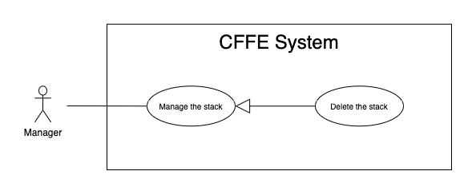

*Figure 20 - <Use Case> Delete the shelf*

|  |  |  |  |
| --- | --- | --- | --- |
| ID and Name: | **UC-22 Delete the stack** | | |
| Created By: | LuanNM | Date Created: | 10/05/2021 |
| Primary Actor: | Manager | Secondary Actors: | N/A |
| Description: | This feature allows Manager to delete the stack. | | |
| Trigger: | Manager sends a request to delete the stack. | | |
| Preconditions: | PRE-01. User has logged in the system as manager role.  PRE-02. Manager is on “Shelf detail” page.  PRE-03. Manager selects a stack. | | |
| Post-conditions: | POST-01:   * Success: CFFE system shows success message and reloads "Shelf Detail" page. * Fail: CFFE system shows error message. | | |
| Normal Flow: | **22.0 Delete the stack**   1. Manager clicks on "Change to Inactive" button. 2. CFFE system redirects to “Inactive” page and shows required form:  * "Reason": text area * "Save": button * "Back": button  1. Manager inputs the field. 2. Manager clicks on "Save" button. (Alternative 22.0) 3. CFFE system validates the required field and the stack. (Exception 22.0.E1, 22.0.E2, 22.0.E3) 4. CFFE system updates the stack's status and redirects to “Stack Detail” page with the success message (MSG-040). | | |
| Alternative Flows: | **22.0 Manager cancels the deleting process.**   1. Manager clicks on "Back" button. 2. CFFE system redirects to “Stack Detail” page and terminates this use case. | | |
| Exceptions: | **22.0.E1 The stack does not exist**   1. CFFE system returns error message (MSG-022) and terminates this use case.   **22.0.E2 Manager does not input the inactive reason and remove the product.**   1. CFFE system returns error message (MSG-095) and terminates this use case.   **22.0.E3 Manager inputs the inactive reason fields that are not valid**   1. CFFE system returns error message (MSG-067) and terminates this use case. | | |
| Priority: | Medium | | |
| Frequency of Use: | Often | | |
| Business Rules: | BR-009, BR-032, BR-033, BR-041 | | |
| Other Information: | In case of internet connection failure, Manager cannot finish this use case properly. | | |
| Assumptions: | N/A | | |

*Table 19 - <Use Case> Delete the stack*

##### 2.3.3.10 <Manager> Create the stack

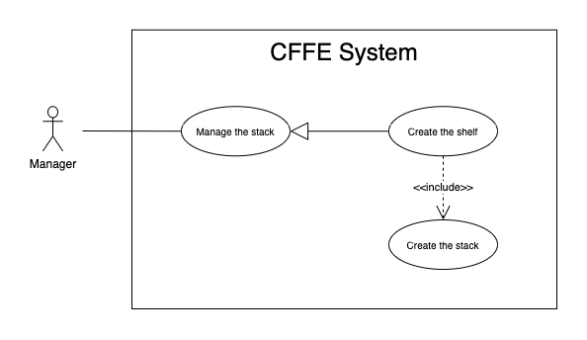

*Figure 21 - <Use Case> Create the stack*

|  |  |  |  |
| --- | --- | --- | --- |
| ID and Name: | **UC-23 Create the stack** | | |
| Created By: | LuanNM | Date Created: | 10/05/2021 |
| Primary Actor: | Manager | Secondary Actors: | N/A |
| Description: | This feature allows Manager to create the stack. | | |
| Trigger: | Manager sends a request to create the stack. | | |
| Preconditions: | PRE-01. User has logged in the system as manager role.  PRE-02. Manager creates the shelf successfully. | | |
| Post-conditions: | POST-01. CFFE system stores newly created stack information. | | |
| Normal Flow: | **23.0 Create the stack**   1. CFFE system creates the stacks based on "Number of stacks" of the shelf and returns the success message (Exception 23.0.E1). | | |
| Alternative Flows: | N/A | | |
| Exceptions: | N/A | | |
| Priority: | Medium | | |
| Frequency of Use: | Often | | |
| Business Rules: | BR-009, BR-035, BR-50, BR-070 | | |
| Other Information: | In case of internet connection failure, Manager cannot finish this use case properly. | | |
| Assumptions: | N/A | | |

*Table 20 - <Use Case> Create the stack*

#### 2.3.4 <Admin> Overview Use Case

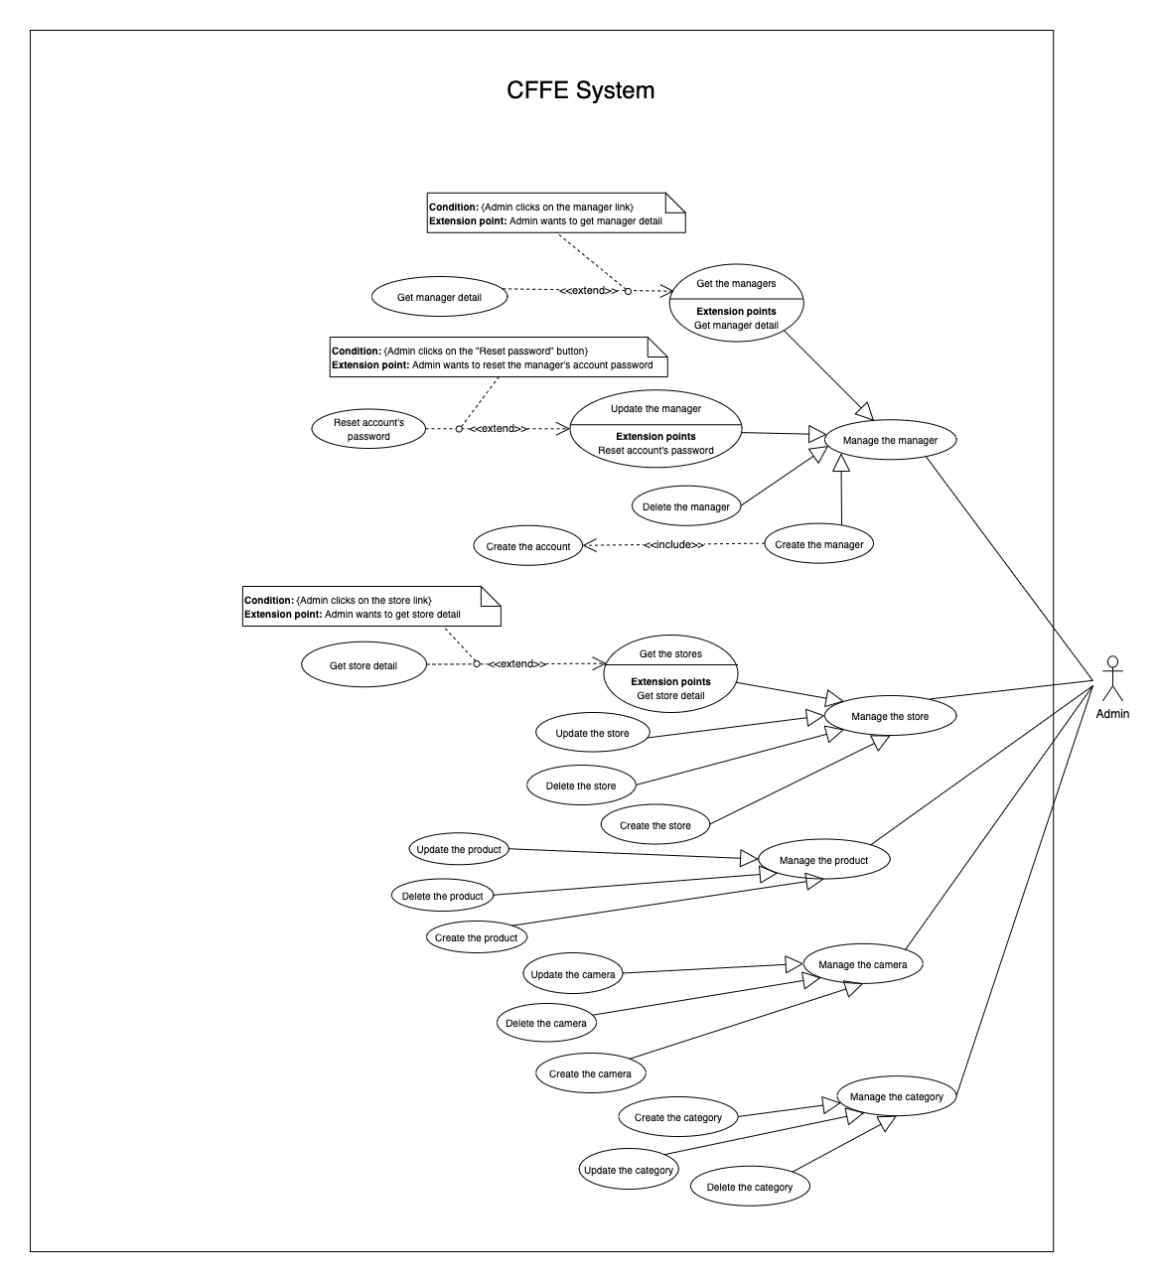*Figure 36 - <Use Case> Get the cameras*

##### 2.3.4.1 <Admin> Get the stores

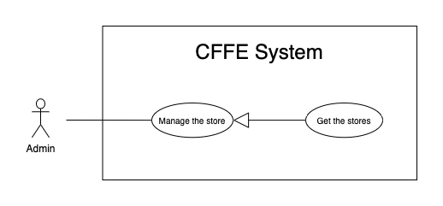

*Figure 37 - <Use Case> Get the stores*

|  |  |  |  |
| --- | --- | --- | --- |
| ID and Name: | **UC-25 Get the stores** | | |
| Created By: | LuanNM | Date Created: | 08/05/2021 |
| Primary Actor: | Admin | Secondary Actors: | N/A |
| Description: | This feature allows admin to get the stores. | | |
| Trigger: | Admin sends a request to get the stores. | | |
| Pre-conditions: | PRE-01. User has logged into the system as admin role. | | |
| Post-conditions: | POST-01. CFFE system returns the list of stores. | | |
| Normal Flow: | **25.0 Get the stores**   1. Admin clicks on "Store" button on the navigation bar. 2. CFFE system requires the store information:  * “Store name”: input text * “Status”: select box  1. Admin inputs/selects the fields. 2. CFFE system returns the list of stores based on below conditions and display them (Exception 25.0.E1). | | |
| Alternative Flows: | N/A | | |
| Exceptions: | **25.0.E1 The list of stores has no data.**   1. CFFE system returns the message (MSG-009). | | |
| Priority: | High | | |
| Frequency of Use: | Usually | | |
| Business Rules: | BR-059, BR-064, BR-065 | | |
| Other Information: | In case of internet connection failure, Admin cannot finish this use case properly. | | |
| Assumptions: | N/A | | |

*Table 35 - <Use Case> Get the stores*

##### 2.3.4.2 <Admin> Get store detail

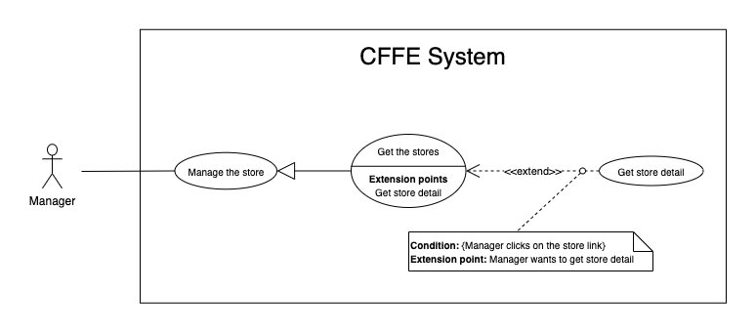

*Figure 38 - <Use Case> Get store detail*

|  |  |  |  |
| --- | --- | --- | --- |
| ID and Name: | **UC-26 Get store detail** | | |
| Created By: | LuanNM | Date Created: | 10/05/2021 |
| Primary Actor: | Admin | Secondary Actors: | N/A |
| Description: | This feature allows the admin to getstoredetail. | | |
| Trigger: | Admin sends a request to get store detail. | | |
| Preconditions: | PRE-01. User has logged in the system as admin role.  PRE-02. There is at least one store link. | | |
| Post-conditions: | POST-01:   * Success: CFFE system returns store detail successfully and redirects to "Store Detail" page. * Fail: CFFE system shows error message. | | |
| Normal Flow: | **26.0 Get store detail**   1. Admin clicks on the store item. 2. CFFE system validates the store exists (Exception 26.0.E1) 3. CFFE system returns the stores information and redirects to “Store Detail” page. | | |
| Alternative Flows: | N/A | | |
| Exceptions: | **26.0.E1 The stores does not exist.**  1. CFFE system returns the message (MSG-035) and terminates this use case. | | |
| Priority: | High | | |
| Frequency of Use: | Usually | | |
| Business Rules: | BR-059, BR-066 | | |
| Other Information: | In case of internet connection failure, Admin cannot finish this use case properly. | | |
| Assumptions: | N/A | | |

*Table 36 - <Use Case> Get camera detail*

##### 2.3.4.3 <Admin> Update the store

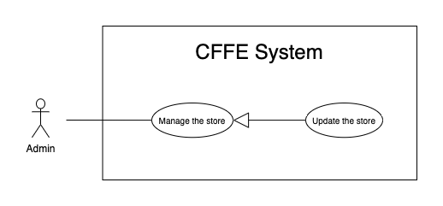

*Figure 39 - <Use Case> Update the store*

|  |  |  |  |
| --- | --- | --- | --- |
| ID and Name: | **UC-27 Update the store** | | |
| Created By: | LuanNM | Date Created: | 18/06/2021 |
| Primary Actor: | Admin | Secondary Actors: | N/A |
| Description: | This feature allows Admin to update store in CFFE system. | | |
| Trigger: | Admin sends a request to update the store. | | |
| Preconditions: | PRE-01. User has logged in the system as admin role.  PRE-02. Admin is on “Store detail” page. | | |
| Post-conditions: | POST-01:   * Success: CFFE system shows success message and reloads "Store Detail" page. * Fail: CFFE system shows error message. | | |
| Normal Flow: | **27.0 Update the store information** (Alternative 27.0, 27.1, 27.2, 27.3)   1. Admin clicks on "Update Information" button. 2. CFFE system redirects to “Update Information” page and show required form that includes:  * “Store Name”: input text * “Address”: input text * “City”: select box * “District”: select box * “Save”: button * “Back”: button  1. Admin inputs/selects the required fields. 2. Admin clicks on “Save” button. (Alternative 27.5) 3. CFFE system validates the fields (Exception 27.0.E1, 27.0.E2) 4. CFFE system updates store information and redirects to “Store Detail” page with the success message (MSG-013). | | |
| Alternative Flows: | **27.0 Adding the manager to managing this store**   1. Admin clicks on "Choose manager" button. 2. CFFE system redirects to “Choose Manager” page and shows:    * "Manager": list box 3. Admin clicks on the manager item. 4. CFFE system shows confirm popup with message "Are you sure to map this manager?" and two buttons for Admin selecting:    * "Yes": button    * "No": button 5. Admin clicks on "Yes" button. (Alternative 27.4) 6. CFFE system validates the chosen manager and store. (Exception 27.0.E3, 27.0.E4) 7. CFFE system adds the manager to the store and redirects to “Store Detail” page with the success message. (MSG-013)   **27.1 Removing the manager from this store**   1. Admin clicks on "Remove manager" button. 2. CFFE system shows confirm popup with message "Are you sure to remove this manager?" and two buttons for Admin selecting:    * "Yes" button    * "No" button 3. Admin clicks on "Yes" button. (Alternative 27.4) 4. CFFE system validates the manager and store. (Exception 27.0.E5, 27.0.E6, 27.0.E7) 5. CFFE system remove the manager from the store and returns the success message (MSG-013).   **27.2 Updating store's image.**   1. Admin clicks on "Change image" button. 2. CFFE system redirects to change image page requires form that includes:    * "Choose": button    * "Save": button    * "Back": button 3. Authenticated User clicks on "Choose" button and selects an image. 4. Admin clicks on "Save" button. (Alternative 27.4) 5. CFFE system validates the image. (Exception 27.0.E9, 27.0.E10, 27.0.E11) 6. CFFE system updates the store's image and redirects to “Store Detail” page with the success message (MSG-013).   **27.3 Reactivate the inactive store.**   1. Admin clicks on "Change to Pending" button. 2. CFFE system shows confirm popup with message "The status will change to Pending. Are you sure?" and two buttons for Admin selecting:    * "Yes" button    * "No" button 3. Admin clicks on "Yes" button. (Alternative 27.4) 4. CFFE system validates the store. (Exception 27.0.E5) 5. CFFE system updates the store's status and returns the success message (MSG-013).   **27.4 Admin cancels the updating process.**   1. Admin clicks on "No" button. 2. CFFE system closes this popup and terminates this use case.   **27.5 Admin cancels the updating process.**   1. Admin clicks on "Back" button. 2. CFFE system redirects to “Store Detail” page and terminates this use case. | | |
| Exceptions: | **27.0.E1 Admin does not input/select the required fields**   1. CFFE system returns to Admin to input/select the required fields again (MSG-106, MSG-036, MSG-038, MSG-039). 2. If Admin inputs/selects the required fields again, CFFE system returns to step 3 of the normal flow. 3. Else if Admin cancels the updating process, then CFFE system terminates this use case.   **27.0.E2 Admin inputs/selects the fields that are not valid**   1. CFFE system returns to Admin to input/select the fields again (MSG-129, MSG-037). 2. If Admin inputs/selects the fields again, CFFE system returns to step 3 of the normal flow. 3. Else if Admin cancels the updating process, then CFFE system terminates this use case.   **27.0.E3 Store does not exist or has not pending status.**   1. CFFE system returns error message (MSG-075) and terminates this use case.   **27.0.E4 Manager does not exist or has not pending status.**   1. CFFE system returns error message (MSG-074) and terminates this use case.   **27.0.E5 Store does not exist.**   1. CFFE system returns error message (MSG-035) and terminates this use case.   **27.0.E6 Manager does not exist.**   1. CFFE system returns error message (MSG-041) and terminates this use case.   **27.0.E7 Manager is not managing this store**   1. CFFE system returns error message (MSG-077) and terminates this use case.   **27.0.E8 Manager is not managing this store**   1. CFFE system returns error message (MSG-077) and terminates this use case.   **27.0.E9 Admin does not select the image**   1. CFFE system returns to Admin to select the image again (MSG-112). 2. If Admin selects the image again, CFFE system returns to step 3 of the alternative flow 27.2. 3. Else if Admin cancels the updating process, then CFFE system terminates this use case.   **27.0.E10 Image is not jpg/jpeg/png format.**   1. CFFE system returns to Admin to select the image again (MSG-113). 2. If Admin selects the image again, CFFE system returns to step 3 of the alternative flow 27.2. 3. Else if Admin cancels the updating process, then CFFE system terminates this use case.   **27.0.E11 CFFE system cannot upload the image.**   1. CFFE system shows error message (MSG-114) and terminates this use case. | | |
| Priority: | Medium | | |
| Frequency of Use: | Often | | |
| Business Rules: | BR-032, BR-040, BR-059, BR-067, BR-68 | | |
| Other Information: | In case of internet connection failure, Admin cannot finish this use case properly. | | |
| Assumptions: | N/A | | |

*Table 37 - <Use Case> Update the store*

##### 2.3.4.4 <Admin> Delete the store

*Figure 40 - <Use Case> Delete the store*

|  |  |  |  |
| --- | --- | --- | --- |
| ID and Name: | **UC-28 Delete the store** | | |
| Created By: | LuanNM | Date Created: | 10/05/2021 |
| Primary Actor: | Admin | Secondary Actors: | N/A |
| Description: | This feature allows Admin to delete the store. | | |
| Trigger: | Admin sends a request to delete the store. | | |
| Preconditions: | PRE-01. User has logged in the system as admin role.  PRE-02. Admin is on “Store detail” page. | | |
| Post-conditions: | POST-01:   * Success: CFFE system shows success message and reloads "Store Detail" page. * Fail: CFFE system shows error message. | | |
| Normal Flow: | **28.0 Delete the store**   1. Admin clicks on "Change to Inactive" button. 2. CFFE system redirects to “Inactive Page” and shows required form:    1. "Reason": text area    2. "Save": button    3. "Back": button 3. Admin inputs the field. 4. Admin clicks on "Save" button. (Alternative 28.0) 5. CFFE system validates the required field and the store. (Exception 28.0.E1, 28.0.E2, 28.0.E3) 6. CFFE system updates the store's status and redirects to “Store Detail” page with the success message (MSG-040). | | |
| Alternative Flows: | **28.0 Admin cancels the deleting process.**   1. Admin clicks on "Back" button. 2. CFFE system redirects to “Store Detail” page and terminates this use case. | | |
| Exceptions: | **28.0.E1 The store does not exist**   1. CFFE system returns error message (MSG-012) and terminates this use case.   **28.0.E2 The store has an manager that is managing and has active or pending shelves.**   1. CFFE system returns error message (MSG-066, MSG-081) and terminates this use case.   **28.0.E3 Admin inputs the inactive reason fields that are not valid**   1. CFFE system returns error message (MSG-067) and terminates this use case. | | |
| Priority: | Medium | | |
| Frequency of Use: | Often | | |
| Business Rules: | BR-032, BR-033, BR-059, BR-069 | | |
| Other Information: | In case of internet connection failure, Admin cannot finish this use case properly. | | |
| Assumptions: | N/A | | |

*Table 38 - <Use Case> Delete the store*

##### 2.3.4.5 <Admin> Create the store

*Figure 41 - <Use Case> Create the store*

|  |  |  |  |
| --- | --- | --- | --- |
| ID and Name: | **UC-29 Create the store** | | |
| Created By: | LuanNM | Date Created: | 10/05/2021 |
| Primary Actor: | Admin | Secondary Actors: | N/A |
| Description: | This feature allows Admin to create the store. | | |
| Trigger: | Admin sends a request to create the store. | | |
| Preconditions: | PRE-01. User has logged in the system as admin role.  PRE-02. Admin is on “Store” page. | | |
| Post-conditions: | POST-01:   * Success: CFFE system shows success message and reloads "Store" page. * Fail: CFFE system shows error message. | | |
| Normal Flow: | **29.0 Create the store**   1. Admin clicks on "New" button. 2. CFFE system redirects to “Create Store” page and shows required form that includes:    * "Store name": input text    * "Image": button    * "Address": input text    * "City": select box    * "District": select box    * "Create": button    * "Back": button 3. Admin inputs/selects the required fields. 4. Admin clicks on the "Create" button to create the store. (Alternative 29.0) 5. CFFE system validates the required fields (Exception 29.0.E1, 29.0.E2). 6. CFFE system stores newly created store and redirects to “Store” page with the success message (MSG-011). | | |
| Alternative Flows: | **29.0 Admin cancels the creating process.**   1. Admin clicks on "Back" button. 2. CFFE system redirects to “Store” page and terminates this use case. | | |
| Exceptions: | **29.0.E1 Admin does not input/select the required fields**   1. CFFE system returns to Admin to input/select the required fields again (MSG-106, MSG-036, MSG-038, MSG-039). 2. If Admin inputs/selects the required fields again, CFFE system returns to step 3 of the normal flow. 3. Else if Admin cancels the creating process, then CFFE system terminates this use case.   **29.0.E2 Admin** **inputs/selects the fields that are not valid**   1. CFFE system returns to Admin to input/select the fields again (MSG-109, MSG-037, MSG-062). 2. If Admin inputs/selects the fields again, CFFE system returns to step 3 of the normal flow. 3. Else if Admin cancels the creating process, then CFFE system terminates this use case. | | |
| Priority: | Medium | | |
| Frequency of Use: | Often | | |
| Business Rules: | BR-035, BR-059, BR-067, BR-070 | | |
| Other Information: | In case of internet connection failure, Admin cannot finish this use case properly. | | |
| Assumptions: | N/A | | |

*Table 39 - <Use Case> Create the store*

##### 2.3.4.6 <Admin> Get the managers

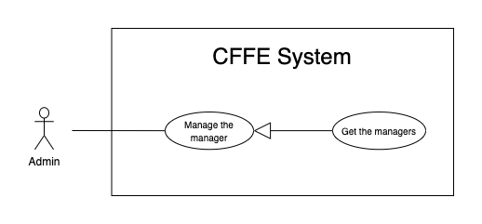

*Figure 37 - <Use Case> Get the manager*

|  |  |  |  |
| --- | --- | --- | --- |
| ID and Name: | **UC-30 Get the managers** | | |
| Created By: | HieuNT | Date Created: | 08/05/2021 |
| Primary Actor: | Admin | Secondary Actors: | N/A |
| Description: | This feature allows admin to get the managers. | | |
| Trigger: | Admin sends a request to get the managers. | | |
| Pre-conditions: | PRE-01. User has logged into the system as admin role. | | |
| Post-conditions: | POST-01. CFFE system returns the list of stores. | | |
| Normal Flow: | **30.0 Get the managers**   1. Admin clicks on "Manager" button on the navigation bar. 2. CFFE system requires the manager information from Admin:  * “Manager full name”: input text * “Status”: select box  1. Admin inputs/selects the fields. 2. CFFE system returns the list of managers based on below conditions and display them (Exception 30.0.E1). | | |
| Alternative Flows: | N/A | | |
| Exceptions: | **30.0.E1 The list of managers has no data.**   1. CFFE system returns the message (MSG-009). | | |
| Priority: | High | | |
| Frequency of Use: | Usually | | |
| Business Rules: | BR-015, BR-017, BR-034 | | |
| Other Information: | In case of internet connection failure, Admin cannot finish this use case properly. | | |
| Assumptions: | N/A | | |

*Table 40 - <Use Case> Get the managers*

##### 2.3.4.7 <Admin> Get manager detail

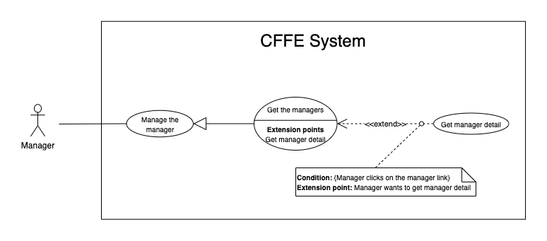

*Figure 43 - <Use Case> Get store detail*

|  |  |  |  |
| --- | --- | --- | --- |
| ID and Name: | **UC-31 Get manager detail** | | |
| Created By: | HieuNT | Date Created: | 10/05/2021 |
| Primary Actor: | Admin | Secondary Actors: | N/A |
| Description: | This feature allows the admin to getmanagerdetail. | | |
| Trigger: | Admin sends a request to get manager detail. | | |
| Preconditions: | PRE-01. User has logged in the system as admin role.  PRE-02. There is at least one manager link. | | |
| Post-conditions: | POST-01:   * Success: CFFE system returns manager detail successfully and redirects to "Manager Detail" page. * Fail: CFFE system shows error message. | | |
| Normal Flow: | **31.0 Get manager detail**   1. Admin clicks on the manager item. 2. CFFE system validates the manager exists (Exception 31.0.E1) 3. CFFE system returns the manager information and redirects to “Manager Detail” page. | | |
| Alternative Flows: | N/A | | |
| Exceptions: | **31.0.E1 The manager does not exist.**  1. CFFE system returns the message (MSG-041) and terminates this use case. | | |
| Priority: | High | | |
| Frequency of Use: | Usually | | |
| Business Rules: | BR-034, BR-061 | | |
| Other Information: | In case of internet connection failure, Admin cannot finish this use case properly. | | |
| Assumptions: | N/A | | |

*Table 42 - <Use Case> Get manager detail*

##### 2.3.4.8 <Admin> Update the manager

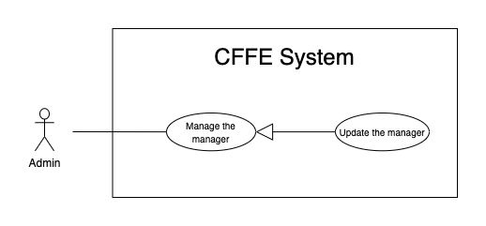

*Figure 44 - <Use Case> Update the manager*

|  |  |  |  |
| --- | --- | --- | --- |
| ID and Name: | **UC-32 Update the manager** | | |
| Created By: | HieuNT | Date Created: | 18/06/2021 |
| Primary Actor: | Admin | Secondary Actors: | N/A |
| Description: | This feature allows Admin to update manager in CFFE system. | | |
| Trigger: | Admin sends a request to update the manager. | | |
| Preconditions: | PRE-01. User has logged in the system as admin role.  PRE-02. Admin is on “Manager detail” page. | | |
| Post-conditions: | POST-01:   * Success: CFFE system shows success message and reloads "Manager Detail" page. * Fail: CFFE system shows error message. | | |
| Normal Flow: | **32.0 Update the manager information** (Alternative 32.0, 32.1, 32.2, 32.3, 32.4)   1. Admin clicks on "Update information" button. 2. CFFE system redirects to “Update Information” page and shows required form that includes:  * “Full name”: input text * “Gender”: checkbox * “Birthday”: date picker * “Identify card”: input text * “Phone number”: input text * “Email”: input text * “Address”: input text * “City”: select box * “District”: select box * “Save”: button * “Back”: button  1. Admin inputs/selects the required fields. 2. Admin clicks on “Save” button. (Alternative 32.5) 3. CFFE system validates the fields (Exception 32.0.E1, 32.0.E2) 4. CFFE system updates manager information and redirects to “Manager Detail” page with the success message (MSG-013). | | |
| Alternative Flows: | **32.0 Adding the store to manage**   1. Admin clicks on " Choose store" button. 2. CFFE system redirects to “Choose Store” page and shows:    * "Store": list box 3. Admin clicks on the store item. 4. CFFE system shows confirm popup with message "Are you sure to map this store?" and two buttons for Admin selecting:    * "Yes": button    * "No": button 5. Admin clicks on "Yes" button. (Alternative 32.4) 6. CFFE system validates the chosen store and manager. (Exception 32.0.E3, 32.0.E4) 7. CFFE system adds the store to the manager and redirects to “Manager Detail” page with the success message. (MSG-013)   **32.1 Removing the store that is managing**   1. Admin clicks on "Remove store" button. 2. CFFE system shows confirm popup with message "Are you sure to remove this store?" and two buttons for Admin selecting:    1. "yes" button    2. "No" button 3. Admin clicks on "Yes" button. (Alternative 32.4) 4. CFFE system validates the manager and store. (Exception 32.0.E5, 32.0.E6, 32.0.E7) 5. CFFE system remove the store from the manager and returns the success message (MSG-013).   **32.2 Updating manager avatar.**   1. Admin clicks on "Change avatar" button. 2. CFFE system redirects to “Change Avatar” page and shows required form that includes:    * "Choose": button    * "Save": button    * "Back": button 3. Authenticated User clicks on "Choose" button and selects an image. 4. Admin clicks on "Save" button. (Alternative 32.5) 5. CFFE system validates the image. (Exception 32.0.E9, 32.0.E10, 32.0.E11) 6. CFFE system updates the manager's avatar and redirects to “Manager Detail” page with the success message (MSG-013).   **32.3 Reactivate the inactive manager.**   1. Admin clicks on "Change to Pending" button. 2. CFFE system shows confirm popup with message "The status will change to Pending. Are you sure?" and two buttons for Admin selecting:    * "Yes" button    * "No" button 3. Admin clicks on "Yes" button. (Alternative 32.4) 4. CFFE system validates the manager. (Exception 32.0.E6) 5. CFFE system updates the manager's status and returns the success message (MSG-013).   **32.4 Admin cancels the updating process.**   1. Admin clicks on "No" button. 2. CFFE system closes this popup and terminates this use case.   **32.5 Admin cancels the updating process.**   1. Admin clicks on "Back" button. 2. CFFE system redirects to “Manager Detail” page and terminates this use case. | | |
| Exceptions: | **32.0.E1 Admin does not input/select the required fields**   1. CFFE system returns to Admin to input/select the required fields again (MSG-014, MSG-036, MSG-038, MSG-039, MSG-049, MSG-044, MSG-047, MSG-051, MSG-054). 2. If Admin inputs/selects the required fields again, CFFE system returns to step 3 of the normal flow. 3. Else if Admin cancels the updating process, then CFFE system terminates this use case.   **32.0.E2 Admin inputs/selects the fields that are not valid**   1. CFFE system returns to Admin to input/select the fields again (MSG-015, MSG-037, MSG-042, MSG-045, MSG-052, MSG-073). 2. If Admin inputs/selects the fields again, CFFE system returns to step 3 of the normal flow. 3. Else if Admin cancels the updating process, then CFFE system terminates this use case.   **32.0.E3 Store does not exist or has not pending status.**   1. CFFE system returns error message (MSG-075) and terminates this use case.   **32.0.E4 Manager does not exist or has not pending status.**   1. CFFE system returns error message (MSG-074) and terminates this use case.   **32.0.E5 Store does not exist.**   1. CFFE system returns error message (MSG-035) and terminates this use case.   **32.0.E6 Manager does not exist.**   1. CFFE system returns error message (MSG-041) and terminates this use case.   **32.0.E7 Manager is not managing this store**   1. CFFE system returns error message (MSG-077) and terminates this use case.   **32.0.E9 Admin does not select the image**   1. CFFE system returns to Admin to select the image again (MSG-112). 2. If Admin selects the image again, CFFE system returns to step 3 of the alternative flow 32.2. 3. Else if Admin cancels the updating process, then CFFE system terminates this use case.   **32.0.E10 Image is not jpg/jpeg/png format.**   1. CFFE system returns to Admin to select the image again (MSG-113). 2. If Admin selects the image again, CFFE system returns to step 3 of the alternative flow 32.2. 3. Else if Admin cancels the updating process, then CFFE system terminates this use case.   **32.0.E11 CFFE system cannot upload the image.**   1. CFFE system shows error message (MSG-114) and terminates this use case. | | |
| Priority: | Medium | | |
| Frequency of Use: | Often | | |
| Business Rules: | BR-032, BR-034, BR-040, BR-060, BR-068 | | |
| Other Information: | In case of internet connection failure, Admin cannot finish this use case properly. | | |
| Assumptions: | N/A | | |

*Table 37 - <Use Case> Update the store*

##### 2.3.4.9 <Admin> Reset account's password

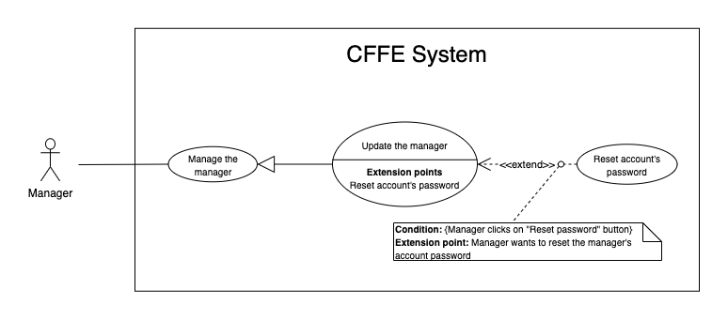

*Figure 44 - <Use Case> Reset account's password*

|  |  |  |  |
| --- | --- | --- | --- |
| ID and Name: | **UC-33 Reset account's password** | | |
| Created By: | HieuNT | Date Created: | 18/06/2021 |
| Primary Actor: | Admin | Secondary Actors: | N/A |
| Description: | This feature allows Admin to reset account's password in CFFE system. | | |
| Trigger: | Admin sends a request to reset account's password. | | |
| Preconditions: | PRE-01. User has logged in the system as admin role.  PRE-02. Admin is on “Manager detail” page. | | |
| Post-conditions: | POST-01:   * Success: CFFE system shows success message and sends account's password to manager's email. * Fail: CFFE system shows error message. | | |
| Normal Flow: | **33.0 Reset account's password**   1. Admin clicks on "Reset password" button. 2. CFFE system shows confirm popup with message "Are you sure to reset password for this manager?" and two buttons for Admin selecting:    * "yes" button    * "No" button 3. Admin clicks on “Yes” button. (Alternative 33.0) 4. CFFE system validates the manager and send account's new password to manager's email (Exception 33.0.E1, 33.0.E2) 5. CFFE system updates manager information and returns the success message (MSG-013). | | |
| Alternative Flows: | **33.0 Admin cancels the resetting process.**   1. Admin clicks on "No" button. 2. CFFE system closes this popup and terminates this use case. | | |
| Exceptions: | **33.0.E1 Manager is not found**   1. CFFE system returns error message (MSG-063) and terminates this use case.   **33.0.E2 Send email failed**   1. CFFE system shows error message (MSG-124) and terminates this use case. | | |
| Priority: | Medium | | |
| Frequency of Use: | Often | | |
| Business Rules: | BR-008, BR-012 | | |
| Other Information: | In case of internet connection failure, Admin cannot finish this use case properly. | | |
| Assumptions: | N/A | | |

*Table 37 - <Use Case> Reset account's password*

##### 2.3.4.10 <Admin> Delete the manager

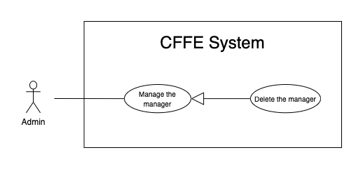

*Figure 45 - <Use Case> Delete the manager*

|  |  |  |  |
| --- | --- | --- | --- |
| ID and Name: | **UC-34 Delete the manager** | | |
| Created By: | LuanNM | Date Created: | 10/05/2021 |
| Primary Actor: | Admin | Secondary Actors: | N/A |
| Description: | This feature allows Admin to delete the manager. | | |
| Trigger: | Admin sends a request to delete the manager. | | |
| Preconditions: | PRE-01. User has logged in the system as admin role.  PRE-02. Admin is on “Manager detail” page. | | |
| Post-conditions: | POST-01:   * Success: CFFE system shows success message and reloads "Manager Detail" page. * Fail: CFFE system shows error message. | | |
| Normal Flow: | **34.0 Delete the manager**   1. Admin clicks on "Change to Inactive" button. 2. CFFE system redirects to “Inactive” page and shows required form:  * "Inactive reason": text area * "Save": button * "Back" button  1. Admin inputs the field. 2. Admin clicks on "Save" button. (Alternative 34.0) 3. CFFE system validates the required field and the manager. (Exception 34.0.E1, 34.0.E2, 34.0.E3) 4. CFFE system updates the manager's status and returns the success message (MSG-040). | | |
| Alternative Flows: | **34.0 Admin cancels the deleting process.**   1. Admin clicks on "No" button. 2. CFFE system redirects to “Manager Detail” page and terminates this use case. | | |
| Exceptions: | **34.0.E1 Manager is not found**   1. CFFE system returns error message (MSG-063) and terminates this use case.   **34.0.E2 Manager is managing a store**   1. CFFE system shows error message (MSG-066) and terminates this use case.   **34.0.E3 Admin inputs the inactive reason fields that are not valid**   1. CFFE system returns error message (MSG-067) and terminates this use case. | | |
| Priority: | Medium | | |
| Frequency of Use: | Often | | |
| Business Rules: | BR-003, BR-032, BR-033, BR-034 | | |
| Other Information: | In case of internet connection failure, Admin cannot finish this use case properly. | | |
| Assumptions: | N/A | | |

*Table 38 - <Use Case> Delete the manager*

##### 2.3.4.11 <Admin> Create the manager

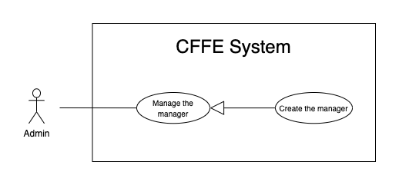

*Figure 46 - <Use Case> Create the manager*

|  |  |  |  |
| --- | --- | --- | --- |
| ID and Name: | **UC-35 Create the manager** | | |
| Created By: | LuanNM | Date Created: | 10/05/2021 |
| Primary Actor: | Admin | Secondary Actors: | N/A |
| Description: | This feature allows Admin to create the manager. | | |
| Trigger: | Admin sends a request to create the manager. | | |
| Preconditions: | PRE-01. User has logged in the system as admin role.  PRE-02. Admin is on “Manager” page. | | |
| Post-conditions: | POST-01:   * Success: CFFE system shows success message and reloads "Manager" page. * Fail: CFFE system shows error message. | | |
| Normal Flow: | **35.0 Create the manager**   1. Admin clicks on "New" button. 2. CFFE system redirects to “Create Manager” page and shows required form that includes:    * "Avatar": button    * "Full name": input text    * "Email": input text    * "Identity card": input text    * "Phone number": input text    * "Gender": checkbox    * "Birthday": date picker    * "Address": input text    * "City": select box    * "District": select box    * "Create": button    * "Cancel": button 3. Admin inputs/selects the required fields. 4. Admin clicks on the "Create" button to create the manager. (Alternative 35.0) 5. CFFE system validates the required fields. (Exception 35.0.E1, 35.0.E2) 6. CFFE system stores newly created manager and redirects to “Manager” page with the success message (MSG-011). | | |
| Alternative Flows: | **35.0 Admin cancels the creating process.**   1. Admin clicks on "Back" button. 2. CFFE system redirects to “Manager” page and terminates this use case. | | |
| Exceptions: | **35.0.E1 Admin does not input/select the required fields**   1. CFFE system returns to Admin to input/select the required fields again (MSG-014, MSG-036, MSG-038, MSG-039, MSG-044, MSG-047, MSG-049, MSG-051, MSG-054). 2. If Admin inputs/selects the required fields again, CFFE system returns to step 3 of the normal flow. 3. Else if Admin cancels the creating process, then CFFE system terminates this use case.   **35.0.E2 Admin inputs/selects the fields that are not valid**   1. CFFE system returns to Admin to input/select the fields again (MSG-015, MSG-037, MSG-042, MSG-045, MSG-048, MSG-052, MSG-055, MSG-056, MSG-073). 2. If Admin inputs/selects the fields again, CFFE system returns to step 3 of the normal flow. 3. Else if Admin cancels the creating process, then CFFE system terminates this use case. | | |
| Priority: | Medium | | |
| Frequency of Use: | Often | | |
| Business Rules: | BR-034, BR-035, BR-060, BR-070 | | |
| Other Information: | In case of internet connection failure, Admin cannot finish this use case properly. | | |
| Assumptions: | N/A | | |

*Table 47 - <Use Case> Create the manager*

##### 2.3.4.12 <Admin> Create the account

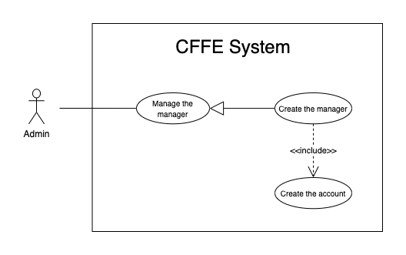

*Figure 46 - <Use Case> Create the account*

|  |  |  |  |
| --- | --- | --- | --- |
| ID and Name: | **UC-36 Create the account** | | |
| Created By: | LuanNM | Date Created: | 10/05/2021 |
| Primary Actor: | Admin | Secondary Actors: | N/A |
| Description: | This feature allows Admin to create the manager. | | |
| Trigger: | Admin sends a request to create the account. | | |
| Preconditions: | PRE-01. User has logged in the system as admin role.  PRE-02. Admin creates a manager successfully. | | |
| Post-conditions: | POST-01. CFFE system stores newly accounts and sends manager's account to manager's email. | | |
| Normal Flow: | **36.0 Create the account**   1. CFFE system creates the account for newly manager and sends account to manager's email. | | |
| Alternative Flows: | N/A | | |
| Exceptions: | **36.0.E1 Send email failed**   1. CFFE system shows error message (MSG-124) and terminates this use case. | | |
| Priority: | Medium | | |
| Frequency of Use: | Often | | |
| Business Rules: | BR-008, BR-012, BR-043 | | |
| Other Information: | In case of internet connection failure, Admin cannot finish this use case properly. | | |
| Assumptions: | N/A | | |

*Table 47 - <Use Case> Create new account*

##### 2.3.3.13 <Admin> Update the product

*Figure 24 - <Use Case> Update the product*

|  |  |  |  |
| --- | --- | --- | --- |
| ID and Name: | **UC-37 Update the product** | | |
| Created By: | HieuNT | Date Created: | 18/06/2021 |
| Primary Actor: | Admin | Secondary Actors: | N/A |
| Description: | This feature allows admin to update product in CFFE system. | | |
| Trigger: | Admin sends a request to update the product. | | |
| Preconditions: | PRE-01. User has logged in the system as admin role.  PRE-02. Admin is on “Product detail” page. | | |
| Post-conditions: | POST-01:   * Success: CFFE system shows success message and reloads "Product Detail" page. * Fail: CFFE system shows error message. | | |
| Normal Flow: | **37.0 Update the product information** (Alternative 37.0, 37.1)   1. Admin clicks on "Update information" button. 2. CFFE requires product information that includes:  * “Product name”: input text * “Description”: input text * “Category”: dropdown list * "Save": button * "Back": button  1. Admin inputs/selects the required fields. 2. Admin clicks on “Save” button. (Alternative 37.3) 3. CFFE system validates the fields. (Exception 37.0.E1, 37.0.E2, 37.0.E6) 4. CFFE system updates product information and redirects to “Product Detail” page with the success message (MSG-013). | | |
| Alternative Flows: | **37.0 Updating product’s image.**   1. Admin clicks on "Change image" button. 2. CFFE system redirects to “Change Image” page requires form that includes:    * "Choose": button    * "Save": button    * "Back": button 3. Admin clicks on "Choose" button and selects an image. 4. Admin clicks on "Save" button. (Alternative 37.3) 5. CFFE system validates the image. (Exception 37.0.E3, 37.0.E4, 37.0.E5, 37.0.E6) 6. CFFE system updates the product's image and redirects to “Product Detail” page with the success message (MSG-013).   **37.1 Reactivate the inactive product.**   1. Admin clicks on "Change to Pending" button. 2. CFFE system shows confirm popup with message "The status will change to Pending. Are you sure?" and two buttons for Admin selecting:    * "Yes" button    * "No" button 3. Admin clicks on "Yes" button. (Alternative 37.2) 4. CFFE system validates the product. (Exception 37.0.E6) 5. CFFE system updates the product's status and returns the success message (MSG-013).   **37.2 Admin cancels the updating process.**   1. Admin clicks on "Cancel" button. 2. CFFE system closes this popup and terminates this use case.   **37.3 Admin cancels the updating process.**   1. Admin clicks on "Back" button. 2. CFFE system redirects to “Product Detail” page and terminates this use case. | | |
| Exceptions: | **37.0.E1 Admin does not input/select the required fields**   1. CFFE system returns to Admin to input/select the required fields again (MSG-016, MSG-099, MSG-102). 2. If Admin inputs/selects the required fields again, CFFE system returns to step 3 of the normal flow. 3. Else if Admin cancels the updating process, then CFFE system terminates this use case.   **37.0.E2 Admin inputs/selects the fields that are not valid**   1. CFFE system returns to Admin to input/select the fields again (MSG-017, MSG-060, MSG-103, MSG-104, MSG-130). 2. If Admin inputs/selects the fields again, CFFE system returns to step 3 of the normal flow. 3. Else if Admin cancels the updating process, then CFFE system terminates this use case.   **37.0.E3 Admin does not select the image**   1. CFFE system returns to Admin to select the image again (MSG-112). 2. If Admin selects the image again, CFFE system returns to step 3 of the alternative flow 37.0. 3. Else if Admin cancels the updating process, then CFFE system terminates this use case.   **37.0.E4 Image is not jpg/jpeg/png format.**   1. CFFE system returns to Admin to select the image again (MSG-113). 2. If Admin selects the image again, CFFE system returns to step 3 of the alternative flow 37.0. 3. Else if Admin cancels the updating process, then CFFE system terminates this use case.   **37.0.E5 CFFE system cannot upload the image.**   1. CFFE system shows error message (MSG-114) and terminates this use case.   **37.0.E6 Product does not exist.**   1. CFFE system returns error message (MSG-023) and terminates this use case. | | |
| Priority: | Medium | | |
| Frequency of Use: | Often | | |
| Business Rules: | BR-032, BR-047 | | |
| Other Information: | In case of internet connection failure, Admin cannot finish this use case properly. | | |
| Assumptions: | N/A | | |

*Table 13 - <Use Case> Update the product*

##### 2.3.3.15 <Admin> Delete the product

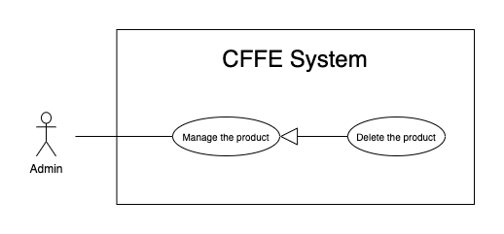

*Figure 24 - <Use Case> Delete the product*

|  |  |  |  |
| --- | --- | --- | --- |
| ID and Name: | **UC-38 Delete the product** | | |
| Created By: | HieuNT | Date Created: | 10/05/2021 |
| Primary Actor: | Admin | Secondary Actors: | N/A |
| Description: | This feature allows Admin to delete the product. | | |
| Trigger: | Admin sends a request to delete the product. | | |
| Preconditions: | PRE-01. User has logged in the system as Admin role.  PRE-02. Admin is on “Product detail” page. | | |
| Post-conditions: | POST-01:   * Success: CFFE system shows success message and reloads "Product Detail" page. * Fail: CFFE system shows error message. | | |
| Normal Flow: | **38.0 Delete the product**   1. Admin on "Change to Inactive" button. 2. CFFE system redirects to inactive page and shows required form:  * "Inactive reason": text area * " Save": button * " Back " button  1. Admin inputs the field. 2. Admin clicks on " Save " button. (Alternative 38.0) 3. CFFE system validates the product. (Exception 38.0.E1, 38.0.E2, 38.E3) 4. CFFE system updates the product's status and redirects to product detail page with the success message (MSG-040). | | |
| Alternative Flows: | **38.0 Admin cancels the deleting process.**   1. Admin clicks on "Back" button. 2. CFFE system redirects to “Product Detail” page and terminates this use case. | | |
| Exceptions: | **38.0.E1 Product does not exist**   1. CFFE system returns error message (MSG-023) and terminates this use case.   **38.0.E2 The product is still on the stack.**   1. CFFE system shows error message (MSG-097) and terminates this use case.   **38.0.E3 Admin inputs the inactive reason fields that are not valid**   1. CFFE system returns error message (MSG-067) and terminates this use case. | | |
| Priority: | Medium | | |
| Frequency of Use: | Often | | |
| Business Rules: | BR-032, BR-033, BR-049 | | |
| Other Information: | In case of internet connection failure, Admin cannot finish this use case properly. | | |
| Assumptions: | N/A | | |

*Table 24 - <Use Case> Delete the product*

##### 2.3.3.15 <Admin> Create the product

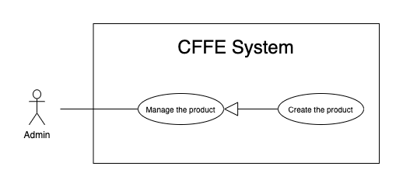

*Figure 26 - <Use Case> Create new product*

|  |  |  |  |
| --- | --- | --- | --- |
| ID and Name: | **UC-39 Create the product** | | |
| Created By: | HieuNT | Date Created: | 10/05/2021 |
| Primary Actor: | Admin | Secondary Actors: | N/A |
| Description: | This feature allows Admin to create the product. | | |
| Trigger: | Admin sends a request to create the product. | | |
| Preconditions: | PRE-01. User has logged in the system as Admin role.  PRE-02. Admin is on “Product” page. | | |
| Post-conditions: | POST-01:   * Success: CFFE system shows success message and reloads "Product" page. * Fail: CFFE system shows error message. | | |
| Normal Flow: | **39.0 Create the product**   1. Admin clicks on "New" button. 2. CFFE system redirects to create product page and shows required form that includes:    * "Image": button    * "Product name": input text    * "Description": input text    * "Category": dropdown list    * "Create": button    * "Back": button 3. Admin inputs/selects the required fields. 4. Admin clicks on the "Create" button to create the product. (Alternative 39.0) 5. CFFE system validates the required fields (Exception 39.0.E1, 39.0.E2) 6. CFFE system stores newly created product information and redirects to “Product” page with the success message (MSG-011). | | |
| Alternative Flows: | **39.0 Admin cancels the creating process.**   1. Admin clicks on "Back" button. 2. CFFE system redirects to “Product” page and terminates this use case. | | |
| Exceptions: | **39.0.E1 Admin does not input/select the required fields**   1. CFFE system returns to Admin to input/select the required fields again (MSG-016, MSG-099, MSG-102). 2. If Admin inputs/selects the required fields again, CFFE system returns to step 3 of the normal flow. 3. Else if Admin cancels the updating process, then CFFE system terminates this use case.   **39.0.E2 Admin inputs/selects the fields that are not valid**   1. CFFE system returns to Admin to input/select the fields again (MSG-017, MSG-060, MSG-103, MSG-104, MSG-130). 2. If Admin inputs/selects the fields again, CFFE system returns to step 3 of the normal flow. 3. Else if Admin cancels the updating process, then CFFE system terminates this use case. | | |
| Priority: | Medium | | |
| Frequency of Use: | Often | | |
| Business Rules: | BR-035, BR-047, BR-070 | | |
| Other Information: | In case of internet connection failure, Admin cannot finish this use case properly. | | |
| Assumptions: | N/A | | |

*Table 25 - <Use Case> Create new product*

##### 2.3.3.15 <Admin> Update the camera

*Figure 29 - <Use Case> Update the camera*

|  |  |  |  |
| --- | --- | --- | --- |
| ID and Name: | **UC-40 Update the camera** | | |
| Created By: | HuuDN | Date Created: | 18/06/2021 |
| Primary Actor: | Admin | Secondary Actors: | N/A |
| Description: | This feature allows Admin to update camera in CFFE system. | | |
| Trigger: | Admin sends a request to update the camera. | | |
| Preconditions: | PRE-01. User has logged in the system as Admin role.  PRE-02. Manager is on “Camera detail” page. | | |
| Post-conditions: | POST-01:   * Success: CFFE system shows success message and reloads "Camera Detail" page. * Fail: CFFE system shows error message. | | |
| Normal Flow: | **40.0 Update the camera information**   1. Admin clicks on "Update information" button. 2. CFFE system redirects to “Update Camera” page and shows required form that includes:  * “Camera name”: input text * “IP address”: input text * "MAC address": input text * “RTSP string”: input text * “Save”: button * “Back”: button  1. Admin inputs the required fields. 2. Admin clicks on “Save” button to update camera information. (Alternative 40.3) 3. CFFE system validates the fields (Exception 40.0.E1, 40.0.E2, 40.0.E6) 4. CFFE system updates camera information and redirects to “Camera Detail” page with the success message (MSG-013). | | |
| Alternative Flows: | **40.0 Updating camera image.**   1. Admin clicks on "Change image " button. 2. CFFE system redirects to “Change Image” page and shows required form that includes:    * "Choose": button    * "Save": button    * "Back": button 3. Admin clicks on "Choose" button and select an image. 4. Admin clicks on "Save" button. (Alternative 40.3) 5. CFFE system validates the image. (Exception 40.0.E3, 40.0.E4, 40.0.E5, 40.0.E6) 6. CFFE system updates the camera's image and redirects to “Camera Detail” page with the success message (MSG-013).   **40.1 Reactivate the inactive camera.**   1. Admin clicks on "Change to Pending" button. 2. CFFE system shows confirm popup with message " The status will change to Pending. Are you sure?" and two buttons for Admin selecting:    * "Yes" button    * "No" button 3. Admin clicks on "Yes" button. (Alternative 40.2) 4. CFFE system validates the camera. (Exception 40.0.E6) 5. CFFE system updates the camera's status and returns the success message (MSG-013).   **40.2 Admin cancels the updating process.**   1. Admin clicks on "Cancel" button. 2. CFFE system closes this popup and terminates this use case.   **40.3 Admin cancels the updating process.**   1. Admin clicks on "Back" button. 2. CFFE system redirects to “Camera Detail” page and terminates this use case. | | |
| Exceptions: | **40.0.E1 Admin does not input the required fields**   1. CFFE system returns to Admin to input the required fields again (MSG-031, MSG-030, MSG-082, MSG-125). 2. If Admin inputs the required fields again, CFFE system returns to step 3 of the normal flow. 3. Else if Admin cancels the updating process, then CFFE system terminates this use case.   **40.0.E2 Admin inputs the fields that are not valid**   1. CFFE system returns to Admin to input the fields again (MSG-032, MSG-059, MSG-083, MSG-126). 2. If Admin inputs the fields again, CFFE system returns to step 3 of the normal flow. 3. Else if Admin cancels the updating process, then CFFE system terminates this use case.   **40.0.E3 Admin does not select the image**   1. CFFE system returns to Admin to select the image again (MSG-112). 2. If Admin selects the image again, CFFE system returns to step 3 of the alternative flow 40.0. 3. Else if Admin cancels the updating process, then CFFE system terminates this use case.   **40.0.E4 Image is not jpg/jpeg/png format.**   1. CFFE system returns to Admin to select the image again (MSG-113). 2. If Admin selects the image again, CFFE system returns to step 3 of the alternative flow 40.0. 3. Else if Admin cancels the updating process, then CFFE system terminates this use case.   **40.0.E5 CFFE system cannot upload the image.**   1. CFFE system shows error message (MSG-114) and terminates this use case.   **40.0.E6 Camera does not exist.**   1. CFFE system returns error message (MSG-020) and terminates this use case. | | |
| Priority: | Medium | | |
| Frequency of Use: | Often | | |
| Business Rules: | BR-029, BR-032, BR-055, BR-056 | | |
| Other Information: | In case of internet connection failure, Admin cannot finish this use case properly. | | |
| Assumptions: | N/A | | |

*Table 28 - <Use Case> Update the camera*

##### 2.3.3.15 <Admin> Delete the camera

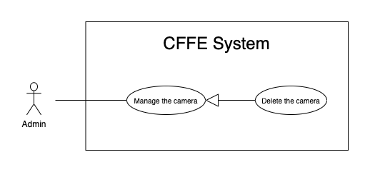

*Figure 29 - <Use Case> Delete the camera*

|  |  |  |  |
| --- | --- | --- | --- |
| ID and Name: | **UC-41 Delete the camera** | | |
| Created By: | HuuDN | Date Created: | 10/05/2021 |
| Primary Actor: | Admin | Secondary Actors: | N/A |
| Description: | This feature allows Admin to delete the camera. | | |
| Trigger: | Admin sends a request to delete the camera. | | |
| Preconditions: | PRE-01. User has logged in the system as manager role.  PRE-02. Admin is on “Camera detail” page. | | |
| Post-conditions: | POST-01:   * Success: CFFE system shows success message and reloads "Camera Detail" page. * Fail: CFFE system shows error message. | | |
| Normal Flow: | **41.0 Delete the camera**   1. Admin clicks on "Change to Inactive" button. 2. CFFE system redirects to “Inactive” page and shows required form that includes:  * "Inactive reason": text area * "Save": button * "Back" button  1. Admin inputs the field. 2. Admin clicks on "Save" button. (Alternative 41.0) 3. CFFE system validates the product. (Exception 41.0.E1, 41.0.E2, 41.0.E3) 4. CFFE system updates the camera's status and redirects to “Camera Detail” page with the success message (MSG-040). | | |
| Alternative Flows: | **41.0 Admin cancels the deleting process.**   1. Admin clicks on "Back" button. 2. CFFE system redirects to “Camera Detail” page and terminates this use case. | | |
| Exceptions: | **41.0.E1 Camera does not exist**   1. CFFE system returns error message (MSG-020) and terminates this use case.   **41.0.E2 The camera is still on the shelf or stack.**   1. CFFE system shows error message (MSG-066) and terminates this use case.   **41.0.E3 Admin inputs the inactive reason fields that are not valid**   1. CFFE system returns error message (MSG-067) and terminates this use case. | | |
| Priority: | Medium | | |
| Frequency of Use: | Often | | |
| Business Rules: | BR-032, BR-033, BR-056, BR-058 | | |
| Other Information: | In case of internet connection failure, Admin cannot finish this use case properly. | | |
| Assumptions: | N/A | | |

*Table 24 - <Use Case> Delete the camera*

##### 2.3.3.18 <Admin> Create the camera

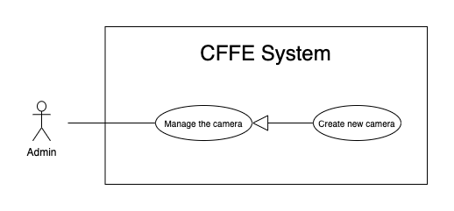

*Figure 30 - <Use Case> Create new camera*

|  |  |  |  |
| --- | --- | --- | --- |
| ID and Name: | **UC-42 Create new product** | | |
| Created By: | HuuDN | Date Created: | 10/05/2021 |
| Primary Actor: | Admin | Secondary Actors: | N/A |
| Description: | This feature allows Admin to create the camera. | | |
| Trigger: | Admin sends a request to create the camera. | | |
| Preconditions: | PRE-01. User has logged in the system as Admin role.  PRE-02. Admin is on “Camera” page. | | |
| Post-conditions: | POST-01:   * Success: CFFE system shows success message and reloads "Camera" page. * Fail: CFFE system shows error message. | | |
| Normal Flow: | **42.0 Create new camera**   1. Admin clicks on "New" button. 2. CFFE system redirects to “Create Camera” page and shows required form that includes:    * "Image" button    * "Camera name": input text    * "IP address": input text    * "MAC address": input text    * "RPST string": input text    * "Type detect": radio button    * "Create": button    * "Back": button 3. Admin inputs/selects the required fields. 4. Admin clicks on the "Create" button to create the camera (Alternative 42.0). 5. CFFE system validates the required fields (Exception 42.0.E1, 42.0.E2). 6. CFFE system stores newly created camera information and redirects to “Camera” page with the success message (MSG-011). | | |
| Alternative Flows: | **42.0 Admin cancels the creating process.**   1. Admin clicks on "Back" button. 2. CFFE system redirects to “Camera” page and terminates this use case. | | |
| Exceptions: | **42.0.E1 Admin does not input/select the required fields**   1. CFFE system returns to Admin to input/select the required fields again (MSG-031, MSG-030, MSG-082, MSG-125). 2. If Admin inputs/selects the required fields again, CFFE system returns to step 3 of the normal flow. 3. Else if Admin cancels the creating process, then CFFE system terminates this use case.   **42.0.E1 Admin inputs/selects the fields that are not valid**   1. CFFE system returns to Admin to input/select the fields again (MSG-032, MSG-059, MSG-083, MSG-084, MSG-126). 2. If Admin inputs/selects the fields again, CFFE system returns to step 3 of the normal flow. 3. Else if Admin cancels the creating process, then CFFE system terminates this use case. | | |
| Priority: | Medium | | |
| Frequency of Use: | Often | | |
| Business Rules: | BR-035, BR-055, BR-056, BR-070 | | |
| Other Information: | In case of internet connection failure, Admin cannot finish this use case properly. | | |
| Assumptions: | N/A | | |

*Table 30 - <Use Case> Create new camera*

##### 2.3.3.19 <Admin> Update the category

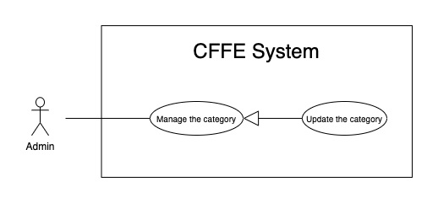

*Figure 33 - <Use Case> Update the category*

|  |  |  |  |
| --- | --- | --- | --- |
| ID and Name: | **UC-43 Update the category** | | |
| Created By: | HuuDN | Date Created: | 18/06/2021 |
| Primary Actor: | Admin | Secondary Actors: | N/A |
| Description: | This feature allows Admin to update category in CFFE system. | | |
| Trigger: | Admin sends a request to update the category. | | |
| Preconditions: | PRE-01. User has logged in the system as Admin role.  PRE-02. Admin is on “Category” page. | | |
| Post-conditions: | POST-01:   * Success: CFFE system shows success message and reloads "Category" page. * Fail: CFFE system shows error message. | | |
| Normal Flow: | **43.0 Update the category** (Alternative 43.0)   1. Admin clicks on "Update information" button. 2. CFFE system redirects to update category page and shows required form that includes:  * “Category name”: input text * “Save”: button * “Back”: button  1. Admin inputs the required fields. 2. Admin clicks on “Save” button. (Alternative 43.2) 3. CFFE system validates the fields (Exception 43.0.E1, 43.0.E2, 43.0.E3) 4. CFFE system updates camera information and redirects to category detail page with the success message (MSG-013). | | |
| Alternative Flows: | **43.0 Reactivate the inactive camera.**   1. Admin clicks on "Change to Active" button. 2. CFFE system shows confirm popup with message " The status will change to Pending. Are you sure?" and two buttons for Admin selecting:    * "Yes": button    * "No": button 3. Admin clicks on "Yes" button. (Alternative 43.1) 4. CFFE system validates the camera. (Exception 43.0.E3) 5. CFFE system updates the camera's status and returns the success message (MSG-013).   **43.1 Admin cancels the updating process.**   1. Admin clicks on "No" button. 2. CFFE system closes this popup and terminates this use case.   **43.2 Admin cancels the updating process.**   1. Admin clicks on "Back" button.   CFFE system redirects to “Category Detail” page and terminates this use case. | | |
| Exceptions: | **43.0.E1 Admin does not input the required fields**   1. CFFE system returns to Admin to input/select the required fields again (MSG-105). 2. If Admin inputs the required fields again, CFFE system returns to step 3 of the normal flow. 3. Else if Admin cancels the login process, then CFFE system terminates this use case.   **43.0.E2 Admin inputs the fields that are not valid**   1. CFFE system returns to Admin to input/select the fields again (MSG-059, MSG-050). 2. If Admin inputs the fields again, CFFE system returns to step 3 of the normal flow. 3. Else if Admin cancels the login process, then CFFE system terminates this use case.   **43.0.E3 Category does not exist.**   1. CFFE system returns error message (MSG-029) and terminates this use case. | | |
| Priority: | Medium | | |
| Frequency of Use: | Often | | |
| Business Rules: | BR-032, BR-063 | | |
| Other Information: | In case of internet connection failure, Admin cannot finish this use case properly. | | |
| Assumptions: | N/A | | |

*Table 33 - <Use Case> Update the category*

##### 2.3.3.20 <Admin> Delete the category

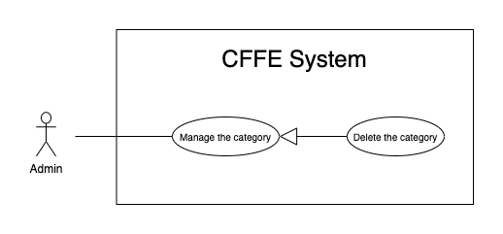

*Figure 33 - <Use Case> Update the category*

|  |  |  |  |
| --- | --- | --- | --- |
| ID and Name: | **UC-44 Delete the category** | | |
| Created By: | HuuDN | Date Created: | 18/06/2021 |
| Primary Actor: | Admin | Secondary Actors: | N/A |
| Description: | This feature allows Admin to delete category in CFFE system. | | |
| Trigger: | Admin sends a request to delete the category. | | |
| Preconditions: | PRE-01. User has logged in the system as Admin role.  PRE-02. Admin is on “Category” page. | | |
| Post-conditions: | POST-01:   * Success: CFFE system shows success message and reloads "Category" page. * Fail: CFFE system shows error message. | | |
| Normal Flow: | **44.0 Delete the category**   1. Admin clicks on "Change to Inactive" button. 2. CFFE system redirects to “Inactive” page and shows required form that includes:    * "Inactive reason": text area    * "Save": button    * "Back": button 3. Admin clicks on "Save" button. (Alternative 44.0) 4. CFFE system validates the product. (Exception 44.0.E1, 44.0.E2) 5. CFFE system updates the camera's status and redirects to category detail page with the success message (MSG-013). | | |
| Alternative Flows: | **44.0 Admin cancels the deleting process.**   1. Admin clicks on "Back" button. 2. CFFE system redirects to “Detail” page and terminates this use case. | | |
| Exceptions: | **44.0.E1 Category does not exist**   1. CFFE system returns error message (MSG-029) and terminates this use case.   **44.0.E2 Category has a product.**   1. CFFE system shows error message (MSG-066) and terminates this use case. | | |
| Priority: | Medium | | |
| Frequency of Use: | Often | | |
| Business Rules: | BR-057 | | |
| Other Information: | In case of internet connection failure, Admin cannot finish this use case properly. | | |
| Assumptions: | N/A | | |

*Table 33 - <Use Case> Update the category*

##### 2.3.3.21 <Admin> Create new category

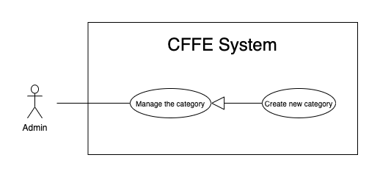

*Figure 35 - <Use Case> Create new category*

|  |  |  |  |
| --- | --- | --- | --- |
| ID and Name: | **UC-45 Create new category** | | |
| Created By: | TruongTN | Date Created: | 10/05/2021 |
| Primary Actor: | Admin | Secondary Actors: | N/A |
| Description: | This feature allows Admin to create the category. | | |
| Trigger: | Admin sends a request to create the category. | | |
| Preconditions: | PRE-01. User has logged in the system as Admin role.  PRE-02. Admin is on “Category” page. | | |
| Post-conditions: | POST-01:   * Success: CFFE system shows success message and reloads "Category" page. * Fail: CFFE system shows error message. | | |
| Normal Flow: | **45.0 Create the category**   1. Admin clicks on "New" button. 2. CFFE system redirects to create category page and shows required form that includes:    * "Category name": input text    * “Create”: button    * “Back”: button 3. Admin inputs the required fields. 4. Admin clicks on the "Create" button to create the category. (Alternative 45.0) 5. CFFE system validates the required fields (Exception 45.0.E1, 45.0.E2). 6. CFFE system stores newly created category information and redirects to “Category” page with the success message (MSG-011). | | |
| Alternative Flows: | **45.0 Admin cancels the creating process.**   1. Admin clicks on "Back" button. 2. CFFE system closes this popup and terminates this use case. | | |
| Exceptions: | **45.0.E1 Admin does not input the required fields**   1. CFFE system returns to Admin to input the required fields again (MSG-105). 2. If Admin inputs the required fields again, CFFE system returns to step 3 of the normal flow. 3. Else if Admin cancels the creating process, then CFFE system terminates this use case.   **45.0.E1 Admin inputs the fields that are not valid**   1. CFFE system returns to Admin to input the fields again (MSG-059, MSG-050). 2. If Admin inputs the fields again, CFFE system returns to step 3 of the normal flow. 3. Else if Admin cancels the creating process, then CFFE system terminates this use case. | | |
| Priority: | Medium | | |
| Frequency of Use: | Often | | |
| Business Rules: | BR-063 | | |
| Other Information: | In case of internet connection failure, Admin cannot finish this use case properly. | | |
| Assumptions: | N/A | | |

*Table 31 - <Use Case> Create new category*