**2. Authorized user**

**Overview manage the stack use case:**

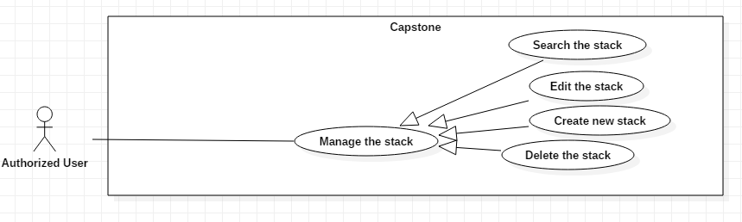

**2.1 <Authorized user> Create new stack**

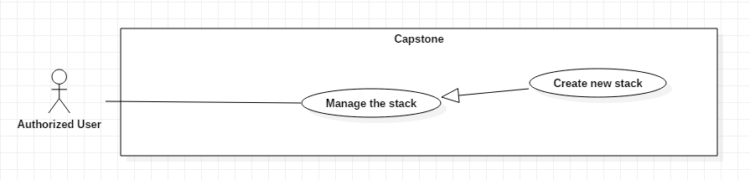

|  |  |  |  |
| --- | --- | --- | --- |
| **USE CASE – Capstone System** | | | |
| **Use Case No.** | EGS-48 | **Use Case Version** | 1.0 |
| **Use Case Name** | Create new stack | | |
| **Author** | LuanNM | | |
| **Date** | 3/02/2021 | **Priority** | Normal |
| **Actor:**  - Authorized user  **Summary:**  - This use case allows the authorized user to create new stack in the system.  **Goal:**  - Authorized user can create a new stack.  **Triggers:**  - Authorized user clicks on the “Create new stack” button.  **Preconditions:**  - Authorized user must login to the system.  - Authorized user is on the creating stack page.  **Postconditions:**  - **Success**: Authorized user create a shelf successfully.  - **Fail**: System shows the error message.  **Main Success Scenario:**   |  |  |  | | --- | --- | --- | | **Step** | **Actor Action** | **System Response** | | 1 | Authorized user clicks on the “Create new stack” button | System shows the form that includes:  - Shelf: Dropdown box  - Position: Dropdown box | | 2 | Authorized user inputs or selects fields |  | | 3 | Authorized user clicks on the “Create” button | System shows the message that the request is being processing.  System shows the message that the stack created succesfully. |   **Alternative Scenarios:** N/A  **Exceptions:**   |  |  |  | | --- | --- | --- | | **No** | **Actor Action** | **System Response** | | 1 | Internet problem. | System shows the message: "The system is busy" when the internet is lost. |   **Relationships:** N/A  **Business Rules:**   * After generated successfully, system redirects to the main view screen. | | | |

**2.2 <Authorized user> Edit an exist stack**

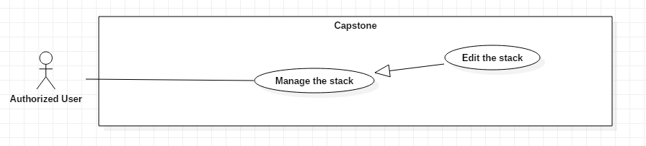

|  |  |  |  |
| --- | --- | --- | --- |
| **USE CASE – Capstone System** | | | |
| **Use Case No.** | EGS-48 | **Use Case Version** | 1.0 |
| **Use Case Name** | Edit the stack | | |
| **Author** | LuanNM | | |
| **Date** | 3/02/2021 | **Priority** | Normal |
| **Actor:**  - Authorized user  **Summary:**  - This use case allows the authorized user to edit a shelf in the system.  **Goal:**  - Authorized user can edit the stack.  **Triggers:**  - Authorized user clicks on the “Edit stack” button.  **Preconditions:**  - Authorized user must login to the system.  - Authorized user is on the editing stack page.  **Postconditions:**  - **Success**: Authorized user edit a stack successfully.  - **Fail**: System shows the error message.  **Main Success Scenario:**   |  |  |  | | --- | --- | --- | | **Step** | **Actor Action** | **System Response** | | 1 | Authorized user clicks on the “Edit a stack” button | System shows the form that includes:  - Shelf: Dropdown box  - Position: Dropdown box | | 2 | Authorized user inputs or selects fields |  | | 3 | Authorized user clicks on the “Edit” button | System shows the message that the request is being processing.  System shows the message that the stack edited succesfully. |   **Alternative Scenarios:** N/A  **Exceptions:**   |  |  |  | | --- | --- | --- | | **No** | **Actor Action** | **System Response** | | 1 | Internet problem. | System shows the message: "The system is busy" when the internet is lost. |   **Relationships:** N/A  **Business Rules:**   * After edited successfully, system redirects to the main view screen. | | | |

**2.3 <Authorized user> Delete a stack**

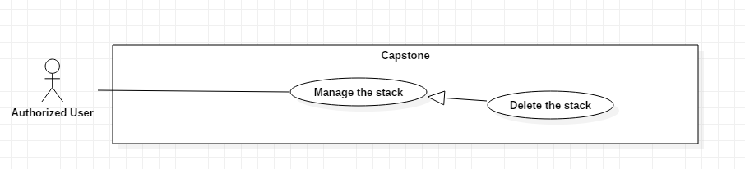

|  |  |  |  |
| --- | --- | --- | --- |
| **USE CASE – Capstone System** | | | |
| **Use Case No.** | EGS-48 | **Use Case Version** | 1.0 |
| **Use Case Name** | Delete the stack | | |
| **Author** | LuanNM | | |
| **Date** | 3/02/2021 | **Priority** | Normal |
| **Actor:**  - Authorized user  **Summary:**  - This use case allows the authorized user to delete a shelf in the system.  **Goal:**  - Authorized user can delete a shelf.  **Triggers:**  - Authorized user clicks on the “Delete stack” button.  **Preconditions:**  - Authorized user must login to the system.  - Authorized user is on the stack managing page.  **Postconditions:**  - **Success**: Authorized user delete a stack successfully.  - **Fail**: System shows the error message.  **Main Success Scenario:**   |  |  |  | | --- | --- | --- | | **Step** | **Actor Action** | **System Response** | | 1 | Authorized user clicks on the “Delete the stack” button | System asks authorized user to confirm the action | | 2 | Authorized user chooses to confirm the action. | System shows the message that the promotion is removed.  [Exception 1] |   **Alternative Scenarios:** N/A  **Exceptions:**   |  |  |  | | --- | --- | --- | | **No** | **Actor Action** | **System Response** | | 1 | Internet problem. | System shows the message: "The system is busy" when the internet is lost. |   **Relationships:** N/A  **Business Rules:**   * System redirects to the promotion details screen. * The changing stack status is “Deleted”. | | | |

**2.4 <Authorized user> Search a stack**

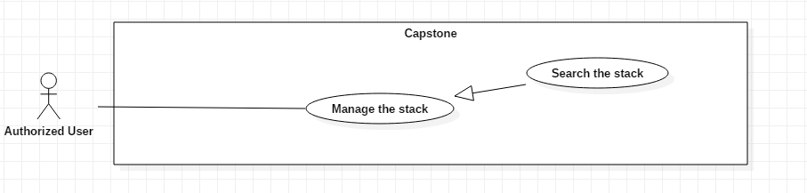

|  |  |  |  |
| --- | --- | --- | --- |
| **USE CASE – Capstone System** | | | |
| **Use Case No.** | EGS-48 | **Use Case Version** | 1.0 |
| **Use Case Name** | Search the stack | | |
| **Author** | LuanNM | | |
| **Date** | 3/02/2021 | **Priority** | Normal |
| **Actor:**  - Authorized user  **Summary:**  - This use case allows the authorized user to search stacks in the system.  **Goal:**  - Authorized user can search stacks.  **Triggers:**  - Authorized user clicks on the “Search stack” button.  **Preconditions:**  - Authorized user must login to the system.  - Authorized user is on the stack managing page.  **Postconditions:**  - **Success**: Authorized user view stack with indicated condition.  - **Fail**: System shows the error message.  **Main Success Scenario:**   |  |  |  | | --- | --- | --- | | **Step** | **Actor Action** | **System Response** | | 1 | Authorized user inputs the id of the shelf | System shows the stack with the indicated condition. |   **Alternative Scenarios:** N/A  **Exceptions:**   |  |  |  | | --- | --- | --- | | **No** | **Actor Action** | **System Response** | | 1 | Internet problem. | System shows the message: "The system is busy" when the internet is lost. |   **Relationships:** N/A  **Business Rules:**   * System redirects to the main screen. | | | |

**Overview manage the stack use case:**

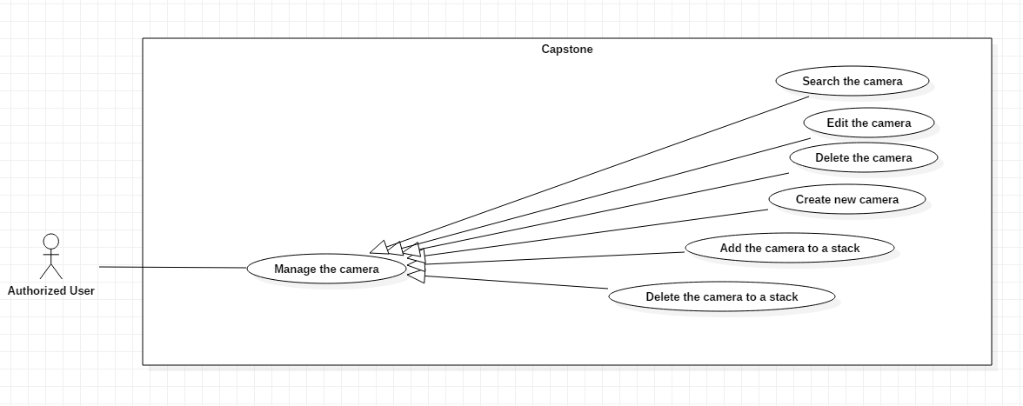

**2.5 <Authorized user> Create new camera**

|  |  |  |  |
| --- | --- | --- | --- |
| **USE CASE – Capstone System** | | | |
| **Use Case No.** | EGS-48 | **Use Case Version** | 1.0 |
| **Use Case Name** | Create new camera | | |
| **Author** | LuanNM | | |
| **Date** | 3/02/2021 | **Priority** | Normal |
| **Actor:**  - Authorized user  **Summary:**  - This use case allows the authorized user to create new camera in the system.  **Goal:**  - Authorized user can create a new camera.  **Triggers:**  - Authorized user clicks on the “Create new camera” button.  **Preconditions:**  - Authorized user must login to the system.  - Authorized user is on the creating camera page.  **Postconditions:**  - **Success**: Authorized user create a camera successfully.  - **Fail**: System shows the error message.  **Main Success Scenario:**   |  |  |  | | --- | --- | --- | | **Step** | **Actor Action** | **System Response** | | 1 | Authorized user clicks on the “Create new camera” button | System shows the form that includes:  - Stack: Dropdown box | | 2 | Authorized user inputs or selects fields |  | | 3 | Authorized user clicks on the “Create” button | System shows the message that the request is being processing.  System shows the message that the camera created succesfully. |   **Alternative Scenarios:** N/A  **Exceptions:**   |  |  |  | | --- | --- | --- | | **No** | **Actor Action** | **System Response** | | 1 | Internet problem. | System shows the message: "The system is busy" when the internet is lost. |   **Relationships:** N/A  **Business Rules:**   * After generated successfully, system redirects to the main view screen. | | | |

**2.6 <Authorized user> Edit an exist camera**

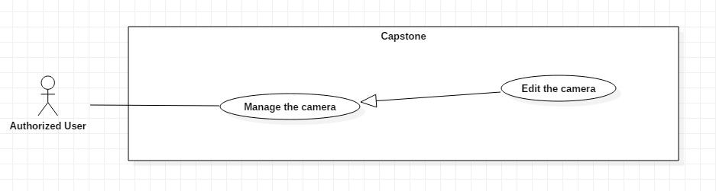

|  |  |  |  |
| --- | --- | --- | --- |
| **USE CASE – Capstone System** | | | |
| **Use Case No.** | EGS-48 | **Use Case Version** | 1.0 |
| **Use Case Name** | Edit the camera | | |
| **Author** | LuanNM | | |
| **Date** | 3/02/2021 | **Priority** | Normal |
| **Actor:**  - Authorized user  **Summary:**  - This use case allows the authorized user to edit a camera in the system.  **Goal:**  - Authorized user can edit the camera.  **Triggers:**  - Authorized user clicks on the “Edit camera” button.  **Preconditions:**  - Authorized user must login to the system.  - Authorized user is on the editing stack page.  **Postconditions:**  - **Success**: Authorized user edit a stack successfully.  - **Fail**: System shows the error message.  **Main Success Scenario:**   |  |  |  | | --- | --- | --- | | **Step** | **Actor Action** | **System Response** | | 1 | Authorized user clicks on the “Edit a camera” button | System shows the form that includes:  - Stack: Dropdown box | | 2 | Authorized user inputs or selects fields |  | | 3 | Authorized user clicks on the “Edit” button | System shows the message that the request is being processing.  System shows the message that the camera edited succesfully. |   **Alternative Scenarios:** N/A  **Exceptions:**   |  |  |  | | --- | --- | --- | | **No** | **Actor Action** | **System Response** | | 1 | Internet problem. | System shows the message: "The system is busy" when the internet is lost. |   **Relationships:** N/A  **Business Rules:**   * After edited successfully, system redirects to the main view screen. | | | |

**2.7 <Authorized user> Delete a camera**

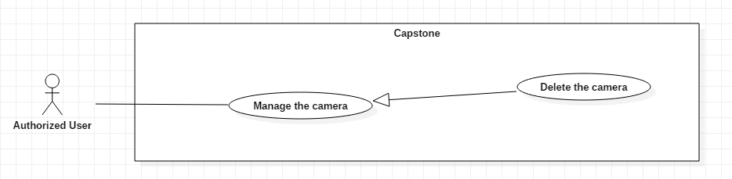

|  |  |  |  |
| --- | --- | --- | --- |
| **USE CASE – Capstone System** | | | |
| **Use Case No.** | EGS-48 | **Use Case Version** | 1.0 |
| **Use Case Name** | Delete the camera | | |
| **Author** | LuanNM | | |
| **Date** | 3/02/2021 | **Priority** | Normal |
| **Actor:**  - Authorized user  **Summary:**  - This use case allows the authorized user to delete a camere in the system.  **Goal:**  - Authorized user can delete a camere.  **Triggers:**  - Authorized user clicks on the “Delete camera” button.  **Preconditions:**  - Authorized user must login to the system.  - Authorized user is on the stack managing page.  **Postconditions:**  - **Success**: Authorized user delete a camera successfully.  - **Fail**: System shows the error message.  **Main Success Scenario:**   |  |  |  | | --- | --- | --- | | **Step** | **Actor Action** | **System Response** | | 1 | Authorized user clicks on the “Delete the camera” button | System asks authorized user to confirm the action | | 2 | Authorized user chooses to confirm the action. | System shows the message that the promotion is removed.  [Exception 1] |   **Alternative Scenarios:** N/A  **Exceptions:**   |  |  |  | | --- | --- | --- | | **No** | **Actor Action** | **System Response** | | 1 | Internet problem. | System shows the message: "The system is busy" when the internet is lost. |   **Relationships:** N/A  **Business Rules:**   * System redirects to the promotion details screen. * The changing camera status is “Deleted”. | | | |