1. **Authorized user**

**Overview generate the report use case:**

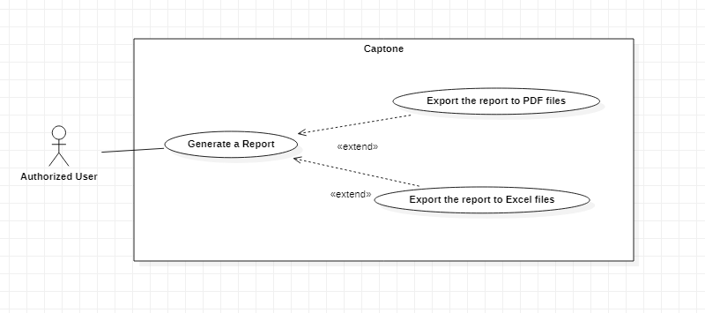

**2.1 <Authorized user> Generate a report**

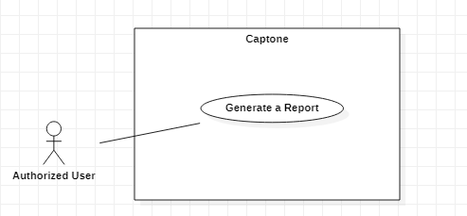

|  |  |  |  |
| --- | --- | --- | --- |
| **USE CASE – Capstone System** | | | |
| **Use Case No.** | EGS-48 | **Use Case Version** | 1.0 |
| **Use Case Name** | Generate a report | | |
| **Author** | LocTP | | |
| **Date** | 3/02/2021 | **Priority** | Normal |
| **Actor:**  - Admin  **Summary:**  - This use case allows the admin to generate a report.  **Goal:**  - Admin can create a report in the indicated time.  **Triggers:**  - Admin clicks on the “Generate” button.  **Preconditions:**  - Admin must login to the system.  - Admin is on the generating report page.  **Postconditions:**  - **Success**: Admin generate a report successfully.  - **Fail**: System shows the error message.  **Main Success Scenario:**   |  |  |  | | --- | --- | --- | | **Step** | **Actor Action** | **System Response** | | 1 | Admin clicks on the “Edit” button on the list of requests. | System shows the form that includes:  - Date From: combox  - Date To: combobox  - File Format: combobox | | 2 | Admin choose “File Format” combobox |  | | 3 | Admin inputs or selects fields |  | | 4 | Admin clicks on the “Export” button | System shows the message that the request is being processing.  System shows the message that the report created. |   **Alternative Scenarios:** N/A  **Exceptions:**   |  |  |  | | --- | --- | --- | | **No** | **Actor Action** | **System Response** | | 1 | Internet problem. | System shows the message: "The system is busy" when the internet is lost. |   **Relationships:** N/A  **Business Rules:**   * After generated successfully, system redirects to the main view screen. | | | |

**2.2 <Authorized user> Export the report to PDF files**

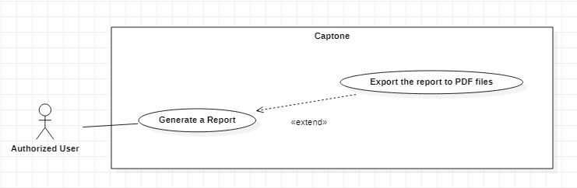

|  |  |  |  |
| --- | --- | --- | --- |
| **USE CASE – Capstone System** | | | |
| **Use Case No.** | EGS-48 | **Use Case Version** | 1.0 |
| **Use Case Name** | Export the report to PDF files | | |
| **Author** | LocTP | | |
| **Date** | 3/02/2021 | **Priority** | Normal |
| **Actor:**  - Admin  **Summary:**  - This use case allows the admin to export a report to PDF file.  **Goal:**  - Admin can get a report in the indicated time.  **Triggers:**  - Admin clicks on the “Export” button.  **Preconditions:**  - Admin must login to the system.  - Admin chose PDF file in “File Format” combobox at generating report page  - Admin is on the report page.  **Postconditions:**  - **Success**: Admin export a report successfully.  - **Fail**: System shows the error message.  **Main Success Scenario:**   |  |  |  | | --- | --- | --- | | **Step** | **Actor Action** | **System Response** | | 1 | Admin clicks on the “Export” button | System shows the message that the request is being processing.  System shows the message that the report created. |   **Alternative Scenarios:** N/A  **Exceptions:**   |  |  |  | | --- | --- | --- | | **No** | **Actor Action** | **System Response** | | 1 | Internet problem. | System shows the message: "The system is busy" when the internet is lost. |   **Relationships:** N/A  **Business Rules:**   * After generated successfully, system redirects to the main view screen. | | | |

**2.3 <Authorized user> Export the report to Excel files**

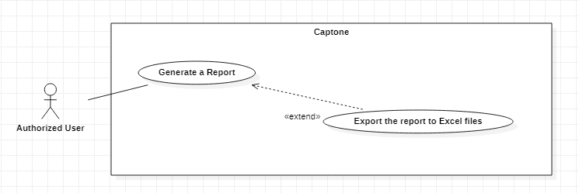

|  |  |  |  |
| --- | --- | --- | --- |
| **USE CASE – Capstone System** | | | |
| **Use Case No.** | EGS-48 | **Use Case Version** | 1.0 |
| **Use Case Name** | Export the report to Excel files | | |
| **Author** | LocTP | | |
| **Date** | 3/02/2021 | **Priority** | Normal |
| **Actor:**  - Admin  **Summary:**  - This use case allows the admin to export a report to Excel file.  **Goal:**  - Admin can get a report in the indicated time.  **Triggers:**  - Admin clicks on the “Export” button.  **Preconditions:**  - Admin must login to the system.  - Admin chose Excel file in “File Format” combobox at generating report page  - Admin is on the generating report page.  **Postconditions:**  - **Success**: Admin export a report successfully.  - **Fail**: System shows the error message.  **Main Success Scenario:**   |  |  |  | | --- | --- | --- | | **Step** | **Actor Action** | **System Response** | | 1 | Admin clicks on the “Export” button | System shows the message that the request is being processing.  System shows the message that the report created. |   **Alternative Scenarios:** N/A  **Exceptions:**   |  |  |  | | --- | --- | --- | | **No** | **Actor Action** | **System Response** | | 1 | Internet problem. | System shows the message: "The system is busy" when the internet is lost. |   **Relationships:** N/A  **Business Rules:**   * After generated successfully, system redirects to the main view screen. | | | |

**Overview generate the report use case:**

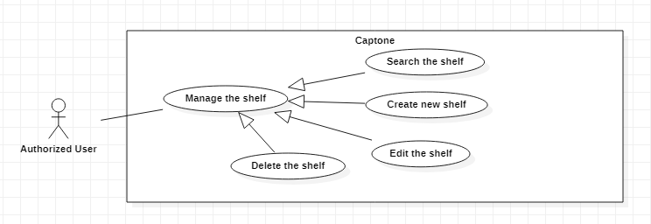

**2.4 <Authorized user> Create new shelf**

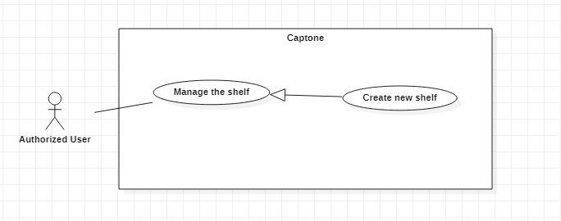

|  |  |  |  |
| --- | --- | --- | --- |
| **USE CASE – Capstone System** | | | |
| **Use Case No.** | EGS-48 | **Use Case Version** | 1.0 |
| **Use Case Name** | Create new shelf | | |
| **Author** | LocTP | | |
| **Date** | 3/02/2021 | **Priority** | Normal |
| **Actor:**  - Admin  **Summary:**  - This use case allows the admin to create new shelf in the system.  **Goal:**  - Admin can create a new shelf.  **Triggers:**  - Admin clicks on the “Create new shelf” button.  **Preconditions:**  - Admin must login to the system.  - Admin is on the creating shelf page.  **Postconditions:**  - **Success**: Admin create a shelf successfully.  - **Fail**: System shows the error message.  **Main Success Scenario:**   |  |  |  | | --- | --- | --- | | **Step** | **Actor Action** | **System Response** | | 1 | Admin clicks on the “Create new shelf” button | System shows the form that includes:  - Position: input  - Type: input | | 2 | Admin inputs or selects fields |  | | 3 | Admin clicks on the “Create” button | System shows the message that the request is being processing.  System shows the message that the shelf created succesfully. |   **Alternative Scenarios:** N/A  **Exceptions:**   |  |  |  | | --- | --- | --- | | **No** | **Actor Action** | **System Response** | | 1 | Internet problem. | System shows the message: "The system is busy" when the internet is lost. |   **Relationships:** N/A  **Business Rules:**   * After generated successfully, system redirects to the main view screen. | | | |

**2.5 Edit an exist shelf**

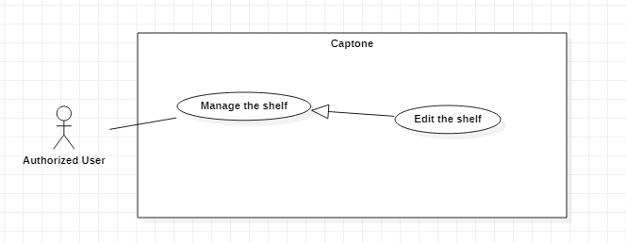

|  |  |  |  |
| --- | --- | --- | --- |
| **USE CASE – Capstone System** | | | |
| **Use Case No.** | EGS-48 | **Use Case Version** | 1.0 |
| **Use Case Name** | Edit a exist shelf | | |
| **Author** | LocTP | | |
| **Date** | 3/02/2021 | **Priority** | Normal |
| **Actor:**  - Admin  **Summary:**  - This use case allows the admin to edit a shelf in the system.  **Goal:**  - Admin can edit a new shelf.  **Triggers:**  - Admin clicks on the “Edit shelf” button.  **Preconditions:**  - Admin must login to the system.  - Admin is on the editing shelf page.  **Postconditions:**  - **Success**: Admin edit a shelf successfully.  - **Fail**: System shows the error message.  **Main Success Scenario:**   |  |  |  | | --- | --- | --- | | **Step** | **Actor Action** | **System Response** | | 1 | Admin clicks on the “Edit a shelf” button | System shows the form that includes:  - Position: input  - Type: input | | 2 | Admin inputs or selects fields |  | | 3 | Admin clicks on the “Edit” button | System shows the message that the request is being processing.  System shows the message that the shelf edited succesfully. |   **Alternative Scenarios:** N/A  **Exceptions:**   |  |  |  | | --- | --- | --- | | **No** | **Actor Action** | **System Response** | | 1 | Internet problem. | System shows the message: "The system is busy" when the internet is lost. |   **Relationships:** N/A  **Business Rules:**   * After edited successfully, system redirects to the main view screen. | | | |

**2.6 <Authorized user> Delete a shelf**

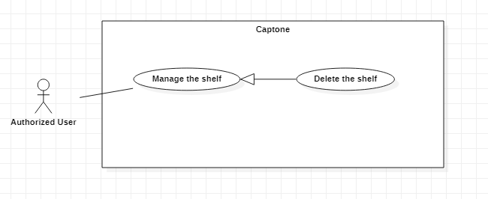

|  |  |  |  |
| --- | --- | --- | --- |
| **USE CASE – Capstone System** | | | |
| **Use Case No.** | EGS-48 | **Use Case Version** | 1.0 |
| **Use Case Name** | Delete a shelf | | |
| **Author** | LocTP | | |
| **Date** | 3/02/2021 | **Priority** | Normal |
| **Actor:**  - Admin  **Summary:**  - This use case allows the admin to delete a shelf in the system.  **Goal:**  - Admin can delete a shelf.  **Triggers:**  - Admin clicks on the “Delete shelf” button.  **Preconditions:**  - Admin must login to the system.  - Admin is on the shelf managing page.  **Postconditions:**  - **Success**: Admin delete a shelf successfully.  - **Fail**: System shows the error message.  **Main Success Scenario:**   |  |  |  | | --- | --- | --- | | **Step** | **Actor Action** | **System Response** | | 1 | Admin clicks on the “Delete the shelf” button | System asks admin to confirm the action | | 2 | Admid chooses to confirm the action. | System shows the message that the promotion is removed.  [Exception 1] |   **Alternative Scenarios:** N/A  **Exceptions:**   |  |  |  | | --- | --- | --- | | **No** | **Actor Action** | **System Response** | | 1 | Internet problem. | System shows the message: "The system is busy" when the internet is lost. |   **Relationships:** N/A  **Business Rules:**   * System redirects to the promotion details screen. * The changing shelf status is “Deleted”. | | | |

**2.7 <Authorized user> Search a shelf**

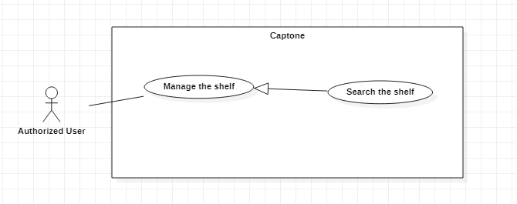

|  |  |  |  |
| --- | --- | --- | --- |
| **USE CASE – Capstone System** | | | |
| **Use Case No.** | EGS-48 | **Use Case Version** | 1.0 |
| **Use Case Name** | Search shelfs | | |
| **Author** | LocTP | | |
| **Date** | 3/02/2021 | **Priority** | Normal |
| **Actor:**  - Admin  **Summary:**  - This use case allows the admin to search shelfs in the system.  **Goal:**  - Admin can search shelfs.  **Triggers:**  - Admin clicks on the “Search shelf” button.  **Preconditions:**  - Admin must login to the system.  - Admin is on the shelf managing page.  **Postconditions:**  - **Success**: Admin view shelfs with indicated condition.  - **Fail**: System shows the error message.  **Main Success Scenario:**   |  |  |  | | --- | --- | --- | | **Step** | **Actor Action** | **System Response** | | 1 | Admin inputs the id of the shelf | System shows the shelf with the indicated condition. |   **Alternative Scenarios:** N/A  **Exceptions:**   |  |  |  | | --- | --- | --- | | **No** | **Actor Action** | **System Response** | | 1 | Internet problem. | System shows the message: "The system is busy" when the internet is lost. |   **Relationships:** N/A  **Business Rules:**   * System redirects to the main screen. | | | |