

**Capstone Project Report**

**Report 2 – System Requirement Specification**

– Ho Chi Minh, January 2021 –

### 1.2 Business Rules

|  |  |
| --- | --- |
| ID | Rule Definition |
| BR-01 | User logs in using username and password are registered. If the username and password are correct, system redirects users to corresponding home page:   * User logs in as role “admin”, the system will display admin home page * User logs in as role “customer”, the system will display customer home page |
| BR-02 | After logout successfully, user become the “Unauthenticated User” and systems will direct to login page |
| BR-03 | A search shelf form fields:   * Book shelf name: between 1-50 characters * Row number: between 1-100 * Column number: between 1-100   - ID: unique id identifier.  - Name: between 1 - 100.  - Status: text input, blank.  - “Created date”: text input, blank.  - “Creator”: text input, blank.  - “Location”: combobox. |
| BR-04 | Admin or librarian can view all of bookshelves in system  Admin or librarian can search by name with search bar on top  Tables contains max 10 items per page |
| BR-05 | Admin can edit bookshelf information |
| BR-06 | If one bookshelf has been removed, all drawers in bookshelf are also removed |
| BR-07 | A bookshelf requires fields:   * Location name: between 1-50 characters |
| BR-08 | Admin or librarian can view all of locations in system  Admin or librarian can search by name with search bar on top  Tables contains max 10 items per page |
| BR-09 | If one location has been removed, all bookshelves in location are also removed |
| BR-10 | Admin can view all of customer in system  Admin can search by name with search bar on top  Tables contains max 10 items per page |
| BR-11 | A book group requires fields:   * Book group name: between 1-250 characters * Author: between 1-100 characters * Page Number: between 1-1000 * Width: between 1-100 * Height: between 1-100 * Quantity: between 1-100 * Fee: between 1-5 * Punish Fee: between 1-5 * Publishing Company: between 1-250 characters * Publishing Number: between 1-100 * Publishing Date: must be smaller than current time * Publishing Palace: between 1-250 characters   After a book group is added, PAPV will automatically add the number of books to the book group equal to the number of librarians just imported.  Librarian need to prepare books before creating a book group |
| BR-12 | Librarian can view all of book groups in system  Librarian can search by name with search bar on top  Tables contains max 10 items per page |
| BR-13 | Librarian can edit book group information |
| BR-14 | After search book group by location, librarian can edit book group information details |
| BR-15 | After search book group by name, librarian can edit book group information details |
| BR-16 | A book group requires fields:   * Book group name: between 1-250 characters * Author: between 1-100 characters * Page Number: between 1-1000 * Width: between 1-100 * Height: between 1-100 * Quantity: between 1-100 * Fee: between 1-5 * Punish Fee: between 1-5 * Publishing Company: between 1-250 characters * Publishing Number: between 1-100 * Publishing Date: must be smaller than current time * Publishing Palace: between 1-250 characters |
| BR-17 | If one book group has been removed, all book in this book group are also removed |
| BR-18 | A category requires fields:   * Category name: between 1-50 characters |
| BR-19 | Librarian can view all of book in a specific drawer  Librarian can search by book name with search bar on top  Tables contains max 20 items per page |

#### System Actors

|  |  |  |
| --- | --- | --- |
| **#** | **Actor** | **Description** |
| 1 | Unauthenticated User | Unauthenticated User is person who has no account |
| 2 | Authenticated User | Authenticated User is person who has account in system (admin, librarian, customer) |
| 3 | Customer | Customer borrows and returns book of library |
| 4 | Librarian | Librarian manages books in library |
| 5 | Admin | Admin manages location, bookshelf, librarian and customer |
| 6 | Drone | Drone sends video to system’s server |
| 7 | PAPV System | PAPV System deals with internal processes |

##### 2.2.1.1 <Unauthenticated User > Login

|  |  |  |  |
| --- | --- | --- | --- |
| ID and Name: | **UC-1 Login** | | |
| Created By: | TruongTN | Date Created: | 25/01/2021 |
| Primary Actor: | Unauthenticated User | Secondary Actors: | N/A |
| Description: | This feature allows unauthenticated user to login into system to verify role, give them access to more features in the system. | | |
| Trigger: | Unauthenticated User sends request to login into system. | | |
| Pre-conditions: | PRE-01. User is not logged in system  PRE-02. Unauthenticated User in “Login” page. | | |
| Post-conditions: | POST-01. Screen redirect to “Home Page”. | | |
| Normal Flow: | 1. **Login into system** 2. Unauthenticated User inputs a login form:   - “Username”: text input, blank  - “Password”: text input, blank  2. Unauthenticated User click to “Login” button.  3. System validate the username, password  4. System determines user’s identity, role and permission then redirects user to home page (see 1.0.E1, 1.0.E2) | | |
| Alternative Flows: | N/A | | |
| Exceptions: | 1. **E1 Unauthenticated User fails to fill in all the required fields** 2. System returns to unauthenticated user to fill in the missing fields   2a. If unauthenticated user input again username and password, return to step 2 of normal flow  2b. Else if unauthenticated user cancels the login process, then system terminates use case  **1.0.E2 Unauthenticated User enters wrong password with entered username**  1. System returns to unauthenticated user to fill the password again  2a. If unauthenticated user input password again, return to step 2 of normal flow  2b. Else if unauthenticated user cancels the login process, then system terminates use case | | |
| Priority: | Medium. | | |
| Frequency of Use: | Usually. | | |
| Business Rules: | BR-01 | | |
| Other Information: | In case of internet connection failure, unauthenticated user cannot finish this use case. | | |
| Assumptions: | N/A | | |

##### 2.2.1.2 < Authenticated > Logout

|  |  |  |  |
| --- | --- | --- | --- |
| ID and Name: | **UC-3 Logout** | | |
| Created By: | TruongTN | Date Created: | 25/01/2021 |
| Primary Actor: | Authenticated User | Secondary Actors: | N/A |
| Description: | This feature allows authenticated user to log out system. | | |
| Trigger: | Authenticated user sends request to log out system. | | |
| Pre-conditions: | PRE-01. User has logged in Customer/Admin. | | |
| Post-conditions: | POST-01. System delete their login cookie.  POST-02. User is navigated to “Login” page. | | |
| Normal Flow: | **3.0 Logout the system**  1. Authenticated user click “Logout” button.  2. System delete their cookie.  3. System navigates user to login page. | | |
| Alternative Flows: | N/A | | |
| Exceptions: | N/A | | |
| Priority: | Simple. | | |
| Frequency of Use: | Often. | | |
| Business Rules: | BR-02 | | |
| Other Information: | In case of internet connection failure, authenticated user cannot finish this use case properly. | | |
| Assumptions: | N/A | | |

##### 2.2.1.3 <Guest> Watch the video

|  |  |  |  |
| --- | --- | --- | --- |
| ID and Name: | **UC-4 Watch the video** | | |
| Created By: | TruongTN | Date Created: | 25/01/2021 |
| Primary Actor: | Guest | Secondary Actors: | N/A |
| Description: | This feature allows the guest to watch the video. | | |
| Trigger: | Customer sends request to watch the video. | | |
| Pre-conditions: | PRE-01. User has logged in the web as customer role.  PRE-02. Customer in “Manage Video” page. | | |
| Post-conditions: | POST-01. System returns video clip. | | |
| Normal Flow: | **4.0 Watch the video**  1. Customer clicks play icon on a specific video.  2. System will show video. | | |
| Alternative Flows: | N/A | | |
| Exceptions: | N/A | | |
| Priority: | Simple. | | |
| Frequency of Use: | Often. | | |
| Business Rules: | xxx | | |
| Other Information: | In case of internet connection failure, customer cannot finish this use case properly. | | |
| Assumptions: | N/A | | |

##### 2.2.1.4 <Guest> Delete the video

|  |  |  |  |
| --- | --- | --- | --- |
| ID and Name: | **UC-5 Delete the video** | | |
| Created By: | TruongTN | Date Created: | 25/01/2021 |
| Primary Actor: | Guest | Secondary Actors: | N/A |
| Description: | This feature allows the customer to delete the video. | | |
| Trigger: | Customer sends request to delete a specific video. | | |
| Pre-conditions: | PRE-01. User has logged in the web as guest role.  PRE-02. Customer is on “Mange Video” page. | | |
| Post-conditions: | POST-01. System deletes the video. | | |
| Normal Flow: | 1. Customer clicks on the “Delete” button.  2. System shows confirm popup with two buttons:  - “Yes” button  - “No” button  3. Customer clicks on “Yes” button, system delete the video.  4. Customer clicks on “No” button, close popup and nothing change. | | |
| Alternative Flows: | N/A | | |
| Exceptions: |  | | |
| Priority: | Simple. | | |
| Frequency of Use: | Often. | | |
| Business Rules: | N/A | | |
| Other Information: | In case of internet connection failure, customer cannot finish this use case properly. | | |
| Assumptions: | N/A | | |

##### 2.2.1.5 <Customer> Analyze the video

|  |  |  |  |
| --- | --- | --- | --- |
| ID and Name: | **UC-48 Analyze the video** | | |
| Created By: | TruongTN | Date Created: | 18/01/2021 |
| Primary Actor: | Guest | Secondary Actors: | N/A |
| Description: | This feature allows the customer to analyze the video. | | |
| Trigger: | Customer send request to analyze the video. | | |
| Preconditions: | PRE-01. User has logged in web as Customer Role  PRE-02 Customer in “Manage the video” page | | |
| Post-conditions: | POST-1. System returns an analysis report. | | |
| Normal Flow: | **7.0 Delete a bookshelf**  1. Customer clicks on “Analyze” button of specific video.  2. System shows a form story for customer can select:  - “Date From”: date picker  - “Date To”: date picker  - “Hour From”: time picker  - “Hour To”: time picker  - “Group by time”: combobox  - “Group by …” xxx(1)  3. Customer clicks on “Analyze” button, system analyzes video.  4. Customer clicks on “Cancel” button, close popup and nothing change | | |
| Alternative Flows: | N/A | | |
| Exceptions: | N/A | | |
| Priority: | Medium | | |
| Frequency of Use: | Approximately 10 usages per day. | | |
| Business Rules: | N/A | | |
| Other Information: | 1. In case of internet connection failure, customer cannot finish this use case properly. | | |
| Assumptions: | N/A | | |

##### 2.2.1.6 <Customer> Search the shelf

|  |  |  |  |
| --- | --- | --- | --- |
| ID and Name: | **UC-16 Search the shelf** | | |
| Created By: | TruongTN | Date Created: | 25/01/2021 |
| Primary Actor: | Customer | Secondary Actors: | N/A |
| Description: | This feature allows customer to search the shelf. | | |
| Trigger: | Customer sends request to search the shelf. | | |
| Pre-conditions: | PRE-01. User has logged in the web as customer role.  PRE-02. Customer in “Manage shelf” page. | | |
| Post-conditions: | POST-01. System returns all shelfs in specific search conditions. | | |
| Normal Flow: | **33.0 Search shelf by conditions.**  1. Customer inputs a search conditions form to search the shelf:  - “Shelf ID”: text input, blank.  - “Shelf Name”: text input, blank.  - “Shelf Status”: text input, blank.  - “Creator”: text input, blank.  - “Created Date”: text input, blank.  - “Location”: combobox.  2. Customer clicks on “Search” button  3. System returns all shelfs in the requested conditions. | | |
| Alternative Flows: | N/A | | |
| Exceptions: | **3.0.E1 Customer does not have any fields to be filled out.**   1. System returns customers to fill at least 1 of the missing fields. | | |
| Priority: | Simple. | | |
| Frequency of Use: | Often. | | |
| Business Rules: | xxx | | |
| Other Information: | In case of internet connection failure, customer cannot finish this use case properly. | | |
| Assumptions: | N/A | | |

##### 2.2.1.7 <Customer> Create new shelf

|  |  |  |  |
| --- | --- | --- | --- |
| ID and Name: | **UC-17 Create new shelf** | | |
| Created By: | TruongTN | Date Created: | 25/01/2021 |
| Primary Actor: | Customer | Secondary Actors: | N/A |
| Description: | This feature allows customer to create a new shelf. | | |
| Trigger: | User sends request to create shelf. | | |
| Pre-conditions: | PRE-01. User has logged in the web as customer role.  PRE-02. Customer in “Manage shelf” page. | | |
| Post-conditions: | POST-01. System return a message that shelf has been created successfully. System stores shelf detail. | | |
| Normal Flow: | **9.0 Create new shelf**  1. User clicks “New shelf” to send request to create a shelf.  2. System will show a form that requires identity information of shelf:  - “Shelf name”: input text, blank.  - “Store”: combobox.  - “Position”: input text, blank.  - “Number of stacks:” number input, blank.  3. Customer fills in the shelf information (see xxx)  4. Customer clicks “Submit” button to send request to create a shelf.  5. System validates the shelf information and stores shelf information. | | |
| Alternative Flows: | N/A | | |
| Exceptions: | **3.0.1 Customer fails to fill in all the requires fields**   1. System returns to customer to fill in the missing fields. | | |
| Priority: | Simple. | | |
| Frequency of Use: | Often. | | |
| Business Rules: | BR-3 | | |
| Other Information: | In case of internet connection failure, customer cannot finish this use case properly. | | |
| Assumptions: | N/A | | |

##### 2.2.1.8 <Customer> Update the shelf

|  |  |  |  |
| --- | --- | --- | --- |
| ID and Name: | **UC-10 Update the shelf** | | |
| Created By: | TruongTN | Date Created: | 18/01/2021 |
| Primary Actor: | Customer | Secondary Actors: | N/A |
| Description: | This feature allows the customer to update shelf information in the system. | | |
| Trigger: | Customer sends request to update shelf information. | | |
| Preconditions: | PRE-01. User has logged in web as customer role.  PRE-02. Customer views “Shelf detail” page. | | |
| Post-conditions: | POST-01. New shelf information had been updated. | | |
| Normal Flow: | **Xx. Update the shelf**  1. Customer edits shelf information form (see xxx).  2. Customer clicks on “Update” button.  3. System shows confirm popup with two buttons:  - “Yes” button.  - “No” button.  4. Customer clicks on “Yes” button, system updates specific shelf.  5. Customer clicks on “No” button, close popup and nothing to change. | | |
| Alternative Flows: | N/A | | |
| Exceptions: | **Xx.E1 Shelf is not exist in system.**  1. System has no shelf to update. System returns message: [xxx] | | |
| Priority: | High | | |
| Frequency of Use: | Approximately 2 usages per week. | | |
| Business Rules: | N/A | | |
| Other Information: | 1. In case of internet connection failure, customer cannot finish this use case properly. | | |
| Assumptions: | N/A | | |

##### 2.2.1.9 <Customer> Delete the shelf

|  |  |  |  |
| --- | --- | --- | --- |
| ID and Name: | **UC-10 Delete the shelf** | | |
| Created By: | TruongTN | Date Created: | 25/01/2021 |
| Primary Actor: | Customer | Secondary Actors: | N/A |
| Description: | This feature allows the customer to delete the shelf in the system. | | |
| Trigger: | Customer sends request to update shelf information. | | |
| Pre-conditions: | PRE-01. User has logged in the web as Customer role.  PRE-02. Customer views “Shelf Detail” page. | | |
| Post-conditions: | POST-01. System deletes the shelf. | | |
| Normal Flow: | **xx. Delete the shelf**  1. Customer clicks on “Delete” button.  2. System shows confirm popup with two buttons:  - “Yes” button.  - “No” button.  3. Customer clicks on “Yes” button, system deletes the specific shelf.  4. Customer clicks on “No” button, system closes popup and nothing to change. | | |
| Alternative Flows: | N/A | | |
| Exceptions: | N/A | | |
| Priority: | Simple. | | |
| Frequency of Use: | Often. | | |
| Business Rules: | xxx | | |
| Other Information: | In case of internet connection failure, customer cannot finish this use case properly. | | |
| Assumptions: | N/A | | |

##### 2.2.1.10 <Admin> Export the report file XXXXXXXXX

|  |  |  |  |
| --- | --- | --- | --- |
| ID and Name: | **UC-6 Export the report file** | | |
| Created By: | TruongTN | Date Created: | 18/01/2021 |
| Primary Actor: | Customer | Secondary Actors: | N/A |
| Description: | This feature allows the customer to export the report file. | | |
| Trigger: | Customer sends request to export the report file. | | |
| Preconditions: | PRE-01. User has logged in web as Librarian Role.  PRE-02 Customer in “Manage report” page. | | |
| Post-conditions: | POST-01. System exports a report file. | | |
| Normal Flow: |  | | |
| Alternative Flows: | N/A | | |
| Exceptions: | N/A | | |
| Priority: | Medium | | |
| Frequency of Use: | Approximately 10 usages per day. | | |
| Business Rules: | BR-09 | | |
| Other Information: | 1. In case of internet connection failure, customer cannot finish this use case properly. | | |
| Assumptions: | N/A | | |

##### 2.2.1.11 <Customer > Register account XXXXXXXXX

|  |  |  |  |
| --- | --- | --- | --- |
| ID and Name: | **UC-12 Register account** | | |
| Created By: | TruongTN | Date Created: | 25/01/2021 |
| Primary Actor: | User | Secondary Actors: | N/A |
| Description: | This feature allows customer to register account. | | |
| Trigger: | Admin sends request to get customers list | | |
| Pre-conditions: | PRE-01. User has logged in the web as customer role.  PRE-02. Admin/Librarian in “Customer” page | | |
| Post-conditions: | POST-01. PAPV return customers list | | |
| Normal Flow: | **12.0 Get all customers**  1. Admin sends request to get all customers  2. PAPV return list customers (see 4.0.E1) | | |
| Alternative Flows: | N/A | | |
| Exceptions: | **4.0.E1 Admin has no customer to manage**   1. PAPV returns message: MSG10 | | |
| Priority: | Simple. | | |
| Frequency of Use: | Often. | | |
| Business Rules: | BR-10 | | |
| Other Information: | In case of internet connection failure, Admin/ Librarian cannot view all bookshelf. | | |
| Assumptions: | N/A | | |

##### 2.2.1.12 <Customer> View all store

|  |  |  |  |
| --- | --- | --- | --- |
| ID and Name: | **UC-13 View all store** | | |
| Created By: | TruongTN | Date Created: | 25/01/2021 |
| Primary Actor: | Customer | Secondary Actors: | N/A |
| Description: | This feature allows customer view all store. | | |
| Trigger: | Customer sends request to view all store. | | |
| Pre-conditions: | PRE-01. User has logged in the web as customer role.  PRE-02. Customer in “Manage Store” page. | | |
| Post-conditions: | POST-01. System returns store list. | | |
| Normal Flow: | **5.0 View all store**  1. Customer sends request to view all store (see 5.0.E1)  2. System returns store list. | | |
| Alternative Flows: | N/A | | |
| Exceptions: | **380.E1 System has no store to view.**  1. System returns message: [MSG10] | | |
| Priority: | Simple. | | |
| Frequency of Use: | Often. | | |
| Business Rules: | xxx | | |
| Other Information: | In case of internet connection failure, customer cannot finish this use case. | | |
| Assumptions: | N/A | | |

##### 2.2.2.1 <Librarian> View store detail

|  |  |  |  |
| --- | --- | --- | --- |
| ID and Name: | **UC-24 View store detail** | | |
| Created By: | TruongTN | Date Created: | 18/01/2021 |
| Primary Actor: | Customer | Secondary Actors: | N/A |
| Description: | This feature allows customer view a store detail. | | |
| Trigger: | Customer sends request to view store detail. | | |
| Preconditions: | PRE-01. User has logged in as customer role.  PRE-02. Customer in “Manage Store” page. | | |
| Post-conditions: | POST-01. System returns a store detail. | | |
| Normal Flow: | **5.0 View store detail**  1. Customer clicks link on specific store.  2. System will redirect to view store detail. | | |
| Alternative Flows: | N/A | | |
| Exceptions: | N/A | | |
| Priority: | High | | |
| Frequency of Use: | Librarian will do in the weekend, once pre week | | |
| Business Rules: | N/A | | |
| Other Information: | In case of internet connection failure, customer cannot finish this use case properly. | | |
| Assumptions: | N/A | | |

##### 2.2.2.2 <Customer> Search the store

|  |  |  |  |
| --- | --- | --- | --- |
| ID and Name: | **UC-25 Search the store** | | |
| Created By: | TruongTN | Date Created: | 18/01/2021 |
| Primary Actor: | Customer | Secondary Actors: | N/A |
| Description: | This feature allows the customer to search the store. | | |
| Trigger: | Customer sends request to search the store. | | |
| Preconditions: | PRE-01. User has logged in as customer role.  PRE-02. Customer in “Manage Store” page. | | |
| Post-conditions: | POST-01. System returns all stores in specific search conditions. | | |
| Normal Flow: | **33.0 Search store by conditions.**  1. Customer input a search conditions form to search the shelf:  - “Store ID”: text input, blank.  - “Store Name”: text input, blank.  - “Store Status”: text input, blank.  - “Creator”: text input, blank.  - “Created Date”: text input, blank.  - “Location”: combobox.  2. Customer clicks on “Search” button.  3. System returns all store in the requested conditions. | | |
| Alternative Flows: | N/A | | |
| Exceptions: | **3.0.E1 Customer does not have any fields to be filled out.**  1. System returns customers to fill at least 1 of the missing fields. | | |
| Priority: | High | | |
| Frequency of Use: | Approximately 15 usages per day. | | |
| Business Rules: | N/A | | |
| Other Information: | 1. In case of internet connection failure, customer cannot finish this use case properly | | |
| Assumptions: | N/A | | |

##### 2.2.2.3 <Customer> Create new store

|  |  |  |  |
| --- | --- | --- | --- |
| ID and Name: | **UC-17 Create new store** | | |
| Created By: | TruongTN | Date Created: | 25/01/2021 |
| Primary Actor: | Customer | Secondary Actors: | N/A |
| Description: | This feature allows customer to create a store. | | |
| Trigger: | User send request to create store. | | |
| Pre-conditions: | PRE-01. User has logged in the web as customer role.  PRE-02. User in “Manage Store” page. | | |
| Post-conditions: | POST-01. System return a message that shelf has been created successfully. System stores shelf detail. | | |
| Normal Flow: | **9.0 Create new store**  1. Customer clicks “New Store” to send request to create a store.  2. System will show a form that requires identity information of store:  - “Store name”: input text, blank.  - “Location”: input text, blank.  3. Customer fills in the store information (see **3.0.1**)  4. Customer clicks “Create” button to send request to create a store.  5. System validates the store information and stores them. | | |
| Alternative Flows: | N/A | | |
| Exceptions: | **3.0.1 Customer fails to fill in all the requires fields**  1. System returns to customer to fill in the missing fields. | | |
| Priority: | Simple. | | |
| Frequency of Use: | Often. | | |
| Business Rules: | xxx | | |
| Other Information: | In case of internet connection failure, customer cannot finish this use case properly. | | |
| Assumptions: | N/A | | |

##### 2.2.2.4 <Customer> Update the store

|  |  |  |  |
| --- | --- | --- | --- |
| ID and Name: | **UC-10 Update the store** | | |
| Created By: | TruongTN | Date Created: | 18/01/2021 |
| Primary Actor: | Customer | Secondary Actors: | N/A |
| Description: | This feature allows the customer to update store information in the system. | | |
| Trigger: | Customer send request to update store information. | | |
| Preconditions: | PRE-01. User has logged in web as customer role.  PRE-02. Customer views “Store Detail” page. | | |
| Post-conditions: | POST-01. New shelf information had been updated. | | |
| Normal Flow: | **Xx. Update the store**  1. Customer edits store information form (see xxx).  2. Customer clicks on “Update” button.  3. System shows confirm popup with two buttons:  - “Yes” button.  - “No” button.  4. Customer clicks on “Yes” button, system updates a specific store.  5. Customer clicks on “No” button, close popup and nothing to change. | | |
| Alternative Flows: | N/A | | |
| Exceptions: | **xx.E1**  1. System has no store to update. System returns message: [xxx] | | |
| Priority: | High | | |
| Frequency of Use: | Approximately 2 usages per week. | | |
| Business Rules: | N/A | | |
| Other Information: | 1. In case of internet connection failure, customer cannot finish this use case properly. | | |
| Assumptions: | N/A | | |

##### 2.2.2.5 <Customer> Delete the store

|  |  |  |  |
| --- | --- | --- | --- |
| ID and Name: | **UC-10 Delete the store** | | |
| Created By: | TruongTN | Date Created: | 25/01/2021 |
| Primary Actor: | Customer | Secondary Actors: | N/A |
| Description: | This feature allows the customer to delete the store in the system. | | |
| Trigger: | Customer sends request to update store information. | | |
| Pre-conditions: | PRE-01. User has logged in the web as customer role.  PRE-02. Customer views “Store Detail” page. | | |
| Post-conditions: | POST-01. System deletes the store. | | |
| Normal Flow: | **xx. Delete the shelf**  1. Customer clicks on “Delete” button.  2. System shows confirm popup with two buttons:  - “Yes” button.  - “No” button.  3. Customer clicks on “Yes” button, system deletes the specific store.  4. Customer clicks on “No” button, system closes popup and nothing to change. | | |
| Alternative Flows: | N/A | | |
| Exceptions: | N/A | | |
| Priority: | Simple. | | |
| Frequency of Use: | Often. | | |
| Business Rules: | xxx | | |
| Other Information: | In case of internet connection failure, customer cannot finish this use case properly. | | |
| Assumptions: | N/A | | |

##### 2.2.2.13 <Customer> Remove the store

|  |  |  |  |
| --- | --- | --- | --- |
| ID and Name: | **UC-10 Remove the store** | | |
| Created By: | TruongTN | Date Created: | 25/01/2021 |
| Primary Actor: | Customer | Secondary Actors: | N/A |
| Description: | This feature allows the customer to remove the store in system. | | |
| Trigger: | Customer sends request to update store information. | | |
| Pre-conditions: | PRE-01. User has logged in the web as customer role.  PRE-02. Customer views “Manage Store” page. | | |
| Post-conditions: | POST-01. System removes the specific store from user. | | |
| Normal Flow: | **xx. Remove the shelf**  1. Customer clicks on “Remove” button.  2. System shows confirm popup with two buttons:  - “Yes” button.  - “No” button.  3. Customer clicks on “Yes” button, system remove the specific store from user.  4. Customer clicks on “No” button, close popup and nothing to change. | | |
| Alternative Flows: | N/A | | |
| Exceptions: | N/A | | |
| Priority: | Simple. | | |
| Frequency of Use: | Often. | | |
| Business Rules: | xxx | | |
| Other Information: | In case of internet connection failure, customer cannot finish this use case properly. | | |
| Assumptions: | N/A | | |

##### 2.2.2.6 <Customer> View all shelf

|  |  |  |  |
| --- | --- | --- | --- |
| ID and Name: | **UC-13 View all shelf** | | |
| Created By: | TruongTN | Date Created: | 25/01/2021 |
| Primary Actor: | Customer | Secondary Actors: | N/A |
| Description: | This feature allows customer view all shelf. | | |
| Trigger: | Customer sends request to view all shelf. | | |
| Pre-conditions: | PRE-01. User has logged in the web as customer role.  PRE-02. Customer in “Manage Shelf” page. | | |
| Post-conditions: | POST-01. System returns shelf list. | | |
| Normal Flow: | **5.0 View all shelf**  1. Customer sends request to view all shelf.  2. System returns shelf list (see xxx) | | |
| Alternative Flows: | N/A | | |
| Exceptions: | **380.E1 System has no shelf to view.**  1. System returns message: [MSG10] | | |
| Priority: | Simple. | | |
| Frequency of Use: | Often. | | |
| Business Rules: | xxx | | |
| Other Information: | In case of internet connection failure, customer cannot finish use case properly. | | |
| Assumptions: | N/A | | |

##### 2.2.2.7 <Customer> View shelf detail

|  |  |  |  |
| --- | --- | --- | --- |
| ID and Name: | **UC-24 View shelf detail** | | |
| Created By: | TruongTN | Date Created: | 18/01/2021 |
| Primary Actor: | Customer | Secondary Actors: | N/A |
| Description: | This feature allows customer view a shelf detail. | | |
| Trigger: | Customer sends request to view shelf detail. | | |
| Preconditions: | PRE-01. User has logged in as customer role.  PRE-02. Customer in “Manage shelf” page. | | |
| Post-conditions: | POST-01. System returns a shelf detail. | | |
| Normal Flow: | **5.0 View shelf detail**  1. Customer clicks link on specific shelf.  2. System will redirect to view shelf details | | |
| Alternative Flows: | N/A | | |
| Exceptions: | N/A | | |
| Priority: | High | | |
| Frequency of Use: | Often | | |
| Business Rules: | N/A | | |
| Other Information: | In case of internet connection failure, customer cannot finish this use case properly. | | |
| Assumptions: | N/A | | |

##### 2.2.2.8 <Authorized User> Update the profile

|  |  |  |  |
| --- | --- | --- | --- |
| ID and Name: | **UC-10 Update the profile** | | |
| Created By: | TruongTN | Date Created: | 18/01/2021 |
| Primary Actor: | xRole | Secondary Actors: | N/A |
| Description: | This feature allows the xxx to update profile information in the system. | | |
| Trigger: | xRole sends request to update profile information. | | |
| Preconditions: | PRE-01. User has logged in web as customer/admin role.  PRE-02. Xxx in “Profile Detail” page. | | |
| Post-conditions: | POST-01. New profile information had been updated. | | |
| Normal Flow: | **Xx. Update the profile**  1. xRole edits profile information form (see xxx).  2. xRole clicks on “Update” button.  3. System shows confirm popup with two buttons:  - “Yes” button.  - “No” button.  4. Customer clicks on “Yes” button, system updates a new profile.  5. Customer clicks on “No” button, close popup and nothing to change. | | |
| Alternative Flows: | N/A | | |
| Exceptions: | **Xx.E1 XRole fails to fill in all the required fields.**  1. System return message[MSGXX] | | |
| Priority: | High | | |
| Frequency of Use: | Approximately 2 usages per week. | | |
| Business Rules: | N/A | | |
| Other Information: | 1. In case of internet connection failure, xRole cannot finish this use case properly. | | |
| Assumptions: | N/A | | |

##### 2.2.2.9 <Admin> View all user

|  |  |  |  |
| --- | --- | --- | --- |
| ID and Name: | **UC-13 View all user** | | |
| Created By: | TruongTN | Date Created: | 25/01/2021 |
| Primary Actor: | Admin | Secondary Actors: | N/A |
| Description: | This feature allows customer view all user. | | |
| Trigger: | Customer sends request to view all user. | | |
| Pre-conditions: | PRE-01. User has logged in the web as admin role.  PRE-02. Customer in “Manage User” page. | | |
| Post-conditions: | POST-01. System returns user list. | | |
| Normal Flow: | **5.0 View all user**  1. Customer sends request to view all user.  2. System returns list user (see xxx) | | |
| Alternative Flows: | N/A | | |
| Exceptions: | **380.E1 System has no user to view.**  1. System returns message: [MSGxx] | | |
| Priority: | Simple. | | |
| Frequency of Use: | Often. | | |
| Business Rules: | xxx | | |
| Other Information: | In case of internet connection failure, admin cannot finish use case properly. | | |
| Assumptions: | N/A | | |

##### 2.2.2.10 <Admin> View user detail

|  |  |  |  |
| --- | --- | --- | --- |
| ID and Name: | **UC-24 View user detail** | | |
| Created By: | TruongTN | Date Created: | 18/01/2021 |
| Primary Actor: | Admin | Secondary Actors: | N/A |
| Description: | This feature allows admin view a user detail. | | |
| Trigger: | Admin sends request to view user detail. | | |
| Preconditions: | PRE-01. User has logged in as customer role.  PRE-02. Admin in “Manage User” page. | | |
| Post-conditions: | POST-01. System returns a shelf detail. | | |
| Normal Flow: | **5.0 View shelf detail**  1. Admin clicks link on specific user.  2. System will redirect to view user detail. | | |
| Alternative Flows: | N/A | | |
| Exceptions: | N/A | | |
| Priority: | High | | |
| Frequency of Use: | Often | | |
| Business Rules: | N/A | | |
| Other Information: | In case of internet connection failure, admin cannot finish this use case properly. | | |
| Assumptions: | N/A | | |

##### 2.2.2.11 <Admin> Search the user

|  |  |  |  |
| --- | --- | --- | --- |
| ID and Name: | **UC-25 Search the user** | | |
| Created By: | TruongTN | Date Created: | 18/01/2021 |
| Primary Actor: | Customer | Secondary Actors: | N/A |
| Description: | This feature allows the admin to search the user. | | |
| Trigger: | Admin sends request to search the user. | | |
| Preconditions: | PRE-01. User has logged in as admin role.  PRE-02. Admin in “Manage User” page. | | |
| Post-conditions: | POST-01. System returns all users in specific search conditions. | | |
| Normal Flow: | **33.0 Search store by conditions.**  1. Customer input a form search condition to search the shelf:  - “User ID”: text input, blank.  - “User Name”: text input, blank.  - “Email”: text input, blank.  - “User Status”: text input, blank.  - “Created Date”: text input, blank.  2. Customer clicks on “Search” button  3. System returns all store in the requested conditions. | | |
| Alternative Flows: | N/A | | |
| Exceptions: | **3.0.E1 Admin does not have any fields to be filled out.**  1. System returns admin to fill at least 1 of the missing fields. | | |
| Priority: | High | | |
| Frequency of Use: | Approximately 15 usages per day. | | |
| Business Rules: | N/A | | |
| Other Information: | 1. In case of internet connection failure, admin cannot finish this use case properly | | |
| Assumptions: | N/A | | |

##### 2.2.2.12 <Admin> Deactivate a user

|  |  |  |  |
| --- | --- | --- | --- |
| ID and Name: | **UC-38 Deactivate a user** | | |
| Created By: | TruongTN | Date Created: | 18/01/2021 |
| Primary Actor: | Admin | Secondary Actors: | N/A |
| Description: | This feature allows admin to deactivate a user. | | |
| Trigger: | Admin sends request to deactivate a user. | | |
| Preconditions: | PRE-01. User has logged in web as admin role  PRE-02. Librarian in “Manage User” page. | | |
| Post-conditions: | POST-01. System deactivates a user. | | |
| Normal Flow: | **38.0 Deactivate a user**  1. Admin clicks on “Deactivate” button (see 38.0.E1)  2. System shows confirm popup with two buttons:  - “Yes” button.  - “No” button.  3. Customer clicks on “Yes” button, system deactivates a specific user.  4. Customer clicks on “No” button, close popup and nothing to change. | | |
| Alternative Flows: | N/A | | |
| Exceptions: | N/A | | |
| Priority: | Medium | | |
| Frequency of Use: | Approximately 10 usages per day. | | |
| Business Rules: | N/A | | |
| Other Information: | 1. In case of internet connection failure, librarian cannot finish this use case properly | | |
| Assumptions: | N/A | | |

=>>>>>>>>>>>>>>>>>>>>>>>>>>>>>>>>>>>

##### 2.2.2.14 <Librarian> Delete category

|  |  |  |  |
| --- | --- | --- | --- |
| ID and Name: | **UC-39 Delete category** | | |
| Created By: | LinhNH | Date Created: | 18/01/2021 |
| Primary Actor: | Librarian | Secondary Actors: | N/A |
| Description: | This feature allows librarian to delete one or more categories | | |
| Trigger: | Librarian send request to delete one or more categories | | |
| Preconditions: | PRE-01. User has logged in web as Librarian Role | | |
| Post-conditions: | POST-01. PAPV removes the category | | |
| Normal Flow: | |  |  |  | | --- | --- | --- | | Step | Actor Action | System Response | | 1 | Librarian sends request to delete category |  | |  |  | PAPV returns to librarian that category has been deleted | | | |
| Alternative Flows: | N/A | | |
| Exceptions: | N/A | | |
| Priority: | Medium | | |
| Frequency of Use: | Approximately 10 usages per day. | | |
| Business Rules: | N/A | | |
| Other Information: | 1. In case of internet connection failure, librarian cannot finish this use case properly | | |
| Assumptions: | N/A | | |

##### 2.2.2.15 <Librarian> View specific drawers

|  |  |  |  |
| --- | --- | --- | --- |
| ID and Name: | **UC-40 View specific drawers** | | |
| Created By: | LinhNH | Date Created: | 18/01/2021 |
| Primary Actor: | Librarian | Secondary Actors: | N/A |
| Description: | This feature allows to get details of a drawers that librarian manage | | |
| Trigger: | Librarian send request to get drawers details | | |
| Preconditions: | PRE-01. User has logged in web as Librarian Role | | |
| Post-conditions: | POST-01. PAPV returns drawers details | | |
| Normal Flow: | |  |  |  | | --- | --- | --- | | Step | Actor Action | System Response | | 1 | Librarian sends request to get the details of a drawers that they manage |  | |  |  | PAPV returns the requested drawers details | | | |
| Alternative Flows: | N/A | | |
| Exceptions: | N/A | | |
| Priority: | Medium | | |
| Frequency of Use: | Approximately 10 usages per day. | | |
| Business Rules: | N/A | | |
| Other Information: | 1. In case of internet connection failure, librarian cannot finish this use case properly | | |
| Assumptions: | N/A | | |

##### 2.2.2.16 <Librarian> View books in drawer

|  |  |  |  |
| --- | --- | --- | --- |
| ID and Name: | **UC-41 View books in drawer** | | |
| Created By: | LinhNH | Date Created: | 18/01/2021 |
| Primary Actor: | Librarian | Secondary Actors: | N/A |
| Description: | This feature allows to get all book in a specific drawer that they manage | | |
| Trigger: | Librarian send request to get book in a drawer | | |
| Preconditions: | PRE-01. User has logged in web as Librarian Role  PRE-02. Librarian in “Organize Books” page. | | |
| Post-conditions: | POST-01. PAPV returns book in drawer | | |
| Normal Flow: | **41.0 Get all book in a drawer**  1. Librarian double clicks on a specific drawer (see 41.0.E1)  2. PAPV shows a popup and returns book list in requested drawer | | |
| Alternative Flows: | N/A | | |
| Exceptions: | **41.0.E1 PAPV has no book in requested drawer**  1. PAPV returns messages: [MSG10] | | |
| Priority: | Medium | | |
| Frequency of Use: | Approximately 10 usages per day. | | |
| Business Rules: | BR-19 | | |
| Other Information: | 1. In case of internet connection failure, librarian cannot finish this use case properly | | |
| Assumptions: | N/A | | |

##### 2.2.2.17 <Librarian> Add books into a drawer

|  |  |  |  |
| --- | --- | --- | --- |
| ID and Name: | **UC-42 Add books into a drawer** | | |
| Created By: | LinhNH | Date Created: | 18/01/2021 |
| Primary Actor: | Librarian | Secondary Actors: | N/A |
| Description: | This feature allows to add one or more book into a specific drawer that they manage | | |
| Trigger: | Librarian send request to add one or more book into a drawer | | |
| Preconditions: | PRE-01. User has logged in web as Librarian Role  PRE-02. Librarian in “Organize Books” page. | | |
| Post-conditions: | POST-01. PAPV returns book in drawer | | |
| Normal Flow: | **42.0 Add book into a specific drawer**  1. Librarian clicks to selected one or more book on popup drawer detail to add into drawer  2. PAPV clicks “Add books” button on popup drawer detail  3. PAPV stores selected books has been added to the drawer | | |
| Alternative Flows: | N/A | | |
| Exceptions: | **42.0.E1 PAPV has no book in requested drawer**  1. PAPV returns messages: [MSG10] | | |
| Priority: | Medium | | |
| Frequency of Use: | Approximately 10 usages per day. | | |
| Business Rules: | BR-20 | | |
| Other Information: | 1. In case of internet connection failure, librarian cannot finish this use case properly | | |
| Assumptions: | N/A | | |

##### 2.2.2.18 <Librarian> Find book group by category

|  |  |  |  |
| --- | --- | --- | --- |
| ID and Name: | **UC-48 Find Book Group By Category** | | |
| Created By: | HoangTT | Date Created: | 25/01/21 |
| Primary Actor: | Librarian | Secondary Actors: | N/A |
| Description: | This use case allows librarian to find book group by category | | |
| Trigger: | Librarian sends request to find book group by category | | |
| Preconditions: | PRE-01. User has logged in the system as Librarian  PRE-02. Librarian in “Manage Books” page. | | |
| Post-conditions: | POST-01. PAPV returns book group list by category | | |
| Normal Flows: | |  |  |  | | --- | --- | --- | | Step | Actor Action | System Response | | 1 | Librarian sends request to find book group by category [Exception 1] |  | |  |  | PAPV returns book group list by category | | | |
| Alternative Flows: | N/A | | |
| Exceptions: | |  |  |  | | --- | --- | --- | | No | Cause | System Response | | 1 | PAPV has no book group | PAPV returns message: [MSG] | | | |
| Priority: | Medium | | |
| Frequency of Use: | Usually | | |
| Business Rules: |  | | |
| Other Information: | Librarian cannot find book group by category when internet has no connection | | |
| Assumptions: | N/A | | |

### 2.3 Mobile Application

#### 2.3.1 <Unauthenticated User> Overview Use Case

##### 2.3.1.1 <Unauthenticated User> Login

|  |  |  |  |
| --- | --- | --- | --- |
| ID and Name: | **UC-1 Login** | | |
| Created By: | PhuNH | Date Created: | 25/01/2021 |
| Primary Actor: | Unauthenticated User | Secondary Actors: | N/A |
| Description: | Unauthenticated User login to PAPV to verify role, give them access to more features in the system | | |
| Trigger: | Unauthenticated User request login into PAPV | | |
| Pre-conditions: | PRE-01. User is not logged in | | |
| Post-conditions: | POST-01. Screen redirect to “Home Page”. | | |
| Normal Flow: | 1. **Login into PAPV System** 2. Unauthenticated User access web admin 3. PAPV requires information from Unauthenticated User:   - “Username”: text input, blank  - “Password”: text input, blank  3. Unauthenticated User input to login form: username, password  4. Unauthenticated User click to “Login” button.  5. PAPV validate the username, password  6. PAPV determines user’s identity, role and permission then redirects user to home page (see 1.0.E1, 1.0.E2) | | |
| Alternative Flows: | N/A | | |
| Exceptions: | 1. **E1 Unauthenticated User fails to fill in all the required fields** 2. PAPV returns to unauthenticated user to fill in the missing fields   2a. If unauthenticated user input again username and password, return to step 4 of normal flow  2b. Else if unauthenticated user cancels the login process, then PAPV terminates use case  **1.0.E2 Unauthenticated User enters wrong password with entered username**  1. PAPV returns to unauthenticated user to fill the password again  2a. If unauthenticated user input password again, return to step 4 of normal flow  2b. Else if unauthenticated user cancels the login process, then PAPV terminates use case | | |
| Priority: | Medium. | | |
| Frequency of Use: | Usually. | | |
| Business Rules: | BR-1 | | |
| Other Information: | In case of internet connection failure, Unauthenticated User cannot login into PAPV | | |
| Assumptions: | N/A | | |

#### 2.3.2 <Authenticated User> Overview Use Case

##### 2.3.2.1<Authenticated User> Logout

|  |  |  |  |
| --- | --- | --- | --- |
| ID and Name: | **UC-2 Logout** | | |
| Created By: | PhuNH | Date Created: | 25/01/2021 |
| Primary Actor: | Authenticated User | Secondary Actors: | N/A |
| Description: | Authenticated User log out PAPV. | | |
| Trigger: | Authenticated User send request to log out PAPV | | |
| Pre-conditions: | PRE-01. User has logged in | | |
| Post-conditions: | POST-01. PAPV delete their login cookie.  POST-02. User is navigated to “Login” page. | | |
| Normal Flow: | **2.0 Logout the PAPV System**  1. Authenticated User click “Logout” button.  2. PAPV delete their cookie.  3. PAPV navigates user to login page. | | |
| Alternative Flows: | N/A | | |
| Exceptions: | N/A | | |
| Priority: | Simple. | | |
| Frequency of Use: | Often. | | |
| Business Rules: | BR-2 | | |
| Other Information: | In case of internet connection failure, Authenticated User cannot log out PAPV. | | |
| Assumptions: | N/A | | |

#### 2.3.3 <Customer> Overview Use Case

##### 2.3.3.1 <Customer>

##### <Customer>

#### 2.3.4 <Librarian> Overview Use Case

##### 2.3.4.1 <Librarian>

### Drone

#### <Drone> Overview Use Case

##### 2.4.1.1 <Drone> Send video to server

### PAPV System

#### <PAPV System> Overview Use Case

##### 2.5.1.1 <PAPV System> Check out customer

##### 2.5.1.2 <PAPV System> Send notification

##### 2.5.1.3 <PAPV System> Detect Barcode, QR code and character

## 3. Functional Requirements

### 3.1 System Functional Overview

#### 3.1.1 Screen Flow

##### <Admin> Web Application Screen Flow

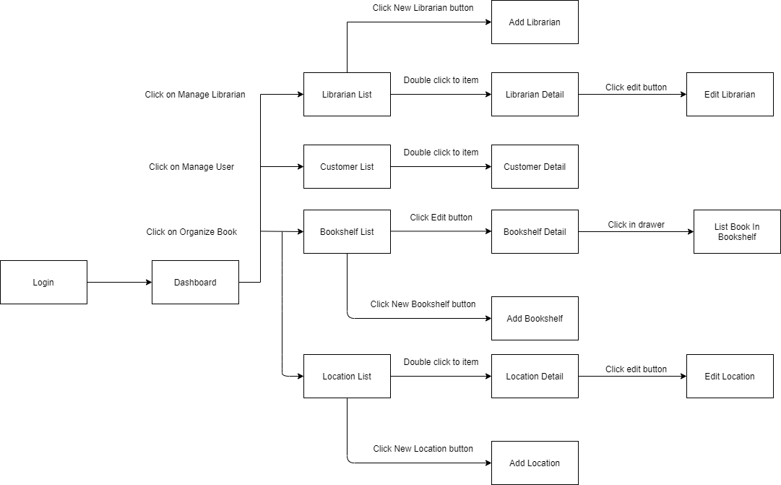

[*Figure 3 - <Admin> Web Application Screen Flow*](https://drive.google.com/file/d/1Ed1ol9jqNSSn5GLb2yABKotTkOdpD3no/view?usp=sharing)

##### <Librarian> Web Application Screen Flow

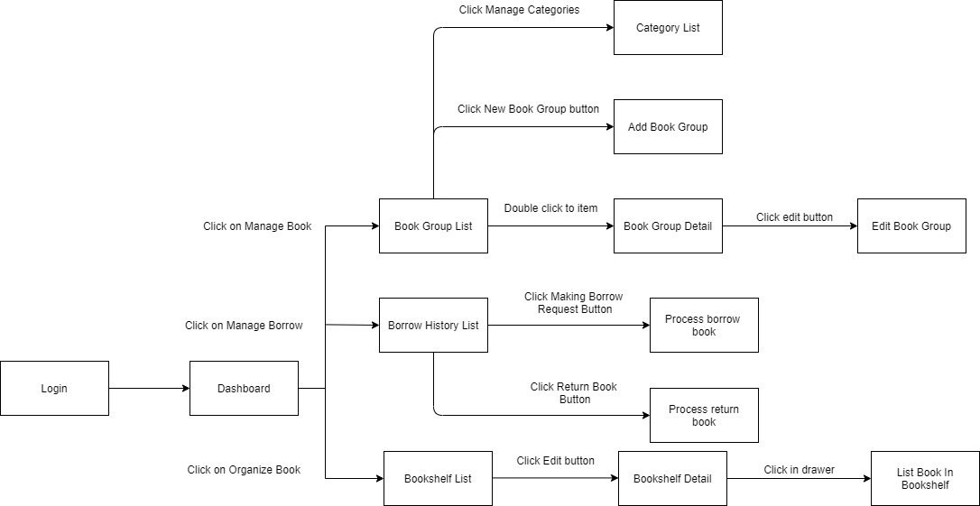

[*Figure 4 - <Librarian> Web Application Screen Flow*](https://drive.google.com/file/d/1WSxn9fGcdB9q74ah3C1KsZIked6oGvch/view?usp=sharing)

##### <Librarian> Mobile Application Screen Flow

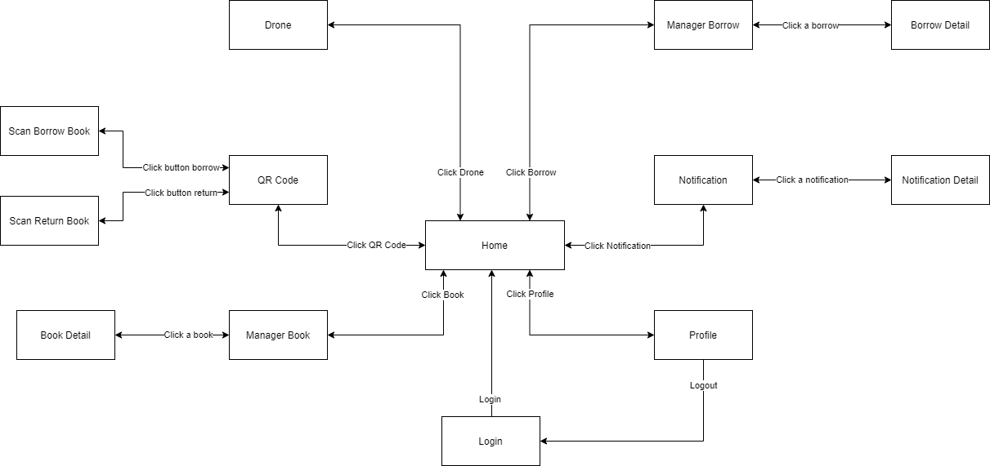

[*Figure 5 - <Librarian> Mobile Application Screen Flow*](https://drive.google.com/file/d/1pXos9aJCquZ1aiMbf5GTqOIv312BATcl/view?usp=sharing)

##### <Customer> Web Application Screen Flow

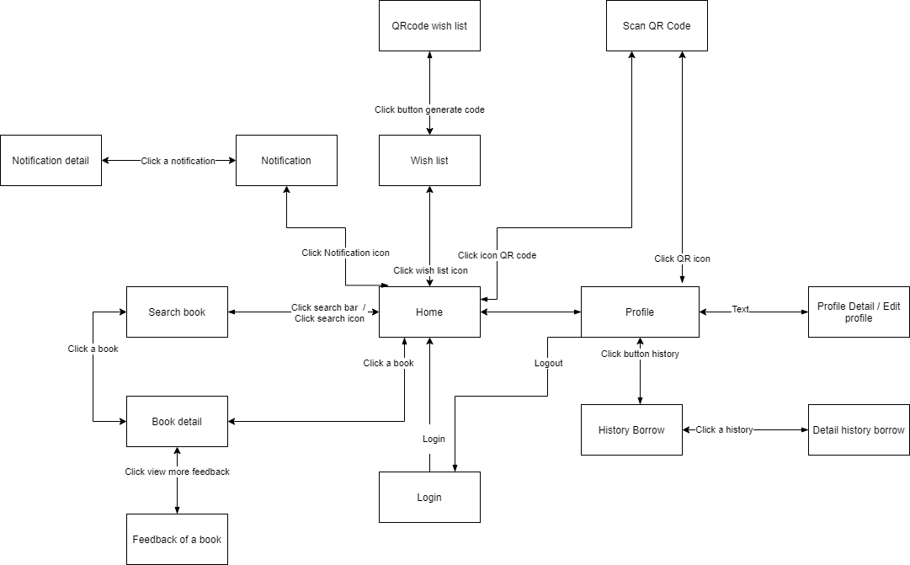

[*Figure 6 - <Customer> Mobile Application Screen Flow*](https://drive.google.com/file/d/1ZZBwSD1SDKMCjoQcQJ4fH0qZ6HqiEMu6/view?usp=sharing)

#### 3.1.2 Screen Details

##### 3.1.2.1 Web Application Admin Screen Details

|  |  |  |  |
| --- | --- | --- | --- |
| **Id** | **Feature** | **Screen** | **Description** |
|  |  |  |  |
|  |  |  |  |
|  |  |  |  |

##### 3.1.2.2 Web Application Librarian Screen Details

|  |  |  |  |
| --- | --- | --- | --- |
| **Id** | **Feature** | **Screen** | **Description** |
|  |  |  |  |
|  |  |  |  |
|  |  |  |  |

##### 3.1.2.3 Mobile Application Librarian Screen Details

|  |  |  |  |
| --- | --- | --- | --- |
| **Id** | **Feature** | **Screen** | **Description** |
|  |  |  |  |
|  |  |  |  |
|  |  |  |  |

##### 3.1.2.4 Mobile Application

|  |  |  |  |
| --- | --- | --- | --- |
| **Id** | **Feature** | **Screen** | **Description** |
|  |  |  |  |
|  |  |  |  |
|  |  |  |  |

#### Screen Authorization

|  |  |  |  |  |  |
| --- | --- | --- | --- | --- | --- |
| **Screen** | **Unauthenticated User** | **Authenticated User** | **Admin** | **Librarian** | **Customer** |
|  |  |  |  |  |  |
|  |  |  |  |  |  |
|  |  |  |  |  |  |
|  |  |  |  |  |  |
|  |  |  |  |  |  |
|  |  |  |  |  |  |
|  |  |  |  |  |  |
|  |  |  |  |  |  |
|  |  |  |  |  |  |
|  |  |  |  |  |  |
|  |  |  |  |  |  |
|  |  |  |  |  |  |

In which:

* Unauthenticated User: The user has no account or has not logged in system
* Authenticated User: The user who has logged in system successfully
* Admin: The user who manages location, bookshelf, librarian and customer
* Librarian: The user who manages books in library
* Customer: The user who borrows and returns book of library

#### Non-Screen Functions

|  |  |  |
| --- | --- | --- |
| **#** | **System Function** | **Description** |
| 1 | Check out customer | PAPV automatically checks out customer has checked-in in day at 00:00:00 AM every day |
| 2 | Detect Barcode, QR Code and character | PAPV detects Barcode, QR Code and character |
| 3 | Send notification | PAPV sends notification to customer when their borrow book is expiring before one day |
| 4 | Send video to server | Drone sends video to server |

#### Entity Relationship Diagram

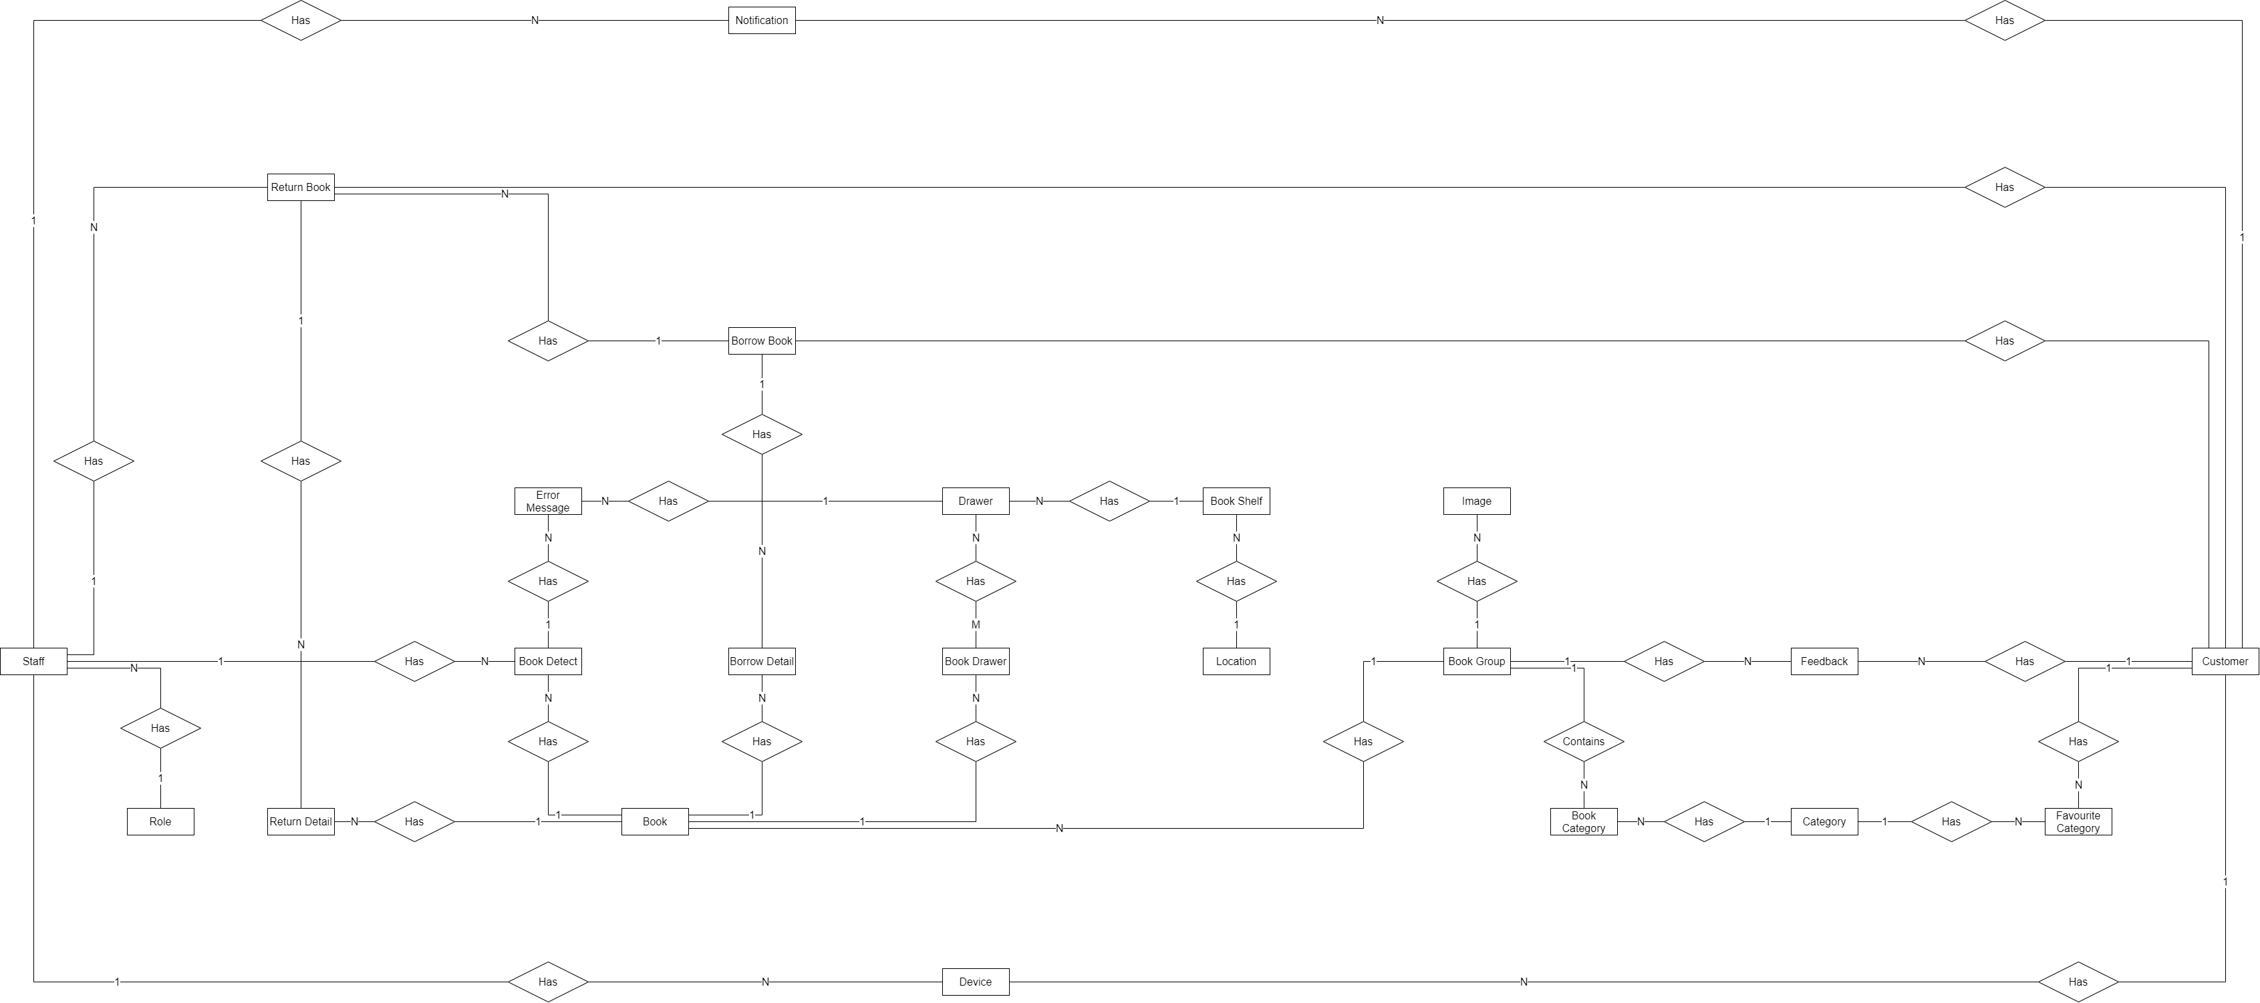

[*Figure 7 - Entity Relationship Diagram (without attributes)*](https://drive.google.com/file/d/1-cYZpe9ZTD95S4HrL3RUBlyRJSBxcRlp/view?usp=sharing)

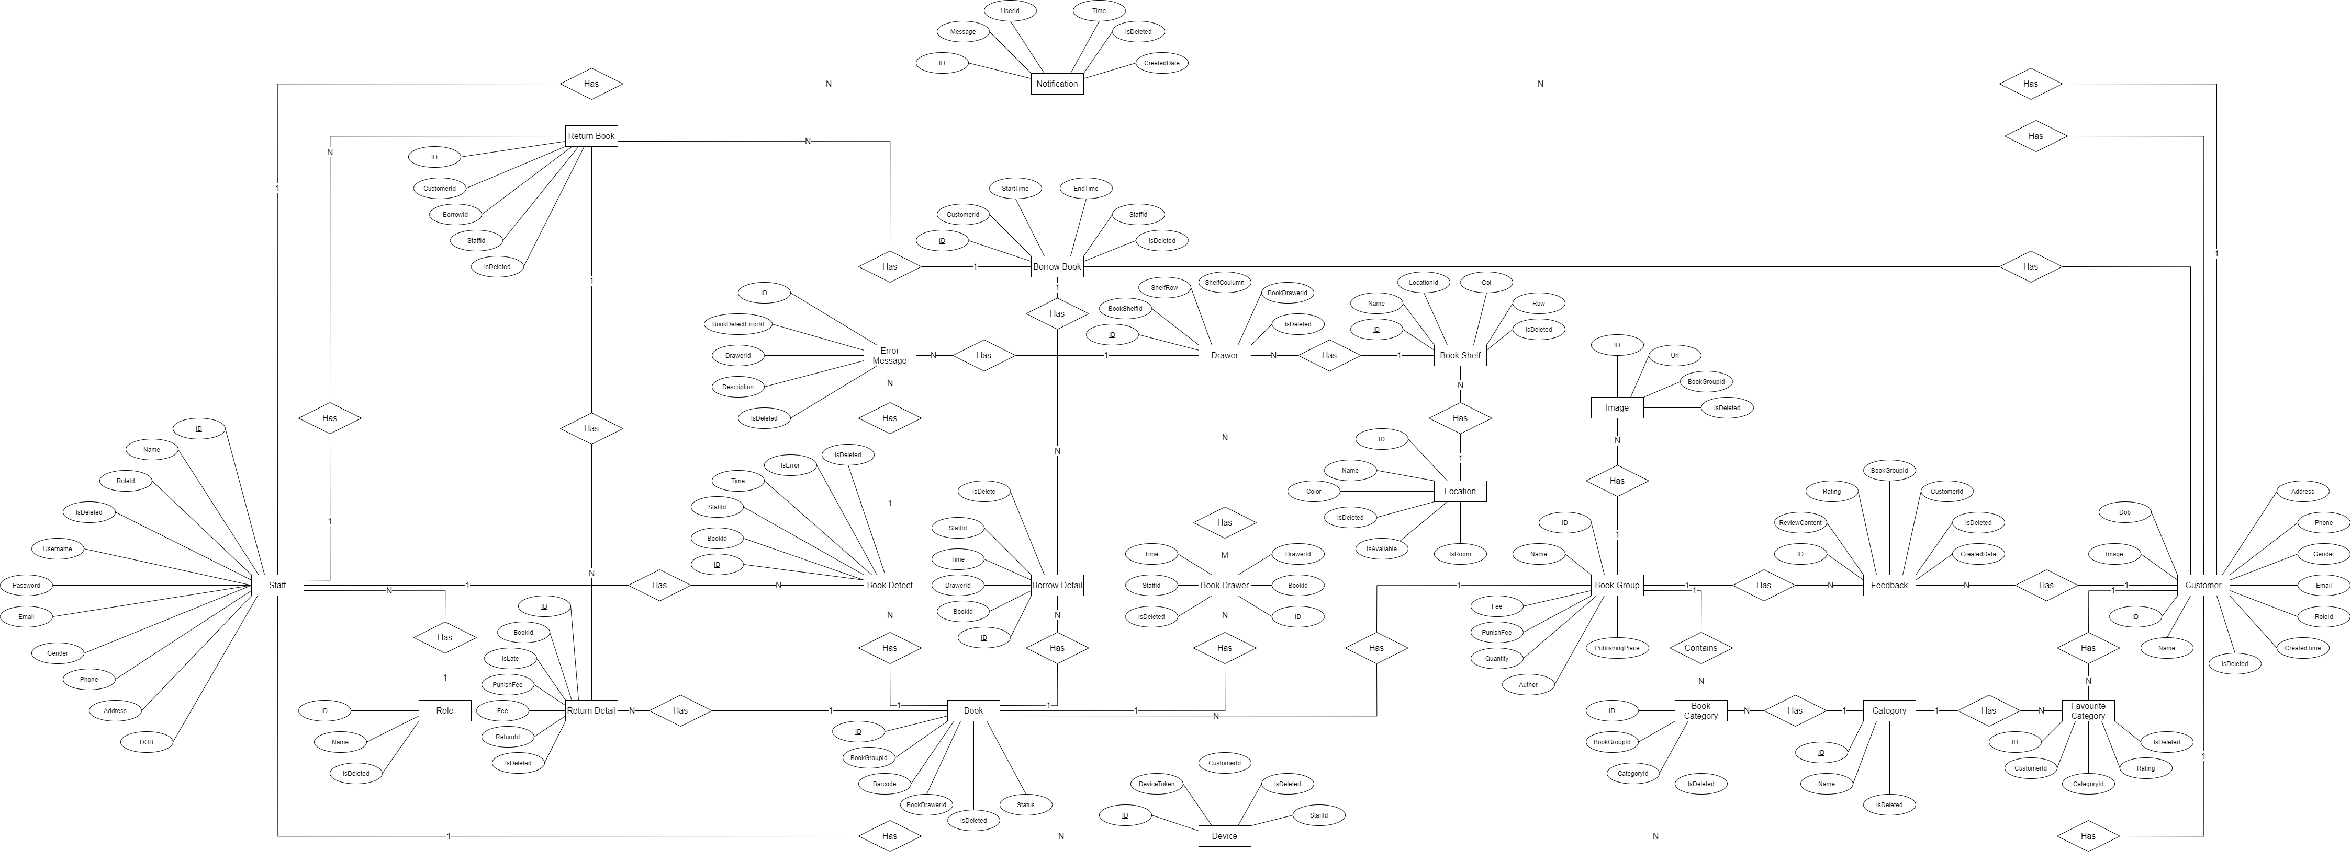

[*Figure 8 - Entity Relationship Diagram (with attributes)*](https://drive.google.com/file/d/1N2tnKgZQWCzH2v-niody4OtYY-jBaEXx/view?usp=sharing)

|  |  |  |
| --- | --- | --- |
| **#** | **Entity** | **Description** |
| 1 | Staff | Staff is an entity represents staff information that includes admin and librarian |
| 2 | Role | Role is an entity represents role information |
| 3 | Notification | Notification is an entity represents notification information |
| 4 | Customer | Customer is an entity represents customer information |
| 5 | Device | Device is an entity represents device information of user in the system |
| 6 | Return Book | Return book is an entity represents return book information |
| 7 | Return Detail | Return detail is an entity represents return book detail information |
| 8 | Borrow Book | Borrow book is an entity represents borrow book information |
| 9 | Book Detect | Borrow detect is an entity represents book detect information |
| 10 | Error Message | Error message is an entity represents error message information |
| 11 | Drawer | Drawer is an entity represents drawer information |
| 12 | Book Drawer | Book drawer is an entity represents book drawer information |
| 13 | Book Shelf | Book shelf is an entity represents book shelf information |
| 14 | Location | Location is an entity represents location information |
| 15 | Book | Book is an entity represents book information |
| 16 | Book Detail | Book detail is an entity represents book detail information |
| 17 | Book Group | Book group is an entity represents book group information |
| 18 | Image | Image is an entity represents image information |
| 19 | Feedback | Feedback is an entity represents feedback information |
| 20 | Book Category | Book category is an entity represents book category information |
| 21 | Category | Category is an entity represents category information |
| 22 | Favourite Category | Favourite Category is an entity represents favourite category information |

## 4. Non-Functional Requirements

### 4.1 External Interfaces

#### 4.1.1 User Interfaces

UI-1: GUI has to be friendly to use

UI-2: Language used in application is English

UI-3: UI can be responsive on multiple screen size

UI-4: Mobile application follow Material-UI design

UI-5: Web application follow Ant Design

#### 4.1.2 Software Interfaces

SI-1: File Storage Service

SI-1.1: PAPV can integrate with Firebase Storage Service and use its upload file API

SI-2: Real-time Message Transform Service

SI-2.1: PAPV can integrate with SignalR Real-time Message Transform Service to transform message between web application and mobile application

#### 4.1.3 Hardware Interfaces

PAPV System requires Drone to send video to system. Like other system, PAPV just requires basic devices for input, output as personal computer or laptop and smartphone. All of devices must have internet permission and camera permission for smartphone.

#### 4.1.4 Communications Interfaces

PAPV System’s communication interfaces depend on sending and retrieving data through online protocol to connect between applications.

### Quality Attributes

#### Usability

* Mobile UI/UX follows Material Design to be friendly with users
* Web Application follows Ant Design which is clear and easy to use
* Admin and librarian can use PAPV with less than a day of guidance
* Customer does not require to have technical knowledge before using.

#### Reliability

* PAPV failure is less than 5% and availability of the system is over 80%
* Mean time to hotfix and deploy is less than 6 hours

#### Performance

* Librarian’s mobile application scan QR Code to get customer’s book wish list with real time message transform SignalR needs under 5 seconds
* Customer’s mobile application scan QR Code to check-in needs under 3 seconds
* PAPV needs under 5 minutes to detect and notify book position tracking
* All common response time is under 3 seconds

#### 4.2.4 Dependability

##### 4.2.4.1 Security

* PAPV always checks authorization
* Each role can only access its own functions
* Account must be unique, password must be encrypted

##### 4.2.4.2 Safety

* Librarian cannot change borrow fee of borrowing book

#### 4.2.3 Supportability

* Beside web application for Librarian, PAPV support a group of functions to Librarian on mobile application

#### Design Constraints

* Application language is English
* Application uses TypeScripts to increase maintainability

#### Support Documents

* PAPV does not support o-line user documentation

#### Purchased Components

* IIS Server
* Firebase Storage
* Firebase Notification
* Google Colab

## 5. Other Requirements

### 5.1 Messages List

|  |  |  |  |  |
| --- | --- | --- | --- | --- |
| **#** | **Message code** | **Message Type** | **Context** | **Content** |
| 1 | MSG01 | In line, under input form, red text | "Username" input field and "Password" input field is empty | Username and Password must not empty |
| 2 | MSG02 | In line, under input form, red text | Account with user name and password not exist in PAPV | Username and Password not correct |
| 3 | MSG03 | in line, popup, black text | Librarian request to tracking | Use drone to start tracking |
| 4 | MSG04 | in line, popup, black text | Admin successful create bookshelf | Successful created bookshelf |
| 5 | MSG05 | in line, popup, black text | Required field in input form is empty | Required must not empty |
| 6 | MSG06 | in line, text field, green text | All book in book shelf are correct position | All book are correct position |
| 7 | MSG07 | in line, text field, red text | One book in book shelf are wrong position | The book with {id} is wrong position |
| 8 | MSG08 | in line, text field, red text | One book in book shelf was lost | The book with {id} was lost |
| 9 | MSG09 | in line, text field, red text | Row or Column in create bookshelf form is less than 0 | Row and Column must be upper than 0 |
| 10 | MSG10 | in line, text field, grey text | No data in PAPV | No data |