

**Capstone Project Report**

**Report 2 – System Requirement Specification**

– Ho Chi Minh, January 2021 –

**Table of Contents**

I. Project Report 3

1. Status Report 3

2. Team Involvements 3

3. Issues/Suggestions 3

II. System Requirement Specification 4

1. Overall Description 4

1.1 Product Overview 4

1.2 Business Rules 5

2. User Requirements 9

2.1 Overview 9

2.2 User case specification 11

3. Other Requirements 57

3.1 Messages List 57

# I. Project Report

## 1. Status Report

|  |  |  |  |
| --- | --- | --- | --- |
| **#** | **Work Item** | **Status** | **Notes (Work Item in Details)** |
| 1 | Overall Description |  |  |
| 2 | User Requirements |  |  |
| 3 | Functional Requirements |  |  |
| 4 | Non-Functional Requirements |  |  |
| 5 | Others Requirements |  |  |

## 2. Team Involvements

|  |  |  |  |
| --- | --- | --- | --- |
| **#** | **Task** | **Member** | **Notes (Task Details, etc.)** |
| 1 | Overall Description |  |  |
| 2 | User Requirements |  |  |
| 3 | Functional Requirements |  |  |
| 4 | Non-Functional Requirements |  |  |
| 5 | Others Requirements |  |  |

## 3. Issues/Suggestions

|  |  |  |  |
| --- | --- | --- | --- |
| **#** | **Issue** | **Status** | **Notes (Solution, Suggestion, etc.)** |
| 1 |  |  |  |

# II. System Requirement Specification

## 1. Overall Description

### 1.1 Product Overview

#### Unauthenticated User Requirements

Unauthenticated user who has not been identified by CFFA system. Unauthenticated user has limited access to the system with the following feature:

* Login

#### Authenticated User Requirements

Authenticated User who has been logged into the CFFA system. Authenticated user can use the following functions:

* Logout
* Change account's password
* Watch the video
* Save the video
* Delete the video
* View the reports
* View report detail
* Export the report file

#### Manager Requirements

Manager is a person who accesses to the system as manager role. Manager can use the following functions:

* View the shelves
* View shelf detail
* Search the shelf
* Create new shelf
* Update the shelf
* Delete the shelf
* View the stacks
* View stack detail
* Search the stacks
* Create new stack
* Update the stack
* Delete the stack
* View the products
* View product detail
* Search the products
* Create new product
* Update the product
* Delete the product
* View the cameras
* View camera detail
* Search the cameras
* Create new camera
* Update the camera
* Delete the camera
* View the categories
* Create new category
* Update the category
* Delete the category

#### Admin Requirements

Admin is a person who accesses to the system as admin role. Admin can use the following functions:

* View the managers
* View manager detail
* Search the manager
* Create new manager
* Update the manager
* Delete the manager
* View the accounts
* View account detail
* Search the account
* Create new account
* Update the account
* Delete the account
* View the stores
* View store detail
* Search the store
* Create new store
* Update the store
* Delete the account
* Send the mail to the manager

#### Camera Requirements

Camera is an actor which can do:

* Send the videos to the server

#### System AI Requirements

System AI is an actor which can do:

* Analyze facial expression
* Detect the "hotspot"

### 1.2 Business Rules

|  |  |
| --- | --- |
| ID | Rule Definition |
| BR-001 | User logs in using username and password are registered. If the username and password are correct, CFFA system redirects users to corresponding home page:   * User logs in as “manager” role, CFFA system will display the manager's home page. * User logs in as “admin” role, CFFA system will display the admin's home page. |
| BR-002 | After logging in as "manager" role, if the manager has not yet mapped to any store, CFFA system will display the "You don't have a store to manage" message and log out CFFA system. |
| BR-003 | After logging in as "manager" role, if this is the first time to log in, CFFA system will redirect to the "Change password" page. |
| BR-004 | After logging out successfully, user becomes the “Unauthenticated User” and CFFA system will direct to login page. |
| BR-005 | JSON web token will be removed on the client-side. |
| BR-006 | Cookies will be destroyed on the client-side. |
| BR-007 | The password must be SHA256 encrypted before sending it to the server. |
| BR-008 | Exporting a file is PDF format for the user with the file name is current time that has hh:mm-DD/MM/YY format and store name separated by '_'. |
| BR-009 | CFFA system only allows users to download the report which has data. |
| BR-010 | CFFA system only allows users to play video that has been analyzed and stored. |
| BR-011 | CFFA system only allows to play the "hotspots" on a specific shelf or the emotions on a specific shelf/stack/product/camera video. |
| BR-012 | Password must be at least 8 characters and must contain the following:   * At least one uppercase letter * At least one lowercase letter * At least one digits |
| BR-013 | Time must be hh:mm dd/mm/yyyy format. |
| BR-014 | Shelf combobox can select multiple values that include:   * All shelves * Specific shelves ( including active, pending, and inactive shelves that sort by shelf's name)   Default value is all shelves. |
| BR-015 | Stack combobox can select multiple values that include:   * All stacks * Specific stacks ( including active, pending, and inactive stacks that sort by shelf's name and No   Default value is all stacks |
| BR-016 | Product combobox can select multiple values that include:   * All products * Specific products ( including active, and inactive products that sort by product's name)   Default value is all products |
| BR-017 | Camera combobox can select multiple values that include:   * All cameras * Specific cameras ( including active, pending, and inactive cameras that sort by camera's name   Default value is all cameras |
| BR-018 | Analyzed options checkbox can select multiple values that include:   * Emotions * Hotspots   Default value is emotions and hotspots. |
| BR-019 | Time filter only selects single value that includes:   * Hour * Day * Week * Month * Quarter * Year   Default value is hour. |
| BR-020 | Selecting all values cannot select specific values and vice versa. |
| BR-021 | Start time is always less than End time.  Default period of the start and end time is one week. |
| BR-022 | Video options check box only selects single value that includes:   * Emotions * Hotspots   Default value is emotions. |
| BR-023 | Set time combobox only selects single value that includes from 0 to 23 hours. |
| BR-024 | Using pagination to display 15 lines / page. |
| BR-025 | There is a limit of 200 records / request. |
| BR-026 | Manager can search the shelves with following conditions:   * Shelf name * Status ( Shelf's status includes all status, active, and inactive)   Status's default value is all status. |
| BR-027 | Displays a list of shelves with the following information:   * No (List of shelves order by shelf name) * Shelf name * Number of stacks * Last Updated * Status |
| BR-028 | Displays the shelf detail with the following information:   * Id * Shelf name * Description * Maximum of stacks * Created * Last Updated * Reason inactive * Status * Camera detail * List of stacks |
| BR-029 | Shelf's status has two options:   * Active * Inactive |
| BR-030 | When changing the shelf's status from active to inactive, there must be a reason and sure that all the stacks and cameras on the shelf are removed. |
| BR-031 | A shelf information required fields:   * Name: between 1 - 100 characters, unique * Description: between 1 - 250 characters * Maximum of stacks: between 1 - 30 stacks * Status: active/inactive |
| BR-032 | After updating or deleting, CFFA system updates the last update time. |
| BR-033 | Deletion is a change to inactive status |
| BR-034 | The newly created shelf's status is active. |
| BR-035 | After creation, CFFA system stores the create time. |
| BR-036 | Manager can search the stacks with following conditions:   * Status ( Shelf's status includes all status, active, pending, and inactive)   Status's default value is all status. |
| BR-037 | Displays a list of stacks with the following information:   * No (List of stacks order by shelf name and No) * Shelf name * Product * Camera * Last update * Status |
| BR-038 | Displays the stack detail with the following information:   * Id * Shelf name * No * Product detail * Camera detail * Created * Last Updated * Reason inactive * Status |
| BR-039 | Manager only can select a pending camera, product to set up on the shelf, stack. |
| BR-040 | Shelf's status has two options:   * Active * Pending * Inactive |
| BR-041 | When changing the stack status from active, pending to inactive, there must be a reason and sure that the product and camera on the stack are removed. |
| BR-042 | If the product or camera on the stack is missed, the status will change to pending |
| BR-043 | The newly created stack's status is pending. |
| BR-044 | Manager can search the products with following conditions:   * Product name * Product category * Status ( Product's status includes all status, active, pending, and inactive)   Product category's default value is all categories.  Status's default value is all status. |
| BR-045 | Displays a list of products with the following information:   * No (List of stacks order by product name) * Product name * Product image * Product category * Last update * Status |
| BR-046 | Displays the product detail with the following information:   * Id * Product name * Product image * Category * Description * List of stack * Created * Last Updated * Reason inactive * Status |
| BR-047 | A product information required fields:   * Name: between 1 - 100 characters, unique * Image: must be png, jpg, jpeg format * Category: at least one category * Description: between 1 - 250 characters * Status: active/inactive |
| BR-048 | Shelf's status has two options:   * Active * Inactive |
| BR-049 | When changing the product status from active to inactive, there must be a reason and sure that this product on all stacks are removed. |
| BR-050 | Stack's No is the position on the shelf that is automatically generated by the CFFA system in the order of creation. |
| BR-051 | The newly created product's status is active. |
| BR-052 | Manager can search the cameras with following conditions:   * Camera name * Status ( Camera's status includes all status, active, pending, and inactive)   Status's default value is all status. |
| BR-053 | Displays a list of cameras with the following information:   * No (List of stacks order by camera name) * Camera name * Camera image * IP address * Last update * Status |
| BR-054 | Displays the camera detail with the following information:   * Id * Camera name * Camera image * Ip address * RTSP string Shelf * Stack Created * Last Updated * Reason inactive * Status |
| BR-055 | A camera information required fields:   * Name: between 1 - 100 characters, unique * Image: must be png, jpg, jpeg format * IP address: x.x.x.x ( x is number between 0 to 255), unique * RTSP string: at least 1 characters, unique * Status: active/pending/inactive |
| BR-056 | Camera status has two options:   * Active * Pending * Inactive |
| BR-057 | When changing the camera status from active, pending to inactive, there must be a reason and sure that this camera are removed from stack. |
| BR-058 | When changing the camera status from active to inactive, there must be a reason and sure that this camera are removed from the stack. |
| BR-059 | The newly created camera's status is pending. |
| BR-060 | When the camera does not setup on any stack, the camera's status is changed to pending |
| BR-061 | Displays a list of cameras with the following information:   * No (List of stacks order by category name) * Category name |
| BR-062 | Displays the category detail with the following information:   * ID * Category name * Products belongs to the category |
| BR-063 | A category information required fields:   * Name: between 1 - 100 characters, unique |
| BR-064 | Admin can search the stores with following conditions:   * Store name * City * District * Status (Store's status includes all status, active and inactive) Status's default value is all status. |
| BR-065 | Displays a list of stores with the following information:   * No (List of stacks order by store name) * Store name * Image * Manager * Address * Last update * Status |
| BR-066 | Displays the store detail with the following information:   * Id * Store name * Image * Manager * Address * City * District * Created * Last Updated * Reason inactive * Status |
| BR-067 | A store information required fields:   * Name: between 1 - 100 characters, unique * Image: must be png, jpg, jpeg format * Address: between 1 - 250 character * City * District * Status: active/inactive |
| BR-068 | Store status has two options:   * Active * Inactive |
| BR-069 | When changing the store status from active to inactive, there must be a reason and sure that this manager are removed from store. |
| BR-070 | The newly created camera's status is pending. |
| BR-071 | Admin can search the manager with following conditions:   * Employee code * Manager name * Username * Status ( Manager's status includes all status, active and inactive)   Status's default value is all status. |
| BR-072 | Displays a list of manager with the following information:   * No (List of stacks order by Employee code) * Employee code * Manager name * Username * Store * Image * Identify card * Last update * Status |
| BR-073 | Displays the store detail with the following information:   * Id * Employee code * Manager name * Username * Image * Gender * BirthDate * Identify Card * Phone * Email * Store * Address * City * District * Created * Last Updated * Reason inactive * Status |
| BR-074 | A manager information required fields:   * Employee code: unique * Email: match regex ^\(?([0-9]{3})\)?[-. ]?([0-9]{3})[-. ]?([0-9]{4})$ * Status: active/inactive |
| BR-075 | Manager status has two options:   * Active * Inactive |
| BR-076 | When changing the manager status from active to inactive, there must be a reason and sure that this manager are removed from store. |
| BR-077 | The newly created manager's status is active. |

*Table 1 - Business rules*

## 2. User Requirements

### 2.1 Overview

#### Use Case Diagram

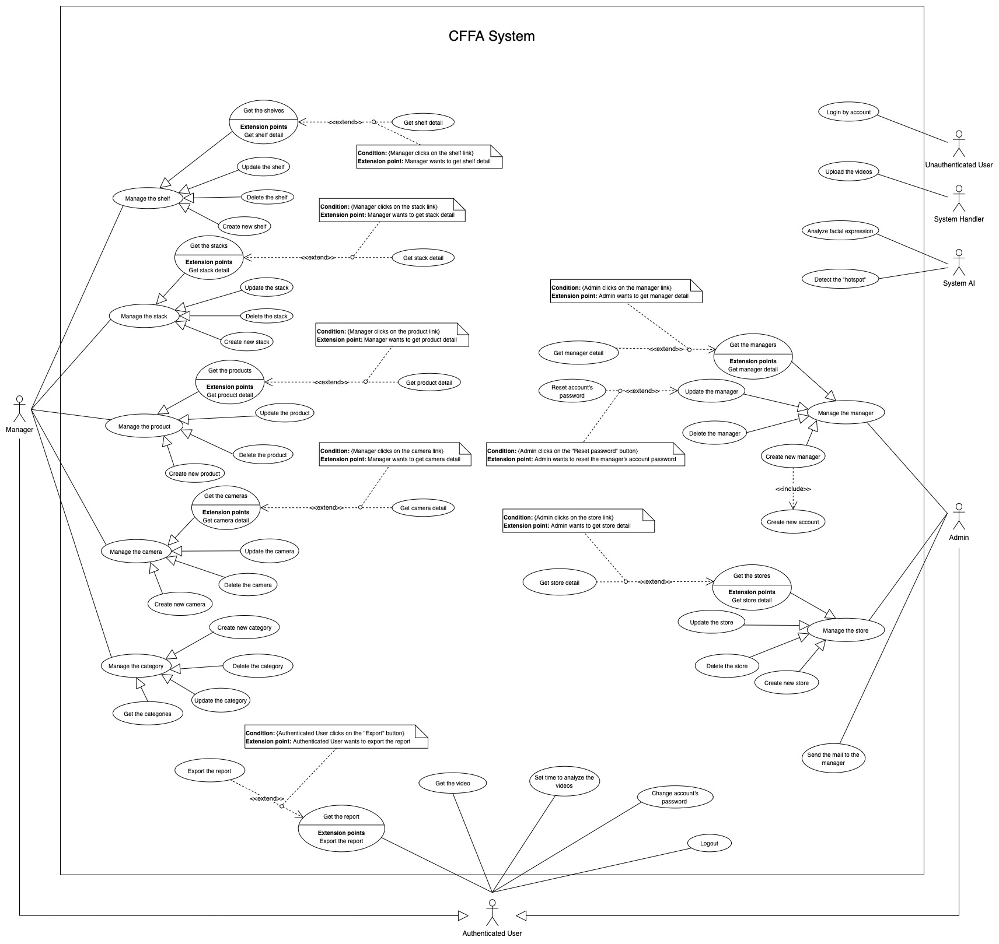

*Figure 1 - <Use Case Overview> Overview*

#### System Actors

|  |  |  |
| --- | --- | --- |
| **#** | **Actor** | **Description** |
| 1 | Unauthenticated User | Unauthenticated User is person who has no account. |
| 2 | Authenticated User | Authenticated User is a person who has an account in the system (There are two roles that are admin and manager). |
| 3 | Manager | Manager manages the store's products, shelves, stacks, and cameras. |
| 4 | Admin | Admin manages the managers, accounts, and stores in the system. |
| 5 | System AI | System AI analyzes customers' emotions and detects the "hotspot" in the stores. |

*Table 2 - System actors*

#### Use Case List

|  |  |  |  |
| --- | --- | --- | --- |
| **ID** | **Use Case** | **Primary Actors** | **Secondary Actors** |
| UC-01 | Login by account | Unauthenticated User | N/A |
| UC-02 | Logout | Authenticated User | N/A |
| UC-03 | Change account's password | Authenticated User | N/A |
| UC-04 | Get the report | Authenticated User | N/A |
| UC-05 | Export the report | Authenticated User | N/A |
| UC-06 | Get the video | Authenticated User | N/A |
| UC-07 | Set time to analyze the videos | Authenticated User | N/A |
| UC-08 | Get the shelves | Manager | N/A |
| UC-09 | Get shelf detail | Manager | N/A |
| UC-10 | Update the shelf | Manager | N/A |
| UC-11 | Delete the shelf | Manager | N/A |
| UC-12 | Create new shelf | Manager | N/A |
| UC-13 | Get the stacks | Manager | N/A |
| UC-14 | Get stack detail | Manager | N/A |
| UC-15 | Update the stack | Manager | N/A |
| UC-16 | Delete the stack | Manager | N/A |
| UC-17 | Create new stack | Manager | N/A |
| UC-18 | Get the products | Manager | N/A |
| UC-19 | Get product detail | Manager | N/A |
| UC-20 | Update the product | Manager | N/A |
| UC-21 | Delete the product | Manager | N/A |
| UC-22 | Create new product | Manager | N/A |
| UC-23 | Get the cameras | Manager | N/A |
| UC-24 | Get camera detail | Manager | N/A |
| UC-25 | Update the camera | Manager | N/A |
| UC-26 | Delete the camera | Manager | N/A |
| UC-27 | Create new camera | Manager | N/A |
| UC-28 | Get the categories | Manager | N/A |
| UC-29 | Get category detail | Manager | N/A |
| UC-30 | Update the category | Manager | N/A |
| UC-31 | Create new category | Manager | N/A |
| UC-32 | Get the stores | Admin | N/A |
| UC-33 | Get store detail | Admin | N/A |
| UC-34 | Update the store | Admin | N/A |
| UC-35 | Delete the store | Admin | N/A |
| UC-36 | Create new store | Admin | N/A |
| UC-37 | Get the managers | Admin | N/A |
| UC-38 | Get manager detail | Admin | N/A |
| UC-39 | Update the manager | Admin | N/A |
| UC-40 | Delete the manager | Admin | N/A |
| UC-41 | Create new manager | Admin | N/A |
| UC-42 | Reset account's password | Admin | N/A |
| UC-43 | Create new account | Admin | N/A |
| UC-44 | Send the mail to the manager | Admin | N/A |
| UC-45 | Detect the "hotspot" | System AI | N/A |
| UC-46 | Analyze facial expression | System AI | N/A |
| UC-47 | Upload the videos | System Handler | N/A |

*Table 3 - Use case list*

### User case specification



#### 2.2.1 <Unauthenticated User> Overview Use Case

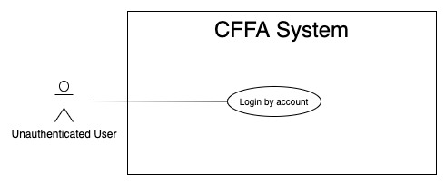

*Figure 2 - <Overview Use Case> Unauthenticated User*

##### 2.2.1.1 <Unauthenticated User> Login by account



*Figure 3 - <Use Case> Login by account*

|  |  |  |  |
| --- | --- | --- | --- |
| ID and Name: | **UC-01 Login by account** | | |
| Created By: | TruongTN | Date Created: | 25/01/2021 |
| Primary Actor: | Unauthenticated User | Secondary Actors: | N/A |
| Description: | This feature allows the unauthenticated user to login to CFFA system to verify the role and gives them access to more features. | | |
| Trigger: | Unauthenticated User sends a request to login to CFFA system. | | |
| Pre-conditions: | PRE-01. User's account has been created.  PRE-02. User's account has been authorized as Admin or Manager role.  PRE-03. User has not logged in to CFFA system. | | |
| Post-conditions: | POST-01. User has successfully logged into CFFA system. | | |
| Normal Flow: | **1.0 Login by account**   1. Unauthenticated User send a request to login to the CFFA system. 2. CFFA system requires information from Unauthenticated User:  * “Username”: text input, blank * “Password”: text input, blank  1. Unauthenticated User inputs a login form: username, password. 2. Unauthenticated User clicks to “Login” button. 3. CFFA system validates the username and password. (see 1.0.E1, 1.0.E2) 4. CFFA system determines the user’s identity, role, and permission then redirects to the home page. | | |
| Alternative Flows: | N/A | | |
| Exceptions: | **1.0.E1 Unauthenticated User does not enter the required fields**   1. CFFA system returns to Unauthenticated User to fill the required fields again (MSG-001, MSG-002). 2. If Unauthenticated User inputs the required fields again, CFFA system returns to step 3 of normal flow. 3. Else if Unauthenticated User cancels the login process, then CFFA system terminates this use case.   **1.0.E2 Unauthenticated User enters wrong username or password.**   1. CFFA system returns to Unauthenticated User to fill the required fields again (MSG-003). 2. If Unauthenticated User inputs username and password again, CFFA system returns to step 3 of normal flow. 3. Else if Unauthenticated User cancels the login process, then CFFA system terminates this use case. | | |
| Priority: | High | | |
| Frequency of Use: | Always | | |
| Business Rules: | BR-001, BR-002, BR-003, BR-008, BR-012 | | |
| Other Information: | In case of internet connection failure, Unauthenticated User cannot finish this use case. | | |
| Assumptions: | N/A | | |

*Table 4 - <Use Case> Login by account*

#### 2.2.2 <Authenticated User> Overview Use Case

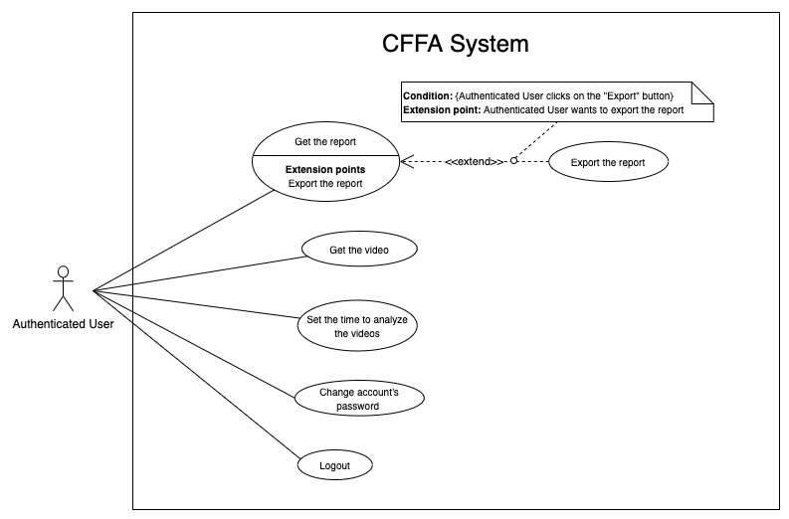

*Figure 4 - <Overview Use Case> Authenticated User*

##### 2.2.2.1 <Authenticated User> Logout

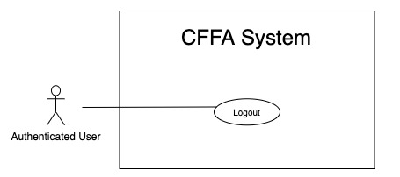

*Figure 5 - <Use Case> Logout*

|  |  |  |  |
| --- | --- | --- | --- |
| ID and Name: | **UC-02 Logout** | | |
| Created By: | TruongTN | Date Created: | 25/01/2021 |
| Primary Actor: | Authenticated User | Secondary Actors: | N/A |
| Description: | This feature allows Authenticated User to log out from CFFA system. | | |
| Trigger: | Authenticated user sends a request to log out from CFFA system. | | |
| Pre-conditions: | PRE-01. User has logged into CFFA system. | | |
| Post-conditions: | POST-01. User has successfully logged out CFFA system. | | |
| Normal Flow: | **2.0 Logout**   1. Authenticated user clicks on “Logout” button. 2. CFFA system deletes their cookies. 3. CFFA system redirects to "Login" page. | | |
| Alternative Flows: | N/A | | |
| Exceptions: | N/A | | |
| Priority: | Medium | | |
| Frequency of Use: | Sometimes | | |
| Business Rules: | BR-004, BR-005, BR-006 | | |
| Other Information: | In case of internet connection failure, Authenticated User cannot finish this use case. | | |
| Assumptions: | N/A | | |

*Table 5 - <Use Case> Logout*

##### 2.2.2.2 <Authenticated User> Change account's password

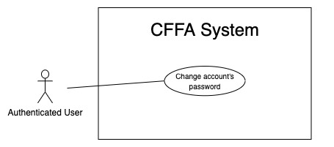

*Figure 6 - <Use Case> Change account's password*

|  |  |  |  |
| --- | --- | --- | --- |
| ID and Name: | **UC-03 Change account's password** | | |
| Created By: | HuuDN | Date Created: | 10/05/2021 |
| Primary Actor: | Authenticated User | Secondary Actors: | N/A |
| Description: | This feature allows Authenticated User to change the account's password. | | |
| Trigger: | Authenticated User sends a request to change the account's password. | | |
| Pre-conditions: | PRE-01. User has logged into CFFA system. | | |
| Post-conditions: | POST-01. Authenticated User has successfully changed the account's password. | | |
| Normal Flow: | **3.0 Change account's password**   1. Authenticated User sends a request to change the account's password. 2. CFFA system requires information from Authenticated User:  * “Old password”: text input, blank * “New Password”: text input, blank * “Re-enter New Password”: text input, blank  1. Authenticated User inputs a changing password form: old password, new password, and re-enter new password. 2. Authenticated User clicks to "Save" button. 3. CFFA system validates the old password, new password, and re-enter new password. (see 3.0.E1, 3.0.E2) 4. CFFA system will stores changing information. | | |
| Alternative Flows: | N/A | | |
| Exceptions: | **3.0.E1 Authenticated User does not enter the required fields**   1. CFFA system returns to Authenticated User to fill the required fields again (MSG-004, MSG-005, MSG-006, MSG-007). 2. If Authenticated User inputs the required fields again, CFFA system returns to step 3 of normal flow. 3. Else if Unauthenticated User cancels the login process, then CFFA system terminates this use case.   **3.0.E2 Authenticated User enters the required fields that are not valid**   1. CFFA system returns to Authenticated User to fill the required fields again (MSG-003). 2. If Authenticated User inputs the required fields again, CFFA system returns to step 3 of normal flow. 3. Else if Unauthenticated User cancels the login process, then CFFA system terminates this use case. | | |
| Priority: | Medium | | |
| Frequency of Use: | Sometimes | | |
| Business Rules: | BR-002, BR-003, BR-007, BR-008, BR-012 | | |
| Other Information: | In case of internet connection failure, Authenticated User cannot finish this use case. | | |
| Assumptions: | N/A | | |

*Table 6 - <Use Case> Change account's password*

##### 2.2.2.3 <Authenticated User> Get the report

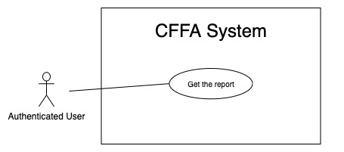

*Figure 7 - <Use Case> Get the report*

|  |  |  |  |
| --- | --- | --- | --- |
| ID and Name: | **UC-04 Get the report** | | |
| Created By: | HuuDN | Date Created: | 11/05/2021 |
| Primary Actor: | Authenticated User | Secondary Actors: | N/A |
| Description: | This feature allows the Authenticated User to get the report. | | |
| Trigger: | Authenticated User sends a request to get the report. | | |
| Preconditions: | PRE-01. User has logged into CFFA system as admin or manager role. | | |
| Post-conditions: | POST-01. Authenticated User has successfully got the report. | | |
| Normal Flow: | **4.0 Get the report**   1. Authenticated User sends a request to get the report. 2. CFFA system requires the report's information from Authenticated User:  * “Start Time”: text input, blank * “End Time”: text input, blank * “Shelf”: combobox * “Stack”: combobox * “Product”: combobox * “Camera”: combobox * “Analyzed Options”: checkbox * “Time Filter”: checkbox  1. Authenticated User inputs/selects a form: start time, end time, shelf, stack, product, camera, analyzed options, and time filter. 2. CFFA system returns the reports (see 4.0.E1). | | |
| Alternative Flows: | N/A | | |
| Exceptions: | **4.0.E1 The report has no data.**   1. CFFA system returns the message (MSG-010). | | |
| Priority: | High | | |
| Frequency of Use: | Often | | |
| Business Rules: | BR-013, BR-014, BR-015, BR-016, BR-017, BR-018, BR-019, BR-020, BR-021. | | |
| Other Information: | In case of internet connection failure, Authenticated User cannot finish this use case properly. | | |
| Assumptions: | N/A | | |

*Table 7 - <Use Case> Get the report*

##### 2.2.2.4 <Authenticated User> Export the report

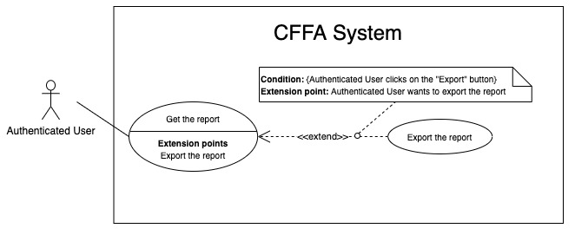

*Figure 8 - <Use Case> Export the report*

|  |  |  |  |
| --- | --- | --- | --- |
| ID and Name: | **UC-05 Export the report** | | |
| Created By: | HuuDN | Date Created: | 18/01/2021 |
| Primary Actor: | Authenticated User | Secondary Actors: | N/A |
| Description: | This feature allows Authenticated User to export the report. | | |
| Trigger: | Authenticated User sends a request to export the report. | | |
| Preconditions: | PRE-01. User has logged into CFFA system as admin or manager role.  PRE-02. Authenticated User has got the report. | | |
| Post-conditions: | POST-01. Authenticated User has successfully exported the report. | | |
| Normal Flow: | **5.0 Export the report**   1. Authenticated User clicks on "Export" button. 2. CFFA system returns the report file for Authenticated User (see 5.0.E1) | | |
| Alternative Flows: | N/A | | |
| Exceptions: | **5.0.E1 The report has no data**   1. CFFA system returns the message (MSG-010). | | |
| Priority: | High | | |
| Frequency of Use: | Often | | |
| Business Rules: | BR-008, BR-009. | | |
| Other Information: | In case of internet connection failure, Authenticated User cannot finish this use case properly. | | |
| Assumptions: | N/A | | |

*Table 8 - <Use Case> Export the report*

##### 2.2.2.5 <Authenticated User> Get the video

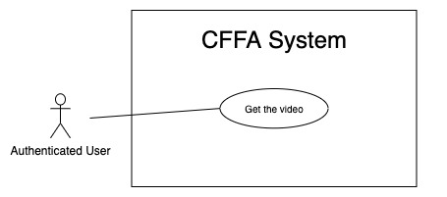

*Figure 9 - <Use Case> Get the video*

|  |  |  |  |
| --- | --- | --- | --- |
| ID and Name: | **UC-06 Get the video** | | |
| Created By: | HuuDN | Date Created: | 11/05/2021 |
| Primary Actor: | Authenticated User | Secondary Actors: | N/A |
| Description: | This feature allows Authenticated User to get the video. | | |
| Trigger: | Authenticated User sends a request to get the video. | | |
| Preconditions: | PRE-01. User has logged into CFFA system as admin or manager role. | | |
| Post-conditions: | POST-01. Authenticated User has successfully played the video. | | |
| Normal Flow: | **6.0 Get the video**   1. Authenticated User sends a request to get the report. 2. CFFA system requires the report's information from Authenticated User:  * “Start Time”: text input, blank * “End Time”: text input, blank * “Shelf”: combobox * “Stack”: combobox * “Product”: combobox * “Camera”: combobox * “Video Options”: checkbox  1. Authenticated User inputs/selects a form: start time, end time, shelf, stack, product, camera, video options. 2. Authenticated User clicks on "Play" button. 3. CFFA system plays the video (see 6.0.E1). | | |
| Alternative Flows: | N/A | | |
| Exceptions: | **6.0.E1 The video has no data to play.**   1. CFFA system returns the message (MSG-011). | | |
| Priority: | High | | |
| Frequency of Use: | Often | | |
| Business Rules: | BR-010, BR-011, BR-013, BR-021, BR-022. | | |
| Other Information: | In case of internet connection failure, Authenticated User cannot finish this use case properly. | | |
| Assumptions: | N/A | | |

*Table 9 - <Use Case> Get the video*

##### 2.2.2.6 <Authenticated User> Set time to analyze the videos

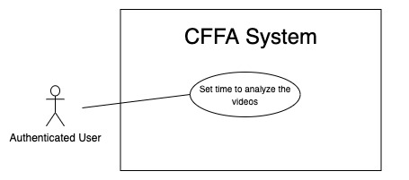

*Figure 10 - <Use Case> Set time to analyze the videos*

|  |  |  |  |
| --- | --- | --- | --- |
| ID and Name: | **UC-07 Set time to analyze the videos** | | |
| Created By: | HuuDN | Date Created: | 11/05/2021 |
| Primary Actor: | Authenticated User | Secondary Actors: | N/A |
| Description: | This feature allows Authenticated User to set time to analyze the videos. | | |
| Trigger: | Authenticated User sends a request to set time to analyze the video. | | |
| Preconditions: | PRE-01. User has logged into CFFA system as admin or manager role. | | |
| Post-conditions: | POST-01. Authenticated User has successfully got the report. | | |
| Normal Flow: | **7.0 Set time to analyze the videos**   1. Authenticated User sends a request to set time to analyze the videos. 2. CFFA system requires the information from Authenticated User:  * “Set time”: combobox  1. Authenticated User inputs a form: set time 2. Authenticated User clicks on "Save" button. 3. CFFA system stores the time to analyze the videos. | | |
| Alternative Flows: | N/A | | |
| Exceptions: | N/A | | |
| Priority: | Low | | |
| Frequency of Use: | Rarely | | |
| Business Rules: | BR-023. | | |
| Other Information: | In case of internet connection failure, Authenticated User cannot finish this use case properly. | | |
| Assumptions: | N/A | | |

*Table 10 - <Use Case> Set time to analyze the videos*

#### 2.2.3 <Manager> Overview Use Case

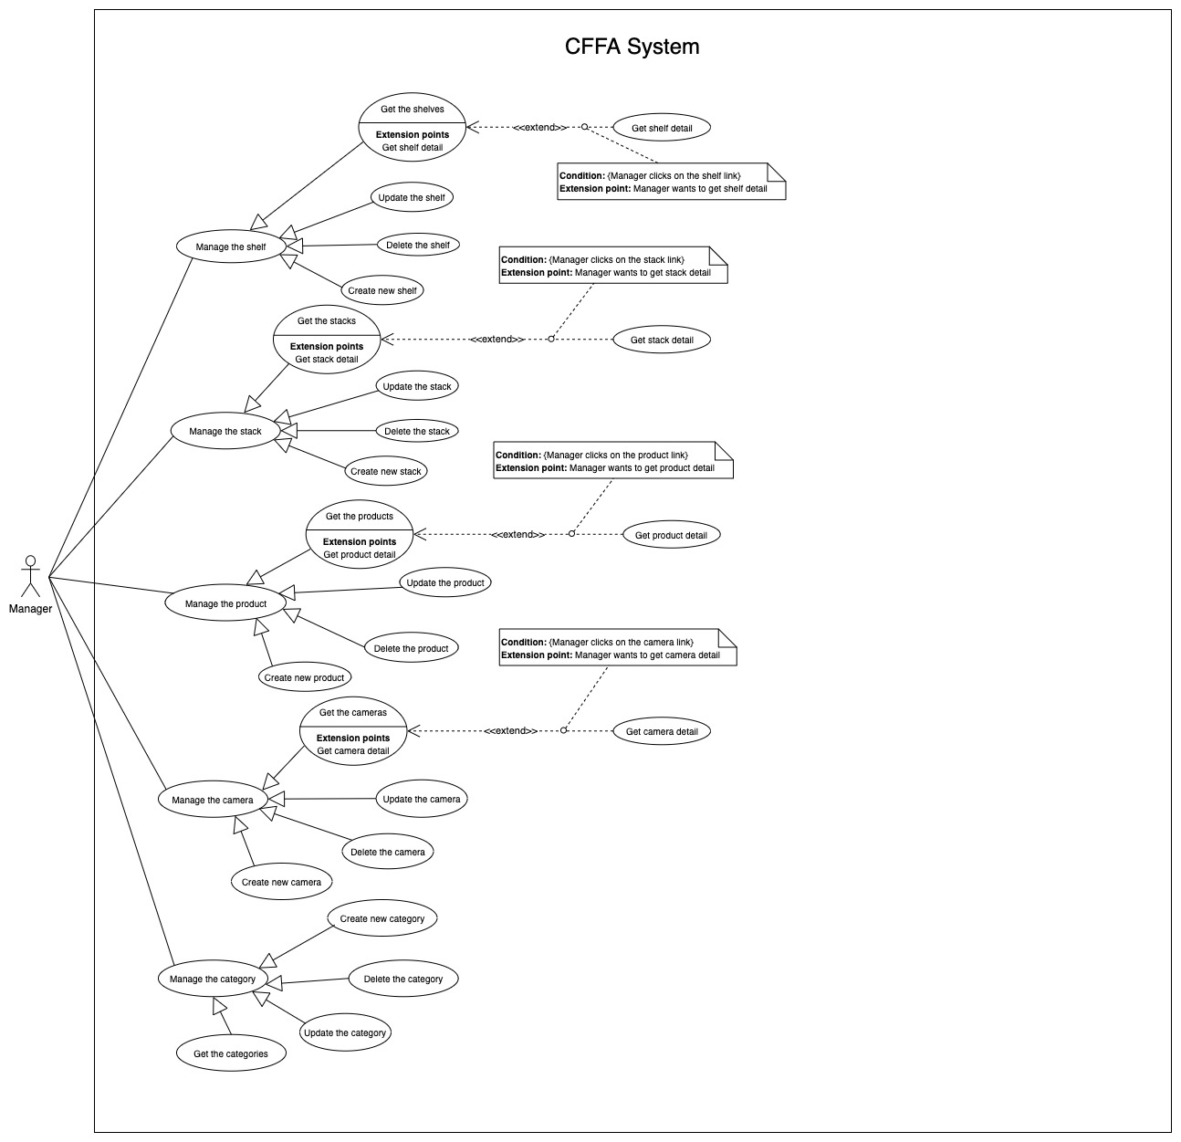

*Figure 11 - <Overview Use Case> Manager*

##### 2.2.3.1 <Manager> Get the shelves

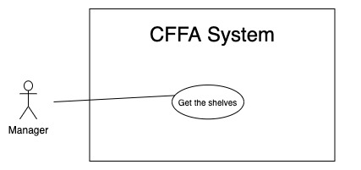

*Figure 12 - <Use Case> Get the shelves*

|  |  |  |  |
| --- | --- | --- | --- |
| ID and Name: | **UC-08 Get the shelves** | | |
| Created By: | TruongTN | Date Created: | 08/05/2021 |
| Primary Actor: | Manager | Secondary Actors: | N/A |
| Description: | This feature allows manager to get the shelves. | | |
| Trigger: | Manager sends a request to get the shelves. | | |
| Pre-conditions: | PRE-01. User has logged into the system as manager role.  PRE-02. Manager is managing a store. | | |
| Post-conditions: | POST-01. CFFA system returns the list of shelves. | | |
| Normal Flow: | **8.0 Get the shelves**   1. Manager sends a request to get the shelves. 2. CFFA system requires the shelf information from Manager:  * “Name”: text input, blank * “Status”: combobox  1. Manager inputs/selects a form: name and status. 2. Manager clicks on "Search" button. 3. CFFA system returns the shelves based on below conditions and display them (see 8.0.E1). | | |
| Alternative Flows: | N/A | | |
| Exceptions: | **8.0.E1 The list of shelves has no data.**   1. CFFA system returns the message (MSG-009). | | |
| Priority: | High | | |
| Frequency of Use: | Usually | | |
| Business Rules: | BR-024, BR-025, BR-026, BR-027 | | |
| Other Information: | In case of internet connection failure, Manager cannot finish this use case properly. | | |
| Assumptions: | N/A | | |

*Table 11 - <Use Case> Get the shelves*

##### 2.2.3.2 <Manager> Get shelf detail

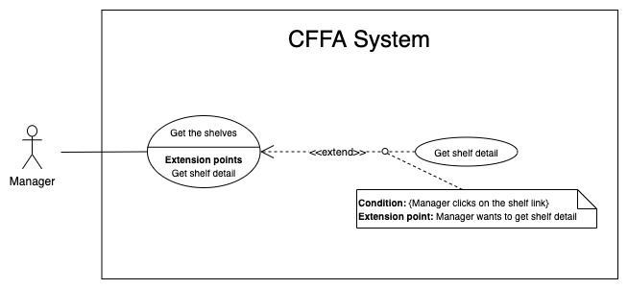

*Figure 13 - <Use Case> Get shelf detail*

|  |  |  |  |
| --- | --- | --- | --- |
| ID and Name: | **UC-09 Get shelf detail** | | |
| Created By: | TruongTN | Date Created: | 10/05/2021 |
| Primary Actor: | Manager | Secondary Actors: | N/A |
| Description: | This feature allows the Manager to get shelf detail. | | |
| Trigger: | Manager sends a request to get shelf detail. | | |
| Preconditions: | PRE-01. User has logged in the system as manager role.  PRE-02. There is at least one the shelf link. | | |
| Post-conditions: | POST-01. CFFA system returns shelf information and redirect to shelf detail page. | | |
| Normal Flow: | **9.0 Get shelf detail**   1. Manager clicks on the shelf link. 2. CFFA system validates the shelf exists (see 9.0.E1) 3. CFFA system returns the shelf information and redirects to shelf detail page. | | |
| Alternative Flows: | N/A | | |
| Exceptions: | **9.0.E1 The shelf does not exist.**  1. CFFA system returns the message (MSG-0012) and terminates this use case. | | |
| Priority: | High | | |
| Frequency of Use: | Usually | | |
| Business Rules: | BR-028 | | |
| Other Information: | In case of internet connection failure, Manager cannot finish this use case properly. | | |
| Assumptions: | N/A | | |

*Table 12 - <Use Case> Get shelf detail*

##### 2.2.3.3 <Manager> Update the shelf

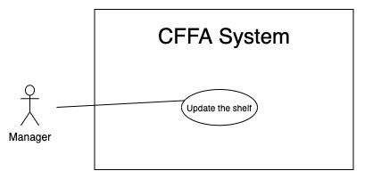

*Figure 14 - <Use Case> Update the shelf*

|  |  |  |  |
| --- | --- | --- | --- |
| ID and Name: | **UC-10 Update the shelf** | | |
| Created By: | TruongTN | Date Created: | 18/01/2021 |
| Primary Actor: | Manager | Secondary Actors: | N/A |
| Description: | This feature allows Manager to update shelf information in CFFA system. | | |
| Trigger: | Manager sends a request to update the shelf. | | |
| Preconditions: | PRE-01. User has logged in the system as manager role.  PRE-02. Manager is on “Shelf detail” page. | | |
| Post-conditions: | POST-01. CFFA system updates shelf information.  POST-02. CFFA system returns the message. | | |
| Normal Flow: | **10.0 Update the shelf**   1. Manager sends a request to update the shelf. 2. CFFA system requires shelf information that includes:  * “Shelf name”: input text, blank. * “Description”: input text, blank. * “Maximum of stacks:” input text, blank. * “Status”: combobox. * “Camera”: popup.  1. Manager inputs/selects the required fields. 2. Manager clicks on “Save” button. 3. CFFA system validates the required fields (see 10.0.E1, 10.0.E2) 4. CFFA system updates shelf information and returns the message (MSG-013). | | |
| Alternative Flows: | N/A | | |
| Exceptions: | **10.0.E1 Manager does not enter the required fields**   1. CFFA system returns to Manager to fill the required fields again (MSG-014, MSG-016, MSG-018). 2. If Manager inputs the required fields again, CFFA system returns to step 3 of normal flow. 3. Else if Manager cancels the login process, then CFFA system terminates this use case.   **10.0.E2 Manager enters the required fields that are not valid**   1. CFFA system returns to Authenticated User to fill the required fields again (MSG-015, MSG-017, MSG-018, MSG-020, MSG-034). 2. If Manager inputs the required fields again, CFFA system returns to step 3 of normal flow. 3. Else if Manager cancels the login process, then CFFA system terminates this use case. | | |
| Priority: | Medium | | |
| Frequency of Use: | Often | | |
| Business Rules: | BR-029, BR-030, BR-031, BR-032, BR-039 | | |
| Other Information: | In case of internet connection failure, Manager cannot finish this use case properly. | | |
| Assumptions: | N/A | | |

*Table 13 - <Use Case> Update the shelf*

##### 2.2.3.4 <Manager> Delete the shelf

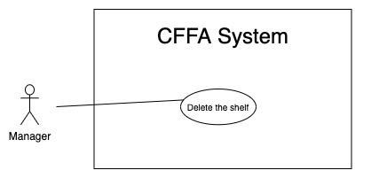

*Figure 15 - <Use Case> Delete the shelf*

|  |  |  |  |
| --- | --- | --- | --- |
| ID and Name: | **UC-11 Delete the shelf** | | |
| Created By: | TruongTN | Date Created: | 18/01/2021 |
| Primary Actor: | Manager | Secondary Actors: | N/A |
| Description: | This feature allows Manager to delete the shelf. | | |
| Trigger: | Manager sends a request to delete the shelf. | | |
| Preconditions: | PRE-01. User has logged in the system as manager role.  PRE-02. Manager is on “Shelf detail” page. | | |
| Post-conditions: | POST-01. CFFA system updates shelf information.  POST-02. CFFA system returns the message. | | |
| Normal Flow: | **11.0 Delete the shelf**   1. Manager sends a request to delete the shelf. 2. CFFA system shows delete popup with message: "Are you sure?" and two buttons for Manager can select:  * "Yes" button * "No" button   1. Manager clicks on "Yes" button, CFFA system updates shelf information and returns the message (MSG-021) (see 11.0.E1).   2. Manager clicks on "No" button, close popup and nothing change. | | |
| Alternative Flows: | N/A | | |
| Exceptions: | **11.0.E1 The shelf does not exist**   1. CFFA system returns a message (MSG-012). 2. CFFA system redirects to manage shelf page and terminates this use case. | | |
| Priority: | Medium | | |
| Frequency of Use: | Often | | |
| Business Rules: | BR-030, BR-032, BR-033 | | |
| Other Information: | In case of internet connection failure, Manager cannot finish this use case properly. | | |
| Assumptions: | N/A | | |

*Table 14 - <Use Case> Delete the shelf*

##### 2.2.3.5 <Manager> Create new shelf

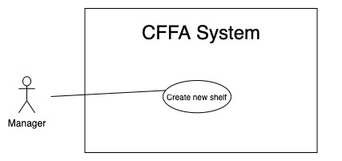

*Figure 16 - <Use Case> Create new shelf*

|  |  |  |  |
| --- | --- | --- | --- |
| ID and Name: | **UC-12 Create new shelf** | | |
| Created By: | TruongTN | Date Created: | 10/05/2021 |
| Primary Actor: | Manager | Secondary Actors: | N/A |
| Description: | This feature allows Manager to create new shelf. | | |
| Trigger: | Manager sends a request to create new shelf. | | |
| Preconditions: | PRE-01. User has logged in the system as manager role.  PRE-02. Manager is on “Manage Shelf” page. | | |
| Post-conditions: | POST-01. CFFA system stores newly shelf information.  POST-02. CFFA system returns the message. | | |
| Normal Flow: | **12.0 Create new shelf**   1. Manager sends a request to create new shelf. 2. CFFA system requires shelf information that includes:  * “Shelf name”: input text, blank. * “Description”: input text, blank. * “Maximum of stacks:” input text, blank.  1. Manager inputs/selects the required fields. 2. Manager clicks on “Create” button. 3. CFFA system validates the required fields (see 12.0.E1, 12.0.E2). 4. CFFA system stores newly shelf information and returns the message (MSG-013). | | |
| Alternative Flows: | N/A | | |
| Exceptions: | **12.0.E1 Manager does not enter the required fields**   1. CFFA system returns to Manager to fill the required fields again (MSG-014, MSG-016, MSG-018). 2. If Manager inputs the required fields again, CFFA system returns to step 3 of normal flow. 3. Else if Manager cancels the login process, then CFFA system terminates this use case.   **12.0.E2 Manager enters the required fields that are not valid**   1. CFFA system returns to Authenticated User to fill the required fields again (MSG-015, MSG-017, MSG-018, MSG-020, MSG-034). 2. If Manager inputs the required fields again, CFFA system returns to step 3 of normal flow. 3. Else if Manager cancels the login process, then CFFA system terminates this use case. | | |
| Priority: | Medium | | |
| Frequency of Use: | Often | | |
| Business Rules: | BR-031, BR-034, BR-035 | | |
| Other Information: | In case of internet connection failure, Manager cannot finish this use case properly. | | |
| Assumptions: | N/A | | |

*Table 15 - <Use Case> Create new shelf*

##### 2.2.3.6 <Manager> Get the stacks

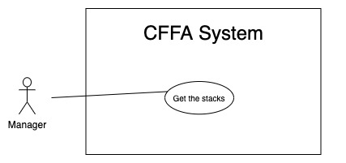

*Figure 17 - <Use Case> Get the stacks*

|  |  |  |  |
| --- | --- | --- | --- |
| ID and Name: | **UC-13 Get the stacks** | | |
| Created By: | LuanNM | Date Created: | 08/05/2021 |
| Primary Actor: | Manager | Secondary Actors: | N/A |
| Description: | This feature allows manager to get the stacks. | | |
| Trigger: | Manager sends a request to get the stacks. | | |
| Pre-conditions: | PRE-01. User has logged into the system as manager role.  PRE-02. Manager is managing a store. | | |
| Post-conditions: | POST-01. CFFA system returns the list of stacks. | | |
| Normal Flow: | **13.0 Get the stacks**   1. Manager sends a request to get the stacks. 2. CFFA system requires the stack information from Manager:  * “Status”: combobox  1. Manager selects a status. 2. Manager clicks on "Search" button. 3. CFFA system returns the stacks based on below conditions and display them (see 13.0.E1). | | |
| Alternative Flows: | **13.1 Get the stacks on a shelf**   1. Manager clicks on the shelf link to redirect to shelf detail page. 2. CFFA system returns the stacks on the shelf based on below conditions and display them (see 13.0.E1). | | |
| Exceptions: | **13.0.E1 The list of stacks has no data.**   1. CFFA system returns the message (MSG-009). | | |
| Priority: | High | | |
| Frequency of Use: | Usually | | |
| Business Rules: | BR-024, BR-025, BR-036, BR-037 | | |
| Other Information: | In case of internet connection failure, Manager cannot finish this use case properly. | | |
| Assumptions: | N/A | | |

*Table 16 - <Use Case> Get the stacks*

##### 2.2.3.7 <Manager> Get stack detail

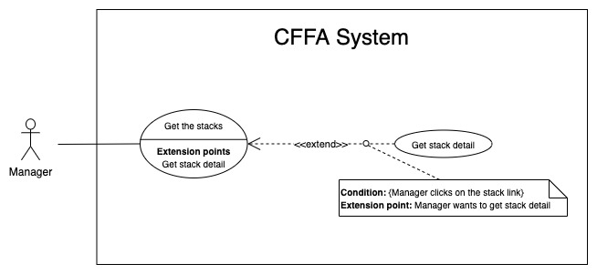

*Figure 18 - <Use Case> Get stack detail*

|  |  |  |  |
| --- | --- | --- | --- |
| ID and Name: | **UC-14 Get stack detail** | | |
| Created By: | LuanNM | Date Created: | 10/05/2021 |
| Primary Actor: | Manager | Secondary Actors: | N/A |
| Description: | This feature allows the Manager to getstackdetail. | | |
| Trigger: | Manager sends a request to get stack detail. | | |
| Preconditions: | PRE-01. User has logged in the system as manager role.  PRE-02. There is at least one the stack link. | | |
| Post-conditions: | POST-01. CFFA system returns stack information and redirect to stack detail page. | | |
| Normal Flow: | **14.0 Get stack detail**   1. Manager clicks on the stack link. 2. CFFA system validates the stack exists (see 14.0.E1) 3. CFFA system returns the stack information and redirects to stack detail page. | | |
| Alternative Flows: | N/A | | |
| Exceptions: | **14.0.E1 The stack does not exist.**  1. CFFA system returns the message (MSG-0022) and terminates this use case. | | |
| Priority: | High | | |
| Frequency of Use: | Usually | | |
| Business Rules: | BR-038 | | |
| Other Information: | In case of internet connection failure, Manager cannot finish this use case properly. | | |
| Assumptions: | N/A | | |

*Table 17 - <Use Case> Get stack detail*

##### 2.2.3.8 <Manager> Update the stack

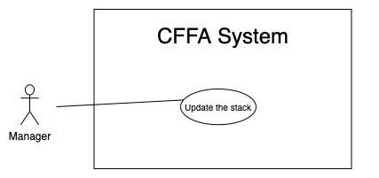

*Figure 19 - <Use Case> Update the stack*

|  |  |  |  |
| --- | --- | --- | --- |
| ID and Name: | **UC-15 Update the stack** | | |
| Created By: | LuanNM | Date Created: | 18/01/2021 |
| Primary Actor: | Manager | Secondary Actors: | N/A |
| Description: | This feature allows Manager to update stack information in CFFA system. | | |
| Trigger: | Manager sends a request to update the stack. | | |
| Preconditions: | PRE-01. User has logged in the system as manager role.  PRE-02. Manager is on “Stack detail” page. | | |
| Post-conditions: | POST-01. CFFA system updates stack information.  POST-02. CFFA system returns the message. | | |
| Normal Flow: | **15.0 Update the stack**   1. Manager sends a request to update the stack. 2. CFFA system requires stack information that includes:  * “Product”: popup. * “Camera”: popup. * “Status”: combobox.  1. Manager selects the fields. 2. Manager clicks on “Save” button. 3. CFFA system validates the fields (see 15.0.E1) 4. CFFA system updates stack information and returns the message (MSG-013). | | |
| Alternative Flows: | N/A | | |
| Exceptions: | **15.0.E1 Manager inputs/selects the fields that are not valid**   1. CFFA system returns to Manager to input/select the fields again (MSG-023, MSG-024). 2. If Manager selects the fields again, CFFA system returns to step 3 of normal flow. 3. Else if Manager cancels the login process, then CFFA system terminates this use case. | | |
| Priority: | Medium | | |
| Frequency of Use: | Often | | |
| Business Rules: | BR-032, BR-039, BR-040, BR-041, BR-042 | | |
| Other Information: | In case of internet connection failure, Manager cannot finish this use case properly. | | |
| Assumptions: | N/A | | |

*Table 18 - <Use Case> Update the stack*

##### 2.2.3.9 <Manager> Delete the stack

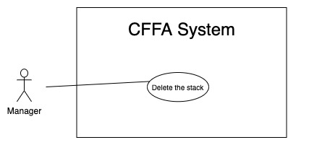

*Figure 20 - <Use Case> Delete the shelf*

|  |  |  |  |
| --- | --- | --- | --- |
| ID and Name: | **UC-16 Delete the stack** | | |
| Created By: | LuanNM | Date Created: | 10/05/2021 |
| Primary Actor: | Manager | Secondary Actors: | N/A |
| Description: | This feature allows Manager to delete the stack. | | |
| Trigger: | Manager sends a request to delete the stack. | | |
| Preconditions: | PRE-01. User has logged in the system as manager role.  PRE-02. Manager is on “Stack detail” page. | | |
| Post-conditions: | POST-01. CFFA system updates stack information.  POST-02. CFFA system returns the message. | | |
| Normal Flow: | **16.0 Delete the stack**   1. Manager sends a request to delete the stack. 2. CFFA system shows delete popup with message: "Are you sure?" and two buttons for Manager can select:  * "Yes" button * "No" button   1. Manager clicks on "Yes" button, CFFA system updates stack information and returns the message (MSG-021) (see 11.0.E1).   2. Manager clicks on "No" button, close popup and nothing change. | | |
| Alternative Flows: | N/A | | |
| Exceptions: | **16.0.E1 The stack does not exist**   1. CFFA system returns a message (MSG-022). 2. CFFA system redirects to manage stack page and terminates this use case. | | |
| Priority: | Medium | | |
| Frequency of Use: | Often | | |
| Business Rules: | BR-032, BR-033, BR-041 | | |
| Other Information: | In case of internet connection failure, Manager cannot finish this use case properly. | | |
| Assumptions: | N/A | | |

*Table 19 - <Use Case> Delete the stack*

##### 2.2.3.10 <Manager> Create new stack

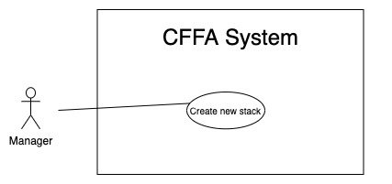

*Figure 21 - <Use Case> Create new stack*

|  |  |  |  |
| --- | --- | --- | --- |
| ID and Name: | **UC-17 Create new stack** | | |
| Created By: | LuanNM | Date Created: | 10/05/2021 |
| Primary Actor: | Manager | Secondary Actors: | N/A |
| Description: | This feature allows Manager to create new stack. | | |
| Trigger: | Manager sends a request to create new stack. | | |
| Preconditions: | PRE-01. User has logged in the system as manager role.  PRE-02. Manager is on “Shelf detail” page.  PRE-03. This shelf has total of stacks less than maximum of stacks. | | |
| Post-conditions: | POST-01. CFFA system stores newly created stack information.  POST-02. CFFA system returns the message. | | |
| Normal Flow: | **17.0 Create new stack**   1. Manager sends a request to create new stack. 2. CFFA system stores newly created stack information and returns the message (MSG-013) (see 17.0.E1). | | |
| Alternative Flows: | N/A | | |
| Exceptions: | **17.0.E1 The shelf is full**   1. CFFA system returns a message (MSG-025) and terminates this use case. | | |
| Priority: | Medium | | |
| Frequency of Use: | Often | | |
| Business Rules: | BR-035, BR-043, BR-50 | | |
| Other Information: | In case of internet connection failure, Manager cannot finish this use case properly. | | |
| Assumptions: | N/A | | |

*Table 20 - <Use Case> Create new stack*

##### 2.2.3.11 <Manager> Get the products

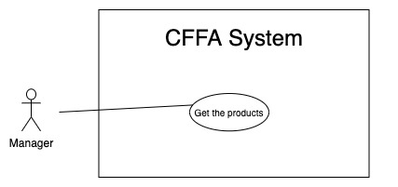

*Figure 22 - <Use Case> Get the products*

|  |  |  |  |
| --- | --- | --- | --- |
| ID and Name: | **UC-18 Get the products** | | |
| Created By: | HieuNT | Date Created: | 08/05/2021 |
| Primary Actor: | Manager | Secondary Actors: | N/A |
| Description: | This feature allows manager to get the products. | | |
| Trigger: | Manager sends a request to get the products. | | |
| Pre-conditions: | PRE-01. User has logged into the system as manager role.  PRE-02. Manager is managing a store. | | |
| Post-conditions: | POST-01. CFFA system returns the list of products. | | |
| Normal Flow: | **18.0 Get the products**   1. Manager sends a request to get the products. 2. CFFA system requires the product information from Manager:  * “Product name”: input text, blank * “Category”: combobox * “Status”: combobox  1. Manager inputs/selects the fields: product name, category, status. 2. Manager clicks on "Search" button. 3. CFFA system returns the list of products based on below conditions and display them (see 18.0.E1). | | |
| Alternative Flows: | N/A | | |
| Exceptions: | **18.0.E1 The list of product has no data.**   1. CFFA system returns the message (MSG-009). | | |
| Priority: | High | | |
| Frequency of Use: | Usually | | |
| Business Rules: | BR-024, BR-025, BR-044, BR-045 | | |
| Other Information: | In case of internet connection failure, Manager cannot finish this use case properly. | | |
| Assumptions: | N/A | | |

*Table 21 - <Use Case> Get the products*

##### 2.2.3.7 <Manager> Get product detail

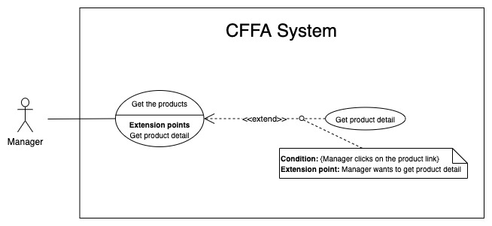

*Figure 23 - <Use Case> Get product detail*

|  |  |  |  |
| --- | --- | --- | --- |
| ID and Name: | **UC-19 Get product detail** | | |
| Created By: | HieuNT | Date Created: | 10/05/2021 |
| Primary Actor: | Manager | Secondary Actors: | N/A |
| Description: | This feature allows the Manager to getproductdetail. | | |
| Trigger: | Manager sends a request to get product detail. | | |
| Preconditions: | PRE-01. User has logged in the system as manager role.  PRE-02. There is at least one the product link. | | |
| Post-conditions: | POST-01. CFFA system returns product information and redirect to product detail page. | | |
| Normal Flow: | **19.0 Get product detail**   1. Manager clicks on the product link. 2. CFFA system validates the product exists (see 19.0.E1) 3. CFFA system returns the product information and redirects to product detail page. | | |
| Alternative Flows: | N/A | | |
| Exceptions: | **19.0.E1 The stack does not exist.**  1. CFFA system returns the message (MSG-0023) and terminates this use case. | | |
| Priority: | High | | |
| Frequency of Use: | Usually | | |
| Business Rules: | BR-046 | | |
| Other Information: | In case of internet connection failure, Manager cannot finish this use case properly. | | |
| Assumptions: | N/A | | |

*Table22 - <Use Case> Get product detail*

##### 2.2.3.13 <Manager> Update the product

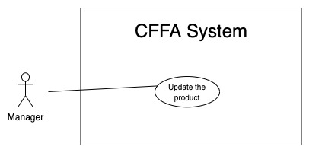

*Figure 24 - <Use Case> Update the product*

|  |  |  |  |
| --- | --- | --- | --- |
| ID and Name: | **UC-20 Update the product** | | |
| Created By: | HieuNT | Date Created: | 18/01/2021 |
| Primary Actor: | Manager | Secondary Actors: | N/A |
| Description: | This feature allows Manager to update product information in CFFA system. | | |
| Trigger: | Manager sends a request to update the product. | | |
| Preconditions: | PRE-01. User has logged in the system as manager role.  PRE-02. Manager is on “Product detail” page. | | |
| Post-conditions: | POST-01. CFFA system updates product information.  POST-02. CFFA system returns the message. | | |
| Normal Flow: | **20.0 Update the product**   1. Manager sends a request to update the product. 2. CFFA system requires product information that includes:  * “Product Name”: input text * “Image”: button * “Category”: combobox * “Description”: input text * “Status”: combobox.  1. Manager inputs/selects the required fields. 2. Manager clicks on “Save” button. 3. CFFA system validates the fields (see 20.0.E1, 20.0.E2) 4. CFFA system updates product information and returns the message (MSG-013). | | |
| Alternative Flows: | N/A | | |
| Exceptions: | **20.0.E1 Manager does not input/select the required fields**   1. CFFA system returns to Manager to input/select the required fields again (MSG-014, MSG-016, MSG-026, MSG-028). 2. If Manager inputs/selects the required fields again, CFFA system returns to step 3 of normal flow. 3. Else if Manager cancels the login process, then CFFA system terminates this use case.   **20.0.E2 Manager inputs/selects the fields that are not valid**   1. CFFA system returns to Manager to input/select the fields again (MSG-015, MSG-017, MSG-027, MSG-029, MSG-034). 2. If Manager inputs/selects the fields again, CFFA system returns to step 3 of normal flow. 3. Else if Manager cancels the login process, then CFFA system terminates this use case. | | |
| Priority: | Medium | | |
| Frequency of Use: | Often | | |
| Business Rules: | BR-032, BR-047, BR-048, BR-049 | | |
| Other Information: | In case of internet connection failure, Manager cannot finish this use case properly. | | |
| Assumptions: | N/A | | |

*Table 13 - <Use Case> Update the product*

##### 2.2.3.14 <Manager> Delete the product

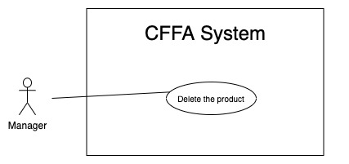

*Figure 24 - <Use Case> Delete the product*

|  |  |  |  |
| --- | --- | --- | --- |
| ID and Name: | **UC-21 Delete the product** | | |
| Created By: | HieuNT | Date Created: | 10/05/2021 |
| Primary Actor: | Manager | Secondary Actors: | N/A |
| Description: | This feature allows Manager to delete the product. | | |
| Trigger: | Manager sends a request to delete the product. | | |
| Preconditions: | PRE-01. User has logged in the system as manager role.  PRE-02. Manager is on “Product detail” page. | | |
| Post-conditions: | POST-01. CFFA system updates product information.  POST-02. CFFA system returns the message. | | |
| Normal Flow: | **21.0 Delete the product**   1. Manager sends a request to delete the product. 2. CFFA system shows delete popup with message: "Are you sure?" and two buttons for Manager can select:  * "Yes" button * "No" button   1. Manager clicks on "Yes" button, CFFA system updates product information and returns the message (MSG-021) (see 21.0.E1).   2. Manager clicks on "No" button, close popup and nothing change. | | |
| Alternative Flows: | N/A | | |
| Exceptions: | **21.E1 The product does not exist**   1. CFFA system returns a message (MSG-023). 2. CFFA system redirects to manage product page and terminates this use case. | | |
| Priority: | Medium | | |
| Frequency of Use: | Often | | |
| Business Rules: | BR-032, BR-033, BR-049 | | |
| Other Information: | In case of internet connection failure, Manager cannot finish this use case properly. | | |
| Assumptions: | N/A | | |

*Table 24 - <Use Case> Delete the product*

##### 2.2.3.15 <Manager> Create new product

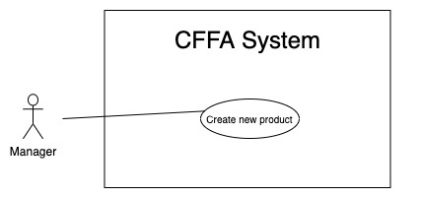

*Figure 26 - <Use Case> Create new product*

|  |  |  |  |
| --- | --- | --- | --- |
| ID and Name: | **UC-22 Create new product** | | |
| Created By: | HieuNT | Date Created: | 10/05/2021 |
| Primary Actor: | Manager | Secondary Actors: | N/A |
| Description: | This feature allows Manager to create new product. | | |
| Trigger: | Manager sends a request to create new product. | | |
| Preconditions: | PRE-01. User has logged in the system as manager role.  PRE-02. Manager is on “Manage product” page. | | |
| Post-conditions: | POST-01. CFFA system stores newly created product information.  POST-02. CFFA system returns the message. | | |
| Normal Flow: | **22.0 Create new product**   1. Manager sends a request to create new product. 2. CFFA system requires the product information:    * "Product name": input text, blank    * "Description": input text, blank    * "Category": combobox    * "Image": button 3. Manager inputs/selects the required fields. 4. Manager clicks on the "Create" button to create new product. 5. CFFA system validates the required fields (see 22.0.E1, 22.0.E2) 6. CFFA system stores newly created product information and returns the message (MSG-013). | | |
| Alternative Flows: | N/A | | |
| Exceptions: | **22.0.E1 Manager does not input/select the required fields**   1. CFFA system returns to Manager to input/select the required fields again (MSG-014, MSG-016, MSG-026, MSG-028). 2. If Manager inputs/selects the required fields again, CFFA system returns to step 3 of normal flow. 3. Else if Manager cancels the login process, then CFFA system terminates this use case.   **22.0.E1 Manager inputs/selects the fields that are not valid**   1. CFFA system returns to Manager to input/select the fields again (MSG-015, MSG-017, MSG-027, MSG-029, MSG-034). 2. If Manager inputs/selects the fields again, CFFA system returns to step 3 of normal flow. 3. Else if Manager cancels the login process, then CFFA system terminates this use case. | | |
| Priority: | Medium | | |
| Frequency of Use: | Often | | |
| Business Rules: | BR-035, BR-051 | | |
| Other Information: | In case of internet connection failure, Manager cannot finish this use case properly. | | |
| Assumptions: | N/A | | |

*Table 25 - <Use Case> Create new product*

##### 2.2.3.16 <Manager> Get the cameras

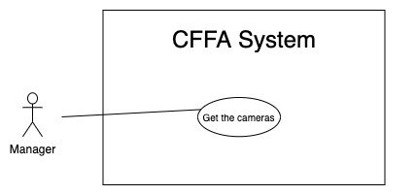

*Figure 27 - <Use Case> Get the cameras*

|  |  |  |  |
| --- | --- | --- | --- |
| ID and Name: | **UC-23 Get the cameras** | | |
| Created By: | HuuDN | Date Created: | 08/05/2021 |
| Primary Actor: | Manager | Secondary Actors: | N/A |
| Description: | This feature allows manager to get the cameras. | | |
| Trigger: | Manager sends a request to get the cameras. | | |
| Pre-conditions: | PRE-01. User has logged into the system as manager role.  PRE-02. Manager is managing a store. | | |
| Post-conditions: | POST-01. CFFA system returns the list of cameras. | | |
| Normal Flow: | **23.0 Get the cameras**   1. Manager sends a request to get the cameras. 2. CFFA system requires the camera information from Manager:  * “Camera name”: input text, blank * “Status”: combobox  1. Manager inputs/selects the fields: product name, status. 2. Manager clicks on "Search" button. 3. CFFA system returns the list of products based on below conditions and display them (see 23.0.E1). | | |
| Alternative Flows: | N/A | | |
| Exceptions: | **23.0.E1 The list of cameras has no data.**   1. CFFA system returns the message (MSG-009). | | |
| Priority: | High | | |
| Frequency of Use: | Usually | | |
| Business Rules: | BR-024, BR-025, BR-052, BR-053 | | |
| Other Information: | In case of internet connection failure, Manager cannot finish this use case properly. | | |
| Assumptions: | N/A | | |

*Table 26 - <Use Case> Get the products*

##### 2.2.3.17 <Manager> Get camera detail

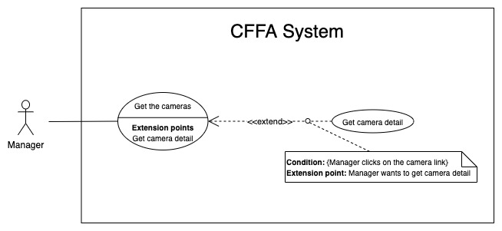

*Figure 28 - <Use Case> Get camera detail*

|  |  |  |  |
| --- | --- | --- | --- |
| ID and Name: | **UC-24 Get camera detail** | | |
| Created By: | HuuDN | Date Created: | 10/05/2021 |
| Primary Actor: | Manager | Secondary Actors: | N/A |
| Description: | This feature allows the Manager to getcameradetail. | | |
| Trigger: | Manager sends a request to get camera detail. | | |
| Preconditions: | PRE-01. User has logged in the system as manager role.  PRE-02. There is at least one the camera link. | | |
| Post-conditions: | POST-01. CFFA system returns camera information and redirect to camera detail page. | | |
| Normal Flow: | **24.0 Get product detail**   1. Manager clicks on the camera link. 2. CFFA system validates the camera exists (see 24.0.E1) 3. CFFA system returns the camera information and redirects to camera detail page. | | |
| Alternative Flows: | N/A | | |
| Exceptions: | **24.0.E1 The camera does not exist.**  1. CFFA system returns the message (MSG-0024) and terminates this use case. | | |
| Priority: | High | | |
| Frequency of Use: | Usually | | |
| Business Rules: | BR-054 | | |
| Other Information: | In case of internet connection failure, Manager cannot finish this use case properly. | | |
| Assumptions: | N/A | | |

*Table 27 - <Use Case> Get camera detail*

##### 2.2.3.18 <Manager> Update the camera

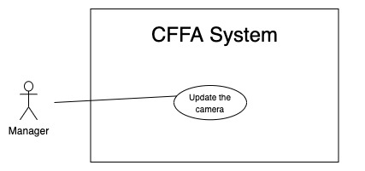

*Figure 29 - <Use Case> Update the camera*

|  |  |  |  |
| --- | --- | --- | --- |
| ID and Name: | **UC-25 Update the camera** | | |
| Created By: | HuuDN | Date Created: | 18/01/2021 |
| Primary Actor: | Manager | Secondary Actors: | N/A |
| Description: | This feature allows Manager to update camera information in CFFA system. | | |
| Trigger: | Manager sends a request to update the camera. | | |
| Preconditions: | PRE-01. User has logged in the system as manager role.  PRE-02. Manager is on “Camera detail” page. | | |
| Post-conditions: | POST-01. CFFA system updates camera information.  POST-02. CFFA system returns the message. | | |
| Normal Flow: | **25.0 Update the camera**   1. Manager sends a request to update the camera. 2. CFFA system requires camera information that includes:  * “Camera Name”: input text * “Image”: button * “IP address”: input text * “RTSP string”: input text * “Status”: combobox.  1. Manager inputs/selects the required fields. 2. Manager clicks on “Save” button. 3. CFFA system validates the fields (see 25.0.E1, 25.0.E2) 4. CFFA system updates camera information and returns the message (MSG-013). | | |
| Alternative Flows: | N/A | | |
| Exceptions: | **25.0.E1 Manager does not input/select the required fields**   1. CFFA system returns to Manager to input/select the required fields again (MSG-014, MSG-026, MSG-028, MSG-031). 2. If Manager inputs/selects the required fields again, CFFA system returns to step 3 of normal flow. 3. Else if Manager cancels the login process, then CFFA system terminates this use case.   **25.0.E2 Manager inputs/selects the fields that are not valid**   1. CFFA system returns to Manager to input/select the fields again (MSG-015, MSG-027, MSG-029, MSG-032, MSG-034). 2. If Manager inputs/selects the fields again, CFFA system returns to step 3 of normal flow. 3. Else if Manager cancels the login process, then CFFA system terminates this use case. | | |
| Priority: | Medium | | |
| Frequency of Use: | Often | | |
| Business Rules: | BR-032, BR-055, BR-056, BR-57, BR-60 | | |
| Other Information: | In case of internet connection failure, Manager cannot finish this use case properly. | | |
| Assumptions: | N/A | | |

*Table 28 - <Use Case> Update the product*

##### 2.2.3.19 <Manager> Delete the camera

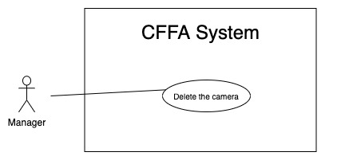

*Figure 29 - <Use Case> Delete the camera*

|  |  |  |  |
| --- | --- | --- | --- |
| ID and Name: | **UC-26 Delete the camera** | | |
| Created By: | HuuDN | Date Created: | 10/05/2021 |
| Primary Actor: | Manager | Secondary Actors: | N/A |
| Description: | This feature allows Manager to delete the camera. | | |
| Trigger: | Manager sends a request to delete the camera. | | |
| Preconditions: | PRE-01. User has logged in the system as manager role.  PRE-02. Manager is on “Camera detail” page. | | |
| Post-conditions: | POST-01. CFFA system updates camera information.  POST-02. CFFA system returns the message. | | |
| Normal Flow: | **26.0 Delete the camera**   1. Manager sends a request to delete the camera. 2. CFFA system shows delete popup with message: "Are you sure?" and two buttons for Manager can select:  * "Yes" button * "No" button   1. Manager clicks on "Yes" button, CFFA system updates camera information and returns the message (MSG-021) (see 26.0.E1).   2. Manager clicks on "No" button, close popup and nothing change. | | |
| Alternative Flows: | N/A | | |
| Exceptions: | **26.E1 The camera does not exist**   1. CFFA system returns a message (MSG-024). 2. CFFA system redirects to manage camera page and terminates this use case. | | |
| Priority: | Medium | | |
| Frequency of Use: | Often | | |
| Business Rules: | BR-032, BR-033, BR-058 | | |
| Other Information: | In case of internet connection failure, Manager cannot finish this use case properly. | | |
| Assumptions: | N/A | | |

*Table 24 - <Use Case> Delete the product*

##### 2.2.3.20 <Manager> Create new camera

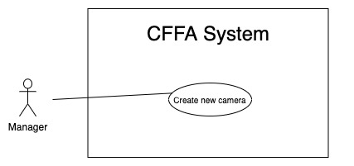

*Figure 30 - <Use Case> Create new camera*

|  |  |  |  |
| --- | --- | --- | --- |
| ID and Name: | **UC-27 Create new product** | | |
| Created By: | HuuDN | Date Created: | 10/05/2021 |
| Primary Actor: | Manager | Secondary Actors: | N/A |
| Description: | This feature allows Manager to create new camera. | | |
| Trigger: | Manager sends a request to create new camera. | | |
| Preconditions: | PRE-01. User has logged in the system as manager role.  PRE-02. Manager is on “Manage camera” page. | | |
| Post-conditions: | POST-01. CFFA system stores newly created camera information.  POST-02. CFFA system returns the message. | | |
| Normal Flow: | **27.0 Create new camera**   1. Manager sends a request to create new camera. 2. CFFA system requires the camera information:    * "Camera name": input text, blank    * "Image": button    * "Ip address": input text, blank    * "RPST string": input text, blank 3. Manager inputs/selects the required fields. 4. Manager clicks on the "Create" button to create new camera. 5. CFFA system validates the required fields (see 27.0.E1, 27.0.E2). 6. CFFA system stores newly created camera information and returns the message (MSG-013). | | |
| Alternative Flows: | N/A | | |
| Exceptions: | **27.0.E1 Manager does not input/select the required fields**   1. CFFA system returns to Manager to input/select the required fields again (MSG-014, MSG-026, MSG-028, MSG-031). 2. If Manager inputs/selects the required fields again, CFFA system returns to step 3 of normal flow. 3. Else if Manager cancels the login process, then CFFA system terminates this use case.   **27.0.E1 Manager inputs/selects the fields that are not valid**   1. CFFA system returns to Manager to input/select the fields again (MSG-015, MSG-027, MSG-029, MSG-032, MSG-034). 2. If Manager inputs/selects the fields again, CFFA system returns to step 3 of normal flow. 3. Else if Manager cancels the login process, then CFFA system terminates this use case. | | |
| Priority: | Medium | | |
| Frequency of Use: | Often | | |
| Business Rules: | BR-035, BR-055, BR-059, BR-060 | | |
| Other Information: | In case of internet connection failure, Manager cannot finish this use case properly. | | |
| Assumptions: | N/A | | |

*Table 30 - <Use Case> Create new camera*

##### 2.2.3.21 <Manager> Get the categories

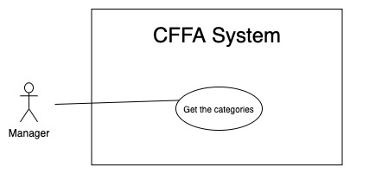

*Figure 32 - <Use Case> Get the categories*

|  |  |  |  |
| --- | --- | --- | --- |
| ID and Name: | **UC-28 Get the categories** | | |
| Created By: | TruongTN | Date Created: | 08/05/2021 |
| Primary Actor: | Manager | Secondary Actors: | N/A |
| Description: | This feature allows manager to get the categories. | | |
| Trigger: | Manager sends a request to get the categories. | | |
| Pre-conditions: | PRE-01. User has logged into the system as manager role.  PRE-02. Manager is managing a store. | | |
| Post-conditions: | POST-01. CFFA system returns the list of categories. | | |
| Normal Flow: | **28.0 Get the categories**   1. Manager sends a request to get the categories. 2. CFFA system requires the camera information from Manager:  * “Category name”: input text, blank  1. Manager inputs/selects the fields: category name 2. Manager clicks on "Search" button. 3. CFFA system returns the list of products based on below conditions and display them (see 28.0.E1). | | |
| Alternative Flows: | N/A | | |
| Exceptions: | **28.0.E1 The list of categories has no data.**   1. CFFA system returns the message (MSG-009). | | |
| Priority: | High | | |
| Frequency of Use: | Usually | | |
| Business Rules: | BR-024, BR-025, BR-061 | | |
| Other Information: | In case of internet connection failure, Manager cannot finish this use case properly. | | |
| Assumptions: | N/A | | |

*Table 31 - <Use Case> Get the categories*

##### 2.2.3.22 <Manager> Get category detail

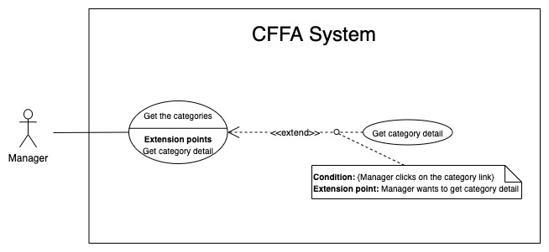

*Figure 33 - <Use Case> Get category detail*

|  |  |  |  |
| --- | --- | --- | --- |
| ID and Name: | **UC-29 Get category detail** | | |
| Created By: | HuuDN | Date Created: | 10/05/2021 |
| Primary Actor: | Manager | Secondary Actors: | N/A |
| Description: | This feature allows the Manager to getcategorydetail. | | |
| Trigger: | Manager sends a request to get categorydetail. | | |
| Preconditions: | PRE-01. User has logged in the system as manager role.  PRE-02. There is at least one the categorylink. | | |
| Post-conditions: | POST-01. CFFA system returns categoryinformation and redirect to categorydetail page. | | |
| Normal Flow: | **29.0 Get product detail**   1. Manager clicks on the categorylink. 2. CFFA system validates the categoryexists (see 24.0.E1) 3. CFFA system returns the categoryinformation and redirects to categorydetail page. | | |
| Alternative Flows: | N/A | | |
| Exceptions: | **29.0.E1 The category does not exist.**  1. CFFA system returns the message (MSG-0033) and terminates this use case. | | |
| Priority: | High | | |
| Frequency of Use: | Usually | | |
| Business Rules: | BR-062 | | |
| Other Information: | In case of internet connection failure, Manager cannot finish this use case properly. | | |
| Assumptions: | N/A | | |

*Table 32 - <Use Case> Get camera detail*

##### 2.2.3.22 <Manager> Update the category

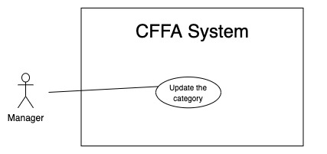

*Figure 33 - <Use Case> Update the category*

|  |  |  |  |
| --- | --- | --- | --- |
| ID and Name: | **UC-30 Update the category** | | |
| Created By: | HuuDN | Date Created: | 18/01/2021 |
| Primary Actor: | Manager | Secondary Actors: | N/A |
| Description: | This feature allows Manager to update category information in CFFA system. | | |
| Trigger: | Manager sends a request to update the category. | | |
| Preconditions: | PRE-01. User has logged in the system as manager role.  PRE-02. Manager is on “Category detail” page. | | |
| Post-conditions: | POST-01. CFFA system updates category information.  POST-02. CFFA system returns the message. | | |
| Normal Flow: | **30.0 Update the category**   1. Manager sends a request to update the camera. 2. CFFA system requires category information that includes:  * “Category Name”: input text  1. Manager inputs/selects the required fields. 2. Manager clicks on “Save” button. 3. CFFA system validates the fields (see 30.0.E1, 30.0.E2) 4. CFFA system updates camera information and returns the message (MSG-013). | | |
| Alternative Flows: | N/A | | |
| Exceptions: | **30.0.E1 Manager does not input/select the required fields**   1. CFFA system returns to Manager to input/select the required fields again (MSG-014). 2. If Manager inputs/selects the required fields again, CFFA system returns to step 3 of normal flow. 3. Else if Manager cancels the login process, then CFFA system terminates this use case.   **30.0.E2 Manager inputs/selects the fields that are not valid**   1. CFFA system returns to Manager to input/select the fields again (MSG-015, MSG-034). 2. If Manager inputs/selects the fields again, CFFA system returns to step 3 of normal flow. 3. Else if Manager cancels the login process, then CFFA system terminates this use case. | | |
| Priority: | Medium | | |
| Frequency of Use: | Often | | |
| Business Rules: | BR-063 | | |
| Other Information: | In case of internet connection failure, Manager cannot finish this use case properly. | | |
| Assumptions: | N/A | | |

*Table 33 - <Use Case> Update the product*

##### 2.2.3.20 <Manager> Create new category

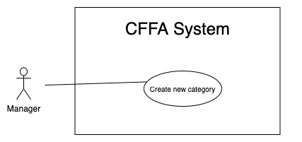

*Figure 35 - <Use Case> Create new category*

|  |  |  |  |
| --- | --- | --- | --- |
| ID and Name: | **UC-31 Create new category** | | |
| Created By: | TruongTN | Date Created: | 10/05/2021 |
| Primary Actor: | Manager | Secondary Actors: | N/A |
| Description: | This feature allows Manager to create new category. | | |
| Trigger: | Manager sends a request to create new category. | | |
| Preconditions: | PRE-01. User has logged in the system as manager role.  PRE-02. Manager is on “Manage category” page. | | |
| Post-conditions: | POST-01. CFFA system stores newly created category information.  POST-02. CFFA system returns the message. | | |
| Normal Flow: | **31.0 Create new camera**   1. Manager sends a request to create new category. 2. CFFA system requires the category information:    * "Category name": input text, blank 3. Manager inputs the required fields. 4. Manager clicks on the "Create" button to create new category. 5. CFFA system validates the required fields (see 31.0.E1, 31.0.E2). 6. CFFA system stores newly created category information and returns the message (MSG-013). | | |
| Alternative Flows: | N/A | | |
| Exceptions: | **31.0.E1 Manager does not input/select the required fields**   1. CFFA system returns to Manager to input the required fields again (MSG-014). 2. If Manager inputs/selects the required fields again, CFFA system returns to step 3 of normal flow. 3. Else if Manager cancels the login process, then CFFA system terminates this use case.   **31.0.E1 Manager inputs the fields that are not valid**   1. CFFA system returns to Manager to input the fields again (MSG-015, MSG-034). 2. If Manager inputs the fields again, CFFA system returns to step 3 of normal flow. 3. Else if Manager cancels the login process, then CFFA system terminates this use case. | | |
| Priority: | Medium | | |
| Frequency of Use: | Often | | |
| Business Rules: | BR-063 | | |
| Other Information: | In case of internet connection failure, Manager cannot finish this use case properly. | | |
| Assumptions: | N/A | | |

*Table 31 - <Use Case> Create new category*

#### 2.2.4 <Admin> Overview Use Case

##### 2.2.4.1 <Admin> Get the stores

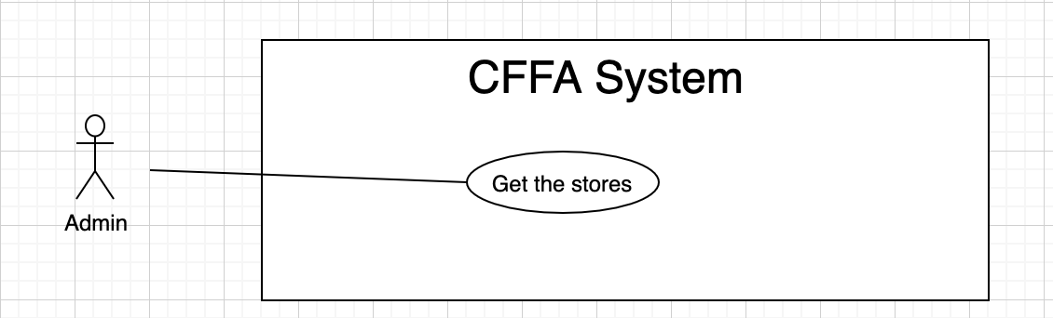

*Figure 37 - <Use Case> Get the stores*

|  |  |  |  |
| --- | --- | --- | --- |
| ID and Name: | **UC-32 Get the stores** | | |
| Created By: | LuanNM | Date Created: | 08/05/2021 |
| Primary Actor: | Admin | Secondary Actors: | N/A |
| Description: | This feature allows admin to get the stores. | | |
| Trigger: | Admin sends a request to get the stores. | | |
| Pre-conditions: | PRE-01. User has logged into the system as admin role. | | |
| Post-conditions: | POST-01. CFFA system returns the list of stores. | | |
| Normal Flow: | **32.0 Get the stores**   1. Admin sends a request to get the stores. 2. CFFA system requires the store information from Admin:  * “Store name”: input text, blank * “City”: combobox * “District”: combobox * “Status”: combobox  1. Admin inputs/selects the fields: Store name, city, district, and status. 2. Admin clicks on "Search" button. 3. CFFA system returns the list of stores based on below conditions and display them (see 32.0.E1). | | |
| Alternative Flows: | N/A | | |
| Exceptions: | **32.0.E1 The list of stores has no data.**   1. CFFA system returns the message (MSG-009). | | |
| Priority: | High | | |
| Frequency of Use: | Usually | | |
| Business Rules: | BR-024, BR-025, BR-064, BR-065 | | |
| Other Information: | In case of internet connection failure, Admin cannot finish this use case properly. | | |
| Assumptions: | N/A | | |

*Table 35 - <Use Case> Get the stores*

##### 2.2.4.2 <Admin> Get store detail

*Figure 38 - <Use Case> Get store detail*

|  |  |  |  |
| --- | --- | --- | --- |
| ID and Name: | **UC-33 Get store detail** | | |
| Created By: | LuanNM | Date Created: | 10/05/2021 |
| Primary Actor: | Admin | Secondary Actors: | N/A |
| Description: | This feature allows the admin to getstoredetail. | | |
| Trigger: | Admin sends a request to get store detail. | | |
| Preconditions: | PRE-01. User has logged in the system as admin role.  PRE-02. There is at least one the store link. | | |
| Post-conditions: | POST-01. CFFA system returns stores information and redirect to store detail page. | | |
| Normal Flow: | **33.0 Get store detail**   1. Admin clicks on the admin link. 2. CFFA system validates the store exists (see 33.0.E1) 3. CFFA system returns the stores information and redirects to store detail page. | | |
| Alternative Flows: | N/A | | |
| Exceptions: | **33.0.E1 The stores does not exist.**  1. CFFA system returns the message (MSG-035) and terminates this use case. | | |
| Priority: | High | | |
| Frequency of Use: | Usually | | |
| Business Rules: | BR-066 | | |
| Other Information: | In case of internet connection failure, Admin cannot finish this use case properly. | | |
| Assumptions: | N/A | | |

*Table 36 - <Use Case> Get camera detail*

##### 2.2.4.3 <Admin> Update the store

*Figure 39 - <Use Case> Update the store*

|  |  |  |  |
| --- | --- | --- | --- |
| ID and Name: | **UC-34 Update the store** | | |
| Created By: | LuanNM | Date Created: | 18/01/2021 |
| Primary Actor: | Admin | Secondary Actors: | N/A |
| Description: | This feature allows Admin to update store information in CFFA system. | | |
| Trigger: | Admin sends a request to update the store. | | |
| Preconditions: | PRE-01. User has logged in the system as admin role.  PRE-02. Admin is on “Store detail” page. | | |
| Post-conditions: | POST-01. CFFA system updates store information.  POST-02. CFFA system returns the message. | | |
| Normal Flow: | **34.0 Update the store**   1. Admin sends a request to update the store. 2. CFFA system requires store information that includes:  * “Store Name”: input text * “Image”: button * “Address”: input text * “City”: combobox * “District”: combobox * “Manager”: combobox * “Status”: combobox.  1. Admin inputs/selects the required fields. 2. Admin clicks on “Save” button. 3. CFFA system validates the fields (see 34.0.E1, 34.0.E2) 4. CFFA system updates store information and returns the message (MSG-013). | | |
| Alternative Flows: | N/A | | |
| Exceptions: | **34.0.E1 Admin does not input/select the required fields**   1. CFFA system returns to Admin to input/select the required fields again (MSG-014, MSG-026, MSG-036, MSG-038, MSG-039). 2. If Admin inputs/selects the required fields again, CFFA system returns to step 3 of normal flow. 3. Else if Admin cancels the login process, then CFFA system terminates this use case.   **34.0.E2 Admin inputs/selects the fields that are not valid**   1. CFFA system returns to Manager to input/select the fields again (MSG-015, MSG-027, MSG-037, MSG-034). 2. If Admin inputs/selects the fields again, CFFA system returns to step 3 of normal flow. 3. Else if Admin cancels the login process, then CFFA system terminates this use case. | | |
| Priority: | Medium | | |
| Frequency of Use: | Often | | |
| Business Rules: | BR-032, BR-067, BR-68, BR-69 | | |
| Other Information: | In case of internet connection failure, Admin cannot finish this use case properly. | | |
| Assumptions: | N/A | | |

*Table 37 - <Use Case> Update the store*

##### 2.2.4.4 <Admin> Delete the store

*Figure 40 - <Use Case> Delete the store*

|  |  |  |  |
| --- | --- | --- | --- |
| ID and Name: | **UC-35 Delete the store** | | |
| Created By: | LuanNM | Date Created: | 10/05/2021 |
| Primary Actor: | Admin | Secondary Actors: | N/A |
| Description: | This feature allows Admin to delete the store. | | |
| Trigger: | Admin sends a request to delete the store. | | |
| Preconditions: | PRE-01. User has logged in the system as admin role.  PRE-02. Admin is on “Store detail” page. | | |
| Post-conditions: | POST-01. CFFA system updates store information.  POST-02. CFFA system returns the message. | | |
| Normal Flow: | **35.0 Delete the store**   1. Admin sends a request to delete the camera. 2. CFFA system shows delete popup with message: "Are you sure?" and two buttons for Admin can select:  * "Yes" button * "No" button   1. Admin clicks on "Yes" button, CFFA system updates store information and returns the message (MSG-021) (see 35.0.E1).   2. Admin clicks on "No" button, close popup and nothing change. | | |
| Alternative Flows: | N/A | | |
| Exceptions: | **35.E1 The store does not exist**   1. CFFA system returns a message (MSG-035). 2. CFFA system redirects to manage store page and terminates this use case. | | |
| Priority: | Medium | | |
| Frequency of Use: | Often | | |
| Business Rules: | BR-032, BR-033, BR-069 | | |
| Other Information: | In case of internet connection failure, Admin cannot finish this use case properly. | | |
| Assumptions: | N/A | | |

*Table 38 - <Use Case> Delete the store*

##### 2.2.4.5 <Admin> Create new store

*Figure 41 - <Use Case> Create new store*

|  |  |  |  |
| --- | --- | --- | --- |
| ID and Name: | **UC-36 Create new store** | | |
| Created By: | LuanNM | Date Created: | 10/05/2021 |
| Primary Actor: | Admin | Secondary Actors: | N/A |
| Description: | This feature allows Admin to create new store. | | |
| Trigger: | Admin sends a request to create new store. | | |
| Preconditions: | PRE-01. User has logged in the system as admin role.  PRE-02. Admin is on “Manage store” page. | | |
| Post-conditions: | POST-01. CFFA system stores newly created store information.  POST-02. CFFA system returns the message. | | |
| Normal Flow: | **36.0 Create new store**   1. Admin sends a request to create new store. 2. CFFA system requires the store information:    * "Store name": input text, blank    * "Image": button    * "Address": input text    * "City": combobox    * "District": combobox 3. Admin inputs/selects the required fields. 4. Admin clicks on the "Create" button to create new store. 5. CFFA system validates the required fields (see 36.0.E1, 36.0.E2). 6. CFFA system stores newly created camera information and returns the message (MSG-013). | | |
| Alternative Flows: | N/A | | |
| Exceptions: | **36.0.E1 Admin does not input/select the required fields**   1. CFFA system returns to Admin to input/select the required fields again (MSG-014, MSG-026, MSG-036, MSG-038, MSG-39). 2. If Admin inputs/selects the required fields again, CFFA system returns to step 3 of normal flow. 3. Else if Admin cancels the login process, then CFFA system terminates this use case.   **36.0.E1 Admin** **inputs/selects the fields that are not valid**   1. CFFA system returns to Admin to input/select the fields again (MSG-015, MSG-027, MSG-034, MSG-037). 2. If Admin inputs/selects the fields again, CFFA system returns to step 3 of normal flow. 3. Else if Admin cancels the login process, then CFFA system terminates this use case. | | |
| Priority: | Medium | | |
| Frequency of Use: | Often | | |
| Business Rules: | BR-035, BR-067, BR-070 | | |
| Other Information: | In case of internet connection failure, Admin cannot finish this use case properly. | | |
| Assumptions: | N/A | | |

*Table 39 - <Use Case> Create new store*

##### 2.2.4.6 <Admin> Get the managers

*Figure 37 - <Use Case> Get the stores*

|  |  |  |  |
| --- | --- | --- | --- |
| ID and Name: | **UC-37 Get the managers** | | |
| Created By: | HieuNT | Date Created: | 08/05/2021 |
| Primary Actor: | Admin | Secondary Actors: | N/A |
| Description: | This feature allows admin to get the managers. | | |
| Trigger: | Admin sends a request to get the managers. | | |
| Pre-conditions: | PRE-01. User has logged into the system as admin role. | | |
| Post-conditions: | POST-01. CFFA system returns the list of stores. | | |
| Normal Flow: | **37.0 Get the managers**   1. Admin sends a request to get the managers. 2. CFFA system requires the manager information from Admin:  * “Employee code”: input text, blank * “Manager name”: input text, blank * “Username”: input text, blank * “Status”: combobox  1. Admin inputs/selects the fields: Manager name, and status. 2. Admin clicks on "Search" button. 3. CFFA system returns the list of stores based on below conditions and display them (see 37.0.E1). | | |
| Alternative Flows: | N/A | | |
| Exceptions: | **37.0.E1 The list of managers has no data.**   1. CFFA system returns the message (MSG-009). | | |
| Priority: | High | | |
| Frequency of Use: | Usually | | |
| Business Rules: | BR-024, BR-025, BR-071, BR-072 | | |
| Other Information: | In case of internet connection failure, Admin cannot finish this use case properly. | | |
| Assumptions: | N/A | | |

*Table 40 - <Use Case> Get the managers*

##### 2.2.4.7 <Admin> Get manager detail

*Figure 43 - <Use Case> Get store detail*

|  |  |  |  |
| --- | --- | --- | --- |
| ID and Name: | **UC-38 Get manager detail** | | |
| Created By: | HieuNT | Date Created: | 10/05/2021 |
| Primary Actor: | Admin | Secondary Actors: | N/A |
| Description: | This feature allows the admin to getmanagerdetail. | | |
| Trigger: | Admin sends a request to get manager detail. | | |
| Preconditions: | PRE-01. User has logged in the system as admin role.  PRE-02. There is at least one the manager link. | | |
| Post-conditions: | POST-01. CFFA system returns manager information and redirect to manager detail page. | | |
| Normal Flow: | **38.0 Get manager detail**   1. Admin clicks on the manager link. 2. CFFA system validates the manager exists (see 38.0.E1) 3. CFFA system returns the manager information and redirects to manager detail page. | | |
| Alternative Flows: | N/A | | |
| Exceptions: | **38.0.E1 The manager does not exist.**  1. CFFA system returns the message (MSG-041) and terminates this use case. | | |
| Priority: | High | | |
| Frequency of Use: | Usually | | |
| Business Rules: | BR-073 | | |
| Other Information: | In case of internet connection failure, Admin cannot finish this use case properly. | | |
| Assumptions: | N/A | | |

*Table 42 - <Use Case> Get manager detail*

##### 2.2.4.8 <Admin> Update the manager

*Figure 44 - <Use Case> Update the manager*

|  |  |  |  |
| --- | --- | --- | --- |
| ID and Name: | **UC-39 Update the manager** | | |
| Created By: | HieuNT | Date Created: | 18/01/2021 |
| Primary Actor: | Admin | Secondary Actors: | N/A |
| Description: | This feature allows Admin to update manager information in CFFA system. | | |
| Trigger: | Admin sends a request to update the manager. | | |
| Preconditions: | PRE-01. User has logged in the system as admin role.  PRE-02. Admin is on “Manager detail” page. | | |
| Post-conditions: | POST-01. CFFA system updates manager information.  POST-02. CFFA system returns the message. | | |
| Normal Flow: | **39.0 Update the manager**   1. Admin sends a request to update the store. 2. CFFA system requires store information that includes:  * “Employee code”: input text * “Manager name”: input text * “Store”: combobox * “Identify card”: input text * “Phone”: input text * “Gender”: checkbox * “BirthDate”: combobox * “Email”: input text * “Image”: button * “Address”: input text * “City”: combobox * “District”: combobox * “Status”: combobox.  1. Admin inputs/selects the required fields. 2. Admin clicks on “Save” button. 3. CFFA system validates the fields (see 39.0.E1, 39.0.E2) 4. CFFA system updates manager information and returns the message (MSG-013). | | |
| Alternative Flows: | N/A | | |
| Exceptions: | **39.0.E1 Admin does not input/select the required fields**   1. CFFA system returns to Admin to input/select the required fields again (MSG-014, MSG-042, MSG-044). 2. If Admin inputs/selects the required fields again, CFFA system returns to step 3 of normal flow. 3. Else if Admin cancels the login process, then CFFA system terminates this use case.   **39.0.E2 Admin inputs/selects the fields that are not valid**   1. CFFA system returns to Manager to input/select the fields again (MSG-015, MSG-043, MSG-045). 2. If Admin inputs/selects the fields again, CFFA system returns to step 3 of normal flow. 3. Else if Admin cancels the login process, then CFFA system terminates this use case. | | |
| Priority: | Medium | | |
| Frequency of Use: | Often | | |
| Business Rules: | BR-032, BR-074, BR-075, BR-076 | | |
| Other Information: | In case of internet connection failure, Admin cannot finish this use case properly. | | |
| Assumptions: | N/A | | |

*Table 37 - <Use Case> Update the store*

##### 2.2.4.9 <Admin> Delete the manager

*Figure 45 - <Use Case> Delete the manager*

|  |  |  |  |
| --- | --- | --- | --- |
| ID and Name: | **UC-40 Delete the manager** | | |
| Created By: | LuanNM | Date Created: | 10/05/2021 |
| Primary Actor: | Admin | Secondary Actors: | N/A |
| Description: | This feature allows Admin to delete the manager. | | |
| Trigger: | Admin sends a request to delete the manager. | | |
| Preconditions: | PRE-01. User has logged in the system as admin role.  PRE-02. Admin is on “Manager detail” page. | | |
| Post-conditions: | POST-01. CFFA system updates manager information.  POST-02. CFFA system returns the message. | | |
| Normal Flow: | **40.0 Delete the manager**   1. Admin sends a request to delete the manager. 2. CFFA system shows delete popup with message: "Are you sure?" and two buttons for Admin can select:  * "Yes" button * "No" button   1. Admin clicks on "Yes" button, CFFA system updates manager information and returns the message (MSG-021) (see 40.0.E1).   2. Admin clicks on "No" button, close popup and nothing change. | | |
| Alternative Flows: | N/A | | |
| Exceptions: | **40.E1 The manager does not exist**   1. CFFA system returns a message (MSG-041). 2. CFFA system redirects to manage store page and terminates this use case. | | |
| Priority: | Medium | | |
| Frequency of Use: | Often | | |
| Business Rules: | BR-032, BR-033, BR-076 | | |
| Other Information: | In case of internet connection failure, Admin cannot finish this use case properly. | | |
| Assumptions: | N/A | | |

*Table 38 - <Use Case> Delete the store*

##### 2.2.4.10 <Admin> Create new manager

*Figure 46 - <Use Case> Create new manager*

|  |  |  |  |
| --- | --- | --- | --- |
| ID and Name: | **UC-41 Create new manager** | | |
| Created By: | LuanNM | Date Created: | 10/05/2021 |
| Primary Actor: | Admin | Secondary Actors: | N/A |
| Description: | This feature allows Admin to create new manager. | | |
| Trigger: | Admin sends a request to create new manager. | | |
| Preconditions: | PRE-01. User has logged in the system as admin role.  PRE-02. Admin is on “Manage manager” page. | | |
| Post-conditions: | POST-01. CFFA system stores newly created store information.  POST-02. CFFA system returns the message. | | |
| Normal Flow: | **41.0 Create new manager**   1. Admin sends a request to create new store. 2. CFFA system requires the manager information:    * "Manager name": input text, blank    * "Employee code": input text, blank    * "Identify card": input text, blank    * "Email": input text, blank    * "Phone": input text, blank    * "BirthDate": datepicker    * "Gender": checkbox    * "Image": button    * "Address": input text    * "City": combobox    * "District": combobox 3. Admin inputs/selects the required fields. 4. Admin clicks on the "Create" button to create new store. 5. CFFA system validates the required fields (see 41.0.E1, 41.0.E2). 6. CFFA system stores newly created camera information and returns the message (MSG-013). | | |
| Alternative Flows: | N/A | | |
| Exceptions: | **41.0.E1 Admin does not input/select the required fields**   1. CFFA system returns to Admin to input/select the required fields again (MSG-014, MSG-042, MSG-044). 2. If Admin inputs/selects the required fields again, CFFA system returns to step 3 of normal flow. 3. Else if Admin cancels the login process, then CFFA system terminates this use case.   **41.0.E2 Admin inputs/selects the fields that are not valid**   1. CFFA system returns to Manager to input/select the fields again (MSG-015, MSG-043, MSG-045). 2. If Admin inputs/selects the fields again, CFFA system returns to step 3 of normal flow. 3. Else if Admin cancels the login process, then CFFA system terminates this use case. | | |
| Priority: | Medium | | |
| Frequency of Use: | Often | | |
| Business Rules: | BR-035, BR-074, BR-070, BR-077 | | |
| Other Information: | In case of internet connection failure, Admin cannot finish this use case properly. | | |
| Assumptions: | N/A | | |

*Table 47 - <Use Case> Create new manager*

#### 2.2.5 <System AI> Overview Use Case

##### 

##### 2.2.5.1 <System AI> Detect “hotspot”

|  |  |  |  |
| --- | --- | --- | --- |
| ID and Name: | **UC-45** | | |
| Created By: | LuanNM | Date Created: | 20/03/2021 |
| Primary Actor: | System AI | Secondary Actors: | N/A |
| Description: | This feature allows System AI to detect “hotspot”. | | |
| Trigger: | System AI runs at the scheduled time. | | |
| Preconditions: | PRE-01. System AI has video files in the server. | | |
| Post-conditions: | POST-01. System AI transfers detected result video file to Firebase Storage.  POST-02. System AI saves detected result into Database server. | | |
| Normal Flow: | **45.0 Detect “hotspot”**  1. System AI detects video files in the server.  2. System AI saves detected result into Database server.  3. System AI transfers detected result video files to Firebase Storage.  4. System AI deletes video files in server. | | |
| Alternative Flows: | N/A | | |
| Exceptions: | N/A | | |
| Priority: | Medium | | |
| Frequency of Use: | Often. | | |
| Business Rules: | N/A | | |
| Other Information: | In case of internet connection failure, System AI cannot finish this use case properly. | | |
| Assumptions: | N/A | | |

##### 2.2.5.2 <System AI> Analyze facial expression

|  |  |  |  |
| --- | --- | --- | --- |
| ID and Name: | **UC-46** | | |
| Created By: | LuanNM | Date Created: | 20/03/2021 |
| Primary Actor: | System AI | Secondary Actors: | N/A |
| Description: | This feature allows System AI to analyze facial expression. | | |
| Trigger: | System AI runs at the scheduled time. | | |
| Preconditions: | PRE-01. System AI has video files in the server. | | |
| Post-conditions: | POST-01. System AI transfers analyzed result video file to Firebase Storage.  POST-02. System AI saves analyzed results into Database server. | | |
| Normal Flow: | **46.0 Detect “hotspot”**  1. System AI analyzes video files in the server.  2. System AI saves analyzed results into Database server.  3. System AI transfers analyzed result video files to Firebase Storage.  4. System AI deletes video files in the server. | | |
| Alternative Flows: | N/A | | |
| Exceptions: | N/A | | |
| Priority: | Medium | | |
| Frequency of Use: | Often. | | |
| Business Rules: | N/A | | |
| Other Information: | In case of internet connection failure, System AI cannot finish this use case properly. | | |
| Assumptions: | N/A | | |

#### 2.2.6 <System Handler> Overview Use Case

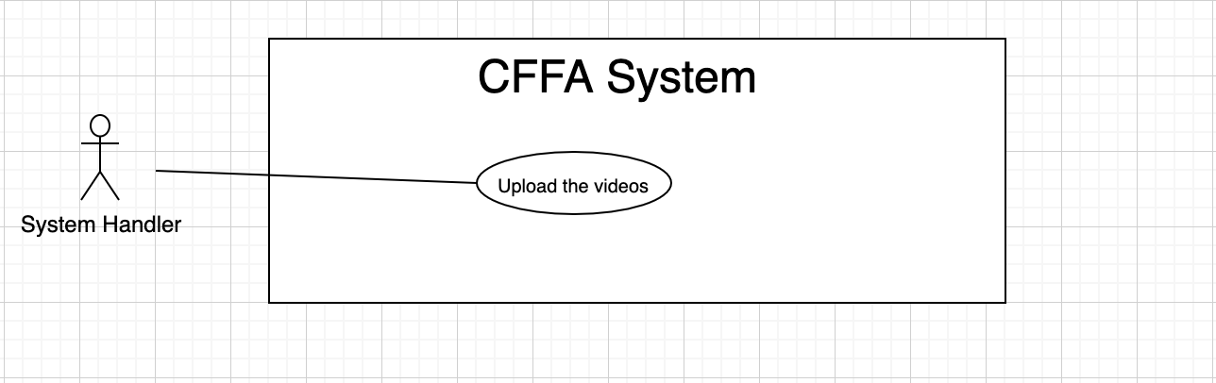

##### 2.2.6.1 <System AI> Upload the video

|  |  |  |  |
| --- | --- | --- | --- |
| ID and Name: | **UC-47** | | |
| Created By: | LuanNM | Date Created: | 20/03/2021 |
| Primary Actor: | System Handler | Secondary Actors: | N/A |
| Description: | This feature allows System Handler to upload the videos. | | |
| Trigger: | ?????????? | | |
| Preconditions: | PRE-01. System Handler has RTSP connection string of the cameras.  PRE-02. System Handler | | |
| Post-conditions: | POST-01. System Handler uploads videos to the server. | | |
| Normal Flow: | **47.0 Upload the video**  1. System Handler catches streaming of videos and saves them to be video files. (see 47.0.E1)  2. System Handler starts to upload video files to the server at appointed time. | | |
| Alternative Flows: | N/A | | |
| Exceptions: | **47.0.E1 RTSP connection doesn’t found.**  ??????????? | | |
| Priority: | Medium | | |
| Frequency of Use: | Often. | | |
| Business Rules: | BR-078 | | |
| Other Information: | In case of internet connection failure, System Handler cannot finish this use case properly. | | |
| Assumptions: | N/A | | |

## 

## 3. Other Requirements

### 3.1 Messages List

|  |  |  |  |  |
| --- | --- | --- | --- | --- |
| **#** | **Message code** | **Message Type** | **Context** | **Content** |
| 1 | MSG-001 | In line, under input form, red text | The username cannot be empty | Username is required |
| 2 | MSG-002 | In line, under input form, red text | The password cannot be empty | Password is required |
| 3 | MSG-003 | In line, under input form, red text | Invalid username or password | Invalid username or password |
| 4 | MSG-004 | In line, under input form, red text | The old password cannot be empty | Old password is required |
| 5 | MSG-005 | In line, under input form, red text | The new password cannot be empty | New password is required |
| 6 | MSG-006 | In line, under input form, red text | The retype password cannot be empty | Retype password is required |
| 7 | MSG-007 | In line, under input form, red text | The new password and retype password must be matched | New password and retype password must be matched |
| 8 | MSG-008 | In line, under input form, red text | The password must be at least 8 characters and must contain the following:  - At least one uppercase letter - At least one lowercase letter - At least one digits | Password must be at least 8 chracters and must contain the following:  - At least one uppercase letter - At least one lowercase letter  - At least one digits |
| 9 | MSG-009 |  | The list has no data | No data |
| 10 | MSG-010 |  | The report has no data | No data |
| 11 | MSG-011 |  | The video doesn't exist | No data |
| 12 | MSG-012 |  | The shelf doesn't exist | This shelf doesn't exist |
| 13 | MSG-013 |  | The updating process is successful | Updating process is successful |
| 14 | MSG-014 | In line, under input form, red text | The name is empty | The name is required |
|  | MSG-015 | In line, under input form, red text | The name is between 1 to 100 characters | The name is between 1 to 100 characters |
|  | MSG-016 | In line, under input form, red text | The description is empty | The description is required |
|  | MSG-017 | In line, under input form, red text | The description is between 1 to 250 characters | The description is between 1 to 250 characters |
|  | MSG-018 | In line, under input form, red text | The shelf's maximum of stack is empty | The shelf's maximum of stack is required |
|  | MSG-019 | In line, under input form, red text | The shelf's maximum of stack is between 1 to 30 stacks | The shelf's maximum of stack is between 1 to 30 stacks |
|  | MSG-020 | In line, under input form, red text | The camera doesn't exist | This camera doesn't exist |
|  | MSG-021 | In line, under input form, red text | The deleting process is successful | Deleting process is successful |
|  | MSG-022 | In line, under input form, red text | The stack doesn't exist | This stack doesn't exist |
|  | MSG-023 | In line, under input form, red text | The product doesn't exist | This product doesn't exist |
|  | MSG-024 | In line, under input form, red text | The camera doesn't exist | This camera doesn't exist |
|  | MSG-025 | In line, under input form, red text | The shelf has total of stacks equal then maximum of stacks | This shelf is full |
|  | MSG-026 | In line, under input form, red text | The image is empty | Image is required |
|  | MSG-027 | In line, under input form, red text | The image is not png, jpg, jpeg format | The image must be png, jpg, jpeg format |
|  | MSG-028 | In line, under input form, red text | The category is empty | Category is required |
|  | MSG-029 | In line, under input form, red text | The category does not exist | Category does not exist |
|  | MSG-030 | In line, under input form, red text | The RTSP string is empty | The RTSP string is required |
|  | MSG-031 | In line, under input form, red text | The ip address is empty | The ip address is required |
|  | MSG-032 | In line, under input form, red text | The ip address must be x.x.x.x format (x is number between 0 to 255) | The ip address must be x.x.x.x format (x is number between 0 to 255) |
|  | MSG-033 | In line, under input form, red text | The category doesn't exist | The category doesn't exist |
|  | MSG-034 | In line, under input form, red text | The name already exist | The name already exist |
|  | MSG-035 | In line, under input form, red text | The store doesn't exist | The store doesn't exist |
|  | MSG-036 | In line, under input form, red text | The address is empty | Address is required |
|  | MSG-037 | In line, under input form, red text | The address is between 1 to 250 characters | Address is between 1 to 250 characters |
|  | MSG-038 | In line, under input form, red text | City has not been selected | City is required |
|  | MSG-039 | In line, under input form, red text | District has not been selected | District is required |
|  | MSG-041 | In line, under input form, red text | The manager doesn't exist | The manager doesn't exist |
|  | MSG-042 | In line, under input form, red text | Employee code is null | Employee code is required |
|  | MSG-043 | In line, under input form, red text | Manager already exists | Manager already exists |
|  | MSG-044 | In line, under input form, red text | Email is null | Email is required |
|  | MSG-045 | In line, under input form, red text | Email does not match regex ^\(?([0-9]{3})\)?[-. ]?([0-9]{3})[-. ]?([0-9]{4})$ | Email is wrong format |
|  |  |  |  |  |
|  |  |  |  |  |
|  |  |  |  |  |
|  |  |  |  |  |