### Code

1. **C#:**

Navigate to folder /PCApp/BIO_MONITORING and run the BIO_MONITORING.sln file.

1. **Arduino:**

Navigate to folder /MCU/BioMon and open BioMon.ino file.

In this file I set a constant:

#define USE_ETHERNET

Please set it to 1 if you would like to use Ethernet connection.

Please set it to 0 if you would like to use Serial.

After change the value, please flash code to Arduino.

The default program I sent you is Ethernet. So If you want to use Ethernet, don’t need to to anything.

1. **Dust Counter:**

Just connect 4 wire cable to the sensor and run. If you want to modify code, please navigate to folder /MCU/DustCounter

## Hardware

1. **Ethernet cable or Serial:**
2. If you use Ethernet, place a jumper at POWER_SEL on IO shield (I have already done it).

Connect Ethernet cable only. (Don’t connect USB cable, it will damage your Arduino).

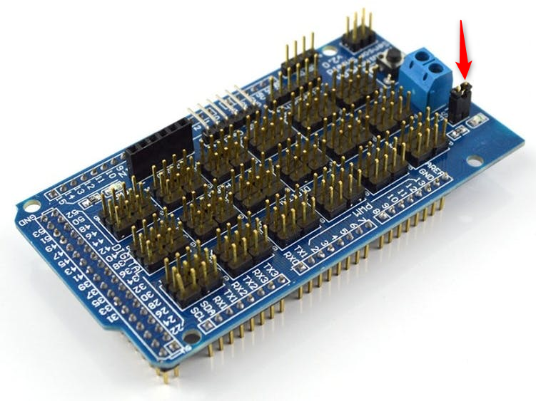

1. If you use Serial

Please disconnect the POWER_SEL jumper and then connect USB cable.

1. **Sensor 3 wires:**

I already connect all wires from inside to outside for you. Please be inform here is my standard for all wires:

|  |  |  |
| --- | --- | --- |
|  | From Box | Sensor |
| 1 | **Green wire** | GND |
| 2 | **Black wire** | VCC |
| 3 | **Red wire** | Signal |

1. **Actuator:**

Connect 12V pump to the wire labled: **+12VPump** and **GND.**

Connect 220VAC pump to female AC connector labled: **220Pump**

Take out 8 Relay board and conect to Vacuum pump, Cooler, Lighting, …

1. **Power**

Connect +12V and GND to your 12V Source. I already marked it.

## Usage

After setup, turn AC Switch off. Connect male AC connector which labled L - N to 220VAC ( L to Line, N to neutral: safety function). Turn AC switch on, wait for LCD display IP or baurate. Start PC App, hit connect button.