大数据项目实验报告

一、项目概述

课程的大项目:位置相关服务:附近的出租车

位置相关服务:Location-Based Services (LBS) 利用定位技术获得移动终端(人)的位置信息，并通过通信网络 向移动终端(人)提供与位置相关的信息服务

目标 ： 随时(Anytime)、随地(Anywhere)为所有的人(Anybody)和事(Anything)提供实时的“4A”服务

项目介绍： 以北京市出租车移动轨迹数据作为切入点，实现项目“位置相关服务:附近的 出租车”，目的是实现一个基于位置信息的查询服务，通过位置相关的持续查 询技术，实时回答用户:“我附近的出租车”，以此加深大家对相关领域理解 并提高实践能力。

项目主要内容：空间索引技术 利用空间索引有效地管理出租车的位置信息，并加快检索数据。 近邻查询技术 查询某一时刻处于某个地理区域的移动对象。 查询离某一点最近的移动对象

二、系统设计

系统环境：

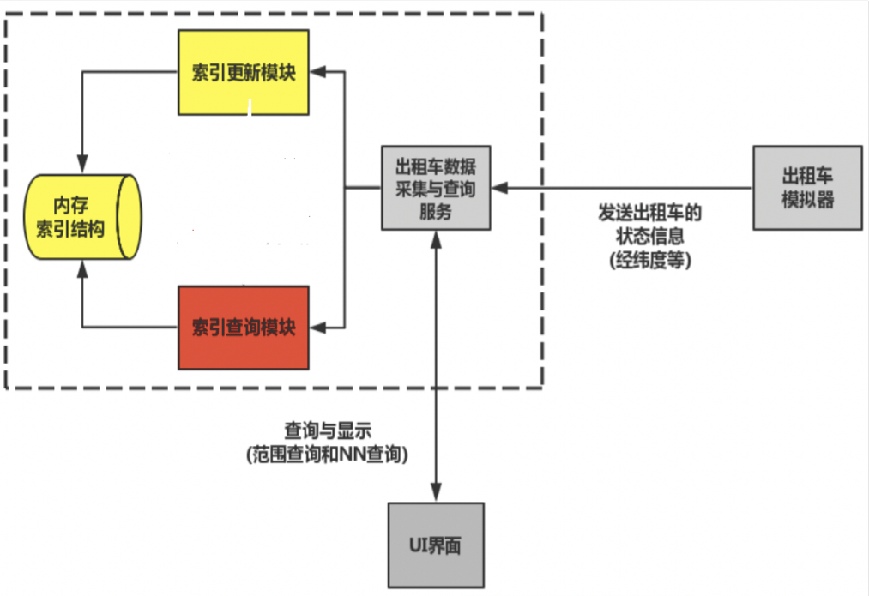

模拟器起停

**启动**

cd lbs

./runKsimulator.sh

停止

cd lbs

lbs服务运行

./stop-simulator.sh • **lbs**

启动

• cd lbs

• ./run-server.sh

停止

• cd lbs

• ./stop-server.sh

三、功能设计分工

梅子豪：出租车位置更新，堆结构的建立。

陈润泽：建立hash表，建堆，网格与点的位置关系函数建立。

杨若云：网格位置索引，位图索引。

共同完成：大循环；公共模块

四、代码设计

lbs_index.cpp

#include "server/grid/lbs_index.h"

#include <stdio.h>

#include <stdlib.h>

#include "common/log.h"

#include "server/grid/lbs_distance.h"

#define LBS_LON_MIN 116

#define LBS_LON_MAX 117

#define LBS_LAT_MIN 39

#define LBS_LAT_MAX 41

#define LBS_ROW_NUM 200

#define LBS_COL_NUM 100

#include "lbs_grid.h"

#include "get_cell_id.h"

#include "calculate_distance.h"

#include "lbs_bitmap.h"

#include "SERVER_GRID_LBS_NN_HEAP.h"

static lbs_grid_t lbs_grid;

// 初始化网格索引

int lbs_grid_index_init() {

lbs_grid_init(&lbs_grid, LBS_LON_MIN, LBS_LON_MAX, LBS_LAT_MIN, LBS_LAT_MAX, LBS_ROW_NUM, LBS_COL_NUM);

return 0;

}

// 更新接口[出租车位置更新]

int lbs_grid_index_update(double lon,

double lat,

uint64_t timestamp,

uint32_t id) {

lbs_grid_update(&lbs_grid, lon, lat, timestamp, id);

// TODO: by student

return 0;

}

// 范围查询接口[查询某一范围内的所有出租车信息]

int lbs_grid_index_range_query(double lon1,

double lon2,

double lat1,

double lat2,

lbs_res_node_t* out) {

int row1= lbs_grid_cell_row(&lbs_grid,lat1);

int col1= lbs_grid_cell_col(&lbs_grid,lon1);

int row2= lbs_grid_cell_row(&lbs_grid,lat2);

int col2= lbs_grid_cell_col(&lbs_grid,lon2);

for(int row=row1;row<=row2;row++)

{

for(int col=col1;col<=col2;col++)

{

int cell_id = lbs_grid_cell_id(&lbs_grid,row,col);

lbs_mov_node_t *head = &(lbs_grid.cell[cell_id].dammy_node);

lbs_mov_node_t *current = (lbs_mov_node_t *)head->queue.next;

while(current!=head){

if(current->lon>=lon1 && current->lon<=lon2 && current->lat>=lat1 && current->lat<=lat2){

lbs_res_node_t* node = (lbs_res_node_t*)malloc(sizeof(lbs_res_node_t));

node->lon= current->lon;

node->lat= current->lat;

lbs_queue_insert_head(&(out->queue), &(node->queue));

}

current = (lbs_mov_node_t*)current->queue.next;

}

}

}

// TODO: by student

return 0;

}

// NN查询接口[查询离lon,lat最近的出租车]

int lbs_grid_index_nn_query(double lon, double lat, lbs_res_node_t* out) {

// TODO: by student

//计算查询q所在的网格

int row=lbs_grid_cell_row(&lbs_grid,lat);

int col=lbs_grid_cell_col(&lbs_grid,lon);

int cell_id=lbs_grid_cell_id(&lbs_grid,row,col);

//Mindist=0

int Mindist=lbs_min_distance(&lbs_grid,cell_id,lon,lat);

lbs_nnheap_t lbs_nnheap;

lbs_bitmap_t lbs_bitmap;

//创建小顶堆

lbs_nnheap_init(&lbs_nnheap);

lbs_bitmap_init(&lbs_bitmap, lbs_grid.row_num * lbs_grid.col_num);

lbs_bitmap_setbit(&lbs_bitmap, cell_id);

printf("start insert heap\n");

lbs_nnheap_insert(&lbs_nnheap, NULL, cell_id, 1, Mindist);

printf("end insert heap\n");

while ((&lbs_nnheap)->heap_nodes[0].is_grid != 0) {

int grid_cell_id = (&lbs_nnheap)->heap_nodes[0].cell_id;

printf("start pop\n");

lbs_nnheap_pop(&lbs_nnheap);

printf("end pop\n");

/// Step1: insert cars in cell

lbs_cell_t* head =lbs_grid_cell(&lbs_grid, grid_cell_id);

lbs_mov_node_t *cur = (lbs_mov_node_t*)head->dammy_node.queue.next;

while(cur!= &(head->dammy_node))

{ //q与空间点的距离

double dis=lbs_distance(lon,lat, cur->lon, cur->lat) ;

//将空间点插入小顶堆

printf("start insert heap\n");

lbs_nnheap_insert(&lbs_nnheap, cur, grid_cell_id, 0, dis);

printf("end insert heap\n");

cur= (lbs_mov_node_t*)cur->queue.next;

}

/*求周围的cell_id*/

int a[8];

lbs_get_cell_id(&lbs_grid, grid_cell_id, a);

/*计算到周围格子的距离并放入堆*/

for(int i=0; i<8; i++){

double dis = lbs_min_distance(&lbs_grid,a[i],lon,lat);

if(lbs_bitmap_isset(&lbs_bitmap, a[i]) == 0) {

lbs_nnheap_insert(&lbs_nnheap, NULL,a[i],1, dis);

lbs_bitmap_setbit(&lbs_bitmap,a[i]);

}

}

printf("grid_cell_id=%d\n", grid_cell_id);

}

lbs_res_node_t* node = (lbs_res_node_t*)malloc(sizeof(lbs_res_node_t));

node->lon = lbs_nnheap.heap_nodes[0].node->lon;

node->lat = lbs_nnheap.heap_nodes[0].node->lat;

lbs_queue_insert_head(&(out->queue), &(node->queue));

return 0;

//return &lbs_nnheap->heap_nodes[0];

}

hash表：

#include "lbs_hashtable.h"

#include <stdlib.h>

int lbs_hashtable_init(lbs_hashtable_t* lbs_hashtable) {

lbs_hashtable->capacity = 20000;

lbs_hashtable->size = 0;

lbs_hashtable->hash_nodes = (lbs_hashnode_t*)malloc(sizeof(lbs_hashnode_t) * lbs_hashtable->capacity);

for (int i = 0; i < lbs_hashtable->capacity; i++) {

lbs_queue_init(&(lbs_hashtable->hash_nodes[i].queue));

}

return 0;

}

int lbs_hashtable_destory(lbs_hashtable_t* lbs_hashtable) {

free (lbs_hashtable->hash_nodes);

lbs_hashtable->hash_nodes = NULL;

lbs_hashtable->capacity = 0;

lbs_hashtable->size = 0;

return 0;

}

int hash(uint32_t id) {

return id%20000;

}

int lbs_hashtable_set(lbs_hashtable_t* lbs_hashtable, uint32_t id, lbs_mov_node_t* lbs_move_node, int cell_id) {

int index = hash(id);

lbs_hashnode_t* node = (lbs_hashnode_t*)malloc(sizeof(lbs_hashnode_t));

node->cell_id = cell_id;

node->mov_node = lbs_move_node;

lbs_queue_insert_head(&(lbs_hashtable->hash_nodes[index].queue) , &(node->queue));

return 0;

}

lbs_hashnode_t* lbs_hashtable_get(lbs_hashtable_t* lbs_hash_table, uint32_t id) {

int index = hash(id);

lbs_hashnode_t *head = (lbs_hashnode_t*)&(lbs_hash_table->hash_nodes[index].queue);

lbs_hashnode_t *current = (lbs_hashnode_t*)head->queue.next;

while(head != current) {

if (current->mov_node->id == id) {

return current;

}

current = (lbs_hashnode_t*)current->queue.next;

}

return NULL;

}

位置索引：

#include"server/grid/lbs_hashtable.h"

#include "server/grid/lbs_queue.h"

#include "server/grid/lbs_grid.h"

#include <stdlib.h>

int lbs_grid_init(lbs_grid_t* lbs_grid, double lon1, double lon2, double lat1,double lat2, int row_num, int col_num)

{

lbs_grid->row_num=row_num;

lbs_grid->col_num=col_num ;

lbs_grid->cell_width=(lon2-lon1)/col_num;

lbs_grid->cell_height=(lat2-lat1)/row_num;

lbs_grid->lon_min=lon1;

lbs_grid->lat_min=lat1;

lbs_hashtable_init(&(lbs_grid->hash_table));

lbs_grid->cell=(lbs_cell_t*)malloc(row_num*col_num*sizeof(lbs_cell_t));

for(int i=0;i<row_num*col_num;i++)

{

lbs_queue_init(&(lbs_grid->cell[i].dammy_node.queue));

}

return 0;

}

int lbs_grid_cell_row(lbs_grid_t* lbs_grid,double lat) {

int cell_row;

cell_row=(lat-lbs_grid->lat_min)/lbs_grid->cell_height;

return cell_row;

}

int lbs_grid_cell_col(lbs_grid_t* lbs_grid,double lon)

{

int cell_col;

cell_col= (lon-lbs_grid->lon_min)/lbs_grid->cell_width;

return cell_col;

}

int lbs_grid_cell_id(lbs_grid_t* lbs_grid,int cell_row,int cell_col)

{ int cell_id;

cell_id= lbs_grid->col_num * cell_row + cell_col;

return cell_id;

}

void lbs_grid_cell_row_col(lbs_grid_t* lbs_grid,int cell_id,int*cell_row,int*cell_col)

{

*cell_row=cell_id/lbs_grid->col_num;

*cell_col=cell_id%lbs_grid->col_num;

}

lbs_cell_t* lbs_grid_cell(lbs_grid_t* lbs_grid, int cell_id)

{

return lbs_grid->cell+cell_id;

}

位置更新：

#include"lbs_grid.h"

#include <stdlib.h>

int lbs_grid_update(lbs_grid_t* lbs_grid,double lon,double lat,uint64_t timestamp,uint32_t id)

{

lbs_hashnode_t* p;

lbs_mov_node_t* q;

//计算lon lat对应的col row

int row1 = lbs_grid_cell_row(lbs_grid, lat);

int col1 = lbs_grid_cell_col(lbs_grid, lon);

//算出lon lat对应的cell id

int cell_id=lbs_grid_cell_id(lbs_grid, row1, col1);

//遍历hash表

p = lbs_hashtable_get(&lbs_grid->hash_table, id);

if (p)

{

//修改数据

p->mov_node->lon=lon;

p->mov_node->lat=lat;

p->mov_node->timestamp=timestamp;

if (p->cell_id != cell_id)

{

lbs_queue_remove(&p->mov_node->queue);

lbs_queue_insert_head(&lbs_grid->cell[cell_id].dammy_node.queue,

&p->mov_node->queue);

p->cell_id = cell_id;

}

}

else//没找到就执行5

{

q=(lbs_mov_node_t*)malloc(sizeof(lbs_mov_node_t));

q->lon=lon;

q->lat=lat;

q->id=id;

q->timestamp=timestamp;

lbs_queue_insert_head(&lbs_grid->cell[cell_id].dammy_node.queue,

&q->queue);

lbs_hashtable_set(&lbs_grid->hash_table, id, q, cell_id);

}

return 0;

}

位图索引：

#include<stdlib.h>

#include "server/grid/lbs_bitmap.h"

int arr[8]={128,64,32,16,8,4,2,1};

int lbs_bitmap_init(lbs_bitmap_t* lbs_bitmap, uint32_t bits_num)

{

lbs_bitmap->bits_num=bits_num ;

if(bits_num%8!=0) {

lbs_bitmap->bits=(uint8_t *)calloc(1, (bits_num/8+1)*sizeof(uint8_t));

} else {

lbs_bitmap->bits=(uint8_t *)calloc(1, (bits_num/8)*sizeof(uint8_t));

}

return 0;

}

int lbs_bitmap_destroy(lbs_bitmap_t* lbs_bitmap) {

free(lbs_bitmap->bits);

}

int lbs_bitmap_setbit(lbs_bitmap_t* lbs_bitmap, uint32_t pos)

{

int pos_num= pos/8;

int pos_id=pos%8;

lbs_bitmap->bits[pos_num]=lbs_bitmap->bits[pos_num]|arr[pos_id];

return 0;

}

int lbs_bitmap_unsetbit(lbs_bitmap_t* lbs_bitmap, uint32_t pos) { }

int lbs_bitmap_isset(lbs_bitmap_t* lbs_bitmap, uint32_t pos)

{

int pos_num= pos/8;

int pos_id=pos%8;

if((lbs_bitmap->bits[pos_num]&arr[pos_id])!=0)

{

return 1;

}else

{

return 0;

}

}

最近邻查询：

#include <stdio.h>

#include <stdlib.h>

#include"SERVER_GRID_LBS_NN_HEAP.h"

int lbs_nnheap_init(lbs_nnheap_t* lbs_nnheap) {

lbs_nnheap->capacity = 100;

lbs_nnheap->size = 0;

lbs_nnheap->heap_nodes = (lbs_heapnode_t*)malloc(sizeof(lbs_heapnode_t) * lbs_nnheap->capacity);

return 0;

}

int lbs_nnheap_destroy(lbs_nnheap_t* lbs_nnheap) {

free(lbs_nnheap->heap_nodes);

lbs_nnheap->heap_nodes = NULL;

lbs_nnheap->capacity = 0;

lbs_nnheap->size = 0;

return 0;

}

int lbs_nnheap_insert(lbs_nnheap_t* lbs_nnheap,

lbs_mov_node_t* lbs_mov_node,

int cell_id, uint8_t is_grid, double distance) {

if (lbs_nnheap->size == lbs_nnheap->capacity) {

lbs_nnheap->capacity *= 2;

lbs_nnheap->heap_nodes = (lbs_heapnode_t*)realloc(lbs_nnheap->heap_nodes,

sizeof(lbs_heapnode_t) * lbs_nnheap->capacity);

}

lbs_nnheap->heap_nodes[lbs_nnheap->size].is_grid = is_grid;

lbs_nnheap->heap_nodes[lbs_nnheap->size].distance = distance;

lbs_nnheap->heap_nodes[lbs_nnheap->size].cell_id = cell_id;

lbs_nnheap->heap_nodes[lbs_nnheap->size].node = lbs_mov_node;

lbs_nnheap->size++;

int i = lbs_nnheap->size;

while(i > 1) {

if(lbs_nnheap->heap_nodes[i - 1].distance < lbs_nnheap->heap_nodes[i/2 - 1].distance){

lbs_heapnode_t a;

a = lbs_nnheap->heap_nodes[i - 1];

lbs_nnheap->heap_nodes[i - 1] = lbs_nnheap->heap_nodes[i/2 - 1];

lbs_nnheap->heap_nodes[i/2 - 1] = a;

i = i/2;

} else {

break;

}

}

return 0;

}

lbs_heapnode_t* lbs_nnheap_top(lbs_nnheap_t* lbs_nnheap) {

return &lbs_nnheap->heap_nodes[0];

}

void lbs_nnheap_pop(lbs_nnheap_t* lbs_nnheap) {

int i =lbs_nnheap->size;

lbs_nnheap->heap_nodes[0] = lbs_nnheap->heap_nodes[i - 1];

lbs_nnheap->size = lbs_nnheap->size - 1;

int a = 1;

while(2*a <= i){

int min = 2*a;

if(2*a <= i - 1) {

if(lbs_nnheap->heap_nodes[2*a - 1].distance > lbs_nnheap->heap_nodes[2*a].distance) {

min = 2*a + 1;

}

}

if(lbs_nnheap->heap_nodes[a - 1].distance > lbs_nnheap->heap_nodes[min-1].distance) {

lbs_heapnode_t b;

b = lbs_nnheap->heap_nodes[min - 1];

lbs_nnheap->heap_nodes[min - 1] = lbs_nnheap->heap_nodes[a - 1];

lbs_nnheap->heap_nodes[a - 1] = b;

a = min;

}

else{

return;

}

}

}

五、运行结果

基本符合项目要求，能够查询到某一点附近的出租车数量，比较成功的解决问题。

六、心得体会

首先，关于这次小组活动，前期我负责的是“位置更新”这一板块，并且在后两天进行了“建堆”，但是由于队友没有考虑到我们的任务分配问题，热心的将建堆任务完成，于是我们小组建堆的代码用的是队友的代码；我们三个人共同完成了大循环和其他的任务。我认为我们这个分工十分的合理，不仅给了我们充分的独立思考的时间，而且让我们在合作中解决了这个问题。

其次，这次的活动真的是让我获益匪浅，我们小组三个人都不是计算机专业的，所以在实习开始前，我们都恶补了很多的相关知识，来了以后也是每天晚上自己查阅资料进行学习，说到这里，我特别感谢两位老师，，他们的专业知识都特别的强，教学水平也很高，对于我们抛出的各种问题都能迎刃而解，所以这次的实习我们都进行的非常顺利，在老师以及同学们的帮助下，我们成功解决了这个问题，并且学习到了很多知识。

最后，我想说这次实习带给我的不仅是知识欠缺上的弥补，还有老师潜移默化传授的思维方式，这对我们今后的学习和研究都会起着重要的作用，能帮助我们在今后碰到其他困难时依然能够克服。还有，这次的实习经历也让我认识到了很多优秀的同学，让我在反省自身的同时，以他们为目标来努力学习。这次的学习之旅将成为我人生中一笔宝贵的财富。