**Introduction**

**Student Name**: Trinh Luan

**Student ID**: s3372775

**Assignment Name**: Microcontroller Emulation

**Assignment No**: 1

**Year**: 2014B

**Lecturer**: Mr. Pham Chi Thanh

**How to build/install**

Type **make** to build the program

Type **./main** to run the program

Type **make clean** to clean the program

**Implementation**

**Class diagram**

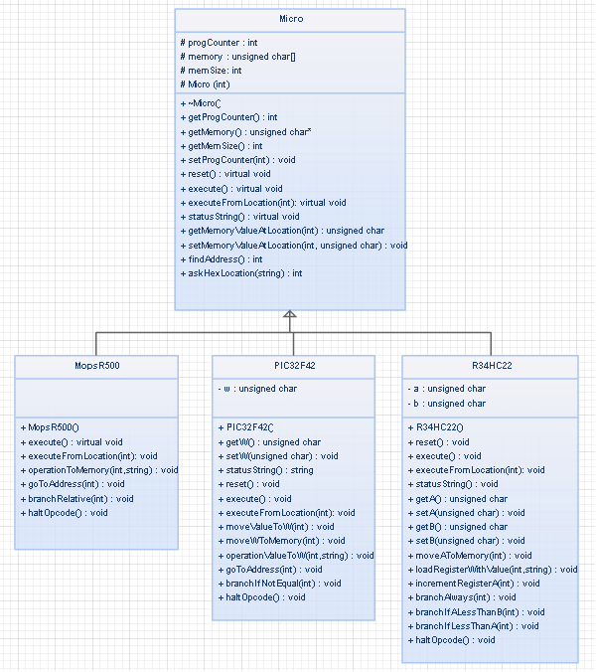

**Class description**

**Inheritance**

MopsR500, PIC32F42 and 34HC22 are inherited from Micro class. The Micro class is a base class and other 3 microcontrollers are sub-classes.

**MopsR500, 34HC22 and PIC32F42 classes**

The following functions are declared in virtual void because they are override in Micro base class.

* reset()
* execute()
* executeFromLocation()
* statusString() (excluding MopsR500 class)

In each microcontroller sub-class, they have some addition functions to perform the opcode.

**Extra features**

**Problems and Solutions**