**NBA Player Analysis Report**

**Introduction**

This report presents key findings from the analysis of the NBA Draft Combine data. Various visualizations were created to explore player participation trends, physical attributes, and performance metrics. The aim is to provide insights that can inform scouting, training, and recruitment strategies.

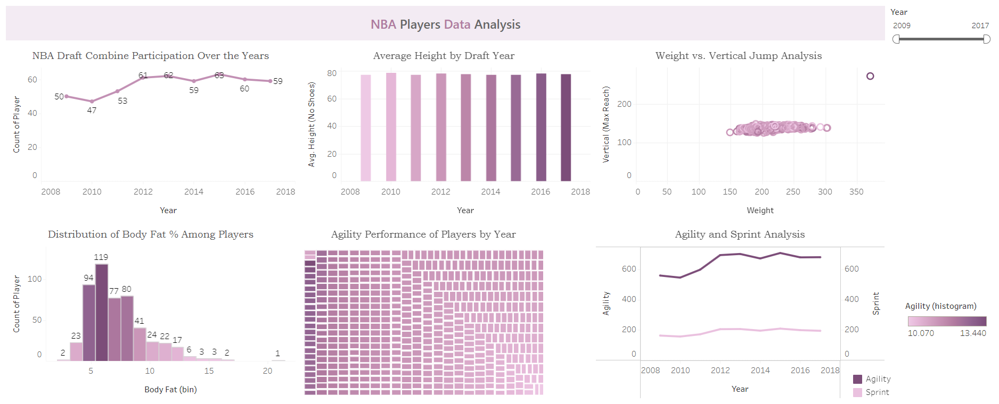

**Key Findings**

1. **Draft Year Analysis**

Player participation fluctuated over the years, with peaks suggesting heightened interest or stronger talent pools. Year 2015 recorded highest number of players which was 63

1. **Average Height by Draft Year**

The average height, wingspan, weight, and other measurements of players have varied over different draft years.

This variation indicates that the physical profile of players entering the draft has changed over time, potentially reflecting evolving trends in the type of players valued in the NBA.

1. **Weight vs. Vertical Jump Analysis**

Lighter players tend to have higher vertical jumps, but some heavier players still exhibit impressive vertical leap abilities.

Weight isn’t always a limiting factor for jumping ability, but strength and conditioning can play a critical role. Player Marcos Thornton had the highest vertical jump reach and weight

1. **Body Fat Distribution**

The histogram displays the distribution of body fat percentages among players, segmented into bins.

A significant portion of players fall within the 5-10% body fat range, which is optimal for athletic performance. This suggests that lower body fat is a common trait among players entering the draft, emphasizing the importance of fitness and conditioning in player development.

1. **Agility Performance Analysis**

The treemap visualizes the sum of agility scores, highlighting player performance in this metric.

Players with higher agility scores are crucial for quick movements on the court. This visualization can assist coaches in identifying agile players who can enhance team performance, particularly in fast-paced game situations.

1. **Agility and Sprint Analysis**

Players with shorter sprint and agility times generally perform better on the court, especially guards.

Speed and agility are crucial attributes for player success, particularly for positions requiring quick movement.

**Conclusion**

The analysis of the NBA Draft Combine dataset reveals significant insights into player physical attributes and performance metrics. These findings can guide teams in scouting and recruiting decisions, while also informing training and development strategies.