SCHOOL MANAGEMENT SYSTEM

Student’s name:
Mr. /Ms.:

Luan Vu Van | Student645959
Dung Nguyen Tuan | Student654095

Installation Guide

Submitted by: Miss. Thu Hien Nguyen Thi
Date of Issue: Jul, 2013
Authorized Signature: …………..

TABLE CONTENT
A. INSTALLATION SOFTWARE 3
I. For Window Server 3
1. Install MySQL Server 3
2. Install Java 24
II. For Linux 28
1. Install MySQL Server 28
2. Install Java 29
B . ATTACH DATABASE AND DEPLOY WEBSITE 30
I. Attach Database 30
II. Config Application for first time 36

A. INSTALLATION SOFTWARE

I. For Window Server
- Install MySQL Server
Step 1: Go to http://dev.mysql.com/downloads/installer/ to download last version of MySQL Server.
At the website the follow the below procedure as showing in snapshots below
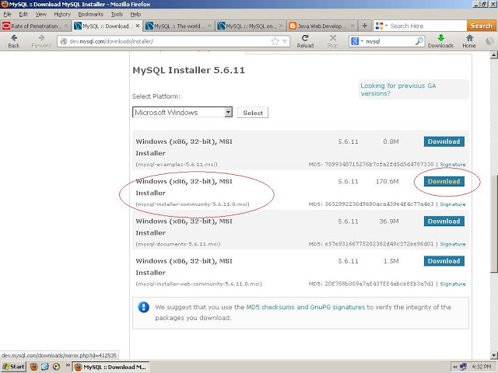

Fill the required information if you are new and click OK
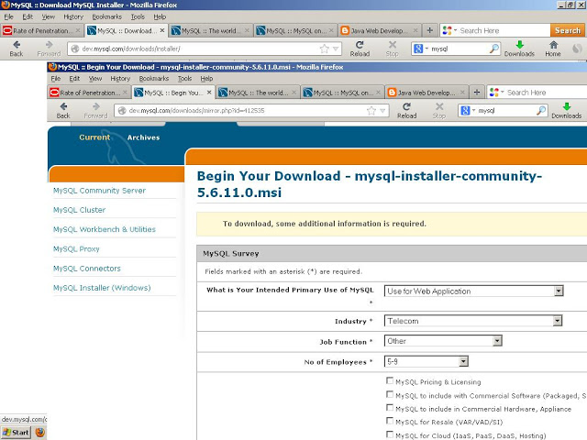

save the file at your desired folder
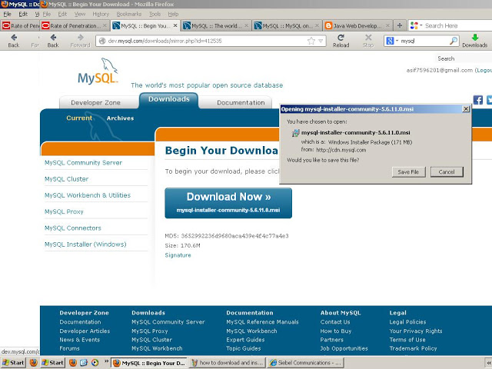

2- Double click the mysql-installer-community-5.6 setup file to run the installation

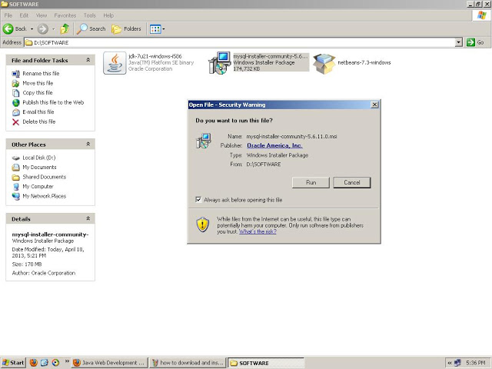

Click at install mySQL Product
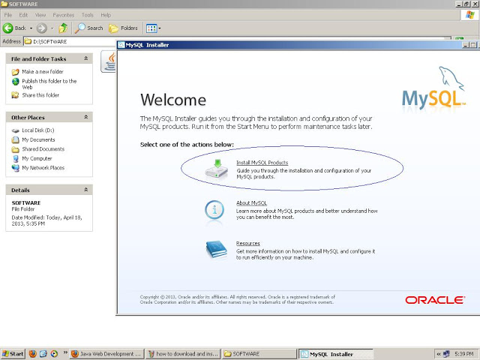

Accept the License agreement
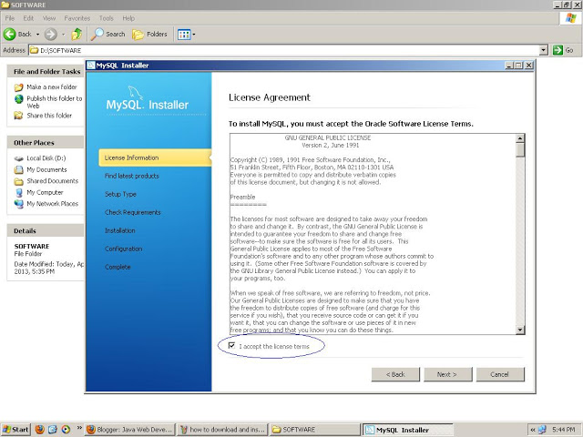

check the option to skip for updates
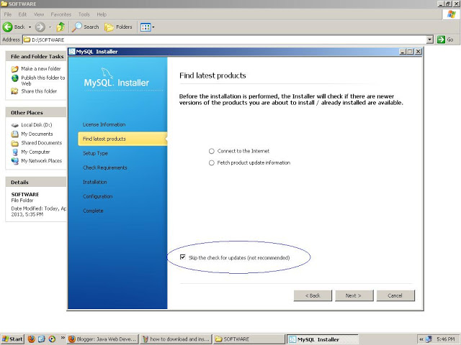

Here you have different option to install the MySQL Database. As your requirement select the option and click at next for further procedure.
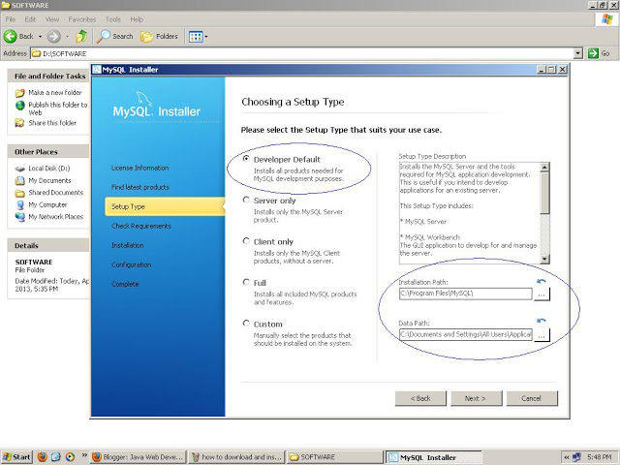

Click at execute
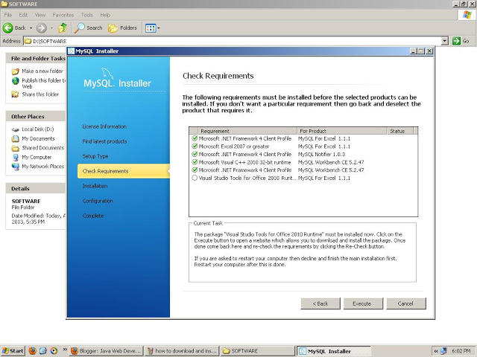

Click next
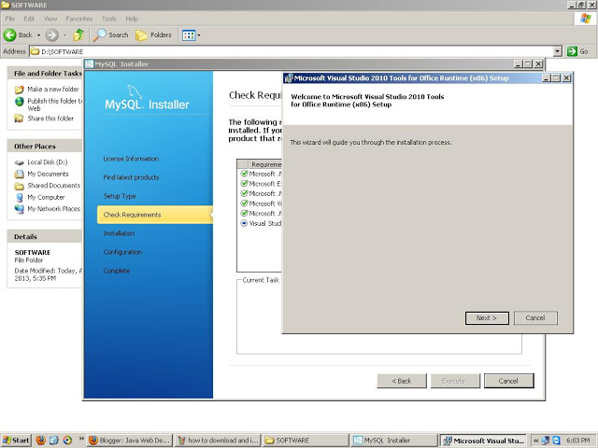

Accept the License terms and click at install

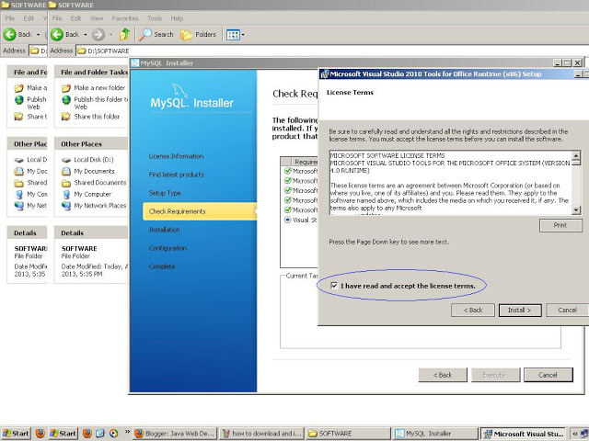

Click at finish
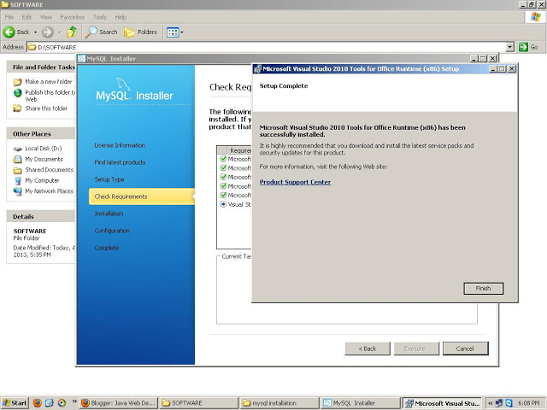

Click next
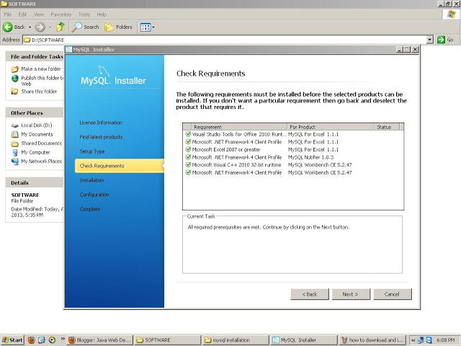

Click at execute for installation
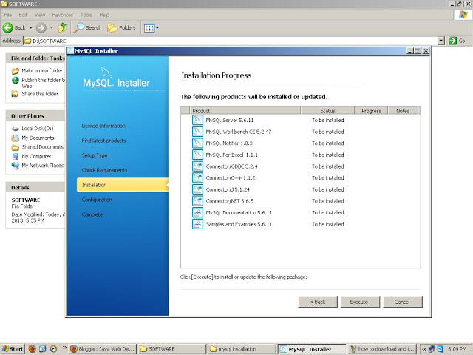

Click at Next
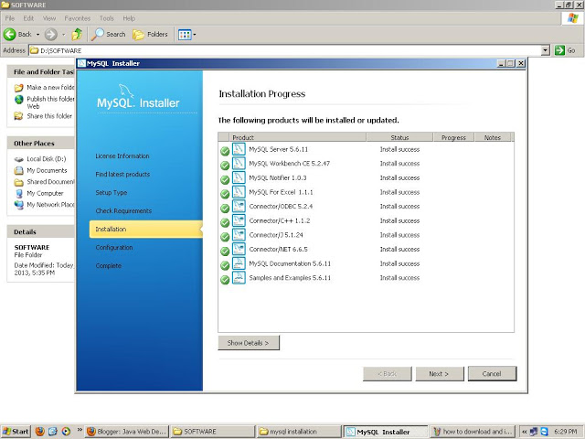

Click at Next
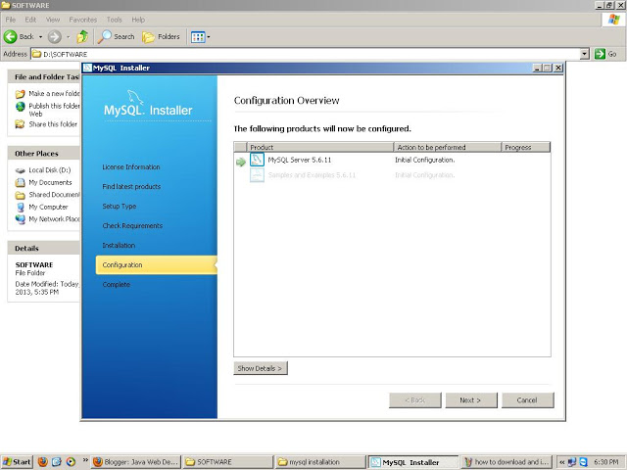

Click at Next as default options
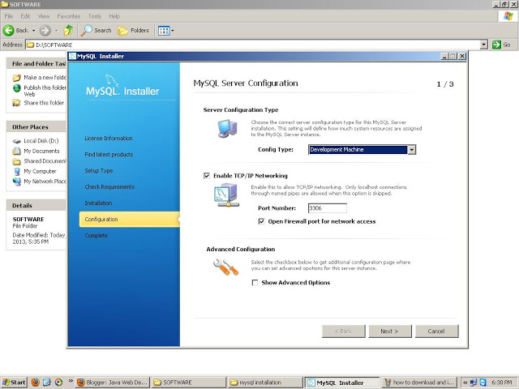

Give Root account password and here you can also add more user accounts
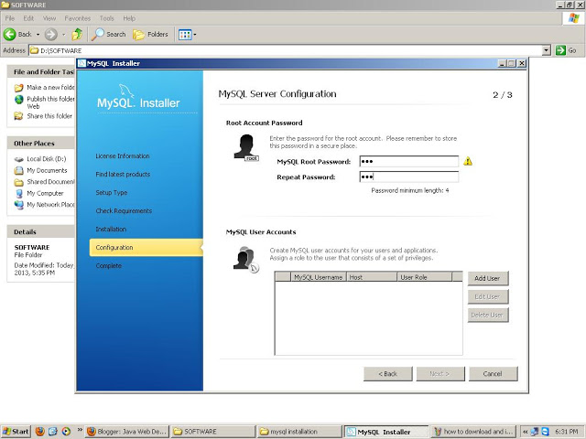

Click at Next.
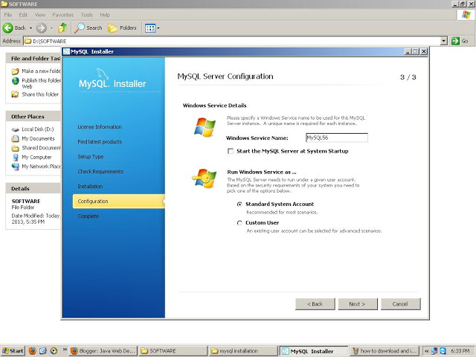

Click at Next.
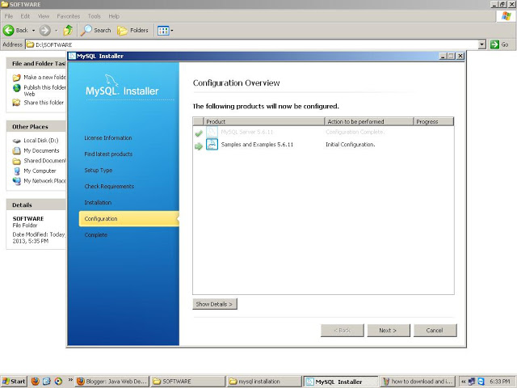

Congratulation you have successfully installed the MySQL Server and MySQL workbench.
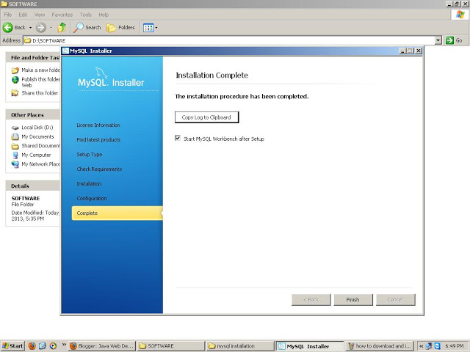

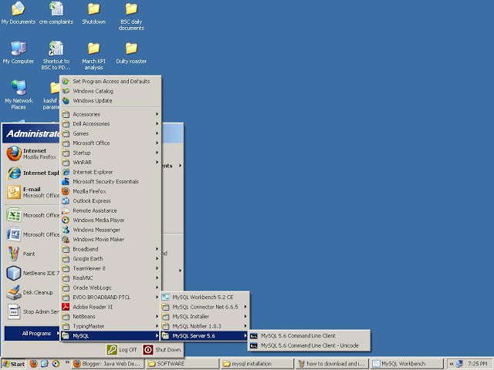

- Install Java

Visit http://www.java.com/en/download/index.jsp  To download lastest Java version | 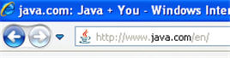
Next click on the Verify Java Version button. | 
If you are not running Java or do not have the most current version, you will receive the "Oops" message at right. | 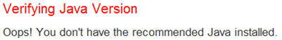
Click on the "Download Java Now" button and follow the instructions for installing it. | 
Select the "Agree and Start Free Download" button. | 
Choose "Run" to start the File Download. | 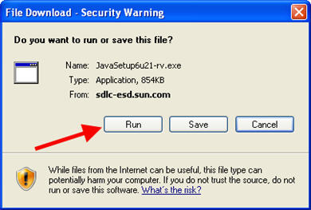
You may see this Security Warning in Internet Explorer. Click "Run". | 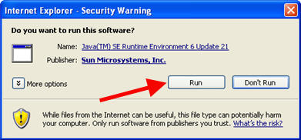
After the files has downloaded, the Java Setup window will appear. Click "Install". | 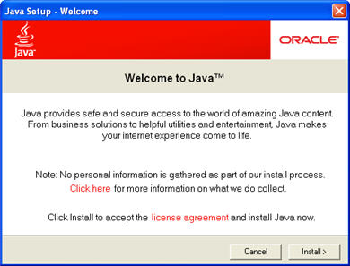
You will be asked if you want to install the Bing Toolbar. If so leave the Yes check box selected. If no, please deselect. Click "Next". | 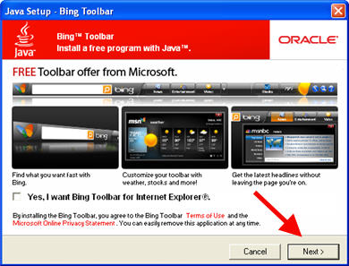
If you are currently using Java, you will be asked to close all browsers before continuing. Click "Close Browsers and Continue". | 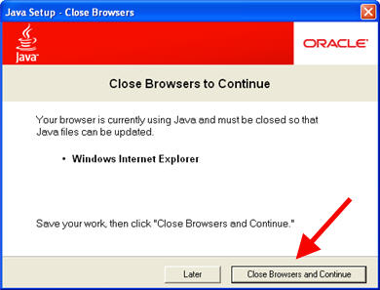
The Java Setup - Progress window will appear. | 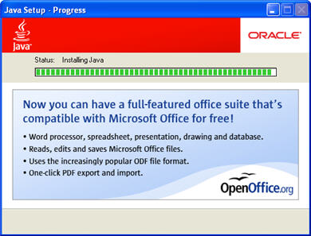
Once the installation is complete, you will get the Java Setup - Complete window. Click "Close" to exit the Java Setup. | 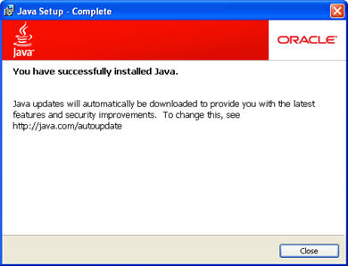

II. For Linux

1. Install MySQL Server
Go to Terminal or Press Ctrl + Alt + T
Run the following command from a terminal prompt:
sudo apt-get install mysql-server
To start with MySQL, run commant:
mysql -h [localhost] -u [username] -p
Then enter your password

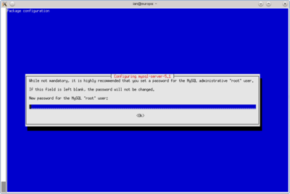
Re-enter Password

2. Install Java
Go to Terminal or Press Ctrl + Alt + T
Run the following command from a terminal prompt:
sudo apt-get purge openjdk*

B . ATTACH DATABASE AND DEPLOY WEBSITE

I. Attach Database
Open MySQL WorkBench
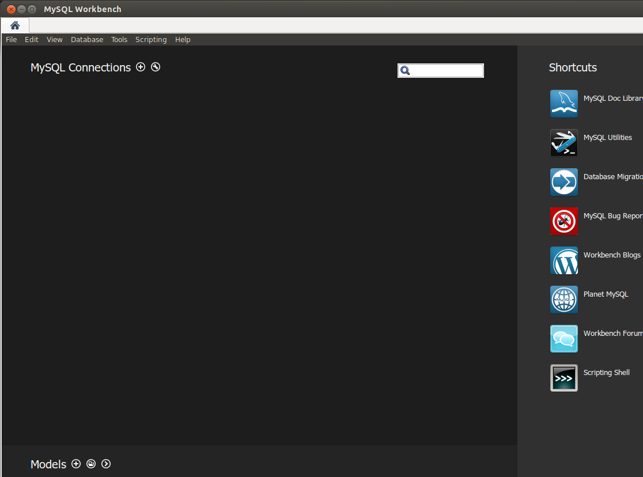

Connect database
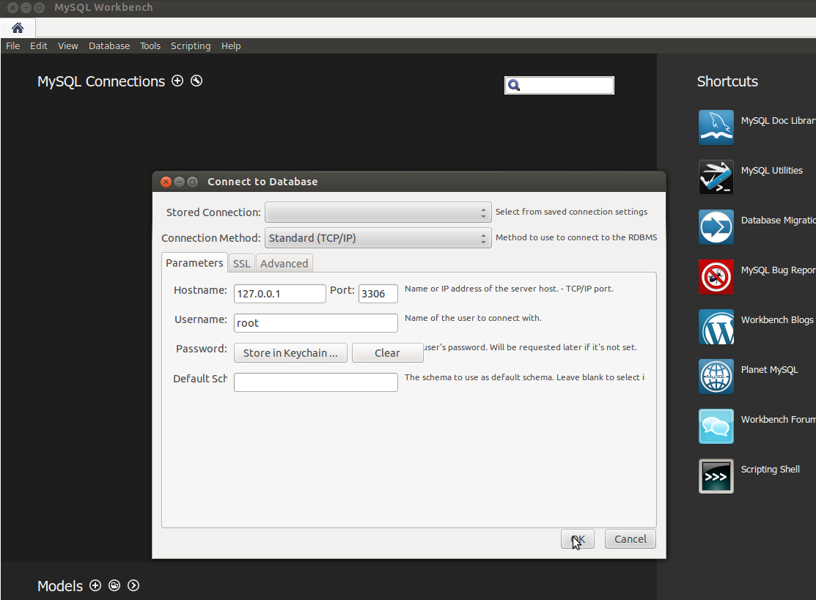

Create new schema (database)
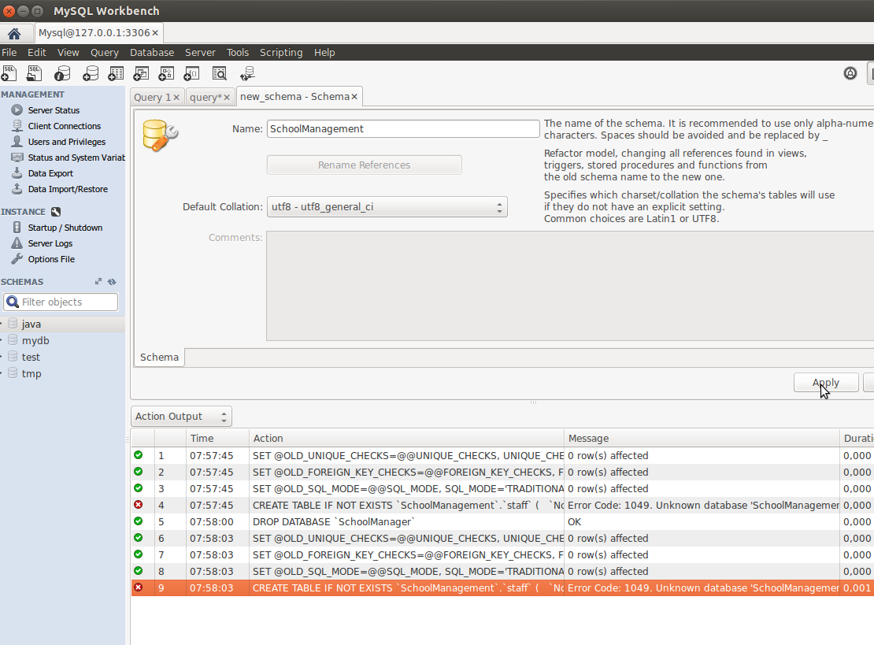
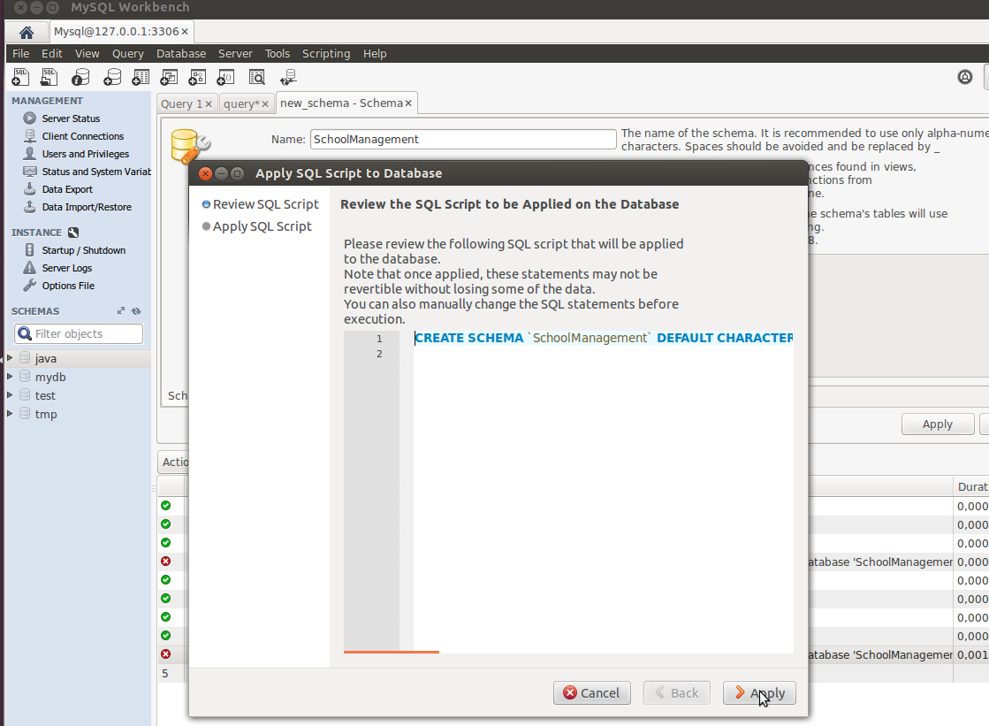

Add query.sql
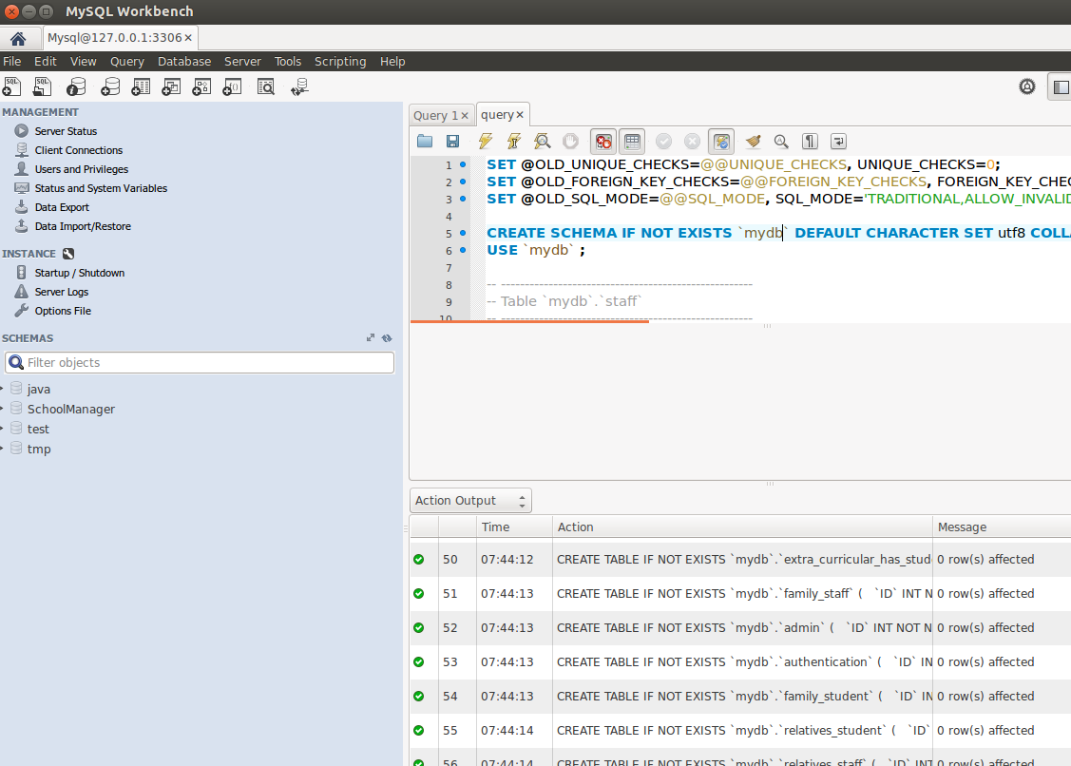
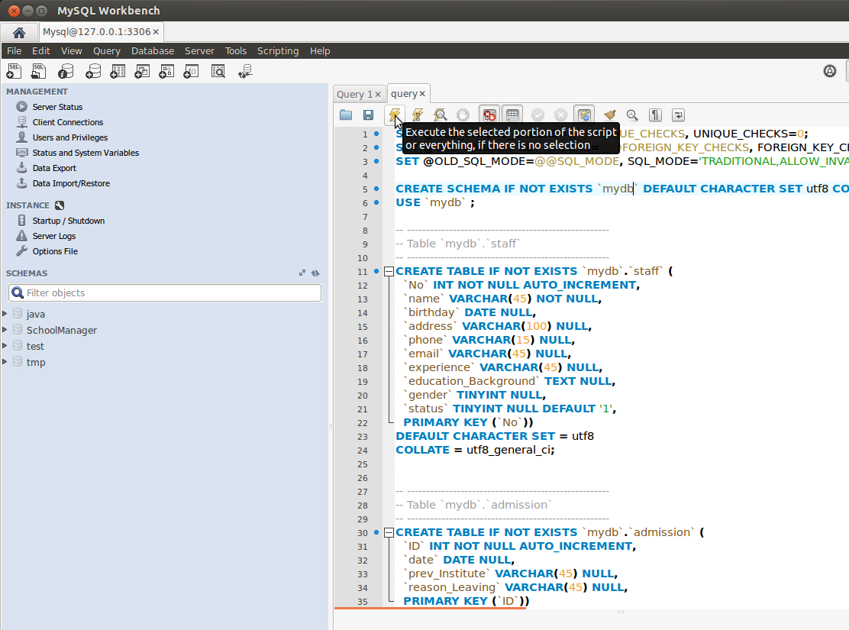

- Config Application for first time
Run Application
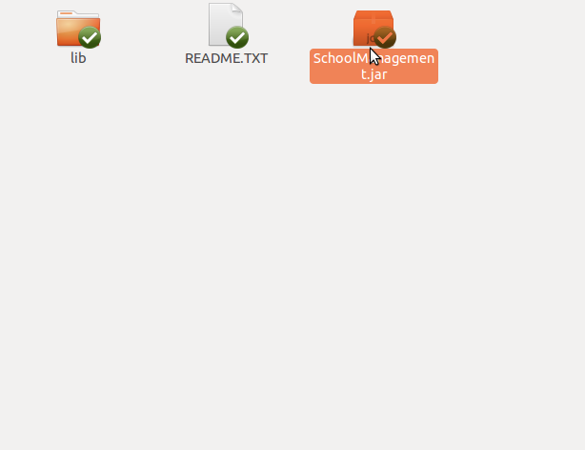

Settings
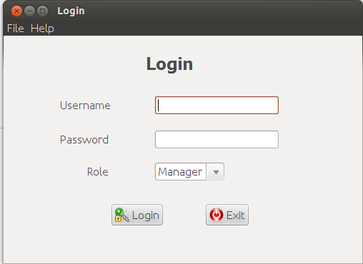

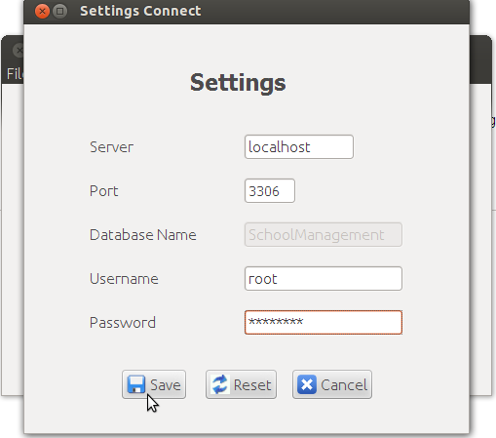

Login with
Username: admin
Password: password
Done !

