SCHOOL MANAGEMENT SYSTEM

Student’s name:
Mr. /Ms.:
Luan Vu Van | Student645959
Dung Nguyen Tuan | Student654095

Manual Guide

Submitted by: Miss. Thu Hien Nguyen Thi
Date of Issue: Jul, 2013
Authorized Signature: …………..

TABLE CONTENT

1. Login 3
2. Account information 4
3. User Management Screen 5
4. Staff Management Screen 6
5. Department Management Screen 10
6. Position Management Screen 12
7. Student Management Screen 13
8. Subject Management Screen 17
9. Batch Management Screen 18
10. Mark Management Screen 19
11. Extra Curricular Management Screen 20

- Login

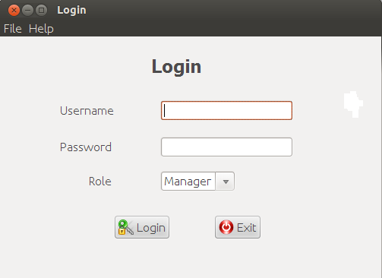

- Account information

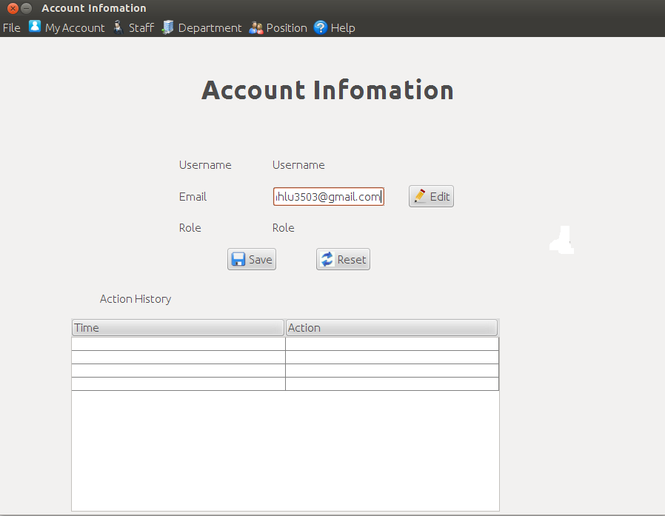

- User Management Screen

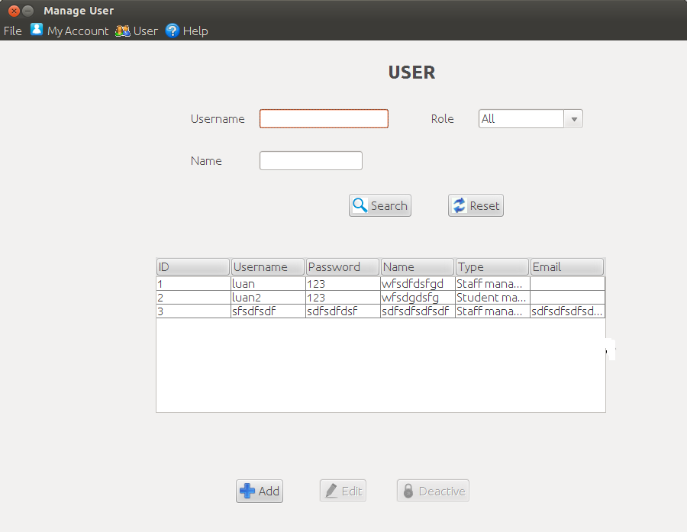

- Staff Management Screen

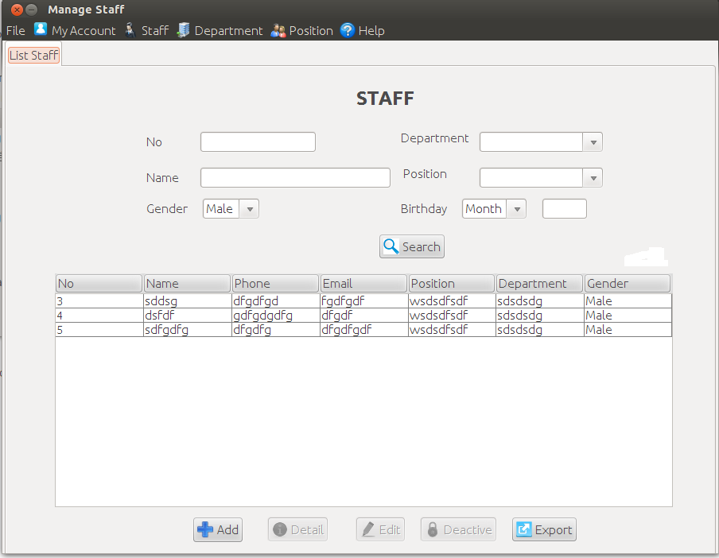

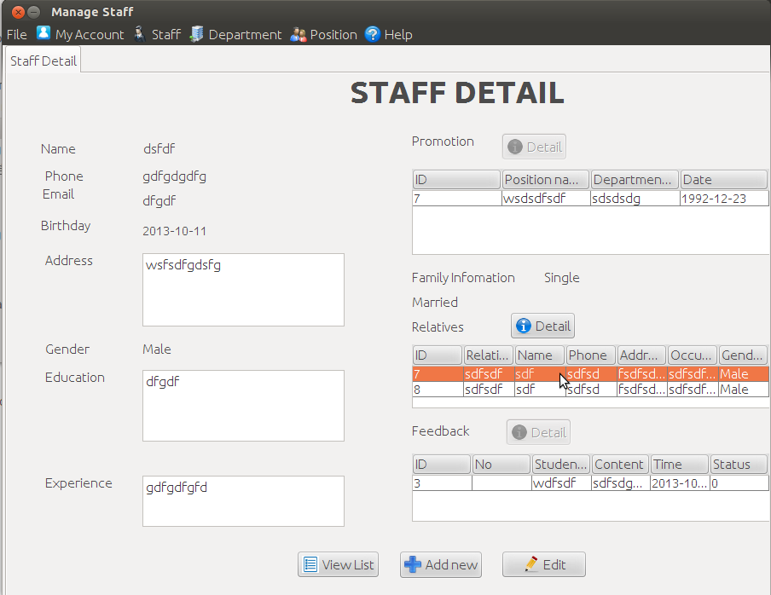

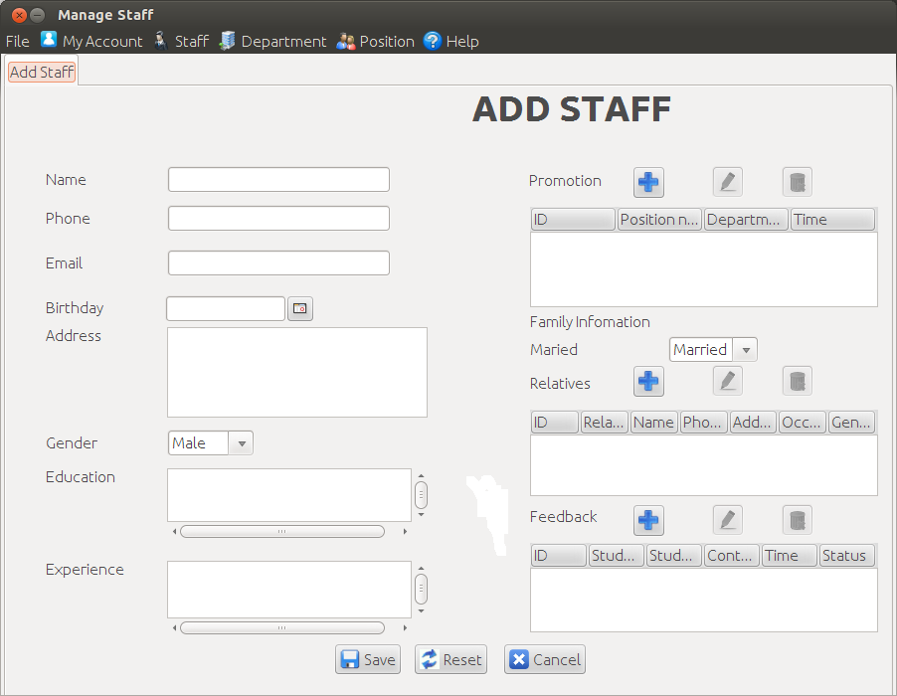

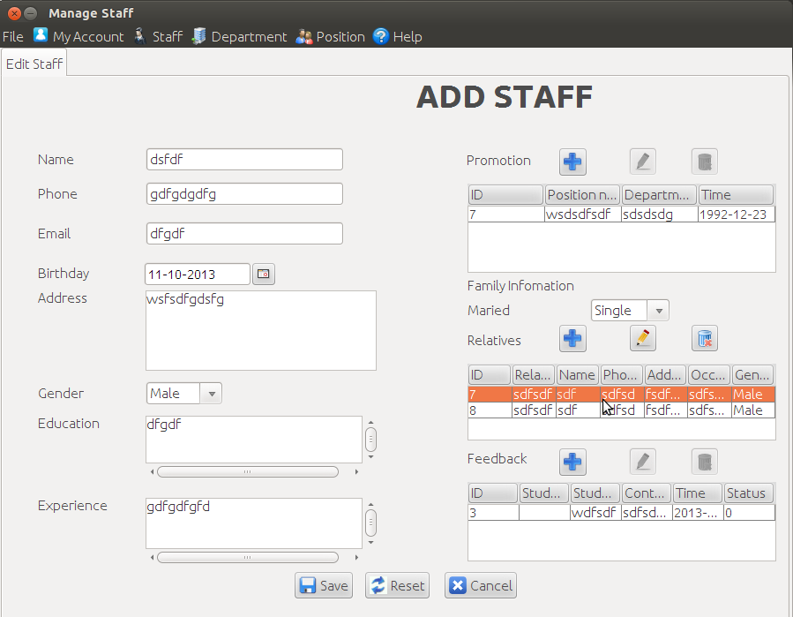

- Department Management Screen

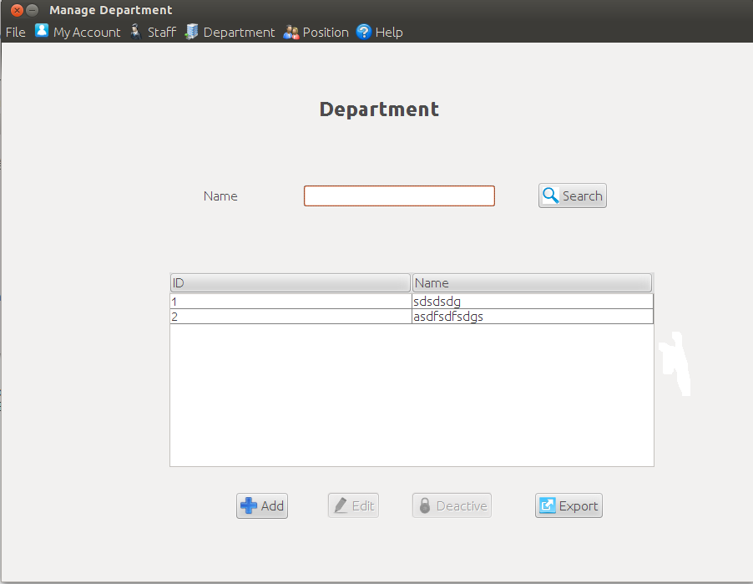

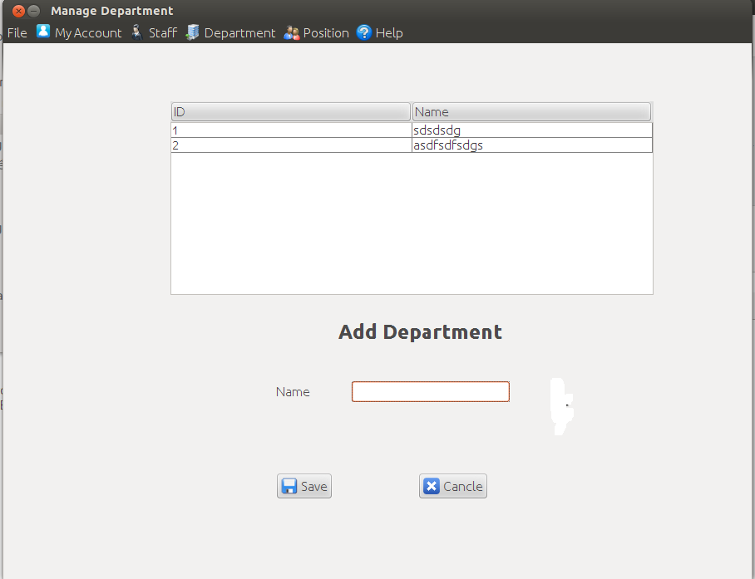

- Position Management Screen
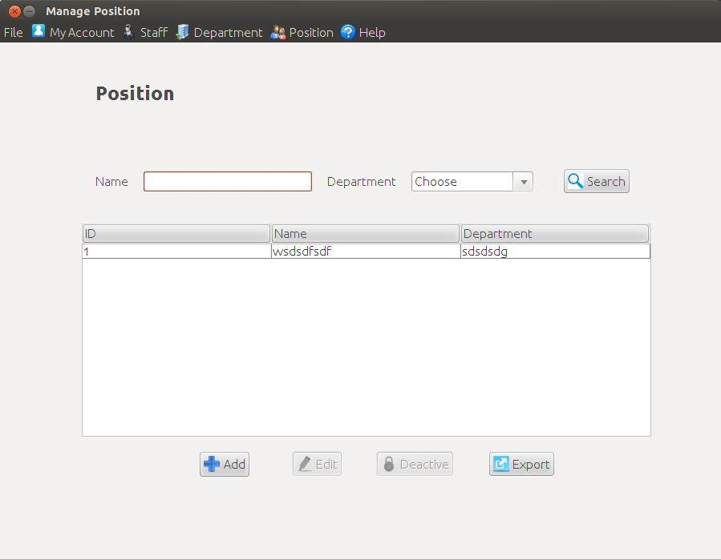

- Student Management Screen

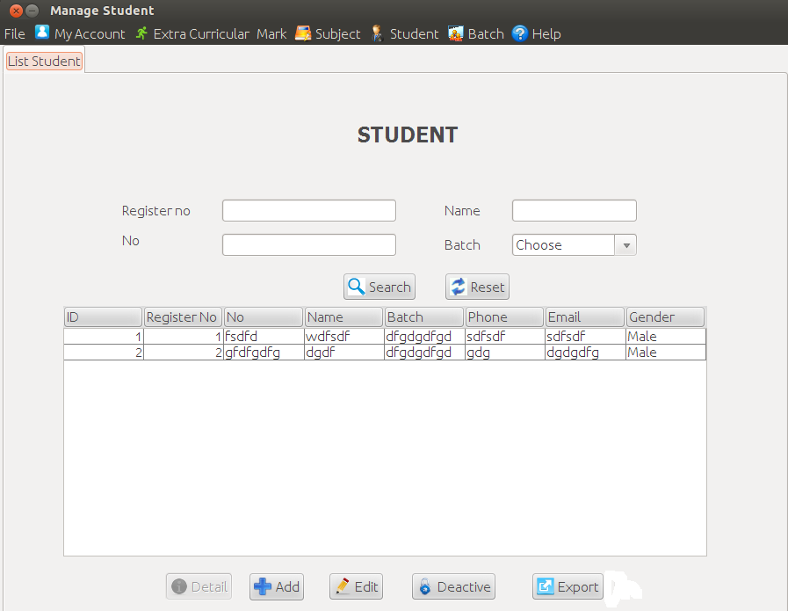

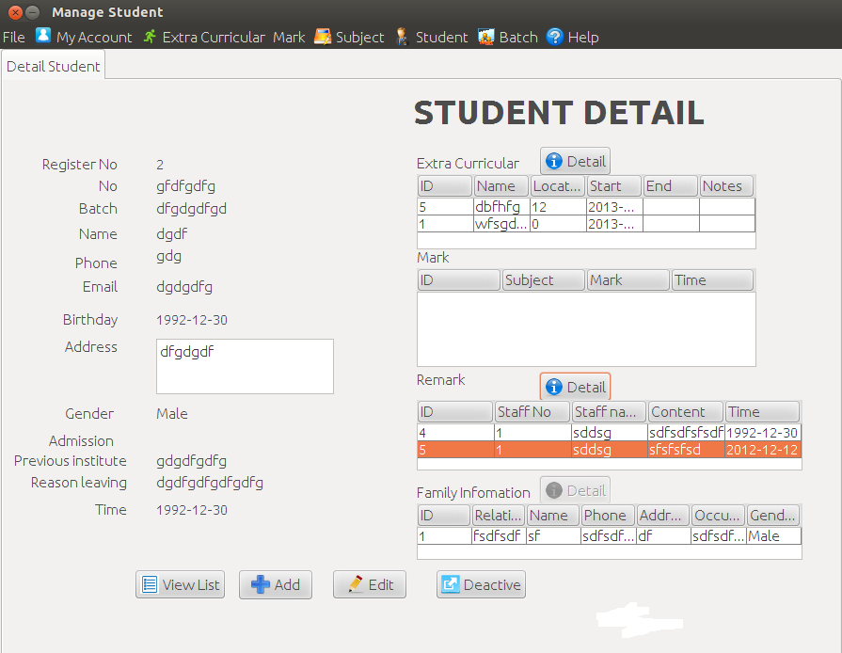

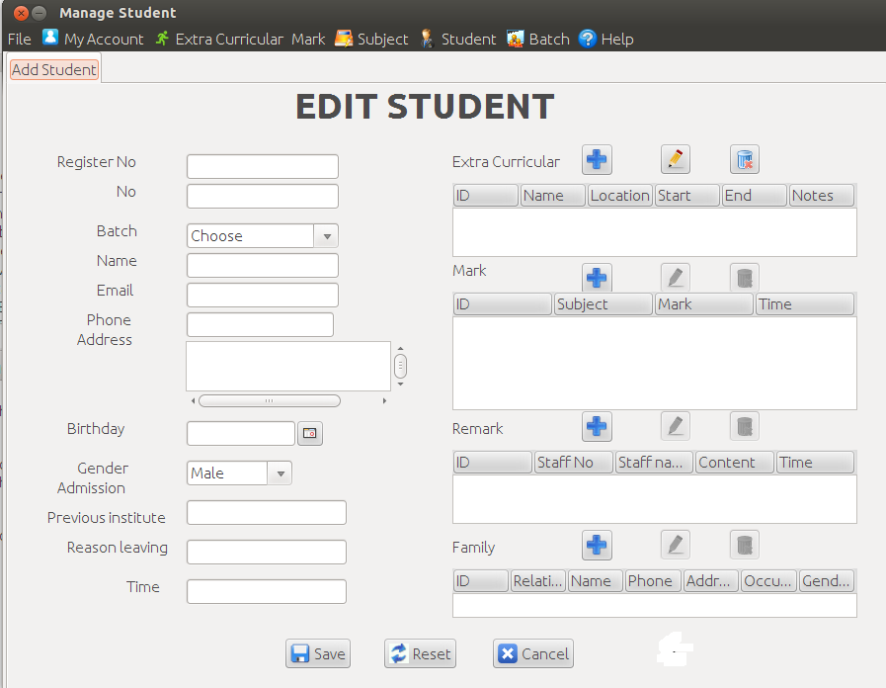

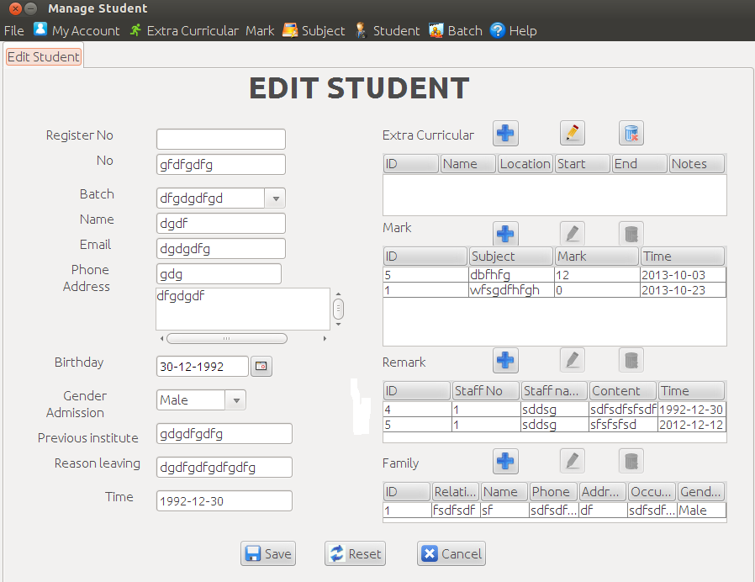

- Subject Management Screen

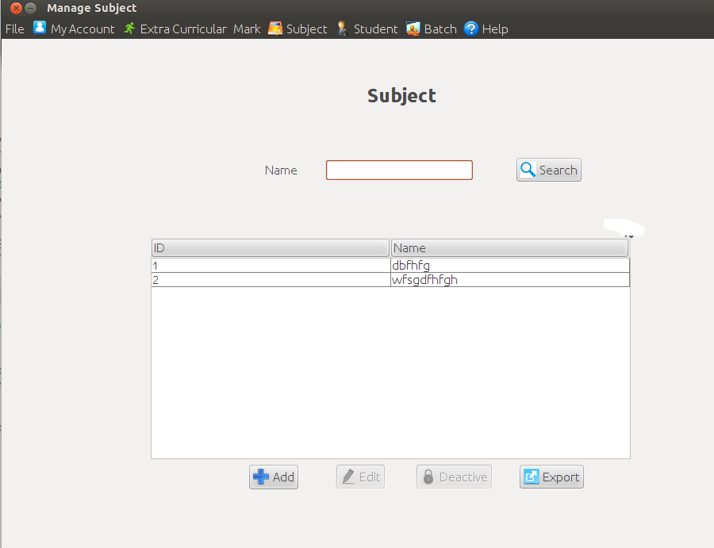

- Batch Management Screen

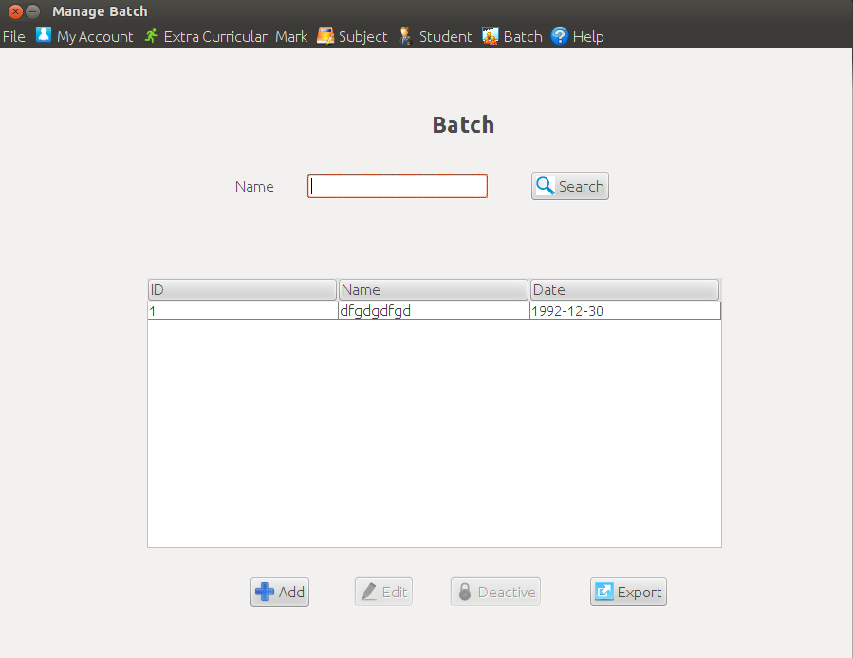

- Mark Management Screen

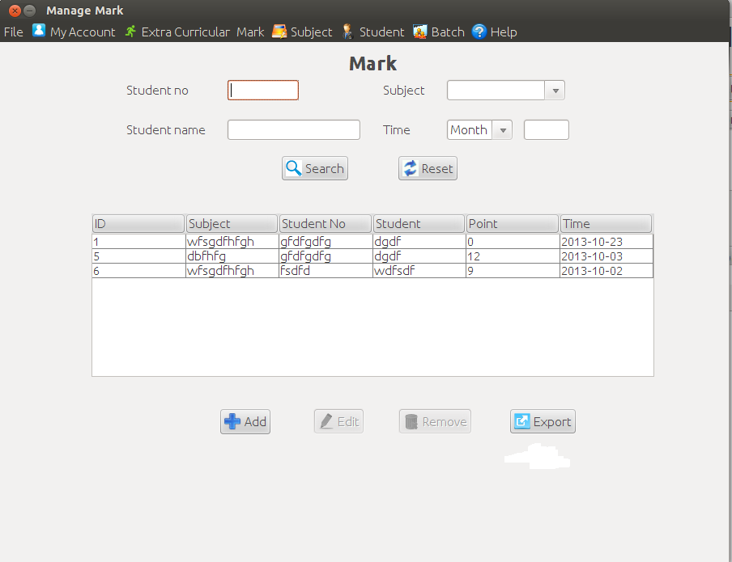

- Extra Curricular Management Screen

