

Supportive Learning
Documentation

Group 242
Group Member | Luan Vu Van  Luong Dinh Minh

- Hanoi, 12/2013 -
INDEX
1. Problem Definition 3
1.1. Problem Abstraction 3
1.2. The Current System 3
1.3. The Proposed System 3
1.4. Boundaries of the System 4
1.5. Hardware and Software Requirements 5
1.5.1. Minimum Requirements 5
1.5.2. Recommended Requirements 6
2. Customer Requirements Specification 6
2.1. Users of the System 6
2.2. System functions 6
3. Architecture & Design of Project 12
3.1. Architecture 12
3.2. Data Flow Diagram 12
3.3. Flow Chart 18
3.4. Entity Relationship Diagram 24
3.5. Database Structure 25
3.5.1. Table Design 25
3.5.2. Database Diagram 32
3.6. Screen Design 33
4. Task Sheet 34
5. Checklists 35
5.1. Check List of Validation 35
5.2. Submission Checklist 35

Problem Definition

Problem Abstraction
Our client is Royal Educational Academy, which generally runs the courses for B.Tech, B.Pharmacy, M.B.A and M.C.A. For the convenience of the students they had even started part time courses for the above mentioned courses. Every year as the classes begin, they schedule the classes as per the time slot and the syllabus assigned to these particular courses

The Current System
They generally give assignments to the students, which they need to work upon and submit the same by the assigned date. There by ensuring the effective participation from the students and thus enhancing the learning process. They now want to incorporate one of the most technically advanced systems, by incorporating the web portal. And so they approached us for helping them by developing this portal.

The Proposed System
They want the web portal to be incorporated with the following functionalities :

- The web portal should have a menu comprising of the following links
- Login page (applicable for the administrator, the staff and the students)
- Assignments Section (here all the assignments, that are currently assigned will be listed. And in this section, the staff can view, delete and upload the assignments)
- A common login will be created for the students of a particular batch of a particular year and particular semester.
- File Uploading (For Students) or File Downloading (Viewing and here the uploaded files are viewed by the staff based on the students roll number)
- Marks for Assignments
- Feedback or post a query
- FAQ s

- The administrator will have the rights for creating, editing and deleting the usernames and passwords (username and passwords are to be created based on the batch, year, and semester. These are unique for the whole batch)

- One should be able to access the assignments section only after the login, as it will direct to the page based on the user name and the password with which the student has logged in.

- After completing the assignments, the students can submit their survey online, through the link “File Uploading”.

- For the student’s login, the link is “File Uploading”. Where as for the staff login the link is “View the uploaded file”. And for the administrator login, both the links will be visible, and can perform both the actions (uploading the file and viewing the uploaded file).

- For submitting the assignment, they need to upload the file (Note: The file will be text document)

- Once the assignment is uploaded, the assignments should be downloaded by the staff and the administrator.

- The staff will assign the marks after evaluating the assignment once they are downloaded. The marks assigned will then be uploaded on the site through the links “marks”, based on the roll number.

- The students should be able to view the marks that are assigned for their assignments, through the link marks. Here the students can view their marks by entering their roll number.

- On the Feedback/Post a Query page, the students should be able to post their feedback or their queries. The queries thus posted will then be answered by the staff.

- The FAQ s Page will have the following questions, along with their answers.
- How to check the assignments?
- How to download the assignment?
- How to submit the assignment?
- How to check the marks?
- How to post a Query?

- The administrator will have the right to answer the query, view or edit or delete the FAQ s.

Boundaries of the System
    - Student functions:
- Login
- Logout
- Search
- View Assignment
- Can submit Assignment by “File Uploading”
- View Mark Assignment
- Send Feedback/Post
- View FAQ s

    - Staff functions:
- Login
- Logout
- Search
- View, delete and upload Assignments
- View the Uploaded file
- Download Assignment is uploaded
- Rate assignment
- View Feedback/Post and reply

    - Admin functions:
- Login
- Logout
- Search
- View, delete, update, add new Student
- View, delete, update, add new Staff
- View, delete, add new Assignment
- View, update, add new “File Uploading”
- View, update, add new Marks Assignment
- View, delete, add new, reply Feedback/Post
- View, delete, update, add new FAQ s

Hardware and Software Requirements

Minimum Requirements
- Software requirement:

Server | Client
- Operating System Windows 2000 Server or Win 2003 Server  - My SQL 5.6.15.0  - My SQL Workbench 6.0.8  - GlassFish Server 4.0  - Java EE 7  - Netbean 7.4  - Internet Explorer 8.0 or laster, FireFox 19.0 | - Operating System Windows 2000 or Win NT  - Internet Explorer 6.0 or laster, FireFox 3.0

- Hardware requirement:

Server | Client
- CPU Pentium 166MHz  - Ram 128M  - HDD 20GB Free | - CPU Pentium 166MHz  - Ram 128M  - HDD 20GB Free

Recommended Requirements
- Software requirement:

Server | Client
- Operating System Windows 2000 Server or Win 2003 Server  - My SQL 5.6.15.0  - My SQL Workbench 6.0.8  - GlassFish Server 4.0  - Java EE 7  - Netbean 7.4  - Internet Explorer 8.0 or laster, FireFox 19.0 | - Operating System Win 7 Server or Win XP Professional  - Internet Explorer 8.0 or laster, FireFox 19.0

- Hardware requirement:

Server | Client
- CPU Pentium IV or higher  - Ram 4 GB  - HDD 360 GB | - CPU Pentium IV or higher  - Ram 2 GB  - HDD 80 GB

Customer Requirements Specification

Users of the System
- Admin
- Staff
- Student

System functions

Student functions:

- Login:

Description | Student enters username and password to login.
Input | Username and Password
Process | - Get username, password.  - Connect to database.  - Open Student table which stores the student information  - Filter records which has data filed username, and password coincide with input data  - If not found, alert the error and require to login.  - If found then display menu Student of system  - Disconnect from database.
Output | Display the successful login process or alert the error.

- Logout:

Description | Student logout the system
Input | Username
Process | - Get Username  - Delete cookies of username in current session.
Output | Display the successful logout process or alert the error.

- View Assignment:

Description | Student views the information of Assignment.
Input | Batch ID
Process | - Get Batch ID  - Connection to database.  - Open the Assignment table which stores the Assignment information.  - Filter records which has the data filed coincide with input data.  - If not found, notify user that cannot find or alert the error.  - If found, display the details of Assignment.  - Disconnect from database.
Output | Display the information of Assignment or alert the error

- View mark Assignment:

Description | Student views the information of mark Assignment.
Input | Student ID
Process | - Get Student ID  - Connection to database.  - Open the Mark Assignment table which stores the mark Assignment information.  - Filter records which has the data filed coincide with input data.  - If not found, notify user that cannot find or alert the error.  - If found, display the details of mark Assignment.  - Disconnect from database.
Output | Display the information of mark Assignment or alert the error

- Send Feedback/Post:

Description | Student send Feedback/Post to staff
Input | Feedback/post of the request
Process | - Connect to database.  - Check if student login to system or not.  - If not login, require to login and display login form.  - If login successfully then next to following steps:  - Get the Feedback/Post information.  - Saved the information in Feedback table.  - If save successfully then display the successful request process or alert the error.  - Disconnect from database.
Output | Display the successful request process or alert the error.

- Uploading Assignment:

Description | Student uploading assignment
Input | File path
Process | - Connect to database.  - Check if student login to system or not.  - If not login, require to login and display login form.  - If login successfully then next to following steps:  - Get the File path information.  - Saved the information in Mark assignment table.  - If save successfully then display the successful request process or alert the error.  - Disconnect from database.
Output | Display the successful request process or alert the error.

- View FAQ:

Description | Student views the information of FAQ.
Input | FAQ ID
Process | - Get FAQ ID  - Connection to database.  - Open the FAQ table which stores the FAQ information.  - Filter records which has the data filed coincide with input data.  - If not found, notify user that cannot find or alert the error.  - If found, display the details of FAQ.  - Disconnect from database.
Output | Display the information of FAQ or alert the error

    - Admin Functions:

- Login:

Description | Admin enters username and password to login.
Input | Username and Password
Process | - Get username, password.  - Connect to database.  - Open User table which stores the Admin information  - Filter records which has data filed username, and password coincide with input data  - If not found, alert the error and require to login.  - If found then verity role.  + If admin role, display menu admin of system  + If staff, display menu staff of system  - Disconnect from database.
Output | Display the successful login process or alert the error.

- Logout:

Description | Admin logout the system.
Input | Username
Process | - Get Username.  - Delete cookies of username in current session.
Output | Message.

- Create FAQs:

Description | Admin create new FAQs.
Input | Questions and answers.
Process | Create new FAQs in database.
Output | Message.

- Delete Student, staff, assignment, feedback/post, FAQs:

Description | Admin delete student staff, assignment, feedback/post, FAQs in the system.
Input | Select Student, staff, assignment, feedback/post, FAQs.
Process | Delete from database.
Output | Message.

- Create new student, staff, assignment, file uploading, marks assignment, feedback/post :

Description | Admin create a new student, staff, assignment, file uploading, marks assignment, feedback/post in system.
Input | Data
Process | - Validate information.  - Change student, staff, assignment, file uploading, marks assignment, feedback/post information.
Output | Message.

- Edit student, staff, file uploading, marks assignment, feedback/post:

Description | Admin edit student, staff, file uploading, marks assignment, feedback/post in system.
Input | Select and input Data
Process | - Validate information.  - Change student, staff, file uploading, marks assignment, feedback/post information.
Output | Message.

- Search student, staff, assignment, file uploading, marks assignment, feedback/post, FAQs:

Description | Admin search student, staff, assignment, file uploading, marks assignment, feedback/post, FAQs in system.
Input | Data
Process | - Get data input  - Connect to database.  - Filter records which has the data filed coincide with input data.  + If not found, show message or alert the error.  + If found, display the details of student, staff, assignment, file uploading, marks assignment, feedback/post, FAQs.  - Disconnect the database.
Output | Display information of student, staff, assignment, file uploading, marks assignment, feedback/post, FAQs or alert the error.

    - Staff Functions:

- Login
- Logout
- Search
- Download Assignment is Students uploaded

Description | Staff download Assignment is Students uploaded.
Input | Select file assignment.
Process | Load file.
Output | Message.

- Rate Assignment:

Description | Staff Rate Assignment.
Input | Mark assignment.
Process | - Check validate  - Save to MarkAssignment table.
Output | Message.

- Reply Feedback:

Description | Staff reply feedback/post of students.
Input | Data
Process | - Check validate  - Save to Feedback table.
Output | Message.

Architecture & Design of Project

Architecture:

Web-tier

Middle-tier

Database-tier
User interface with HTML
Java(code-behind) files containing business logic
SQL server 2005

Web-Based Distributed 3-tier Architecture of the Project

Data Flow Diagram:

Supportive
Learning
Admin
Student
Staff
DFD level 0: Context Diagram

Staff

2.0
Authentication
6.0
Feedback
Management

3.0
Assignment
Management
4.0
Student, Staff
Management

5.0
Mark
Management

Student

Admin

7.0
FAQ s
Management
s
1.0
Search
Results
Results
Search information
Search information
Search information
Results
User, password
User, password
User, password
Assignment Detail
report
report
report
report
report
FAQ s
Staff Detail
Mark
Post
DFD level 1: Supporting learning
Authentication
Authentication
Authentication

Admin

Staff

Student

1.0
Search
FAQ
Batch
Feedback
Course
Semester
Subject
News
DFD level 1.1: Search process
Results
Results
Search information
Search information
Search information
Results

Admin

Staff

Student

2.0
Authentication
DFD level 1.2: Authentication process
User, Password
User, Password
User, Password
Authentication Detail
Authentication Detail
Authentication Detail
Admin, Staff

3.1
View
3.2
Delete
3.3
Add new
Assignment
Student

DFD level 1.3: Assignment process
Information new Assignment
Report
Info Assignment
Report
Request
Report

Admin

4.1
View
4.2
Delete
4.3
Add new
Student, Staff
4.4
Update
Request
Report
Information edit
Information new
Information delete
Report
Report
Report
DFD level 1.4: Student, Staff process
Admin, Staff

5.1
View
5.2
Delete
5.3
Add new
Mark
Assignment
Student

DFD level 1.5: Mark Assignment process
Information new Assignment
Report
Info Assignment
Report
Request
5.4
File
Upload
Request
Report
Report
Info
Admin

3.1
Delete
3.2
Send or
Reply
3.2
View
Feedback
DFD level 1.6: Assignment process
Report
Info delete
Staff, Student

Request
Request
Report
Info post
Report

Admin

7.1
View
7.2
Delete
7.3
Add new
FAQ
7.4
Update
Request
Report
Information edit
Information new
Information delete
Report
Report
Report
DFD level 1.7: FAQ process

Flow Chart

    - Login

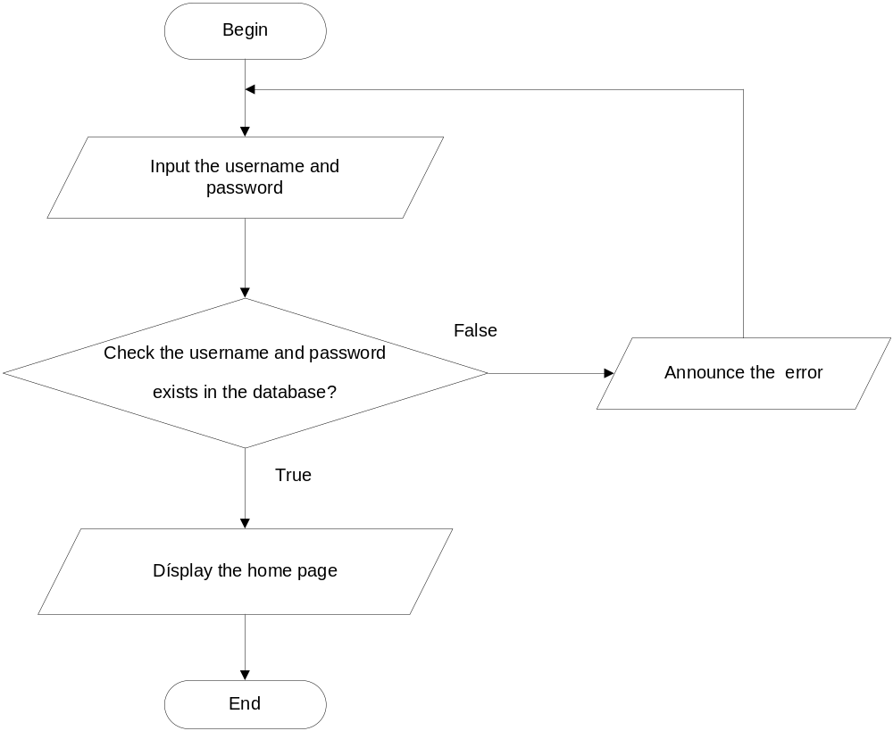

    - Search

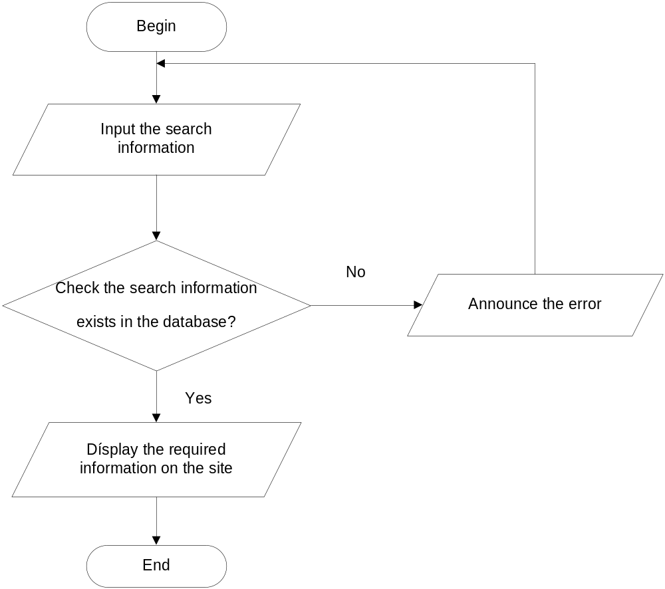

    - Send Feedback

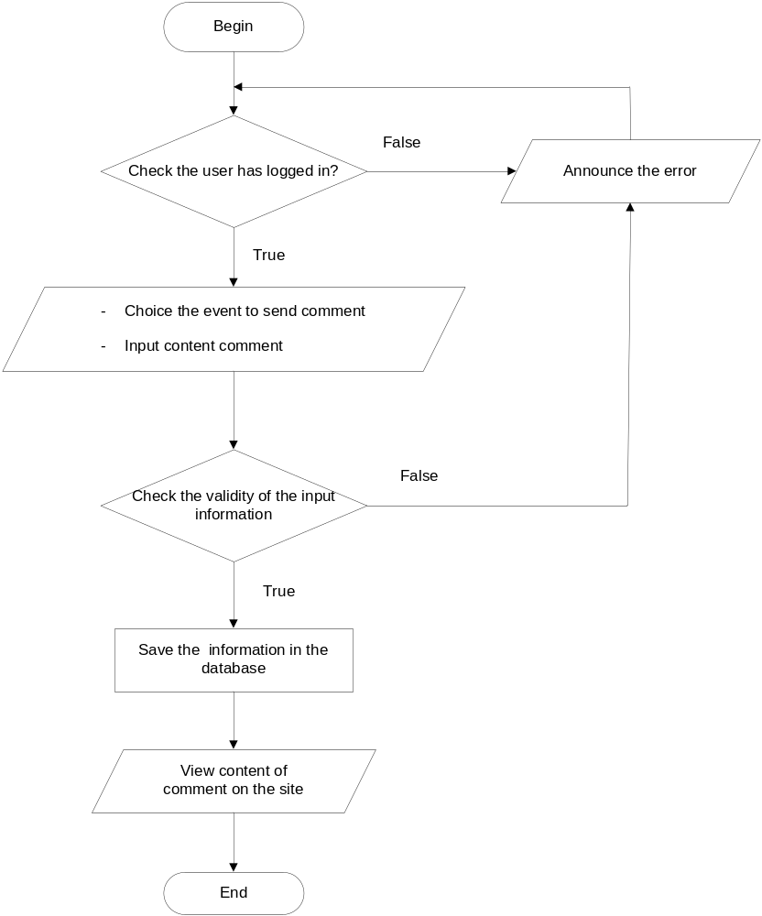

    - Send FAQ

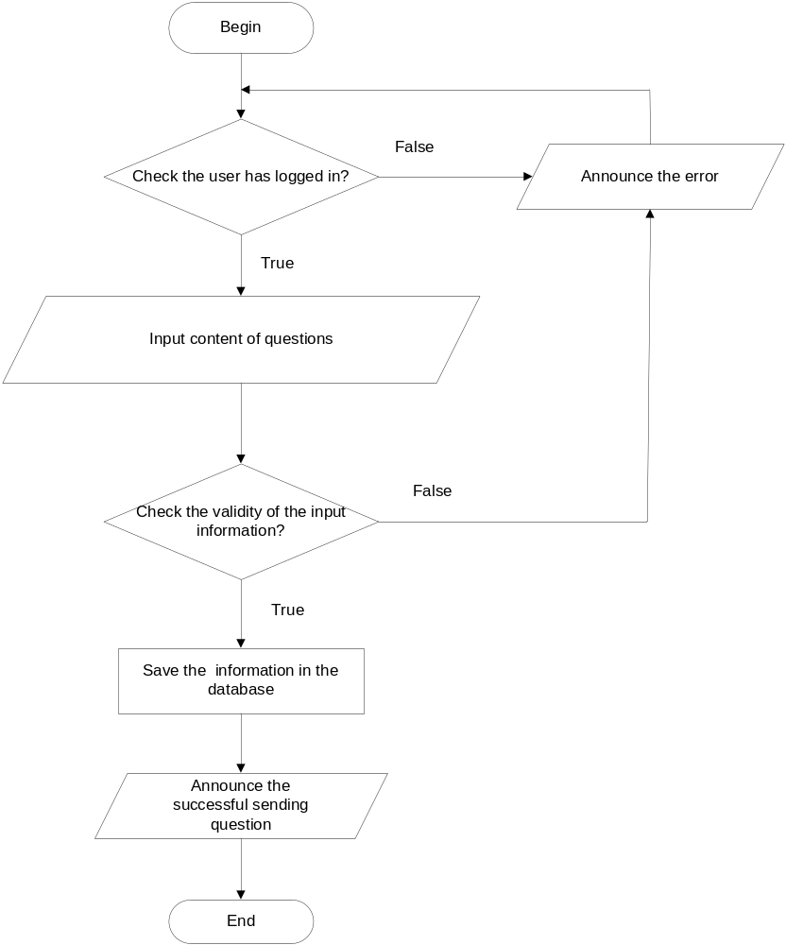

    - Delete FAQ

Begin
Choice FAQ delete
Delete FAQ

Check into database
Show message
End
Show message
True
False

    - Edit FAQ

Begin
Choice FAQ edit
Input info of FAQ
Save info FAQ in the database

Check validity
Input info
Show message
End
Show message
True
False

Entity Relationship Diagram

Feedback

Student

Mark Assignment

Assignment

User

Role

Batch

Subject

Course

Semester

News

FAQ

1
N
N
M
M
N
N
M
M
N
N
1
N
1
1
N
N
M
1
1
N
N

Database Structure

Table Design

      - User

STT | Key | Column Name | Data Type | Length | Allow Nulls | Description
1 | PK | UserID | Int |  | No | Stores the identification number of the user.
2 | UK | UserName | Varchar | 50 | No | Store the username of user.
3 |  | Password | Varchar | 30 | No | Store the password of user.
4 |  | DateCreate | Datetime |  | No | Store the Date create user.
5 |  | LastName | Varchar | 45 | No | Store the LastName of user.
6 |  | FirstName | Varchar | 45 | No | Store the FirstName of user.
7 |  | Email | Varchar | 50 | No | Store the email of user.
8 |  | Phone | Varchar | 50 | Yes | Store the phone of user
9 |  | Address | Varchar | 200 | Yes | Store the address of user
10 |  | Birthday | Datetime |  | Yes | Store the birthday image link.
11 |  | Gender | bit |  | Yes | Store the gender of the user.
12 |  | Status | Bit |  | Yes | Stores the status of the user.
13 |  | Avarta | Varchar | 45 | Yes | Stores the url image link of the user.

      - Table Role

STT | Key | Column Name | Data Type | Length | Allow Nulls | Description
1 | PK | Role_ID | Int |  | No | Stores the identification number of the Role.
2 |  | Name | Varchar | 30 | Yes | Store the Name of role.
3 |  | Description | Varchar | 100 | Yes | Store the description of role.

      - Table User_Role

STT | Key | Column Name | Data Type | Length | Allow Nulls | Description
1 | PK | Ro_Us_ID | Int |  | No | Stores the identification number.
2 | FK | User_ID | Int |  | No | Foreign key references User.
3 | FK | Role_ID | Int |  | No | Foreign key references Role.

      - Table FAQ

STT | Key | Column Name | Data Type | Length | Allow Nulls | Description
1 | PK | FAQ_ID | Int |  | No | Stores the identification number of the FAQ.
2 |  | Answer | Text |  | No | Store the Answer of FAQ.
3 |  | Question | Text |  | No | Store the question of FAQ.
4 |  | Date | Datetime |  | No | Store the Date create FAQ.

      - Table News
STT | Key | Column Name | Data Type | Length | Allow Nulls | Description
1 | PK | News_ID | Int |  | No | Stores the identification number of the News.
2 |  | Title | Varchar | 100 | Yes | Store the title of News.
3 |  | Content | Text |  | Yes | Store the content of News.
4 |  | Image | Varchar | 45 | Yes | Store the image of News.
5 |  | Date | Datetime | 45 | No | Store the Date create News.

      - Table Assignment

STT | Key | Column Name | Data Type | Length | Allow Nulls | Description
1 | PK | Ass_ID | Int |  | No | Stores the identification number of the Assignment.
2 | FK | Batch_ID | Int |  | No | Foreign key references Batch.
3 |  | Name | Varchar | 40 | Yes | Store the name of Assignment.
4 |  | FilePath | Varchar | 100 | No | Store the File path of Assignment.
5 |  | Description | Text |  | Yes | Store the description of Assignment.
7 |  | StartDate | Datetime |  | No | Store the Start date of Assignment.
8 |  | EndDate | Datetime |  | No | Store the End date of Assignment.
9 |  | Status | Bit |  | Yes | Store the status of Assignment.
10 |  | Type | Bit |  | Yes | Store the type of Assignment.
11 | FK | Subject_ID | Int |  | No | Foreign key references Subject.
12 | FK | User_ID | Int |  | No | Foreign key references User.

      - Table Staff_Subject

STT | Key | Column Name | Data Type | Length | Allow Nulls | Description
1 | PK | St_Sub_ID | Int |  | No | Stores the identification number of the Staff_Subject.
2 | FK | Staff_ID | Int |  | No | Foreign key references User.
3 | FK | Subject_ID | Int |  | No | Store the name of Subject.

      - Table Subject

STT | Key | Column Name | Data Type | Length | Allow Nulls | Description
1 | PK | Subject_ID | Int |  | No | Stores the identification number of the Subject.
2 |  | Name | Varchar | 50 | No | Store the name of the Subject.
3 |  | Code | Varchar | 10 | No | Store the Code of Subject.

      - Table Subject_Semester

STT | Key | Column Name | Data Type | Length | Allow Nulls | Description
1 | PK | Su_Ses_ID | Int |  | No | Stores the identification number of the Subject_Semester.
2 | FK | Subject_ID | Int |  | No | Foreign key references Subject.
3 | FK | Semester_ID | Int |  | No | Foreign key references Semester.
4 |  | Order | Tinyint |  | No | Store the order of Semester.

      - Table Semester

STT | Key | Column Name | Data Type | Length | Allow Nulls | Description
1 | PK | Semester_ID | Int |  | No | Stores the identification number of the Semester.
2 |  | SemesterOrder | Tinyint |  | No | Store the semester order of the Subject.
3 |  | Name | Varchar | 15 | No | Store the Name of Semester.
4 | FK | Course_ID | Int |  | No | Foreign key references Course.

      - Table Course

STT | Key | Column Name | Data Type | Length | Allow Nulls | Description
1 | PK | Course_ID | Int |  | No | Stores the identification number of the Course.
2 |  | Code | Varchar | 20 | No | Store the code of the Course.
3 |  | Name | Varchar | 20 | No | Store the name of Course.
4 |  | Time | Datetime |  | No | Store the time of the Course.

      - Table Batch

STT | Key | Column Name | Data Type | Length | Allow Nulls | Description
1 | PK | Batch_ID | Int |  | No | Stores the identification number of the Batch.
2 |  | Name | Varchar | 50 | No | Store the name of the Batch.
3 |  | StartDate | Datetime |  | No | Store the start date of Batch.
4 | FK | Semester_ID | Int |  | No | Foreign key references Semester.
5 | FK | Course_ID | Int |  | No | Foreign key references Course.
6 | FK | Staff_ID | Int |  | No | Foreign key references Staff.
7 | FK | Subject_ID | Int |  | No | Foreign key references Subject.

      - Table Student
STT | Key | Column Name | Data Type | Length | Allow Nulls | Description
1 | PK | Student_ID | Int |  | No | Stores the identification number of the Student.
2 | FK | Batch_ID | Int |  | No | Foreign key references Batch
3 |  | UserName | Varchar | 45 | Yes | Store the user name of Student.
4 |  | Password | Varchar | 45 | Yes | Store the password of the Student.
5 |  | DateCreate | Datetime |  | No | Store the date create of Student.
6 |  | LastName | Varchar | 45 | Yes | Store the last name of Student
7 |  | FirstName | Varchar | 45 | Yes | Store the first name of Student.
8 |  | Birthday | Datetime |  | Yes | Store the birthday of Student.
9 |  | Phone | Varchar | 15 | Yes | Store the phone of Student.
10 |  | Email | Varchar | 45 | Yes | Store the email of Student.
11 |  | Gender | Bit |  | No | Store the gender of Student.
12 |  | Address | Varchar | 200 | Yes | Store the address of Student.
13 |  | Status | Bit |  | Yes | Store the status of the Student.
14 |  | Avatar | Varchar | 45 | Yes | Store the image of the Student.
15 |  | Roll | Varchar | 12 | No | Store the roll of the Student.

      - Table Feedback

STT | Key | Column Name | Data Type | Length | Allow Nulls | Description
1 | PK | Feedback_ID | Int |  | No | Stores the identification number of the Feedback.
2 | FK | Student_ID | Int |  | No | Foreign key references Student.
3 |  | Title | Varchar | 100 | Yes | Store the title of Feedback.
4 |  | Content | Text |  | Yes | Store the content of the Feedback.
5 |  | Date | Date |  | Yes | Store the date of Feedback.

      - Table Mark Assignment

STT | Key | Column Name | Data Type | Length | Allow Nulls | Description
1 | PK | MarkAss_ID | Int |  | No | Stores the identification number of the Mark Assignment.
2 | FK | Assignment_ID | Int |  | No | Foreign key references Assignment.
3 | FK | StudentID | Int |  | No | Foreign key references Student.
4 |  | Mark | Float |  | Yes | Store the mark of the Mark Assignment.
5 |  | Date | Datetime |  | Yes | Store the date of Mark Assignment.
6 |  | FilePath | Varchar | 45 | Yes | Store the file path of Mark Assignment.

Database Diagram

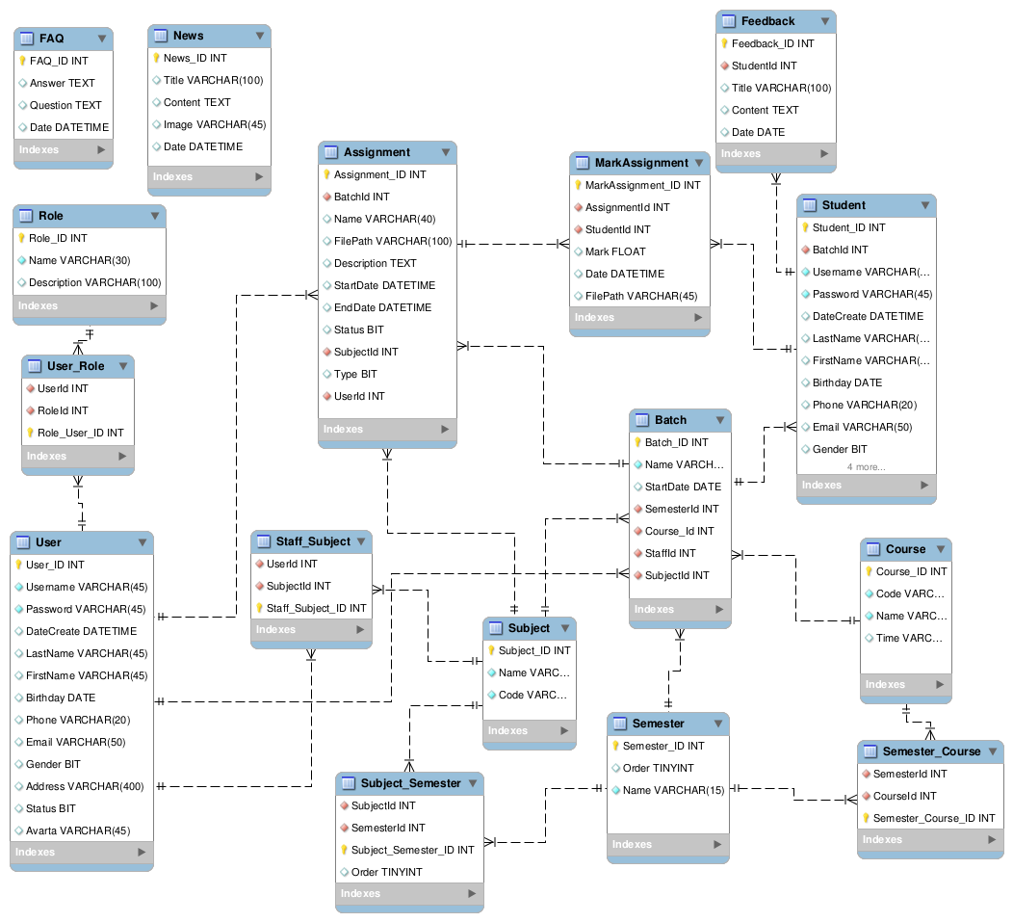

Screen Design
- Home page.

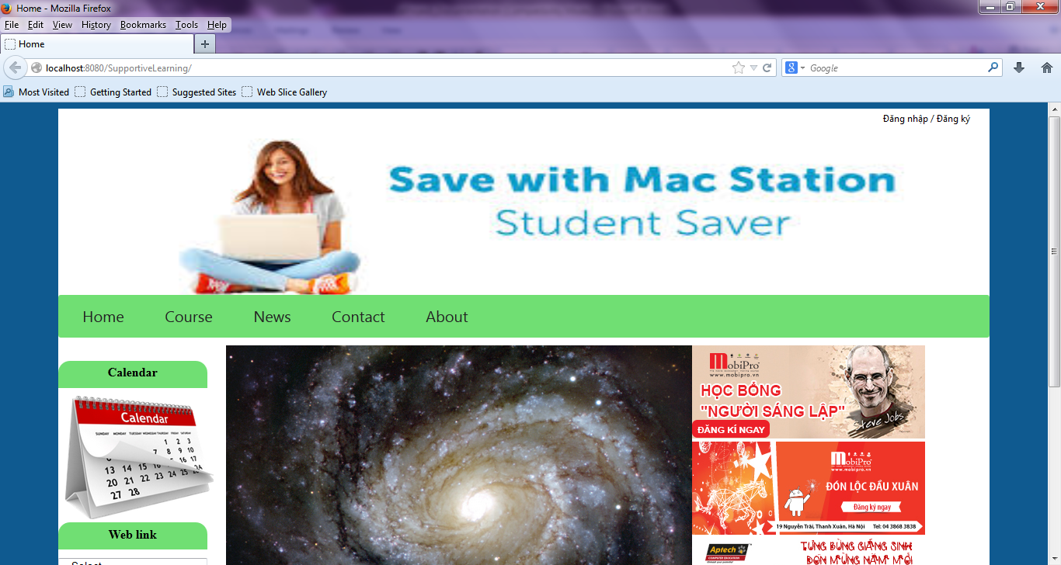
- Course

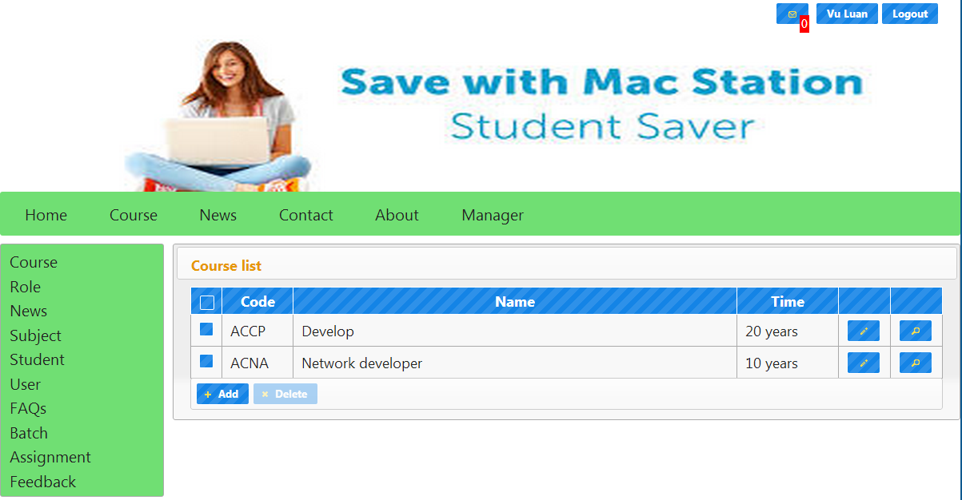

Update news

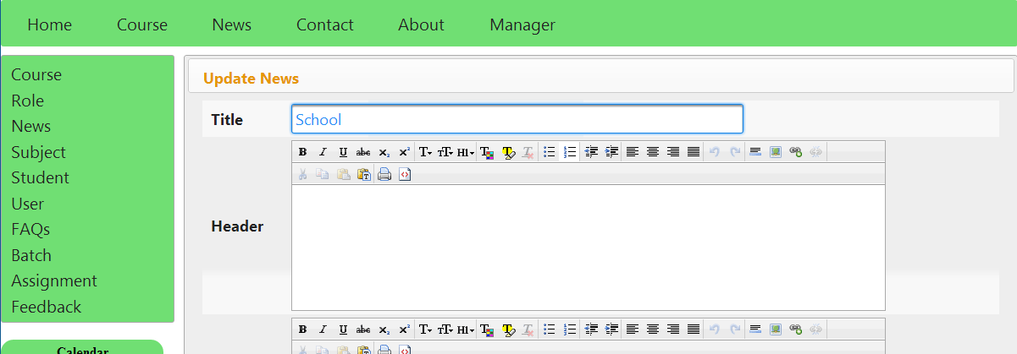

- Subject

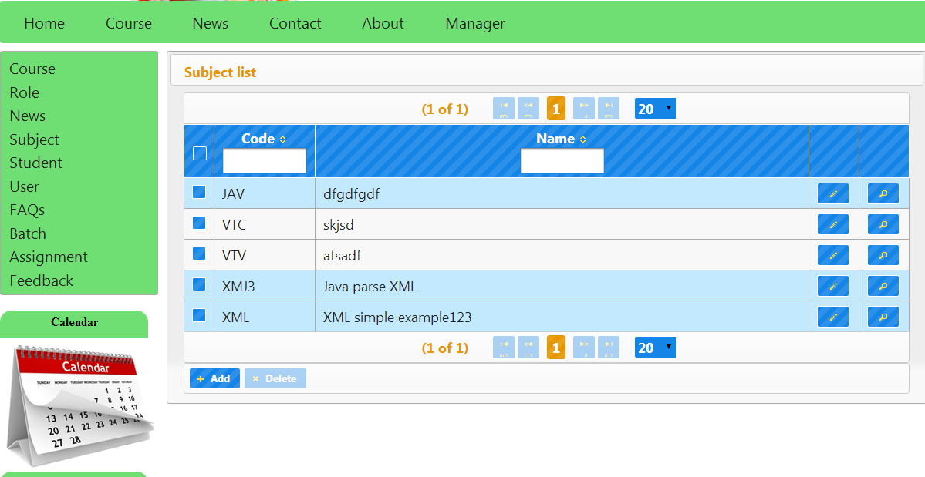

- Student Detail

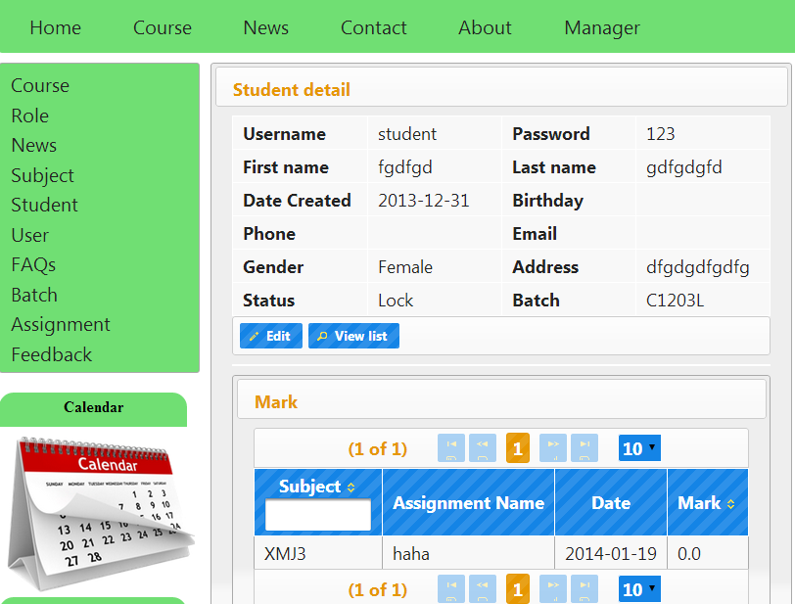

- Assignment

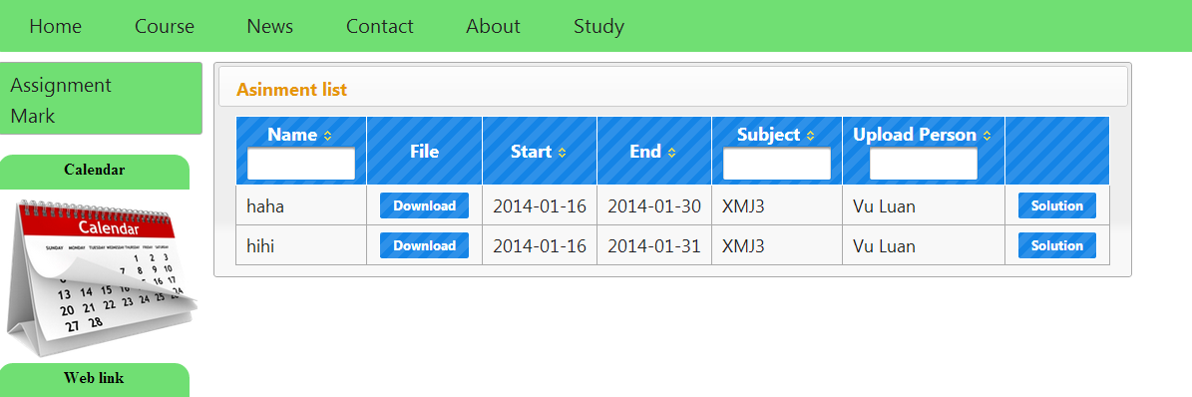

- Mark

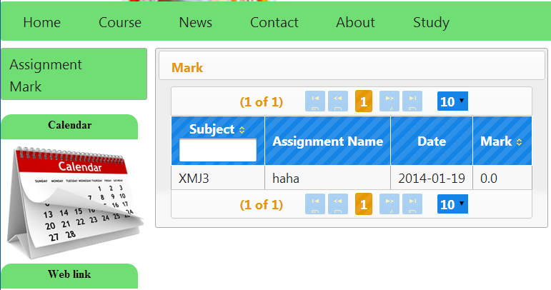

Task Sheet

Project Ref. No: |  | Date of Preparation of Activity Plan:
Sr.No | Task | Team Member Names | Status
1 | Document, DFD | Luong, Luan | OK
2 | Installation guide | Luong | OK
3 | Write help to application | Luan | OK
4 | Database Design | Luong, Luan | OK
5 | Design interface Supporting Learning | Luan | OK
6 | Coding manage Student | Luong | OK
7 | Coding manage Staff | Luan | OK
8 | Coding manage Assignment | Luan | OK
9 | Coding manager Mark Assignment | Luong | OK
10 | Coding manager Feedback | Luan | OK
11 | Coding manager FAQs | Luan | OK
12 | Advance search | Luong | OK
13 | Coding Admin | Luan | OK
14 | Coding Staff | Luong | OK
15 | Code Student | Luan | OK
16 | View Mark | Luan | OK
17 | Orther work client | Luong | OK
18 | Test & validate | Luong | OK
19 | Modify | Luong | OK

Checklists

Check List of Validation

Option | Validated
All fields in forms are validated | yes
Data input is validated | yes
Ensure data in constraint | yes

Submission Checklist

Sr. No. | Particulars | Yes | No | NA | Comments
1 | All forms activate well | x
2 | Are the all users able to login to the application after validation is performed on the username and password? | x
3 | All pages have not mistake | x
4 | Is the application user-friendly? | x
5 | Is there alert when mis data fill? | x

THE END

