**How-To**

**Intended Audience**

Spring Boot and JPA developers

**Purpose**

This guidelines are based on successfully presentation on the group project in Enterprise Architecture course teaching by Prof. Payman Salek. It shows step by step how to setup and running the project.

**Prerequisites**

1. Spring Tool Suite IDE
2. MySQL server
3. Active MQ server (<http://activemq.apache.org/activemq-5143-release.html>)

**Steps**

There are 2 separated projects:

. TMAppointment (main web project – for user operations)

. TMAppointmentUtil (standalone project – utility which is sending email, handing JMS message receive, and Quartz scheduling)

***Step 1. TMAppointment application.properties file***

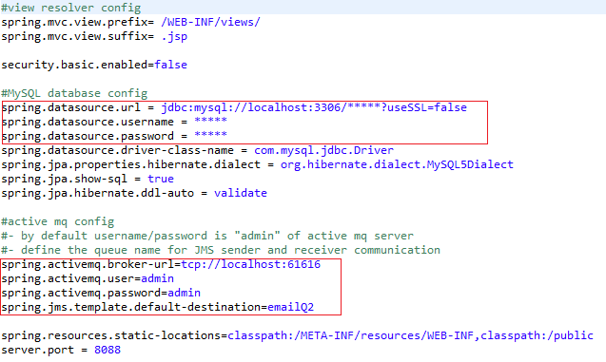

***Step 2. TMAppointmentUtil application.properties file***

Using gmail to send email, and below config is for sender email username/password.

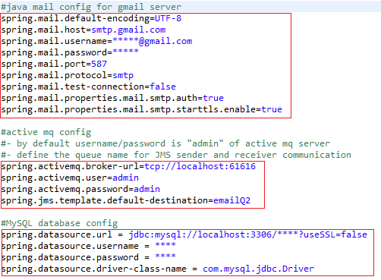

***Step 3. Start ActiveMQ server***

Download and unzip the ActiveMQ server, using below command to start the server. The command in “bin” folder.

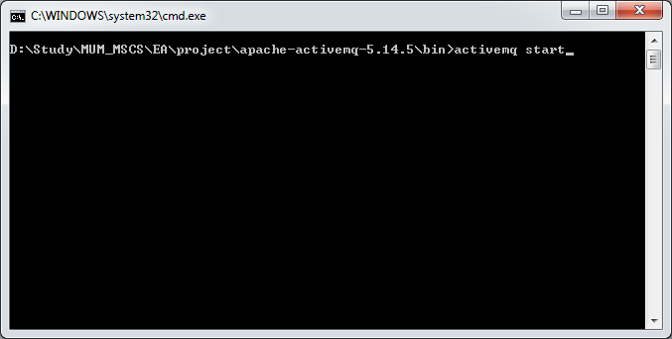

After the server started, using web browser to access server by: <http://localhost:8161/admin/>

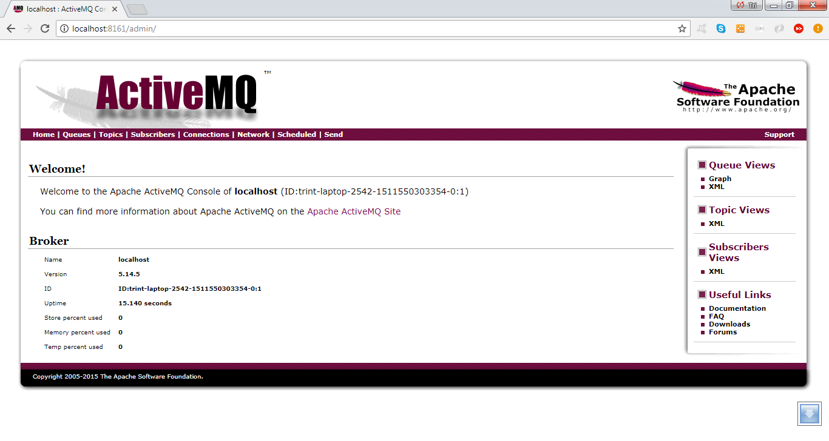

Using this interface, we can monitor the number of consumers and messages in the queues, as well as for the topics.

***Step 4. Start TMAppointmentUtil project as Spring Boot App***

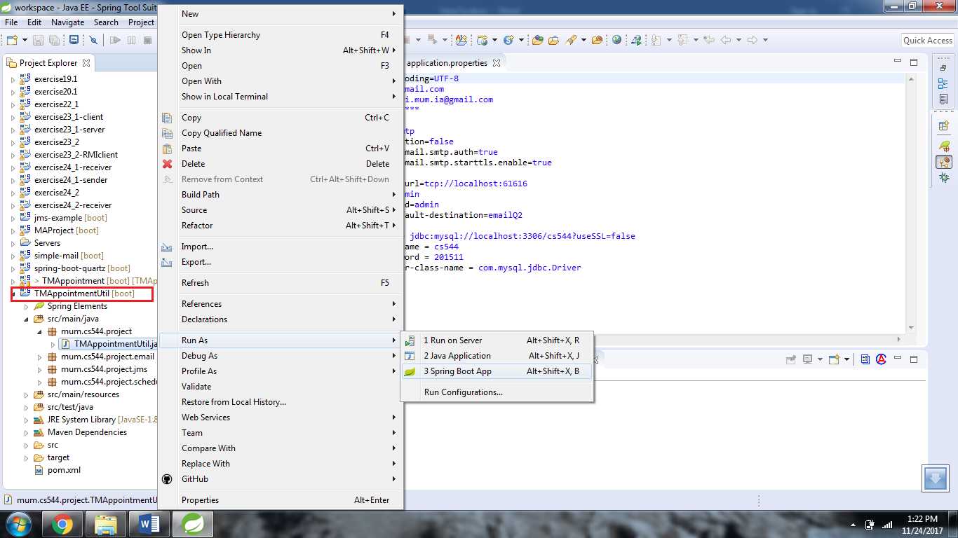

***Step 5. Start TMAppointment project as Spring Boot App***

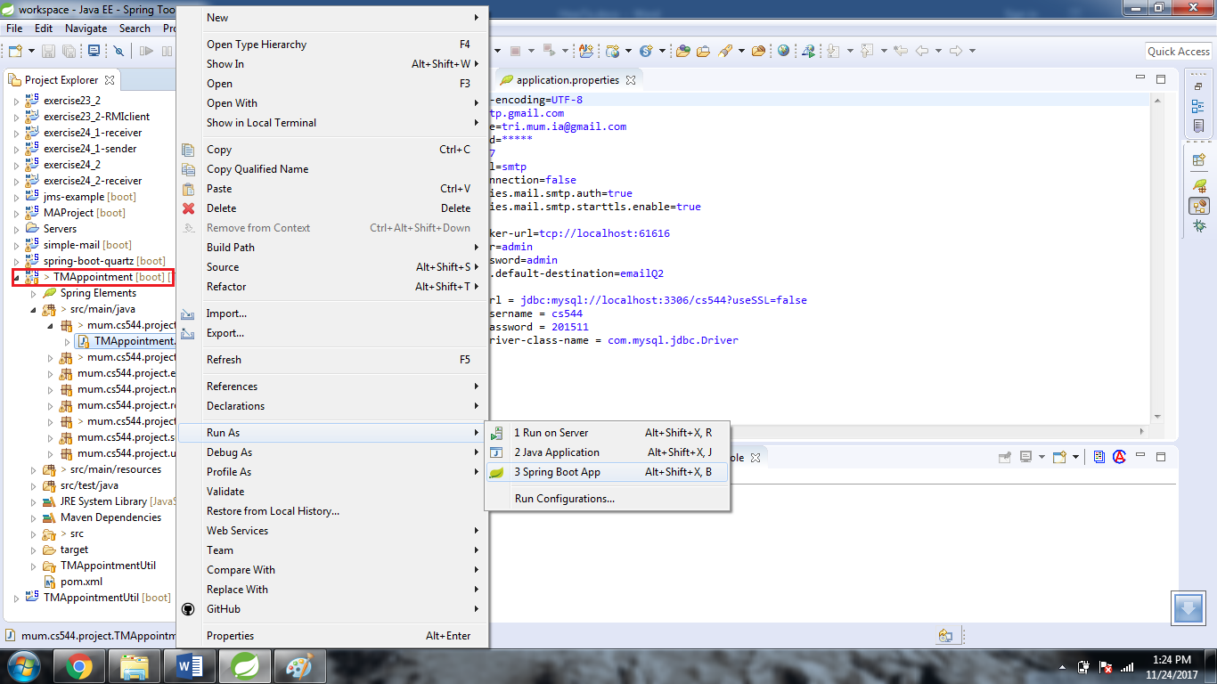

***Step 6. Access web in web browser***

