UGFit - Website Development Project Report

Group Information
Group Name: B
Project: UGFit Health & Fitness Website
Date: 18 November 2025

Member Name |Role| Responsibilities|

Lubega Derrick 2025 – B071 - 20300 | create full working page and Group Leader, compel report and contribution | html, css, and js for Home and contact page, combine all pages and Complete website development |
Ssentamu Dauglas 2025 - B071 - 23702| create full working page, report contribution| html, css, and js for services page|
Mubiru Arnold 2025 - B071 - 22232| create full working page, report contribution | html, css, and js for gallery page|
Agotre Stephen 2024 - B071 - 21799| create full working page, report contribution | html, css, and js for product page|

Website Topic and Purpose
Website Name: UGFit
Topic: Health, Fitness & Wellness

Purpose: To provide a comprehensive health and fitness platform that offers workout programs, and professional fitness services to help users achieve their health goals.

Page Descriptions and Functionality
1. Homepage (index.html)
Functionality:
- Hero section with call-to-action buttons
- Features overview with service highlights
- Responsive design for all devices
2. Services Page (services.html)
Functionality:
- Filterable workout programs by difficulty level
- Workout Tips & Guidelines
- Exercise instructions and durations
3. Products Page (products.html)
Functionality:
- Detailed products offerings with pricing
- Product categories: Personal Training, Group Classes, Nutrition Coaching, Online Coaching
- Direct booking buttons for each service
- Clean card-based layout
4. Gallery Page (gallery.html)
Functionality:
- 8 photo grid with consistent sizing
- Hover effects with slight zoom and lift
- Clean captions below each image
- Responsive grid that adapts to screen size
5. Contact Page (contact.html)
Functionality:
- Comprehensive contact form with validation
- Business information and hours
- Service selection dropdown

Technologies Used
HTML5 | CSS | JavaScript
- Semantic HTML structure  - Forms with proper input types  - Accessible mark-up  - SEO-friendly elements | - CSS Grid and Flex box for layouts  - CSS Custom Properties (Variables)  - Responsive design with media queries  - Modern animations and transitions  - Mobile-first approach | -DOM manipulation and event handling  - Form validation and user feedback  - Filtering systems  - Dynamic content updates

Page 1: Homepage
- Clean hero section
- Feature cards highlighting services
- Responsive navigation menu
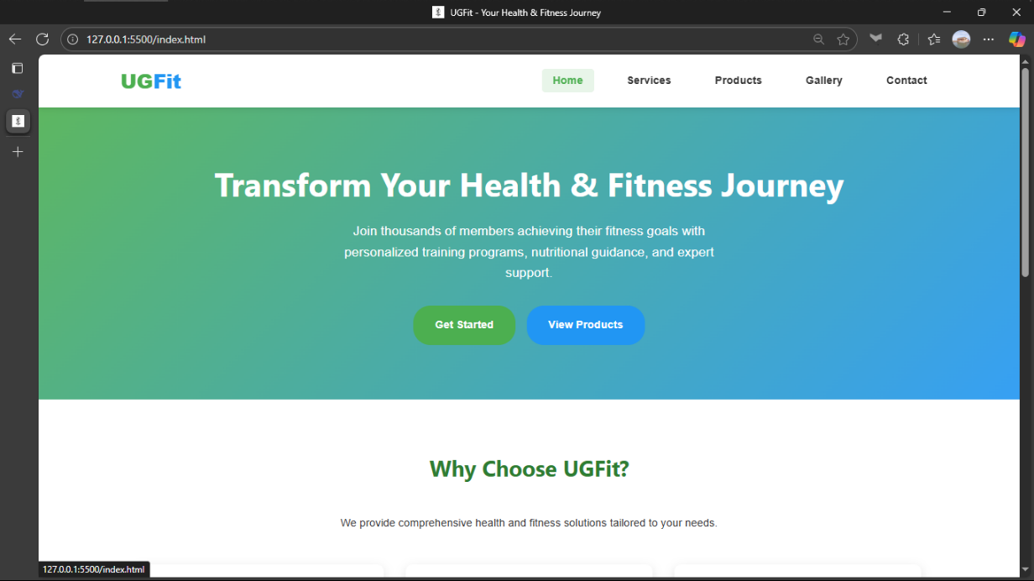

Page 2: Servicespage
- Filter buttons for workout difficulty
- Workout cards with exercise details
- Workout Tips & Guidelines
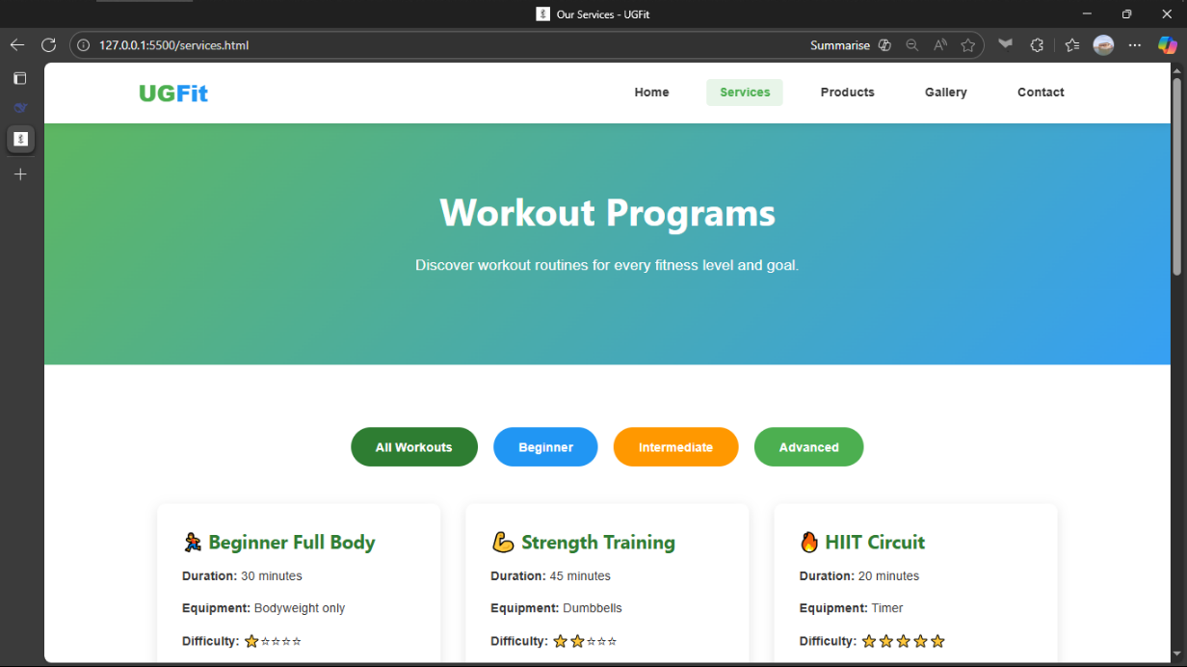

Page 3: Prouductpage
- Clear call-to-action buttons
- Product cards with pricing information
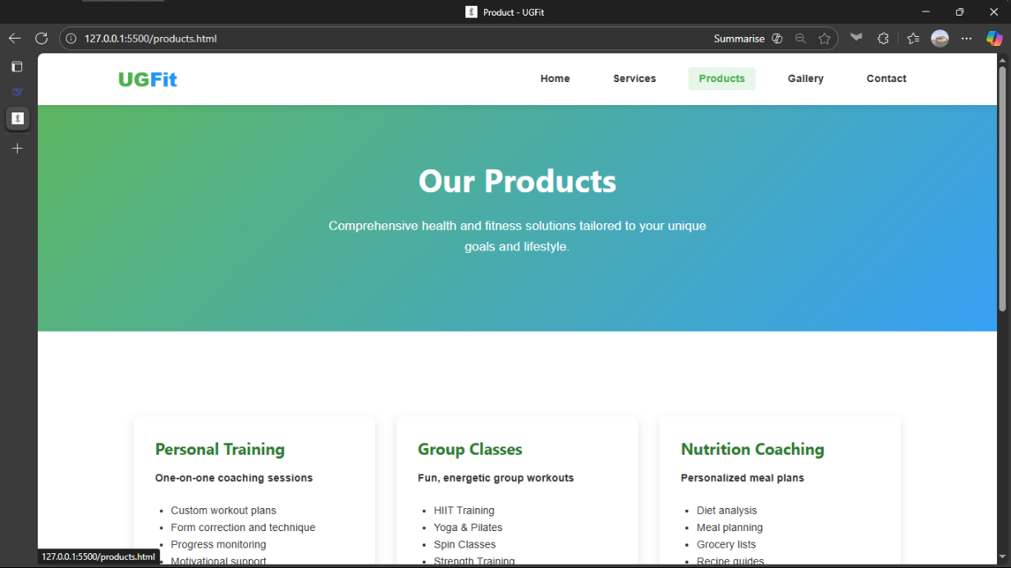

Page 4: Gallerypage
- Click any photo to view enlarged version
- 8 photo grid with consistent sizing
- Clean captions below each image
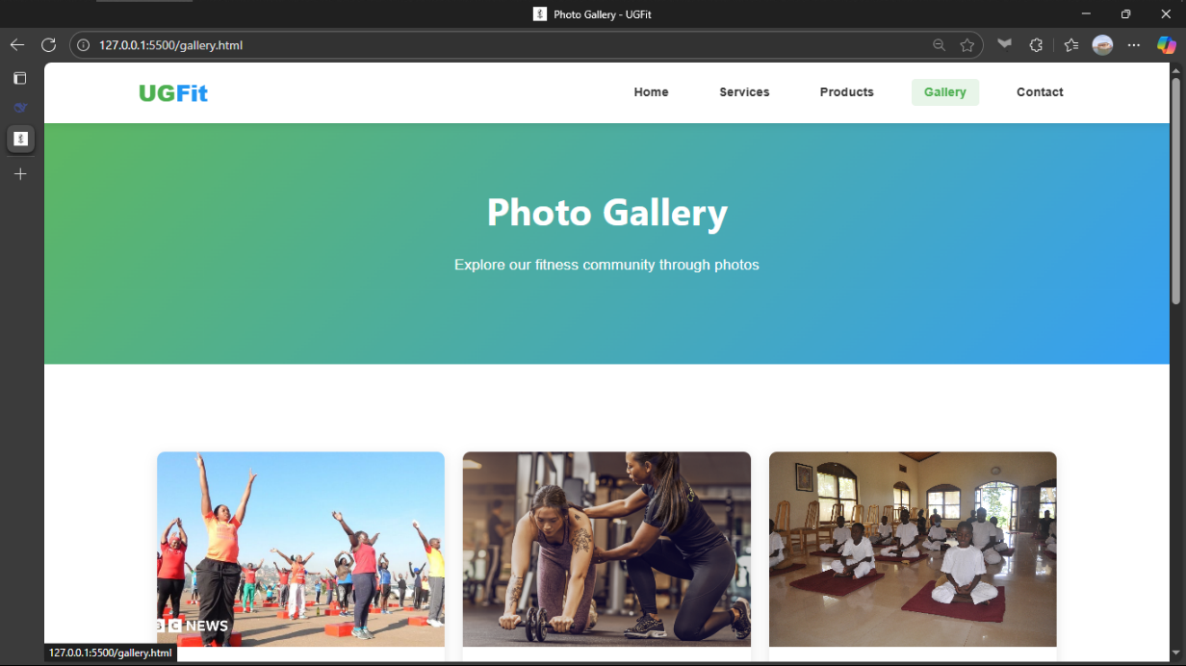

Page 5: Contactpage
- Contact form with validation
- Business information section
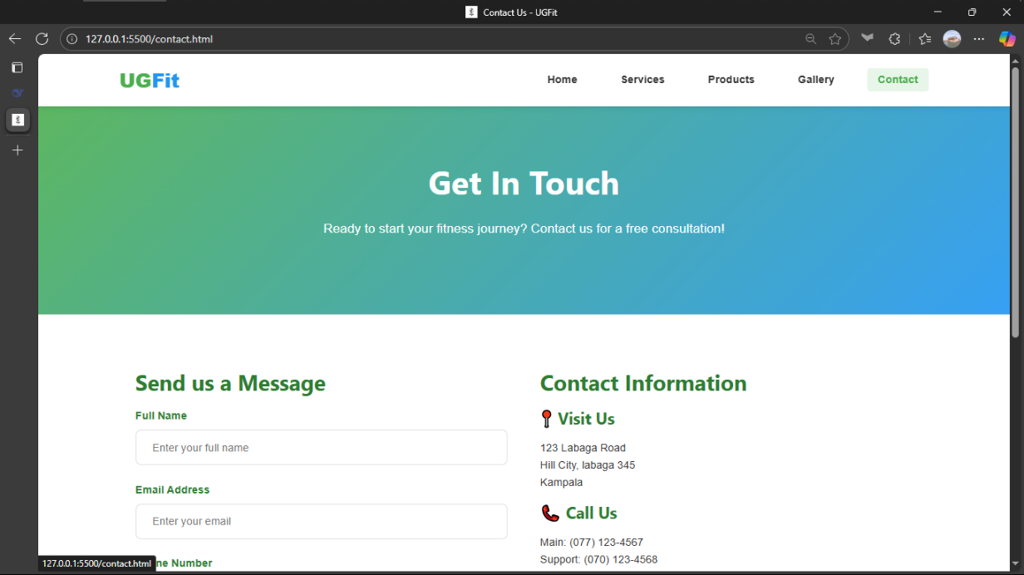

Challenges
We had Technical Challenges which include the following:
1. Responsive Design Complexity
Challenge: Ensuring consistent layout across mobile, tablet, and desktop
2. JavaScript State Management
Challenge: Managing multiple interactive elements (filters)
3. Form Validation
Challenge: Creating user-friendly validation with immediate feedback
And we also had design Challenges
4. Colour Scheme Selection
Challenge: Choosing colours that reflect health and energy while maintaining accessibility
5. Content Organization
Challenge: Presenting complex health information in digestible formats
Lessons Learned
1. Planning is Crucial
Creating detailed wireframes and style guides before coding saved significant development time
2. Code Maintainability
Using CSS variables and modular JavaScript made updates and debugging much easier
3. Progressive Enhancement
Building core functionality first, then adding enhancements, ensures broader compatibility
4. Testing is Ongoing
Regular testing throughout development caught issues early and reduced final debugging time

