**Project2 Classification**

**E94056178 工科系 盧柏翔**

**Topic：判斷是否為Loser？**

1. **Definition**

**Attribute(共20項)：**

Height 身高(150~200cm)

Weight 體重(40~100kg)

shape 身形(slim / heavy)

appearance 樣貌(handsome / ugly)

salary 月薪(0~10000USD)

house 擁有房子(0~5)

car 擁有汽車(0~5)

girlFriend 擁有女朋友(0~5)

friend 朋友多寡(few many)

education 教育程度(highschool / Bachelor / Master / Doctor)

emotion 情緒(gloomy / optimism)

behavior 處事行為(positive / passive)

cellphone 手機作業系統(apple / android)

sick 常生病(True / False)

brain 腦袋(stupid / smart)

selfConfidence 自信(0~100%)

interest 興趣(0~20項)

GPA 大學學業成績(0~4.3)

sexmate 炮友數量(0~10)

responsibility 責任心(True / False)

**Label：”Winner” and “Loser”**

**Definition of “Loser”：**

height <= 165cm

weight >= 70kg

shape:heavy

appearance:ugly

salary <= 1000USD

house < 1

car < 1

girlFriend < 1

friend:few

education <=Bachelor

emotion:gloomy

behavior:passive

cellphone:android

sick:True

brain:stupid

selfConfidence <=50

Interest <=5

GPA <=3

sexmate < 1

responsibility:False

1. **Data**

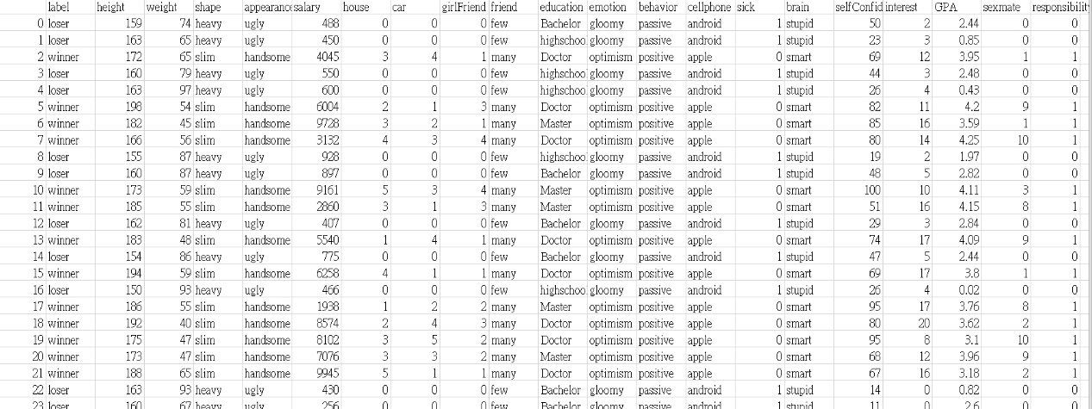Overview

共產生1000筆Loser資料，1000筆Winner資料，詳細看 data.csv 和 data_r.csv

1. Result─(1)

使用Decision Tree

1. Result─(2)

使用Decision Tree

1. Conclusion