fcoex: using coexpression to explore cell type diversity in scRNA-seq data

This manuscript ([permalink](https://lubianat.github.io/fcoex_report/v/bb7fe23800e47b5c9655760486c619015ef3647c/)) was automatically generated from [lubianat/fcoex_report@bb7fe23](https://github.com/lubianat/fcoex_report/tree/bb7fe23800e47b5c9655760486c619015ef3647c) on May 14, 2021.

## Authors

* **Tiago Lubiana** ORCID icon [0000-0003-2473-2313](https://orcid.org/0000-0003-2473-2313) · GitHub icon [lubianat](https://github.com/lubianat) Department of Clinical and Toxicological Analyses, School of Pharmaceutical Sciences, University of São Paulo, São Paulo, Brazil
* **Helder I Nakaya** ORCID icon [0000-0001-5297-9108](https://orcid.org/0000-0001-5297-9108) Department of Clinical and Toxicological Analyses, School of Pharmaceutical Sciences, University of São Paulo, São Paulo, Brazil

## Abstract

# Introduction

Single-cell RNA sequencing (scRNA-seq) data analysis is at the core of the current quest to describe all human cell types. [1] The annotation of cell events in scRNA-seq is commonly done by clustering single cells and manually identifying cell types on the dataset. [2]:

Clusters (and their markers) are a prime tool for discovering new groupings with biological relevance. Fine-grained Louvain clustering can highlight out rare, uniform population like the newly identified airway ionocytes. [3] [3] Complementarily, hierarchical clustering provides a multilevel perspective on cell identity, providing knowledge on upper cell classes, prone for ontology building[4])

While such methodologies are already powerful, we identified a gap: current works seldom explore the multi-hierarchy clustering. Biologists are used to tree-like; single-hierarchy classifications, such as the so-called tree-of-life. That tree-like structure rises as a natural side-effect of the macroevolutionary process of vertebrates, where species give rise to one (or more) others. Cell type classifications, however, are functional in essence[5] and, thus, do not need to be tree-like. In fact, formal ontologies of cell types (like the Cell Ontology) catalog many cell types with multiple direct parents. [6] [7]

We build fcoex, an R package that builds coexpression networks as an scaffold for multi-hierarchy classification of cell types, and describe its application to some datasets.

# Results

## The fcoex method

The *fcoex* tool was built from first principles to provide better understandability. Our first goal was to develop a smaller set of genes that globally captured the cellular diversity of a dataset.

For that, we decided to explore feature selection by *symmetrical uncertainty*, the correlation metric of FCBF, a popular feature selection algorithm for machine learning (over 2700 Google Scholar citations) with little previous use in biomedical sciences (8 PubMed results for “FCBF” as of April 2021).

Symmetrical uncertainty relies on entropy (in the information-theory sense), which relies on categories for calculation. Thus, we implemented a set of heuristics to binarize gene expressions (https://bioconductor.org/packages/release/bioc/html/FCBF.html) which can be accessed via the fcoex::discretize() function.

As mutual information is a supervised method, fcoex also needs pre-made cluster assignments obtained after running a standard scRNA-seq clustering pipeline. Cluster assignments convey information about the relations between cells and help to guide feature selection.

Fcoex, then, selects genes global markers, which might be specific to 1, 2, or more clusters; the common factor is that they provide information to tell clusters apart.

To find the coexpression-module, we inverted the FCBF redundancy removal algorithm as a heuristic to find redundant (co-expressed) gene expression patterns. (see Supplementary Methods for details).

The gene coexpression modules yielded by the pipeline are small by design (10s of genes per module), so to facilitate manual exploration of the coexpression landscape. Each module has one “header” gene, which expression pattern is most representative of the genes in the module.

The ultimate goal of the *fcoex* pipeline is not necessarily the modules but to find biologically relevant populations.

Modules contain correlated and anti-correlated genes and thus might hold signatures for two different populations.

Fcoex treats each module as a gene set to find cell populations. It then uses only the expression of genes in the module to re-classify the cells.

After projecting the pipelines, we intend to verify if the modules captured complimentary views on cell identities comparatively to the Seurat clustering pipeline.

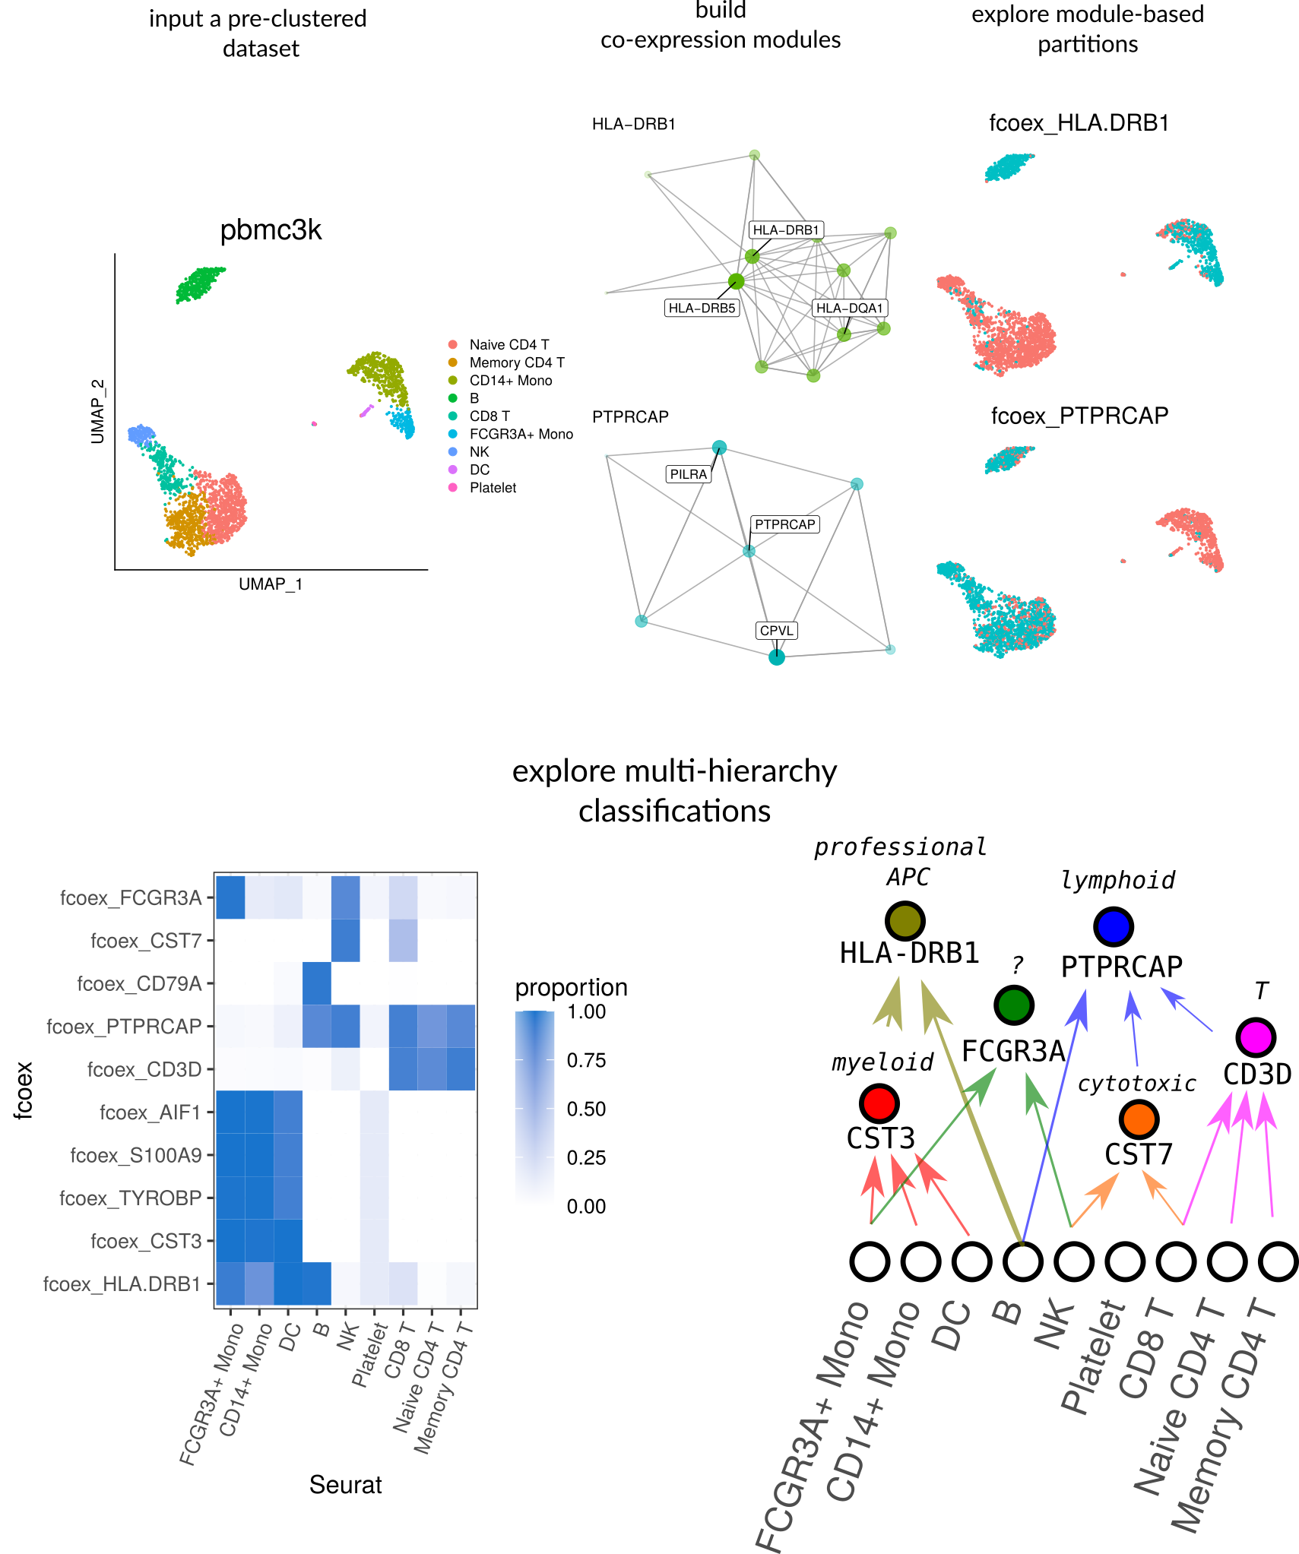

Figure 1: Overview

## fcoex recovers multi-hierarchy of blood types

To validate the fcoex pipeline, we selected the well-known pbmc3k dataset from SeuratData, which contains around 2700 peripheral blood mononuclear cells (PBMC) with author-defined cluster labels.

The standard fcoex pipeline detected nine modules that capture different parts of the cellular diversity in the dataset.

For example, module M8, containing cytotoxicity genes as PRF1 and GZMA, split the dataset into cytotoxic (NK and CD8) and non-cytotoxic cells. M2 (CD3D) split the dataset clearly in T-cells and non-T-cells. M5 (HLA-DRB1) grouped monocytes, B cells, and dendritic cells, all known antigen-presenting cells (APC) (https://www.ebi.ac.uk/ols/ontologies/cl/terms?obo_id=CL:0000145).

In general, fcoex clusters combined biologically similar cell types of the original dataset. The clusterings, then, help to explore and classify upper cell classes by function. Even in that super well-studied dataset, fcoex provided a new light on the shared functionality of some NK cells and macrophages: they both markedly express the CD16-coding gene FCGR3A, whose product is a key player in Antibody-dependent cellular cytotoxicity (ADCC). Thus, a complete functional classification of cells might want to include an ’ADCC-performing cells" class.

# Discussion

Here we presented fcoex, a ready-to-use R/Bioconductor package for co-expression-based reclustering of single-cell RNA-seq data. We note that other methods are increasingly available for co-expression analysis of single cells. The monocle R package [8], widely used for pseudotime analysis, has implemented algorithms for detecting co-expression modules (<https://cole-trapnell-lab.github.io/monocle3/docs/differential/#gene-modules>), and WGCNA, widely used in bulk transcriptomics, has also been applied to scRNA-seq [9] [10].

In principle, any of those algorithms could be used as input for our framework (and we provide code showing how to integrate them to fcoex). We note, though, that fcoex modules are generally smaller and provide module header genes, making it a sensible first-pass approach to explore the multi-layered diversity in single-cell transcriptomics datasets. In that way, fcoex offers ways to explore data-driven classifications of cells, aligning itself with the challenges of the Human Cell Atlas and, specifically, of building ontologies of cell types in the single-cell era.

# Supplementary Methods

## Preprocessing

### pbmc3k dataset preprocessing

**pbmc3k** was loaded as a Seurat object from the SeuratData package. The expression matrix in the “data” slot and the labels in the “Idents” slot as input for creating the *fcoex* object.

# Gene expression discretization

As the original Fast Correlation-Based Filter [11] algorithm was constructed to deal with discrete data, we had to discretize gene counts. We chose as a discretization metric a min-max-percent approach. For each gene, we took the lowest and the highest normalized value across the cells. We set a threshold at 25% of the max-min range. All the values below this threshold were considered “OFF,” and all above was “ON”.

# Identification of *fcoex* modules

## Filtering genes by correlation to labels

After the discretization step, genes were ranked by their correlation to labels previously assigned by the Seurat Data team. The correlation metric we used was the nonlinear Symmetrical Uncertainty, a variation of mutual information that maps the values between 0 (worst) and 1 (best), and accounts for differences in entropy ranges that arise when variables have a different number of classes (number of labels and number of gene classes). All downstream steps were performed only with the previously filtered genes

## Building the coexpression network

Each module M is composed of one module seed (x) predominantly-correlated to the label (L) and all the genes (Yi) more correlated to the seed than to the label. In practice, the algorithm builds an all x all correlation matrix by symmetrical uncetainty, the adjacency matrix of the co-expression network. This adjacency matrix is then trimmed, and edges between nodes Yi and Yj are removed from the network iff SU(Yi, Yj) < SU(Yi, L) or SU(Yi, Yj) < SU(Yj, L). Inferring coexpression modules Modules were built in a bottom-up approach, first selecting genes predominantly correlated to the labels. These genes are the output of the Fast Correlation-Based Filter (FCBF) algorithm for feature selection. Each selected featured forms a new cluster, corresponding to all the genes associated to it in the trimmed network. The modules formed in that way are fuzzy, as a gene might belong to several modules.

## Reclustering of cells

To recluster the cells based on each module, we use the “recluster” function of the *fcoex* module. It uses the gene sets in each co-expression community to subset the expression table given originally as input. This reduced table contains the expression values regarding those genes for all the cells in the dataset. The distances between cells in this reduced matrix was calculated by the manhattan distance, and hierarchical clustering was performed. The metric used to calculate the linkage distance between groups was the “ward.D2” metric as implemented in the hclust function of the stats package in R 3.6.1. Two groups of cells were retrieved from each clustering (the k parameter was set to 2) . ## Code availability The *fcoex* package, which performs the coexpression analysis is available at <http://bioconductor.org/packages/fcoex/>. The discretization and feature selection algorithms are available in a second package, FCBF (<http://bioconductor.org/packages/FCBF/>). All the analyses performed for this work are available at <https://github.com/lubianat/fcoex paper>.

# Acknowledgments

We would like to thank Pedro Russo, Gustavo Ferreira and Lucas Cardozo for contributions to software development, as well as all members of the Computational Systems Biology Laboratory for discussions and feedback. This work was supported by grants 2018/10257-2 and 2019/26284-1, São Paulo Research Foundation (FAPESP).

## References

1. **The Human Cell Atlas.**   
Aviv Regev, Sarah Teichmann, Eric Lander, Amir Giladi, Christophe Benoist, Ewan Birney, Bernd Bodenmiller, Peter Campbell, Piero Carninci, Menna R. Clatworthy, … Human Cell Atlas Meeting Participants  
*eLife* (2017-12-05) <https://www.wikidata.org/wiki/Q46368626>   
DOI: [10.7554/elife.27041](https://doi.org/10.7554/elife.27041)

2. **Current best practices in single-cell RNA-seq analysis: a tutorial**   
Malte D. Luecken, Fabian J. Theis  
*Molecular Systems Biology* (2019-06-19) <https://www.wikidata.org/wiki/Q64974172>   
DOI: [10.15252/msb.20188746](https://doi.org/10.15252/msb.20188746)

3. **A single-cell atlas of the airway epithelium reveals the CFTR-rich pulmonary ionocyte**   
Lindsey W. Plasschaert, Rapolas Žilionis, Rayman Choo-Wing, Virginia Savova, Judith Knehr, Guglielmo Roma, Allon M. Klein, Aron B. Jaffe  
*Nature* (2018-08-01) <https://www.wikidata.org/wiki/Q57318689>   
DOI: [10.1038/s41586-018-0394-6](https://doi.org/10.1038/s41586-018-0394-6)

4. **Conserved cell types with divergent features in human versus mouse cortex**   
Rebecca D. Hodge, Rebecca D. Hodge, Trygve E. Bakken, Jeremy A. Miller, Kimberly A. Smith, Eliza R. Barkan, Lucas T. Gray, Jennie L. Close, Brian R. Long, Nelson Johansen, … Ed S. Lein  
*Nature* (2019-01-01) <https://www.wikidata.org/wiki/Q71306466>   
DOI: [10.1038/s41586-019-1506-7](https://doi.org/10.1038/s41586-019-1506-7)

5. **What Is Your Conceptual Definition of “Cell Type” in the Context of a Mature Organism?**   
Paul Blainey, Hans Clevers, Cole Trapnell, Ed Lein, Emma Lundberg, Alfonso Martinez Arias, Joshua R. Sanes, Jay Shendure, James Eberwine, Junhyong Kim, … Mathias Uhlén  
*Cell systems* (2017-03-01) <https://www.wikidata.org/wiki/Q87649649>   
DOI: [10.1016/j.cels.2017.03.006](https://doi.org/10.1016/j.cels.2017.03.006)

6. **An ontology for cell types**   
Jonathan Bard, Sue Rhee, Michael Ashburner  
*Genome Biology* (2005-01-01) <https://www.wikidata.org/wiki/Q21184168>   
DOI: [10.1186/gb-2005-6-2-r21](https://doi.org/10.1186/gb-2005-6-2-r21)

7. **A revised airway epithelial hierarchy includes CFTR-expressing ionocytes**   
Daniel T. Montoro, Adam L. Haber, Moshe Biton, Vladimir Vinarsky, Brian Lin, Susan E. Birket, Feng Yuan, Sijia Chen, Hui Min Leung, Jorge Villoria, … Jayaraj Rajagopal  
*Nature* (2018-08-01) <https://www.wikidata.org/wiki/Q57318688>   
DOI: [10.1038/s41586-018-0393-7](https://doi.org/10.1038/s41586-018-0393-7)

8. **The dynamics and regulators of cell fate decisions are revealed by pseudotemporal ordering of single cells.**   
Cole Trapnell, Davide Cacchiarelli, Jonna Grimsby, Prapti Pokharel, Shuqiang Li, Michael Morse, Niall J. Lennon, Kenneth J. Livak, Tarjei S. Mikkelsen, John L. Rinn  
*Nature Biotechnology* (2014-03-23) <https://www.wikidata.org/wiki/Q41861103>   
DOI: [10.1038/nbt.2859](https://doi.org/10.1038/nbt.2859)

9. **WGCNA: an R package for weighted correlation network analysis**   
Peter Langfelder, Steve Horvath  
*BMC Bioinformatics* (2008-01-01) <https://www.wikidata.org/wiki/Q21284194>   
DOI: [10.1186/1471-2105-9-559](https://doi.org/10.1186/1471-2105-9-559)

10. **webCEMiTool: Co-expression Modular Analysis Made Easy**   
Lucas E. Cardozo, Pedro S. T. Russo, Bruno Gomes-Correia, Mariana Araujo-Pereira, Gonzalo Sepúlveda-Hermosilla, Vinicius Maracaja-Coutinho, Helder Nakaya  
*Frontiers in Genetics* (2019-01-01) <https://www.wikidata.org/wiki/Q62485122>   
DOI: [10.3389/fgene.2019.00146](https://doi.org/10.3389/fgene.2019.00146)

11. **Feature Selection for High-Dimensional Data: A Fast Correlation-Based Filter Solution**   
Lei Yu, Huan Liu  
<https://www.wikidata.org/wiki/Q106704674>