**Vehicle Routing Planner**

***Authors note:***

*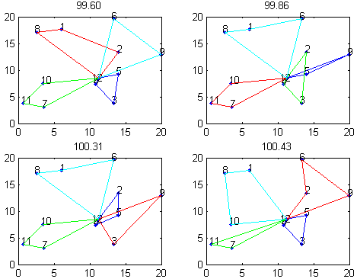This project is for me a little bit as solving Rubik’s cube. There are a lot of methods in the internet, but finding them yourself by trying and thinking about issues is much more satisfying.*

***History:***

**2012**

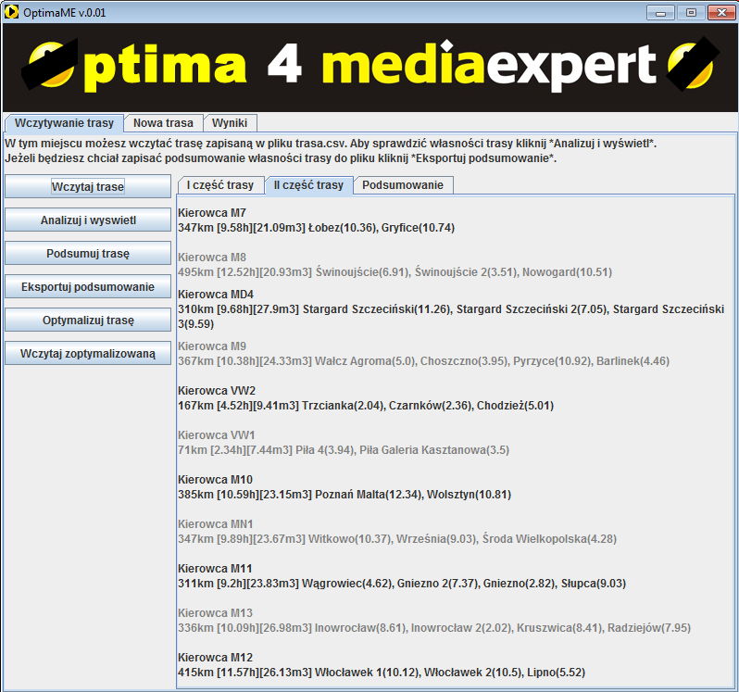I have been developing this project since getting engineer diploma with many months of breaks. After developing basics of an algorithm in Matlab[legacy/2012/engineersProject] I did some comparision between C++ and Java code efficiency and I decided to develop console application. Before that I had developed Java application for MediaExpert company, which I believed should convince them to cooperation with me. It didn’t.

Image 1: Results of Matlab script for 12 cities.

**2013**

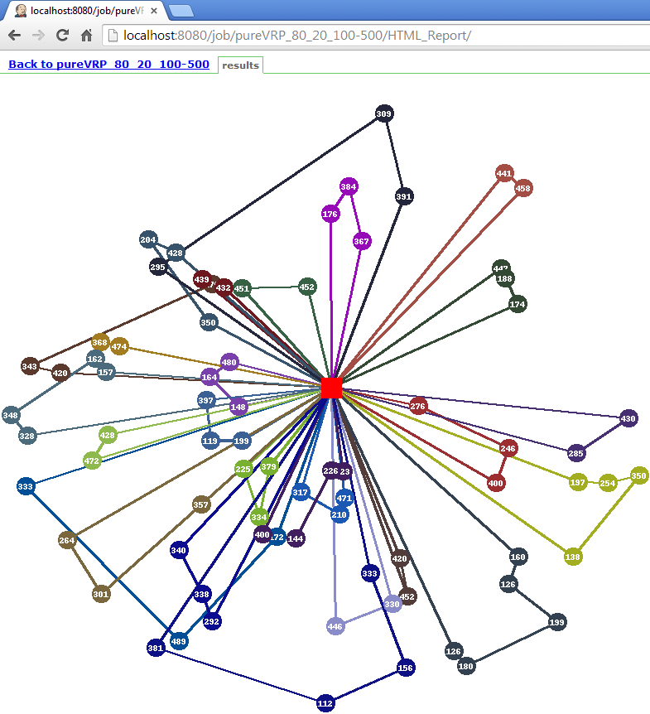During this year only from time to time I was implementing some optimizations or tests. It was quite intense year because of studying and working at the same time.  
  
**04/2014**  
I had 2 weeks holidays, and in few days I rewrite an algorithm to more OO form. So most of C++ code in currentOrSupported/VRP/VRPCore comes from that period of time. There were no reviews, so the quality is not high, and also my skills were lower then. At the same time I wrote C# application [pureCVRPClient] to compare user and algorithm results. Also I used Python and Jenkins to test application I had written.

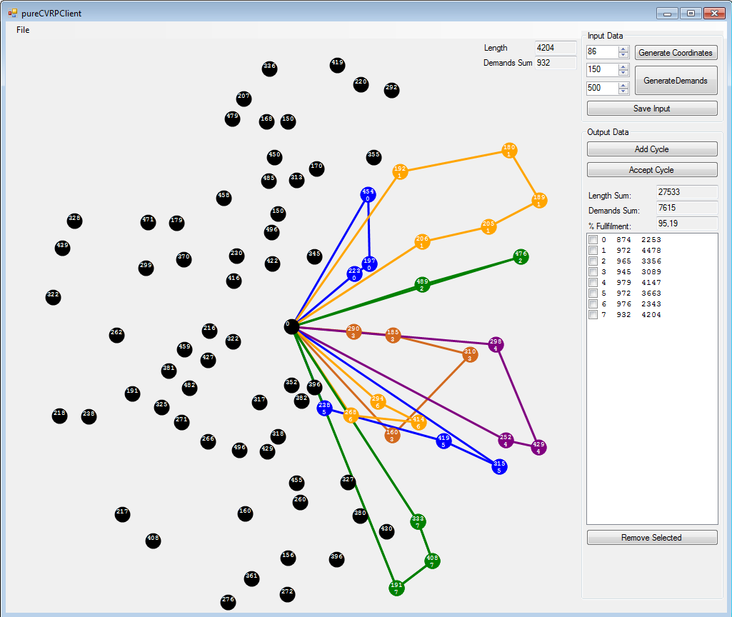

Image 4: pureCVRPClient – small C# application.

Image 2: Java application for MediaExpert

Image 3: Python draw of VRPCore output in Jenkins