Predicting Median Housing Values in California:
A Statistical and Machine Learning Analysis
Technical Report

Prepared by: Francois Lubin & Angelica Johnson
Final Project: Statistical Analysis & Predictive Modeling Team Project
Date: October 19, 2026

Executive Summary
This report documents the end-to-end statistical analysis of the California Housing dataset (1990 U.S. Census, 20,640 block-group records), covering data cleaning, exploratory data analysis (EDA), predictive model development, and validation. After cleaning, 18,575 records remained for analysis. Two candidate models were compared to predict median_house_value: a multiple linear regression baseline and a random forest regressor. Using 5-fold cross-validation and a held-out 20% test set, the random forest regressor was selected as the final model, achieving a test RMSE of approximately $44,715 and R² = 0.796, compared to $58,464 RMSE and R² = 0.652 for linear regression. Median household income was the strongest single predictor in both models. Residual diagnostics revealed right-skewed, moderately heteroscedastic residuals (Shapiro-Wilk p < 0.001), a limitation discussed in Section 7.

Table of Contents
- 1. Introduction
- 2. Data Description
- 3. Data Cleaning and Preparation
- 4. Exploratory Data Analysis
- 5. Modeling Methodology
- 6. Results
- 7. Statistical Validity and Model Selection Discussion
- 8. Limitations
- 9. Conclusion
- 10. References

1. Introduction
Housing affordability and valuation are central questions in applied statistics and urban economics. This project analyzes the California Housing dataset, derived from the 1990 U.S. Census, to build a model that predicts the median house value of a census block group from geographic, demographic, and housing-stock characteristics. The objective is twofold: (1) to produce a statistically sound, well-validated predictive model, and (2) to communicate the reasoning behind model selection using appropriate statistical diagnostics rather than accuracy metrics alone.
The project follows a standard applied statistics workflow: data cleaning and preparation, exploratory data analysis, model development and comparison, and validation of the final model's statistical assumptions.

2. Data Description
The raw dataset contains 20,640 observations across 10 variables: longitude, latitude, housing_median_age, total_rooms, total_bedrooms, population, households, median_income, median_house_value (target), and ocean_proximity (categorical: <1H OCEAN, INLAND, NEAR OCEAN, NEAR BAY, ISLAND). Each row represents a census block group rather than an individual household.
Variable | Description
median_house_value | Target variable: median value of owner-occupied homes (USD)
median_income | Median household income (tens of thousands USD)
housing_median_age | Median age of houses in the block group (years)
total_rooms / total_bedrooms | Aggregate room and bedroom counts for the block group
population / households | Aggregate population and household counts
ocean_proximity | Categorical proximity to the ocean

3. Data Cleaning and Preparation
Cleaning followed a reproducible pipeline (src/data_prep.py) applying the following steps in order:
- Duplicate removal: exact duplicate rows were dropped (0 found).
- Invalid record removal: rows with non-positive housing_median_age, total_rooms, households, or median_house_value were removed, along with rows where total_bedrooms logically exceeded total_rooms.
- Top-coded target handling: median_house_value is capped at $500,001 in the source data, producing an artificial spike at that value. The 965 top-coded records were removed; the model's scope is therefore restricted to block groups with median values below $500,001.
- Missing-value imputation: total_bedrooms had 207 missing values (1.0% of records). These were imputed using the median total_bedrooms within the same ocean_proximity group, a context-aware alternative to a single global median. Imputed values were capped at that row's total_rooms to preserve logical consistency.
- Feature engineering: three ratio features were derived — rooms_per_household, bedrooms_per_room, and population_per_household — which are more directly informative than the raw aggregate counts.
- Outlier removal: the 1.5×IQR rule was applied to rooms_per_household and population_per_household, removing 1,100 extreme records (e.g., block groups with implausibly high rooms-per-household ratios).
After cleaning, 18,575 of the original 20,640 records (90.0%) remained for analysis.

4. Exploratory Data Analysis

4.1 Distribution of the Target Variable
The distribution of median_house_value is right-skewed (skewness = 0.78), with a mean of $193,935 and median of $176,400. This is consistent with typical income and price distributions, where a majority of block groups cluster at moderate values while a smaller number of higher-value areas extend the right tail.
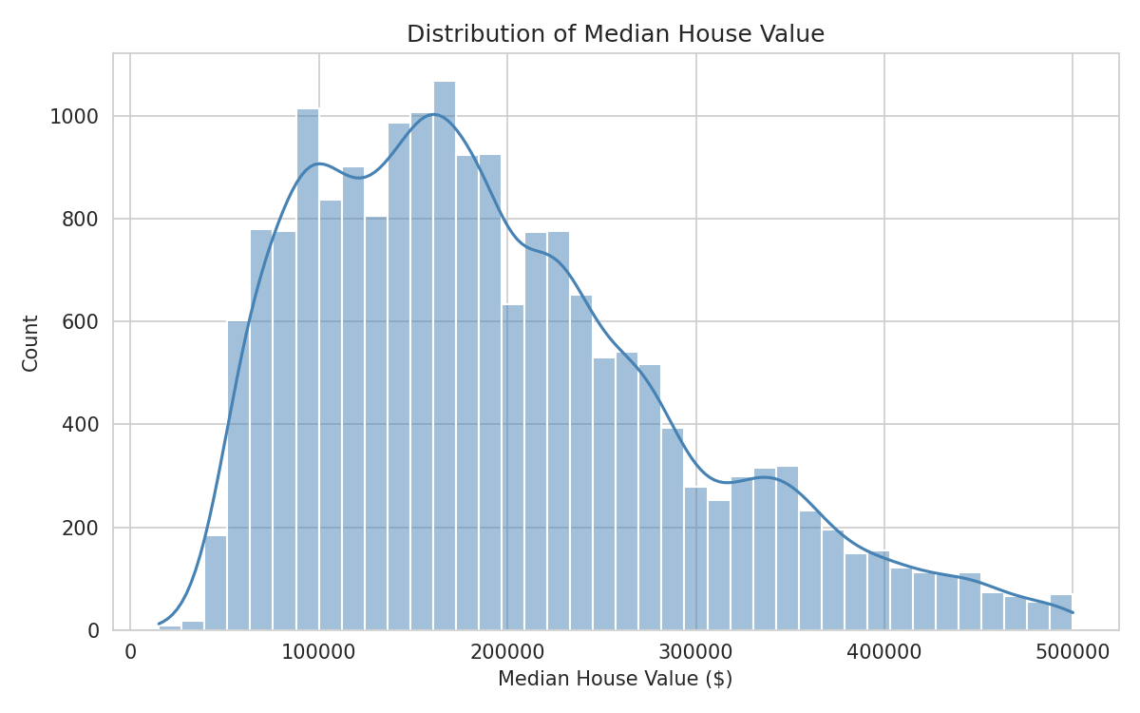
Figure 1. Distribution of median house value after cleaning.

4.2 Correlation Structure
Median income shows the strongest linear association with the target (r = 0.64), consistent with economic expectations. rooms_per_household and bedrooms_per_room are strongly negatively correlated with each other (r = -0.80), reflecting that block groups with more rooms per household tend to have proportionally fewer bedrooms per room (larger, non-bedroom living space).
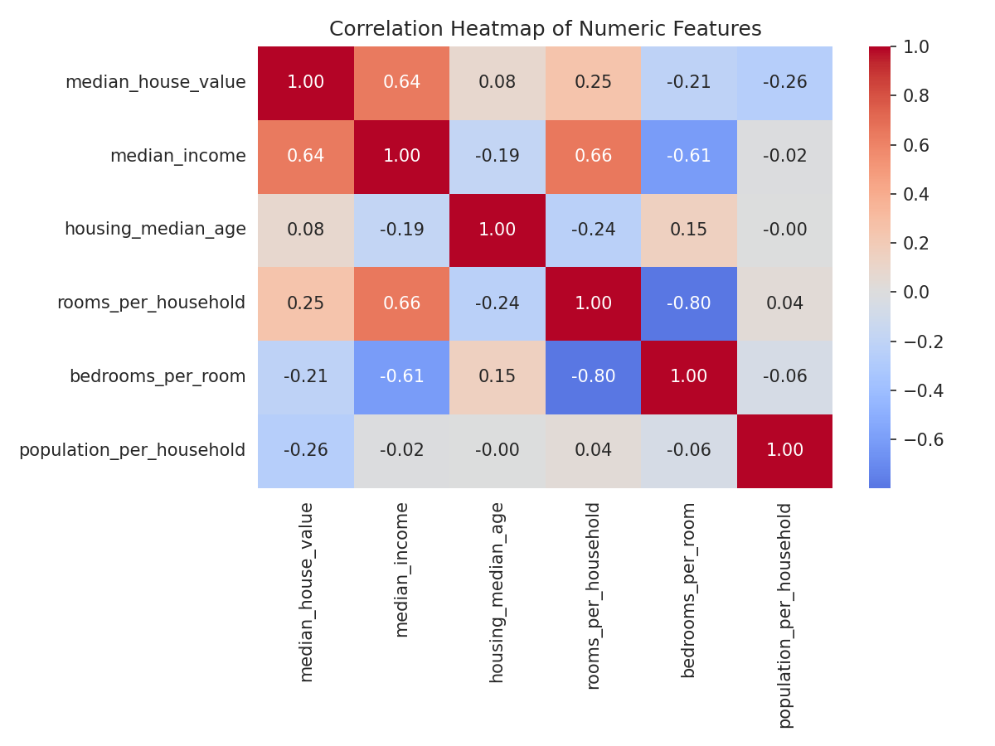
Figure 2. Correlation heatmap of numeric features.

4.3 Income vs. House Value
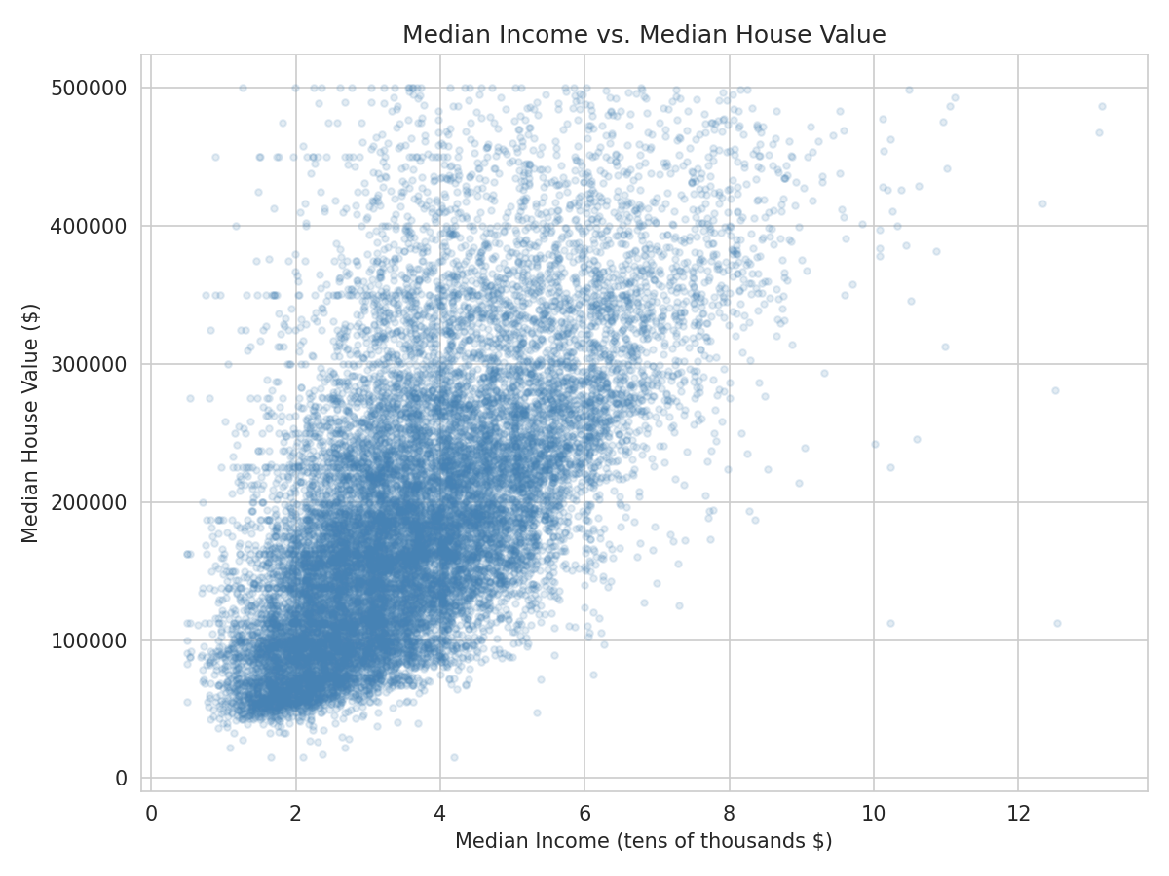
Figure 3. Median income vs. median house value. The positive association is clearly visible, along with increasing spread (heteroscedasticity) at higher income levels.

4.4 Geographic Distribution
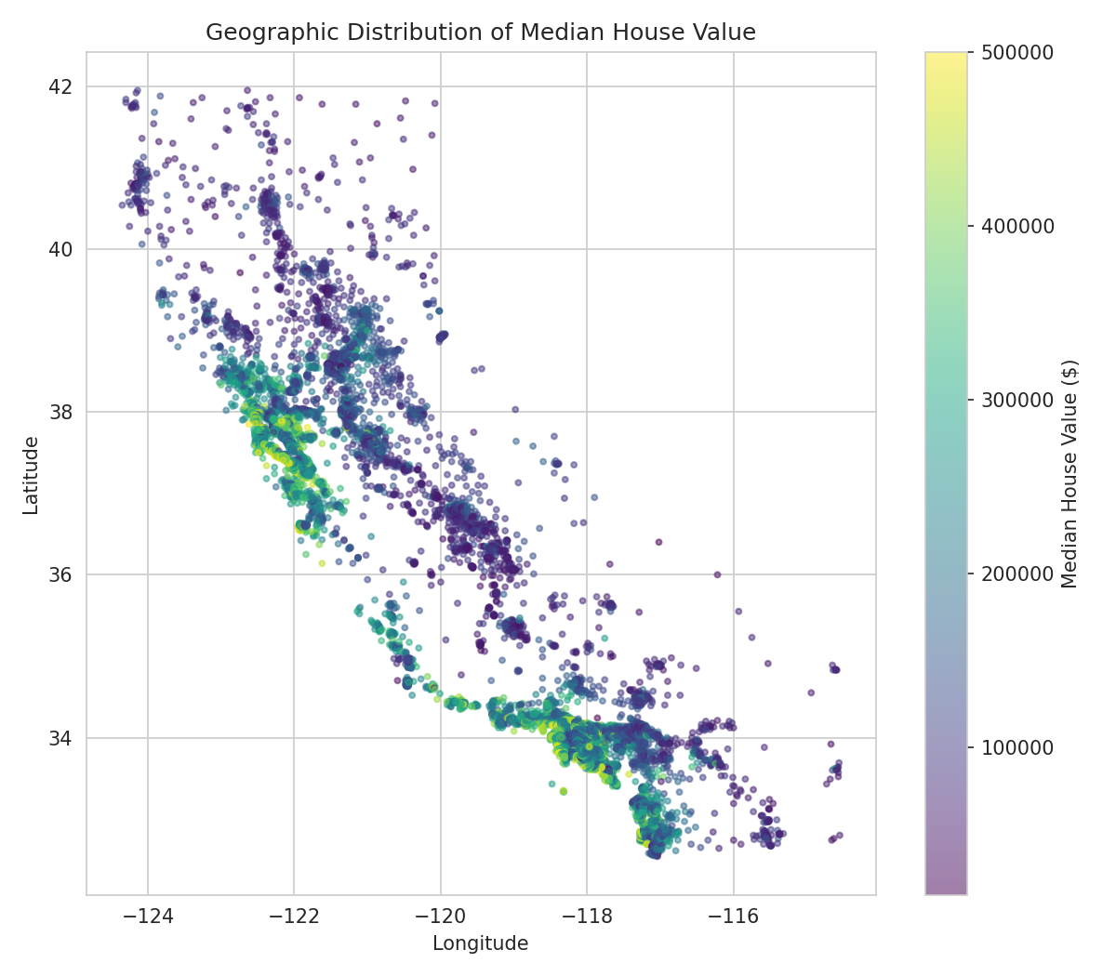
Figure 4. Geographic distribution of median house value across California. Coastal areas, particularly near the Bay Area and Los Angeles, show visibly higher values.

4.5 House Value by Ocean Proximity
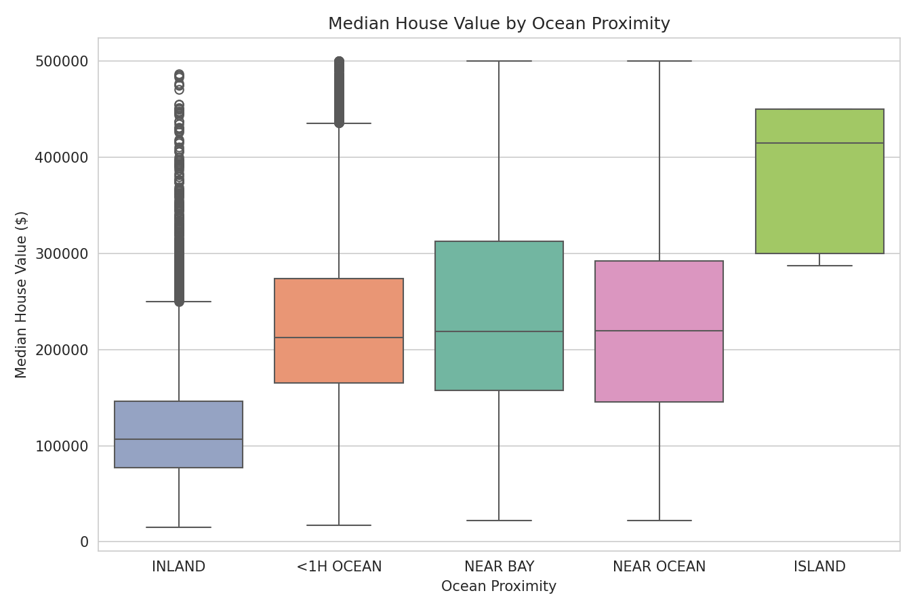
Figure 5. Median house value by ocean proximity category. INLAND block groups show systematically and substantially lower values, later confirmed as the second most important predictor in the random forest model.

5. Modeling Methodology
The cleaned data were split into training (80%, n = 14,860) and test (20%, n = 3,715) sets using a fixed random seed for reproducibility. All numeric features were median-imputed (safeguarding against any residual missingness) and standardized; the categorical ocean_proximity feature was one-hot encoded. Both steps were encapsulated in a scikit-learn ColumnTransformer to prevent data leakage between training and test sets.
Two models were trained and compared:
- Linear Regression: an ordinary least squares baseline, included to establish an interpretable reference point and to test whether the relationship between predictors and price is adequately captured by a linear, additive model.
- Random Forest Regressor: an ensemble of 150 regression trees (max depth 18, min_samples_leaf = 3), selected as a candidate capable of capturing non-linear relationships and interaction effects (e.g., the value of income may depend on geographic location) without requiring explicit interaction terms. Tree depth and count were constrained to control model file size and reduce overfitting risk, with negligible cost to accuracy (see Section 6).
Model comparison used 5-fold cross-validation on the training set, scored by root mean squared error (RMSE), followed by a final, single evaluation of each fitted model on the held-out test set to obtain an unbiased performance estimate. The model with the lower mean cross-validated RMSE was selected as final and re-evaluated on the test set for reporting.

6. Results
Model | CV RMSE (mean ± SD) | Test RMSE | Test MAE | Test R²
Linear Regression | $57,478 ± $1,081 | $58,464 | $43,137 | 0.652
Random Forest (final) | $45,204 ± $1,245 | $44,715 | $29,899 | 0.796

The random forest reduced test RMSE by approximately 24% relative to linear regression and improved R² from 0.652 to 0.796, indicating it explains a substantially larger share of the variance in median house value. The gap between cross-validated and test RMSE is small for both models (< 2%), indicating neither model is meaningfully overfit to the training folds.

6.1 Feature Importance (Random Forest)
Feature | Importance
median_income | 0.429
ocean_proximity: INLAND | 0.181
population_per_household | 0.111
longitude | 0.077
latitude | 0.069

Median income alone accounts for roughly 43% of the random forest's total feature importance, consistent with its strong marginal correlation identified in the EDA. Notably, longitude and latitude together contribute meaningfully (about 15% combined), confirming that geographic location carries predictive information beyond what is captured by ocean_proximity alone — consistent with the visible coastal-value gradient in Figure 4.

7. Statistical Validity and Model Selection Discussion

7.1 Why Random Forest Was Selected
Model selection was based on cross-validated RMSE rather than a single train/test split, reducing the risk that the comparison reflects one particular partition of the data (an application of the sampling-variability principle: a single point estimate of performance carries sampling error, while averaging over 5 folds gives a more stable estimate of true generalization error). The random forest's substantially lower cross-validated RMSE (by approximately $12,274, or 21%) and tight standard deviation across folds ($1,245) indicate the improvement is consistent and not an artifact of a favorable fold split.
The magnitude of improvement is also consistent with the underlying data structure observed in EDA: the relationship between predictors (especially geographic coordinates and ocean_proximity interacting with income) and house value is not purely linear or additive. Random forests can model such interactions and non-linearities without explicit specification, which is a plausible statistical explanation for its improved fit over ordinary least squares.

7.2 Residual Diagnostics
For a regression model to support valid inference (beyond point prediction), residuals should be approximately normally distributed with constant variance (homoscedasticity). These assumptions were assessed for the final model on the test set:
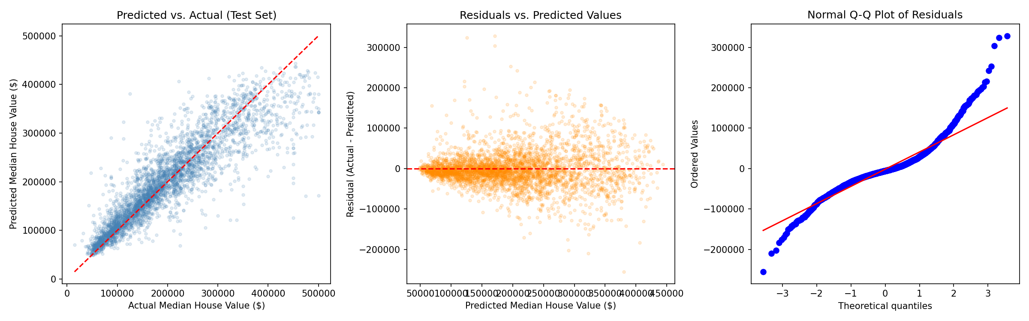
Figure 6. Predicted vs. actual values (left), residuals vs. predicted values (center), and a normal Q-Q plot of residuals (right) for the final random forest model on the test set.
- Predicted vs. actual (left panel): points cluster around the 45° reference line, confirming the model tracks the target reasonably well across most of its range, with somewhat more scatter at higher home values.
- Residuals vs. predicted (center panel): residual spread increases modestly at higher predicted values, indicating mild heteroscedasticity — the model is less precise for higher-value block groups than for lower-value ones.
- Normal Q-Q plot (right panel): residuals deviate from the reference line in both tails, most visibly in the upper tail, indicating the residual distribution is right-skewed with heavier tails than a normal distribution.
A Shapiro-Wilk test on a random sample of 3,715 test-set residuals formally rejected the null hypothesis of normality (W = 0.908, p < 0.001). Given the very large sample size, even small departures from normality can produce a statistically significant result; the Q-Q plot provides the more informative, practically interpretable evidence of the skew's magnitude.

7.3 Implication for Model Use
The residual non-normality does not invalidate the model's point predictions — random forests make no distributional assumption about residuals during training, unlike ordinary least squares. However, it does mean that naive symmetric prediction intervals (e.g., prediction ± 1.96 × RMSE) would understate uncertainty for high-value block groups and should not be used for formal interval estimation without adjustment (e.g., via quantile regression forests or bootstrap-based asymmetric intervals).

8. Limitations
- Top-coding exclusion: removing records at the $500,001 cap means the model does not extrapolate reliably to California's highest-value housing markets.
- Data age: the dataset reflects 1990 Census conditions; relationships between income, location, and housing value may have shifted substantially in the intervening decades, so the model should not be used for current market prediction without re-fitting on recent data.
- Ecological-level data: each record aggregates an entire census block group, not an individual household; inferences should not be applied to individual homes (an instance of the ecological fallacy).
- Mild heteroscedasticity: prediction uncertainty is not constant across the price range, as shown in Section 7.2, and should be communicated accordingly rather than as a single fixed margin of error.
- Interpretability trade-off: the random forest, while more accurate, is less directly interpretable than linear regression; feature importances describe overall influence but not the sign or functional form of each effect.

9. Conclusion
This analysis cleaned, explored, and modeled the California Housing dataset, comparing a linear regression baseline against a random forest regressor using cross-validated statistical evaluation rather than a single accuracy figure. The random forest was selected as the final model based on a consistent, cross-validated reduction in RMSE and improvement in R², supported by the EDA finding that income and location interact in ways a purely linear model does not capture. Residual diagnostics confirmed reasonable point-prediction accuracy while identifying right-skewed, mildly heteroscedastic residuals that should inform how prediction uncertainty is communicated in any downstream application of this model.

10. References
Pace, R. K., & Barry, R. (1997). Sparse spatial autoregressions. Statistics & Probability Letters, 33(3), 291–297. (Original source of the California Housing dataset.)
Géron, A. (2019). Hands-On Machine Learning with Scikit-Learn, Keras, and TensorFlow (2nd ed.). O'Reilly Media. (Dataset distribution used in this project.)
Pedregosa, F., et al. (2011). Scikit-learn: Machine Learning in Python. Journal of Machine Learning Research, 12, 2825–2830.

