**Questions Answers**

Task 1

2. database design (entity relationship diagram):

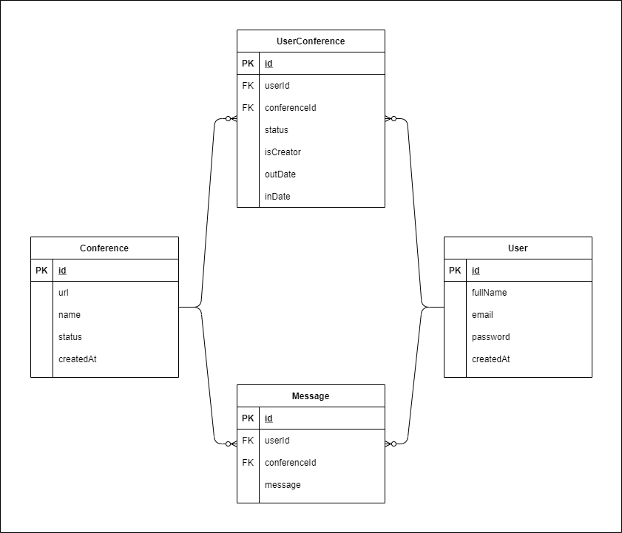

3. we can store the binary files (video -audio) in external storage like amazon web service -s3, bunny storage or any other cdn.

We can store the metadata of the files like url in conference table in our database so that we can reach the files from our application.

4. for the files security we can strict the access to the files using access token that added to the header of the request that get the file and we should change the access token periodically and ensure that only the users of the system can get this access token.

Task 2