**Data warehousing and mining**

**Module 1**

**Data warehousing**

Data warehousing is a method of organizing and compiling data into one database, whereas data mining deals with fetching important data from databases.

Data mining attempts to depict meaningful patterns through a dependency on the data that is compiled in the data warehouse.

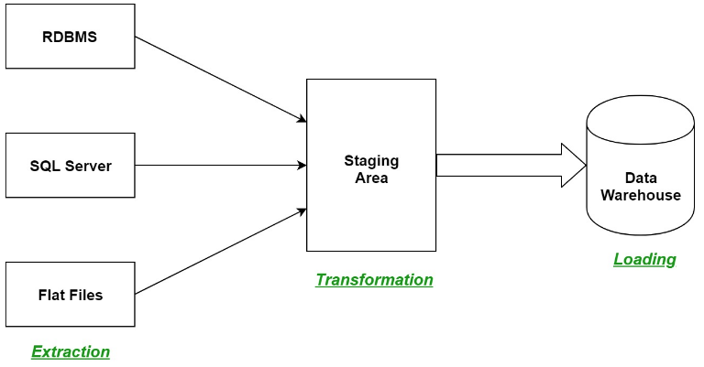

A data warehouse is where data can be collected for mining purposes, usually with large storage capacity. Various organizations’ systems are in the data warehouse, where it can be fetched as per usage.

Source 🡪 Extract 🡪Transform 🡪 Load 🡪 Target.

**Data warehouse process-**

Data warehouses collaborate data from several sources and ensure data accuracy, quality, and consistency. System execution is boosted by differentiating the process of analytics from traditional databases. In a data warehouse, data is sorted into a formatted pattern by type and as needed. The data is examined by query tools using several patterns.

Data warehouses store historical data and handle requests faster, helping in online analytical processing, whereas a database is used to store current transactions in a business process that is called online transaction processing.

**Applications of Data Warehouses:**

Data warehouses help analysts or senior executives analyze, organize, and use data for decision making.

It is used in the following fields:

* Consumer goods
* Banking services
* Financial services
* Manufacturing
* Retail sectors

**Features**

1. **Centralized Data Repository**:
   * Integrates data from various sources into a single repository.
   * Provides a unified view of business data.
2. **Data Integration**:
   * Combines data from disparate sources such as databases, applications, and external systems.
   * Ensures consistency and accuracy of data through ETL (Extract, Transform, Load) processes.
3. **Historical Data Storage**:
   * Maintains historical data for trend analysis and long-term reporting.
   * Allows for time-based analysis, including historical comparisons and forecasting.
4. **Data Aggregation and Summarization**:
   * Supports aggregation and summarization of data to provide high-level insights.
   * Facilitates complex queries and reporting.
5. **Optimized for Query Performance**:
   * Designed to handle complex queries and large volumes of data efficiently.
   * Uses indexing, partitioning, and other techniques to enhance performance.
6. **Support for Data Mining and Analytics**:
   * Provides a foundation for data mining, business intelligence, and advanced analytics.
   * Enables sophisticated analysis and decision-making processes.
7. **Data Quality Management**:
   * Implements data cleaning and validation processes to ensure data quality.
   * Regularly updates and maintains data accuracy and consistency.

**Advantages**

1. **Improved Decision-Making**:
   * Provides comprehensive and accurate data that supports informed decision-making.
   * Facilitates business intelligence and strategic planning through detailed reports and analyses.
2. **Enhanced Reporting and Analysis**:
   * Supports complex queries and detailed reporting, providing valuable insights into business performance.
   * Allows for the creation of dashboards and visualizations for easier interpretation of data.
3. **Data Consistency and Accuracy**:
   * Ensures that data from various sources is integrated and standardized, reducing inconsistencies.
   * Improves data accuracy through rigorous data quality management.
4. **Historical Data Access**:
   * Stores historical data for trend analysis, forecasting, and longitudinal studies.
   * Allows organizations to track changes over time and analyze past performance.
5. **Increased Efficiency**:
   * Reduces the time and effort required to generate reports and perform analyses.
   * Centralizes data access, making it easier for users to obtain the information they need.
6. **Scalability**:
   * Supports the growth of data volumes and complexity over time.
   * Can be scaled to accommodate increasing data and user demands.
7. **Support for Business Intelligence Tools**:
   * Integrates seamlessly with various BI tools for advanced data analysis and visualization.
   * Enhances the capabilities of data mining and predictive analytics.

**Disadvantages**

1. **High Initial Cost**:
   * Requires significant investment in hardware, software, and infrastructure.
   * Implementation and setup costs can be substantial, especially for large organizations.
2. **Complex Implementation**:
   * Building and maintaining a data warehouse can be complex and time-consuming.
   * Requires careful planning and expertise in data modeling, ETL processes, and database management.
3. **Data Latency**:
   * Data may not be updated in real-time, leading to potential delays in data availability.
   * Latency can affect the timeliness of reporting and analysis.
4. **Maintenance and Management**:
   * Ongoing maintenance is required to ensure data accuracy, performance, and security.
   * Regular updates and data management tasks can be resource-intensive.
5. **Data Security and Privacy**:
   * Centralized data repositories can be targets for security breaches and data theft.
   * Requires robust security measures to protect sensitive information and comply with privacy regulations.
6. **Scalability Challenges**:
   * While data warehouses are scalable, scaling can involve additional costs and complexity.
   * Handling large volumes of data may require more advanced infrastructure and optimization.
7. **Data Integration Issues**:
   * Integrating data from diverse sources can be challenging, especially with inconsistent data formats and quality.
   * Requires thorough data cleansing and transformation processes to ensure integration success.

**Design guidelines for data warehousing implementation -**

**1. Define Objectives and Requirements**

* **Business Goals**: Understand the business objectives and what insights or reports the data warehouse needs to support.
* **User Requirements**: Gather requirements from end-users to ensure the data warehouse meets their needs for reporting, analysis, and decision-making.
* **Scope and Budget**: Define the scope of the project and establish a budget to guide the design and implementation process.

**2. Design the Data Model**

* **Conceptual Design**: Create a high-level model that represents the major entities and relationships within the data warehouse. This often involves using ER diagrams.
* **Logical Design**: Develop a detailed schema that includes tables, columns, and relationships. Consider star schemas or snowflake schemas for organizing data.
* **Dimensional Modeling**: Use dimensions and fact tables to structure data for efficient querying and reporting. Define measures, dimensions, and hierarchies.

**3. Plan Data Integration**

* **Data Sources**: Identify and assess the various data sources that will feed into the data warehouse, including databases, applications, and external data sources.
* **ETL Process**: Design the Extract, Transform, Load (ETL) processes to move data from source systems into the data warehouse. Ensure data cleansing, transformation, and loading are handled efficiently.
* **Data Quality**: Implement processes for data quality management, including validation, error handling, and consistency checks.

**4. Ensure Scalability and Performance**

* **Scalability**: Design the data warehouse to handle increasing data volumes and user demands. Consider partitioning, indexing, and scalable architecture.
* **Performance Optimization**: Optimize the data warehouse for query performance by using techniques such as indexing, materialized views, and query optimization.

**5. Implement Security and Privacy**

* **Access Control**: Define user roles and permissions to control access to data. Implement role-based access control and encryption to protect sensitive data.
* **Data Privacy**: Ensure compliance with data privacy regulations (e.g., GDPR, CCPA) and implement measures to protect personal and confidential information.

**6. Plan for Data Management**

* **Data Governance**: Establish data governance policies and procedures for managing data quality, consistency, and compliance.
* **Data Archiving**: Design strategies for archiving historical data to manage storage costs and maintain performance.
* **Data Backup and Recovery**: Implement backup and recovery procedures to protect against data loss and ensure business continuity.

**7. Design the User Interface**

* **Reporting and Analytics**: Develop user-friendly reporting and analytics tools that provide meaningful insights and visualizations. Consider dashboards, ad-hoc reporting, and drill-down capabilities.
* **User Experience**: Ensure the interface is intuitive and meets the needs of various user roles, including analysts, managers, and executives.

**8. Consider Data Warehouse Architecture**

* **Single-Tier Architecture**: For smaller implementations, a single-tier architecture may suffice, where all components reside on a single server.
* **Two-Tier Architecture**: Separates the data warehouse from the reporting and analysis tools, allowing for more scalability and flexibility.
* **Three-Tier Architecture**: Includes a data staging layer, a data warehouse layer, and a presentation layer, providing the most flexibility and scalability.

**9. Plan for Maintenance and Support**

* **Monitoring**: Implement monitoring tools to track performance, data integrity, and system health.
* **Maintenance**: Plan for regular maintenance tasks, including updates, patches, and performance tuning.
* **Support**: Establish a support plan for troubleshooting issues and addressing user queries.

**10. Document and Communicate**

* **Documentation**: Maintain comprehensive documentation of the data warehouse design, data models, ETL processes, and user interfaces.
* **Communication**: Regularly communicate with stakeholders and users throughout the design and implementation process to ensure alignment and address any concerns.

**Multi-Dimensional Data Model?**

A multidimensional model views data in the form of a data-cube. A data cube enables data to be modeled and viewed in multiple dimensions. It is defined by dimensions and facts.

The dimensions are the perspectives or entities concerning which an organization keeps records. For example, a shop may create a sales data warehouse to keep records of the store's sales for the dimension time, item, and location. These dimensions allow the save to keep track of things, for example, monthly sales of items and the locations at which the items were sold. Each dimension has a table related to it, called a dimensional table, which describes the dimension further. For example, a dimensional table for an item may contain the attributes item_name, brand, and type.

A multidimensional data model is organized around a central theme, for example, sales. This theme is represented by a fact table. Facts are numerical measures. The fact table contains the names of the facts or measures of the related dimensional tables.

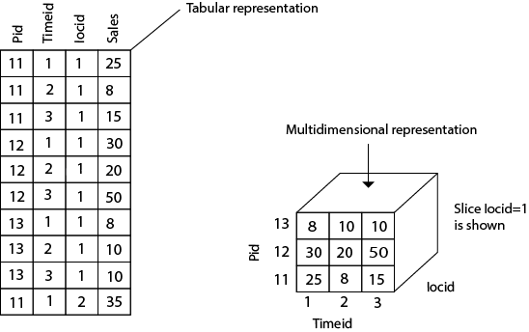

Consider the data of a shop for items sold per quarter in the city of Delhi. The data is shown in the table. In this 2D representation, the sales for Delhi are shown for the time dimension (organized in quarters) and the item dimension (classified according to the types of an item sold). The fact or measure displayed in rupee_sold (in thousands).

**Key Concepts**

1. **Dimensions**:
   * **Definition**: Dimensions are perspectives or attributes by which data can be analyzed. They provide context to the measures and help in slicing and dicing the data.
   * **Examples**: Time, location, product, customer, and sales region.
2. **Facts**:
   * **Definition**: Facts are quantitative data or metrics that are of interest and can be measured. They represent the data points that are analyzed across different dimensions.
   * **Examples**: Sales revenue, number of units sold, profit margins.
3. **Measures**:
   * **Definition**: Measures are the numerical values or quantities that are aggregated or analyzed in the fact tables. They are often calculated from the data stored in the fact tables.
   * **Examples**: Total sales, average revenue per customer.
4. **Fact Tables**:
   * **Definition**: Fact tables store quantitative data and are typically large. They contain measures and foreign keys to the dimension tables.
   * **Structure**: Fact tables include data such as sales transactions, performance metrics, and other numerical data that are analyzed over different dimensions.
5. **Dimension Tables**:
   * **Definition**: Dimension tables contain descriptive attributes or characteristics related to the dimensions. They provide context and additional details for the facts.
   * **Structure**: Dimension tables typically include attributes such as product name, customer address, or time period.
6. **Star Schema**:
   * **Definition**: A star schema is a type of multidimensional model where the fact table is at the center, and dimension tables are connected to it. The structure resembles a star.
   * **Advantages**: Simple design, easy to understand, and efficient for querying and reporting.
   * **Example**: A sales fact table connected to dimension tables for time, product, and location.
7. **Snowflake Schema**:
   * **Definition**: A snowflake schema is a more normalized form of the star schema, where dimension tables are further broken down into related sub-dimension tables. This structure resembles a snowflake.
   * **Advantages**: Reduces data redundancy and improves data integrity.
   * **Example**: A product dimension table broken down into product category and product sub-category tables.
8. **Galaxy Schema (or Fact Constellation Schema)**:
   * **Definition**: A galaxy schema includes multiple fact tables that share dimension tables. It is used for complex data models involving multiple business processes.
   * **Advantages**: Supports complex queries and provides a comprehensive view of different business processes.
   * **Example**: Sales and inventory fact tables sharing common dimension tables for time and product.

**Benefits of Multidimensional Modeling**

1. **Enhanced Query Performance**:
   * Optimized for complex queries and aggregations. Pre-aggregated data and indexing improve performance.
2. **User-Friendly Reporting**:
   * Facilitates intuitive reporting and analysis by allowing users to view data from various perspectives and drill down into details.
3. **Data Consistency**:
   * Provides a consistent view of data across different dimensions and measures, ensuring uniformity in reporting and analysis.
4. **Efficient Data Analysis**:
   * Enables quick slicing, dicing, and pivoting of data, making it easier to analyze trends, patterns, and insights.
5. **Flexibility**:
   * Allows for flexible and dynamic analysis by enabling users to explore data across different dimensions and measures.

**Challenges**

1. **Complexity**:
   * Designing and maintaining a multidimensional model can be complex, especially for large and intricate data warehouses.
2. **Data Redundancy**:
   * Star and snowflake schemas may involve some data redundancy, leading to increased storage requirements.
3. **Performance Trade-offs**:
   * While multidimensional models improve query performance, they may require significant resources and careful tuning.

**OLAP (online analytical processing)**

**Online Analytical Processing (OLAP)** is a category of data processing and analysis that enables users to interactively explore and analyze multidimensional data. Unlike traditional transaction-oriented systems, which focus on handling large volumes of routine transactions, OLAP systems are designed to support complex queries, data analysis, and decision-making. OLAP provides a means to efficiently analyze and aggregate data across different dimensions, allowing users to gain insights into business performance, trends, and patterns.

OLAP, which stands for Online Analytical Processing, is a technology used in data analysis and business intelligence. It allows users to interactively analyze large volumes of multidimensional data in real-time. OLAP systems provide a way to organize, retrieve, and analyze data from various dimensions or perspectives, enabling users to gain insights and make informed decisions.

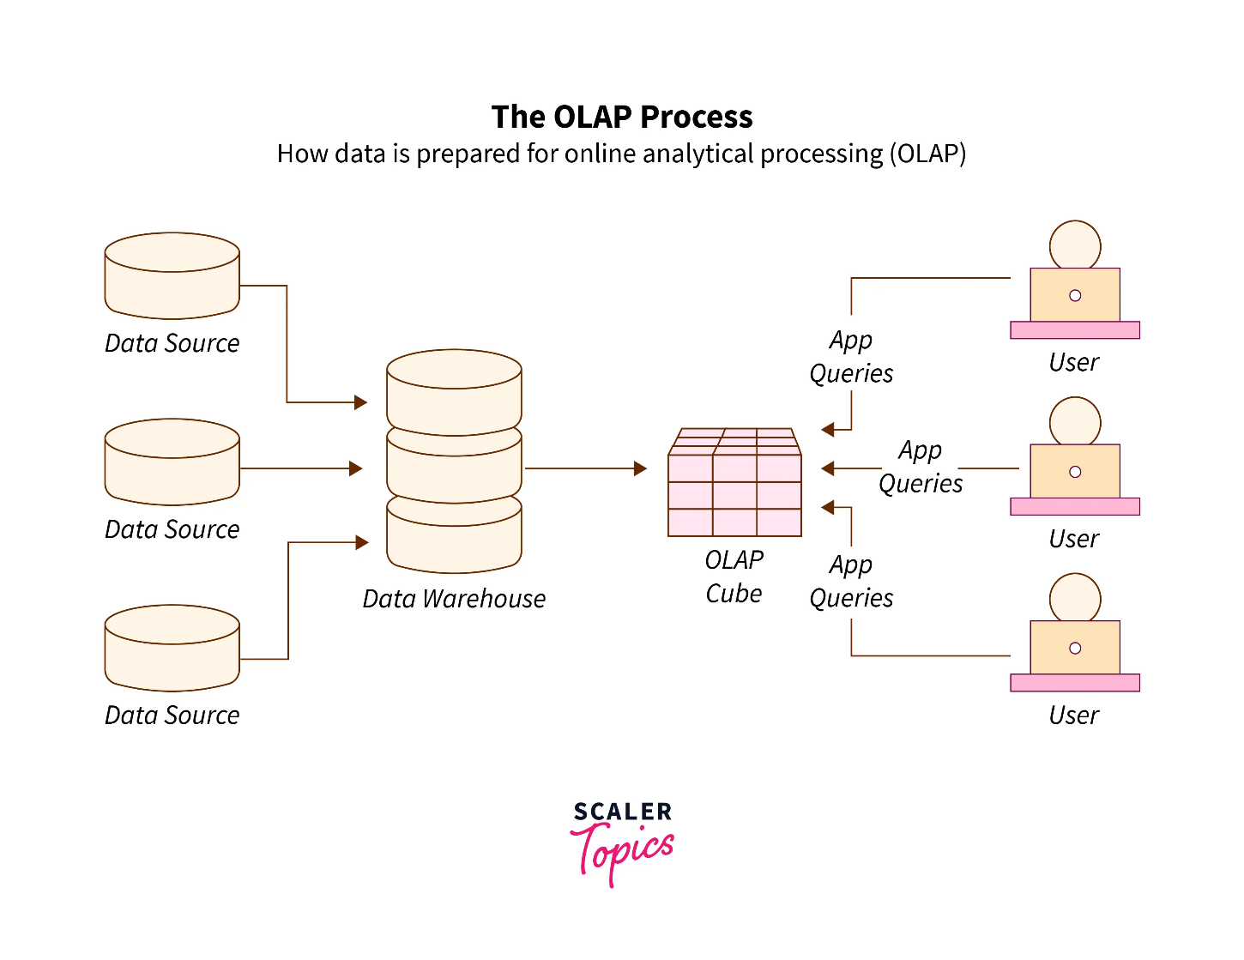

**Purpose and Goals of OLAP**

1. **Data Analysis and Insight**:
   * OLAP is used to uncover insights by analyzing data from multiple perspectives. It helps in identifying trends, patterns, and anomalies that are crucial for strategic decision-making.
2. **Interactive Exploration**:
   * Users can interactively query and explore data, performing operations such as slicing, dicing, drilling down, and rolling up. This interactive capability allows users to generate customized reports and perform ad-hoc analysis
3. **complex Queries**:
   * OLAP systems are optimized for complex analytical queries, enabling users to perform aggregations, calculations, and comparisons that are not feasible with traditional relational databases.
4. **Business Intelligence**:
   * OLAP supports business intelligence (BI) by providing tools for analyzing business performance, forecasting future trends, and generating insights that drive strategic planning and operational improvements.

**Importance of OLAP in Data Warehousing**

1. **Enhanced Analytical Capabilities**:
   * OLAP enhances the analytical capabilities of data warehouses by providing multidimensional views of data. This helps users to analyze data across various dimensions and hierarchies, such as time, geography, and product.
2. **Performance Optimization**:
   * OLAP systems are designed to handle large volumes of data and perform complex calculations efficiently. Techniques such as pre-aggregation, indexing, and caching improve the performance of data retrieval and query execution.
3. **User Accessibility**:
   * OLAP provides user-friendly interfaces that allow non-technical users to perform complex data analysis. Tools such as pivot tables, dashboards, and interactive visualizations make it easier for users to gain insights without needing advanced technical skills.
4. **Scalability and Flexibility**:
   * OLAP systems are scalable and can handle growing volumes of data and increasing numbers of users. They offer flexibility in querying and reporting, allowing users to adjust their analysis based on evolving business needs.

**Types of OLAP**

There are various varieties of OLAP, each serving particular requirements and preferences for data analysis. The primary OLAP kinds are:

1. **MOLAP (Multidimensional OLAP):**MOLAP (Multidimensional OLAP) systems store data in a multidimensional cube structure, with aggregated data based on several dimensions contained in each cell of the cube. MOLAP systems do precalculations and store aggregations, which results in quick query responses. They work effectively in situations when performance is crucial and data quantities aren’t very huge. Microsoft Analysis Services, IBM Cognos TM1, and Essbase are a few MOLAP system examples.
2. **Relational OLAP (ROLAP):**Traditional relational databases are used for data storage by ROLAP systems. They run intricate SQL queries to simulate multidimensional views of the data. ROLAP systems can manage huge datasets and complicated data linkages, therefore they can have slightly slower query speed than MOLAP systems, but they also provide better flexibility and scalability. ROLAP systems include those from Oracle OLAP, SAP BW (Business Warehouse), and Pentaho, as examples.
3. **Hybrid OLAP (HOLAP):**HOLAP systems attempt to combine the benefits of MOLAP and ROLAP. Similar to MOLAP, they enable the ability to obtain detailed data from the underlying relational database as necessary while also storing summary data in cubes. Depending on the type of analysis, this method helps to improve both performance and flexibility. Users of some MOLAP systems have the option of retrieving detailed data or pre-aggregated data by using HOLAP capabilities that are supported by these systems.
4. **DOLAP (Desktop OLAP):**Desktop OLAP, often known as DOLAP, is a simplified form of OLAP that operates on individual desktop PCs. It is appropriate for lone analysts who wish to carry out fundamental data exploration and analysis without requiring a large IT infrastructure. In-memory processing is frequently used by DOLAP tools to deliver comparatively quick performance on tiny datasets. The PivotTable feature in Excel is an illustration of a DOLAP tool.
5. **WOLAP (Web OLAP):**WOLAP systems bring OLAP capabilities to web browsers, allowing users to access and analyze data through a web-based interface. This enables remote access, collaboration, and sharing of analytical insights. WOLAP systems often use a combination of MOLAP, ROLAP, or HOLAP architectures on the backend. Web-based BI tools like Tableau, Power BI, and Looker provide WOLAP features.

**Key Components of OLAP**

1. **Multidimensional Data Model**:
   * OLAP uses a multidimensional data model to organize data into dimensions and measures. This model allows users to analyze data from multiple viewpoints and perform various types of aggregation.
2. **OLAP Cubes**:
   * OLAP cubes are data structures that store pre-aggregated data. They provide a way to quickly retrieve and analyze data across different dimensions and hierarchies.
3. **ETL Processes**:
   * ETL (Extract, Transform, Load) processes are crucial for populating the OLAP cubes with data from various source systems. ETL involves extracting data, transforming it into a suitable format, and loading it into the OLAP system.
4. **Client Tools**:
   * OLAP client tools include reporting and analysis applications that allow users to interact with the OLAP cubes. These tools provide functionalities for querying, reporting, and visualizing data.

**Benefits of OLAP**

1. **Improved Decision-Making**:
   * By providing fast and interactive access to multidimensional data, OLAP enhances decision-making processes, allowing organizations to make data-driven decisions more effectively.
2. **Rapid Data Retrieval**:
   * OLAP systems are optimized for quick data retrieval and complex queries, which improves the efficiency of data analysis and reporting.
3. **Enhanced Data Analysis**:
   * OLAP enables in-depth analysis of data by allowing users to explore data from different angles and levels of granularity, leading to a better understanding of business dynamics.
4. **Real-Time Analysis**:
   * OLAP systems support real-time or near-real-time analysis, providing timely insights that are essential for dynamic business environments.

**Characteristics**:

1. **Multidimensional Analysis**:
   * Enables users to view data from multiple dimensions (e.g., time, geography, product) and perform operations like slicing, dicing, and drilling down.
2. **Interactive Query Processing**:
   * Provides fast response times for analytical queries, allowing users to explore data and generate reports in real-time.
3. **Aggregation and Summarization**:
   * Supports aggregation of data at different levels of granularity, helping users to analyze data at various summary levels (e.g., daily, monthly, yearly).
4. **Complex Calculations**:
   * Allows for advanced calculations, such as ratios, percentages, and trend analyses, directly within the OLAP system.
5. **User-Friendly Interfaces**:
   * Features intuitive interfaces, often with drag-and-drop capabilities, making it accessible for non-technical users to perform data analysis.

**Architecture**:

1. **Data Sources**:
   * **Source Systems**: Various data sources such as transactional databases, ERP systems, and external data feeds from which data is extracted.
2. **ETL (Extract, Transform, Load)**:
   * **Extract**: Data is extracted from source systems.
   * **Transform**: Data is cleaned, transformed, and structured to fit the OLAP model.
   * **Load**: Transformed data is loaded into the OLAP system.
3. **Data Warehouse**:
   * **Central Repository**: Stores integrated and historical data used for analysis. It acts as the source for OLAP cubes.
4. **OLAP Server**:
   * **ROLAP (Relational OLAP)**: Uses relational databases to store data and performs multidimensional queries on relational data structures.
   * **MOLAP (Multidimensional OLAP)**: Uses multidimensional database systems (OLAP cubes) to store pre-aggregated data for fast retrieval.
   * **HOLAP (Hybrid OLAP)**: Combines features of both ROLAP and MOLAP for flexible and efficient processing.
5. **OLAP Cube**:
   * **Multidimensional Structure**: Pre-aggregated data organized into cubes, with dimensions and measures, facilitating fast and efficient querying.
6. **Client Tools**:
   * **Analytical Tools**: Interfaces and applications used by end-users to interact with OLAP cubes and perform data analysis (e.g., reporting tools, dashboards).

**Multidimensional View**:

1. **Dimensions**:
   * **Definition**: Perspectives or attributes used to slice and dice data (e.g., time, location, product).
   * **Hierarchies**: Structures within dimensions (e.g., year > quarter > month > day) that enable drill-down and roll-up operations.
2. **Measures**:
   * **Definition**: Quantitative data points that are analyzed across dimensions (e.g., sales revenue, quantity sold).
   * **Aggregation**: Measures are aggregated along dimensions to provide summary statistics.
3. **Slicing and Dicing**:
   * **Slicing**: Extracting a subset of data by selecting a single dimension value (e.g., sales data for January).
   * **Dicing**: Extracting a sub-cube by selecting multiple dimension values (e.g., sales data for January and February).
4. **Drill-Down and Roll-Up**:
   * **Drill-Down**: Navigating from summary data to more detailed data (e.g., from yearly sales to monthly sales).
   * **Roll-Up**: Aggregating detailed data into summary data (e.g., from monthly sales to yearly sales).

**Efficient Processing of OLAP Queries**:

1. **Pre-Aggregation**:
   * **Definition**: Aggregating data in advance and storing it in OLAP cubes to speed up query response times.
   * **Benefit**: Reduces computation time during query execution by leveraging pre-calculated aggregates.
2. **Indexing**:
   * **Definition**: Creating indexes on dimensions and measures to enhance query performance.
   * **Types**: Bitmap indexes, B-Tree indexes, and multidimensional indexes.
3. **Caching**:
   * **Definition**: Storing frequently accessed data or query results in memory to reduce query execution time.
   * **Benefit**: Improves performance by reducing the need for repetitive calculations.
4. **Partitioning**:
   * **Definition**: Dividing large OLAP cubes into smaller, manageable segments based on dimensions or data ranges.
   * **Benefit**: Enhances performance by allowing parallel processing and reducing the size of data to scan.
5. **Data Compression**:
   * **Definition**: Reducing the size of data stored in OLAP cubes using compression techniques.
   * **Benefit**: Saves storage space and improves query performance by reducing I/O operations.
6. **Optimized Query Processing**:
   * **Definition**: Using query optimization techniques, such as query rewriting and materialized views, to enhance performance.
   * **Benefit**: Ensures that queries are executed efficiently by minimizing resource usage.

**OLAP Operations**

OLAP provides various operations to gain insights from the data stored in multidimensional hypercubes. These operations include:

**Drill Down**

Drill down operation allows a user to zoom in on the data cube i.e., the less detailed data is converted into highly detailed data. It can be implemented by either stepping down a concept hierarchy for a dimension or adding additional dimensions to the hypercube.

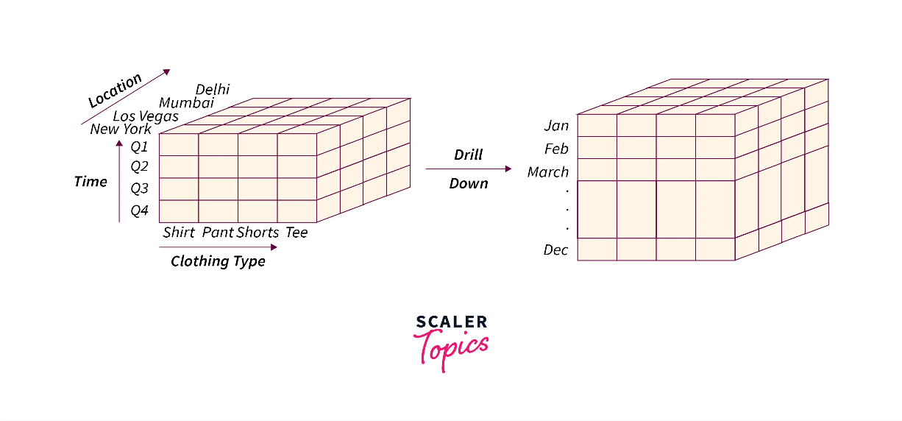**Example:** Consider a cube that represents the annual sales (4 Quarters: Q1, Q2, Q3, Q4) of various kinds of clothes (Shirt, Pant, Shorts, Tees) of a company in 4 cities (Delhi, Mumbai, Las Vegas, New York) as shown below:

 Here, the drill-down operation is applied on the time dimension and the quarter Q1 is drilled down to January, February, and March. Hence, by applying the drill-down operation, we can move down from quarterly sales in a year to monthly or weekly records.

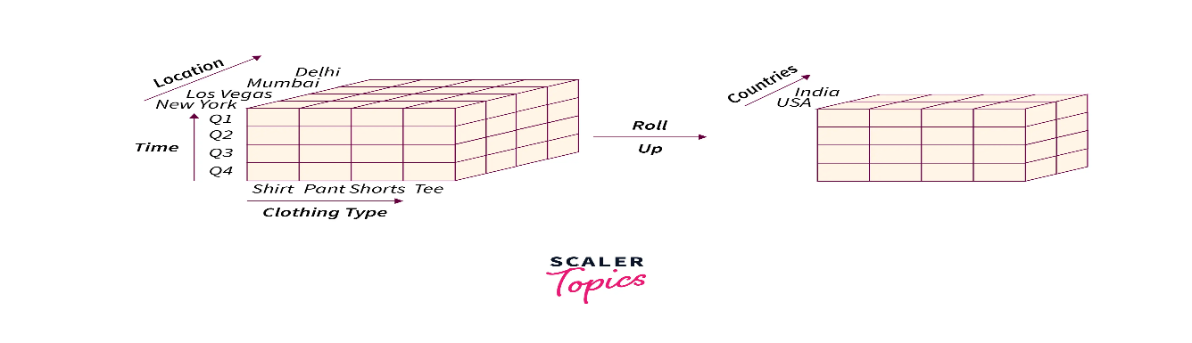**Roll up**

It is the opposite of the drill-down operation and is also known as a drill-up or aggregation operation. It is a dimension-reduction technique that performs aggregation on a data cube. It makes the data less detailed and it can be performed by combining similar dimensions across any axis.

**Example:** Considering the above-mentioned clothing company sales example:

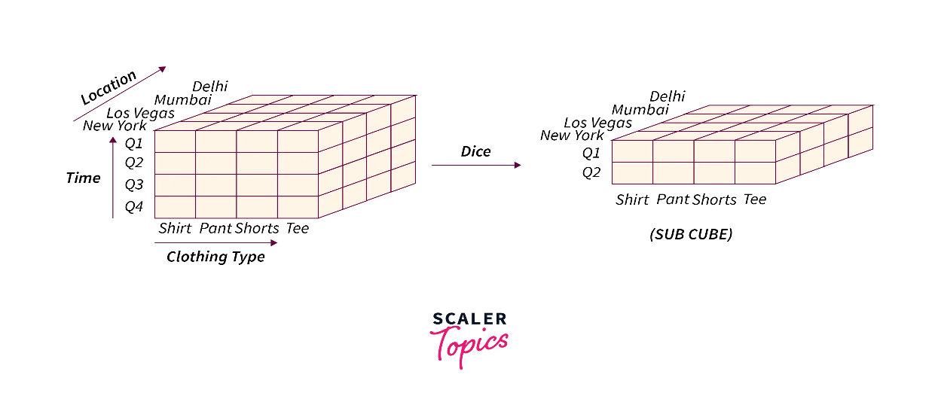 Here, we are performing the Roll-up operation on the given data cube by combining and categorizing the sales based on the countries instead of cities.

**Dice**

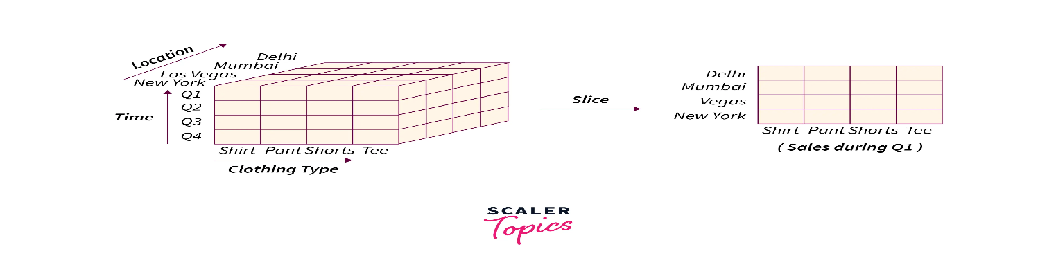Dice operation is used to generate a new sub-cube from the existing hypercube. It selects two or more dimensions from the hypercube to generate a new sub-cube for the given data.

**Example:** Considering our clothing company sales example:

 Here, we are using the dice operation to retrieve the sales done by the company in the first half of the year i.e., the sales in the first two quarters.

**Slice**

Slice operation is used to select a single dimension from the given cube to generate a new sub-cube. It represents the information from another point of view.

**Example:** Considering our clothing company sales example:

 Here, the sales done by the company during the first quarter are retrieved by performing the slice operation on the given hypercube.

**Pivot**

It is used to provide an alternate view of the data available to the users. It is also known as Rotate operation as it rotates the cube’s orientation to view the data from different perspectives.

**Example:** Considering our clothing company sales example:

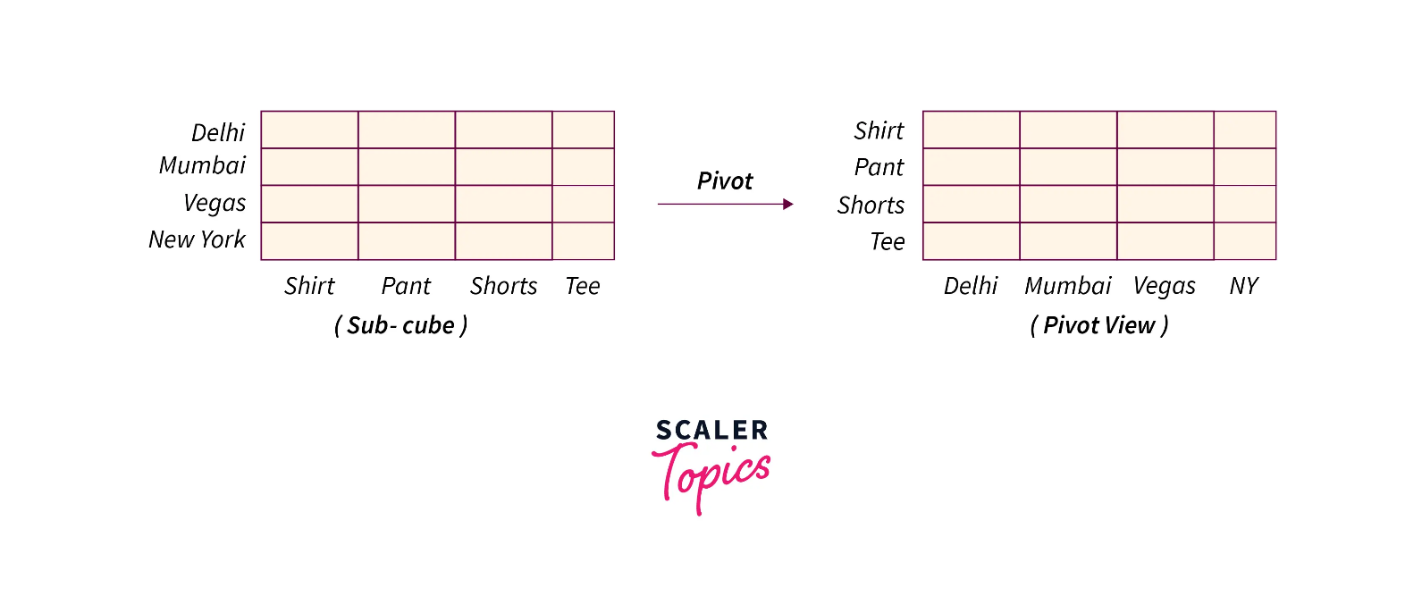

 Here, we are using the Pivot operation to view the sub-cube from a different perspective

**ROLAP vs MOLAP vs HOLAP vs DATA CUBE**

**1. ROLAP (Relational OLAP)**

**Definition**:

* ROLAP uses relational databases to store and manage data. It performs multidimensional analysis by dynamically generating multidimensional views from relational databases at query time.

**Characteristics**:

* **Data Storage**: Uses relational databases (e.g., SQL databases) to store raw data.
* **Query Processing**: Converts multidimensional queries into SQL queries to retrieve and aggregate data from relational tables.
* **Performance**: May be slower compared to MOLAP due to the need to generate multidimensional views and perform aggregation on-the-fly.
* **Scalability**: Highly scalable, as it leverages the scalability of relational databases.

**Advantages**:

* Can handle large volumes of data due to the relational database's scalability.
* No need for data pre-aggregation, which can reduce data redundancy.
* Flexible schema design and supports complex queries.

**Disadvantages**:

* Query performance can be slower, especially for complex queries involving large datasets.
* Data retrieval and aggregation might be less efficient compared to MOLAP.

**Use Case**:

* Suitable for environments where data changes frequently and where complex, detailed queries are needed.

**2. MOLAP (Multidimensional OLAP)**

**Definition**:

* MOLAP uses multidimensional databases (OLAP cubes) to store pre-aggregated data. It provides fast query responses by leveraging pre-computed multidimensional data structures.

**Characteristics**:

* **Data Storage**: Uses multidimensional databases or cubes to store data.
* **Query Processing**: Retrieves pre-aggregated data from OLAP cubes, resulting in faster query performance.
* **Performance**: Generally faster than ROLAP due to the pre-computation of aggregates and indexing.
* **Scalability**: Limited by the size of OLAP cubes and storage capacity.

**Advantages**:

* Provides faster query performance and response times due to pre-aggregated data.
* Efficient for complex calculations and aggregations.
* Excellent for historical data analysis and trends.

**Disadvantages**:

* Limited scalability due to the size constraints of OLAP cubes.
* Requires significant storage space for pre-computed data, potentially leading to data redundancy.

**Use Case**:

* Ideal for scenarios requiring high-performance queries and where data is relatively stable or updated infrequently.

**3. HOLAP (Hybrid OLAP)**

**Definition**:

* HOLAP combines features of both ROLAP and MOLAP. It uses relational databases for detailed data and multidimensional databases for aggregated data, offering a balance between flexibility and performance.

**Characteristics**:

* **Data Storage**: Uses a combination of relational databases and multidimensional cubes.
* **Query Processing**: Utilizes both relational and multidimensional queries, depending on the level of data aggregation required.
* **Performance**: Provides a compromise between ROLAP and MOLAP performance, with faster queries for aggregated data and scalability for detailed data.
* **Flexibility**: Offers flexibility in handling large datasets while providing fast query responses for pre-aggregated data.

**Advantages**:

* Balances the benefits of ROLAP and MOLAP, offering better performance for aggregated data and flexibility for detailed data.
* Can handle large datasets while providing efficient analysis for summary data.

**Disadvantages**:

* Complexity in implementation and management due to the hybrid nature.
* May not achieve the same level of performance as dedicated MOLAP systems for aggregate queries.

**Use Case**:

* Suitable for environments where both detailed and summarized data analysis is needed, and where a balance between performance and scalability is required.

**4. Data Cube**

**Definition**:

* A data cube is a multidimensional array of data used in OLAP systems. It organizes data along multiple dimensions and allows for efficient querying and analysis across those dimensions.

**Characteristics**:

* **Dimensions**: Represents different perspectives or attributes along which data is analyzed (e.g., time, location, product).
* **Measures**: Quantitative data points analyzed across dimensions (e.g., sales revenue, quantity sold).
* **Cells**: Store aggregated values at the intersection of dimension values.
* **Hierarchies**: Different levels of granularity within dimensions that allow for drilling down or rolling up data.

**Advantages**:

* Facilitates complex multidimensional analysis and reporting.
* Supports operations like slice, dice, drill-down, roll-up, pivot, drill-across, and drill-through.
* Provides a structured way to analyze data from multiple perspectives.

**Disadvantages**:

* Requires significant storage space for pre-computed aggregates in MOLAP cubes.
* Performance and scalability can be affected by the size and complexity of the cube.

**Use Case**:

* Used as the underlying data structure in OLAP systems (ROLAP, MOLAP, HOLAP) to support multidimensional analysis and reporting.

**Differences**

| **Aspect** | **ROLAP** | **MOLAP** | **HOLAP** | **Data Cube** |
| --- | --- | --- | --- | --- |

|  |  |  |  |  |
| --- | --- | --- | --- | --- |
| **Data Storage Approach** | Relational databases for detailed data. | Multidimensional databases (cubes) for pre-aggregated data. | Combination of relational databases and multidimensional cubes. | Multidimensional array used to organize and store data. |
| **Performance** | Generally slower due to dynamic query generation. | Typically faster due to pre-computed data in cubes. | Balanced performance combining both relational and multidimensional storage. | Performance depends on the implementation in MOLAP or HOLAP. |
| **Scalability** | Highly scalable with relational databases. | Limited by the size of the OLAP cubes and storage capacity. | Provides a balance, leveraging scalability of relational storage and performance of cubes. | Scalability is influenced by MOLAP or HOLAP implementation. |
| **Data Granularity** | Handles detailed data at a granular level. | Handles aggregated data; less access to detailed data. | Provides both detailed and aggregated data. | Contains pre-aggregated data; granularity depends on cube design. |
| **Complexity of Query Processing** | Queries involve converting multidimensional requests into SQL queries. | Queries are processed against pre-computed cubes, simplifying processing. | Uses both relational and multidimensional queries. | Simplifies querying by providing pre-aggregated views. |
| **Data Refresh** | Reflects current data as it is dynamically generated from relational databases. | Data may need periodic updates to reflect changes. | Provides up-to-date detailed data and periodically refreshed cubes. | Refresh rate depends on cube update frequency. |
| **Flexibility** | More flexible in querying and handling new dimensions. | Less flexible due to predefined cube structure. | Offers flexibility from both relational and multidimensional perspectives. | Flexibility depends on MOLAP or HOLAP usage. |
| **Storage Requirements** | Generally requires less storage space. | Requires more storage for pre-aggregated cubes. | Requires storage for both relational and multidimensional data. | Storage depends on the size and complexity of the cube. |
| **Ease of Implementation** | Easier to implement with existing relational databases. | Requires specialized OLAP cube technology and tools. | Combines complexities of both ROLAP and MOLAP technologies. | Implementation complexity depends on underlying OLAP system. |
| **Historical Data Handling** | Handles historical data through relational databases. | Depends on cube refresh frequency for historical data. | Integrates detailed historical records from relational databases with aggregated data from cubes. | Historical data handling depends on cube maintenance. |

**Similarities**

| **Aspect** | **ROLAP** | **MOLAP** | **HOLAP** | **Data Cube** |
| --- | --- | --- | --- | --- |
| **Multidimensional Analysis** | Yes, supports multidimensional analysis by allowing users to analyze data across multiple dimensions (e.g., time, location, product). | Yes, provides multidimensional analysis with pre-aggregated data stored in cubes. | Yes, supports multidimensional analysis with a combination of relational and multidimensional data. | Yes, organizes data in a multidimensional array, enabling analysis across multiple dimensions. |
| **Support for OLAP Operations** | Yes, supports core OLAP operations such as slice, dice, drill-down, roll-up, and pivot. | Yes, supports OLAP operations using pre-computed cubes, facilitating various analytical queries. | Yes, supports OLAP operations through both relational queries and multidimensional cube queries. | Yes, facilitates OLAP operations by providing pre-aggregated data for efficient querying. |
| **Facilitate Decision-Making** | Yes, designed to help users make informed business decisions by providing insights from complex data sets. | Yes, helps in decision-making with fast query responses and pre-aggregated data. | Yes, combines strengths of relational and multidimensional storage to aid in decision-making. | Yes, provides a structured format for analyzing data and supporting decision-making. |
| **Aggregation and Summarization** | Yes, handles data aggregation and summarization by dynamically generating views from relational databases. | Yes, pre-computes and stores aggregated data in cubes, simplifying summary queries. | Yes, aggregates data from both relational databases and cubes to provide summarized views. | Yes, organizes and stores aggregated data in a multidimensional format, simplifying summarization. |
| **Data Integration** | Yes, integrates data from various relational sources, presenting a unified view for analysis. | Yes, integrates data from various sources into multidimensional cubes for analysis. | Yes, integrates data from relational sources and multidimensional cubes for a comprehensive view. | Yes, integrates data from various sources into a multidimensional structure for analysis. |
| **User-Friendly Interfaces** | Yes, typically offers user-friendly interfaces such as reporting tools and dashboards for querying and analyzing data. | Yes, provides intuitive interfaces for querying pre-aggregated cubes and generating reports. | Yes, offers interfaces that combine querying of relational data and multidimensional cubes. | Yes, provides user-friendly interfaces for querying and exploring multidimensional data. |

**Data Cube**

A **data cube** is a multidimensional array of data used in OLAP (Online Analytical Processing) systems to facilitate complex analysis and reporting. It organizes data in a way that allows users to view and analyze it from multiple dimensions and hierarchies. Each axis of the cube represents a different dimension, and the data within the cube can be aggregated along these dimensions.

**Key Concepts of a Data Cube**

1. **Dimensions**:
   * **Definition**: Dimensions are perspectives or attributes used to view and analyze data. They represent different facets of the data and are typically used to categorize and filter the data.
   * **Types**:
     + **Temporal Dimension**: Time-based attributes (e.g., Year, Quarter, Month, Day).
     + **Geographical Dimension**: Location-based attributes (e.g., Country, State, City).
     + **Product Dimension**: Attributes related to products (e.g., Product Category, Brand).
     + **Customer Dimension**: Attributes related to customers (e.g., Customer ID, Customer Segment).
2. **Measures**:
   * **Definition**: Measures are quantitative data points that are analyzed across dimensions. They represent the values or metrics of interest.
   * **Examples**:
     + **Sales Revenue**: The total revenue generated from sales.
     + **Quantity Sold**: The number of units sold.
     + **Profit Margin**: The difference between revenue and costs.
3. **Cells**:
   * **Definition**: Cells in the data cube store aggregated values for the intersection of dimension values. Each cell represents a unique combination of dimension values and contains a measure.
   * **Example**: The cell at the intersection of “January,” “New York,” and “Electronics” might contain the total sales revenue for that combination.
4. **Hierarchies**:
   * **Definition**: Hierarchies within dimensions represent different levels of granularity. They allow users to drill down or roll up data within a dimension.
   * **Example**:
     + **Time Dimension Hierarchy**: Year > Quarter > Month > Day
     + **Geographical Dimension Hierarchy**: Country > State > City

**Operations on Data Cubes**

1. **Slice**

**Definition**:

* + The slice operation involves selecting a single dimension value to create a sub-cube, effectively cutting through the data cube to reveal a 2D view of the data.

**Example**:

* + In a sales data cube with dimensions of time, location, and product, slicing might involve selecting data for “January” to view sales data for that month across different locations and products.

**Benefits**:

* + Simplifies data analysis by focusing on a specific dimension, making it easier to explore and understand the data within that context.

1. **Dice**

**Definition**:

* + The dice operation involves selecting multiple dimension values to create a smaller, more focused sub-cube. This operation filters the cube along multiple dimensions.

**Example**:

* + Dicing a cube by selecting “Q1 2023,” “New York,” and “Electronics” results in a sub-cube that contains sales data only for the first quarter of 2023, for New York, and for Electronics.

**Benefits**:

* + Provides a targeted view of the data by isolating specific values across multiple dimensions, enabling more detailed and focused analysis.

1. **Drill-Down**

**Definition**:

* + The drill-down operation involves navigating from aggregated data to more detailed data within a hierarchy. This operation allows users to explore data at finer levels of granularity.

**Example**:

* + Starting with annual sales data, drilling down might reveal monthly sales figures, or even daily sales figures, providing more detailed insights into performance.

**Benefits**:

* + Enables users to gain deeper insights by examining data at lower levels of granularity, helping to uncover trends and patterns that might be obscured at higher levels.

1. **Roll-Up**

**Definition**:

* + The roll-up operation involves aggregating data at higher levels in the hierarchy. This operation summarizes detailed data into broader categories.

**Example**:

* + From detailed monthly sales data, rolling up might aggregate the data to show quarterly or yearly totals, providing an overview of performance over a longer period.

**Benefits**:

* + Offers a high-level summary of data, making it easier to identify overall trends and performance across longer time periods.

1. **Pivot (or Rotate)**

**Definition**:

* + The pivot operation involves changing the orientation of dimensions to view data from different perspectives. This operation reconfigures the layout of the cube.

**Example**:

* + Pivoting a data cube might involve switching the axes of time and location, so that instead of viewing sales by location and time, users view sales by time and location.

**Benefits**:

* + Allows users to explore data from various angles, enhancing the ability to discover insights and patterns by reorienting the data dimensions.

1. **Drill-Across**

**Definition**:

* + The drill-across operation involves navigating across different data cubes or fact tables that share common dimensions. This operation enables users to correlate data across different analytical contexts.

**Example**:

* + Comparing sales data with inventory levels by drilling across cubes that both include the time dimension allows users to analyze how inventory levels impact sales performance.

**Benefits**:

* + Facilitates comprehensive analysis by integrating and comparing data from multiple sources, providing a more complete view of related information.

1. **Drill-Through**

**Definition**:

* + The drill-through operation allows users to access detailed transaction-level data underlying the aggregated information in the cube. This operation provides transparency and deeper insights.

**Example**:

* + From aggregated sales data, drill-through might access individual sales transactions to investigate specific sales patterns, customer behavior, or product performance.

**Benefits**:

* + Provides access to raw data for verification and detailed analysis, enabling users to examine the specifics behind aggregated metrics and uncover more granular insights.

**Data Mining:**

In this process, data is extracted and analyzed to fetch useful information. In data mining hidden patterns are researched from the dataset to predict future behavior. Data mining is used to indicate and discover relationships through the data.

Data mining uses statistics, artificial intelligence, machine learning systems, and some databases to find hidden patterns in the data. It supports business-related queries that are time-consuming to resolve.

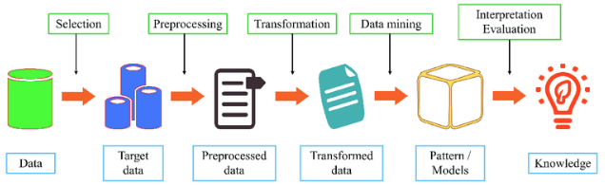

**Features of Data Mining:**

* It is good with large databases and datasets
* It predicts future results
* It creates actionable insights
* It utilizes the automated discovery of patterns

**Advantages**

1. **Insightful Analysis**:
   * Provides valuable insights into data that are not immediately obvious, helping organizations make informed decisions.
2. **Predictive Power**:
   * Enables forecasting of future trends and behaviors based on historical data, aiding in strategic planning.
3. **Pattern Recognition**:
   * Identifies hidden patterns and relationships in data that can lead to new opportunities or insights.
4. **Improved Efficiency**:
   * Optimizes processes and resources by uncovering inefficiencies and areas for improvement.
5. **Competitive Advantage**:
   * Helps organizations gain a competitive edge by leveraging data-driven insights to innovate and respond to market changes.

**Disadvantages**

1. **Complexity**:
   * Data mining can be complex and requires specialized skills and tools to effectively analyze and interpret data.
2. **Data Quality Issues**:
   * The accuracy of insights depends on the quality of the data; poor-quality data can lead to misleading results.
3. **Privacy Concerns**:
   * Handling sensitive or personal data raises privacy and ethical concerns, necessitating proper data protection measures.
4. **High Costs**:
   * Implementing data mining solutions can be expensive due to the need for advanced tools, infrastructure, and expertise.
5. **Overfitting**:
   * Models that are too complex may fit the training data too closely and perform poorly on new data, leading to inaccurate predictions.
6. **Data Volume**:
   * Large volumes of data can be challenging to process and analyze, requiring significant computational resources.

**Applications**

1. **Customer Relationship Management (CRM)**:
   * Analyzing customer behavior to segment markets, personalize marketing efforts, and improve customer satisfaction.
2. **Fraud Detection**:
   * Identifying fraudulent transactions and activities by detecting anomalies and unusual patterns in financial data.
3. **Market Basket Analysis**:
   * Understanding customer purchasing behavior and discovering associations between products to optimize inventory and promotions.
4. **Healthcare**:
   * Predicting patient outcomes, identifying disease patterns, and improving treatment plans through analysis of medical data.
5. **Financial Services**:
   * Assessing credit risk, detecting financial fraud, and analyzing investment opportunities.
6. **Manufacturing**:
   * Enhancing quality control, optimizing supply chains, and predicting equipment failures by analyzing production data.
7. **Telecommunications**:
   * Improving customer retention, detecting network faults, and optimizing service plans through data analysis.

**Techniques for Data Mining**

Data mining techniques are used to extract valuable patterns and insights from large datasets. These techniques leverage various algorithms and methods to uncover hidden patterns, make predictions, and support decision-making. Here are some commonly used data mining techniques:

**1. Classification**

**Description**:

* **Classification** involves assigning data into predefined categories or classes based on its attributes. The goal is to predict the categorical label for new data based on the patterns learned from historical data.

**Algorithms**:

* **Decision Trees**: Uses a tree-like model of decisions and their possible consequences. Examples include CART (Classification and Regression Trees) and C4.5.
* **Naive Bayes**: A probabilistic classifier based on Bayes' theorem with an assumption of independence between features.
* **Support Vector Machines (SVM)**: Finds the hyperplane that best separates different classes in the feature space.
* **k-Nearest Neighbors (k-NN)**: Classifies data based on the majority label of its k nearest neighbors.

**Applications**:

* Email spam detection, credit scoring, medical diagnosis.

**2. Clustering**

**Description**:

* **Clustering** involves grouping similar data points together based on their characteristics. The goal is to identify distinct groups or clusters within the data.

**Algorithms**:

* **k-Means**: Partitions data into k clusters by minimizing the variance within each cluster.
* **Hierarchical Clustering**: Creates a hierarchy of clusters using either agglomerative (bottom-up) or divisive (top-down) approaches.
* **DBSCAN (Density-Based Spatial Clustering of Applications with Noise)**: Groups data points based on density and identifies outliers.
* **Gaussian Mixture Models (GMM)**: Uses a probabilistic model to identify clusters based on Gaussian distributions.

**Applications**:

* Market segmentation, image compression, document clustering.

**3. Association Rule Mining**

**Description**:

* **Association Rule Mining** discovers relationships between variables in large datasets. It aims to find rules that describe how items or features are associated with each other.

**Algorithms**:

* **Apriori**: Identifies frequent itemsets and generates association rules by exploring candidate itemsets.
* **Eclat (Equivalence Class Transformation)**: Uses depth-first search to find frequent itemsets and association rules.
* **FP-Growth (Frequent Pattern Growth)**: Builds a compact data structure called an FP-tree to efficiently mine frequent itemsets.

**Applications**:

* Market basket analysis, recommendation systems, cross-selling strategies.

**4. Regression Analysis**

**Description**:

* **Regression Analysis** is used to predict numerical values based on historical data. It models the relationship between dependent and independent variables.

**Algorithms**:

* **Linear Regression**: Models the relationship between a dependent variable and one or more independent variables using a linear equation.
* **Polynomial Regression**: Extends linear regression by fitting a polynomial equation to the data.
* **Ridge and Lasso Regression**: Regularized versions of linear regression that add penalties to the coefficients to prevent overfitting.

**Applications**:

* Forecasting sales, predicting housing prices, estimating demand.

**5. Anomaly Detection**

**Description**:

* **Anomaly Detection** involves identifying data points that deviate significantly from the norm. It is used to detect unusual or outlier behaviors in data.

**Algorithms**:

* **Statistical Methods**: Uses statistical techniques to identify outliers based on data distributions.
* **Isolation Forest**: Isolates anomalies by randomly partitioning data and identifying instances that are isolated earlier.
* **One-Class SVM**: Models the distribution of normal data and identifies points that fall outside this distribution.

**Applications**:

* Fraud detection, network security, fault detection in manufacturing.

**6. Dimensionality Reduction**

**Description**:

* **Dimensionality Reduction** reduces the number of features or variables in a dataset while retaining as much information as possible. It simplifies the dataset and improves computational efficiency.

**Algorithms**:

* **Principal Component Analysis (PCA)**: Transforms data into a lower-dimensional space by finding the directions of maximum variance.
* **t-Distributed Stochastic Neighbor Embedding (t-SNE)**: Reduces dimensions while preserving the local structure of the data.
* **Linear Discriminant Analysis (LDA)**: Reduces dimensions by maximizing class separability.

**Applications**:

* Data visualization, noise reduction, feature selection.

**7. Text Mining**

**Description**:

* **Text Mining** involves extracting useful information and patterns from text data. It combines techniques from natural language processing and data mining.

**Techniques**:

* **Sentiment Analysis**: Analyzes the sentiment expressed in text, such as positive, negative, or neutral.
* **Topic Modeling**: Identifies topics or themes within a collection of documents (e.g., Latent Dirichlet Allocation - LDA).
* **Text Classification**: Assigns categories or labels to text documents (e.g., spam detection, document categorization).

**Applications**:

* Customer feedback analysis, document classification, social media monitoring.

**Challenges in Data Mining**

1. **Data Quality**:
   * **Incomplete Data**: Missing values or partial records can lead to inaccurate or biased analysis. For instance, a dataset with missing customer demographics might result in misleading marketing strategies.
   * **Noisy Data**: Inaccurate, erroneous, or inconsistent data points can distort mining results. Examples include typographical errors in textual data or sensor malfunctions in numeric data.
   * **Data Integration**: Combining data from heterogeneous sources (e.g., different databases or file formats) can result in conflicts, redundancy, or integration issues, making it challenging to produce a coherent dataset.
2. **Scalability**:
   * **Volume**: Handling and processing large volumes of data efficiently requires significant computational resources. Techniques such as distributed computing and parallel processing are often necessary.
   * **Complexity**: As the complexity of data increases (e.g., with higher dimensions or intricate relationships), the performance and accuracy of data mining algorithms can degrade, requiring sophisticated methods to manage.
3. **Data Privacy and Security**:
   * **Confidentiality**: Protecting sensitive information from unauthorized access during mining is crucial, especially when dealing with personal or proprietary data.
   * **Compliance**: Adhering to legal and regulatory requirements (e.g., GDPR, HIPAA) regarding data privacy and usage is essential to avoid legal issues and maintain user trust.
4. **High Dimensionality**:
   * **Curse of Dimensionality**: With an increasing number of features, the volume of data required grows exponentially, and the distance between data points becomes less meaningful, complicating clustering and classification tasks.
5. **Interpretability**:
   * **Complex Models**: Advanced algorithms (e.g., deep learning) can produce models that are difficult for humans to interpret, making it hard to understand and trust the results.
6. **Data Variety**:
   * **Structured and Unstructured Data**: Integrating and mining various types of data (e.g., text, images, videos) require different processing techniques and tools, adding complexity to the data mining process.

**Data Mining Tasks**

1. **Classification**:
   * **Description**: Assigning items to predefined classes or categories based on their attributes.
   * **Example**: A credit card fraud detection system classifies transactions as "fraudulent" or "legitimate" based on historical transaction data.
   * **Algorithms**: Decision trees, Naive Bayes, Support Vector Machines (SVM), Neural Networks.
2. **Regression**:
   * **Description**: Predicting a continuous numeric value based on input features.
   * **Example**: Predicting housing prices based on factors like location, size, and amenities.
   * **Algorithms**: Linear Regression, Polynomial Regression, Ridge Regression, Lasso Regression.
3. **Clustering**:
   * **Description**: Grouping data points into clusters where items within the same cluster are more similar to each other than to those in other clusters.
   * **Example**: Customer segmentation to identify different buyer personas based on purchasing behavior.
   * **Algorithms**: K-Means, Hierarchical Clustering, DBSCAN, Gaussian Mixture Models.
4. **Association Rule Mining**:
   * **Description**: Identifying interesting relationships or associations between variables in large datasets.
   * **Example**: Market basket analysis to find products frequently purchased together, like bread and butter.
   * **Algorithms**: Apriori Algorithm, Eclat Algorithm, FP-Growth.
5. **Anomaly Detection**:
   * **Description**: Detecting unusual or rare data points that do not conform to the expected pattern.
   * **Example**: Identifying fraudulent transactions in financial systems.
   * **Algorithms**: Isolation Forest, One-Class SVM, Local Outlier Factor (LOF).
6. **Sequential Pattern Mining**:
   * **Description**: Discovering patterns or sequences of events over time.
   * **Example**: Analyzing customer purchase sequences to identify common purchasing patterns.
   * **Algorithms**: PrefixSpan, SPADE, GSP.

**Types of Data**

1. **Structured Data**:
   * **Description**: Data organized in a well-defined manner, typically in tables or spreadsheets with rows and columns.
   * **Examples**: Relational databases (e.g., SQL databases), Excel spreadsheets.
   * **Characteristics**: Easy to query and analyze using standard database tools and techniques.
2. **Unstructured Data**:
   * **Description**: Data that lacks a predefined format or structure.
   * **Examples**: Text documents, social media posts, emails, video files.
   * **Characteristics**: Requires specialized techniques (e.g., Natural Language Processing) for analysis.
3. **Semi-Structured Data**:
   * **Description**: Data that does not conform to a rigid structure but still has some organizational properties.
   * **Examples**: XML files, JSON files, NoSQL databases.
   * **Characteristics**: More flexible than structured data but still contains tags or markers to separate data elements.
4. **Temporal Data**:
   * **Description**: Data that includes a time dimension, capturing changes over time.
   * **Examples**: Time series data (e.g., stock prices), historical records (e.g., weather data).
   * **Characteristics**: Requires techniques to handle temporal aspects and patterns.
5. **Spatial Data**:
   * **Description**: Data related to geographic locations and spatial relationships.
   * **Examples**: Geographic Information Systems (GIS) data, GPS coordinates, maps.
   * **Characteristics**: Analyzed using spatial analysis techniques and tools.

**Data Quality**

1. **Accuracy**:
   * **Description**: Data should accurately represent the real-world entities or events it is meant to describe.
   * **Example**: Ensuring that customer contact information is correct and up-to-date.
2. **Consistency**:
   * **Description**: Data should be uniform and free from contradictions across different datasets or systems.
   * **Example**: Ensuring that the same customer ID is used consistently across all records and databases.
3. **Completeness**:
   * **Description**: Data should contain all necessary attributes or values, with no missing information.
   * **Example**: A dataset for employee records should include all fields such as name, ID, department, and salary.
4. **Timeliness**:
   * **Description**: Data should be current and relevant to the time period of interest.
   * **Example**: Using up-to-date sales data for trend analysis rather than outdated figures.
5. **Validity**:
   * **Description**: Data should conform to defined formats, rules, and constraints.
   * **Example**: Ensuring that email addresses in a dataset follow the correct format (e.g., example@domain.com).
6. **Relevance**:
   * **Description**: Data should be applicable and useful for the intended analysis or business purpose.
   * **Example**: Using relevant customer behavior data to develop targeted marketing strategies.

**Data Preprocessing**

1. **Data Cleaning**:
   * **Description**: Identifying and correcting errors, inconsistencies, and inaccuracies in the data.
   * **Techniques**:
     + **Handling Missing Values**: Imputation, deletion, or using algorithms that handle missing data.
     + **Removing Duplicates**: Identifying and eliminating duplicate records.
     + **Correcting Errors**: Fixing typographical errors, format inconsistencies.
2. **Data Integration**:
   * **Description**: Combining data from multiple sources to create a unified dataset.
   * **Techniques**:
     + **Data Merging**: Combining datasets based on common attributes.
     + **Entity Resolution**: Identifying and merging records that refer to the same entity.
     + **Schema Integration**: Aligning data schemas from different sources.
3. **Data Transformation**:
   * **Description**: Converting data into a suitable format or structure for analysis.
   * **Techniques**:
     + **Normalization**: Scaling numeric values to a common range.
     + **Aggregation**: Summarizing data (e.g., computing averages).
     + **Encoding**: Converting categorical variables into numerical format.
4. **Data Reduction**:
   * **Description**: Reducing the volume of data while preserving its integrity and usefulness.
   * **Techniques**:
     + **Feature Selection**: Selecting the most relevant features for analysis.
     + **Dimensionality Reduction**: Using techniques like Principal Component Analysis (PCA) to reduce the number of features.
     + **Data Compression**: Reducing data size through compression algorithms.
5. **Data Discretization**:
   * **Description**: Converting continuous data into discrete bins or intervals.
   * **Techniques**:
     + **Binning**: Grouping continuous values into bins (e.g., age ranges).
     + **Equal-Width Discretization**: Dividing the range of values into equal-width intervals.
     + **Equal-Frequency Discretization**: Dividing data into intervals with an equal number of data points.

**Measures of Similarity and Dissimilarity**

**1. Euclidean Distance**

* **Description**: Euclidean distance measures the straight-line distance between two points in a multidimensional space. It is derived from the Pythagorean theorem and is commonly used in clustering and classification algorithms.
* **Formula**: Distance(x,y)=∑i=1n(xi−yi)2\text{Distance}(\mathbf{x}, \mathbf{y}) = \sqrt{\sum_{i=1}^{n} (x_i - y_i)^2}Distance(x,y)=∑i=1n​(xi​−yi​)2​
* **Characteristics**:
  + Intuitive and straightforward.
  + Sensitive to the scale of the features.
  + Computationally efficient.
* **Applications**: K-Means clustering, k-Nearest Neighbors (k-NN), anomaly detection.

**2. Manhattan Distance (L1 Norm)**

* **Description**: Also known as city block distance, Manhattan distance measures the sum of the absolute differences between the coordinates of two points. It reflects the distance one would travel along grid lines in a city.
* **Formula**: Distance(x,y)=∑i=1n∣xi−yi∣\text{Distance}(\mathbf{x}, \mathbf{y}) = \sum_{i=1}^{n} |x_i - y_i|Distance(x,y)=∑i=1n​∣xi​−yi​∣
* **Characteristics**:
  + **Less sensitive to outliers** compared to Euclidean distance.
  + Can be more appropriate for high-dimensional spaces.
* **Applications**: Used in various clustering and classification problems, especially when feature distributions are skewed.

**3. Minkowski Distance**

* **Description**: A generalization of both Euclidean and Manhattan distances, Minkowski distance is parameterized by a variable ppp. When p=1p = 1p=1, it corresponds to Manhattan distance, and when p=2p = 2p=2, it corresponds to Euclidean distance.
* **Formula**: Distance(x,y)=(∑i=1n∣xi−yi∣p)1/p\text{Distance}(\mathbf{x}, \mathbf{y}) = \left( \sum_{i=1}^{n} |x_i - y_i|^p \right)^{1/p}Distance(x,y)=(∑i=1n​∣xi​−yi​∣p)1/p
* **Characteristics**:
  + **Flexible** due to the parameter ppp.
  + Provides a range of distance measures depending on the value of ppp.
* **Applications**: Used in various machine learning algorithms that require distance metrics, including generalizations of k-NN and clustering methods.

**4. Cosine Similarity**

* **Description**: Cosine similarity measures the cosine of the angle between two vectors. It is particularly useful for text data and high-dimensional sparse data.
* **Formula**: Similarity(x,y)=x⋅y∥x∥∥y∥\text{Similarity}(\mathbf{x}, \mathbf{y}) = \frac{\mathbf{x} \cdot \mathbf{y}}{\|\mathbf{x}\| \|\mathbf{y}\|}Similarity(x,y)=∥x∥∥y∥x⋅y​ Where x⋅y\mathbf{x} \cdot \mathbf{y}x⋅y is the dot product of the vectors, and ∥x∥\|\mathbf{x}\|∥x∥ and ∥y∥\|\mathbf{y}\|∥y∥ are their magnitudes.
* **Characteristics**:
  + Insensitive to the magnitude of vectors.
  + Measures orientation rather than absolute distance.
* **Applications**: Text similarity, document clustering, and recommendation systems.

**5. Jaccard Similarity**

* **Description**: Jaccard similarity measures the similarity between two sets by comparing the size of their intersection to the size of their union.
* **Formula**: Similarity(A,B)=∣A∩B∣∣A∪B∣\text{Similarity}(A, B) = \frac{|A \cap B|}{|A \cup B|}Similarity(A,B)=∣A∪B∣∣A∩B∣​
* **Characteristics**:
  + Suitable for binary and categorical data.
  + Range between 0 and 1, where 1 indicates complete similarity.
* **Applications**: Used in clustering, classification, and comparing binary attributes or sets.

**6. Pearson Correlation Coefficient**

* **Description**: Pearson correlation measures the linear relationship between two variables. It is a measure of how much one variable is expected to change with another.
* **Formula**: Correlation(x,y)=Cov(x,y)σxσy\text{Correlation}(\mathbf{x}, \mathbf{y}) = \frac{\text{Cov}(\mathbf{x}, \mathbf{y})}{\sigma_x \sigma_y}Correlation(x,y)=σx​σy​Cov(x,y)​ Where Cov is the covariance, and σx\sigma_xσx​ and σy\sigma_yσy​ are the standard deviations of x\mathbf{x}x and y\mathbf{y}y.
* **Characteristics**:
  + Measures linear relationships.
  + Range between -1 and 1, where 1 indicates a perfect positive linear relationship, -1 indicates a perfect negative linear relationship, and 0 indicates no linear correlation.
* **Applications**: Statistical analysis, feature selection, and data visualization.

**7. Hamming Distance**

* **Description**: Hamming distance measures the number of positions at which two strings of equal length differ. It is used for categorical data and binary strings.
* **Formula**:

Distance(x,y)=∑i=1n(xi≠yi)\text{Distance}(x, y) = \sum_{i=1}^{n} (x_i \neq y_i)Distance(x,y)=∑i=1n​(xi​=yi​) Where (xi≠yi)(x_i \neq y_i)(xi​=yi​) is 1 if the characters differ and 0 if they are the same.

* **Characteristics**:
  + Applicable to equal-length strings.
  + Simple and effective for categorical data.
* **Applications**: Error detection and correction, binary sequence comparison.

**8. Mahalanobis Distance**

* **Description**: Mahalanobis distance measures the distance between a point and a distribution. It accounts for correlations between variables and is useful for identifying outliers.
* **Formula**: Distance(x,y)=(x−y)TS−1(x−y)\text{Distance}(\mathbf{x}, \mathbf{y}) = \sqrt{(\mathbf{x} - \mathbf{y})^T \mathbf{S}^{-1} (\mathbf{x} - \mathbf{y})}Distance(x,y)=(x−y)TS−1(x−y)​ Where S\mathbf{S}S is the covariance matrix of the distribution.
* **Characteristics**:
  + Takes into account the correlation between variables.
  + Useful for multivariate data.
* **Applications**: Outlier detection, multivariate anomaly detection, and classification.