BDA400 | ASSIGNMENT 02

TECHNICAL ANALYSIS
USING R
Preliminary Stage · Project Setup, Statistics and Visualization

STUDENT | Lubna Afandi
COURSE | BDA400 — Data Science Tools and Techniques
ASSIGNMENT | Assignment 2 · Technical Analysis Using R
STAGE | Preliminary Stage
Project repository
github.com/lubnaafandi89-coder/TechnicalAnalysis
Prepared as a concise record of the completed Assignment 2 workflow, R analysis, and repository contents.

1. Project overview
This preliminary-stage project establishes a reproducible R workflow for a small stock portfolio. The analysis reads symbols from a plain-text file, obtains historical stock data through quantmod, computes descriptive statistics, calculates a 20-observation moving average, and displays a price chart.

Repository and project files
The public GitHub repository is owned by lubnaafandi89-coder. Assignment 2 is kept in its own folder so the instructor can review the report, input list, R script, and generated summary output together.
Path / file | Purpose
Assignment2/README.md | Assignment overview and run guidance.
Assignment2/portfolio.txt | Stock symbols, one per line: NVDA, AMZN, TSLA.
Assignment2/technical_analysis.R | R script for loading data, calculations, display, and chart.
Assignment2/summary_statistics.csv | Generated summary table committed to GitHub.

Repository evidence
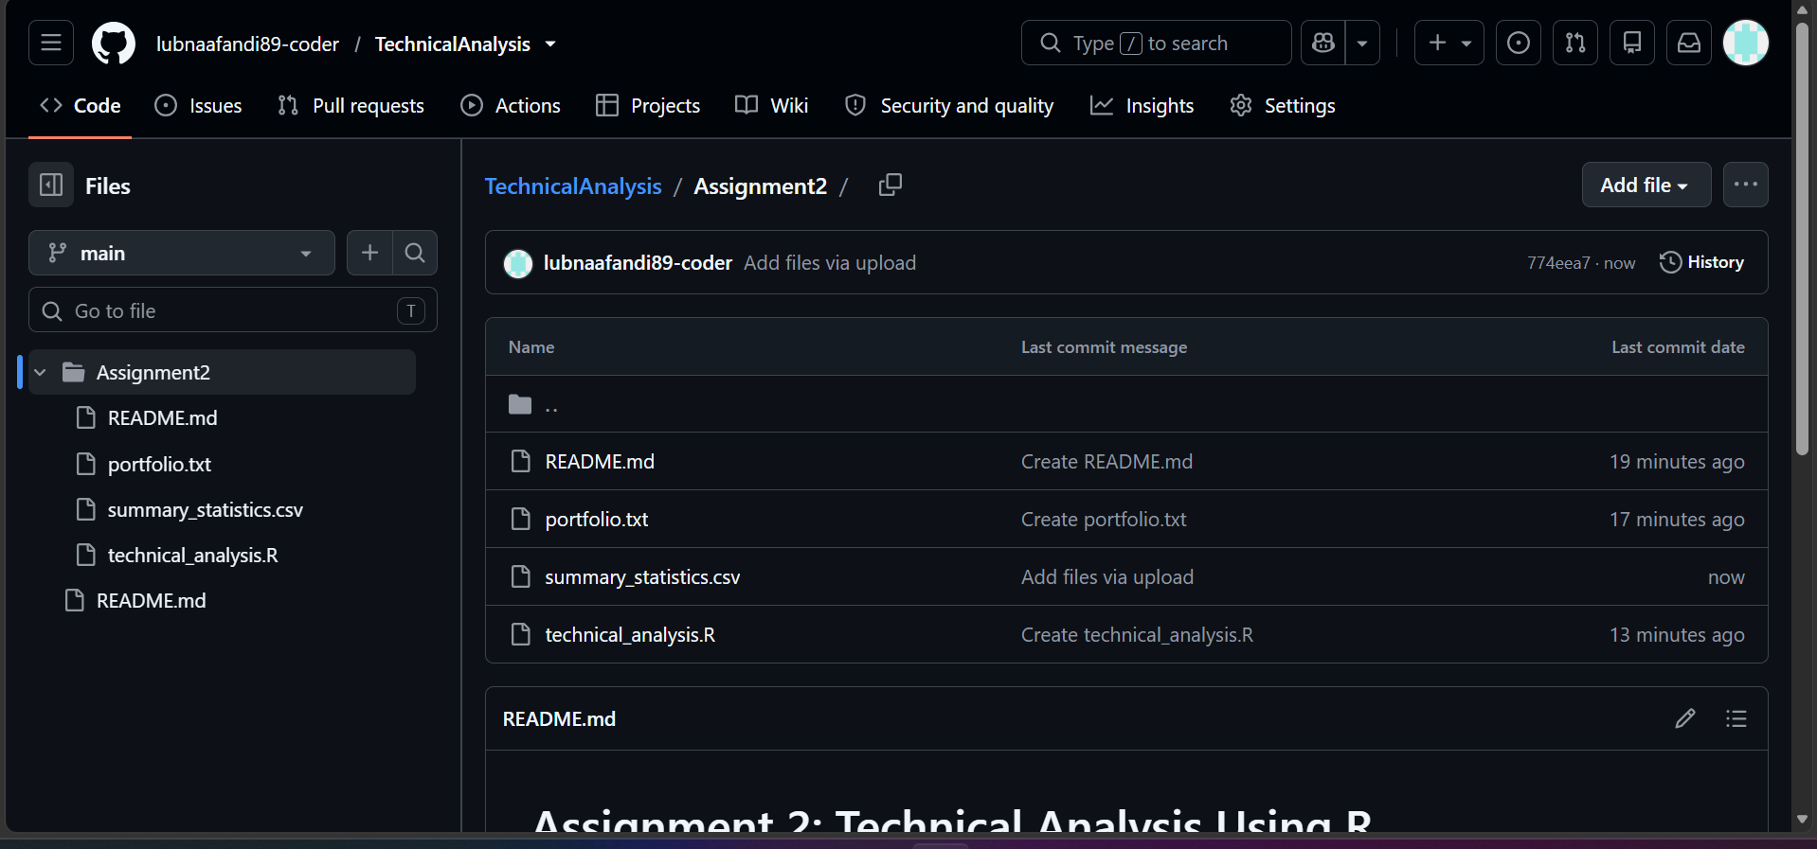
Figure 1. GitHub view of Lubna’s Assignment2 folder, showing the report README, portfolio, R script, and summary CSV.
Repository URL: https://github.com/lubnaafandi89-coder/TechnicalAnalysis

2. R environment and package setup
The script was opened in RStudio and run successfully in an R 4.6.2 session. The visible run output shows the quantmod workflow and package loading messages, followed by the results table and TSLA price chart. The script checks for quantmod and installs it when it is not already available; the run also loads supporting zoo and TTR packages.

Run procedure
1. Download or clone the TechnicalAnalysis repository and open the Assignment2 folder in RStudio.
2. Keep portfolio.txt in the same working folder as technical_analysis.R so readLines() can find the symbols.
3. Open technical_analysis.R and select Source. The script reads the symbols, loads the stock series, calculates the results, prints the summary, and draws the price chart.
4. Review the generated summary_statistics.csv and the chart in the RStudio Plots pane.

Code and run evidence
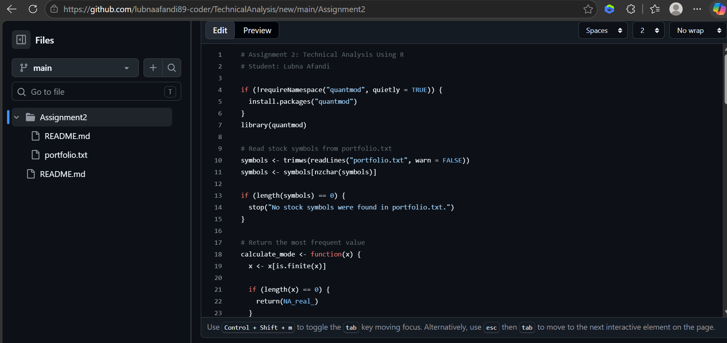
Figure 2. The R source includes package checks, portfolio file loading, and a mode helper; the displayed source is from Lubna’s Assignment2 workflow.
Evidence note: the available screenshots document the installed R/RStudio environment and a successful analysis run. Installer-wizard screenshots were not among the supplied captures.

3. Statistical results and visualization
The completed run processed 711 observations for each symbol. The statistics below are transcribed from the RStudio console shown in the supplied run screenshot. Values are shown at the precision visible in that console.
Symbol | N | Mean | Mode | Median | Std. dev.
NVDA | 711 | 151.8562 | 123.1989 | 144.8713 | 46.17037
AMZN | 711 | 213.4827 | 222.6900 | 214.4700 | 29.96404
TSLA | 711 | 321.2203 | 207.8300 | 339.0300 | 92.17184
The script’s mode helper returns the most frequent finite value in the input series. The standard deviation shown is the value produced by the submitted script. The moving average is calculated over a 20-observation window; early observations do not have a complete 20-day window.

TSLA adjusted close and 20-day moving average
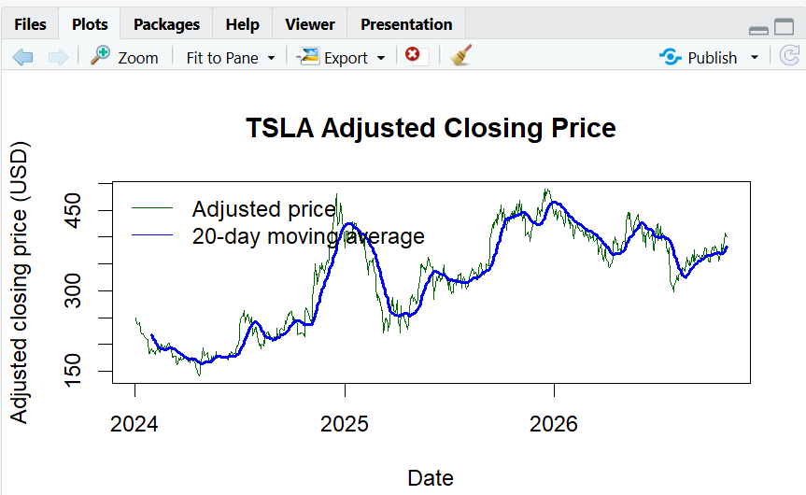
Figure 3. RStudio plot from the successful run. The green line is TSLA adjusted closing price; the blue line is the 20-day moving average.

4. RStudio execution evidence
This cropped console view shows the package-loading messages and the printed summary table from the same successful RStudio session. The personal Windows folder path has been excluded from the figure.
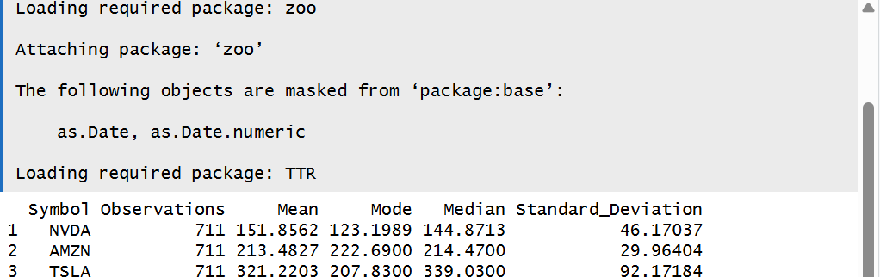
Figure 4. RStudio console output for NVDA, AMZN, and TSLA.

5. Implementation notes and submission checklist

Analysis flow
- Portfolio input: portfolio.txt contains NVDA, AMZN, and TSLA, each on a separate line.
- Data acquisition: quantmod is used to retrieve the stock history; the script processes the adjusted closing-price series for each symbol.
- Statistics: the output table includes observation count, mean, mode, median, and standard deviation for each stock.
- Technical indicator: a 20-observation moving average is plotted alongside the adjusted closing price.
- Output: summary_statistics.csv is saved in the Assignment2 working directory and appears in the public repository.

Submission checklist
Item | Current evidence / next action
Repository | Public GitHub repository named TechnicalAnalysis; Assignment2 subfolder is present.
Portfolio | portfolio.txt committed with the selected stock symbols.
R source | technical_analysis.R committed and run in RStudio.
Results | summary_statistics.csv committed; chart displayed in RStudio.
Report | Save this Word report in Assignment2 and include the repository URL on the cover page.

Reproducibility and limitations
Stock prices can change as the data provider updates historical records. Running the script later may therefore produce slightly different statistics. The plotted values and table in this report document the captured execution, rather than a promise that future downloads will be identical.
The screenshots document the final public repository structure and a successful RStudio execution. They do not show every individual installer-dialog step. If the instructor explicitly requires those exact installation screens, add the original screenshots if available before submitting.
Repository link: TechnicalAnalysis on GitHub

