**ASP.NET Task** 02.01.2023

Note: Create new folder “ASP.NET” contains file in your repo with the bellow:

1. Create the bellow vote page using user control based on cookies:

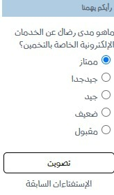

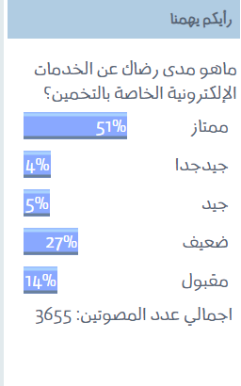

1. Create registration page that support two types of Role