Cairo University  
Faculty of Computers and Information



**CS251**

**Software Engineering I**

Project Name

Software Design

Team Names

Month & Year

Contents

Team 3

Document Purpose and Audience 3

System Models 3

I. System Decomposition 3

II. Class diagrams 4

III. Sequence diagrams 7

Class - Sequence Usage Table 14

Ownership Report 15

Policy Regarding Plagiarism: 15

References 15

Authors 15

# Team

|  |  |  |  |
| --- | --- | --- | --- |
| **ID** | **Name** | **Email** | **Mobile** |
| 20170202 | Lubna Hassan Atia | lubnahassan35@gmail.com | 01100095063 |
| 20170054 | Afnan Samir Mohammed | afnanetman@gmail.com | 01063750746 |
| 20170043 | Esraa Taha Ali Mohammed | esraaselim39@gmail.com | 01102790226 |
| 20170044 | Esraa Mohamed Abdelrahman Morsy | esraamohamed.egy@gmail.com | 01060081977 |

# Document Purpose and Audience

-The purpose of this document is to provide a detailed overview of our software product, and its goals. This document describes the project's target, audience and requirements.

Main audience are developers.

# System Models

## I. System Decomposition

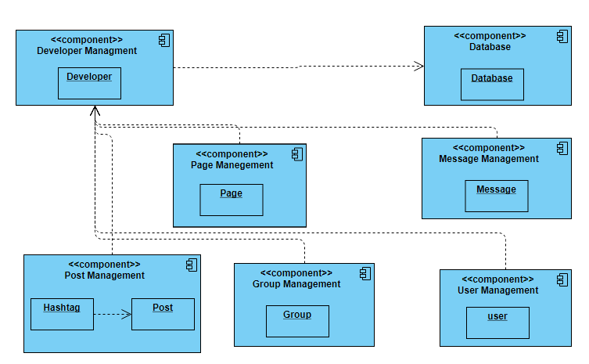

## II. Class diagrams

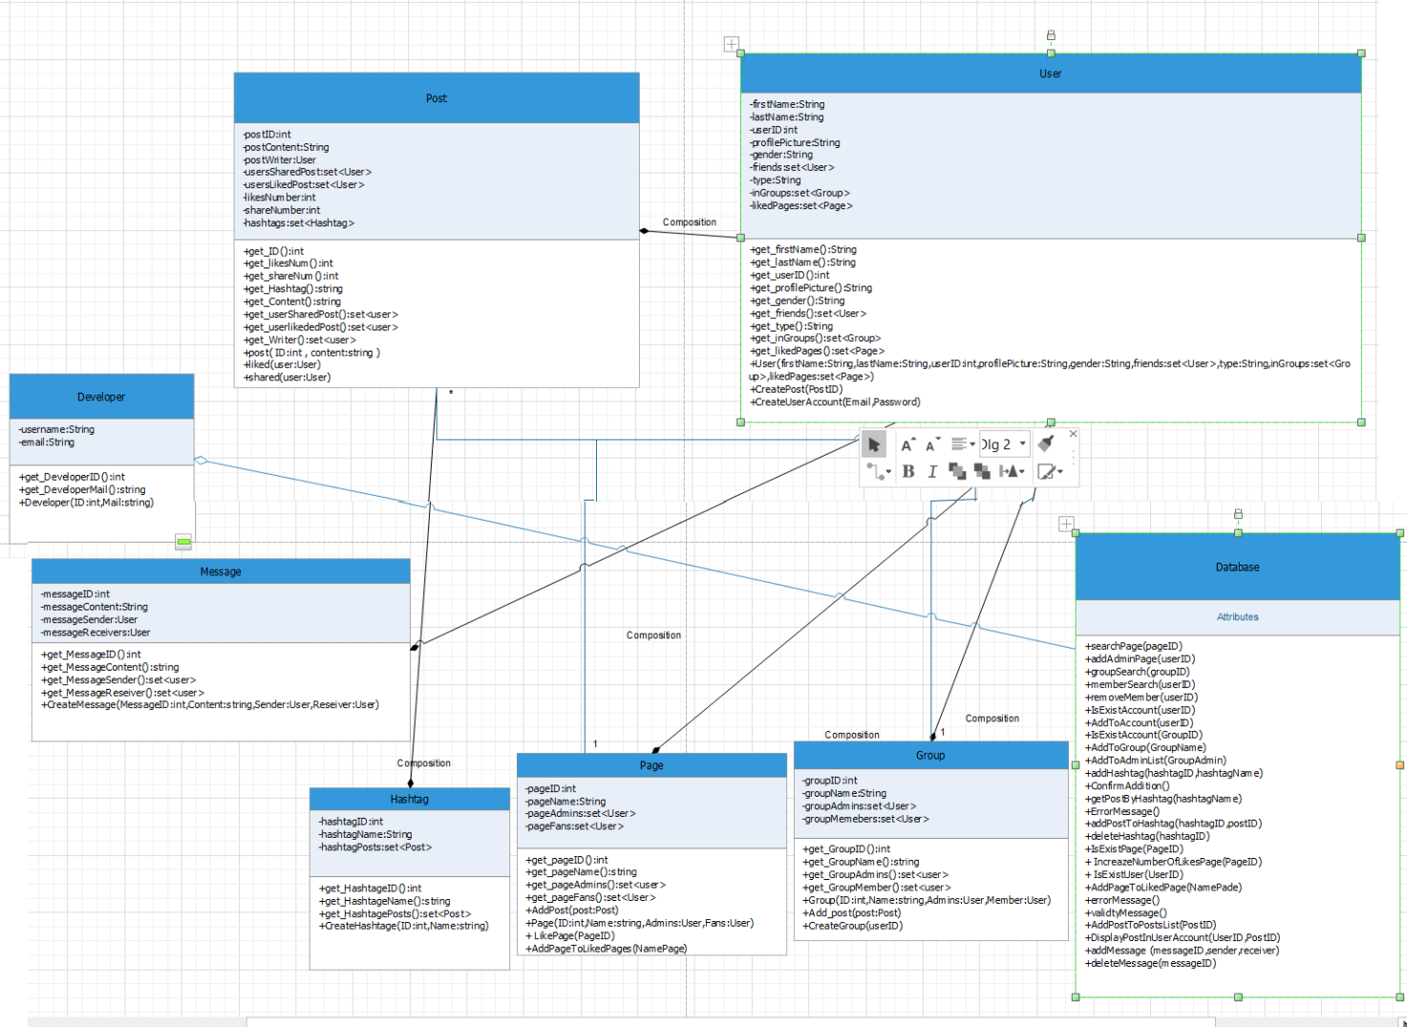

| **Class ID** | **Class Name** | **Subsystem ID** | **Description& Responsibility** |
| --- | --- | --- | --- |
| 1 | Developer | Dev_Manage | Manages all functions and interfaces for developer |
| 2 | Database | DB_Manage | Manages functions of database and storing |
| 3 | User | User_Manage | Manages Interface for social network user |
| 4 | Message | MSG_Manage | Manages Interfaces and functions for messages sending |
| 5 | Post | Post_Manage | Manages post display and functions |
| 6 | Page | Page_Manage | Manages pages functions, creation and liking |
| 7 | Group | Group_Manage | Manages group functions, creation and entering |
| 8 | Hashtag | Post_Manage | Manages posts in every hashtag and sorting them |

## 

## III. Sequence diagrams

#### 1

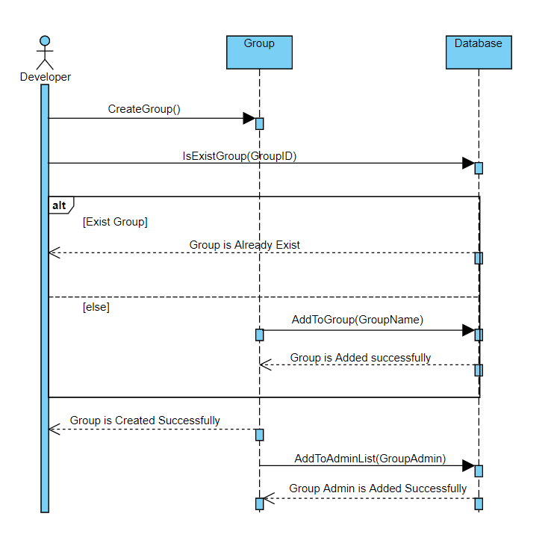

#### 2

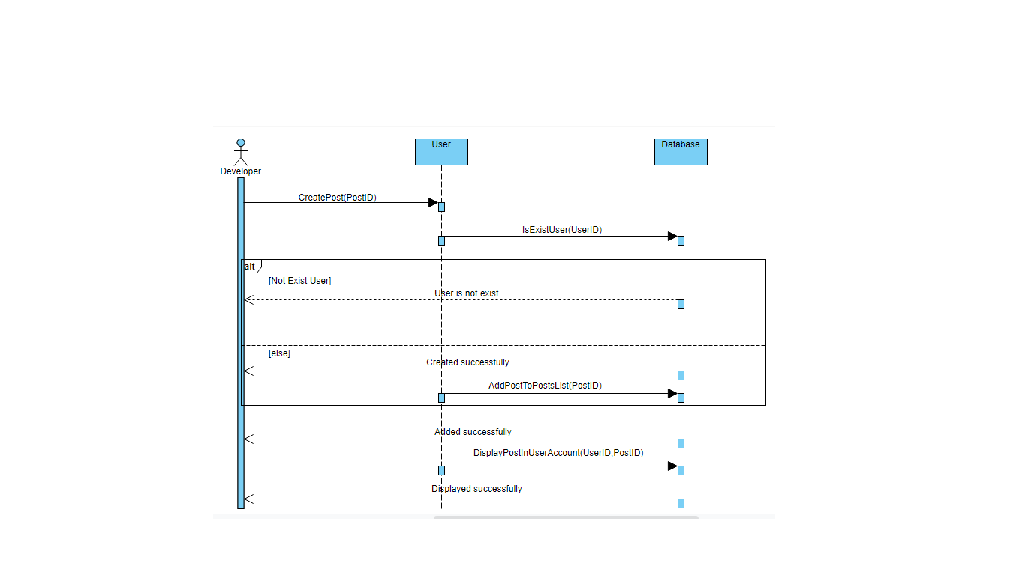

#### 3

#### 

#### 4

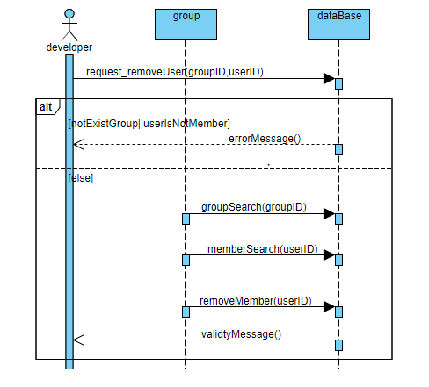

#### 5

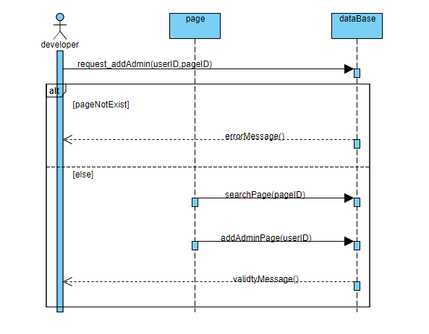

#### 6

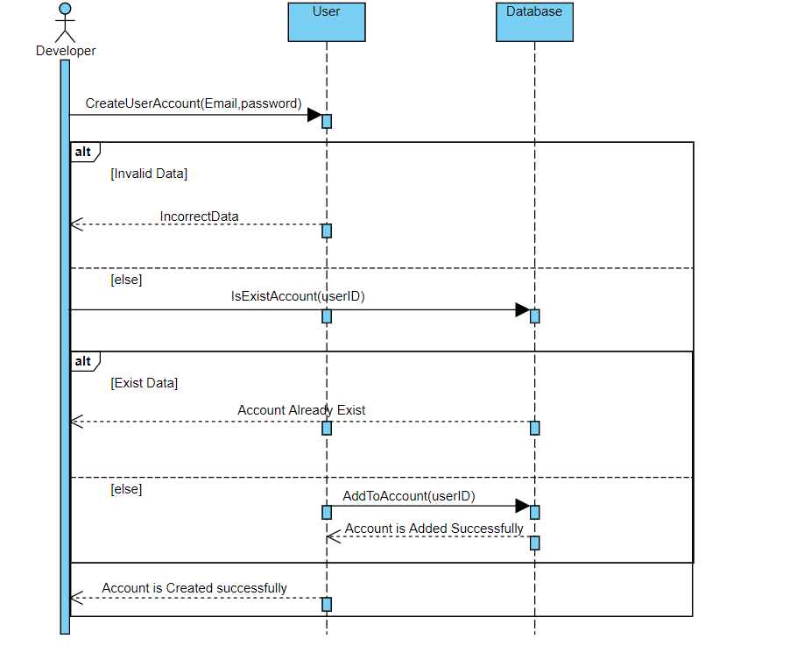

#### 7

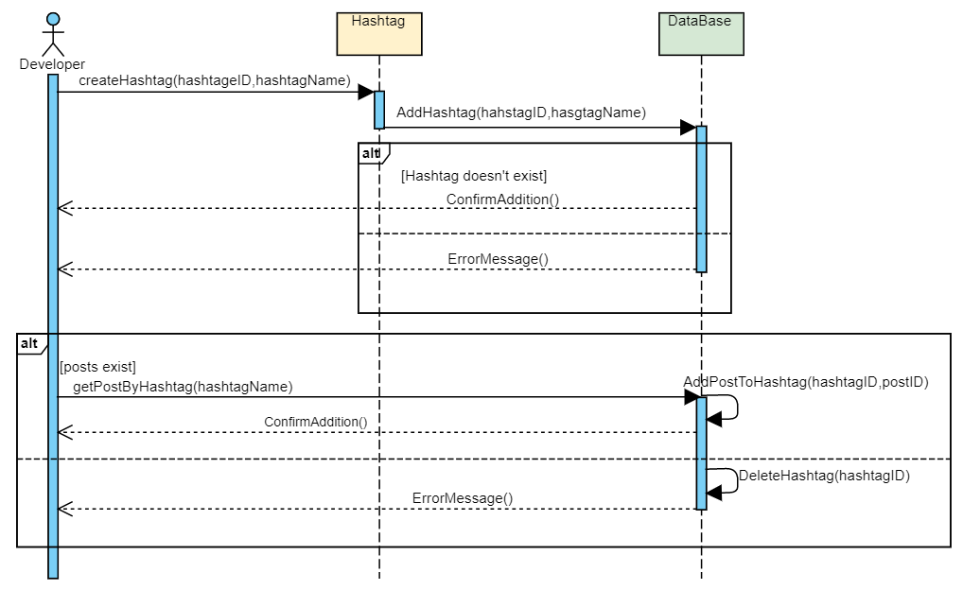

#### 8

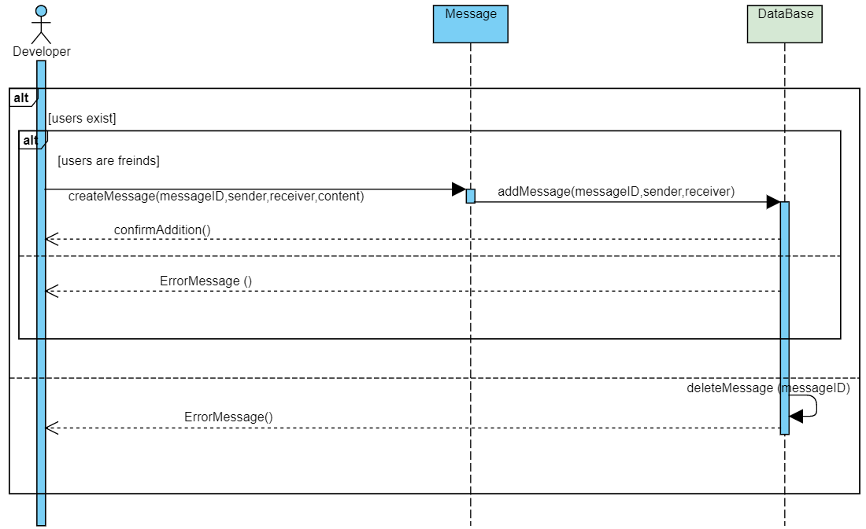

### Class - Sequence Usage Table

| **Class Name** | **Sequence Diagrams** | **Overall used methods** |
| --- | --- | --- |
| Database | 1,2,3,4,5,6,7,8 | addToGroup, addToAdminList, addToPostList, displayPostInUserAccount, groupSearch, memberSearch, removeMember, searchPage, addAdminPage, addToAccount, addHashtag, addPostToHashtag, deleteHashtag, addMessge, deleteMessage |
| User | 2,6 | createUserAccount, |
| Post | 2 | addPostToPostsList |
| Group | 1,4 | creatGroup |
| Message | 8 | createMessage |
| Hashtag | 7 | createHashtag |
| Page | 3,5 | likePage |

# Ownership Report

|  |  |
| --- | --- |
| **Item** | **Owners** |
|  |  |
|  |  |

# Policy Regarding Plagiarism:

**Students have collective ownership and responsibility of their project. Any violation of academic honesty will have severe consequences and punishment for ALL team members.**

1. تشجع الكلية على مناقشة الأفكار و تبادل المعلومات و مناقشات الطلاب حيث يعتبر هذا جوهريا لعملية تعليمية سليمة
2. ساعد زملاءك على قدر ما تستطيع و حل لهم مشاكلهم فى الكود و لكن تبادل الحلول غير مقبول و يعتبر غشا.
3. أى حل يتشابه مع أى حل آخر بدرجة تقطع بأنهما منقولان من نفس المصدر سيعتبر أن صاحبيهما قد قاما بالغش.
4. قد توجد على النت برامج مشابهة لما نكتبه هنا أى نسخ من على النت يعتبر غشا يحاسب عليه صاحبه.
5. إذا لم تكن متأكدا أن فعلا ما يعد غشا فلتسأل المعيد أو أستاذ المادة.
6. فى حالة ثبوت الغش سيأخذ الطالب سالب درجة المسألة ، و فى حالة تكرار الغش سيرسب الطالب فى المقرر.

# References

* http://www.mhhe.com/engcs/compsci/pressman/graphics/Pressman5sepa/common/cs1/design.pdf

# Author