Network Intrusion Detection System
A Machine Learning Web Application
Project Report — “Deploy an ML Web App”
Course: Artificial Intelligence
Electrical and Computer Engineering Department
Capital University of Science & Technology, Islamabad
S# | Student Name | Registration No.
1 | Maryam Riaz | BCPE223004
2 | Lubna Jalil | BCPE223024
3 | Shaeel Hassan | BCPE223039

1. Introduction
A Network Intrusion Detection System (NIDS) monitors network traffic and flags connections that appear malicious. As attacks grow in volume and variety, manually written rules cannot keep up, so modern systems increasingly use machine learning to recognise attack patterns directly from data.
This project implements the term-project idea “Deploy an ML Web App” as a complete intrusion-detection pipeline. A machine-learning model is trained on a labelled network-traffic dataset and then deployed behind a web interface where a user can submit the features of a network connection and instantly receive a classification: normal traffic, or one of four attack categories.
The project covers the full machine-learning workflow required by the proposal: requirement analysis, data collection, preprocessing, exploratory data analysis, model development, training and testing, web-application development, deployment, and evaluation.

1.1 Objectives
- Train machine-learning models to detect and classify network intrusions.
- Compare Logistic Regression, Decision Tree, and Random Forest classifiers.
- Build a user-friendly web interface that returns a prediction for a submitted connection.
- Deploy the trained model so predictions are served in real time through a browser.
- Understand the practical challenges of applying ML to a real security problem.

2. Dataset: NSL-KDD
The project uses the NSL-KDD dataset, a refined version of the classic KDD Cup 1999 dataset and a standard benchmark for intrusion-detection research. It removes the duplicate records that biased the original KDD data, producing a cleaner and more reliable evaluation set.
Property | Value
Training records | 125,973
Test records | 22,544
Features per record | 41 (plus the attack label)
Categorical features | protocol_type, service, flag
Missing values | None

Each record describes one network connection using 41 features grouped into basic features (e.g. duration, protocol, bytes transferred), content features (e.g. failed logins, root access), and traffic features computed over time and host windows (e.g. connection counts and error rates).
The dataset labels 39 specific attacks, which are grouped into the four standard categories used throughout the literature:
- DoS (Denial of Service) — flooding a host so it cannot serve legitimate users (e.g. neptune, smurf).
- Probe — scanning and surveillance to map a network (e.g. satan, nmap, portsweep).
- R2L (Remote to Local) — gaining local access from a remote machine (e.g. guess_passwd).
- U2R (User to Root) — escalating from a normal account to root privileges (e.g. buffer_overflow).
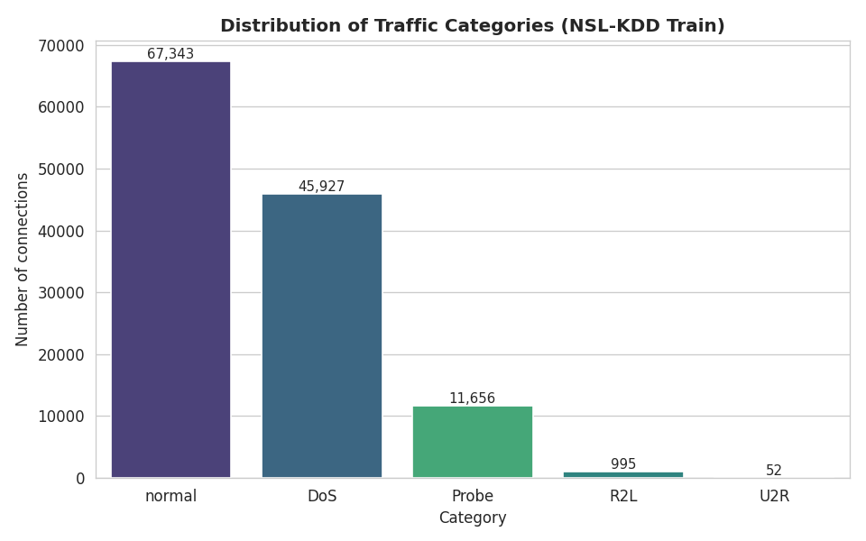
Figure 1: Distribution of traffic categories in the training set. The data is imbalanced — normal and DoS dominate, while U2R and R2L are rare.
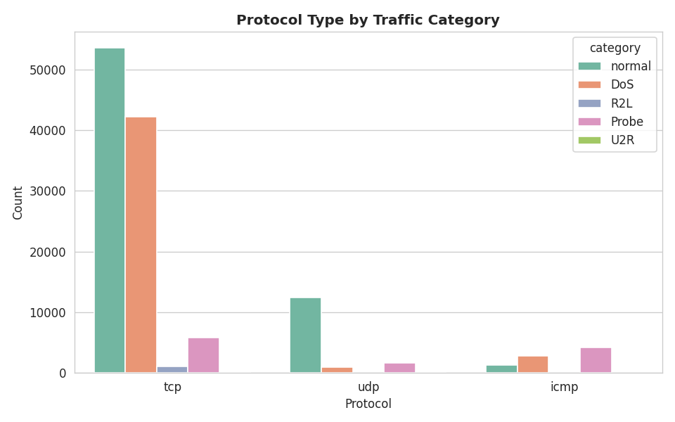
Figure 2: Protocol type by category. ICMP traffic is heavily associated with attacks, while normal traffic is mostly TCP.

3. Methodology

3.1 Data Preprocessing
- Removed the non-feature “difficulty level” column from each record.
- Mapped the 39 specific attack names to the five target classes (normal, DoS, Probe, R2L, U2R).
- Encoded the three categorical features (protocol_type, service, flag) into numeric form using label encoding, fitted on the combined train+test vocabulary so no unseen category breaks inference.
- Standardised all features with StandardScaler so that large-range features (such as byte counts) do not dominate the smaller rate features.

3.2 Exploratory Data Analysis
EDA was used to understand feature distributions and relationships before modelling. The category distribution (Figure 1) revealed strong class imbalance, the protocol breakdown (Figure 2) showed that ICMP is a strong attack signal, and a correlation heatmap (Figure 3) confirmed that several traffic-rate features are highly correlated.
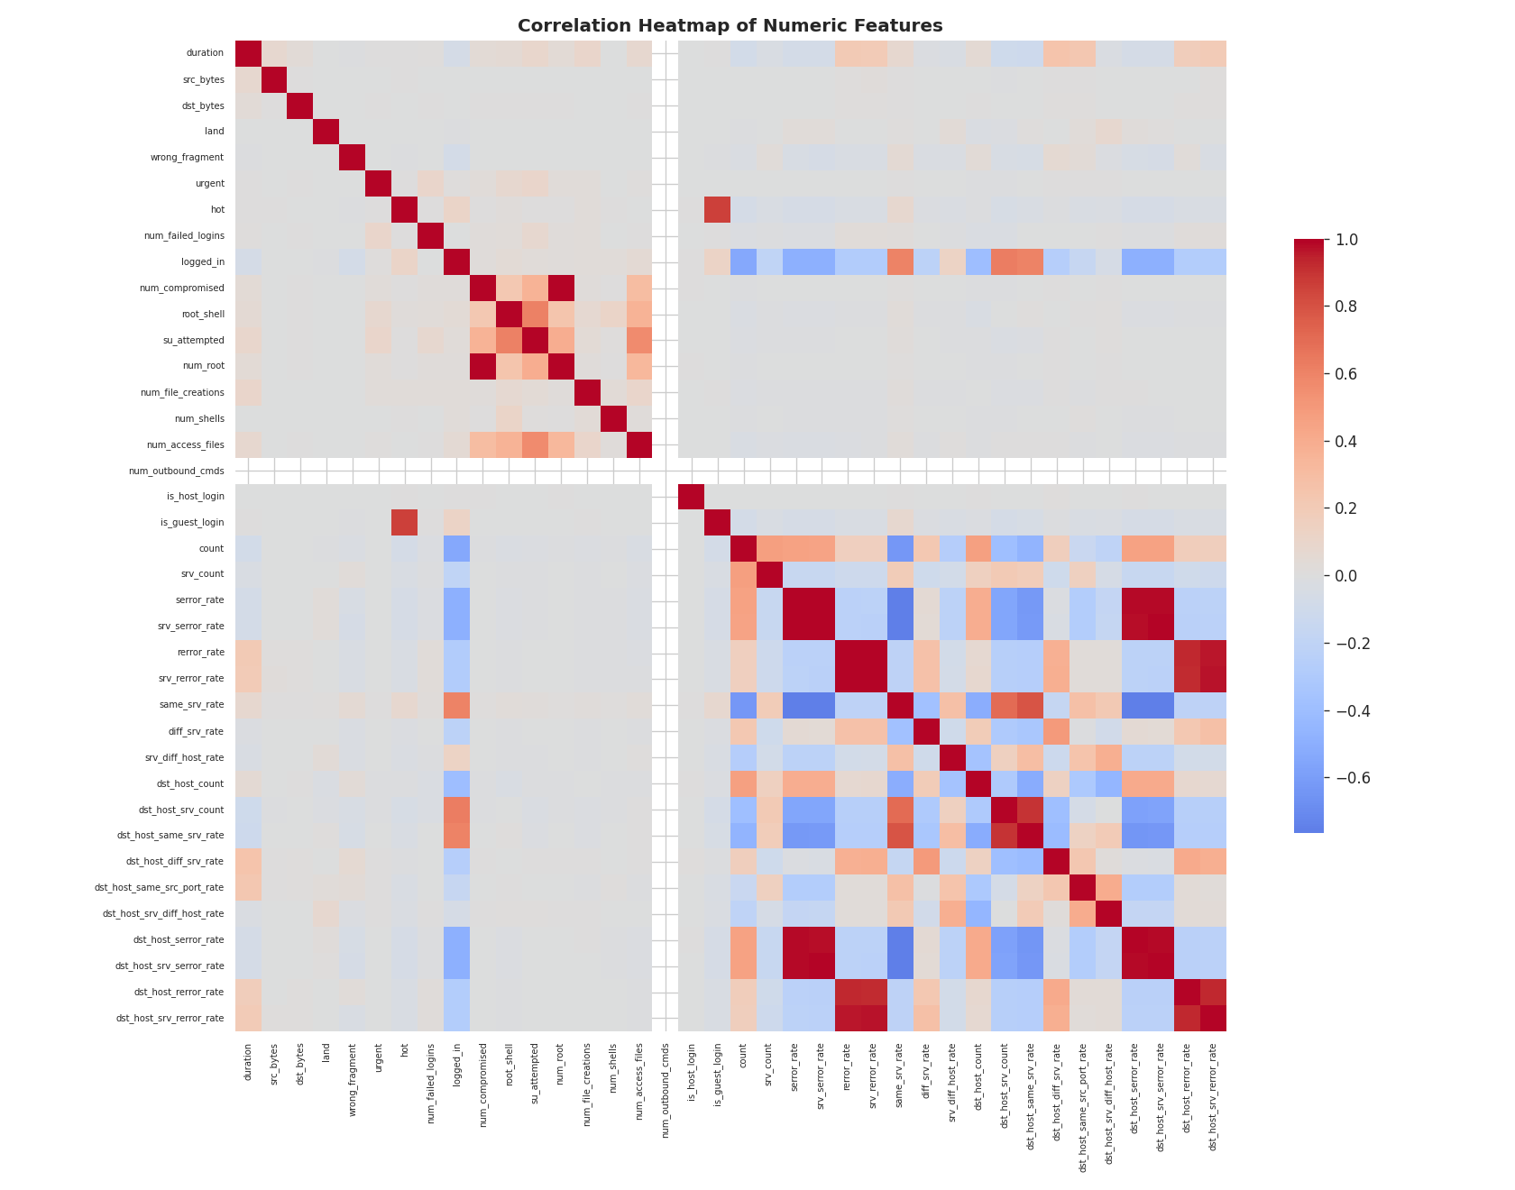
Figure 3: Correlation heatmap of the numeric features.
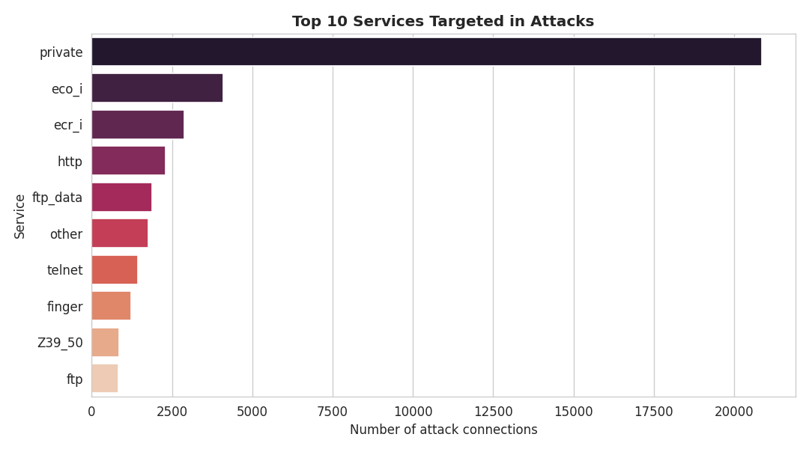
Figure 4: The services most frequently targeted in attack connections.

3.3 Model Development
Three supervised classifiers were trained, as specified in the proposal:
- Logistic Regression — a fast linear baseline.
- Decision Tree — a non-linear, interpretable model.
- Random Forest — an ensemble of decision trees that reduces overfitting and usually generalises best.
Each model was evaluated with 5-fold stratified cross-validation on the training set and then tested on the separate official test set. The model with the highest cross-validation accuracy was selected for deployment.

4. Results and Evaluation
Model | CV Accuracy | Test Accuracy | Test F1
Logistic Regression | 96.6% | 76.2% | 0.714
Decision Tree | 99.8% | 75.3% | 0.709
Random Forest (deployed) | 99.9% | 74.7% | 0.705

Random Forest achieved the highest cross-validation accuracy (99.9%) and was selected as the deployed model. Its confusion matrix (Figure 5) shows that frequent classes — normal, DoS and Probe — are detected reliably, while the rare R2L and U2R classes are harder to catch because so few examples exist to learn from.
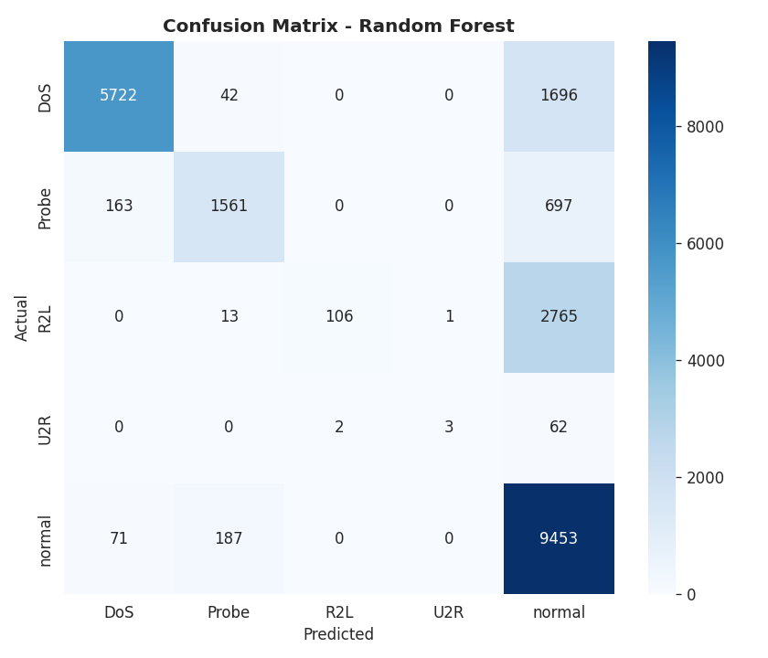
Figure 5: Confusion matrix of the deployed Random Forest on the test set.
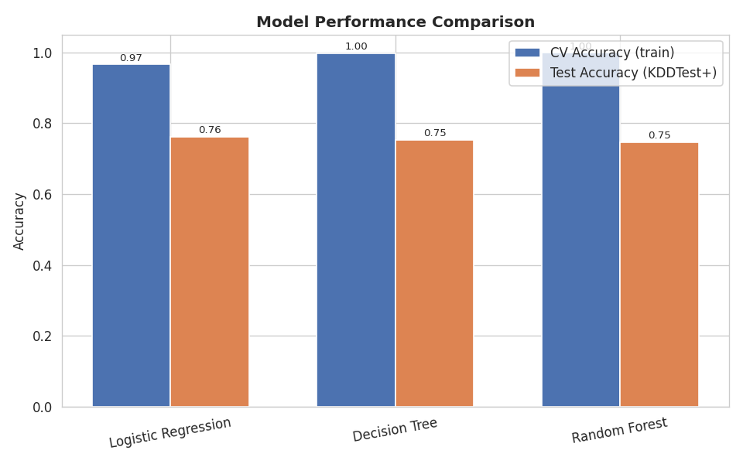
Figure 6: Cross-validation accuracy versus test accuracy for all three models.

4.1 Interpreting the generalisation gap
All three models score far higher in cross-validation (~97–99%) than on the official test set (~75%). This gap is a known and intentional property of NSL-KDD: the test set deliberately contains attack types that never appear in training. The lower test score therefore measures how well the system copes with novel, previously unseen attacks — the single hardest and most realistic problem a real intrusion-detection system faces. The result honestly reflects real-world deployment conditions rather than an inflated laboratory score.

5. Web Application and Deployment
The trained model is served through a Flask web application. The model, scaler, and encoders are loaded once at start-up, and a prediction endpoint accepts a connection's features, applies the identical preprocessing used during training, and returns the predicted category together with the model's confidence for every class.
The interface lets a user load a real captured connection with one click or enter feature values manually. The result panel turns green for normal traffic and red when a threat is detected, and a set of bars shows the probability assigned to each class.
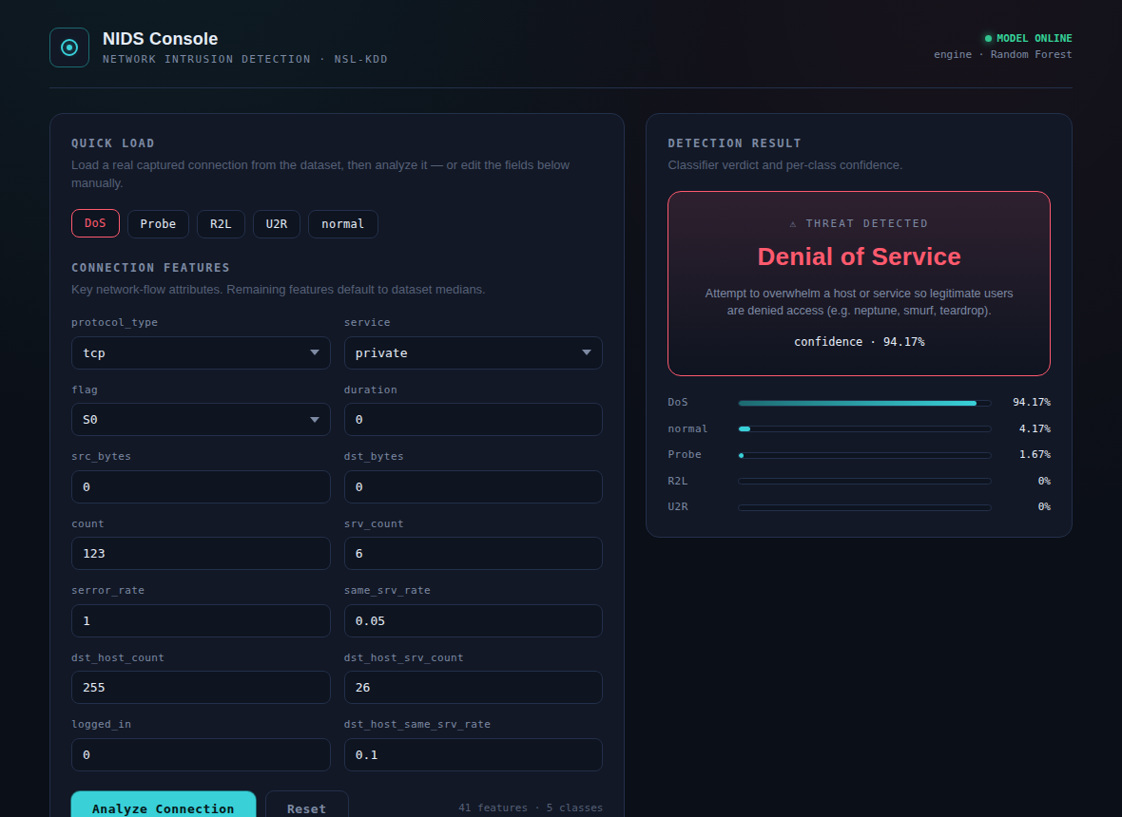
Figure 7: The web application detecting a Denial-of-Service connection with 94% confidence.
For public deployment the app runs behind a production WSGI server (gunicorn) and can be hosted on free platforms such as Render, Railway, or PythonAnywhere.

6. Complex Engineering Problem (CEP) Attributes

6.1 Knowledge Profile (WK)
WK | Description | How it is fulfilled
WK2 | Mathematics, statistics, computer science | Probability, feature scaling, cross-validation, and ML algorithms are applied throughout.
WK3 | Engineering fundamentals | Core ML and data-engineering principles drive the classification design.
WK4 | Specialist engineering knowledge | Three classifiers are developed, tuned, compared, and deployed.
WK5 | Engineering design | An end-to-end pipeline and an intelligent web application are designed and built.
WK6 | Engineering practice | Implemented in Python with scikit-learn, pandas, and Flask.
WK8 | Research-based knowledge | Uses the NSL-KDD research benchmark and addresses its known generalisation challenge.

6.2 Complex Problem Solving (EA)
EA | How the project satisfies it
EA1 | Depth of knowledge: uses datasets, ML libraries, and computing resources to solve a problem with no single obvious solution.
EA2 | Conflicting requirements: integrates machine learning with web technology, and balances detection accuracy against generalisation to unseen attacks.
EA3 | Depth of analysis: applies AI techniques and evaluates them with cross-validation, confusion matrices, and per-class metrics.
EA5 | Beyond standard practice: extends basic programming into model training, evaluation, and real deployment.

7. Conclusion
This project delivered a complete, working machine-learning web application for network intrusion detection. Three classifiers were trained and compared on the NSL-KDD benchmark, and the best-performing Random Forest model was deployed behind a Flask web interface that classifies connections in real time.
Beyond a working artefact, the project demonstrates a realistic engineering trade-off: models that learn training patterns almost perfectly still face a substantial gap when confronted with genuinely new attacks. Recognising and reporting this gap honestly is itself an important engineering outcome and a strong basis for future work — such as adding more attack data, addressing class imbalance, or trying deep-learning models to improve detection of rare R2L and U2R attacks.

References
Tavallaee, M., Bagheri, E., Lu, W., & Ghorbani, A. A. (2009). A detailed analysis of the KDD CUP 99 data set. IEEE Symposium on Computational Intelligence for Security and Defense Applications.
Pedregosa et al. (2011). Scikit-learn: Machine Learning in Python. Journal of Machine Learning Research, 12, 2825–2830.

