Assignment-SQL[Major]

**Submitted by: LUBNA**

**EMAIL: syedamina454@gmail.com**

**Course Name: Business Analyst Career Program (Chat GPT)**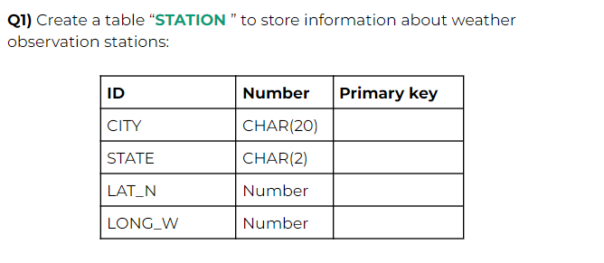

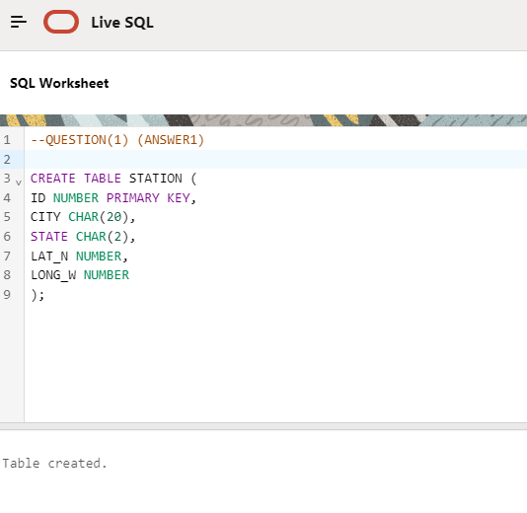

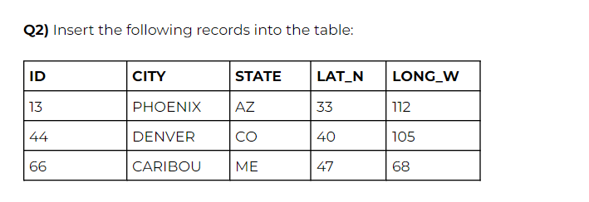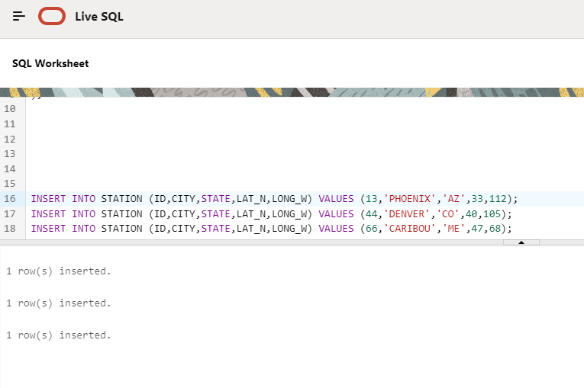

Q3)Execute a query to look at table STATION in undefined order.

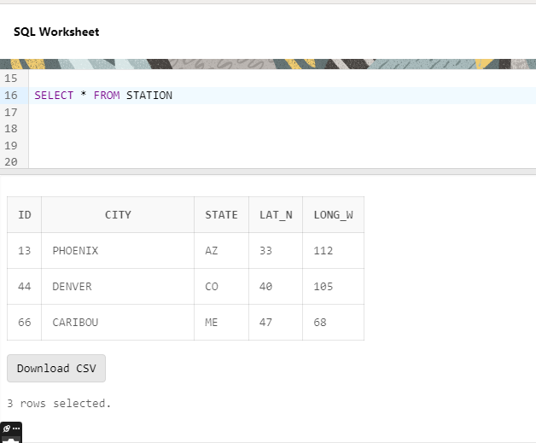

Q4) Execute a query to select Northern stations (Northern latitude >39.7)

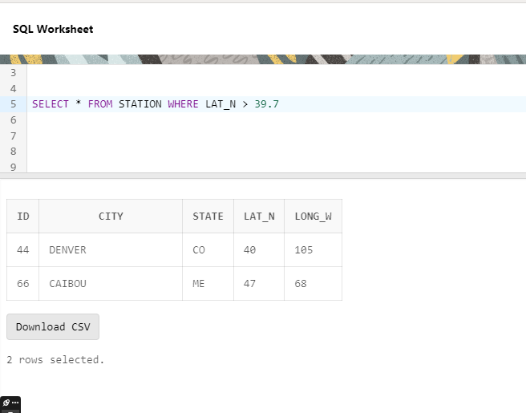.

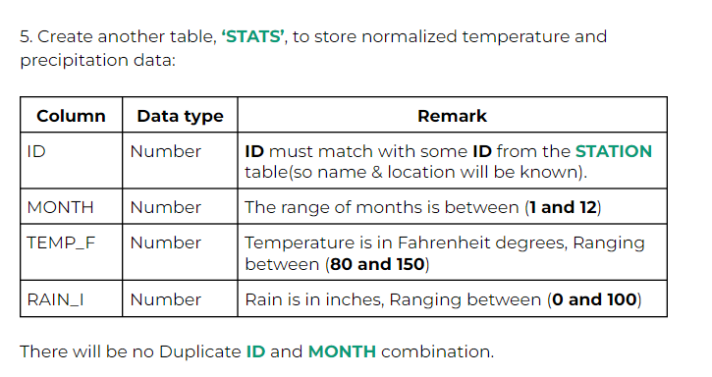

**INSERT INTO STATION (ID, CITY, STATE, LAT_N, LONG_W) VALUES (13, 'PHOENIX', 'AZ', 33, 112);**

**INSERT INTO STATION (ID, CITY, STATE, LAT-N, LONG_W) VALUES (44, 'DENVER', 'CO', 40, 105);**

**INSERT INTO STATION (ID, CITY, STATE, LAT_N, LONG_W) VALUES (66, 'CARIBOU', 'ME', 47, 68); (IN ‘’TEMP_F’’ I GAVE THE SAME DATA TYPE AS MENTIONED IN THE QUESTION BUT I DIN’T USE ‘CHECK’CONSTRAINT BECAUSE THERE IS A LIMIT BETWEEN (80 AND 150) BUT IN INSERTING VALUEALL THE VALUES ARE LESS THAN (80 AND 150) SO I DIDN’T USE ANY CONSTRAINT HERE ANDBECAUSE VALUES ARE INSERTING WITHOUT USING CONSTRAINT AS WELL SO I DIDN’T USE)**

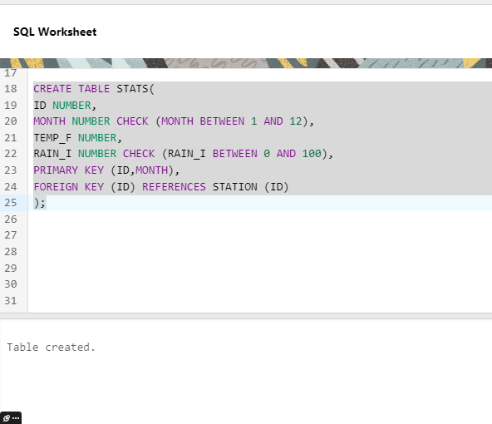

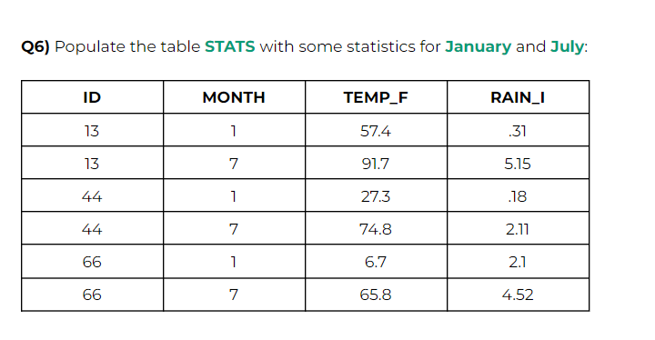

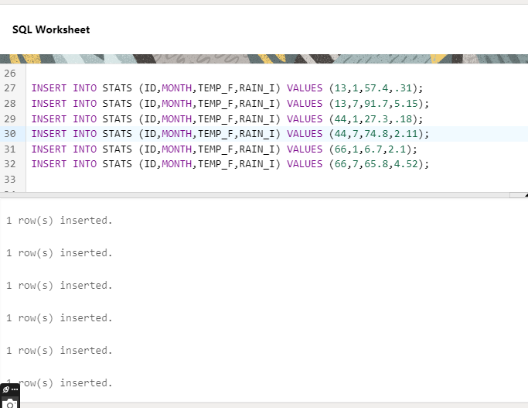

Q7) Execute a query to display temperature stats(from the STATS table)for each city(from the STATION table).

