

**Team “Green Lantern”**

**Project: Pac-Man**

**Telerik Software Academy**

**Group Project C#2**

Sofia, 2014



**List of Team members**

**(in alphabetical order)**

|  |  |
| --- | --- |
| Name | Academy username |
| Kliment Todorov | ktodorov |
| Lachezar Nikolov | Lnickolov |
| Lubomir Angelov | lubomir.angelov |
| Milko Venkov | wnvko |
| Pavel Hristov | lithical |
| Ventsislav Konov | LucasBoy |

**Project details:**

Team “Green Lantern” has chosen to re-create the favorite game of several generations – Pac-Man.

Pac-Man was first released on May 20th 1980 in Japan and for a very short period of time the game became the favourite game of millions around the world.

The Pac-Man created by the “Green Lantern” team for the Telerik Academy C# part 2 group task has the following features, characters and gameplay.

1. The game has the characters from the original game:
   1. Pac-Man – represented on the console by “W” or “G”.
   2. 4 Ghosts – represented in the game by “C”, “O”, “P” & “R”.
      1. Ghost C: ambushes Pac-man.
      2. Ghost O: circles the “maze” without chasing Pac-Man.
      3. Ghost P: chases Pac-Man.
      4. Ghost R: changes its behavior.
   3. If Pac-man eats a power pellet, he will start to eat ghost. The power pellet is represented in the game “@”.
   4. The game includes crumbs which Pac-man “eats” for points. They are represented by “.”. When all the crumbs are gone, a new maze is loaded the game continues.
   5. Walls for the maze are represented in the game by “|”.
2. The game has 3 custom levels (mazes):

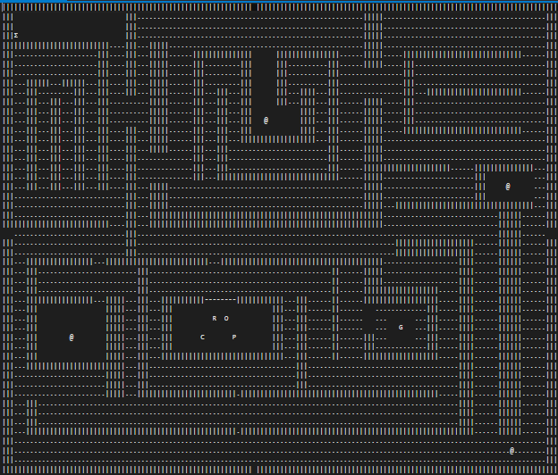 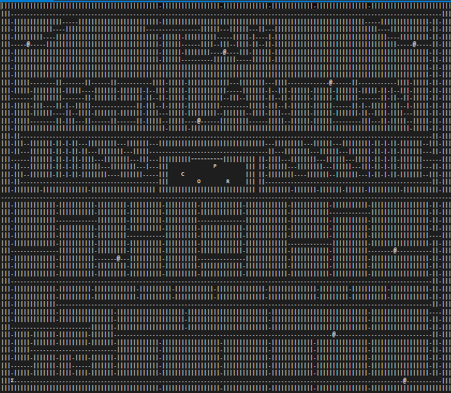 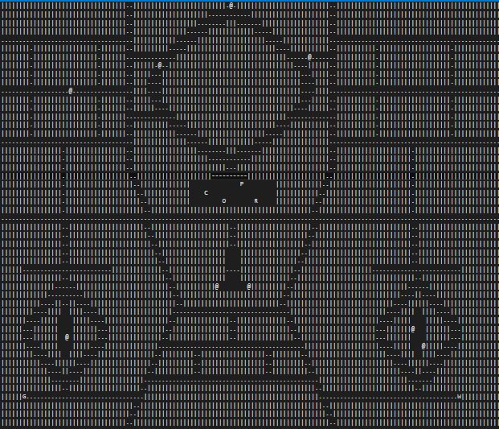

1. Interactive Start screen.
2. Custom mazes are allowed. All mazes are loaded from text files, everybody can create his own maze.
3. Scoreboard containing the 10 best scores in the game.
4. The game allows for a single and multiplayer mode with the following controls:
   1. Single player

← - left

↑ - up

→ - right

↓ - down

* 1. Multiplayer
     1. Player 1

← - left

↑ - up

→ - right

↓ - down

* + 1. Player 2

A – left

W – up

D – right

S – down

1. Rules of the game:

Points and scores:

* 1. Each “eaten” crumb adds 10 points to the player’s score.
  2. Each “eaten” power pellet (@) grants 50 points and makes the ghosts edible by Pac-Man for 15 seconds.
  3. The first “eaten” ghost increases the player’s score with 100 points, the second with 200 points, and the third with 300 points and so on. When the timer for power pellets ends, the bonus for the ghost resets to 100 points.
  4. When the player reaches 10 000 point his/her lives increase with one, and the points required for the next +1 life bonus increase with 10 000.

Game Play:

1. Pac-Man and the ghosts can only move on “.”, “@” and free spaces.
2. When Pac-Man reaches a wall he stops, and the player need to change the direction in order for Pac-man to continue to move.
3. When a ghost reaches a wall, it changes its direction.
4. When Pac-Man or a ghost reaches one of the “holes” in the outer wall of the map, the same comes out from the hole located on the opposite side of the maze.
5. When Pac-Man is eaten, the player’s lives decrease by one and the player returns to the starting point in the maze.
6. Goal of the game is the player to “eat” all crumbs in the current maze:

End Game:

The game has one of two possible outcomes:

1. The player has “eaten” all the crumbs and the power pellets on the map in which case the player is taken to the next map/maze.
2. The player does not have any lives left. In this case, the game ends, and if the player’s score is enough to enter the high score list, his/her result is added to the top 10 scores.

**TFS repository**

**URL:** [**https://greenlantern.codeplex.com/**](https://greenlantern.codeplex.com/)