Writing a Technical Report for Submittal to Professor Barnett

By
Professor Jonathan R. Barnett
Autumn, 2003

Introduction
This document is a general guideline to the use of Word XP to assist you in putting together a document. It is not a guide on developing and writing the report per se. Nonetheless, some guidelines are included in the appendix.

If you are doing an IQP, MQP or Master’s thesis with Prof. Barnett, you must use the guidelines specified in this document. There will be no exceptions.

The Main Features
All reports shall be written using the standard outline numbering scheme from word as was used in this document. The scheme uses the format of the title to determine the section number. To set it up, select Format, Bullets and Numbering, Outline Numbered and then select the format scheme shown in Figure 1-1

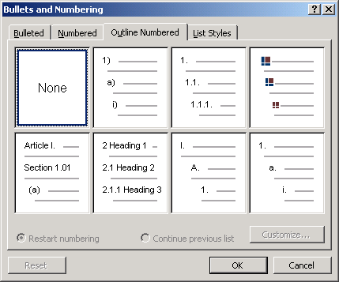
Figure 1-1 Bullets and Numbering Scheme
Once you’ve selected this scheme, Headings are numbered in accordance with their format as illustrated in Figure 1-2. As can be seen, to automatically number a section, select the style type and the section will then be numbered appropriately.
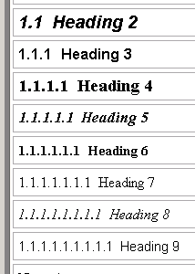
Figure 1-2 Heading Styles and Their Associated Numbering Scheme

Figure, Caption and Other Numbering
All numbering shall be done using the automatic scheme in Word. First make sure the automatic numbering scheme is on. To do this: Insert, Reference, Caption. The dialogue window is illustrated in Figure 1-3. This dialogue window is also used to set up automatic equation and table numberings. You can read about captions and numbering using the help screen under Add Captions. As illustrated Figure 1-4.
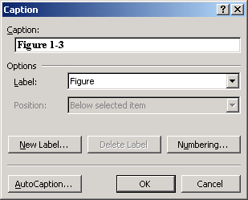
Figure 1-3 Auto-numbering Window
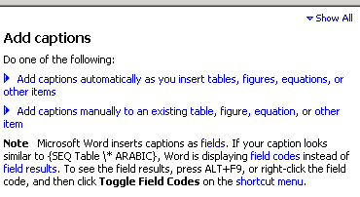
Figure 1-4 Help on “Add Captions”

Use of Reference Options
In general, select Insert, Reference. You then have four choices: Footnote, Caption, Cross-Reference, Index and Tables.

Footnotes
Footnotes should only be used for adding information to the text that is supplementary in nature and not suitable for inclusion in the main text. Citations should not be done in footnotes. Instead, cite by author and page number in the text, and then write the full reference in the Reference List using the MLA style.

Caption
See page 2, section 1.1.1.

Cross Reference
The reference in 1.1.2.2 is a cross reference. If you toggle the field code using Alt - F9 the text becomes: See page { PAGEREF _Ref18454151 \h }, {REF _Ref18454151 \r \h}. If the page or section number changes, the cross reference changes automatically. More explanation is available under Help, Field Codes.

Index and Tables
If you have followed these instructions, you’ll be able to automatically create a table of contents or an index. To create a table of contents, move your cursor to where you want the table of contents inserted, and then select Insert, Index and Tables, Table of contents. The following is a sample Table of Contents. Note you can update it by moving the cursor over it, left click once, then right click and select update. Don’t update this table of contents as the Appendix is not formatted properly (it was not written according to the rules in this document).

1 Introduction 1
1.1 The Main Features 1
1.1.1 Figure, Caption and Other Numbering 2
1.1.2 Use of Reference Options 3
1.1.2.1 Footnotes 3
1.1.2.2 Caption 3
1.1.2.3 Cross Reference 3
1.1.2.4 Index and Tables 3
1.1.3 Equations 4
2 Important Report Structure 5
2.1 Getting Started With the Right Structure 5
2.1.1 Using Outline Mode 5
3 Other Tips 6
3.1 Saving Space 6
A. Appendix: Other Guidelines Error! Bookmark not defined.

Figure 1-5 Sample Table of Contents

List of Figures
A list of figures is inserted in a similar manner:

Figure ‎1-1 Bullets and Numbering Scheme 1
Figure ‎1-2 Heading Styles and Their Associated Numbering Scheme 2
Figure ‎1-3 Auto-numbering Window 2
Figure ‎1-4 Help on “Add Captions” 3
Figure ‎1-5 Sample Table of Contents 4
Figure ‎2-1Outlining Toolbar 6
Figure ‎2-2 Create Sub-document Icon 6
Figure ‎3-1 Formatting Dialogue Box 7

Equations
Equations are also numbered using the Caption feature. First create an equation by selecting Insert, Other, Microsoft Equation 3.0. Equations are centered, followed by a tab and the equation number in parentheses. Note that the equation number uses Field Codes (see Microsoft Help, Field Codes.) You can see the value of the field code by typing ALT+F9. To create the Code you use the Set command and select a name for the equation. For example, let’s call () cross. You create the field code by typing CTRL+F9 (this creates an pair of curly braces) inside a pair of parenthesis, and the following syntax: {SET cross {SEQ eq}}. The “SET cross” gives the equation a name. The “SEQ eq” identifies this is an equation object. You can add a reference identifier by then adding {REF cross}. By defining the REF, you establish a bookmark. You can then refer to the number for equation “cross” by selecting Insert, Bookmark. The numbering is established (or updated if you’ve added several equations) when you hit F9 (after first typing CTRL-F9).

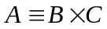 ()
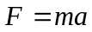 ()

Important Report Structure
As with all technical reports, the first step is to create an outline. For many projects, the basic outline will consist of the items listed in Table 1.

Abstract
Acknowledgements
Authorship Page (if a group project)
Table of Contents
List of Figures
List of Tables
Nomenclature
Executive Summary
Introduction (or Background)
Literature Review
Methodology
Results
Conclusions (may include recommendations, but must not introduce new material)
Reference List
Appendices

Table 1-1 Typical Sections in a Report

Getting Started With the Right Structure
The first step is to create a basic outline of your report. You’ll be able to modify this later, but the more complete it is at this stage, the easier your job will be. Use Headings, Sub-headings, sub-sub-headings to write your outline. You can now split the document into these sections, so that you are only editing/writing one section of your report at a time. Reviewing documents on a computer screen that are more than a few pages in length is very tedious and time consuming. The outline feature of Word makes this simple to do.

Using Outline Mode
Under View, select Outline. Next you create subdocuments by clicking on the Create Subdocument icon from the outlining toolbar (Figure 2-6 and Figure 2-7). A series of files will then be created for each heading in your outline. They are managed by the master document. You can read about the master document under Microsoft Help, Master Document.

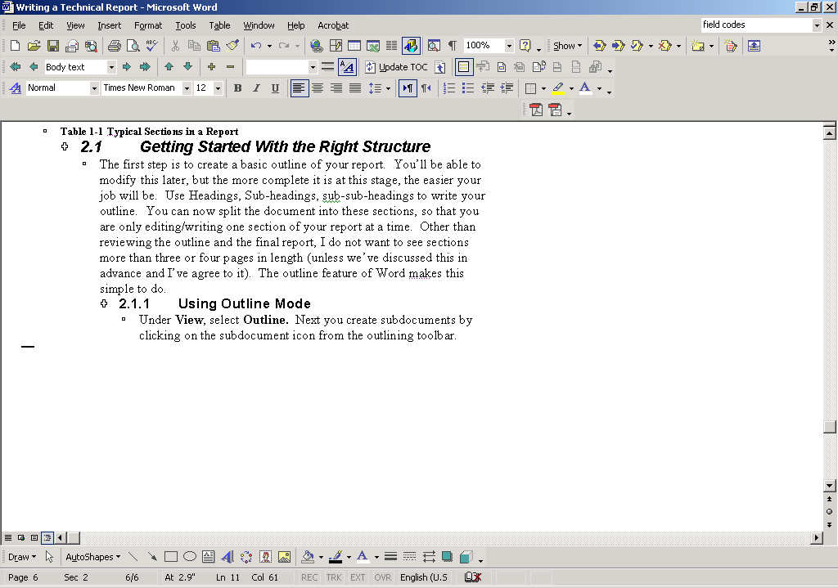
Figure 2-6Outlining Toolbar

Figure 2-7 Create Sub-document Icon

The important reasons for doing this are to 1. Keep organized, 2. Think before you start writing, and 3. Optimize use of my time in correcting your work.

Other Tips

Saving Space
Instead of inserting (or embedding) excel spreadsheets, including excel graphics into an existing document, you can link files. By doing so your word document stays small, making it easy to edit. More important, changes in the original file (the file you are linking to) are reflected in the document. To do this, open your excel spreadsheet. Copy the figure or portion of the table you want to link. Go to your word document and right click and select Paste. Then in the formatting dialogue box, select either “Keep source Formatting and link to Excel”, or “Match Destination Table Style and Link to Excel”. These choices are shown in .

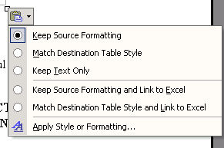
Figure 3-8 Formatting Dialogue Box

Reviewing Mode
As we exchange drafts, I will mark up your work using the reviewing tools of Word. Please do not delete any of my comments. Please address them by correcting the text or by adding your own comment. Please be sure to use "Track Changes" mode.

http://www.westwords.com/guffey/mla.html and http://webster.commnet.edu/mla/index.shtml are excellent reference guides to the MLA format.
Note: you must be in Outline Mode.

