Autoškola Ľubomír Hlavko

Cenník:

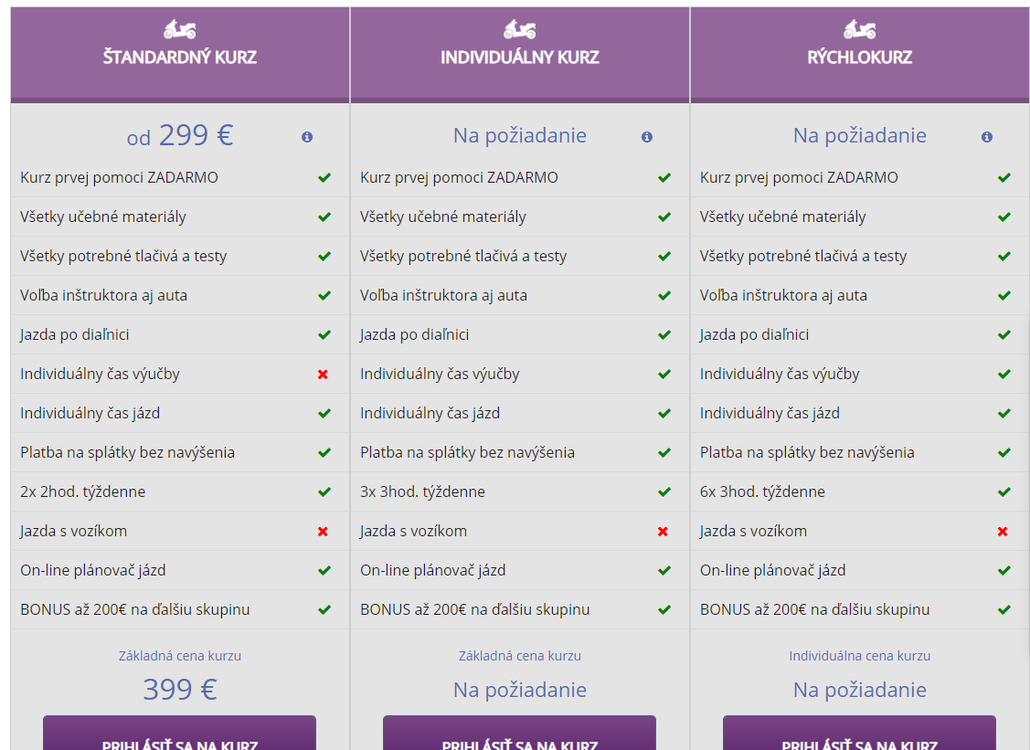

|  |  |  |  |
| --- | --- | --- | --- |
| AM | 299 |  |  |
| A1 |  |  |  |
| A2 |  |  |  |
| A |  |  |  |
| B |  |  |  |
| B96 |  |  |  |
| C |  |  |  |
| CE |  |  |  |
| D |  |  |  |
| T |  |  |  |
| Kondičné jazdy |  |  |  |
| Kurz parkovania |  |  |  |
| Osobitná skúška |  |  |  |

