Eshop_Email_Guru Plugin

Description

This plugin helps to connect and interact customers with your site via email alerts on various actions like purchasing of goods,shipment,payment recieved etc. To get in touch with its customers instantly.

-> This plugin gives Email Alerts on following triggers/events

1)Order placement in COD mode(Order On-Hold status)
2)Order Confirmation in COD mode(Order Pending status)
3)Order placement in Payu mode(Order Processing status)
4)Payment failed(means Order Failed or Payment interrupted)
5)Order Completion
6)Order Refunded
7)Order Cancelled(payment cancelled by user)
8)Payment Completion
9)Resend Cod Confirmation code on user request for order confirmation
10)Order Shipment(send only after filling shipping details & when shipment tracking plugin is installed)
11)Abondoned Cart (items are added to the cart by the customer but not ordered yet)
12) Abondoned Order (when payment fail and order is in pending state)

User interface in admin panel
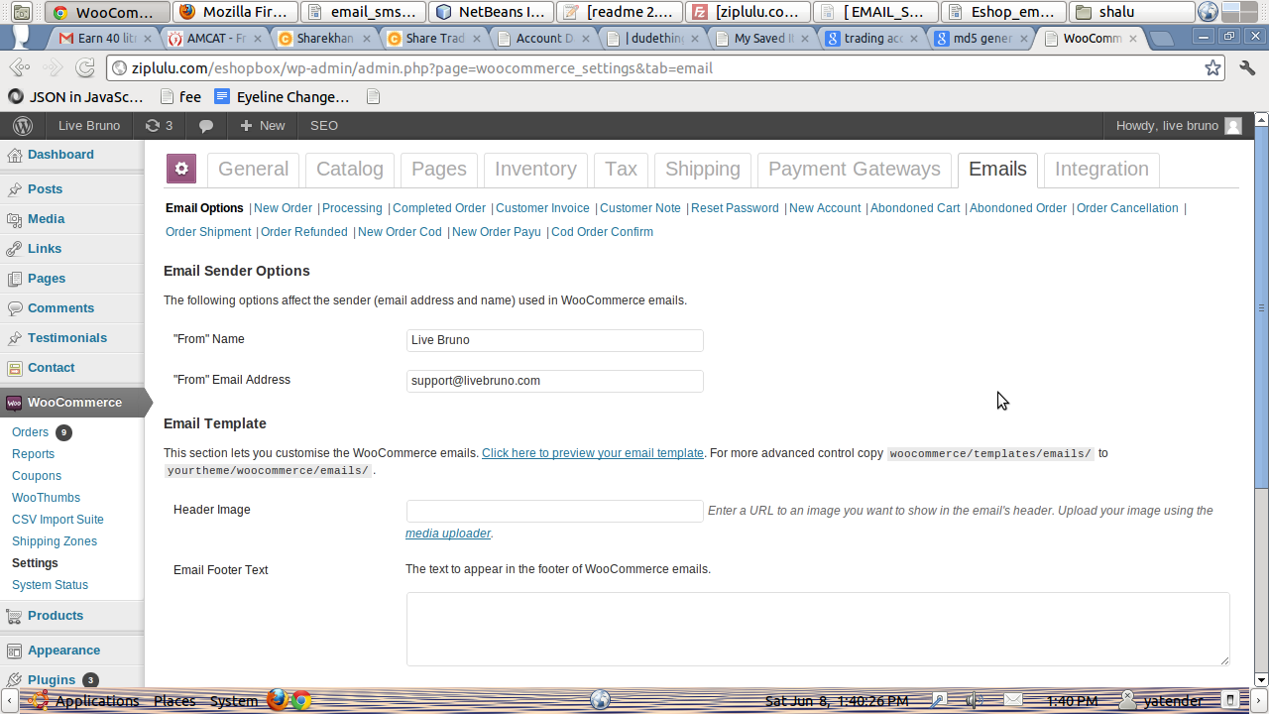

Its user interface

Woocommerce->settings->emails->

then you can find the setting panel for each Email saperately where you can edit heading and content as per requirement.
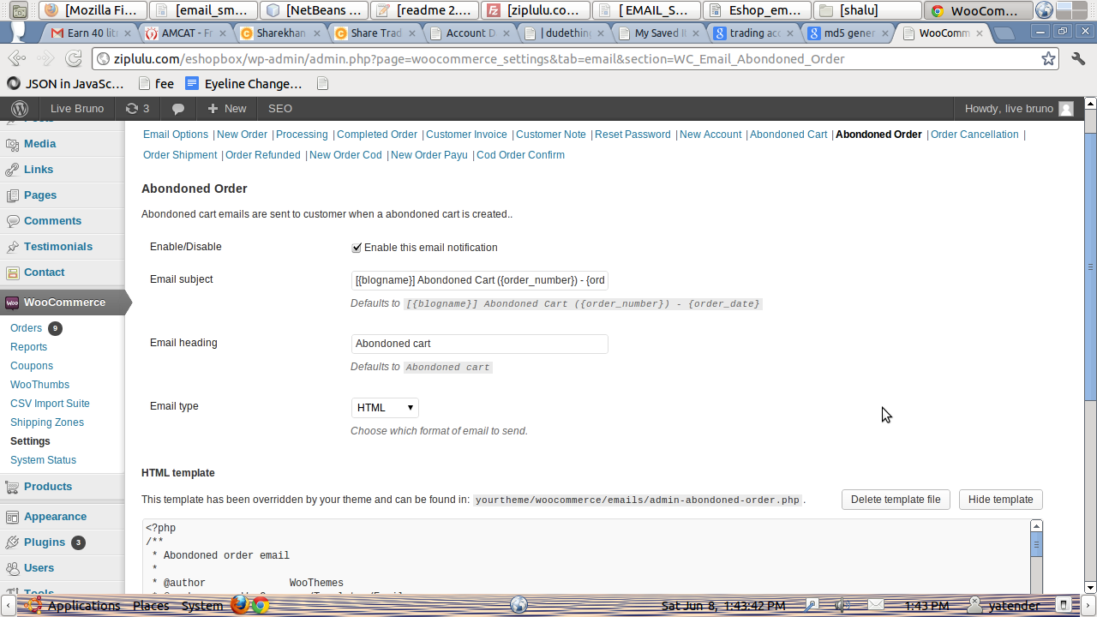

* File Structure

1)eshop_email_guru.php(the main file containing all hooks)

2)Class files for all emails

-> class-wc-email-abondoned-cart.php
-> class-wc-email-abondoned-order.php
-> class-wc-email-neworder-cod.php
-> class-wc-email-neworder-payu.php
-> class-wc-email-order-cancellation.php
-> class-wc-email-order-refunded.php
-> class-wc-email-order-shipment.php
-> class-wc-email-payment-fail.php

3)eshop_abondoned_cart_email.php (file to be called by cron to call abondoned cart functionality)

4)eshop_abondoned_order_email.php (file to be called by cron to call abondoned order functionality)

5)email folder containing(containing html template for emails)

->admin-abondoned-cart.php
->admin-abondoned-order.php
->cod_cofirm_order.php
->new-order-cod.php
->new-order-payu.php
->order-cancellation.php
->order-refunded.php
->order-shipment.php
->email-order-items.php

->plain folder containing(containing plain templates for emails)

->admin-abondoned-cart.php
->admin-abondoned-order.php
->cod_cofirm_order.php
->new-order-cod.php
->new-order-payu.php
->order-cancellation.php
->order-refunded.php
->order-shipment.php

* Installation

1)Activate this plugin from admin panel of wordpress

2)Create cron for abondoned cart & abondoned order

cron command is:

for abondoned cart :

wget -q –delete-after http://dudething.com/eshop-kart4u/applications/Eshop_email_guru/ eshop_abondoned_cart_email.php

for abondoned order :

wget -q –delete-after http://dudething.com/eshop-kart4u/applications/Eshop_email_guru/ eshop_abondoned_order_email.php

3) paste files inside email in themes/woocommerce/email folder to make them editable from admin panel

4)Set the email header and footer inside themes/woocommerce/email to be used particular for your website

5)Still ther is a bug in this plugin that i am not able to call header and footer inside templates of certain emails through hook
So,you need to do just one extra work that inside those templates please paste your header and footer code inside header and footer comments
these files are:

->admin-abondoned-cart.php
->admin-abondoned-order.php
->cod_cofirm_order.php
->order-cancellation.php
->order-refunded.php
->order-shipment.php

6)For customization for certian emails just enable or disable the emails you want from admin panel

7)for shipment mail require one more aditional work other than installation

->go to page

plugins/woocommerce/admin/post-types/writepanels/writepanel-order_data.php

<optgroup label="<?php _e( 'Resend order emails', 'woocommerce' ); ?>">

<?php

global $woocommerce;

$mailer = $woocommerce->mailer();

$available_emails = apply_filters( 'woocommerce_resend_order_emails_available', array( 'new_order', 'customer_processing_order', 'customer_completed_order', 'customer_invoice','order_shipped' ) );

$mails = $mailer->get_emails();

if ( ! empty( $mails ) ) {

foreach ( $mails as $mail ) {

if ( in_array( $mail->id, $available_emails ) ) {

echo '<option value="send_email_'. esc_attr( $mail->id ) .'">' . esc_html( $mail->title ) . '</option>';

}

}

}

?>

<option value="send_email_order_shipped">Send Shipment sms and mail</option> //you just need to add this line

</optgroup>
8)to get different emails for cod and payu mode u need to comment the action hooks of customer processing email class inside woocommerce/classes/emails/customer_ processing_email.php(will be dyanamic in our next version)

* ChangeLog

= Version 1.2 =
a bug resolved i.e. Abondoned cart emails are going even if the cart page gets refreshed without any change
so,now the abondoned cart emails are going only and only if there are some changes in the cart by the user

= Version 1.1 =
user interface added inside woocommerce/setting/emails
new order emails send to eshopbox email also

= Version 1.0 =
First release of Eshop email guru

* Functional dependency on woocmmerce(yet to be resolved)

Unable to call header and footer via woocommerce hook.
Unable to add send shipment sms and mail link in order action dropdown through hook

