Task1 pdf has attached to canvas

Task2

(c) here is the plots for the elapsed time of matmul for three different types under different matrix size range fro m 5 to 14

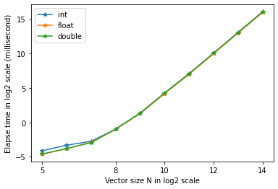

(d) here is the plot for the elapsed time of matmul at different tile block size (4,8,16,32) when the matrix size N is 2^14. From the plot, we found out that block size = 16 has the best performance.

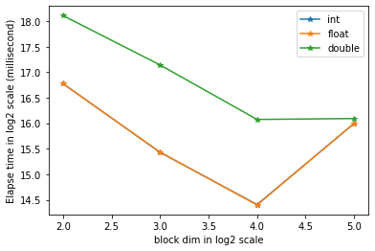

(e) here is the plot of elapsed time for three different data types in ordinary scale. Notice that when the matrix is small, three types has similar performance. However, when the matrix is large, we found out that double > float => int. The reason for that is the double precision request for bits (8 bytes) than others two types (4 bytes). Therefore, more bits in its binary to compute for double. Int and float have almost the same performance but integer is slightly faster (not 100% sure) due to no decimal to calculate.

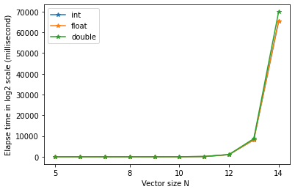

(f) & (g) I put them at same place since have one figure for both problem

here is the plot for three different matrix multiplication method. First of all, for question (f), the tile method performance somehow better when the matrix size is large (after 1024). The tile method utilize the shared memory to speed up the memory communication so that the performance get betters. As for question (g), the cpu compute the matmul sequentially so that it is really slow.

