Task1

(a) 3 levels are classified based on different task of linear algebra.

Level 1: typically for the vector-vector operation, such as dot product, norm, SAXPY

Level 2: typically for the matrix-vector operation, such as matrix-vector multiplication

Level 3: typically for the matrix-matrix operation, such as mmul

(b) two special calls from CUBLAS

cublasSsymm: this is special call for the symmetric mmul. The input of first matrix A is assumed to be a symmetric matrix and it is stored in lower or upper mode depending on whether it is on left side or right side.

CublasCgemm3m: this is complex mmul, and it is implemented by Gauss complexity reduction algorithm, which can lead to an increase in perfor mance up to 25%

(e) see attached task1.pdf

(f)

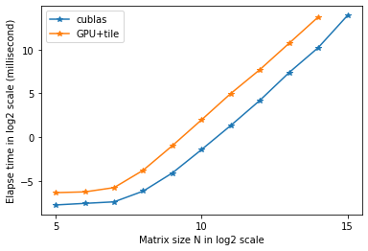(f)

This is the plot of elapsed time between CUBLAS library and HW05 mmul. The cublas computes somehow faster than mine implementations. I believe my code possibly has lots of place to improve such as locality.

Task2

(c) see attached task2_memcheck.txt

(d) see attached task2.pdf