ECE 532 Update 1

Date: Dec – 1 - 2020

Github Repositary link: lubyant/ECE532_CourseProject

|  |  |  |  |  |
| --- | --- | --- | --- | --- |
| Phase | StartDate | EndDate | Content | Finish |
| 1 | Oct/22 | Nov/17 | Linear classifer | 80% |
| 2 | Nov/18 | Dec/1 | KNN | 100% |
| 3 | Dec/2 | Dec/12 | ANN | 0% |
| 4 | Dec/13 | Dec/17 | finalized | 0% |

Brief report for the second updates:

* Build up a k-nearest neighbor classifier using the MATLAB package. The k value which stands for the number of neighbor features will be selected based on series of number from 1 to 10. An optimized k value was pickup based on minimum error rate computed. Here is the result figure for the error rate of different k value using the Euclidean distance.



* Explore the effect and sensitivity of different distance function including:

1. Euclidean Distance: the most common distance function used in KNN classfier. The reason to choose this function is that it is close to the l2 loss function in linear classifier
2. Cityblock Distance: it is a distance usually used in analyzing the geographic info which consider the distance between two points as two tangible line at corner.
3. Minkowski Distance: select it because it is between cityblock and Euclidean distance
4. Correlation Distance: this distance is defined as one minus the correlation between y and X.

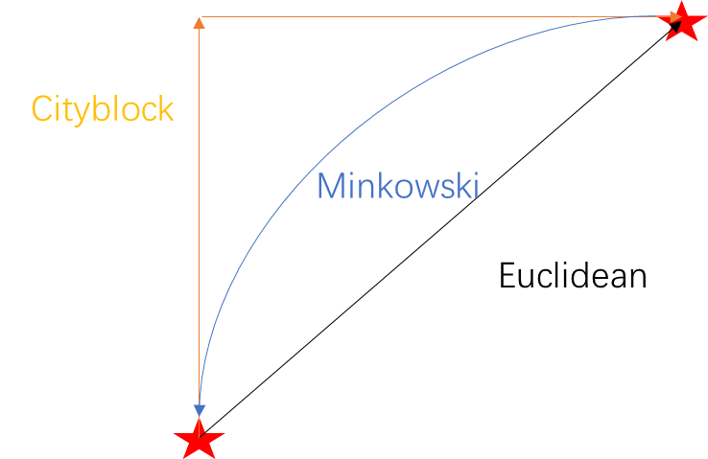

The report of different KNN with different function of distance with K varied from 1 to 10:



The result turns out that k = 3-5 would be a good choice, however, overall the magnitude of error rate for all kNN method still stays large around 12%. The plan for following week is to deal with this piece.