Human resources

Business Requirements Document

00 | 21 Oct. 2010 | L. GIROUX | I. FOULON
Rev. | Date  (dd mmm yyyy) | Author  (Name) | Checked  (Name) | Approved  (Name)

Revision History
Rev No. | Revision Date | Revision Detail
00 | 21 Oct 2010 | Document creation
01 | 9 Nov 2010 | Update after meeting of Nov 3 + study calcul cost
02 | 30 Nov 2010 | Update screen + business rules + strategy of data recovery
03 | 03 Dec 2010 | Update after feedback of Isabelle and Sean
04 | 13 Dec 2010 | Update after feedback HR Team + complements
05 | 22 Dec 2010 | Update before delivery test version

Table of Contents
1. Purpose 5
2. Scope 5
3. Definitions 5
4. Application Features 6
4.1 Header of the application 6
4.2 Entry point: the list of positions 7
4.3 View list of phases 9
4.4 Edit a phase 10
4.5 Add a phase 10
4.6 Create a position 13
4.7 View a phase 14
4.8 Edit a position 16
4.9 Initialize PRF 20
4.10 View PRF 21
4.11 Edit PRF 21
4.12 Initialize recruitment 22
4.13 View recruitment 23
4.14 Edit recruitment 24
4.15 Edit/delete Candidate 25
4.16 Add Candidate 26
4.17 Create new Candidate 27
4.18 View PAF 28
4.19 Edit PAF 29
4.20 View Mobilisation 33
4.21 Edit Mobilisation 33
4.22 To Assign an incumbent 35
4.23 View incumbent 35
4.24 Edit incumbent 36
4.25 View/Edit Logistics 37
4.25.1 Reports 38
4.26 PAF Revised 38
4.27 Staffing Plan : Effective costs 38
4.28 Staffing Plan : forecast costs 39
4.29 Phases History 40
4.30 Incumbents 42
4.30.1 Supplements for the import of data in the database 43
4.31 Database 44
4.32 Reference tables 44
4.32.1 Department 44
4.32.2 Work group 45
4.32.3 Secteur 45
4.32.4 Rotation 46
4.32.5 Area 46
4.32.6 Discipline 46
4.32.7 WorkGroup 49
4.32.8 Function 49
4.32.9 RomeCode 51
4.32.10 Company 52
4.32.11 Work Location 52
4.32.12 Accountable Manager 52
4.32.13 Responsible Manager 53
4.32.14 Point of origin 53
4.33 Database scheme 53
5. Matrix read / write fields 55

Purpose

The purpose of document is to determine the scope and the features provided by the first version of the Human resources Application.

Scope

The scope of the first version of the application is the following:
- Save the staffing plan in an object relationnal database
- Allow users to add/edit data accordingly to their rights
- Develop reports to exploit the data
- Develop report “staffing plan” without the columns of costs.
to calculate estimated costs and actual costs

Definitions

- PRF: Personnel Request Form
- PAF: Personnel Authorization Form
- TRF: Travel Request Form
- TBA : To be announced
- ACE : Alternate Country Expat
- PLT : Project Leadership Team
- VCC: Visa Coordination Center
- V2 : Version n°2 of the application

Groups of persons will provide data for the staffing plan:
- Project Control (PC)
- Human Resources (HR)
- Finance (FIN)
- Mobility (MO)
- Database Administrator (DA)
- Logistics (LO)
Groups of persons may have access to the application (in V2):
- PLT
- VCC
- Travel
- Administration

Application Features

Header of the application
The following header will be always presents in the application.

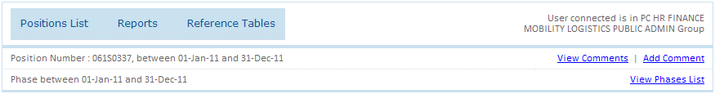
Screen 1
Information available:
- All groups to which the connected user belongs to.
- The start and end date of the position (if a position has been selected).
- The number of the position (if a position has been selected).
- The start and end date of the phase (if a phase has been selected).
- A link returns to the list of the positions.
- A link returns to the list of the phases of the current position.
- A link goes to the comments.
- A link goes to add comment.
- A link goes to the reference tables (Only visible by a user belongs to ADMIN or HR group).
- A link goes to the list of the reports.

Note 1: the start date of the position is the earliest date of its phases and the end date of the position is the most recent date of its phases.
Note 2: The reports will available directly in the portal project. A specific menu will created which contains this application and all corresponding reports.

You can view all comments corresponding to the current phase, when you click on the link “View Comments”:
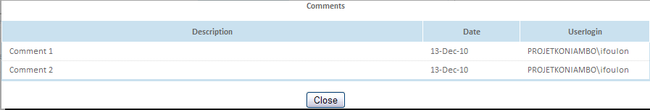
Screen 2

Only HR and PC group can add comment when you click on the link “Add Comment”:
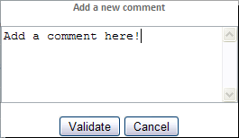
Screen 3

You can edit the comments.
In V2, it will be impossible to edit a comment which you have not created.

Entry point: the list of positions

This is the start point of the application. The user must be granted proper right to access this page.
This default page contains the list of the positions:
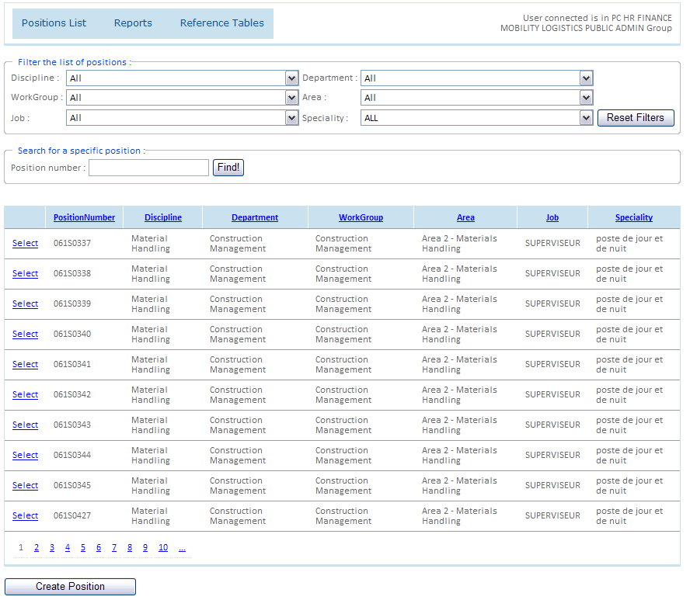
Screen 4
It is possible to use the filters to find a position.

Business rules:
- All groups can view this list, but only the PC group can activate the button “Create Position” (view chapter 4.5)
When the user clicks on the “select” link for a position, 2 events are possible:
- If the position has only one phase, the application opens directly a page with the detail of the phase (see screen 9).
- If the position contains multiple phases, the application opens a page with the list of the phases corresponding to the selected position (see screen 5)
- In V2, the creation of the position will require a submitted form 319000-00000-TEM-GPRM-10001. Without this form, it will be impossible to create a new position.

View list of phases
When a position contains more than one phase, the user is redirected on this screen:

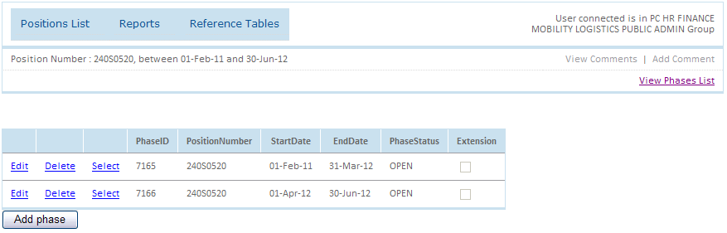
Screen 5

2 events possible to access screen “List of Phases”:
- If the position has more phases, the screen is visible directly after select position in the screen “List of Position”.
- A link “View Phases” is always available in the header of the application.
Business rules:
- All groups can view this list, but only the PC group can see the button “Add Phase”.
- Only the PC group can add, edit and delete a phase.
- Deleted a phase means deleted all objects related to this phase (PRF, Recruitment, PAF, Mobilisation, incumbent and logistics).
- Each position must have at least one phase. If the user tries to delete the last phase, a blocking message will appear.
When a phase is selected, the user can see the detail of the position on the selected phase (see screen 9).

Edit a phase
When the user clicks on the link “Edit”, he can update the start and end dates.
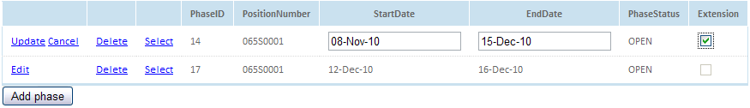
Screen 6
Business rules:
- Two phases, with the same person (incumbent or selected candidate) can’t overlap.
- Impossible to check “Extension” if the PAF doesn’t exist.
- When an extension is checked, only the “POSITION” and “PAF” tabs are visible. The user can have needed to view other to revise the PAF. The PAF must be revised.

Add a phase
As you can see on the screen 6, it is possible to add a phase. When the user clicks on the button “Add phase”, the following screen appears:

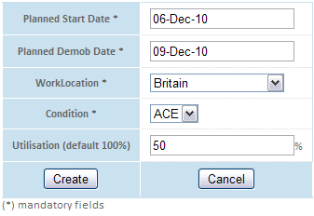
Screen 7
List of input fields:

Fields | Type/Source | Controls | Column in staffing plan
Planned start date | Date picker | Can’t be empty. | PMT PLANNED START DATE
Planned demob date | Date picker | Can’t be empty Must be after planned start date. | PMT PLANNED DEMOBILISATION
Work location | Drop down list Location table (in PAF_DATA) | Can’t be empty | PMT WORK LOCATION
Condition | Drop down list  Values from a static list LWE -> LOE | Can’t be empty | PMT Planned Status  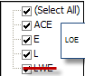
Utilisation | TextBox | Integer between 0 and 100  Default value = 100 | PMT Utilisation  If empty in the staffing plan : 100

Business rules:
- An extension is mandatory when we want expand the period of the phase but we keep the same incumbent.
- If the incumbent is not the same, we must create a new phase.
- When a phase is created, the fields concerning a phase not in the screen of the creation will be initialized :
  - Company : HT
  - Type de mobilisation : MOBI
  - Camp status: Camp inside
  - Marital Status: S
  - Point of origin: APAC
  - Hours per week: using the reference table NbHours to find the right case and take the corresponding amount of hours per week. Be careful the value will be initialize according to the values of the initialization (Marital status = S, Condition = INS etc…)
- When we will import the data in the database, a new phase will be created when the end date of the position is not equal to the end date of the PAF (cf. below).
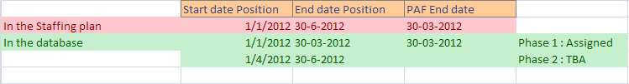

- When importing data, the closed phases won’t be included in the database. Reason: These phases have not Position number with the new format.

At the creation, the status of the phase is “Open”. When an employee will be assigned, the status will become “Active”. And when an employee is unassigned, the status becomes “Open”.
Below, the phase status workflow:
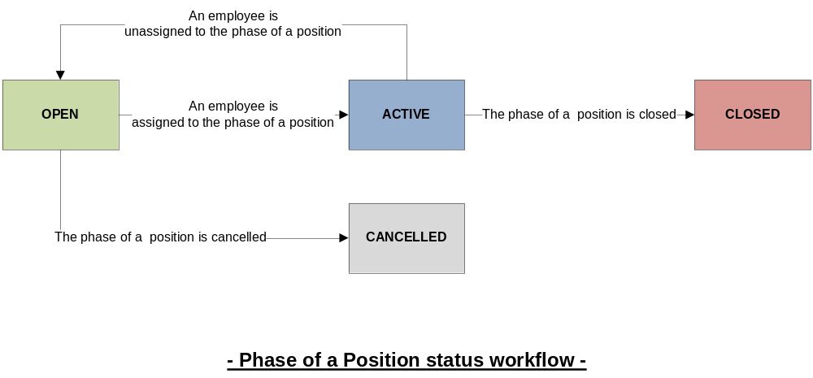
Figure 1
2 manually actions are possible (Screen 9):
- When the phase is open, the user can cancel it.
- When the phase is active, the user can close it.

Create a position
To create a position, click on the button “Create Position” on the screen List of the positions.
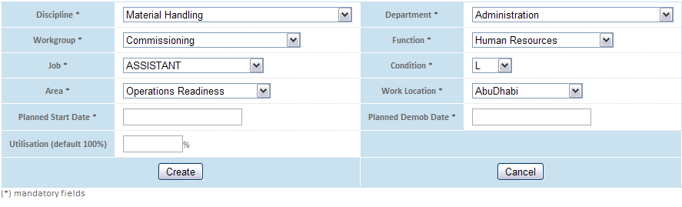
Screen 8
List of input fields:

Fields | Type/Source | Controls | Column in staffing plan
Discipline | Drop down list  Discipline table | Can’t be empty  The Discipline code concatenate with a unique ID is the Position Number. | CC discipline (SQL)
WorkGroup | Drop down list  WorkGroup table de reference | Can’t be empty | PMT GROUP  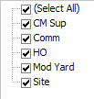  + Operations
Department | Drop down list Department table | Can’t be empty | PMT Department
Function | Drop down list Function table | Can’t be empty | PMT Function (ex-discipline)
Area | Drop down list  Area table | Can’t be empty | PMT Area  IF empty in the staffing plan = 700
Job | Drop down list  Reference table Job | Can’t be empty | Updated staffing plan to provide this data
Work location | Drop down list Location table (in PAF_DATA) | Can’t be empty | PMT WORK LOCATION
Condition | Drop down list  Values from a static list LWE -> LOE | Can’t be empty | PMT Planned Status
Planned start date | Date picker | Can’t be empty. | PMT PLANNED START DATE
Planned demob date | Date picker | Can’t be empty Must be after planned start date. | PMT PLANNED DEMOBILISATION
Utilisation | TextBox | Integer between 0 and 100  Default value = 100 | PMT Utilisation  IF empty in the staffing plan = 100

Business rules:

- A position is created by the PC group.
- When a position is created, one phase is initialized with the start and end dates planned.
- The fields concerning a phase not in the screen of the creation will be initialized with the same way when a new phase is created.

View a phase
When a phase is chosen or when a position with only one phase is selected, we arrive on this screen:

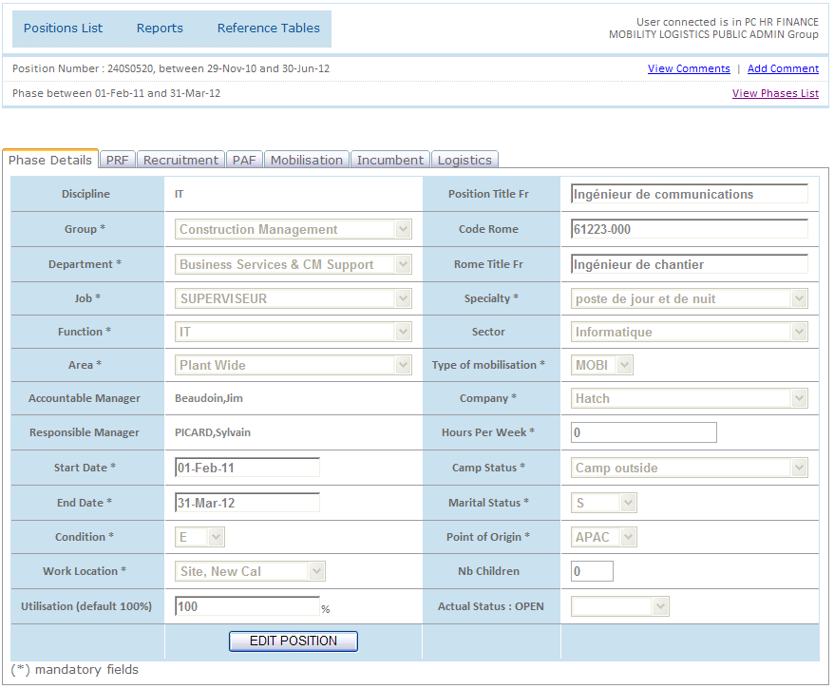
Screen 9

Business rules:
- Only the PC and HR groups can activate the button “EDIT POSITION” and only the HR group can activate the button “INIT PRF”.
- When a user initialized the PRF, the PRF tab becomes visible.
- When the PRF form has already been initialized, the button “INIT PRF” is not visible.

Edit a position
When the user clicks on the button “EDIT POSITION” on the screen 9, all fields (he has access right to) becomes editable.
- Green fields: editable by HR Group.
- Pink fields: editable by PC Group.

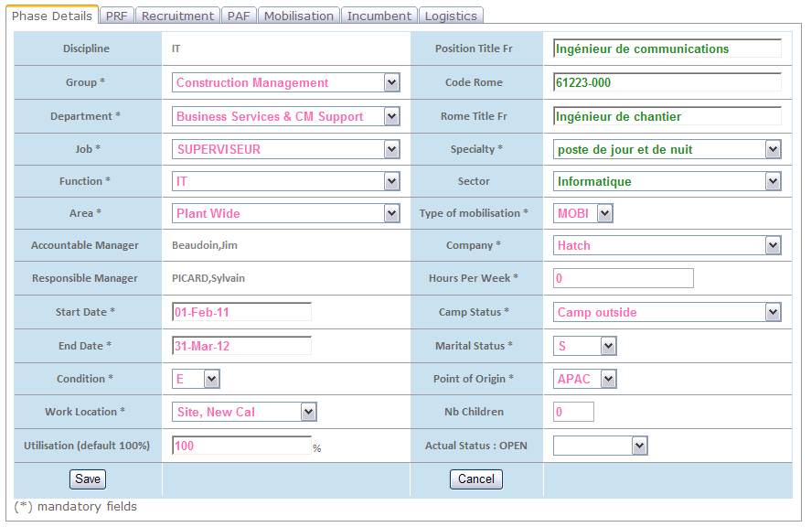
Screen 10

List of input fields for the Position Edition:
Fields | Type/Source |  | Controls |  | Column in staffing plan
Discipline | Read only |  | To add in the screen |  | CC discipline (SQL)
Group | Drop down list  WorkGroup table reference |  | Can’t be empty |  | PMT GROUP  +Operations
Department | Drop down list Department table |  | Can’t be empty |  | PMT Department
Function | Drop down list Function table |  | Can’t be empty |  | PMT Function (ex-discipline)
Area | Drop down list  Area table |  | Can be empty |  | PMT Area  If empty in the staffing plan = 700
Job | Drop down list  Reference table Job |  | Can’t be empty |  | Updated staffing plan to provide this data
Speciality | Drop down list  Reference Speciality  (provided only speciality corresponding to the chosen job) |  | Can be empty at the creation of the position and if a PC user edit the job.  Can’t be empty if a HR user edits the details of the phase. |  | Updated staffing plan to provide this data
Work location |  | Drop down list Location table (in PAF_DATA) |  | Can’t be empty | PMT WORK LOCATION
Condition |  | Drop down list  Values from a static list LWE -> LOE |  | Can’t be empty | PMT Planned Status
Planned start date |  | Date picker |  | Can’t be empty. | PMT PLANNED START DATE
Planned demob date |  | Date picker |  | Can’t be empty Must be after planned start date. | PMT PLANNED DEMOBILISATION
Utilisation |  | TextBox |  | Integer between 0 and 100  Default value = 100 | PMT Utilisation  If empty in the staffing plan = 100
Status |  | Dropdown Lit  Values from a static List : CANCELLED/ CLOSED |  | Can be cancelled only if the phase is open.  Can be closed only if the phase is active and demobilization date is filled and past. | All phases add will be : Open if TBA, Active if a incumbent is assigned.
Accountable Manager |  | AccountableManager table |  | ReadOnly depends of department chosen | Not included
Responsible Manager |  | ResponsibleManager table |  | ReadOnly depends of function chosen | Not included
Rome code |  | TextBox |  | Can be empty | CE ROME CODE
Titre rome français |  | TextBox |  | Can be empty | CE TITRE ROME FRANCAIS
Position title (French) |  | TextBox |  | Can be empty | CE POSITION TITLE (FRENCH)
Sector |  | dropdown List reference table Sector |  | Can be empty | CE SECTEUR
Type of Mobilisation |  | Drop down List Values from a static list |  | Can’t be empty | CC Type de mobilisation  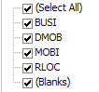  If empty in the staffing plan = MOBI
Company |  | Drop down List Reference table Company (HT, HAT, TPG, LIS, OTH, KNS) |  | Can’t be empty  Default value : HT | FIN Company
Hours per Week |  | Integer Reference table NbHours |  | Must be a integer | Calculated according to the condition, the work location and the construction.  Can be edited
CAMP status |  | Drop down List  Values from a static list  Update staffing plan  Update reference table concerning cost |  | Can’t be empty  Default value =Camp | HR ACTUAL INSIDE/OUTSIDE CAMP  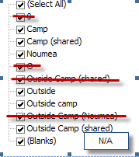
Marital status |  | Drop down List Values from a static list (S, P, F, FU)  S : Single P : Partner F1 : Family with one children FU : Family Unaccompanied  Update staffing plan  Update reference table concerning cost |  | Can be empty  Default value = S | HR SINGLE/PARTNER/FAMILY  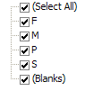
Point of origin |  | Drop down List Values from a static list (AUSI, APAC, ROTW) |  | Can’t be empty  Default value = APAC | LOG Point of origin  Creation table reference with 3 level (AUSI/APAC or ROTW, the country and the town)
Nb Children |  | integer |  |  | Not in the staffing plan?

Business rules:
- 2 groups are authorized to edit a position: PC and HR groups.
- Two phases, with the same person (incumbent or selected candidate) can’t overlap.

Initialize PRF

A PRF is initialized when a member of HR group click on the button “INIT PRF” on the screen tab “POSITION”. At the creation the status of the PRF is:
- “To Approve”, if the phase already exists.
- “Pending”, if the phase has been modified (Extension of position length) or if it is a new phase.
When the phase is “ToApprove”, the status changes to “Approved” if all approvers required are approved the PRF. If one approver rejects the PRF, the status becomes “Rejected”. Below the PRF status workflow:

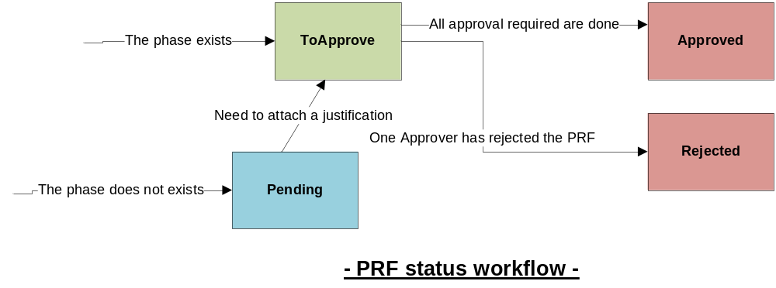

Not management of the PRF status in the first version.

View PRF
When the PRF has been initialized, the tab PRF appears:
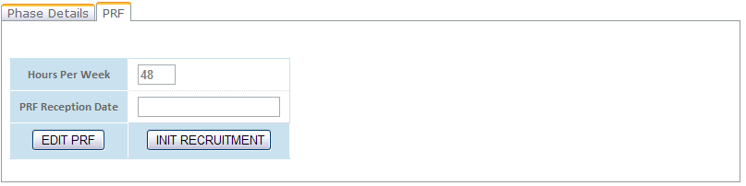
Screen 11

Business rules:
- Only HR group can edit the PRF.
- Only HR group can initialize recruitment.
- When HR user clicks on the button “INIT RECRUITMENT”, the Recruitment tab appears.

Edit PRF
When the user clicks on the button “EDIT PRF”, the following screen appears:

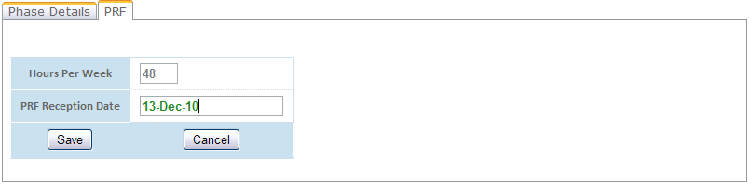
Screen 12

List of input fields:

Fields | Type/Source | Controls | Column in staffing plan
Hours Per Week | Text box Read Only | At the init of the PRF = HoursPerWeek calculated x % of utilisation  If Hours per week or the amount of the utilisation are updated in the Phase details, this field is automatically updated | = HoursPerWeek calculated x % of utilisation
PRF Reception Date | Date picker | Can be empty | HR  PRF reception date (HR-recruitment)
Status | Dropdown list : ToApprove, Pending, Approved, Rejected |  | Not included in the first version

In the second version, the tab will display a report of the PRF. An approval process will be implemented. . And when the PRF will be approved, the recruitment will be automatically initialized
In the first version, the HR members must initialize recruitment.

Initialize recruitment
The HR user can initialize process recruitment by click on button “INIT RECRUITMENT” in the tab position. The tab “RECRUITMENT” becomes then visible.
At the initialization, the recruitment has a status “in progress”. When a person is assigned for this position/phase, the status becomes “finished”. Below the RECRUITMENT status workflow:

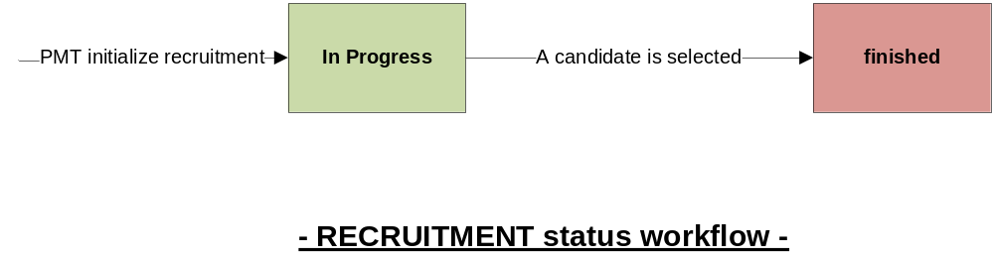

View recruitment
When the recruitment is initialized, the user can view this screen in the tab “Recruitment”:
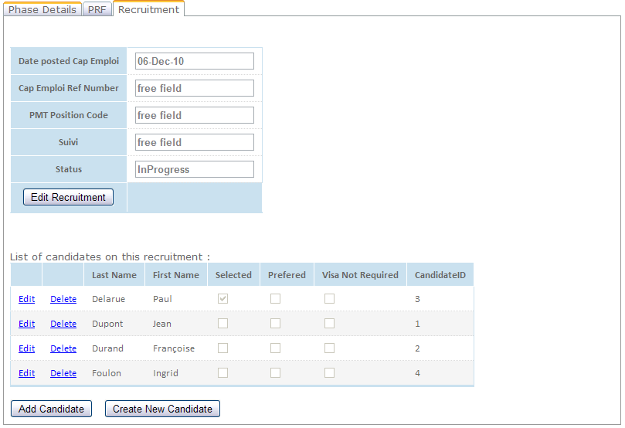
Screen 13

Business rules:
- Only HR group can edit recruitment.
- Only HR group can add or edit or delete a candidate.

Edit recruitment

When the user clicks on the button “Edit recruitment”, he can see this screen:

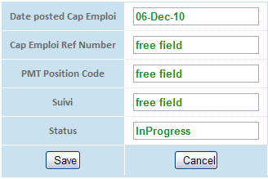
Screen 14

After, the user of HR groups can edit the following fields:
Fields | Type/Source | Controls | Column in staffing plan
Posted Date | Date picker | Can be empty | CE  DATE POSTED TO CAP EMPLOI
Ref Number | Text Field | Can be empty | CE  CAP EMPLOI reference number
PMT position code | Readonly | Can be empty | CE PMT "Cleared with CE" positions code  Import in the database only for the positions
Suivi | Text Field | Can be empty | CE SUIVI
Status | Dropdown list readonly : inProgress, Finished |  | All phase with a candidate in the file will be InProgress. For others, the phase will be Finished

Business rules:
- When a candidate is selected, the status becomes “Finished”.

Edit/delete Candidate

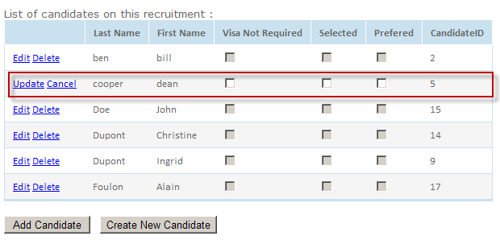
Screen 15

HR user can edit the following fields:
Fields | Type/Source | Controls | Column in staffing plan
Selected | Check box | Just one candidate can be selected for a position. | All candidate will be selected in the recovery
Prefered | Check box | Just one candidate can be check as “Prefered” for a position
Visa Not required | Check box | - | All true for the import in the database

Business rules:
- If a candidate is selected (Check box Selected checked), a PAF form is initialized and the tab “PAF” becomes visible.
- In V2, it will be possible to add a candidate without to be on the specific position. After, we can link recruitment with the new candidate. The HR group can add a candidate thanks to the reference table Candidate.
- A candidate can be deleted only if he is not selected or preferred on the open or active phase.

Add Candidate
When the user clicks on the button “Add Candidate”, he can selected a candidate already in the database.

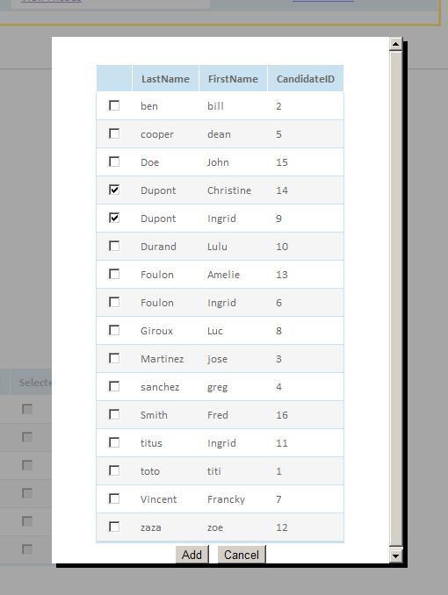
Screen 16

Business rules:
- A candidate cannot be selected to 2 phases which overlap. And, if he is already assigned to a phase, he cannot select on the phase which overlap with the phase assigned.

- If a candidate has been selected and we want selected another candidate: we must deselected the first before to select the good candidate. The PAF won’t be revised; we must update the data of PAF form according to the new candidate.

Create new Candidate
When a candidate is not already in the database, the user must create it. But the candidate created will be automatically assigned to this recruitment.
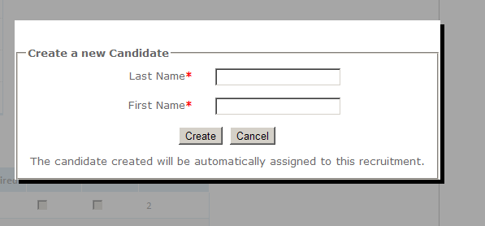
Screen 17

Fields | Type/Source | Controls | Column in staffing plan
Last Name | Text Field | Can’t be empty | HR  Selected Candidate's name
First Name | Text Field | Can’t be empty | HR  Selected Candidate's name

Business rules:
- In V2, it will be possible to create a candidate without to be on the specific position/phase. The user could assign him in the same way that in the screen 16.
- In V2, other information about a candidate can be added in this screen (CV, etc…)

View PAF

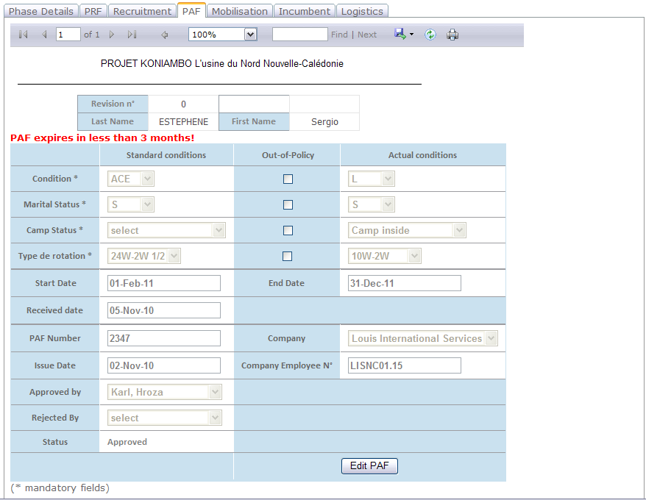
Screen 18

Business rules:
- In V2, the form PAF will be available in this screen.
- If the PAF expires on less than 3 months, a message appears.

Edit PAF
When the user clicks on the button “EDIT PAF”, he can edit (depending his group) some data:
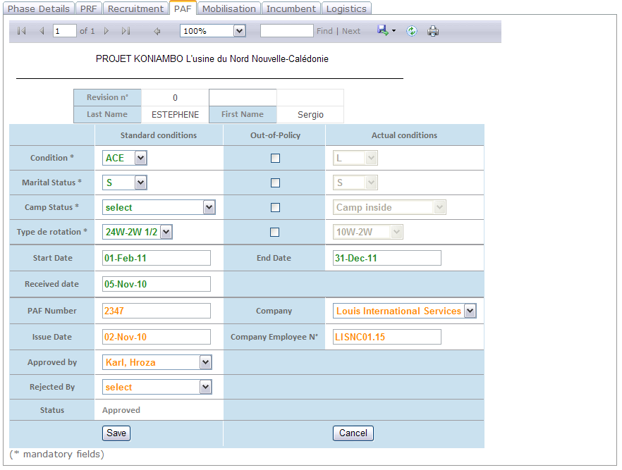
Screen 19

In the tab PAF, an authorized user can edit data about the PAF form:
Fields |  | Type/Source |  | Controls |  | Column in staffing plan
Condition |  |  | Drop down list  Values from a static list LWE -> LOE |  | Can’t be empty | PMT Planned Status
Marital status |  |  | Drop down List Values from a static list (S, P, F, FU)  S : Single P : Partner F1 : Family with one children FU : Family Unaccompanied  Update staffing plan |  | Can’t be empty  Default value = S | HR SINGLE/PARTNER/FAMILY
CAMP status |  |  | Drop down List  Values from a static list  Update staffing plan |  | Can’t be empty  Default value =Camp | HR ACTUAL INSIDE/OUTSIDE CAMP
Type of rotation | Drop down list  Rotation table |  |  | Can’t be empty |  |  | HR  TYPE OF ROTATION  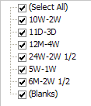
PAF received date |  | Date picker |  |  | Can be empty |  | HR  PRF reception date (HR-recruitment)
PAF start date |  | Date picker |  |  | Can be empty  If different of Phase start date : warning message |  | FIN  PAF START DATE (PAF database)
PAF end Date |  | Date picker |  |  | Can be empty  Must be after the PAF start date  If different of Phase end date : warning message |  | FIN  PAF End Date
PAF issue date |  | Date picker |  |  | Can be empty |  | FIN  PAF ISSUE DATE (PAFTrack)
Approved by |  | Dropdown List |  |  | Reference table AccountableManager + ResponsibleManager |  | FIN  APPROVED BY (PAF Track)
Rejected by |  | Dropdown List |  |  | Reference table AccountableManager + ResponsibleManager |  | Not in the staffing plan NOT included
PAF Number |  | TextBox |  |  |  |  | FIN  PAF NUMBER
Company |  | DropDownlist reference table Company |  |  |  |  | FIN  COMPANY
Company Employee N° |  | Text Box
Status |  | Dropdownlist with values static Pending/Approve |  |  | Cf. rules below
Out of Policy |  | chekbox |  |  |  |  | With reference table standard conditions, false if put in standard case, true else.

Business rules:
- Only HR and FIN groups can edit a PAF form. (Green fields editable by HR and orange fields editable by FIN).
- Last Name and First Name fields are read only and are populated from First Name and Last name of the selected candidate.
- When the field “Marital Status” is updated, the same field is updated in the screen “Phase details” (modification tracked in a report).

- When the field “Camp Status” is updated, the same field is updated in the screen “Phase details” (modification tracked in a report).

- When the field “Condition” is updated, the same field is updated in the screen “Phase details” (modification tracked in a report).

- When the field “Company” is updated, the same field is updated in the screen “Phase details” (modification tracked in a report).

- When any of the “out-of-policy” box is ticked, then it opens the appropriate field for editing in the “actual” column. Otherwise the standard conditions will apply and be printed on the PAF form. -> When we will have the corresponding reference table.

- When the PAF is approved, the Mobilisation, Incumbent and Logistics tabs become available.

- If the PAF is rejected, the user can choose another candidate, the PAF is revised (we keep a record with the PAF rejected) and must be re fill.

- The status will be “To Approve” at the creation, and Approved or Rejected according to the fields “Approved By” or “Rejected By” filled.

The status of a PAF can be:
- Pending.
- To Approve.
- Approved: In the first scope, the PAF will be approved when the field “Approved by” will be published. In a second scope, an approval process will automate the endorsement required for a PAF form.
- Rejected: idem that “Approved” status.
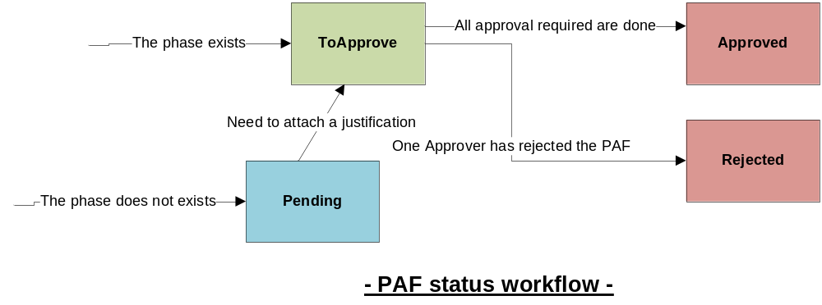
The management of the PAF status will be complete in V2. In the second version, the tab will display a report of the PAF. An approval process will be implemented. So the fields “Approved by” and “Rejected by” will be informed automatically.

View Mobilisation

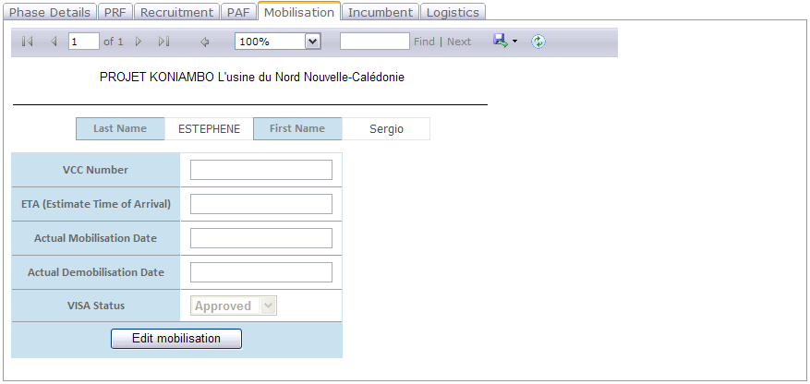
Screen 20

Edit Mobilisation

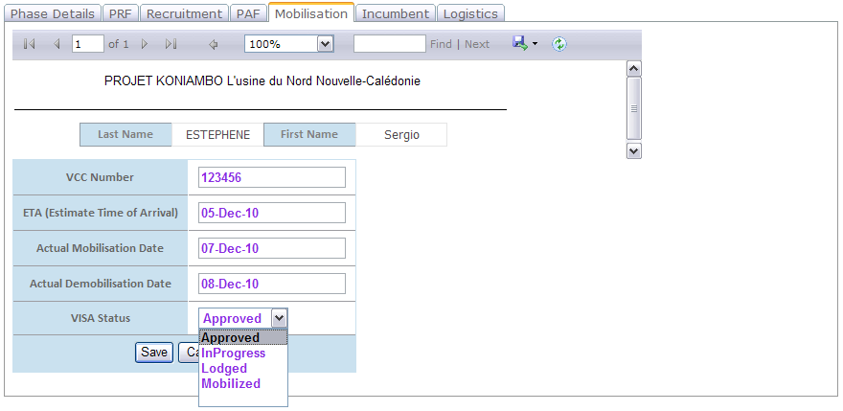
Screen 21

List fields input:
Fields | Type/Source | Controls | Column in staffing plan
Actual mobilisation Date | Date picker |  | HR  ACTUAL MOBILISATION DATE (SITE)
Actual Demobilisation Date | Date picker |  | HR  ACTUAL DMOB DATE
VCC Number | TextBox | Can be null  Must be an integer  If VisaNotRequired is true, VCC Number = Not enable | MOB  VCC reference number
Visa status | Dropdonwlist Values from a static list : Approved, InProgress, Lodged, Mobilized | Can be null | MOB  MOB / DMOB STATUS  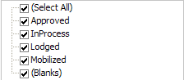
ETA | Date picker | Can be null | MOB  ETA  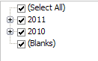

Business rules:
- Only Mobility group can edit data about the mobilisation of an employee.

To Assign an incumbent

In the first version, the HR user must choose an incumbent before to edit it (see screen 22). In the second version, if there is no incumbent assigned to the position, the tab is not visible.

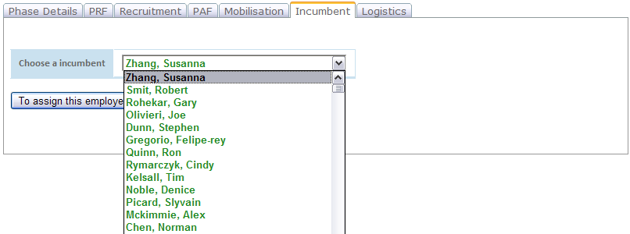
Screen 22
Business rules:
- An incumbent cannot be assigned to 2 phases which overlap.
- When a incumbent is chosen, the status of the current phase becomes ‘ACTIVE’
- List of the employees will be sorted (A->Z).

If the incumbent has ever been assigned to the position, you can see directly the details of the employee (see screen 23).

View incumbent

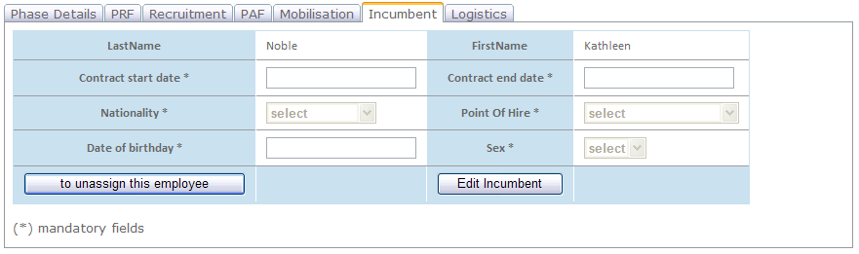
Screen 23

Business rules:
- If you want unassigned a new incumbent with the current phase, you must clicks on the button “To unassign an incumbent”. Then the phase becomes “OPEN” and the screen 22 again available.

Edit incumbent
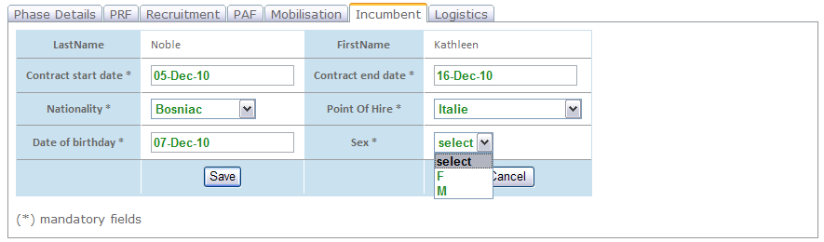
Screen 24

Only a user of HR group can edit data:

Fields |  | Type/Source | Controls | Column in staffing plan
LastName | Label |  | ReadOnly | Not included for employee if already in PAF.  For other employee : HR  INCUMBENT'S FAMILY NAME
FirstName | Label |  | ReadOnly | Not included for employee if already in PAF.  For other employee : HR  INCUMBENT'S FIRST NAME
Contract Start Date | Date picker |  | Can’t be empty  Mandatory when edit | HR  CONTRACT START DATE
Contract End Date | Date picker |  | Can’t be empty  Mandatory when edit | HR  CONTRACT END DATE
Nationality | Dropdown List Reference table Nationality  Update staffing plan |  | Can’t be empty  Mandatory when edit | HR  Nationality  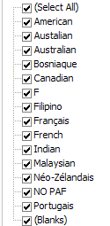
Point of Hire | DropdownList  Reference table Location? |  | Can’t be empty  Mandatory when edit | Not in the staffing plan NOT included
Date of Birthday | Date picker |  | Can’t be empty  Mandatory when edit | Not in the staffing plan NOT included
Sex | Drop down list M/F  Update staffing plan |  | Can’t be empty  Mandatory when edit | HR  Sex (M / F)  Often null

View/Edit Logistics
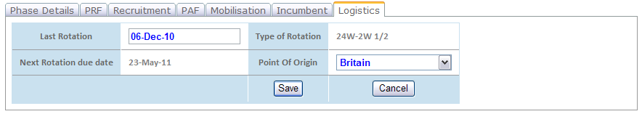
Screen 25
List input fields:
Fields | Type/Source | Controls | Column in staffing plan
Type de rotation | Type of rotation chosen on the screen “Edit PAF” | readonly
Point of origin | Drop down List reference table choose a town | Can’t be empty | LOG Point of origin  Creation table reference with 3 level (AUSI/APAC or ROTW, the country and the town)
Last Rotation | Date picker | Can be null | LOG  LAST R&R or 1ST MOB DATE  If null in the staffing plan, default is actual mob date
Next Rotation |  | Depends of Last rotation and type of rotation | Field calculated (view reference table Rotation)  = Last rotation + In days (corresponding type rotation of PAF) = Next Rotation

Business rules:
- Only logistic group can edit data about Logistic.
- When the field “Point of origin” is updated, the same field is updated in the screen “Phase details” (modification tracked in a report).

Reports

PAF Revised
A report will be available to see all PAF records.
When will the PAF be revised?
- When the phase corresponding is expand.
- When the PAF is rejected.
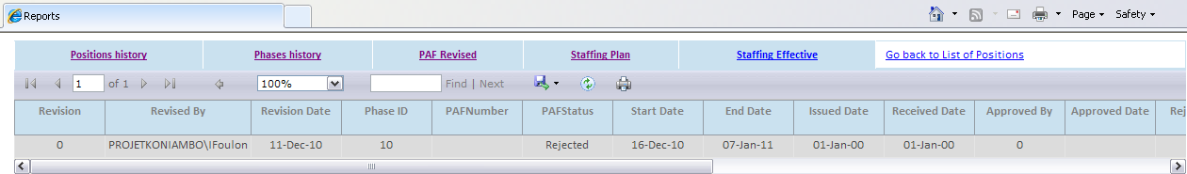

Staffing Plan : Effective costs
The report of the effective costs allows having the costs that represent every employee since the beginning of the project (in October, 2007).

Staffing Plan : forecast costs
The provisional staffing plan allows planning the costs that will represent every employee until the end of the project.
To do it, we need information about the employee himself, his position, his hourly rate, his average Hours per Month, etc...
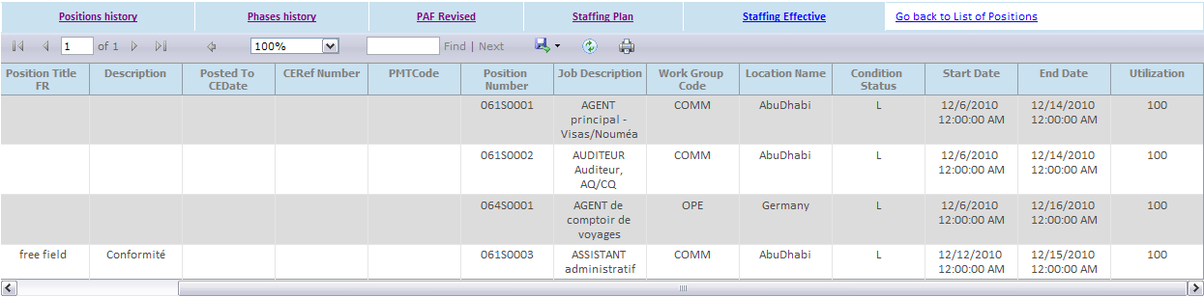
- The users belonging to PLT Group can view only data corresponding to theirs department. Consequently, all user belonging to PLT group must be referenced in reference table “Department”
- Only the group PC will access to all data in the report with forecast cost.

One of the most important information for calculating the forecast cost is probably the mobilization period (start date and end Date). The dates, planned start date and planned end date, are mandatory at the creation of the position.
We will use the start and end dates of the phase to have mobilisation period.

List of fields used to calculate the costs:
Field | OPEN (TBA) | PRF approved | PAF approved | Logistics | Incumbent is assigned
Start Date | X
End Date | X
Company | X |  | X
WorkLocation | X
Type of mobilisation | X
Planned Condition | X |  | X
WorkGroup | X
Camp status | X |  | X
Marital Status | X |  | X
Point of origin | X |  |  | X
Nb children | X
Hours per week | X

In this table, you can see all data used to calculate the forecast costs. For each data, you can see at what step the data is updated. All fields on the phase will be kept update according to its last modification.

We will keep a historic of references tables which contain any costs. Then (with historic of the phases), it will be possible to generate the staffing plan at a given date anytime. Consequently, we can generate specifics reports with costs comparisons: what positions has changed cost, what data has created the delta etc…

In this first version, everything has been planned (in the modeling) to calculate the cost of each employee, monitoring changes in costs, create reports and graphs for cost control.
The next priority (if everyone) is ok is to develop the report staffing plan with associated costs.

Phases History
A report will be available to follow each modification of a phase.

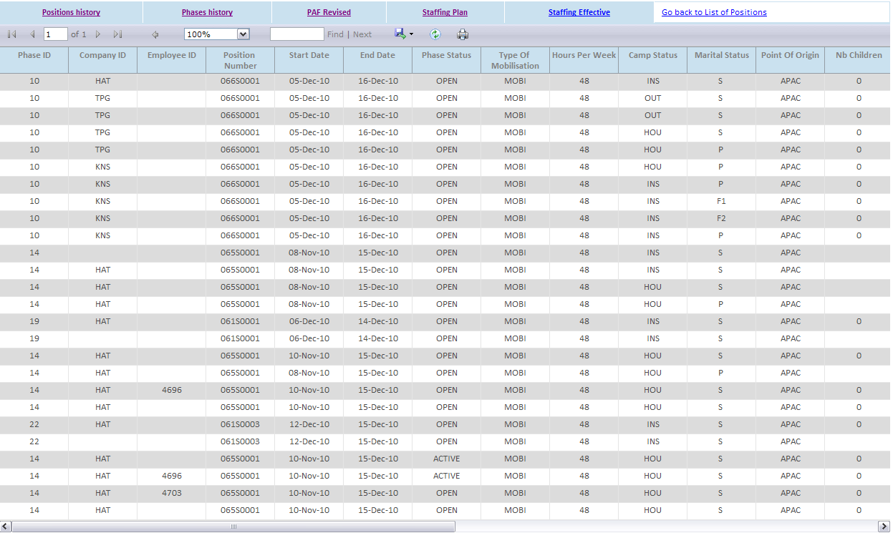
Each modification of a phase will be marking in a table. All automatic updates will be comment with the kind of modification.
List of automatic updates:
updated Field | Comments
Company | Company updates with the company in the PAF form.
WorkLocation | WorkLocation updates with the rateassignLocation of the incumbent (PAF)
Planned Condition | The condition status replaced by status enter on the PAF
Camp status | The camp status replaced by the status enter on the PAF
Marital Status | The marital status replaced by the status enter on the PAF
Point of origin | “The Point of origin replaced by the location enter on the PAF”  According the town chosen in the PAF form, the point of origin for the cost (APAC, AUSI, ROTW) will be updated thanks to the reference table Point of Origin

If the modification is manual (doesn’t provide to updating above), the modification is marked ‘Manual’ (cf. screen below)
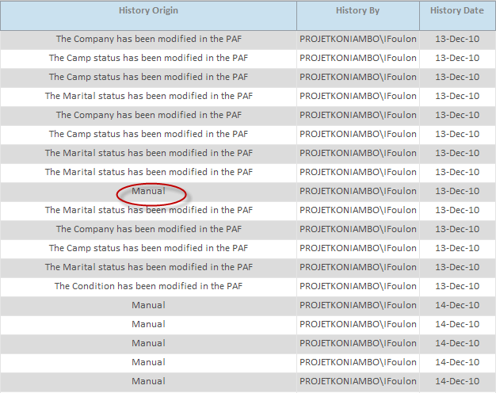

Incumbents

A report will be available to follow each modification of an Incumbent.
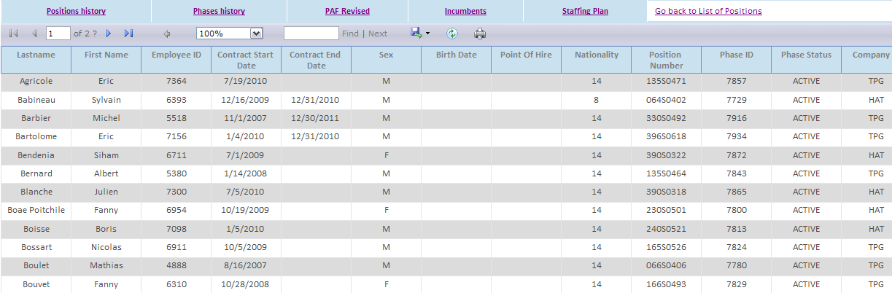

Thanks to this report, we will able to know:
- On what phase(s) the employee worked?
- On what phase(s) the employee was candidate? (Maybe in a different report?)

It will be possible to filter by:
- Name of employee
- Position Number: I want all incumbents who were assigned to this position.
- Contract start date
- Contract end date
- All fields present on the Incumbent tab…
Need to keep a historic of an employee? Currently, if an employee is assigned to new position and the start and end dates of the contract are modified, this data will be lost!!!!!
Keep a historic only if the start and end dates are modified?

We are waiting for your comments to adjust this report (Filters, keep historic for the incumbents, etc...)

Supplements for the import of data in the database
Not included in the database:
- All positions without Position Number filled.
- the positions with a "OLD" position number (generally positions closed)
All dates of creation will be initializing with the day of the import.
For each phase imported in the database, the PRF will be initialized.
For each phase imported in the database, the recruitment will be initialized if the position is not TBA.
For each phase imported in the database, the PAF will be initialized always if the phase is not TBA and Employee Number is filled.
For each phase imported in the database, the Mobilisation and logistics tabs will be initialized if the PAF exists and is approved.

Database

Reference tables
2 groups can access the reference tables: HR and ADMIN.
The HR group can manage the following tables:
- Nationality
- Candidate
- Sector
- Speciality
The ADMIN group can manage the following tables:
- AccountableManager
- Allowance
- Area
- Department
- Discipline
- Function
- Job
- NbHours
- ResponsibleManager
- Rotation
- RotationPerYear
- Ticket
- WorkGroup
- Soon : Point of origin
- Soon : StandardConditions

Department

Department
DepartmentCode | Description | Accountable Manager
PL | Project Leadership | GAS
HO | KL Office & Modularisation | JBE
SI | Site Management & Commissioning | RCA
HS | Health, Safety, Environment & Permitting | GBA
BU | Business Services & CM Support | SFR
OR | Operations Readiness | RBE
CO | Construction Management | KHR
AD | Administration | SFI
HR | HR, Communication and IR | ELU
SE | Construction Services | BLE

Work group

WorkGroup
WorkGroup  Code | Description | CSI
HO | Home Office & CM Sup | 135.026706
MOD | Module & Pre-Fab / Pre-Cast Yards | 148.704991
SITE | Construction Management | 71.3392293
COMM | Commissioning | 71.3392293
CM | Construction Management | 135.026706

Secteur
SECTEUR (VCC)
SecteurID | Description
1 | Ressources Humaines
2 | Achat
3 | Administration
4 | Administration de contrats
5 | Conformité
6 | Construction services
7 | Contrôle de Coûts
8 | Contrôle documentaire
9 | Contrôle matériaux
10 | Contrôle qualité
11 | Coordination travaux
12 | Electricité & Instrumentation
13 | Environnement
14 | Finances
15 | Génie civil
16 | Gestion du camp
17 | Hygiène et Sécurité
18 | Hygiène et Sécurité
19 | Informatique
20 | Ingéniérie
21 | Installations industrielles
22 | Magasin
23 | Management
24 | Manutention
25 | mécanique
26 | Mecanique et tuyauterie
27 | Mesure du progrès
28 | Plannification
29 | STG & CTG
30 | Supervision
31 | Sureté
32 | Tuyauterie

Rotation

Rotation
RotationCode | Description | In Days
1 | 11D-3D | 11
2 | 5W-1W | 35
3 | 10W-2W | 70
4 | 24W-2W 1/2 | 168
5 | 6M-2W 1/2 | 182

Area
Area
AreaCode | Description
100 | Area 1 - Mine
200 | Area 2 - Materials Handling
300 | Area 3 - Met Plant
400 | Area 4 - Power Plant
500 | Area 5 - Utilities & Common
600 | Area 6 - Temporary Facilities
700 | Plant Wide

Discipline
Discipline
DisciplineCode | ApplyTo | Description
110H | HO | Home Office Management
143H | HO | Cost Control
151H | HO | Quality Assurance
160H | HO | VCC
161H | HO | Human Resources
164H | HO | Administration Management
165H | HO | General Administration
230H | HO | Finance
240H | HO | System IT
264H | HO | Planning
265H | HO | Progress
270H | HO | Business Services Mgt
316H | HO | EHS
332H | HO | OSES
344H | HO | Document Controlers
345H | HO | Document Management
361H | HO | Procurement (OFF-SITE)
371H | HO | Services Management
372H | HO | International Contracts
373H | HO | Construction Management
432H | HO | Project Executive
380H | CM Sup | Offsite Engineering
396H | HO | Field Engineering
401H | HO | Permitting
402H | HO | Automation
403H | HO | Systems
501H | HO | Construction Yard Pre Cast (Home Office)
502H | HO | Construction Yard Pre Assembly (Home Office)
600H | HO | Modularization
800H | HO | Special Study Civil Engineering
801H | HO | Special Study Piping
900H | HO | Special engineering requests
143Y | Mod Yard | Project Control, Estimating and Planning
151Y | Mod Yard | Quality
165Y | Mod Yard | Administration and Other Support
316Y | Mod Yard | Health and safety
332Y | Mod Yard | Field Engineering
361Y | Mod Yard | Procurement and Material
371Y | Mod Yard | Construction
372Y | Mod Yard | Contract
432Y | Mod Yard | Management
061S | Site | Material Handling
062S | Site | Met Plant
063S | Site | Power Station
064S | Site | Utilities & Common
065S | Site | Local Earthworks Program
066S | Site | Common Services
135S | Site | Security
143S | Site | Cost
151S | Site | Quality
160S | Site | Visa Coordination
161S | Site | HR
163S | Site | Camp & Logistics
164S | Site | Administration Mgt
165S | Site | Administration
166S | Site | External Affairs
170S | Site | Internal Communications
230S | Site | Finance
240S | Site | IT
264S | Site | Planning & Scheduling
265S | Site | Progress
270S | Site | Business Services Mgt
316S | Site | Health & Safety
330S | Site | Site Management
344S | Site | Document Control
345S | Site | Document Management
368S | Site | Materials Management
371S | Site | Services Management
372S | Site | International Contracts
373S | Site | Construction Management
375S | Site | NC Contracts and Site Procurement
376S | Site | Maintenance & Services
390S | Site | Environment
396S | Site | Field Engineering
401S | Site | Permitting
432S | Site | Project Executive
501S | Site | Construction Yard Pre Cast
502S | Site | Construction Yard Pre Assembly
600S | Site | Modularization
900S | Site | Special engineering requests
381C | COMM | Pre-Commissioning
383C | COMM | Commissioning
230R | OR Sup | Finance (Operation Support)
264R | OR Sup | Planning (Operation Support)

WorkGroup

Work Group
Code | Description
HO | Home Office & CM Sup
MOD | Module & Pre-Fab / Pre-Cast Yards
SITE | Construction Management
COMM | Commissioning
OPE | Operations

Function

Function
FunctionCode | Description | ResponsibleManager
1 | Administration | ?
2 | Area Wide | ?
3 | As-built drawings | ?
4 | Boiler & BOP | ?
5 | Buyer | ?
6 | Catering & Janitorial | ?
7 | Change Management | ?
8 | Civil / Structural | ?
9 | Civil work | ?
10 | Coal Plant | ?
11 | Commissioning | ?
12 | Community | ?
13 | Completions Coordination | ?
14 | Construction Facilities | ?
15 | Contract Administration | ?
16 | Contract Formation | ?
17 | Contracting Strategy | ?
18 | Coordination | ?
19 | Cost | ?
20 | DB Admin | ?
21 | Document Control | ?
22 | E & I | ?
23 | Earthworks | ?
24 | Electrical | ?
25 | Engineering | ?
26 | Engineering Change Management | ?
27 | Environment | ?
28 | Expediting | ?
29 | Field Engineering Requests | ?
30 | Finance & Accounting | ?
31 | Geology | ?
32 | Harbour Master | ?
33 | HAZOP & Model Reviews | ?
34 | Health & Safety | ?
35 | Human Resources | ?
36 | I & C | ?
37 | Inspection | ?
38 | Instrumentation | ?
39 | Insulation & Painting | ?
40 | Insurance | ?
41 | Interface Coordination | ?
42 | IT | ?
43 | Layout & Piping | ?
44 | Management | ?
45 | MARIAN | ?
46 | Marine Environment | ?
47 | Marine Works | ?
48 | Material Tracking | ?
49 | Materials Handling | ?
50 | Mech / Piping | ?
51 | Mechanical | ?
52 | Met Plant | ?
53 | Met Plant Services | ?
54 | MIA & Mine | ?
55 | Mine Environment | ?
56 | Mine Maintenance | ?
57 | Mine Planning | ?
58 | Mine Production | ?
59 | Non Specific | ?
60 | Non-Process Buildings | ?
61 | Offsite Engineering | ?
62 | Offsite Traffic & Logistics | ?
63 | Package Acceptance / Handover | ?
64 | Permitting (Engineering) | ?
65 | Planning | ?
66 | Port Facilities Coord. | ?
67 | Pre-Commissioning | ?
68 | Procedures & MARIAN Support | ?
69 | Process | ?
70 | Process Safety | ?
71 | Procurement & Material | ?
72 | Progress Measurement | ?
73 | QA / QC | ?
74 | Quality Assurance | ?
75 | Quality Control | ?
76 | Quantity Surveying | ?
77 | Recreation & Welfare | ?
78 | Refinery & Shotting | ?
79 | Refractory | ?
80 | Regulatory Compliance | ?
81 | Risk | ?
82 | Security | ?
83 | Site Contracts | ?
84 | Site General Services | ?
85 | Site Logistics | ?
86 | Smelter | ?
87 | STG & CTG | ?
88 | Supervision | ?
89 | Survey | ?
90 | Systems & Automation | ?
91 | Systems & Automation | ?
92 | Temporary Site Facilities | ?
93 | Translation | ?
94 | Utilities Distribution | ?
95 | Utilities Packages | ?
96 | Vendor Rep Coordination | ?
97 | Warehousing | ?
98 | Workers Transportation | ?

RomeCode

RomeCode
RomeCode | DescriptionEn | DescriptionFr
? | ? | ?

- VCC has to provide the Initial RomeCode data

Company
Table already exist in PAF database.

Work Location
Table already exist in PAF database.

Accountable Manager
AccountableManager
ManagerCode | ManagerName
AHU | Andrea HUNT
AWE | Andrew WELLS
DDU | Dean DUNCAN
DVE | Didier VENTURA
FGR | Felipe GREGORIO-REY
GOC | Gary O'CONNELL
HSC | Hermann SCHMIDT
JBL | John BLACKWELL
KKO | KwangHoy KOO
MBA | Michel BARBIER
MDU | Matthieu DUSSUD
MHA | Michel HARANG
MWI | Mark WISEMAN
PNA | Paul NAPIER
SKE | Steve KINCHELOE
TDU | Tara DUNLOP
SPI | Sylvain Picard
FTO | Francisco Toledo
AKA | Amra Karamehmedovic
GDE | Ginette Denis
DGR | Dean Griffiths
RLE | Raymond Le Boucher
JPS | Jean-Pierre Speltz
PME | Peter Menard
SMA | Sonia Magrou
MCH | Marc Charlier
MMI | Mike MIDDAUGH
RKO | Rene KOLKMAN
BMC | Blake McGIBBON
DSC | David SCHOCH
JFL | Jacques FLEURY
VGR | Victor GRENON
FPI | Frederic PINCE
SNO | Sebastien NOLET
JCH | ?
WCU | William CURRA
KVO | Kobus VOS
GKA | George KACHANIWSKY

Responsible Manager

ResponsibleManager
ManagerCode | ManagerName
GAS | Gavin ASHLEY
JBE | Jim BEAUDOIN
RCA | Rejean CARRIER
SFR | Sean FRAZER
RBE | Roy BERRYMAN
KHR | Karl HROZA
SFI | Stuart FIDDES
ELU | Eric Luneau
BLE | Bruno LE ROY

Point of origin

Point of origin
Group | Country | Town
APAC | ? | ?
APAC | ? | ?
APAC | ? | ?
APAC | ? | ?
AUSI | ? | ?
AUSI | ? | ?
AUSI | ? | ?
ROTW | France | Paris
ROTW | France | Toulouse

Database scheme
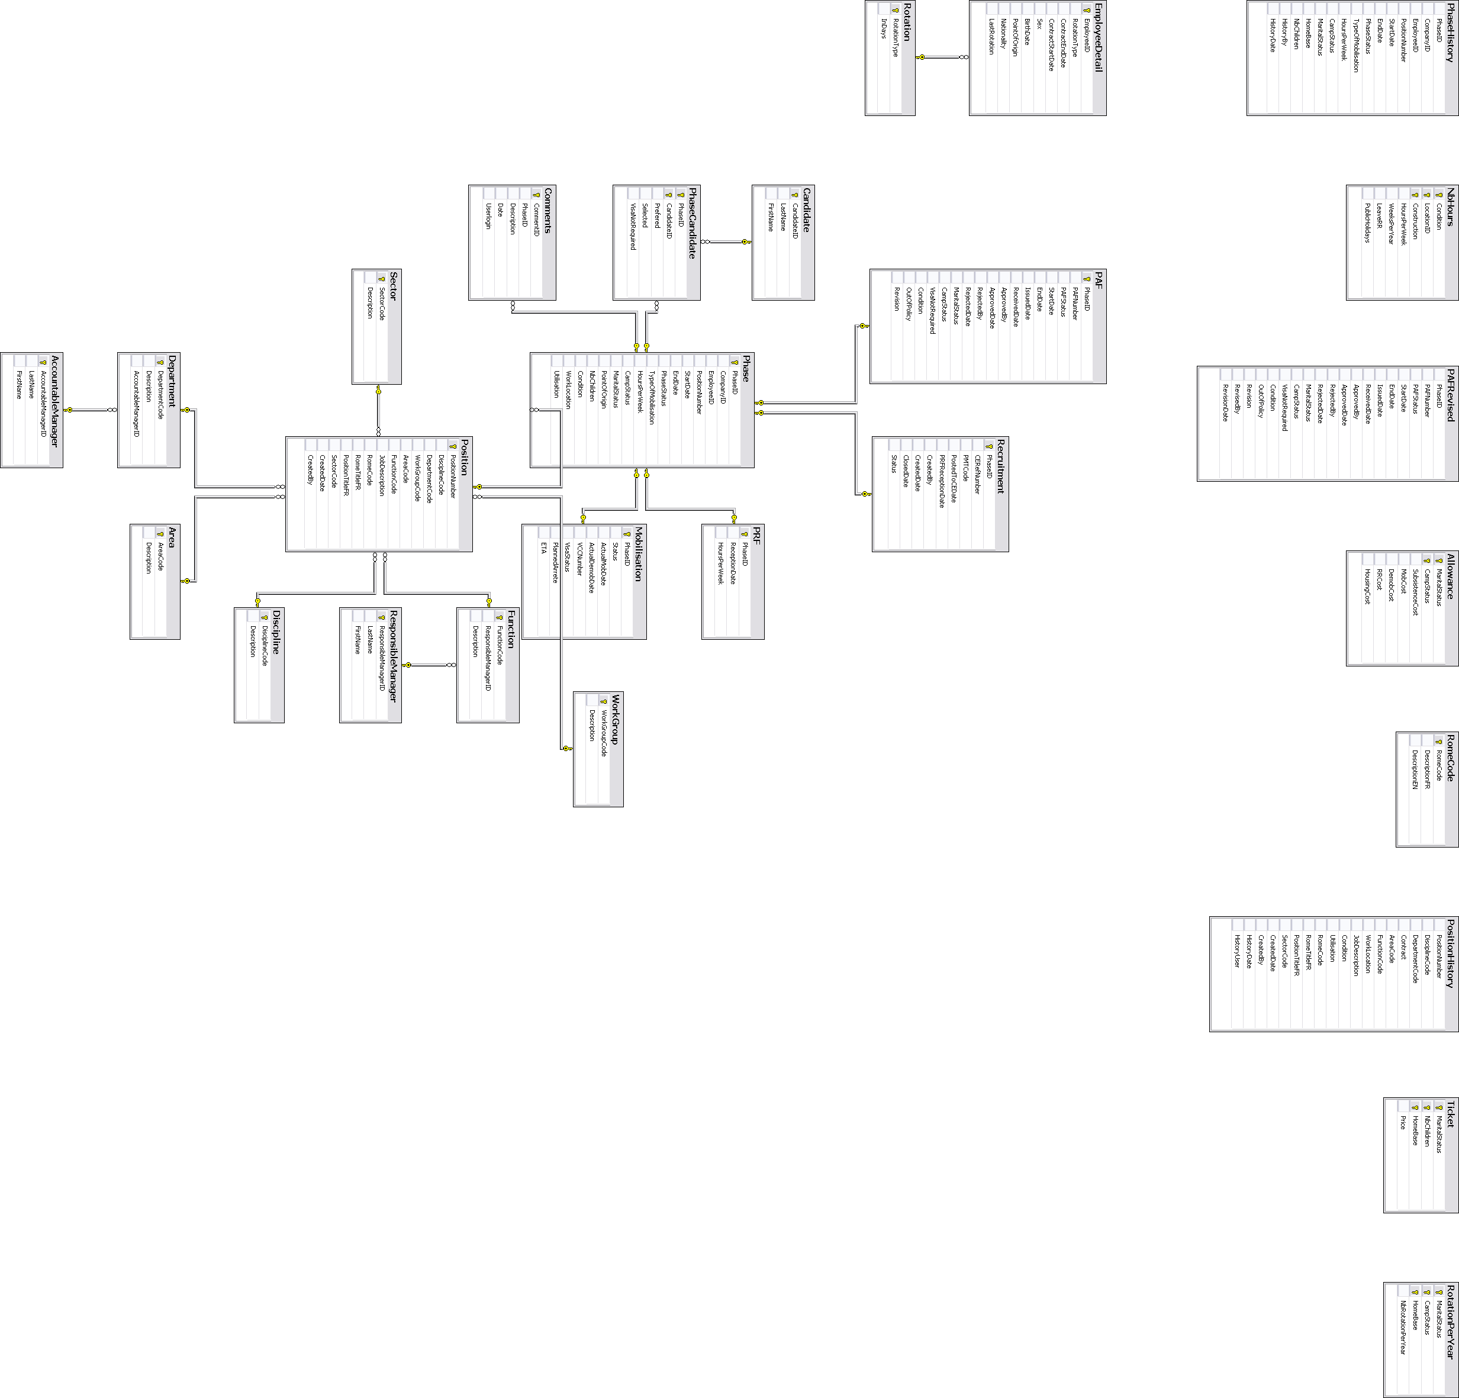

Matrix read / write fields

The following matrix shows the rights in terms of edition and visibility for every fields in the application accordingly to a group.

 |  | PC | HR | FIN |  | MOB |  | LOG
Screen | Field
Phase Details | PositionNumber | R | R | R |  | R |  | R
Phase Details | DisciplineCode | W | R | R |  | R |  | R
Phase Details | DepartmentCode | W | R | R |  | R |  | R
Phase Details | WorkGroupCode | W | R | R |  | R |  | R
Phase Details | Métier | R | W | R |  | R |  | R
Phase Details | Spécialité | R | W | R |  | R |  | R
Phase Details | AreaCode | W | R | R |  | R |  | R
Phase Details | FunctionCode | W | R | R |  | R |  | R
Phase Details | WorkLocation | W | R | R |  | R |  | R
Phase Details | Start Date | W | R | R |  | R |  | R
Phase Details | Condition | W | R | R |  | R |  | R
Phase Details | End Date | W | R | R |  | R |  | R
Phase Details | Utilisation | W | R | R |  | R |  | R
Phase Details | AccountableManager | R | R | R |  | R |  | R
Phase Details | ResponsibleManager | R | R | R |  | R |  | R
Phase Details | Status | W | R | R |  | R |  | R
Phase Details | RomeCode | R | W | R |  | R |  | R
Phase Details | RomeTitleFr | R | W | R |  | R |  | R
Phase Details | PositionTitleFr | R | W | R |  | R |  | R
Phase Details | SecteurCode | R | W | R |  | R |  | R
Phase Details | Type de mobilisation | W | R | R |  | R |  | R
Phase Details | Company | W | R | R |  | R |  | R
Phase Details | HoursPerWeek | W | R | R |  | R |  | R
Phase Details | CampStatus | W | R | R |  | R |  | R
Phase Details | MaritalStatus | W | R | R |  | R |  | R
Phase Details | Point of Origin | W | R | R |  | R |  | R
Phase Details | nbChildren | W | R | R |  | R |  | R
Phase Details | Comment | W | W | R |  | R |  | R
PRF | HoursPerWeek | R | R | R |  | R |  | R
PRF | PRFReceptionDate | R | W | R |  | R |  | R
Recrutement | DatePostedToCE | R | W | R |  | R |  | R
Recrutement | CERefNumber | R | W | R |  | R |  | R
Recrutement | PMTPositionCode | R | W | R |  | R |  | R
Recrutement | Status | R | R | R |  | R |  | R
Recrutement | Suivi | R | W | R |  | R |  | R
Candidate | LastName | R | W |  | R |  | R |  | R
Candidate | FirstName | R | W |  | R |  | R |  | R
Candidate | Selected | R | W |  | R |  | R |  | R
Candidate | Prefered | R | W |  | R |  | R |  | R
PAF | Condition | R | W |  | R |  | R |  | R
PAF | MaritalStatus | R | W |  | R |  | R |  | R
PAF | InOutCamp | R | W |  | R |  | R |  | R
PAF | TypeOfRotation | R | W |  | R |  | R |  | R
PAF | StartDate | R | W |  | R |  | R |  | R
PAF | EndDate | R | W |  | R |  | R |  | R
PAF | ReceivedDate | R | W |  | R |  | R |  | R
PAF | PAFNumber | R | R |  | W |  | R |  | R
PAF | IssueDate | R | R |  | W |  | R |  | R
PAF | Status | R | R |  | R |  | R |  | R
PAF | ApprovedBy | R | R |  | W |  | R |  | R
PAF | RejectedBy | R | R |  | W |  | R |  | R
PAF | Company | R | R |  | W |  | R |  | R
PAF | Company Employee N° | R | R |  | W |  | R |  | R
Mobilisation | ActualMobDate | R | R |  | R |  | W |  | R
Mobilisation | ActualDemobDate | R | R |  | R |  | W |  | R
Mobilisation | VCC Number | R | R |  | R |  | W |  | R
Mobilisation | VISA Status | R | R |  | R |  | W |  | R
 | ETA | R | R |  | R |  | W |  | R
Incumbent | ContractStartDate | R | W |  | R |  | R |  | R
Incumbent | ContractEndDate | R | W |  | R |  | R |  | R
Incumbent | Nationality | R | W |  | R |  | R |  | R
Incumbent | Point of Hire | R | W |  | R |  | R |  | R
Incumbent | DateOfBirth | - | W |  | - |  | - |  | -
Incumbent | Sex | - | W |  | - |  | - |  | -
Logistics

Logistics | Point Of Origin | R | R |  | R |  | R |  | W
Logistics | LastRotation | R | R |  | R |  | R |  | W
Logistics | NextRotationDueDate | R | R |  | R |  | R |  | R

Legend :
W | Write
R | Read
- | Can not see the field
PC | Project Control
HR | Human Resources
FIN | Finance
MOB | Mobility
LOG | Logistics

End of Document

