Manhours Follow Up and Approval on Major Reimbursable Contract

03 | 26 Oct 2010 | T. Guillot | A. Giustizia | A. Wells | S. Frazer | K. Hroza | R. Carrier
02 | 20 Oct 2010 | A. Giustizia | A. Giustizia | A. Wells | S. Frazer | K. Hroza | R. Carrier
01 | 19 Oct 2010 | T. Guillot | A. Giustizia | A. Wells | S. Frazer | K. Hroza | R. Carrier
00 | 14 Sept. 2010 | T. Guillot | L. Dubreuil | A. Wells | S. Frazer | K. Hroza | R. Carrier | IFA
Rev. | Date  (dd mmm yyyy) | Author  (Name) | Checked  (Name) | Approved  (Name) | Approved  (Name) | Approved  (Name) | Approved (Name) | Status
Contract Dept. |  |  |  |  | Project Controls | Construction | Site Manager

Revision History
Rev No. | Revision Date | Revision Detail
0A | 31 Aug 2010 | Issued for discussions
0B | 03 Sept 2010 | Issued for discussions
0C | 07 Sept 2010 | Issued for discussions
00 | 14 Sept 2010 | Issued for Approval
01 | 19 Oct 2010 | Issued for Approval
02 | 20 Oct 2010 | Issued for Approval
03 | 26 Oct 2010 | Issued for Approval

Table of Contents
1. Purpose 4
2. Definitions 4
3. Contract Structure 6
3.1 General Structure 6
3.2 CWP Structure 8
4. Roles & responsibilities 9
4.1 Contractor Roles & Responsibilities 9
4.1.1 Manhours 9
4.1.1.1 List Of Worker 9
4.1.1.2 Work Daily Report Submittal 9
4.1.2 Particular case of the suspension for bad weather 10
4.1.3 Particular case of the night shift 10
4.2 Owner Role & Responsibilities 10
4.2.1 Manhours 10
4.2.1.1 System Update 10
4.2.1.2 Work Daily Report approval 10
5. Practical use 11
6. Forms 11
6.1 Appendix 1: List Of Workers 13
6.2 Appendix 2: List of Authorized Supervisor for manhours submittal 14
6.3 Appendix 3: Work Daily Report 15
6.4 Appendix 4: List of Authorized Supervisor for manhours approval 16
6.5 Weekly Direct Manhours report 17
6.6 Monthly Direct Manhours report 18
6.7 Weekly Indirect Manhours report 19
6.8 Monthly Indirect Manhours report 20
6.9 Allocation of manhours on identified changes 21
6.10 Workflows 22
6.11 RACI MATRIX 23

Purpose
The purpose of this procedure is to define the method of follow up and validation of the hours on Major Reimbursable Contracts and to describe the role and responsibilities of the Contractor and the Owner in this process.
The concerned major reimbursable contracts are the following:
- C003 – Met Plant
- C004 – Power Plant
- C399A – UG Piping JV
- Other Contracts to be selected

Definitions

Work Section (WS): see contract

Work Package (WP): see contract

Construction Work Package (CWP): see contract

Each portion of scope of work is part of a Work Section (WS) and included in a Construction Work Package (CWP).

Each WS/WP is grouping several Work Package (if applicable) composed of several CWP

Each CWP has an allocated target amount of hours

Each WS is composed of the sum of the allocated amount of hours of the group of CWP it is composed of. As a consequence, the timesheets should reference the WS and the CWP.

Each new scope shall be either additional scope related to an existing Work Section / CWP or to a new WS/CWP. As a consequence, whilst Owner shall present SI/SDM/VPR with an allocated WS/CWP, Contractor shall present VNR with an allocated WS/CWP.

Site Instruction (SI): Document from Owner to Contractor for a scope on the spot (this can be an additional scope or not). Contractor can proceed before VO is issued if needed. This CSI will be incorporated in a future VO. The cost of the scope attached to this Contract Site Instruction is followed separately (manhours, equipment…).
Site instruction will be numbered and incremented each time. This document shall contain which WS & CWP are concerned by the change.
See Variation Procedure

Site Design Modification (SDM): Document notifying a change of engineering of the Contract scope due to site conditions. SDM is issued with a VPR or a CSI.
See Variation Procedure

Variation Notification Request (VNR): Document issued by the Contractor to the Owner to request a variation to Contract for a considered scope. This document shall contain which WS & CWP are concerned by the change.
See Variation Procedure

Variation Price Request (VPR): Document issued by the Owner to the Contractor to request the Contractor to quote for a new scope/variation. This document shall contain which WS & CWP are concerned by the change.
See Variation Procedure

Variation Order (VO): Contractual document officialising an agreement on one or several VNR/VPR between Owner and Contractor.
See Variation Procedure

Direct hours: see contract. Maximum total hours per worker is 60 hours per week if derogation granted by local regulators.

Payable Direct Manhours: Inducted Personnel’s Manhours approved on submitted daily timesheets

- As per IRC, “Personnel is considered to have commenced work on the Contract at the start of the Owner’ site Induction”.
- As per Item Reimbursable at Cost, schedule B- appendix 1, Contractor should ensure a follow up of the hours per CWP “on a daily verified and approved time sheets”.
- Payable direct manhours are composed of Productive and Unproductive manhours as follows

Productive Direct Manhours: Manhours generating progress

Unproductive Direct Manhours: manhours spent but not generating progress composed of the here under subcategories:

Agreed Suspension: In accordance with Contract (bad weather, loss of production…)

(O) Rework Direct Manhours: Manhours incurred on rework for which Owner is responsible i.e. where Owner issued an official document. These hours will be considered as part of the target hours until VNR approved. These Hours must be followed separately. (see contract)

Non Payable Direct Manhours: all hours related to a rework for which Contractor is responsible (rejected work by the Owner).

(C) Rework Direct Manhours (if applicable): Manhours incurred on reworks for which Contractor is responsible. They are typically, amongst others, the hours attached to the closure of a Non Conformity issued by the Owner. These hours must be followed separately.

Not inducted Direct Manhours: all hours of presence on site of workers before their safety induction.

Not Compliant Direct Manhours: all hours of presence on site of workers inducted but not qualified to perform the required work.

Indirect hours: see contract. Owner authorizes Contractor to submit Weekly timesheets only.

Payable Indirects Manhours: all hours of inducted and present indirect personnel at site or indirect personnel on approved business trip (Contractor to submit an approval form). Maximum hours per indirect worker is 60 hours per week if derogation granted by local regulators.

Not Payable Indirects Manhours: all others hours (home leave, R&R, annual leave, sickness in accordance with contract…)

Equipment: see contract. Contractor will propose a purchase solution with a guaranteed buy back each time it is cost effective compare to the contract rental budget rate.

Equipment rented will be invoiced on approved timesheets at actual cost as per contract.

If purchased, payment will be made on a lumpsum basis according to purchase agreement.

Equipment not compliant to requirements is not payable.

Equipment broken down is not payable.

Contract Structure

General Structure
These Contracts have a common structure as follow:
Qty of CWP / WS
Qty of Work sections
New WS
Existing WS
CWP #A
CWP #B
CWP #F
CONTRACT
MAIN SOW
ADDITIONAL SOW: VO
WS #XX
CWP #X
CWP #Y
CWP #A
CWP #X
CWP #Y
CWP #Z

CWP Structure
The basis of payment to Contractor by Owner is the payment of Manhours, Equipment & Materials as follow:
CWP #A
Manhours
Equipment
Rent
Not Payable Dir. Manhours
(C) Rework Dir. Manhours
Not Inducted Dir. Manhours
Not compliant manhours
Direct Manhours
Indirects Hours
Inducted & Present
Or
Business Trip
Productive Dir. Manhours
Agreed Suspension
(O) Rework Dir. Manhours

Payable Dir. Manhours
Payable Ind. Manhours
Not Payable Ind. Manhours
Others (Home Leave, Sickness, not inducted…
Purchase
Payable Hours @ Actual Cost
Payable agreed Lumpsum 1 time only.
Materials
Non Payable Hours

Roles & responsibilities

It is Contractor responsibility to provide on required time Owner with accurate reporting datas. It is Contractor scope (i.e. at Contractor’s charge and expense) to define & develop the system of manhours counting, agree with the Owner on the proposed system, implement it accurately and follow up with Owner to get approval.
In the philosophy of Alliance, Owner prepared this procedure aiming at settling a common frame of hours follow up for different Contracts. Given the amount of workers and hours to be counted on a daily basis, Owner recommends that the system is electronic in order to reduce the amount of manual data entries (daily only), i.e. decrease of errors and time saving.
During interim period (settlement of electronic system), Contractor will keep on submitting weekly reports and monthly reports.

Contractor Roles & Responsibilities

Manhours

List Of Worker
The Contractor shall Provide and update on a weekly basis the Owner with the list of workers on the Project.
See appendix 1
Due date: each Monday 10 am

The primary index is the VCC number / badge number.

Minimum datas for each worker are:

- Name
- Surname
- Visa Number
- Job position as per contract price schedule
- VCC/Badge number
- Company
- Nationality
- Status of Safety induction
- Subcontractor

VCC list is a good basis.

Work Daily Report Submittal

Contractor shall Provide and update the Owner with the list of authorized supervisor of Work Daily Report (WDR) submittal filled electronically (excel or electronic timesheet when available).
See appendix 2
Due date: each Monday 10 am

Supervisor in charge of timesheet submittal shall be able to:
- Understand and be aware of the structure of the portion of work in charge i.e. which Work section, which CWP, which variation, which SDM, which site Instruction if any.
- Allocate properly each of the resources he/she manages according the above identified structure filling it the Project system
- Submit for approval all time sheets on a daily basis. Due date: every day before 7 pm (for the considered day) See appendix 3

Weekly report will be submitted automatically by the system every Saturday at 9.30 am to manhours@projetkoniambo.com, Contractor’s management and Owner’s management (list to be defined) for the period from Friday morning to Thursday night.

Particular case of the suspension for bad weather
When the “suspension” box will be ticked, the time sheet will be approved only after Area Construction Manager from Contractor and Owner approved the duration of the suspension.

Particular case of the night shift
In order to work on nights shift, Contractor need to place application to the local authorities. The local authorities upon agreement will grant an authorization with a specified framework. It is important that contractor follows strictly the local authorities framework in such a case and the timesheet should indicate it. (tick box night shift / dayshift).

Owner Role & Responsibilities

Manhours

System Update
Construction management / Contract administration / IT assistant is responsible for making sure that the database is updated:
- On a weekly basis based on the list of worker submitted by Contractor on a weekly basis
Due Date: each Monday before 4pm
- On a daily basis for adding the ongoing changes
Due Date: each day before 4pm

Work Daily Report approval
Owner shall establish the list of the authorized supervisors of Work Daily Report (WDR) approval per WS/CWP/others.
See appendix 4
Due date: each Monday 10 am

Area Construction Manager is responsible for making sure that supervision is reviewing timesheets every day on a duly time and manner so that consolidated daily report can be issued for Area Construction management approval.
Supervisor in charge of timesheet approval shall be able to:
- Understand and be aware of the structure of the portion of work in charge i.e. which Work section, which CWP, which variation if any.
- Verify that Contractor’s allocation of each of the resources he/she manages according the above identified is proper in the Project system
- Approve/Comment all time sheets on a daily basis. Due date: every day before 8 am (for the precedent day)

Practical use

1/ Indirect workers considered as direct per contract
Contractor will count hours of these workers in the Work Daily Report (direct hours) in the column UP/O (unproductivre Hours, Others).
2/Working period: it is important to remember that Dayshift allows Contractor to perform works for a maximum of 60hours per worker and per week (if Contractor was granted authorization by local authorities). If Working period is Night shift, maximum hours will be 48hours or others according to authoriztion granted by local authorities.
3/Suspension: this box should ticked in case of bad weather. In this case, the workers will be unproductive for the duration of suspension and the hours will be recorded in the column UP/W. To be noted that the contractual clauses will apply on top of the recorded hours. Hours suspended do not necessarily correspond to hours paid (see contract). A Suspension cover page summarizing all time sheet concerned by the suspension will be presented to both party agreement.
4/ cas of a CWP part of several work segment: the hours should be allocated properly. Weekly report will consequently be composed of more lines than total quantities of CWP.

Forms
Appendix 1: List of Workers
Appendix 2: List of Authorized Supervisor for manhours submittal
Appendix 3: Work Daily Report
Appendix 4: List of Authorized Supervisor for manhours approval
Appendix 5: Weekly report
Appendix 6: monthly report
Appendix 7: Allocation of manhours on identified changes
Appendix 8: Workflows

End of Procedure

Appendix 1: List Of Workers
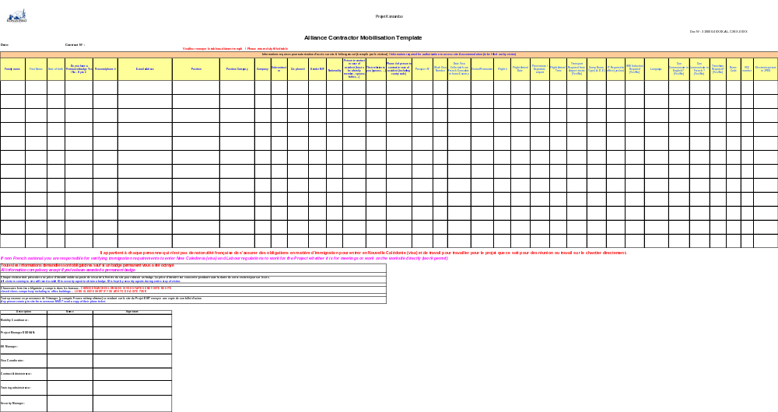

Appendix 2: List of Authorized Supervisor for manhours submittal
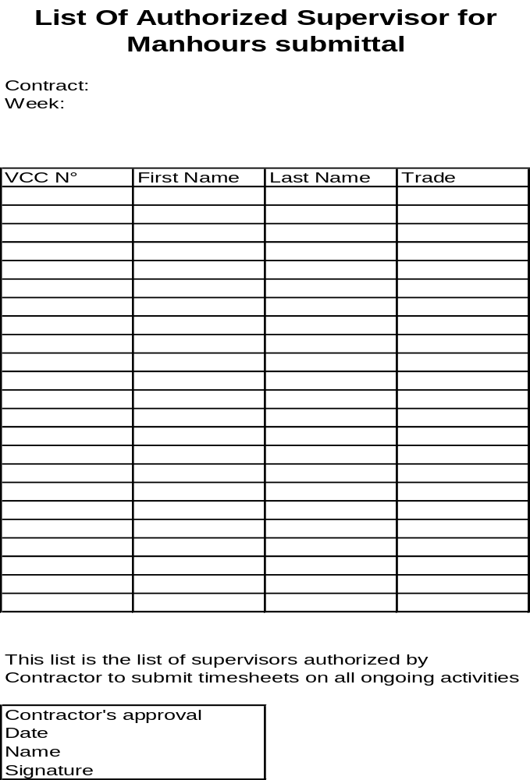

Appendix 3: Work Daily Report
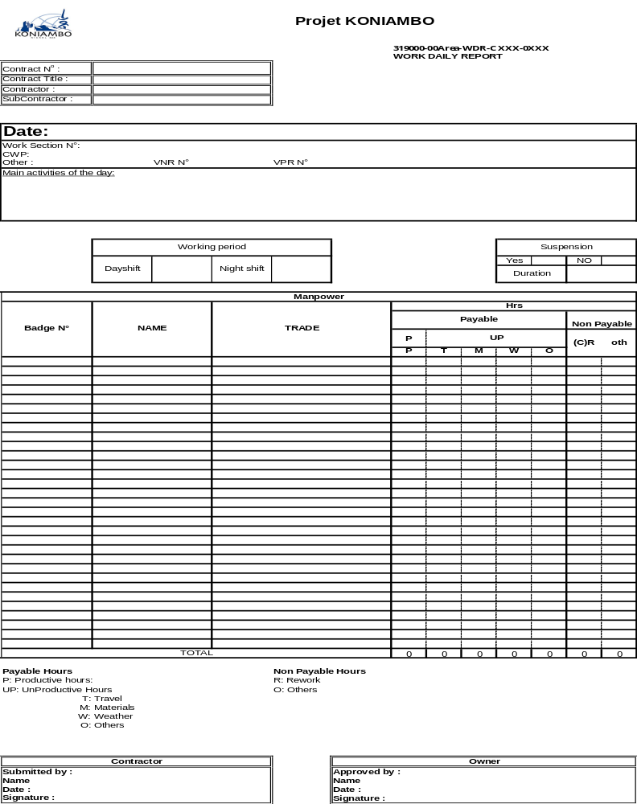

Appendix 4: List of Authorized Supervisor for manhours approval
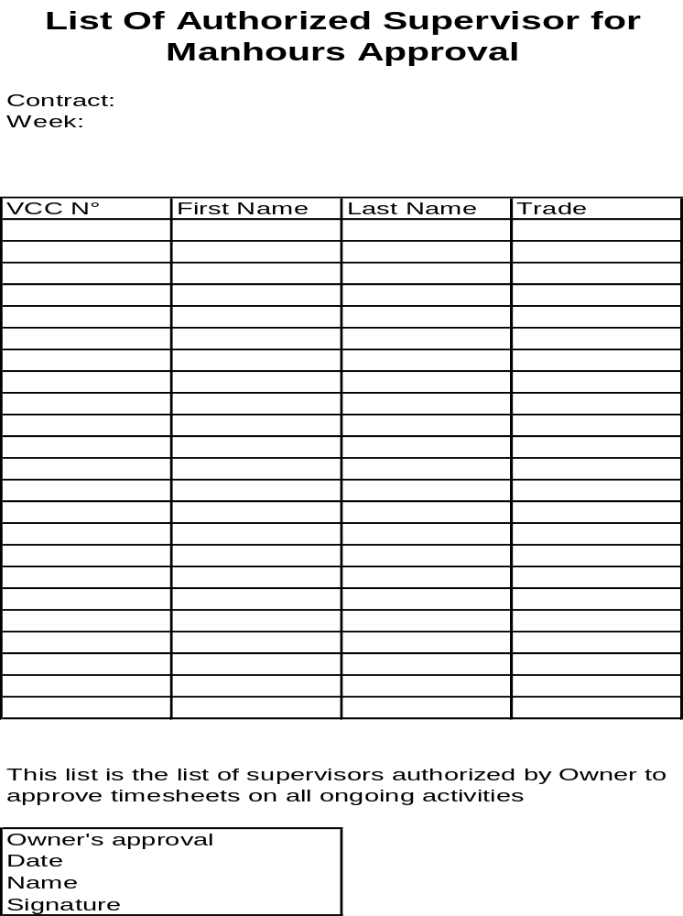

Weekly Direct Manhours report

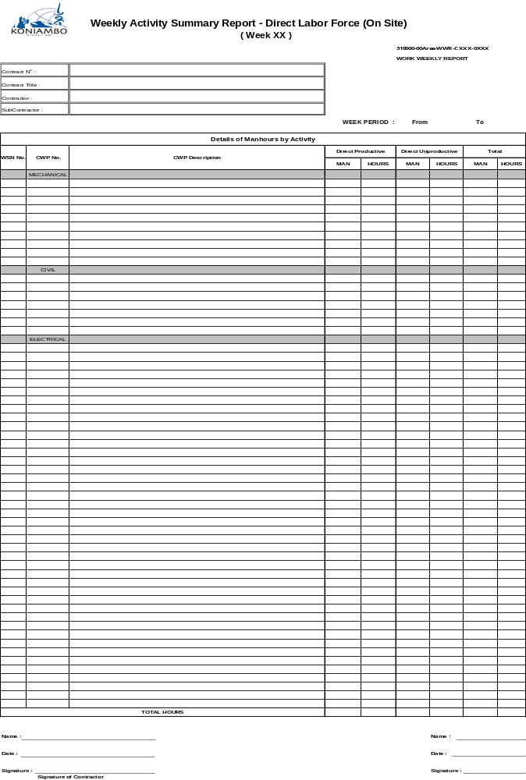

Monthly Direct Manhours report
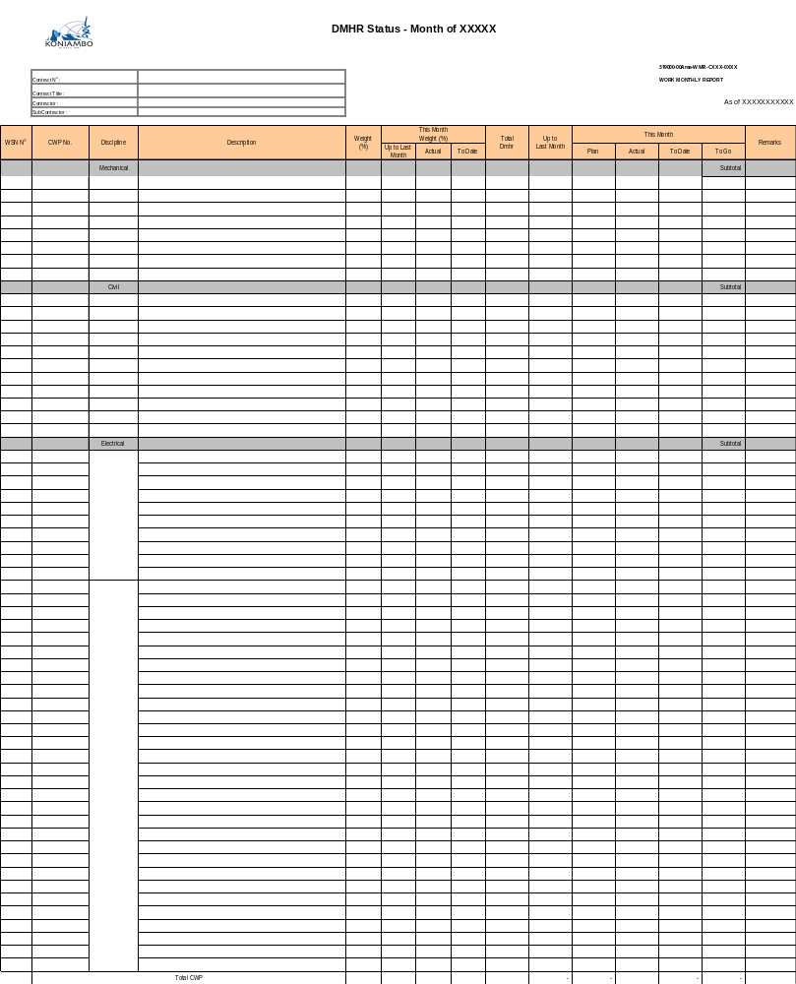

Weekly Indirect Manhours report

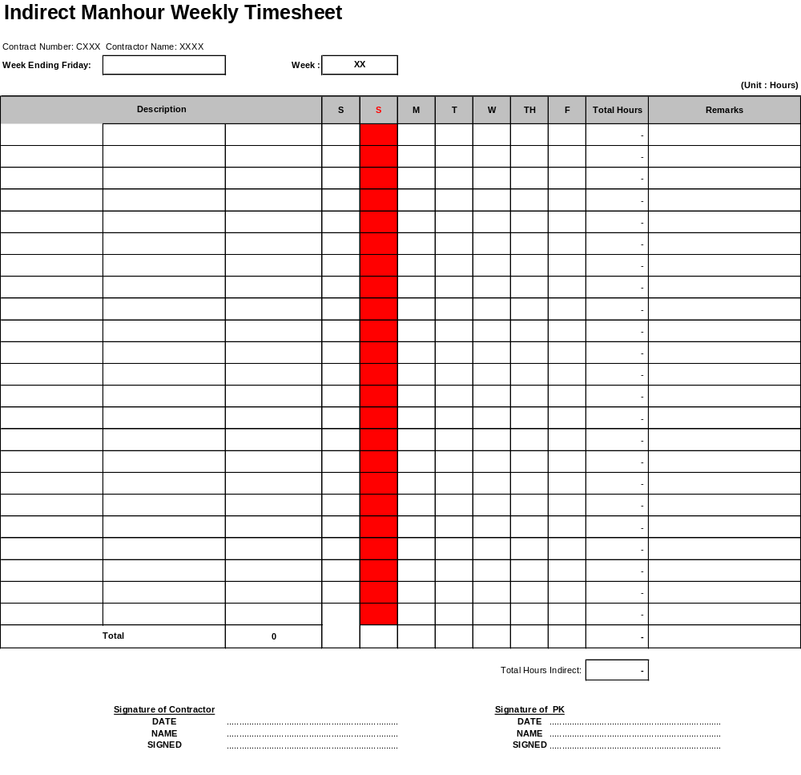

Monthly Indirect Manhours report

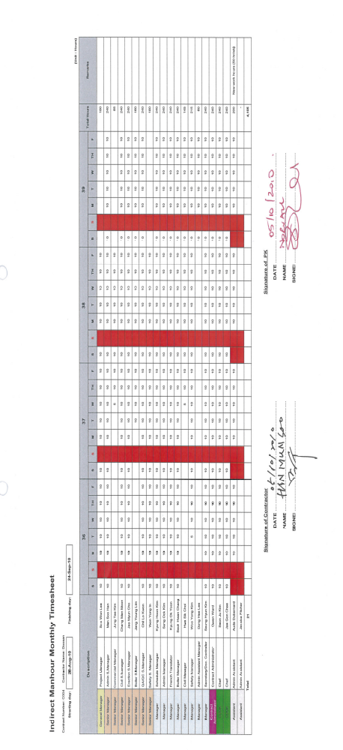

Allocation of manhours on identified changes
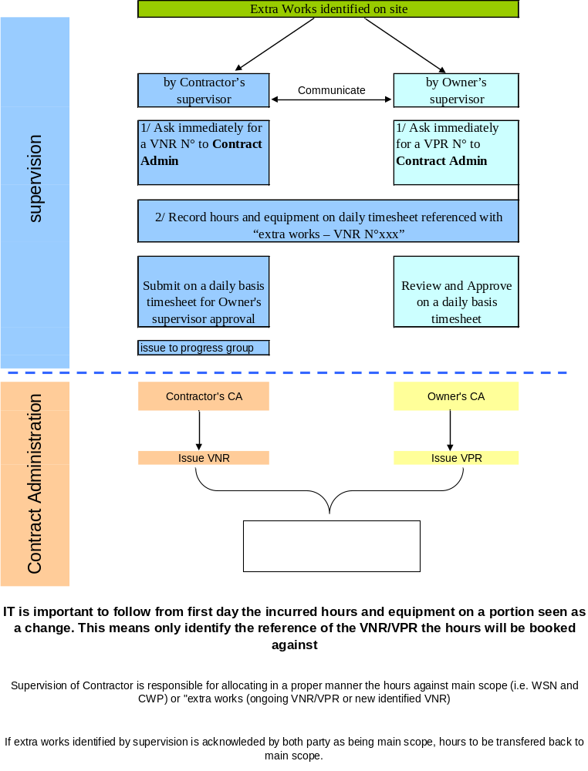

Workflows
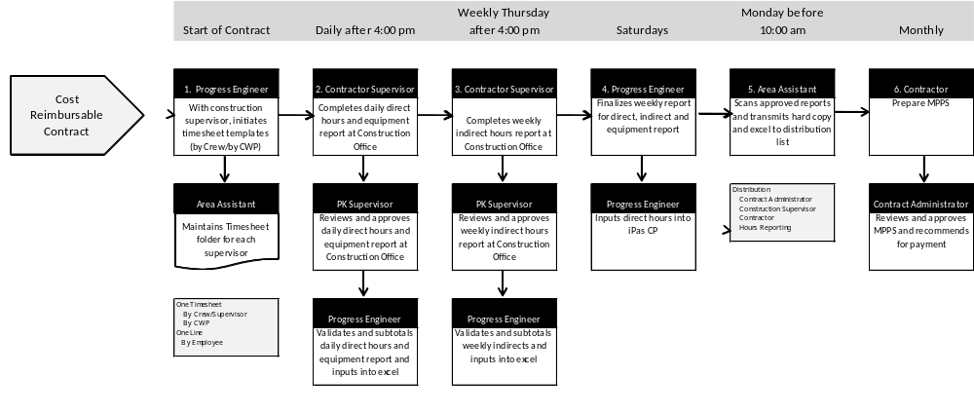

RACI MATRIX
