ALLIANCE TIMESHEETS

Business Requirements Document

04 | 21 Sept. 2010 | L. GIROUX | I. FOULON
Rev. | Date  (dd mmm yyyy) | Author  (Name) | Checked  (Name) | Approved  (Name) | Approved  (Name) | Approved  (Name) | Approved (Name) | Status
Contract Dept. |  |  |  |  | Project Controls | Construction | Site Manager

Revision History
Rev No. | Revision Date | Revision Detail
00 | 21 Sept 2010 | Document creation
01 | 08 Nov 2010 | Document Update
02 | 02 Dec 2010 | Document Update
03 | 09 Dec 2010 | Addition of “call a previous TS”, and follow up for the solution’s implementation, update of questions
04 | 13 Dec 2010 | Modification of the structure , management of workers

Table of Contents
1. Purpose 5
2. Definitions 5
3. Users and Roles 6
4. Features of the application 7
4.1 Product Backlog 7
4.2 Application Login process 8
4.3 Application Access 9
4.4 Note 9
4.5 Application Admin screens 10
4.5.1 Start page 10
4.5.2 Companies 10
4.5.3 Contracts 10
4.5.4 Application’s users management 11
4.6 Owner Contract Admin screens 14
4.6.1 Start Page 14
4.6.2 Manage Workers 14
4.6.2.1 Manage Trades 14
4.6.2.2 Manage Position Categories 15
4.6.2.3 Workers Management 16
4.6.2.4 Workers List 17
4.6.2.5 Create a new worker 17
4.6.2.6 Add an existing worker 19
4.6.2.7 Edit a worker 20
4.6.2.8 Focus on the database scheme (worker section) 22
4.6.3 Manage Subcontractors 22
4.6.4 Contract Structure 23
4.6.4.1 Creation of contract’s elements 23
4.6.4.2 Association of contract’s elements 30
4.6.5 Contract Profile History 31
4.6.6 Timesheets 32
4.6.7 Timesheets Adjustement 32
4.6.8 Reports 35
4.7 Contractor Contract Admin screens 36
4.8 Contractor Supervisor screens 37
4.8.1 Start page 37
4.8.2 Submit a Timesheet 37
4.8.2.1 Business Rules for the timesheet submission: 40
4.8.2.2 Call a previous Timesheet: 42
4.8.3 View Pending approval Timesheets 43
4.8.4 View Approved Timesheets 44
4.8.5 View Rejected Timesheets 45
4.8.6 Timesheet Edition 46
4.9 Owner Supervisor screens 48
4.9.1 Start page 48
4.9.2 Approve Timesheets 48
4.9.3 Timesheet Rejected 50
4.9.4 Timesheets Approved 51
4.10 Reporting 53
4.10.1 Contract Base Scope report 53
4.10.2 Contract Base Scope report 53
4.10.3 Agreed Suspension report 54
4.10.4 Progress Report: weekly base scope 54
4.10.5 Progress Report: weekly Extra works 55
5. Global Business rules 57
6. Database scheme 58
7. What the application does not do 58
8. Follow up of the solution's implementation 59

Purpose

The purpose of document is to determine the scope and the features provided by the “Alliance Timesheet” Application.
The goal of this application is to provide a framework for the manhours follow up for the alliance contractors: define a contract’s profile, submit timesheet, approve timesheet, and get reports on the activity.

Definitions

- CA: Contract Administrator
- Contract’s profile: this concept defines the elements that characterize the contract: the workers, the WS, WP, CWP, VNR, VPR, CSI, RFI, SDM, NCR, other.
- CRUD: operations Create Read Update Delete
- CWP: Construction Work Package
- PK: Project Koniambo
- TS: Timesheet
- VNR: Variation Notification Request
- VPR: Variate Price Request
- WP: Work Package
- WS: Work Section
- CSI: Contract Site Instruction
- RFI: request for information
- SDM: Site Design modification
- NCR: Non Conformance report
- Other: any other reference to be tracked

Users and Roles

Here are the different types of users that have been identified to use the application:

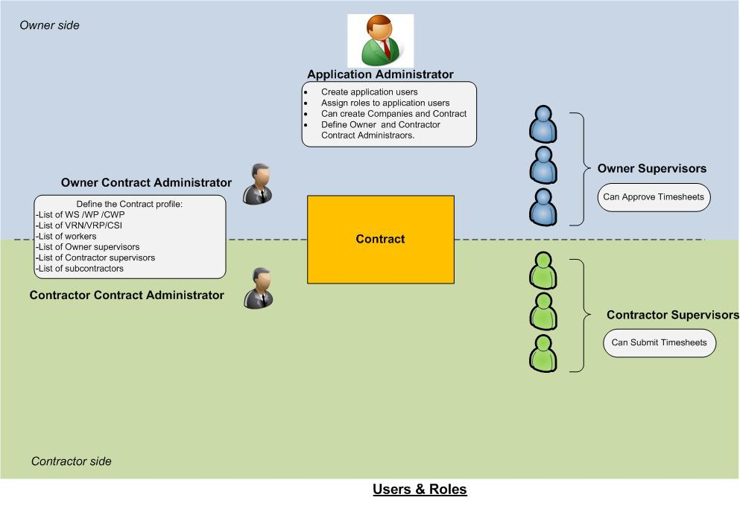

- Application Administrator: Manage the application: create contracts, companies, manage application’s users
- Contract Administrator (Owner): users in charge of the contract’s profile: can modify it.
- Contract Administrator (Contractor): users in charge of the contract’s profile: can not modify it, just read only.
- Contractor Supervisor: users in charge of the timesheets submittal.
- Owner Supervisor: users in charge of the timesheets approval.

Business rules:

- A user can not have severals roles on the same contract, only one role is allowed on one specific contract. But a user can have several roles on several contracts.
- It is possible to have several owner contract administrators on the same contract.
- It is possible to have several contractor contract administrators on the same contract.

Features of the application

Product Backlog

Here is the product backlog that describes in a simple way the features of the application accordingly to the type of user:

User story | Domain | Plannified  in Version
As a user I need a start page to authenticate myself into the system | Security | 1
As the application administrator, I need to manage the global structure of the application : companies, contracts | Productivity | 1
As the application administrator, I need to manage users who can access the application and give them the proper rights on the proper contract | Productivity | 1
As a Owner contract Administrator, I need to manage the contract's profile: WS, WP, CWP, variations, workers, subcontractors, Owner supervisors and Contractor Supervisors | Productivity | 1
As a contractor contract administrator I need to see same elements than the Owner CA but nNo edition is possible for me, except the creation of workers. | Productivity | 1
As a contractor contract administrator I need to see all the modifications that have been made on the contract’s profile. | Productivity | 1
As A Owner CA, I can access a TS adjustment module in order to submit positive or negative TS on specific element. | Productivity | 2
As a contractor supervisor, I need to submit timesheet on a determined contract | Productivity | 1
As a contractor supervisor, I need to define and save a default timesheet with a list of workers | Productivity | 1
As a PK supervisor and PK CA, I need to receive an email notification when there are some pending approval timesheet (everyday, 8pm) | Productivity | 1
As a PK supervisor, I need to approve/reject/comment timesheet on a determined contract | Productivity | 1
As a CA, I need to receive a monthly report by WS and CWP. | Reporting | 1
As a CA, I need to monitor the hours spent by trade | Reporting | 1
As a manhours@projetkoniambo.com, I need to receive a data extraction of data entered and approved into the system on a daily basis | Reporting | 1
As a manhours@projetkoniambo.com, I need to receive weekly report | Reporting | 1

Application Login process

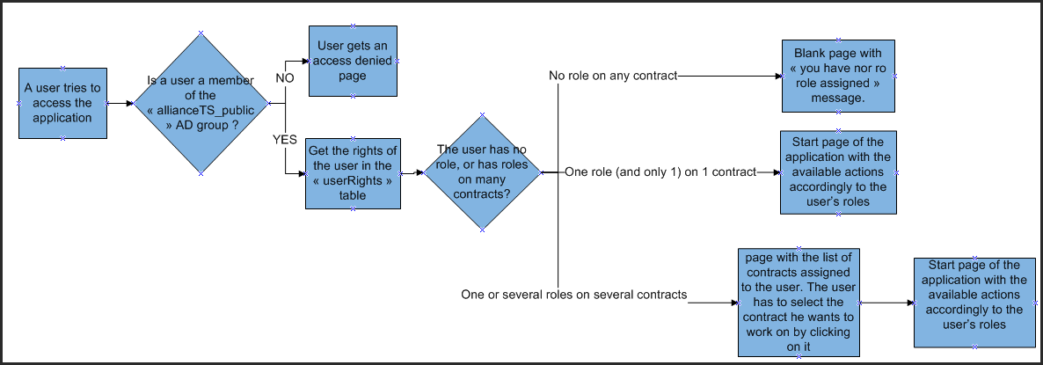

All the work done through the application is realized against a specified contract. Once a user logs into the application, if this user is linked to several contracts, the system will propose to the user to choose on which contract he wants to work for.

Application Access

To access the application, a user must be granted at least:
- To belong to a specific Active Directory group: This association is made by a member of the IT department.
- To have at least 1 role on 1 contract: This association is made either by the application administrator or by the owner contract admin.

Note

On the next paragraphs, all fields marked with a red star on the screenshots are defined as mandatory fields.

Application Admin screens

Start page

Application Admin menu

Companies

Companies list:
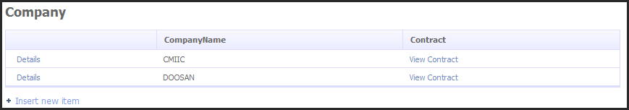

It is not possible to delete / edit a company. (For the data integrity conservation)

Add company:
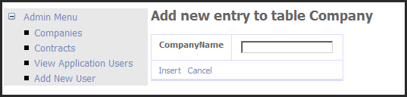

Contracts

Contracts list:
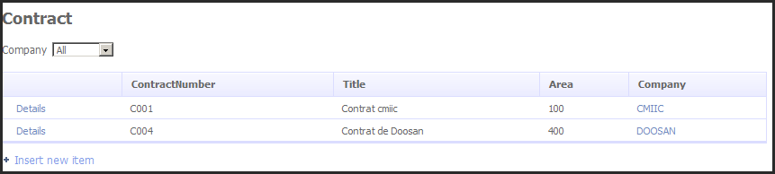

It is not possible to edit / delete edit a contract. (For the data integrity conservation)

Add contract:

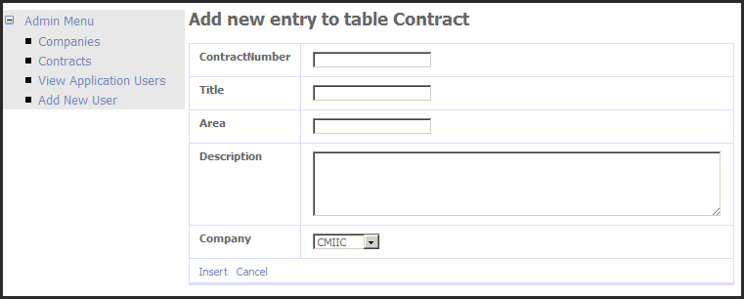

Application’s users management

User List:
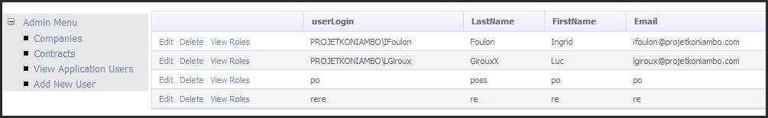

This list contains all the users of the application (no matter the contract).

Roles association:

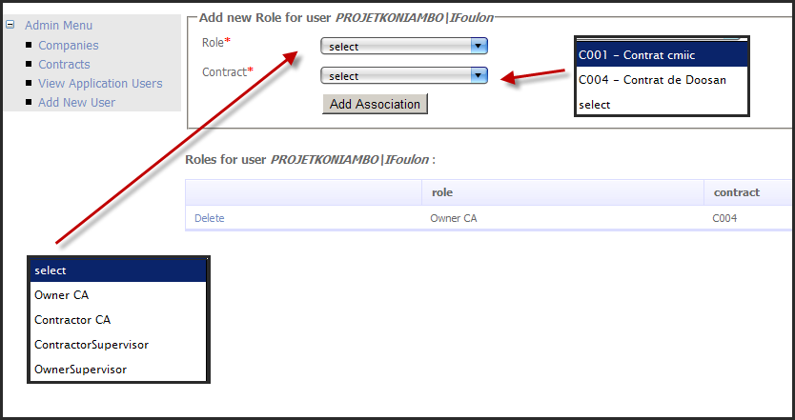

The Application admin can assign all roles to a user on a all existing contract.

Add User:

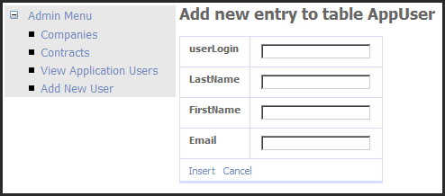

This screen above allows the application administrator to create new users. All fields are mandatory.
Create a new user will not allow him to access the application. See Application Access.

Owner Contract Admin screens

In all of the following screens, all data are displayed according to the contract to which the user is connected (see “Application login process”)

Start Page

Owner CA Menu

Manage Workers

Manage Trades

The trades are defined by contract. Each Owner contract administrator defines its own structure of trades.

List of trades:
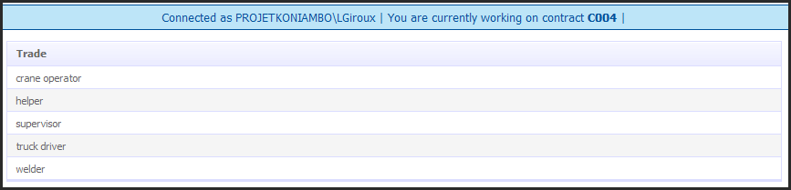

Add Trade:

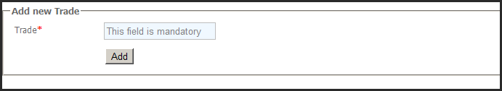

Once created, a trade can not be edited.
Once created, a trade can not be deleted.

Manage Position Categories

The position categories are defined by contract. Each Owner contract administrator defines its own structure of position categories.

List of Position categories:
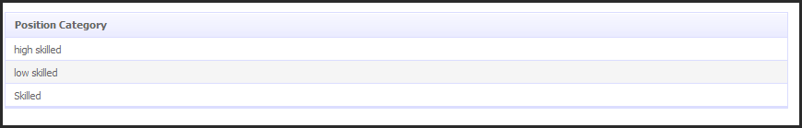

Add Position category:

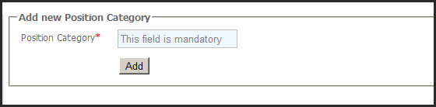

Once created, a position category can not be edited.
Once created, a position category can not be deleted.

Workers Management

We have 2 notions to distinguish. A notion of creation of a new worker, and a notion of association of an existing worker:
- creation of a new worker: When a worker is created by an Owner Contract Admin, the worker is created on the company that owns the contract on which he is created and is also associated on the contract on which he is created
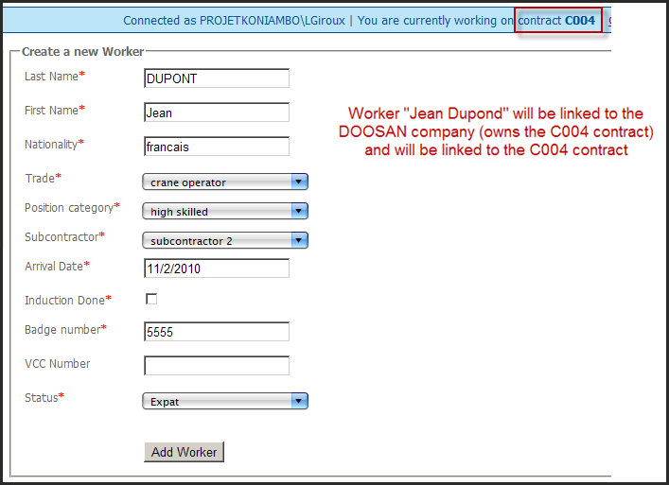

- Association of an existing worker: If an Owner Contract Admin of another contract on the same company also wants to add this worker, he will have to associate this existing worker to his contract (He will not be able to create the worker thanks to the unicity of the badge number). By making the association, the worker will then be available on for timesheet submission on the both contracts.

By doing this, we ensure the data integrity (a worker is defined only 1 time in the database),we can make the hours checks on multiples contracts and we ensure that each contract works independently and has no effect on others contracts.

The trade and the Position Category of a worker are defined at the contract level. That mean that a same worker can be for example a crane operator High skilled on the contract CXXX and a welder low skilled on the contract CYYY.

Workers List

List of workers:
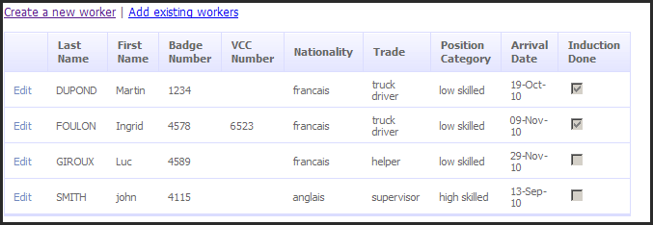

Create a new worker

The unicity of each worker is done by is Badge Number, which is a mandatory field in the creation of the worker.

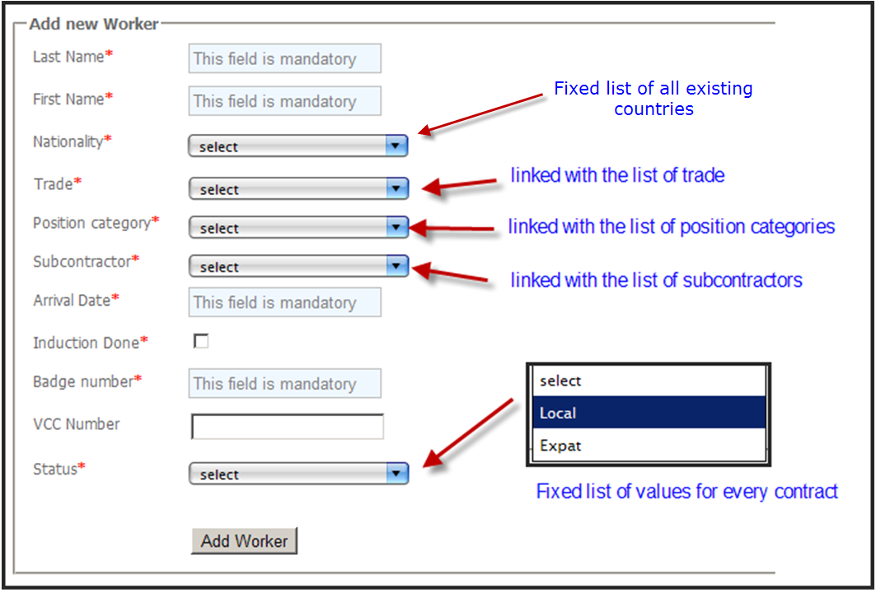

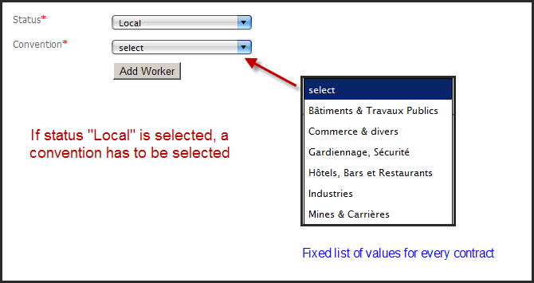

Each convention corresponds to a maximum of overtime hours allowed per year. The amount by convention is defined as following:

Convention | Total overtime hours allowed
Bâtiments & Travaux Publics | 550
Commerce & divers | 480
Gardiennage, Sécurité | 550
Hôtels, Bars et Restaurants | 590
Industries | 550
Mines & Carrières | 600

This list of values is fixed (no values can be added/edited/deleted) and the same for every contracts.
The notion of subcontractor is defined at the worker level. That means that when we associate a worker to a subcontractor during the creation of the worker, the worker will always be associated to this subcontractor even if an owner contract admin of another contract associates this worker to his contract.

Once a worker is created, he can not be deleted.

Add an existing worker

Clic on Add existing workers:
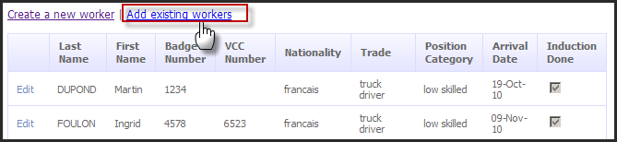

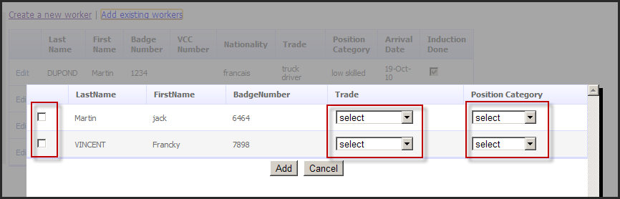

The list of workers above contains all workers that belong to the same company than the company that owns the contract I am currently working on and who are not already on my contract.
The Trade and the position category have to be defined for every selected worker because, as we saw previously in this document, the notions of trade and position category are defined at the contract level.
Tick the worker to associate with the contract and click on the “add” button.

Once a worker is added to a contract, he can not be removed.

Edit a worker

Clic on the “edit” link of the worker wanted to be edited
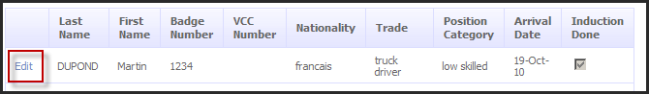

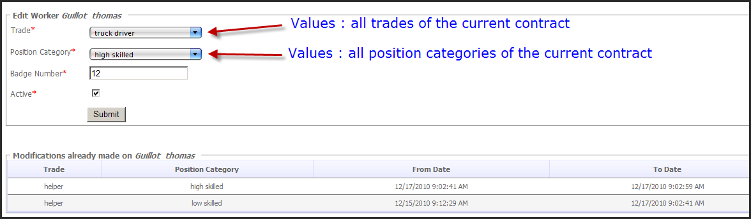

The fields that can be edited for a worker are the following:
- Trade
- Posittion category
- Active
- Badge Number

The notions of Trade, Position Category and Active are defined at the contract level whereas the Badge number is defined at the Workers level. This means that:
- Each modification made by the Owner contract admin on Trades, Position Categories or Active on their workers will not impact other contract even the workers they modified are associated with many contract.
- If I change badge number of “Jean DUPONT” from 5555 to 1234, Jean DUPONT will be seen as “Jean DUPONT 1234” in the worker list of every contract where he is associated.

Each modification made on a Trade of a worker or the Position Category of a worker for a specific contract will be recorded into an historic table (we do not track modifications made on the badge number because no impact on reporting).
The will allow to keep the reports consistent over the modifications made on workers.

If a worker is not ticked as Active, he will be considered as unactive. If a worker is unactive, he will not appear in the list of workers for the timesheet submission.

Focus on the database scheme (worker section)

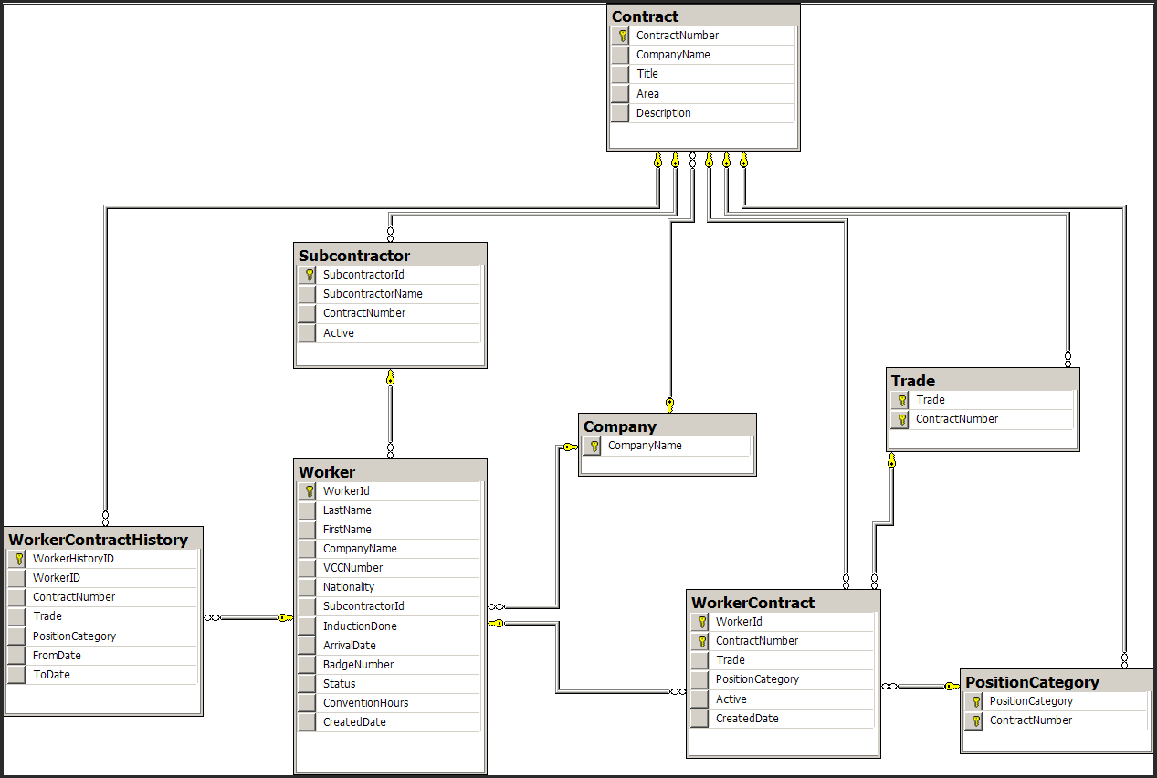

Manage Subcontractors

List of subcontractors:
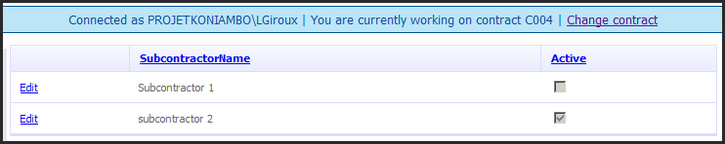

Edition Mode:
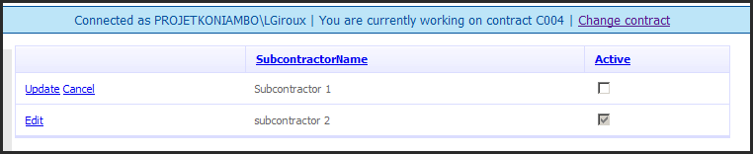

A subcontractor can not be deleted. The name of the subcontractor can not be modified.

Add a subcontractor:

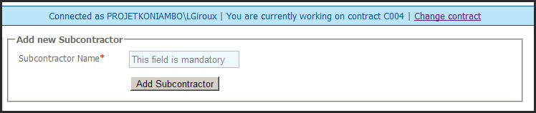

Contract Structure

2 notions must be defined: the notion of creation of the contract’s elements and the notion of association of elements created.

Creation of contract’s elements

4 types of elements have been defined as part of the contract structure:
- WS
- WP
- CWP
- Variations

Each of these elements can be created indenpendently.

WS

Create a WS:

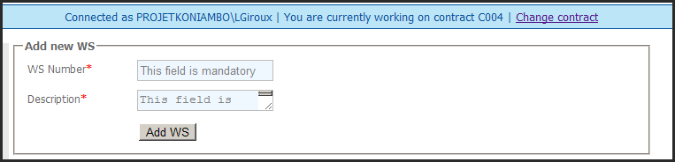

List of WS:
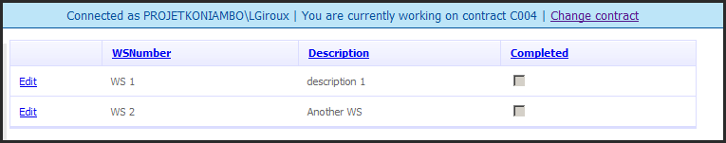

Edition Mode:
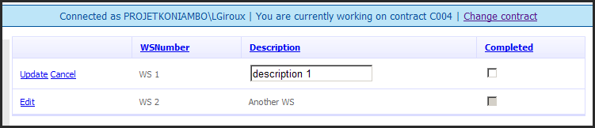

A WS can not be deleted. It can be flagged as “completed” in order to not appear in the WS list on the Timesheet submission screen.

WP

Create a WP:

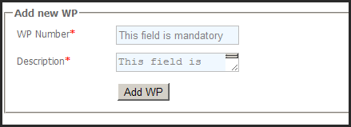

List of WP:
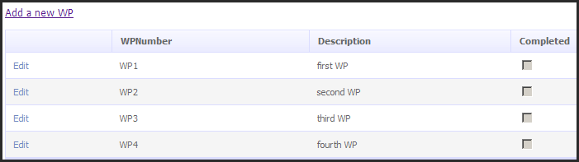

Edition Mode:
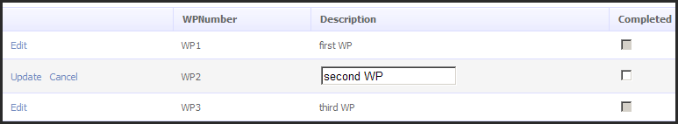
A WP can not be deleted.
If the box Completed is checked, the WP will not appear in the WP list on the timesheet submission form.

CWP

Create a CWP:

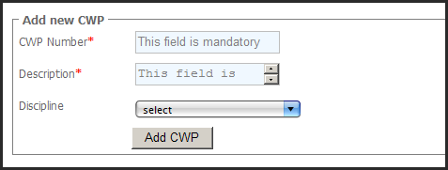

A CWP can be linked to a discipline, but not mandatory.
The list of disciplines is fixed (can not evolve) and is the same for all the contracts:

Mechanical - 13 - ABOVEGROUND PIPING
Mechanical - 14 - UNDERGROUND PIPING
Mechanical - 18 - STEEL
Mechanical - 19 - CLADDING
Mechanical - 21 - INFRASTR / MODULE
Mechanical - 23 - INSULATION
Mechanical - 25 - TANKS / SPHERES
Mechanical - 26 - PAINTING / COATING
Mechanical - 31 - REFRACTORY
Mechanical - 42 - FIRE PROTECTION
Mechanical - 68 - EQUIPMENT (MECHANICAL)
Mechanical - 85 - DUCTING
CW - 01 - MINING
CW - 08 - EARTHWORKS
CW - 09 - MAIN WHARF
CW - 10 - MASS EARTHWORKS
CW - 11 - PILING
CW - 14 - UNDERGROUND PIPING (DRAIN)
CW - 17 - CIVIL (Concrete)
CW - 20 - BUILDINGS
CW - 32 - ROADS & PAVING
CW - 38 - DREDGING
CW - 90 - CONSTR INFRASTRUCTURE
CW - 99 - GENERAL
E&I - 15 - INSTRUMENTATION
E&I - 16 - ELECTRICAL
E&I - 22 - ELECTRICAL (WIRE & CABLE)
E&I - 29 - AUTOMATION OPERATIONS

Once created, a CWP can not be deleted.

List of CWP:
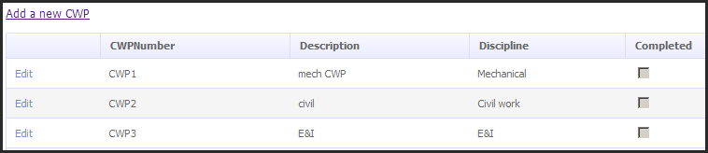

Edition Mode:
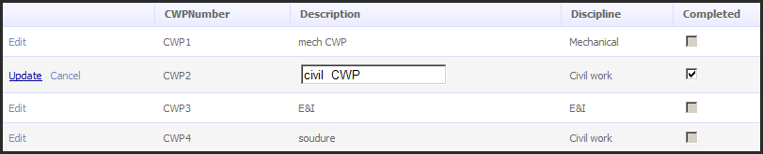
Only Description and Completed fields can be edited.
If the box Completed is checked, the CWP will not appear in the CWP list on the timesheet submission form.

Variations

Create a Variation:

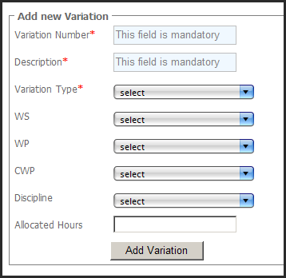

A variation can be linked to a WS OR a WS/WP OR a WS/WP/CWP but not mandatory.
A variation can have an allocated amount of hours, but not mandatory.
The list of disciplines is fixed (can not evolve) and is the same for all the contracts:

Mechanical - 13 - ABOVEGROUND PIPING
Mechanical - 14 - UNDERGROUND PIPING
Mechanical - 18 - STEEL
Mechanical - 19 - CLADDING
Mechanical - 21 - INFRASTR / MODULE
Mechanical - 23 - INSULATION
Mechanical - 25 - TANKS / SPHERES
Mechanical - 26 - PAINTING / COATING
Mechanical - 31 - REFRACTORY
Mechanical - 42 - FIRE PROTECTION
Mechanical - 68 - EQUIPMENT (MECHANICAL)
Mechanical - 85 - DUCTING
CW - 01 - MINING
CW - 08 - EARTHWORKS
CW - 09 - MAIN WHARF
CW - 10 - MASS EARTHWORKS
CW - 11 - PILING
CW - 14 - UNDERGROUND PIPING (DRAIN)
CW - 17 - CIVIL (Concrete)
CW - 20 - BUILDINGS
CW - 32 - ROADS & PAVING
CW - 38 - DREDGING
CW - 90 - CONSTR INFRASTRUCTURE
CW - 99 - GENERAL
E&I - 15 - INSTRUMENTATION
E&I - 16 - ELECTRICAL
E&I - 22 - ELECTRICAL (WIRE & CABLE)
E&I - 29 - AUTOMATION OPERATIONS

Once created, a variation can not be deleted

List of variations:

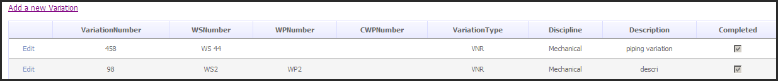

Edition Mode:
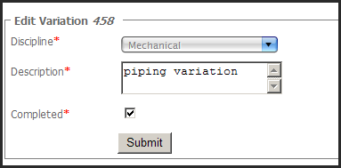

Only fields Description and Completed can be edited.
The field Discipline can be edited only if the variation has never been associated to a discipline (We do not want that a variation can be linked at one time to a given discipline and to another discipline in another time, but we want that the variation can linked to a discipline after the creation because sometimes when the variation is created the discipline is not yet known.)
A variation can not be deleted.
If the box Completed is checked, the variation will not appear in the variation list on the timesheet submission form.

Association of contract’s elements

Now we want to link these independent elements created in order to make the structure of the contract.
The rules defined are the following:
- A WS must be compose with at least one WP
- A WP must be compose with at least one CWP
- An Allocated amount of hours must be given for a WS/WP/CWP association

See the contract structure

We see all the associations between WS WP and CWP on the contract:
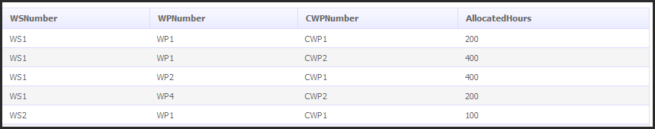
The constraint of unicity is made by the combinaison of WS/WP/CWP under a defined contract. As a result, it is not possible to have two rows with the same WS/WP/CWP.

Edit the contract structure

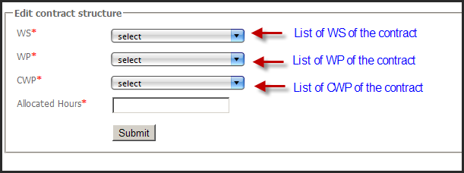
All the fields in the screen above are mandatory.
Once an association is made, it can not be edited or deleted.

Contract Profile History

This report allows contract administrator to see the changes that has been made on various elements on a specific period.

The elements that are tracked are the following (complete list):
- Addition of a new WS/WP/CWP association
- Creation of a variation
- Addition of a new worker
- Edition of the trade of an existing worker
- Edition of the position category of an existing worker
- Edition of the flag “Active” of an existing worker

What is recorded is:
- The type of the change in the element : addition or edition
- The element modified
- The description of the modified fields of the element
- Who made the modification and when.
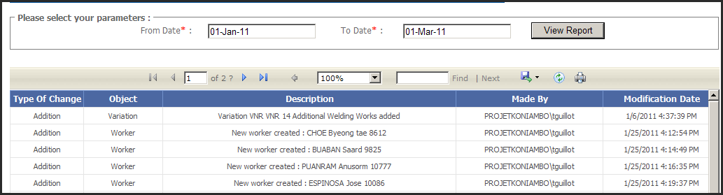

Timesheets

Owner contract admins can see all timesheets (approved, rejected, and pending approval). Screens are the same than those referenced below (but owner CA can only view datas), but the screen “View Approved Timesheets” has some specific differences:
- View Pending approval Timesheets
- View Approved Timesheets (view Timesheets Adjustement chapter below to get all details)
- View Rejected Timesheets (same screens but no edition is possible)

Timesheets Adjustement

When the Owner CA goes on his “View approved TS screen”, he can obviously see approved TS but he can also “cancel” timesheets.

Explanations on this feature: Despite there is a workflow of submission/approbation/rejection, sometimes it happens that some TS have been approved at one time but then we finally discover that the scope is not the good one, ore some hours are not valid. For this reason, Owner CA (and only him) needs to be able to cancel TS.

We can distinguish 2 different types of cancellation:
- Basic cancellation: the TS is cancelled, that means that we create in the system an additionnal TS with negative total hours of the cancelled TS
- Cancellation with adjustment: the TS has to be cancelled and replaced by one ore more new TS.

Here is the workflow of the TS adjustment:
- The contractor supervisor asks the owner CA to cancel an approved TS (for example the TS-001 which has 500 hours). Contractor supervisor has to precise if it is a basic cancellation or a cancellation with adjustment.
This request of cancellation is done by email and has a reference number.
- Owner CA goes on the “View approved TS” screen, select the TS he wants to cancel, and then clics either on :
  - “Cancel this TS” button to make a basic cancellation (When the button is clicked, a prompt window appears and the Owner CA has to provide the “cancellation request number” mandatory). At this moment, the workflow is finished: TS-001 has been cancelled and no more action need to be done. A fictive timesheet TS-001 (-) automatically approved has been created into the system with :
    - the same “TimesheetDate” than TS-001
    - A total of hours of -500 hours
    - An “approved date” wich correspond to the date of cancellation
    - A link reference to the TS-001
The TS-001 appears as “Cancelled” in the system (still appears in the “Approved Timesheets” list), with the “cancellation request number”, who made the cancellation and the date of the cancellation.
Contractor supervisors are notified by email.
  - Or on “Cancel and Adjust this TS” button to make a cancellation with adjustment (When the button is clicked, a prompt window appears and the Owner CA has to provide the “cancellation request number” mandatory). The TS-001 appears as “Pending Adjustment” in the system (still appears in the “Approved Timesheets” list), with the “cancellation request number”, who made the cancellation and the date of the cancellation.
Contractor supervisors are notified by email that TS-001 has been cancelled and that they can now adjust the TS.
In this case, the workflow continues:
- Contractor supervisor goes on the “Pending Adjustment TS” screen. He can then see the list of all pending adjustment TS and selects the one he wants to adjust.
- Contractor supervisor is then taken to the following screen:
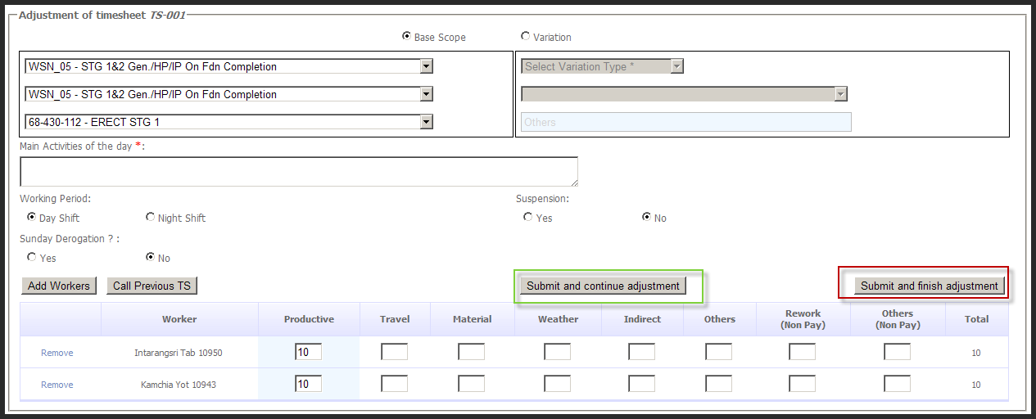
The screen is initialized with all parameters of the timesheet to adjust: scope, workers, hours.
The Timesheet date is not editable: the adjustment is mandatory on the same timesheet date than the TS to adjust.
Contractor supervisor makes the number of adjustments he wants by clicking on “submit and continue adjustement” button and “submit and finish adjustment” for the last timesheet. Let’s take the example that he creates 2 TS of adjustment: TS-ADJ-01 and TS-ADJ-02.
When the adjustment is over, TS-001 disappears from the “Pending adjustment timesheet” list.
TS-ADJ-01 and TS-ADJ-02 are linked to the TS-001 by a foreign key.
At this moment, TS-ADJ-01 and TS-ADJ-02 are not taken into account by reports because they are not “approved”
- Owner supervisor has now to approve the adjustment made. He goes on the “timesheets to approve” page and see the list of TS that have been adjusted and are pending for approval (Need to add a column in the list in order that the owner supervisor can make the distinction between a “classical” TS to approve). He selects the TS-001 and see on the screen that TS-001 has been adjusted by TS-ADJ-01 and TS-ADJ-02. He can see details of TS-ADJ-01 and TS-ADJ-02 by clicking on links.
Owner supervisor can:
- Approve the adjustment: TS-ADJ-01 and TS-ADJ-02 are now in “approved” statuts. The “approved date” of TS-ADJ-01 and TS-ADJ-02 is the approval date. TS-ADJ-01 and TS-ADJ-02 are linked to TS-001 in the system
A fictive timesheet TS-001 (-) automatically approved is created into the system with:
    - the same “TimesheetDate” than TS-001
    - A total of hours of -500 hours
    - An “approved date” wich correspond to the approval date
    - A link reference to the TS-001
- Reject the adjustment: Owner supervisor has to provide the reason of the reject (mandatory). TS-ADJ-01 and TS-ADJ-02 are deleted from the system. An email notification is sent to contractor supervisors. TS-001 is still in “Pending adujstement” status in the system, and appears back in the “Pending adjusment Timesheets” page with the details of rejection (when/who/why).

Notes:
- Timesheet cancellation can only be done by Owner CA
- Timesheet adjusment can only be done by Contractor supervisor
- Timesheet adjusment approval/rejection can only be done by owner supervisor
- When a TS has been adjusted and the adjustment approved, it can not been adjusted anymore: owner CA can not cancel it anymore.
- Timesheet Cancellation request come from Contractor Supervisors.

Reports

Reports are available for owner contract admin under the “report” menu:
Each report is detailled in the Reporting paragraph.

Contractor Contract Admin screens

Contractor contract administrators can access same screens than owner contract admin screens but they can only view data. No addition, no edition and no suppression are allowed.
Contractor CA Menu

Contractor Supervisor screens

Start page

Contractor Supervisor Menu

Submit a Timesheet

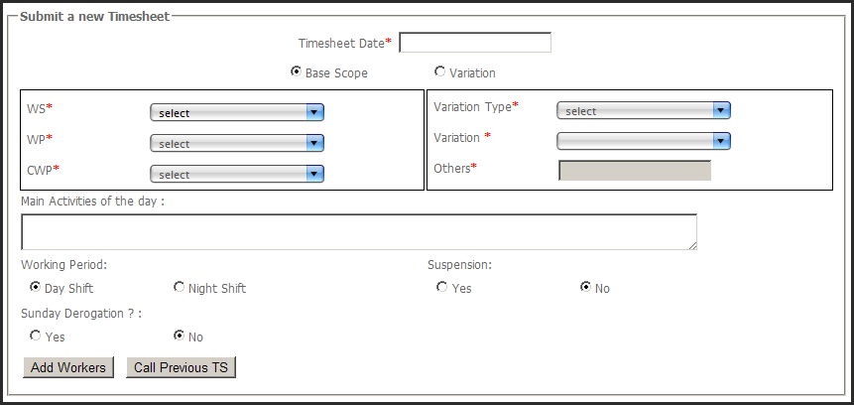

Detail of fields:
- Timesheet Date: clic in the field will show a date picker. The Timesheet date cannot be superior to the current date.
- Base scope / Variation:
  - If “Base scope” is selected, the WS combo box will be enabled.
  - If “Variation” is selected, the Variation type combo box will be enabled.
- WS Combo box: display all the active WS of the contract. When a WS is selected, the WP combo box becomes enabled.
- WP Combo box: display all the active WP of the contract according to the selected WS. When a WP is selected, the CWP combo box becomes enabled.
- CWP Combo box: display all the active CWP of the contract according to the selected WP.
- Variation Type combo box: display the following list:
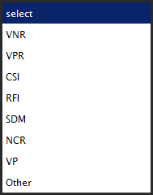
If the value “other” is selected, the input field others becomes enabled.
If another value is selected, the Variation combo box becomes enabled and contains all the active variations according to the type of variation selected.
- Suspension: if “Yes” is selected, the Suspention duration field and Timesheet Duration field will appear:
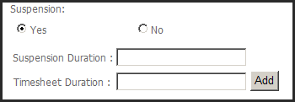
User enters then a Timesheet duration, clics on the Add button, and the value is then added to the Weather Hours field of every worker of the timesheet:
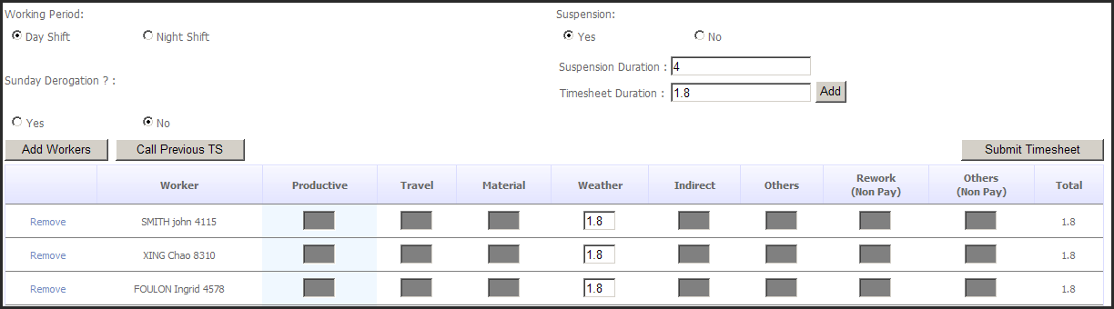
If Suspension is selected, only the column “weather” will be enabled to enter hours
- Sunday Derogation: If “Yes” is selected, the control that checks that every local worker can not work on Sundays is not executed.
- A clic on the Add worker button will show a pop up that will allow the user to make a selection of workers:
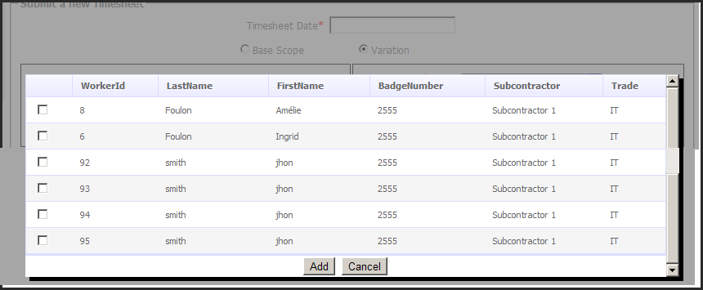
- Workers selected appear then in the form:
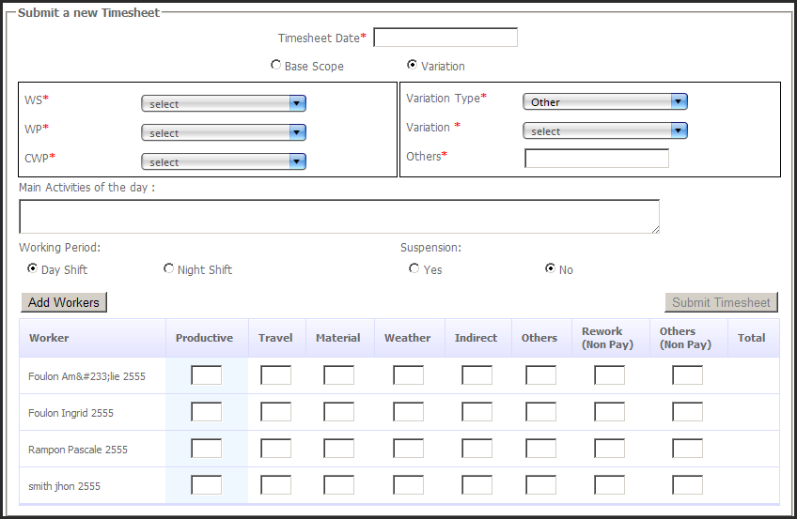

- The Submit Timesheet button will be enabled if the total of hours for every worker is different of zero.

Mandatory fields to provide for the submission:
- Timesheet Date
- And WS & WP & CWP OR one Variation(VNR or VPR or CSI or RFI or SDM or NCR or other)
- And At least provide 1 worker with hours

Business Rules for the timesheet submission:

When a timesheet is submitted for a list of workers, the timesheet is not inserted in the database (and the user will be notified) if one of these rules is not verified:

 | EXPAT Worker | LOCAL Worker
Max hours per day | 12 | 12
Max Hours per week in day shifts | 60 | 60
Max Hours per week in night shifts | 48 | 48
Max Hours per week in day and night shifts (if a worker works only 1 hour in night shift, all his week is considered as night shift) | 48 | 48
Overtime on the year | No control | Can not exceed the “conventionHours” of the worker. The amount of the convention hours is given for a year.
Weekly rest | 1 day per week (can not work more than 6 consecutive days) | Can not work on Sundays, except with a derogation (if the “Sunday derogation” is checked in the “submit timesheet” page

Note:
- Weeks are defined from Monday to Sunday.
- Year is defined from 1st of January to 31st of December
- Overtime hours start from the 39th hour.

It is possible to submit 2 Timesheets for the same day/cwp/ws/contract (for example; one for night shift and one for day shift)
A user granted with the role Contractor supervisor on a given contract can submit timeshetes on all WS//WP/CWP/variations of the given contract.

If a timesheet is submit on a given CWP and if the allocated amount of hours of the CWP is exceeded, nothing is done by the system.

Generation of the timesheet number:
The timesheet reference number (unique even on different contracts) of every timesheets is generated according to the following rule:

319000-00Area-WDR-XXXX-Y

319000-00-WDR-C-: Fixe for every timesheet
Area: Area of the contract of the timesheet
XXX: Contract number of the timesheet
Y: Incremental number (the incrementation is done on the timesheets of a contract)

Particular Case: for the TS whose date is before the 21st of January 2011, the TS number will be as following: 319000-00Area-WDR-XXXX-2010-Y

Error notifications:

When the timesheet is submitted, the rules defined above are tested for every worker. If one worker fails on one test, the process stop, nothing is added to the database, and the user gets an explicit message of the error. He can then correct the worker and sumbit again.
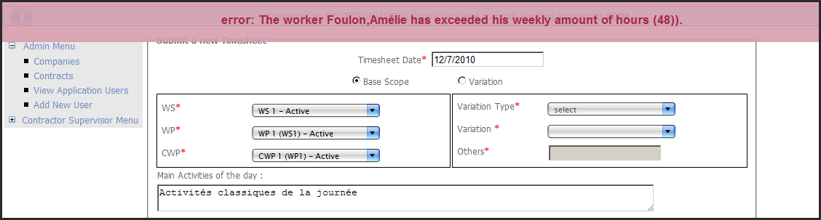

Call a previous Timesheet:

The “Call previous timesheet” button on the interface allows a user to import the list of workers of a previsous timesheet he has submitted.
By clicking on this button, the user will see the list of all timesheets according to the parameters selected (WS/WP/CP or Variation):

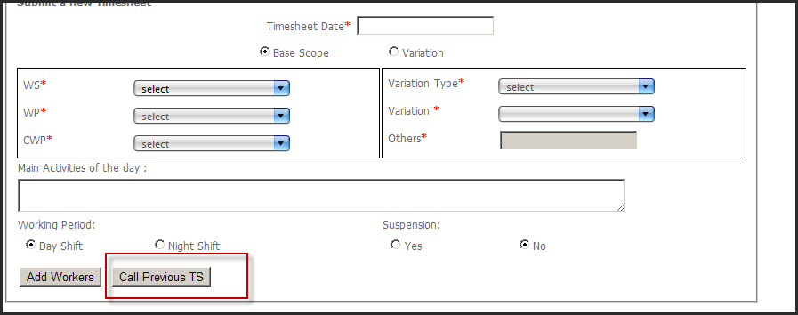

The user will then select a timesheet in the list and he will get on this “timesheet submit” page the list of workers of the selected timesheet.
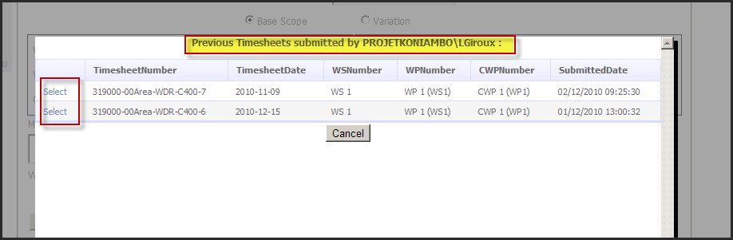

Click on select link:
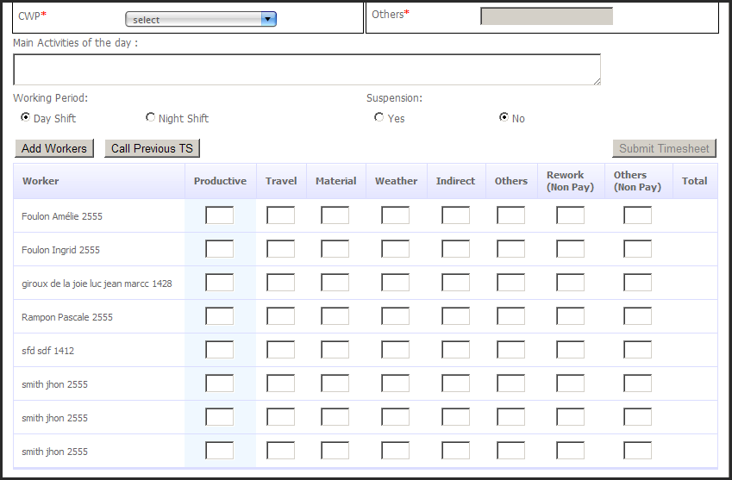

View Pending approval Timesheets

List of pending approval TS:
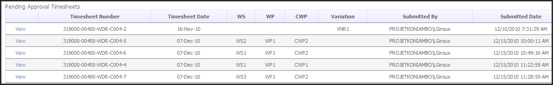

Click on the view button for a timesheet:

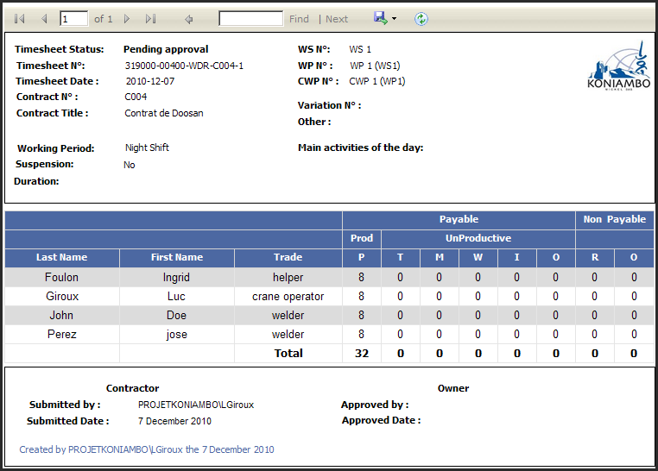

View Approved Timesheets

Users can search for approved timesheets using filters:
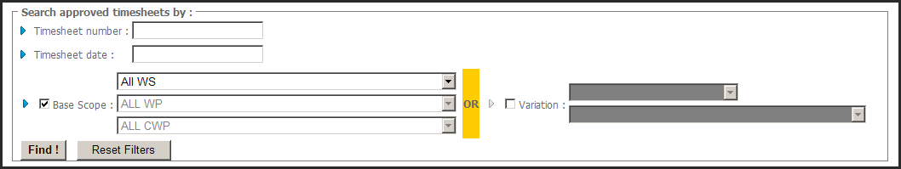

List of approved TS:

Click on the view button for a timesheet:

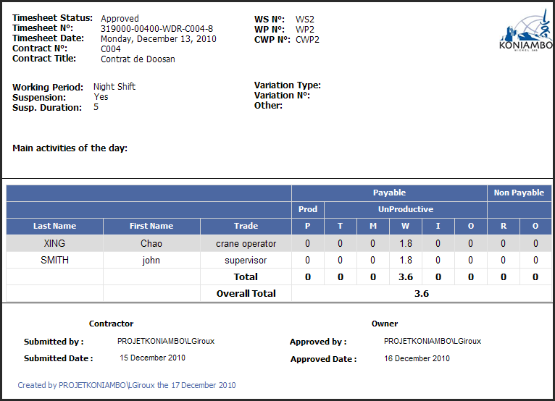

View Rejected Timesheets

List of the rejected timesheets:

Click on the view button for a timesheet:

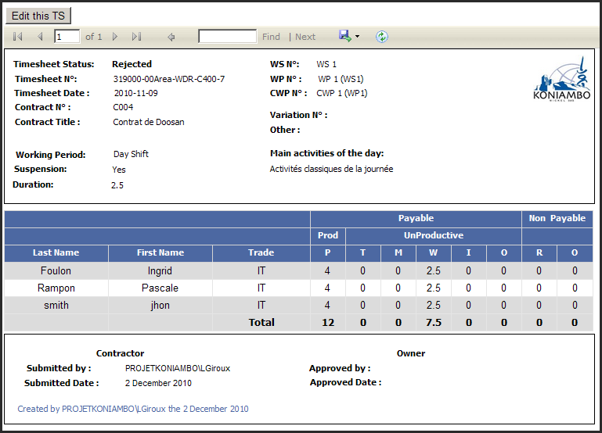

By clicking on the “Edit this TS” button, the user can then edit the timesheet (view next paragraph).

Timesheet Edition

Business rules for the timesheet edition:
- When a timesheet on a given contract is in the “rejected” status, every user members of the “Contractor supervisor” role on this given contract can edit the timesheet and re-submit it.
- During the edition, all fields of the timesheet can be edited.

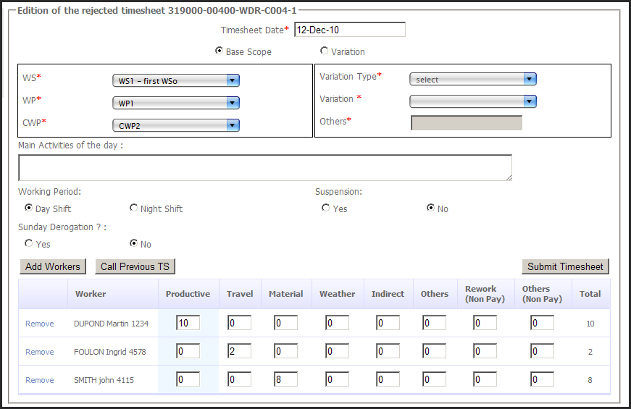

Owner Supervisor screens

Start page

Owner supervisor menu

Approve Timesheets

View Timesheets to approve list:
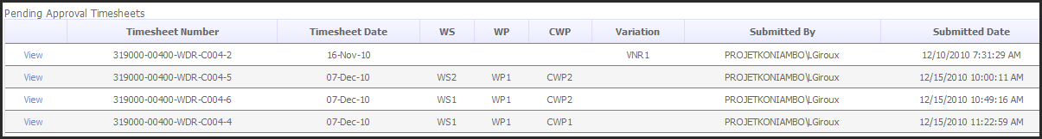

Click on the “view” link of the required timesheet to see details and approve/reject.

Approve / Reject a timesheet:
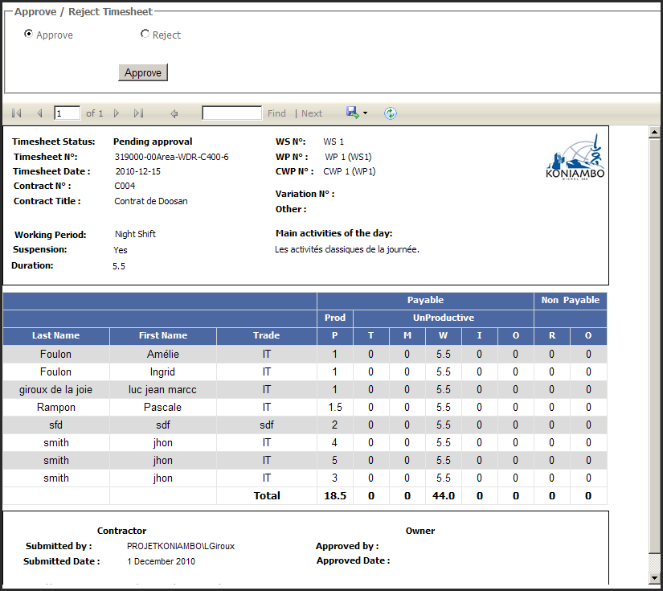

If reject is selected, the user will have to enter a reason of the rejection (mandatory):
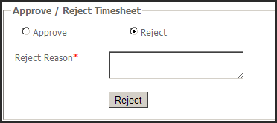

An email notification is send to all contractor supervisor of a specified contract as soon as a timesheet has been rejected on a specified contract.
The notitifcation looks as follow:
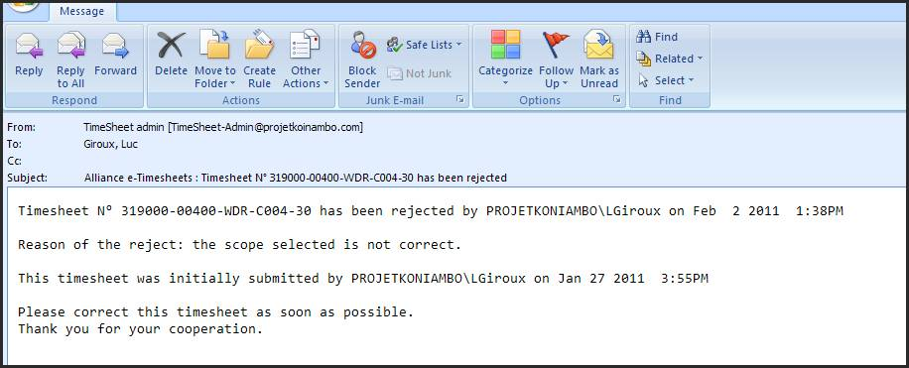

If the timesheet is approved, it will disappear from the “timesheet to approve” list and appear in the “Approved timesheets” list.
If the timesheet is rejected, it will disappear from the “timesheet to approve” list and appear in the “Rejected timesheets” list.

A user granted with the role Owner supervisor on a given contract can approve/reject all the pending approval timesheets on the given contract regardless on the WS//WP/CWP that the timesheets had been submitted on.

Timesheet Rejected

View rejected timesheets list:

View rejected timesheet detail:

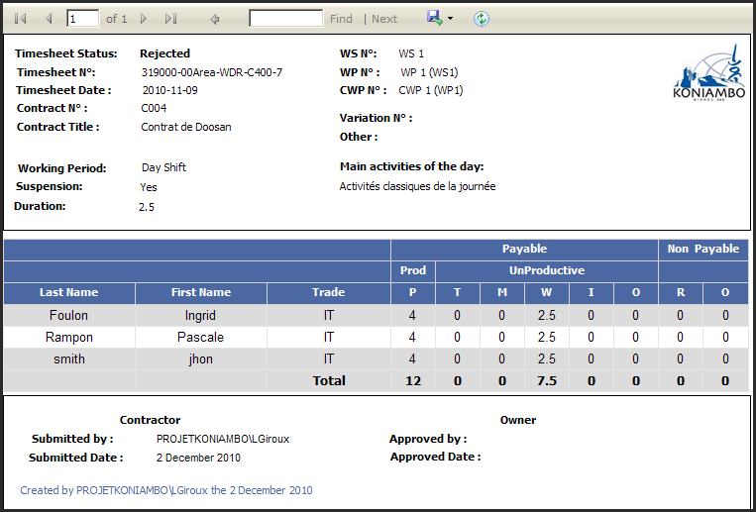

Timesheets Approved

Users can search for approved timesheets using filters:

View approved timesheets list:

View approved timesheet detail
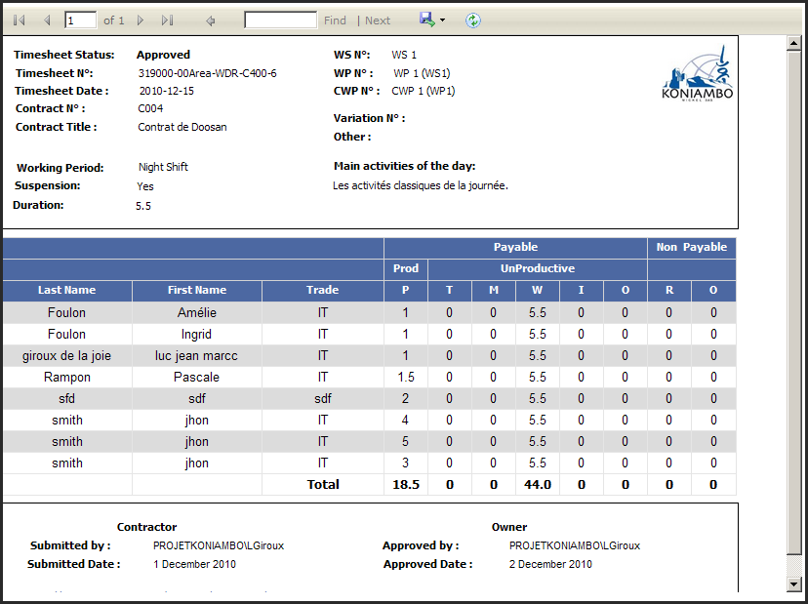

Reporting

Important note: In all the reports below, timesheets which are taken into account for a specific period are those whose “timesheet date” is included in the specific period. Not the “submitted date”, nor the “approved date”, but only the “timesheet date”.

Contract Base Scope report

Goal of this report: display all hours spent on the contract base scope (i.e. only CWP, not variations) for a determined period: the user has to define the start date and the end date for the report generation.
Only Payable hours are displayed.
Hours on “agreed suspension” timesheets are not taken into account. These hours are displayed in the “Agreed suspension” report.
All the contract base scope appears in this report, even if no data has never been submitted on a specific CWP.
Detail of columns in the report:
- Up to “Start Date”: Man hours spent from the beginning to the “Start Date”
- Actual: The man hours spent on the period
- To Date “End date”: up to “Start Date” + Actual
- To Go: Total Allocated – To Date “End date”:

Contract Base Scope report
Goal of this report: display all hours spent on the variations (i.e. only variations) for a determined period: the user has to define the start date and the end date for the report generation.
Only Payable hours are displayed.
Hours on “agreed suspension” timesheets are not taken into account. These hours are displayed in the “Agreed suspension” report.
All the variations defined in the contract’s structure appear in this report, even if no data has never been submitted on a specific CWP. Moreover, hours spent on undefined variations (i.e. “Other” text box in timesheet submission) for the specified period appear in the report in the “Others” discipline.
Detail of columns in the report:
- Up to “Start Date”: Man hours spent from the beginning to the “Start Date”
- Actual: The man hours spent on the period
- To Date “End date”: up to “Start Date” + Actual
- To Go: Total Allocated – To Date “End date”:

Agreed Suspension report
Goal of this report: display all suspension hours spent on the base scope and the variations (i.e. only variations) for a determined period: the user has to define the start date and the end date for the report generation.
Only “Weather Hours” displayed.
All the variations defined in the contract’s structure appear in this report, even if no data has never been submitted on a specific CWP. Moreover, hours spent on undefined variations (i.e. “Other” text box in timesheet submission) for the specified period appear in the report in the “Others” discipline.
Detail of columns in the report:
- Timesheet Number
- Timesheet Date
- The scope
- Main activities: in order to display the agreed suspension reference number
- Total Man Hours: The man hours spent on the period

Progress Report: weekly base scope

Goal of this report: display for each CWP of the contract base scope, how many hours have been spent by type of hour (Productive, travel, materials,…) by how many workers and this detailled for each day of a defined week: the user has to define the week start date for the report generation and then it generates a weekly of 6 following days (for example: you start on Saturday, the weekly will include all data from Saturday to Friday included).

All types of hours are displayed (payable and non payable hours).
Hours on “agreed suspension” timesheets are taken into account.
All the contract base scope appears in this report, even if no data has ever been submitted on a specific CWP.
When values are equal to zero, cells are leaved as blank.
Detail of columns in the report:
- Detail by day
- Man: number of workers who worked on the scope
for the day and for this type of hours.
Important: If a worker works for example 5 hours on productive hours for day1 and works also 3 hours on Travel hours on the same scope for day1 too, the worker will be counted twice: one time in “Man” for productive and one time for “Man” in Travel.
- Hours: total worked hours for a scope/day/type of hours

- Weekly summary: sum of man and hours for each day with detail by type of hours
- Overall summary: overall sum of man and hours for the week
- Manpower: gives an average on how many people worked on a specific scope (WS/WP/CWP). One worker could not be count twice in this specific CWP but could be count several times if he works in several CWP. Here is how this value is calculated:
  - We take total number of distinct workers (nbworkers) who worked on the scope for the week: even if a worker is counted 4 times in detailled day columns (because for example he worked 5 productive hours for day1, 3 Travel hours for day1 too, 10 productive hours on day2 and 10 productive hour on day3) we will only count him once.
  - We take the total number of worked day (nbdays) on the scope for the week: a day is considered as “worked” from the time that at least 1 hour has been submitted on this day.
  - Manpower = (nbworkers) DIVIDIDE BY (nbdays).

Progress Report: weekly Extra works

Goal of this report: display for each variation of the contract base scope, how many hours have been spent by type of hour (Productive, travel, materials,…) by how many workers and this detailled for each day of a defined week: the user has to define the week start date for the report generation and then it generates a weekly of 6 following days (for example: you start on Saturday, the weekly will include all data from Saturday to Friday included).

All types of hours are displayed (payable and non payable hours).
Hours on “agreed suspension” timesheets are taken into account.
All the variations of the contract appear in this report, even if no data has ever been submitted on a specific variation.
When values are equal to zero, cells are leaved as blank.
Detail of columns in the report:
- Detail by day
- Man: number of workers who worked on the scope
for the day and for this type of hours.
Important: If a worker works for example 5 hours on productive hours for day1 and works also 3 hours on Travel hours on the same variation for day1 too, the worker will be counted twice: one time in “Man” for productive and one time for “Man” in Travel.
- Hours: total worked hours for a variation/day/type of hours

- Weekly summary: sum of man and hours for each day with detail by type of hours
- Overall summary: overall sum of man and hours for the week
- Manpower: gives an average on how many people worked on a specific variation. One worker could not be count twice in this specific variation but could be count several times if he works in several variations. Here is how this value is calculated:
  - We take total number of distinct workers (nbworkers) who worked on the variation for the week: even if a worker is counted 4 times in detailled day columns (because for example he worked 5 productive hours for day1, 3 Travel hours for day1 too, 10 productive hours on day2 and 10 productive hour on day3) we will only count him once.
  - We take the total number of worked day (nbdays) on the variation for the week: a day is considered as “worked” from the time that at least 1 hour has been submitted on this day.
  - Manpower = (nbworkers) DIVIDIDE BY (nbdays).

Global Business rules

Here is the list of the principal business rules:
- Company:
  - A company contains one ore more Contracts
- Contract:
  - A contract contains one or more WS.
  - A contract is linked to one and only one company
- WS:
  - A WS contains one or more WP (at least 1 mandatory)
  - A WS can belong to one ore many supervisors/approver
- WP:
  - A WP contains one or more CWP (at least 1 mandatory)
  - A WP can belong to one ore several WS
- CWP:
  - A CWP can belong to one ore several WP
- Variation:
  - A Variation is linked to one and only one Contract
  - A Variation has got a type in the following list: VNR, VPR, CSI, RFI, SDM,NCR,Other
  - A Variation can be linked or not to one WS
  - A Variation can be linked or not to one WP
  - A Variation can be linked or not to one CWP
- Application User:
  - A user can have one and only one role on a given contract
  - A user can have several roles on several contracts
- Timesheet:
  - A timesheet can be modified by a supervisor in the following case:
    - The timesheet has been rejected, i.e the flag “Rejected” is checked
  - The unicity of the timesheet is done by the reference number which is generated accordingly to the contract, area and an incremental number.
- Worker:
  - A worker is linked to one and only one Company
  - A worker is linked to one and only one subcontractor
  - A worker can be associated to many contract within the same company

Database scheme

DatabaseModelisation.png

What the application does not do

- The application does not interact with PAF, access control, visas, or any other system.

Follow up of the solution's implementation

Legend:
- Green: implementation done.
- Orange: items to implement
- Red: blocking item

User story | Plannified  in Version | Working Days | Comments
As a user I need a start page to authenticate myself into the system | 1 | done
As the application administrator, I need to manage the global structure of the application : companies, contracts, subcontractors | 1 | done
As the application administrator, I need to manage users who can access the application and give them the proper rights on the proper contract | 1 | done
As a Owner contract Administrator, I need to manage the contract's profile: WS, WP, CWP, variations, workers, subcontractors, Owner supervisors and Contractor Supervisors | 1 | done
As a contractor contract administrator I need to see the contract’s profile. No edition is possible for me. | 1 | done | Same menu than Owner CA but read only access. Can just create workers
As a contractor contract administrator I need to see all the modifications that have been made on the contract’s profile. | 1 | done
As a owner contract Administrator, I can create workers on the system by using the form “create new worke” | 1 | done
As a contractor supervisor, I need to submit timesheet on a determined contract | 1 | done | Correct bugs and improvments  Implement database control on the submission as defined.
As a contractor supervisor, I need to correct a rejected timesheet | 1 | done | All can be edited
As a contractor supervisor, I need to call previous timesheet during the submission in order to get the list of workers. | 1 | done
As a Owner supervisor and Owner CA, I need to receive an email notification when there are some pending approval timesheet (everyday, 8pm) | 1 | 1 | May be useless for the Owner CA?
As a Owner supervisor, I need to approve/reject/comment timesheet on a determined contract | 1 | done
As a CA (owner and contractor) , I need to receive a monthly report by WS , WP and CWP. | 1 | 1 | Thomas: provide electonic files of what exists now
As a CA( owner and contractor) , I need to monitor the hours spent by trade | 1 | 1.5 | This item joins the point of having a specified list of trade. Have to discuss on that
As a manhours@projetkoniambo.com, I need to receive a data extraction of data entered and approved into the system on a daily basis | 1 | 1 | Check with Thomas the interest of this because we have the ‘Approved TS” list in the application.
As a manhours@projetkoniambo.com, I need to receive weekly report | 1 | 1 | Thomas: provide electonic files of what exists now.  manhours@projetkoniambo.com gets the weekly reports on every contracts?
Modification of the WORKER table: edition of the position, history table, new management of the workers |  | done | Problem solved
No Allocation of hours on variations, WS, WP: problem for reports |  | done | Structure has been modified
Global testing of the application, correction, improvment |  | 2
Deployment of the application on the project portal, create specific site, handle security and session problems |  | done
TOTAL |  | 7.5

End of Document

