|  |
| --- |
|  |
| Capstone Project Document |
| **Remote Learning System** |
|  |
| |  |  |  | | --- | --- | --- | | **RLS Team** | | | | **Project team** | Nguyễn Thị Trang | SE05803 | | Nguyễn Đức Thiện | SE05883 | | Lê Thị Thu Trang | SE05909 | | Đỗ Ngọc Khanh | SE06047 | | Đỗ Trung Đức | SE05844 | | **Supervisor** | Mr. Trần Đình Trí | | | **Project code** | RLS | | |
|  |

|  |
| --- |
| **Ha Noi, 13**th **August 2020** |

**Table of Contents**

**Acknowledgements** **2**

**Definitions and Acronyms** **3**

**Chapter 1 : Introduction** **4**

**Purpose** **4**

**Project Information** **4**

**The people** **4**

**Supervisor** **4**

**Team members** **4**

**Background** **4**

**The existing system** **5**

**The proposal of system** **5**

**System functions** **5**

**Out of scope functions** **5**

**Special approaches** **5**

**Chapter 2: Project Plan** **6**

**Purpose** **6**

**Software Process Model** **6**

**Roles and Responsibilities** **6**

Organization Structure 6

Project Team Member 6

**Tools and Techniques** **7**

**Project Management Plan** **7**

**Tasks** **7**

**Meeting Minutes** **7**

**Coding Conventions** **7**

**Risk Management Plan** **7**

**Communication Plan** **7**

# **Acknowledgements**

# **Definitions and Acronyms**

# **Chapter 1 : Introduction**

## **Purpose**

This chapter provides an overview of the project including background information, describes the scope of the document, gives a brief explanation and raises a proposal for ideas of improvement.

## **Project Information**

* Project name: Remote Learning System
* Project code: RLS
* Project group name: RLS team
* Product type: Website
* Business domain: Education
* Timeline: August 13th 2020 - 2020

## **The people**

## **Supervisor**

|  |  |  |  |  |
| --- | --- | --- | --- | --- |
|  | Full name | Phone | E-Mail | Title |
| Supervisor | Trần Đình Trí |  | tritd@fe.edu.vn | Lecturer |

*Table 1.1: Supervisor's information*

## **Team members**

|  |  |  |  |  |  |
| --- | --- | --- | --- | --- | --- |
|  | Full name | Student code | Phone | E-Mail | Role in Group |
| 1 | Nguyễn Thị Trang | SE05803 | 0337631111 | trangntse05803@fpt.edu.vn | Leader |
| 2 | Nguyễn Đức Thiện | SE05883 | 0566662225 | thienndse05883@fpt.edu.vn | Member |
| 3 | Lê Thị Thu Trang | SE05909 | 0961818500 | tranglttse05909@fpt.edu.vn | Member |
| 4 | Đỗ Ngọc Khanh | SE06047 | 0971703376 | khanhdnse06047@fpt.edu.vn | Member |
| 5 | Đỗ Trung Đức | SE05844 | 0962481497 | ducdtse05844@fpt.edu.vn | Member |

*Table 1.2: Team member's information*

## **Background**

Trong thời đại công nghệ 4.0, phương pháp học tập truyền thống bằng việc đến trường, lớp không còn là phương pháp duy nhất để tiếp cận và trau dồi kiến thức. Nhất là khi đại dịch Covid 19 đang gây nên những tác động tiêu cực đến nhiều ngành nghề, trong đó có ngành giáo dục đang phải gánh chịu hậu quả từ việc đóng cửa phần lớn các trường học trên toàn thế giới.

Với việc sử dụng rộng rãi máy tính và internet hiện nay, nền tảng học tập online là một trong những giải pháp tối ưu cho cả người dạy và người học. Hiểu được điều đó, Remote Learning System ra đời để giúp người học tiếp cận kiến thức tại bất cứ đâu vào bất cứ thời điểm nào với tất cả các lĩnh vực, ngành nghề cũng như các cấp bậc khác nhau. Với Remote Learning System, việc dạy và học chưa bao giờ dễ dàng đến thế!

## **Problem**

Today, there are many people who need to learn new things, new coding languages, etc. But don’t have any remote learning system easy to learn for vietnamese people.

Therefore, our team created a survey to collect information about the distance learning needs of all subjects.

survey : to do

## **The existing system**

|  |  |  |
| --- | --- | --- |
| Features | Coursera | Funix |
| Support Vietnamese | x | x |
| Tìm kiếm ứng viên theo chứng chỉ |  |  |
| Thời lượng tối thiểu xem video để pass | x |  |
| Thời lượng tối thiểu đọc bài đọc |  |  |
| Gợi ý khóa học theo từng chuyên môn, trình độ | x |  |
| Đánh giá khóa học | x |  |
| Bình luận về từng bài giảng |  |  |
| học viên có thể review bài tập cho nhau | x |  |
| % test pass | x | x |
| Đánh giá chất lượng từng nhà cung cấp khóa học | x |  |
| Tùy chỉnh thời hạn khóa học theo từng nhu cầu của 1 group |  |  |
| hỗ trợ đóng góp bản dịch cho các bài giảng | x |  |

## The proposal of system

## System functions

* Both Instructor and Student and Organization leader
  + Register Account with (username password, facebook, google).
  + Login with (username password, facebook, google).
  + Logout
  + Reset password
  + View and update personal information
  + View info of another Instructor and Student
  + Send feedback to the system
  + Report courses violates the community standards
  + Find Organizations
  + Request to join the Organization
* Organization leader
  + See organization overview (Instructor, Student, Course,...)
  + Edit organization info (name, description, ...)
  + Assign leader to another Instructor
  + Invite student or instructor to join organization
  + Browse the Organization join form
  + Remove Instructor from organization
  + View statistics of courses in the organization subject to user Report
  + Deactivate course in organization (if in violation of community standards)
* Instructor
  + View the overview of the courses created
  + Create new courses (public or private)
  + Set a deadline for courses
  + Add course to organization (public or private)
  + Cấp quyền cho học viên học các khóa private
  + Đặt các thuộc tính cho khóa học (category, tag)
  + Chỉnh sửa khóa học mà họ có quyền
  + Tạo bài giảng trong khóa học (dạng text hoặc video)
  + Set thời gian tối thiểu cần học viên pass qua bài giảng
  + Chỉnh sửa bài giảng trong các khóa học họ có quyền
  + Nộp đơn đăng ký Organization
* Student
  + Duyệt toàn bộ khóa học được public (theo bảng chữ cái, ngày tạo, category, tag, organization)
  + Xem tổng quan khóa học trước khi đăng ký (mô tả, Course content, reviews, Instructor info,... )
  + Xem tổng quan tiến độ các khóa đang theo học
  + Đăng ký khóa học (Enroll)
  + Hủy đăng ký khóa học (Unenroll)
  + Xem thống kê chi tiết tiến độ học của một khóa học đang theo học
  + Bình luận từng bài giảng của khóa học
  + Cho phép Chat với giảng viên
  + Xem các thành tích (accomplishments) đã đạt được
  + Reset deadline khóa học
  + Rate kèm bình luận đánh giá khóa học sau khi đã học xong (theo thang 5 sao)
* Staff
  + Login with Staff account
  + View some statistics.
  + Quản lý feedback
  + Quản lý Report khóa học
  + Quản lý category (add, update, delete)
  + Quản lý khóa học (active, inactive nếu vi phạm tiêu chuẩn cộng đồng)
  + Quản lý user Instructor or Student (active, inactive nếu vi phạm tiêu chuẩn cộng đồng)
  + Duyệt đơn đăng ký Organization
  + Quản lý Organization (active, inactive nếu vi phạm tiêu chuẩn cộng đồng)
* Admin
  + Manage data
  + Manage staff account including change role, status, create a new account
  + Edit website info (logo, infor in footer)
  + Quản lý danh sách tiêu chuẩn cộng đồng

## Out of scope functions

However, due to the limitation of team’s effort, we will not implement these following functions in the Ascending initial version 1.0.0 release of the project but not permanently excluded, and will be developed in future version 2.0.0, although we are aware that they so also important:

* + Allows the user to view the job offer according to the certificate obtained
  + Allows users to contribute to the translation of the lectures
  + Allows users to update personal information such as a resume
  + Allows users to create curriculum vitae templates
  + Allows users to search for other users by information (certificates, years of experience, degrees, ...)
  + Allows use of private messages with other users
  + Allows users to create group chats
  + Allows users to donate paid courses to other users
  + Allows users to post status to ask questions to other users
  + Allows users to post recruitment information
  + Allows users to update payment information
  + Allows users to create paid courses
  + Allows users to submit scholarship applications to organizations
  + allows Institutional leaders to design certificates for their courses
  + Allows the instructor to rate users for good performance
  + Allows organization leaders to grant scholarships to each user, providing scholarships for each specific condition
  + Allow organization leaders to post notification status, general information

## Special approaches

* For backend system
  + Using HTTP Methods according to the RESTful API standard.
  + Using HTTP Status Codes Correctly if something goes wrong while serving a request, we must set the correct status code for that in the response.
  + Using JWT (Json Web Token) for authentication and authorization.
  + Using real-time WebSocket technology with STOMP protocol.
* For frontend system
  + Using Angular Framework for web component rendering.

# **Chapter 2: Project Plan**

## **Purpose**

This chapter provides an overview of the project plan including project organization and project management plan.

### Software Process Model

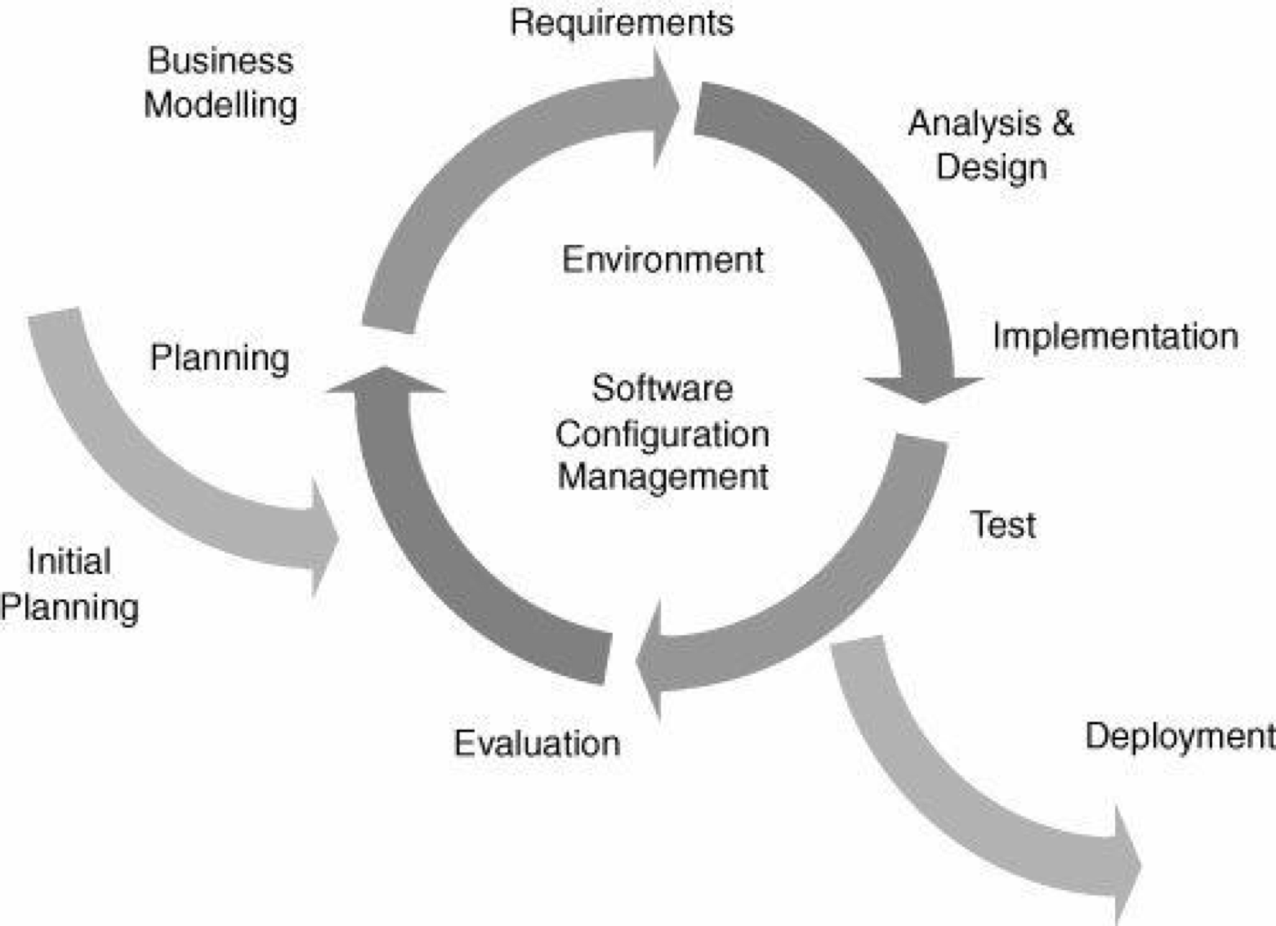

*Figure 1: Software Process Model*

The Iterative and Incremental Software Process Model is mostly used when the scope of the

the project is big, the major requirements are defined clearly, some more details will be added later in software development. By using this software process model, we break down the developing system task into a series of smaller tasks which will be completed separately, allowing us to take advantage of what was learned during development of earlier parts of the system. In addition, the iterative model is easier than other models when the issues are discovered. They are fed back to the team, and solutions will be found while the project is still in development.

### Roles and Responsibilities

|  |  |
| --- | --- |
| **Role** | **Responsibility** |
| Project Manager | Planning, developing schedules, coordinating communication, generally responsible for keeping the team’s focus on the main goal. |
| Programing leader | Responsible for choosing and deciding what technologies should be used, as well as for overseeing the work being done by other  developers. |
| Design leader | Involve to design the product's user interface. |
| Test leader | Involve to test the product. |
| Analyst leader | Analyzes an organization or business domain and documents its business or processes or systems. |

*Table 2.1: Roles and Responsibilities*

#### Organization Structure

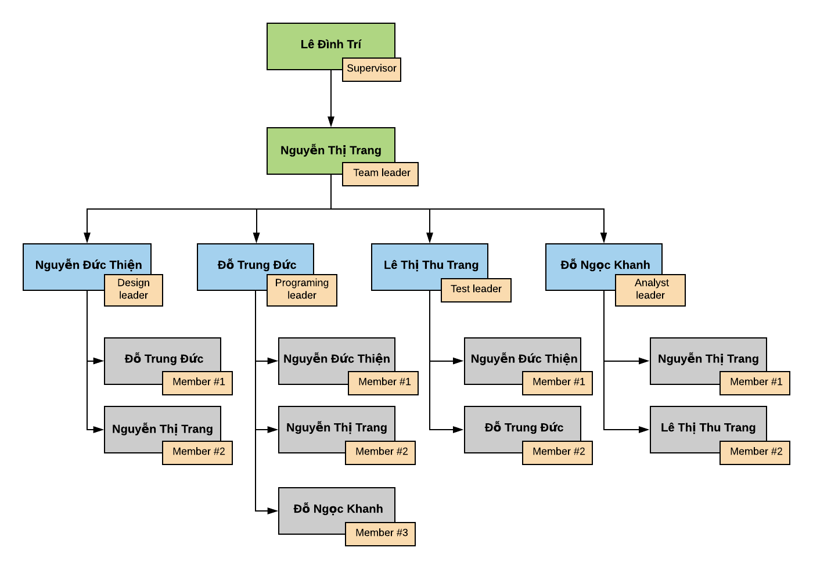

*Figure 2: Organization structure*

#### Project Team Member

|  |  |
| --- | --- |
| **Team member** | **Role** |
| TrangNT | Team leader, Design, Programing, Analyst |
| ThienND | Design leader, Programing, Test |
| TrangLTT | Test leader, Analyst |
| KhanhDN | Analyst leader, Programing |
| DucDT | Programing leader, Design, Test |

*Table 2.2: Project Team Member*

### Tools and Techniques

|  |  |
| --- | --- |
| **Programing languages** | Nodejs, Javascript |
| **Framework** | Angular 8, ExpressJS, Socket.IO |
| **API** |  |
| **DBMS** | PostgreSQL |
| **IDEs,Editors** | Visual Studio Code |
| **UML tools** | Visual Paradigm, Astah UML |
| **Version Control** | Github |
| **Deployment server** | Kubernetes |
| **Project management tool** | Microsoft Project, Trello |
| **Process model** | Iterative and Incremental Software Process Model |
| **Development process** |  |

*Table 2-3: Tools and Techniques*

## **Project Management Plan**

### Tasks

### 

### Meeting Minutes

### All meeting minutes will be written following this template:

|  |  |  |  |  |
| --- | --- | --- | --- | --- |
| **Project Name** | | Remote Learning System | **Project Code** | RLS |
| **Project Manager** | | Nguyen Thi Trang | **Conductor** | Tran Dinh Tri |
| **Secretary** |  |
| **Date** | |  | **Time** |  |
| **Venue** | |  | | |
| **1. Meeting Objective** | | | | |
|  | | | | |
| **2. Attendees** | | | | |
| **No** | **Full Name** | **Unit/ Group** | **Position** | **Attendance** |
| 1 | Tran Dinh Tri | FPT University | Supervisor |  |
| 2 | Nguyen Thi Trang | FPT University | Team Leader |  |
| 3 | Do Trung Duc | FPT University | Team Member |  |
| 4 | Nguyen Duc Thien | FPT University | Team Member |  |
| 5 | Le Thi Thu Trang | FPT University | Team Member |  |
| 6 | Do Ngoc Khanh | FPT University | Team Member |  |
| **3. Done tasks** | | | | |
|  | | | | |
| **4. New Tasks** | | | | |
|  | | | | |
| **5. Risk & Difficulty** | | | | |
|  | | | | |

### 

### Coding Conventions

### We strictly follow Eslint JavaScript Style Guide.

Please refer to JavaScript Style Guide - Eslint.pdf file or the official website at <https://www.npmjs.com/package/eslint>

### Risk Management Plan

|  |  |  |  |  |
| --- | --- | --- | --- | --- |
| **No** | **Description** | **Avoidance plan** | **Contingency plan** | **Impact** |
| **R1** | Project team member do not meet deadlines | - Nhận task phù hợp với chuyên môn và thời gian của từng cá nhân  - Prioritize important tasks first  - Estimate task sau khi đã hiểu rõ về công việc cần làm | - các member khác vô support nếu task đó là task quan trọng | High |
| **R2** | Data loss | - Teach members how to use Git and resolve conflicts.  - Always have important backups. | - Restore backed up data from GitLab.  - If requirement has new update, all members have to join the meeting to aware and make decision. | High |
| **R3** | Conflict between team members | Project Manage need to:  - specify clearly about requirement specification for all member  - Give common solutions |  | High |
| **R4** | Requirement  changed | - Team member has to analyze requirement carefully up to team.  - Every new update of requirement has to be reviewed by all team members and supervisor. | - Discuss with Supervisor to decide which requirement should be implemented.  - Change requirement. Develop for new required func | Medium |
| **R5** | Spirit goes down | hạn chế xung đột trong team, mọi người trong team giúp đỡ lẫn nhau khi gặp vấn đề khó | Thường xuyên giao lưu để mọi người gắn kết hơn | Low |
| **R6** | Lack of skill and knowledge for a specified work | Members training for each other | Learn more courses on coursera | Medium |
| **R7** | Team members may distraction | Team members may not pay enough time for the project. Therefore, project may be over deadline. | - Understand team members' schedule and assign suitable tasks and set appropriate deadlines.  - Require team members to set high priority for the project. | High |
| **R8** | Team members do not understand about requirements | PM phổ biến srs cho các thành viên và mỗi thành viên chủ động tìm hiểu rõ | Các thành viên khi pt dự án đều phải tham gia pt srs | Medium |
| **R9** | Lack of Supervisor support | Supervisor may have not enough time to support project team. Therefore, the work may get more mistakes | - Define a meeting schedule with the Supervisor.  - Ask for support from other sources. | Medium |
| **R10** | The team may work online | All team members quarantine themselves at home. Therefore, team members may not lose connection with others and take more time to finish tasks. | Make new planning to development project online. | High |
| **R11** | The designed database may be failure. | The created database is not working well in the project system and it has not a good architecture. Therefore, team members may spend more time to design the database again and implement code late. | - Team members researchers more about how to design a database.  - Team members discuss and review the project database.  - Ask the support from the supervisor or the database expert | High |
| **R12** | Business problem | Any ideas are welcome but members have to discuss with others and always focus on the reality and possibility. | Make sure the business logic of any ideas is carefully analyzed. | Medium |
| **R13** | Source code may be conflicted | Two or members in team can do same one part. Therefore, system may not run. | - Pull source code before commit the source code.  - Use backup version, discuss with other members and continue to work. | Low |
| **R14** |  |  |  |  |
| **R15** |  |  |  |  |

### 

### Communication Plan

***2.2.5.1 Weekly meeting schedule:***

We use Iterative and Incremental Process Model, then we divide the system into two subsystems (RLS Backend and RLS Frontend), each sub-system is divided into a series of small tasks. Each task is logged to TRELLO then estimated depending on difficulty and the amount of work by the whole team, after that the task will be assigned to team members by the Team Leader and depending on difficulty the Technical Leader will assign deadlines for each task. We will have a meeting every Thursday and Sunday to inform all teams about what each member finished last week, the status (fast, on time or slow), the issues met and how to solve them. If any member raises any issue, the whole team will help to find out a solution together. After that, the team will define detailed stories for next week's tasks.

***2.2.5.2 Daily meeting schedule:***

Each sub-system has one development team with a different schedule.When starting work-day, each team will have a stand-up meeting to inform others: “What did I do yesterday?”, “What will I do today?” and “Is there any difficulty?”. By focusing on what each person accomplished yesterday and will accomplish today, the team gains an excellent understanding of what has been done and what remains.

***2.2.5.3 Unscheduled meeting:***

If someone has an important problem that he wants to solve immediately, we will have a meeting for discussion, usually via some online channel: Google meet, Facebook or Phone.

***2.2..5.4 Communication channel:***

Our main communication channel is google meet. On the other hand, we use face-to-face meetings, Facebook groups, google meet and comment on TRELLO issues. However, we sometimes make a phone call or instant message if someone has a problem

Next chapter here