Software Design Specifications
for
<Project>
Version 0.1 approved
Prepared by <authors>
<team name>
<date created>

Sequence Diagrams
Sequence Join Game
Player tries to join a game.

The functional requirements related to this sequence are:
- FREQ-1: Game Server
- FREQ-2: Connection
- FREQ-3: Lobby
- FREQ-4: GUI
- FREQ-5: User Input

The scenarios which are related to this sequence are:
- SCN-1: Starting a game

Scenario Narration:
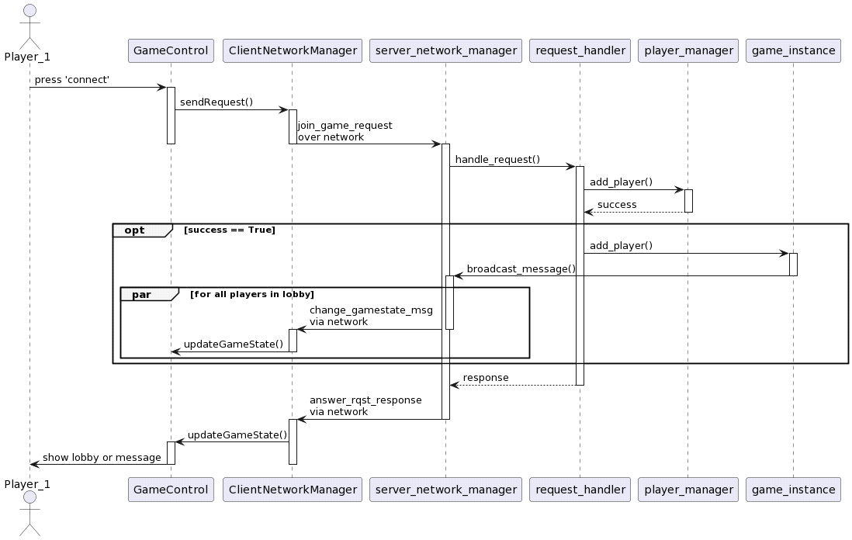
The player fills in their username and the server address in the connection GUI and presses 'connect'. The client sends a 'join_game_request' to the server, where the server tries to add the player to the game. Upon success, the server sends the updated game state to all players. Finally, the server sends the result to the client,

Sequence Perform an Action
The player requests one more card.

The functional requirements related to this sequence are:
- FREQ-1: Game Server
- FREQ-4: GUI
- FREQ-7: Turns
- FREQ-9: Make a Move
- FREQ-10: User Input

The scenarios which are related to this sequence are:
- SCN-3: Playing a turn

Scenario Narration:
During their turn, the player decides they want to 'hit', i.e. obtain another card. They press the 'hit' button. The client sends a ‘action_request' with action_type=”hit” to the server. The server checks if the player is allowed to play, and if so pops a card from the shoe and pushes it to the player's cards. The server recalculates the player's score and sends the updated game state to all players, whose clients update their GUIs. The server then sends the response to the initiating player.

