Software Requirements Specification
for
<Project>
Version 0.1 approved
Prepared by <authors>
<team name>
<date created>
Table of Contents
1. Introduction 1
1.1 Purpose 1
1.2 Document Conventions 1
1.3 Intended Audience and Reading Suggestions 1
1.4 Product Scope 1
1.5 References 1
2. Overall Description 2
2.1 Product Perspective 2
2.2 Product Functions 2
2.3 User Classes and Characteristics 2
2.4 Operating Environment 2
2.5 Design and Implementation Constraints 2
2.6 User Documentation 3
2.7 Assumptions and Dependencies 3
3. External Interfaces and Requirements 3
3.1 User Interface 3
3.2 Software Interfaces 3
3.3 Communications Interfaces 3
4. System Requirements 4
4.1 Functional Requirements 4
4.1.1 FREQ-1: 4
4.1.2 FREQ-2: 4
5. System Scenarios 5
5.1 Use-case Diagrams 5
5.2 Scenarios 5
5.2.1 SCN-1: <Scenario name (a sentence)> 5
5.2.2 SCN-2: <Scenario name (a sentence)> 6
6. System Constraints 7
6.1 Important Nonfunctional Requirements 7
6.1.1 NFREQ-1: 7
6.1.2 NFREQ-2: 7
7. Other Requirements 7

Revision History
Name | Date | Release Description | Version
Felix Friedrich | 17.03.22 | Template for Software Engineering Course in ETHZ. | 0.3
 | 17.03.22 | <Write your new release description over here>

Introduction

Purpose
<Identify the product whose software requirements are specified in this document, including the revision or release number. Describe the scope of the product that is covered by this SRS, particularly if this SRS describes only part of the system or a single subsystem.>

Document Conventions
<Describe any standards or typographical conventions that were followed when writing this SRS, such as fonts or highlighting that have special significance. For example, state whether priorities for higher-level requirements are assumed to be inherited by detailed requirements, or whether every requirement statement is to have its own priority.>

Intended Audience and Reading Suggestions
<Describe the different types of reader that the document is intended for, such as developers, project managers, marketing staff, users, testers, and documentation writers. Describe what the rest of this SRS contains and how it is organized. Suggest a sequence for reading the document, beginning with the overview sections and proceeding through the sections that are most pertinent to each reader type.>

Product Scope
<Provide a short description of the software being specified and its purpose, including relevant benefits, objectives, and goals. Relate the software to corporate goals or business strategies. If a separate vision and scope document is available, refer to it rather than duplicating its contents here.>

References
<List any other documents or Web addresses to which this SRS refers. These may include user interface style guides, contracts, standards, system requirements specifications, use case documents, or a vision and scope document. Provide enough information so that the reader could access a copy of each reference, including title, author, version number, date, and source or location.>

Overall Description

Product Perspective
<Describe the context and origin of the product being specified in this SRS. For example, state whether this product is a follow-on member of a product family, a replacement for certain existing systems, or a new, self-contained product. If the SRS defines a component of a larger system, relate the requirements of the larger system to the functionality of this software and identify interfaces between the two. A simple diagram that shows the major components of the overall system, subsystem interconnections, and external interfaces can be helpful.>

Product Functions
<Summarize the major functions the product must perform or must let the user perform. Details will be provided in Section 3, so only a high level summary (such as a bullet list) is needed here. Organize the functions to make them understandable to any reader of the SRS. A picture of the major groups of related requirements and how they relate, such as a top level data flow diagram or object class diagram, can be effective.>

User Classes and Characteristics
<Identify the various user classes that you anticipate will use this product. User classes may be differentiated based on frequency of use, subset of product functions used, technical expertise, security or privilege levels, educational level, or experience. Describe the pertinent characteristics of each user class. Certain requirements may pertain only to certain user classes. Distinguish the most important user classes for this product from those who are less important to satisfy. >

Operating Environment
<Describe the environment in which the software will operate, including the hardware platform, operating system and versions, and any other software components or applications with which it must peacefully coexist.>

Design and Implementation Constraints
<Describe any items or issues that will limit the options available to the developers. These might include: corporate or regulatory policies; hardware limitations (timing requirements, memory requirements); interfaces to other applications; specific technologies, tools, and databases to be used; parallel operations; language requirements; communications protocols; security considerations; design conventions or programming standards (for example, if the customer’s organization will be responsible for maintaining the delivered software).>

User Documentation
<List the user documentation components (such as user manuals, on-line help, and tutorials) that will be delivered along with the software. Identify any known user documentation delivery formats or standards.>

Assumptions and Dependencies
<List any assumed factors (as opposed to known facts) that could affect the requirements stated in the SRS. These could include third-party or commercial components that you plan to use, issues around the development or operating environment, or constraints. The project could be affected if these assumptions are incorrect, are not shared, or change. Also identify any dependencies the project has on external factors, such as software components that you intend to reuse from another project, unless they are already documented elsewhere (for example, in the vision and scope document or the project plan).>

External Interfaces and Requirements

User Interface
<Describe the logical characteristics of the interface between the software product and the users. This may include sample screen images, any GUI standards or product family style guides that are to be followed, screen layout constraints, standard buttons and functions (e.g., help) that will appear on every screen, keyboard shortcuts, error message display standards, and so on. Define the software components for which a user interface is needed.>

Software Interfaces
<Describe the connections between this product and other specific software components (name and version), including databases, operating systems, tools, libraries, and integrated commercial components. Identify the data items or messages coming into the system and going out and describe the purpose of each. Describe the services needed and the nature of communications. Refer to documents that describe detailed application programming interface protocols. Identify data that will be shared across software components. If the data sharing mechanism must be implemented in a specific way (for example, use of a global data area in a multitasking operating system), specify this as an implementation constraint.>

Communications Interfaces
<Describe the requirements associated with any communications functions required by this product, including e-mail, web browser, network server communications protocols, electronic forms, and so on. Define any pertinent message formatting. Identify any communication standards that will be used, such as FTP or HTTP. Specify any communication security or encryption issues, data transfer rates, and synchronization mechanisms.>

System Requirements
<This template illustrates organizing the functional requirements for the product by system features, the major services provided by the product. You may prefer to organize this section by use case, mode of operation, user class, object class, functional hierarchy, or combinations of these, whatever makes the most logical sense for your product.>

Functional Requirements
<Each requirement should be uniquely identified with a sequence number or a meaningful tag of some kind. These are the software capabilities that must be present in order for the user to carry out the services provided by the system.>

FREQ-1:
The system should ...

Description: <Describe the requirement >
User Priority(x/5): < How important is this requirement for the user, comparing with others?>
Technical Priority(y/5): <How important is this requirement for the system, e.g. do requirements also need it?>

FREQ-2:
...

System Scenarios

Use-case Diagrams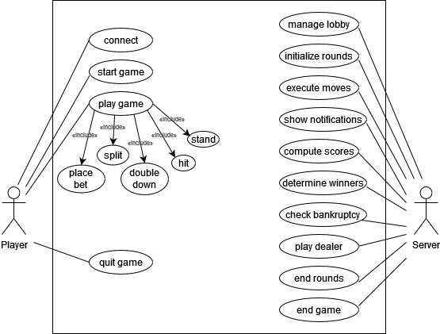

Scenarios

SCN-1: Starting a game

FREQ reference | 1,2,3,4,5,6,10
NFREQ reference | 1,2,3,4,5
Short Description: | John, Jane and Peter want to play a game of Blackjack. John starts the server and communicates the address to Jane and Peter. All three start their clients, enter their usernames and connect to the server by filling in the address and pressing the “connect” button. Jane presses the “start game” button.
Activation action: | John starts the server, all players connect, Jane presses the “start game” button.
Precondition: | All players have the ability to run and control the game client, John also has the ability to run the server. All players have access to the same network as the server.

Basic flow: Starting a game
Step | User action |  | System response
1 | John starts the server application |  | The server application starts and displays its address.
2 | Players start the client |  | The client application starts and shows text input fields for username, and for a server address
3 | Players fill in the required information
4 | Players press the “connect” button |  | All players are connected to the server and added to the lobby, the connected players are displayed
5 | Jane presses the “start game” button |  | The lobby is closed, a new game is initialized with all players that were present in the lobby, the amount of money of each player is set to 100, a shoe is initialized, the round counter is set to 0, players are assigned seats and the game starts by prompting each player to specify a bet.
Post-condition: |  | All players are connected to the server, the game is initialized and players have the ability to specify their desired bets for the first round.

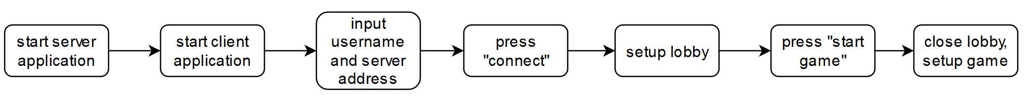
Scenario Diagram for SCN-1 Starting a game

SCN-2: Starting a round

FREQ reference | 4,6,10
NFREQ reference | 1,2,3,4,5
Short Description: | Peter, Jane and John have just finished a round. All of them have enough money left to pay the minimum bet. They each enter their bets for the next round. The next round starts, it’s Peter’s turn.
Activation action: | A round has just ended and all players still have enough money to pay the minimum bet.
Precondition: | John, Jane and Peter are playing Blackjack and a round has just ended. Peter is the starting player in this round.

Basic flow: Starting a round
Step | User action |  | System response
1 | All players specify their desired bets for the next round |  | The bets are displayed, the bet of each player is subtracted from their money.
2 |  |  | Checks if a new shoe needs to be initialized. Initializes new shoe.
3 |  |  | Each player is dealt two cards face up, the dealer is dealt one card face up and one card face down. The dealer’s face up card is a 7 of spades. It’s displayed that Peter is to play.
Post-condition: |  | A new round has started. Two cards are shown face up for each player, for the dealer one card is shown face up and one face down. It’s Peter’s turn.

Scenario Diagram for SCN-2 Starting a round
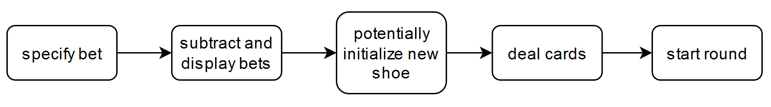

SCN-3: Playing a turn

FREQ reference | 4,6,7,9,10,14
NFREQ reference | 1,2,3,4,5
Short Description: | Jane, John and Peter are playing a round of Blackjack. Peter started the round and has already finished his turn by pressing “stand”. It’s Jane’s turn, she sits to Peter’s left. Her two face up cards are a 6 of spades and a 2 of hearts. She presses ‘hit’ and receives an ace of hearts. She presses the “Stand” button. Her turn ends, it’s John’s turn.
Activation action: | Peter presses “stand”.
Precondition: | Jane, John and Peter are playing a round of Blackjack. Peter’s turn has just ended, it’s Jane’s turn.

Basic flow: Playing a turn
Step | User action |  | System response
1 | Peter presses “stand” |  | Peter’s score is calculated and displayed. Checks whose turn it is and displays that it’s Jane’s turn.
2 | Jane presses “hit” |  | The next card is drawn from the shoe and dealt to Jane. The card is displayed face up. Jane’s intermediate score is calculated, it’s less than or equal to 21, so her turn continues.
3 | Jane presses “stand” |  | Jane’s final score is calculated and displayed. Checks whose turn it is next and displays that it’s John’s turn.
Post-condition: |  | It’s John’s turn. Jane’s score is displayed.

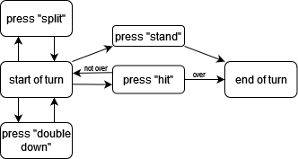
Scenario Diagram for SCN-3 Playing a turn

SCN-4: Ending a round

FREQ reference | 4,7,9,10,11,12,14
NFREQ reference | 1,2,3,4,5
Short Description: | Peter, Jane and John are playing a round of Blackjack. All players have a bet of 50. Peter and Jane have already finished their turns and achieved scores of 19 and 20, respectively. It’s John’s turn. John has a jack of hearts and a king of spades. He presses “hit” and receives a 6 of clubs. John is over, and his turn ends. The dealer’s face down card is turned around. The dealer’s score is 16, so she is dealt another card. It’s a 2 of spades. The dealer has a score of 18 and the round ends. 100 is added to Peter’s and Jane’s money. All players still have money. The players are prompted for their next bets.
Activation action: | John presses “hit”.
Precondition: | John is the last to play in the round and starts with a score of 20. All players have enough money left to pay the minimum bet.

Basic flow: Ending a round
Step | User action |  | System response
1 | John presses “hit” |  | The next card off the shoe is dealt face up to John, it’s a 6 of clubs. The intermediate score of John is calculated and compared to 21. It’s greater, a notification is shown. John’s score is displayed and his turn ends. All players have finished their turns.
2 |  |  | The dealer’s face down card is displayed. The dealer’s score is calculated. It’s 16. The dealer is dealt another card. It’s a 2 of spades. The dealer’s score is calculated, it’s 18. The dealer is finished, her score is displayed.
3 |  |  | All players’ scores are ranked. 100 is added to Jane and Peter’s money. A notification of who won how much is shown.
4 |  |  | The system checks if a player has gone bankrupt. The round ends and players are prompted to specify their next bets.
Post-condition: |  | 100 has been added to Jane’s and Peter’s money. The bet entry prompt is shown.

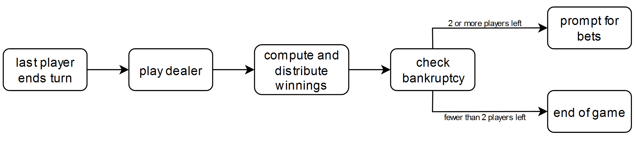
Scenario Diagram for SCN-4 Ending a round

SCN-5: End of the game

FREQ reference | 4,7,9,10,11,12,13,14,15
NFREQ reference | 1,2,3,4,5
Short Description: | John and Jane are playing a game of Blackjack. Both have a bet of 5, Jane’s remaining money is at 200 while John’s is at 0. In the current round, John has already finished playing and achieved 15 points. Jane was dealt 20 points and decides to stand. The dealer achieves 19 points. Jane’s money is increased by 10. John lost and Jane is the only player to have money left. The game ends. Jane wins the game. John closes the game client.
Activation action: | Jane presses “stand”
Precondition: | John has no more money left.

Basic flow: End of the game
Step | User action |  | System response
1 | Jane presses “stand” |  | Jane’s score is calculated and displayed. It’s 20. The system determines that all players have played.
2 |  |  | The dealer’s face down card is turned and her score is calculated. It’s 19. The system determines that the dealer’s play is finished. Her score is displayed.
3 |  |  | The player’s scores are ranked. John loses and Jane wins, so 10 is added to Jane’s money.
4 |  |  | The system determines that John is bankrupt. It displays a notification that John is bankrupt. The system determines that Jane has won the game. It displays the end screen.
 | John closes the game client |  | John’s client closes, all other instances of the system keep running.
Post-condition: |  | Jane sees the end screen

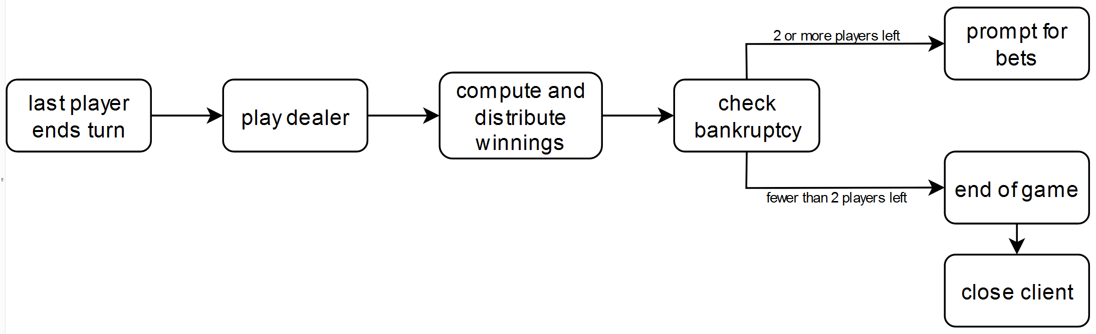
Scenario Diagram for SCN-5 End of game

System Constraints

Important Nonfunctional Requirements
<If there are nonfunctional requirements for the product under various circumstances, state them here and explain their rationale, to help the developers understand the intent and make suitable design choices. Specify the system limitations or extensions to various platforms(e.g. cloud servers), safety or security requirements. Make such requirements as specific as possible. You may need to state the connection between functional requirements.>

NFREQ-1:
The system should ...

Description: <Describe the non functional requirement >
User Priority(x/5): < How important is this requirement for the user, comparing with others>
Technical Priority(y/5): <How important is this requirement for the system, e.g. do requirements also need it?>

NFREQ-2:
...

Other Requirements
<Define any other requirements not covered elsewhere in the SRS. This might include database requirements, internationalization requirements, legal requirements, reuse objectives for the project, and so on. Add any new sections that are pertinent to the project.>
Appendix A: Glossary
<Define all the terms necessary to properly interpret the SRS, including acronyms and abbreviations. You may wish to build a separate glossary that spans multiple projects or the entire organization, and just include terms specific to a single project in each SRS.>
Appendix B: Analysis Models
<Optionally, include any pertinent analysis models, such as data flow diagrams, class diagrams, state-transition diagrams, or entity-relationship diagrams.>
Appendix C: To Be Determined List
<Collect a numbered list of the TBD (to be determined) references that remain in the SRS so they can be tracked to closure.>

