Software Design Specifications
for
Blackjack
Version 1.0 approved
Prepared by Severin Klapproth, Flavia Taras, Luca Wolfart,
Pascal Engeler, Noé Canevascini, Stanislaw Piasecki
Jack Blacks
29.03.2022
Table of Contents
Introduction 1
Purpose 1
Document Conventions 1
Intended Audience and Reading Suggestions 1
Product Perspective 1
Static Modeling 2
Package General 2
Class GameState 2
Class Player 2
Class Shoe 3
Class Card 3
Class Diagram of Package General 3
Package Server & Client_Communications 3
Class BlackJack 4
Class GameControl 4
Class GUI_Window 4
Class ConnectionPanel 4
Class BetPanel 5
Class MainGamePanel 5
Class ClientNetworkManager 5
Class ResponseListenerThread 5
Class client_requests 6
Class server_response 6
Package Server //not needed I guess 6
Class server_network_manager 6
Class player_manager 7
Class game_instance 7
Class request_handler 7
Composite Structure Diagram 9
Sequence Diagrams 10
Sequence <Name> 10
<Another Sequence Name> 10
Interface Modeling 11
Interface <Name> 11
<Message Name> 11
<Another Message Name> 11
<Another Interface Name> 11

Revision History
Name | Date | Release Description | Version
Felix Friedrich | 3/30/22 | Template for Software Engineering Course in ETHZ. | 0.2
Jack Blacks | 3/30/22 | Design Speciication for Blackjack | 1.0

Introduction

Purpose
<Identify the product whose software requirements are specified in this document, including the revision or release number. Describe the scope of the product that is covered by this SDS, particularly if this SDS describes only part of the system or a single subsystem.>

Document Conventions
<Describe any standards or typographical conventions that were followed when writing this SDS, such as fonts or highlighting that have special significance. For example, state whether priorities for higher-level requirements are assumed to be inherited by detailed requirements, or whether every requirement statement is to have its own priority.>

Intended Audience and Reading Suggestions
<Describe the different types of reader that the document is intended for, such as developers, project managers, marketing staff, users, testers, and documentation writers. Describe what the rest of this SDS contains and how it is organized. Suggest a sequence for reading the document, beginning with the overview sections and proceeding through the sections that are most pertinent to each reader type.>

Product Perspective
<Describe the context and origin of the product being specified in this SDS. For example, state whether this product is a follow-on member of a product family, a replacement for certain existing systems, or a new, self-contained product. If the SDS defines a component of a larger system, relate the requirements of the larger system to the functionality of this software and identify interfaces between the two. A simple diagram that shows the major components of the overall system, subsystem interconnections, and external interfaces can be helpful.>

Static Modeling

Package General

This package contains the classes GameState, Player, Shoe and Card which describe the game state and game logic.

Class GameState

This class holds the state of the game and controls the actions which are performed by the players.

The class attributes are:
- int num_players: holds number of players, needed to compute players turns
- vector<player> players: vector of players which participate in the game
- Int turn: holds which players turn it is. Players are numerated from 0 to number_players – 1
- round: holds the number of the current round. First round is round 0
- int min_bet: holds the smallest bet a player can make
- Shoe shoe: hold the card shoe which will be used for the game
The class operations are:
- void next_turn: increase turn counter, make player perform his available actions
- void start_round: make the dealer compute his score, make players take their turn, increase round counter when last player has taken turn
- check_winner: compare the scores of the player to determine winner
- void start_game: when the maximal number of rounds has bee
- compute dealers_hand: computes the hand that the dealer gets by performing the actions which are dictated by the blackjack rules
- void show_first_card: show the dealers first card

Class Player
This class holds the information about the state of every player

The class attributes are:
- int money: the capital which every player possesses
- int bet_size: how much money a player has bet in a round
- vector<Card> cards: the cards which a player has
- bool has_insurance: true if a player has taken insurance for a round
- bool has_doubled_down: true if a player has decided to double down
The class operations are:
- void hit: a player takes one more card
- void stand: a player doesn’t take another card
- void take_insurance: set take_insurance to true
- void double_down: double the size of the bet, set double down to true
- int get_points: compute the amount of points based on the cards a player has
- bool is_broke: check if player has more capital than the minimal bet
- bool check_if_over_21: check if the points are over 21
- int check_if_less_than_dealer: returns -1 if player has less points than the dealer, 0 if he has the same and 1 if the player has more points than the dealer
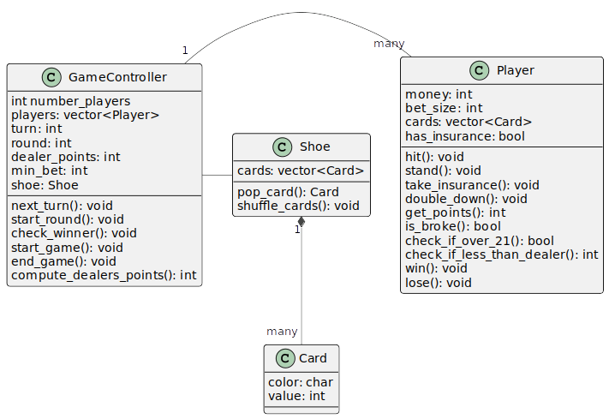
- void win_round: increase capital by bet size, or half the bet size if he has a blackjack
- void lose_round: deduct bet size from capital

Class Shoe
This class holds the state of the shoe, i.e. many card decks

The class attributes are:
- vector<Card> cards: holds all the cards which are in the shoe
The class operations are:
- Card pop_card: removes the last card of the vector and returns it
- void shuffle_cards replenishes the shoe and shuffles the cards

Class Card
This card holds the description of a card

The class attributes are:
- char suit: suit of the card, one of “c”, “p”, “h”, “d”
- int value

Class Diagram of Package General

Package Server & Client_Communications
This package contains all classes and functions required to run the game client and play Blackjack. It is responsible for GUI, interaction of user with the game interface, communication between client and server and running the game locally.

Class BlackJack
This class is used to initialize our application and GUI for a player that wants to run the game. It is derived from the wxApp class defined in the wxWidgets GUI library.

The class operations are:
- OnInit: returns bool which indicates whether processing should continue, derived from wxApp, initializes our game client

Class GameControl
The GameControl class serves as the controller of ongoing actions for the client. It manages user interaction with the Graphical User Interface, but also connection to server and controls current state of the game.

The class attributes are:
- gameWindow: GUI_Window, main game window, current panel
- connectionPanel: ConnectionPanel, connection panel used to connect to the game
- mainGamePanel: MainGamePanel, the main game panel used in the game
- betPanel: BetPanel, the bet panel used to make bets
- my_id: int, id of the player interacting with the client
- currentGameState: GameState, the latest game state
The class operations are:
- init: initializes all panels and displays the connection panel
- connectToServer: reads the user inputs on the connection panel and sends a join_game request
- updateGameState: saves the latest game state in currentGameState
- startGame: sends a start_game request to the server and then starts a game if at least 2 players are in lobby
- hit: sends a hit request to the server
- stand: sends a stand request to the server
- split: sends a split request to the server
- double_down: sends a double_down request to the server
- insure: sends the insure request to the server
- showNewRoundMessage: displays a box showing current round number, the winnings/losses from last round and that next round is about to start
- showGameOverMessage: displays a box showing the winning/losing message and a button to leave the game

Class GUI_Window
This class represents the window of our application. It is responsible for outputting the correct panels to the user. It is derived from the wxFrame class in the wxWidgets GUI library.

The class attributes are:
- currentPanel: wxPanel, the panel to be displayed in the game window
The class operations are:
- showPanel: displays the given panel

Class ConnectionPanel
This class represents the GUI panel that the user uses to input the data needed to host or join a game hosted on the server. It is derived from the wxPanel class in the wxWidgets GUI library.

The class attributes are:
- serverAddress: string, holds the address of the server
- serverPort: string, holds the port of the server
- playerName: string, holds the username picked by the player
The class operations are:
- getServerAddress: returns the server address
- getServerPort: returns the server port
- getPlayerName: returns the player name

Class BetPanel
The BetPanel class represents the panel that user interacts with to place his/her bet of choice. It is derived from the wxPanel class in the wxWidgets GUI library.

The class attributes are:
- betSize: int, holds the size of the players bet
- playerMoney: int, holds the amount of money the player has (before betting)
The class operations are:
- getBetSize: returns the size of the players bet
- getPlayerMoney: returns the amount of money the player has (before betting)

Class MainGamePanel
The MainGamePanel class represents the panel that user interacts with during the actual game. It is derived from the wxPanel class in the wxWidgets GUI library.

The class operations are:
- buildGameController: removes existing GUI elements and builds latest game state GUI
- buildOthers: builds GUI elements of other players hands, money and bets
- buildRoundCounter: builds GUI of the current round number
- buildMyself: builds the hand, money and bet of the player

Class ClientNetworkManager
This class handles the client-server communication on the client side.

The class attributes are:
- is_connected: bool, true if connection to host was succesful
- connection: tcp_connector (defined in sockpp library), used to connect to the host and to initialize the response listener thread
The class operations are:
- init: returns the size of the players bet
- sendRequest: sends a client request to the server
- parseResponse: parses a received server response for further processing

Class ResponseListenerThread
The purpose of this class is to listen to responses of the server to the client and catch them.

The class attributes are:
- connector: tcp_connector (defined in sockpp library), listens to incoming server responses
The class operations are:
- entry: loop which deals with incoming server responses
- outputError: communicates error to the user

Class client_requests
Base class for client requests to the server. ...

The class attributes are:
- player_id: string, ID of the player whose client makes the request
- type: enum RequestType: either join_game, start_game, make_bet, hit, stand, split, double_down, insure

?The class operations are:
Different possible requests, implmented as subclasses, are are:
- join_game_request: Requests to join into the game currently hosted by the server.
- start_game_request: Requests to start the game (can ony be done by first player who joined the game.
- make_bet_request: Requests to make a bet of a certain amount..
- hit_request: Requests to get hit with another card.
- stand_request: Signalized the player_client will stand for this round.
- split_request: Requests to split a pair. (only possible as the first action).
- double_down_request: Requests to double down (only possible as the first action).
- insure_request: Requests an insurance.(only possible as the first action).

Class server_response
Base class for server communication to the client.

Class attributes are:
- type: enum ResponseType: either answer_request or change_gamestate

Different possible requests, implmented as subclasses, are are:
- answer_rqst_response: Answers directly to a request by a client.
- change_gamestate_response: Tells all clients about a change of the game state.
This package contains all classes and functions required to run the game client and play Blackjack. It is responsible for GUI, interaction of user with the game interface, communication between client and server and running the game locally.

Package Server //not needed I guess
This package contains all classes and functions required for running a server, which allows many players to join the game and play against each other. It is responsible for updating the current game state, communication between the server and all clients connected to it, but also starting and maintaining game.

Class server_network_manager
Handles server startup, client requests and broadcasting information to all clients. After the startup the server will execute a listener loop and handle incoming requests from the clients.

The class attributes are:
- acc: tcp_acceptor, for incoming connection requests
- player_id_to_address: map, maps the player ids to client addresses
- address_to_socket: map, maps the client addresses to TCP sockets
The class operations are:
- listener_loop: keeps the server running and catches incoming requests
- handle_incoming_message: receives a message and checks the contents
- read_message: parses a received message for further processing
- send_message: sends a message to a client
- broadcast_message: causes a send to all clients
- on_player_left: handles the event that a player quits the game

Class player_manager
Handles player management during a game.

The class attributes are:
- player_map: map, keeps track of the players and their names
The class operations are:
- get_player: bool, retrieves a player from the player map, returns true if successful
- add_player: bool, adds new player to the player map, returns true if successful

Class game_instance
This class maintains the game instance by tracking the game state based on all server received messages and making sure it is updated. It also passes the updated game information to the server_network_manager class.

The class attributes are:
- game_state: GameState, holds the current updated game state
The class operations are:
- is_started: bool, returns if the game has already started
- is_finished: bool, returns if the game has already finished
- start_game: bool, attempts to start the game, returns true if successful
- add_player: bool, if possible adds a player to the game, otherwise return false
- try_remove_player: bool, if possible removes a player from the game, otherwise return false
- hit: bool, performs “hit” action and updates the game state
- stand: bool, performs “stand” action and updates the game state
- split: bool, performs a split (if allowed) and updates the game state
- double_down: bool, makes player “double down” (if allowed) and updates the game state
- insure: bool, gives player insurance and updates the game state

Class request_handler
Handles different requests from clients: start_game, join_game, make_bet, hit, stand, split, double_down, insure.

The class operations are:
- handle_request: request_response*, handles a client_request, changing the game state and returning a corresponding response

Class Diagram (next Page)

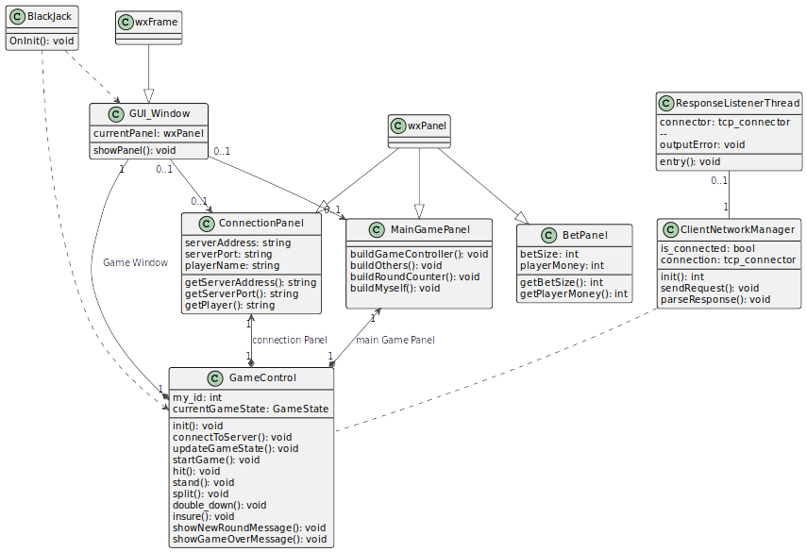
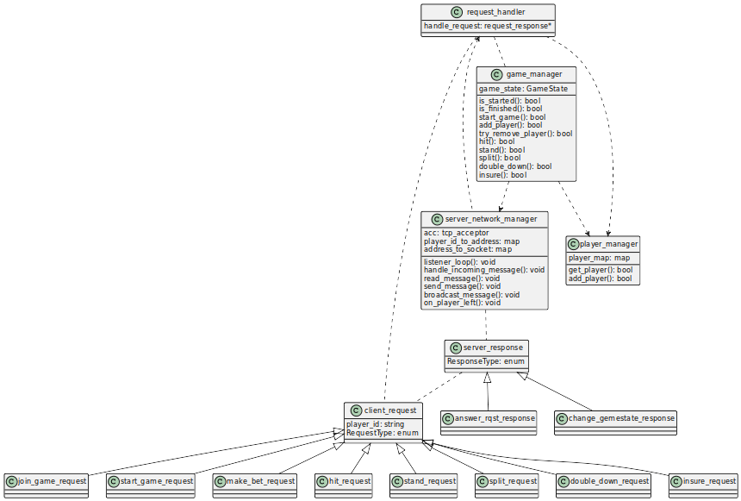

Composite Structure Diagram
<Here the composite diagram describing the connections between each package should be provided.>

Sequence Diagrams
<Sequence Diagrams are linked to the scenarios and the functional requirements of the SRS document. In this diagrams we are trying to show how the modeling can be used to implement this scenarios and requirements.>

Sequence End of Round/Game
The last player of the round finishes his turn. The round finishes.

The functional requirements related to this sequence are:
- FREQ-7: Turns
- FREQ-9: Make a Move
- FREQ-10: User Input
- FREQ-11 Dealer’s turn / Dealer AI
- FREQ-12: Round End & Returns
- FREQ-13: Game End
- FREQ-15: Player Exit
The scenarios which are related to this sequence are:
- SCN-3: Playing a turn
- SCN-4: Ending a round
- SCN-5: End of the game

Scenario Narration:
The last player plays his turn. The Dealer/AI plays his turn. All the scores are computed and the amount of money each player has is updated. The system checks for bankruptcy and if there is only one player left. The system checks if there are still rounds to be played.

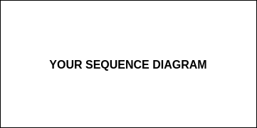

<Another Sequence Name>
…

Interface Modeling
<Interfaces define how data is exchanged between different parts of the system.>

Interface <Name>
<State what the purpose of this interface is and when it is used. Indicate which modules of the software are involved and which one initiates the communication. Define which protocol is used for communication. Indicate what modes of interaction exist and what types of messages are passed in each mode.>

Purpose: …

Communication between: <module X> and <module Y>, initiated by <module X>

Protocol: … (e.g. TCP)

Communication modes: ...

<Message Name>
<State which module is sending the message, which one is receiving it. For each type of message, list the values that are passed, which types they have and if they are required. Define the format of the message, possibly with an example. Also indicate if a response is expected and what type of message that response should be.>

Purpose: …
Direction: <module X> to <module Y>
Content:

- playerID : integer (required)
- moveType: string (required)
- card: integer

Format: as JSON string

Example: { "playerID": 2, "moveType": "draw", "card": 8 }

Expected response: <other message name>

<Another Message Name>

<Another Interface Name>

