Software Design Specifications
for
<Project>
Version 0.1 approved
Prepared by <authors>
<team name>
<date created>
Table of Contents
1. Introduction 1
1.1 Purpose 1
1.2 Document Conventions 1
1.3 Intended Audience and Reading Suggestions 1
1.4 Document Structure 1
1.5 Product Perspective 1
2. Static Modeling 2
2.1 Package <Name> with Priority <x/3> 2
2.1.1 <Class Specifier> <Class Name> 2
2.1.2 <Another class Specifier> <Another Class Name> 2
2.1.3 Class Diagram of Package <Package Name> 3
2.2 Package <Name> with Priority <x/3> 3
2.3 Composite Structure Diagram 3
3. Dynamic Modeling 4
3.1 Sequence Diagrams 4
3.1.1 Sequence Name 4
3.1.2 Another Sequence Name 4
3.2 StateChart Diagrams 4

Revision History
Name | Date | Release Description | Version
Felix Friedrich | 3/30/22 | Template for Software Engineering Course in ETHZ. | 0.2
 | 3/30/22 | <Write your new release description over here>

Introduction

Purpose
<Identify the product whose software requirements are specified in this document, including the revision or release number. Describe the scope of the product that is covered by this SDS, particularly if this SDS describes only part of the system or a single subsystem.>

Document Conventions
<Describe any standards or typographical conventions that were followed when writing this SDS, such as fonts or highlighting that have special significance. For example, state whether priorities for higher-level requirements are assumed to be inherited by detailed requirements, or whether every requirement statement is to have its own priority.>

Intended Audience and Reading Suggestions
<Describe the different types of reader that the document is intended for, such as developers, project managers, marketing staff, users, testers, and documentation writers. Describe what the rest of this SDS contains and how it is organized. Suggest a sequence for reading the document, beginning with the overview sections and proceeding through the sections that are most pertinent to each reader type.>

Product Perspective
<Describe the context and origin of the product being specified in this SDS. For example, state whether this product is a follow-on member of a product family, a replacement for certain existing systems, or a new, self-contained product. If the SDS defines a component of a larger system, relate the requirements of the larger system to the functionality of this software and identify interfaces between the two. A simple diagram that shows the major components of the overall system, subsystem interconnections, and external interfaces can be helpful.>

Static Modeling

Package General
This package contains the classes GameState, Player, Shoe and Card which describe the game state and game logic.

Class GameState

This class holds the state of the game and controls the actions which are performed by the players.

The class attributes are:
- int number_players: holds number of players, needed to compute players turns
- vector<Player> players: vector of players which participate in the game
- int turn: holds which players turn it is. Players are numerated from 0 to number_players – 1
- int round: holds the number of the current round. First round is round 0
- int min_bet: holds the smallest bet a player can make
- Shoe shoe: the card shoe which will be used for the game
- vector <Card> dealers_cards: the cards which the dealer has #MOD
- int dealers_points: number of points of the dealer. #MOD
The class operations are:
- void next_turn: increase turn counter, make player perform his available actions
- void start_round: make the dealer compute his score, make players take their turn, increase round counter when last player has taken turn
- check_winner: compare the scores of the player to determine winner
- compute_dealers_hand: computes the hand that the dealer gets by performing the actions which are dictated by the blackjack rules
- void show_first_card: show the dealers first card
- bool last_hand: checks if the last player has played his round. #MOD
- int send_result: sends the result of the check_winner function to each player
- void terminate player: eliminates broke player from the game and checks how many are left. If there is only one left that is the winner.
- bool max_round_reached: checks if we can play further rounds or if we have reached the maximum.
- void end_

Class Player
This class holds the information about the state of every player
The class attributes are:
- int money: the capital which every player possesses
- int bet_size: how much money a player has bet in a round
- vector<Card> cards: the cards which a player has
- bool has_insurance: true if a player has taken insurance for a round
- bool has_doubled_down: true if a player has decided to double down
- string player_name: contains the name of the player
- int points: number of points of a player
The class operations are:
- void hit: a player takes one more card
- void stand: a player doesn’t take another card
- void take_insurance: set take_insurance to true
- void double_down: double the size of the bet, set double down to true
- int get_points: compute the amount of points based on the cards a player has
- bool is_broke: check if player has more capital than the minimal bet
- bool check_if_over_21: check if the points are over 21
- int check_if_less_than_dealer: returns -1 if player has less points than the dealer, 0 if he has the same and 1 if the player has more points than the dealer
- void win_round: increase capital by bet size, or half the bet size if he has a blackjack
- void lose_round: deduct bet size from players capital
- void send_player_state: sends state of the player to the GameState to show if the player is able to play further turn or if he is broke.

Class Shoe
This class holds the state of the shoe, i.e. many card decks

The class attributes are:
- vector<Card> cards: holds all the cards which are in the shoe
The class operations are:
- Card pop_card: removes the last card of the vector and returns it
- void shuffle_cards replenishes the shoe and shuffles the cards

Class Card
This card holds the description of a card

The class attributes are:
- char suit: suit of the card, one of “c”, “p”, “h”, “d”
- int value
The class operations are:
- n/a

Class Diagram of Package General
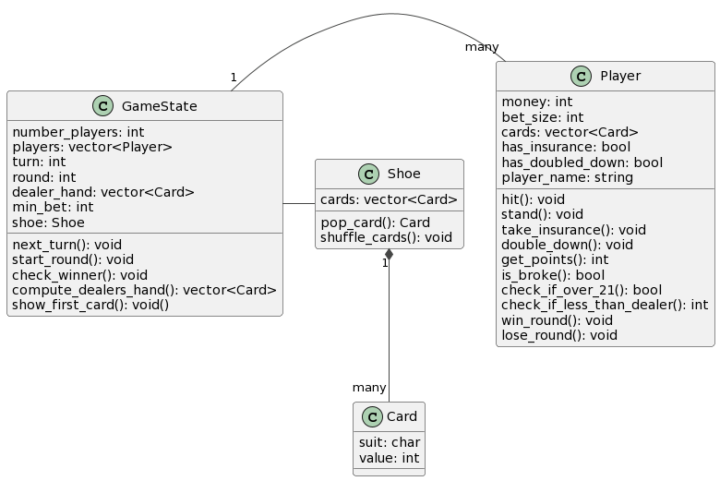

Package <Name>

Composite Structure Diagram
<Here the composite diagram describing the connections between each package should be provided.>

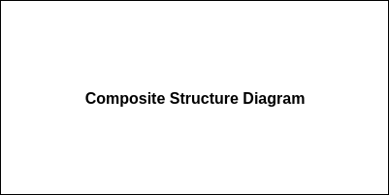

Sequence Diagrams
<Sequence Diagrams are linked to the scenarios and the functional requirements of the SRS document. In this diagrams we are trying to show how the modeling can be used to implement this scenarios and requirements.>

Sequence End of Round
After the last player finishes his turn the dealer has to play. Then the winner and the losers have to be discovered.

The functional requirements related to this sequence are:
- FREQ-7: Turns
- FREQ-9: Make a Move
- FREQ-10: User Input
- FREQ-11: Dealer’s turn / Dealer AI
- FREQ-12: Round End & Returns
- FREQ-13: Game End
- FREQ-15: Player Exit

The scenarios which are related to this sequence are:
- SCN-1: <Write and describe which scenarios from the previous document relate to this sequence>
- …

Scenario Narration:
<Narrate your scenario, along with the given diagram below. The narration should be one/two paragraphs long>

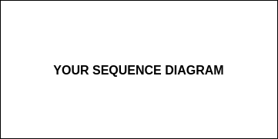

<Another Sequence Name>
…

Interface Modeling
<Interfaces define how data is exchanged between different parts of the system.>

Interface <Name>
<State what the purpose of this interface is and when it is used. Indicate which modules of the software are involved and which one initiates the communication. Define which protocol is used for communication. Indicate what modes of interaction exist and what types of messages are passed in each mode.>

Purpose: …

Communication between: <module X> and <module Y>, initiated by <module X>

Protocol: … (e.g. TCP)

Communication modes: ...

<Message Name>
<State which module is sending the message, which one is receiving it. For each type of message, list the values that are passed, which types they have and if they are required. Define the format of the message, possibly with an example. Also indicate if a response is expected and what type of message that response should be.>

Purpose: …
Direction: <module X> to <module Y>
Content:

- playerID : integer (required)
- moveType: string (required)
- card: integer

Format: as JSON string

Example: { "playerID": 2, "moveType": "draw", "card": 8 }

Expected response: <other message name>

<Another Message Name>

<Another Interface Name>

