External Interfaces and Requirements
User Interface

As a user you will interact with the game through the Graphical User Interface (GUI). There will be a login menu and a game interface. The interaction between the game and the user can be done through clicking on buttons or writing in the appropriate places.

In the login menu the following inputs are available:
- Option to begin a game and name it.
- Choose an username.
- Option to join a game.
- [TODO I do not know what the following point should be useful for but in case I put it in. I took it from the Lama example. Take it out if it is useless: “Includes fields for connection setup to the game server”]

The gaming interface must provide the following:
- Username of the other players.
- Amount of money each player has.
- Visible cards drawn by all players.
- Player which turn it is must be clearly displayed.
- When it is the users turn, the playing options must be shown correctly, they are:
  - Draw another card.
  - Stand (pass the turn).

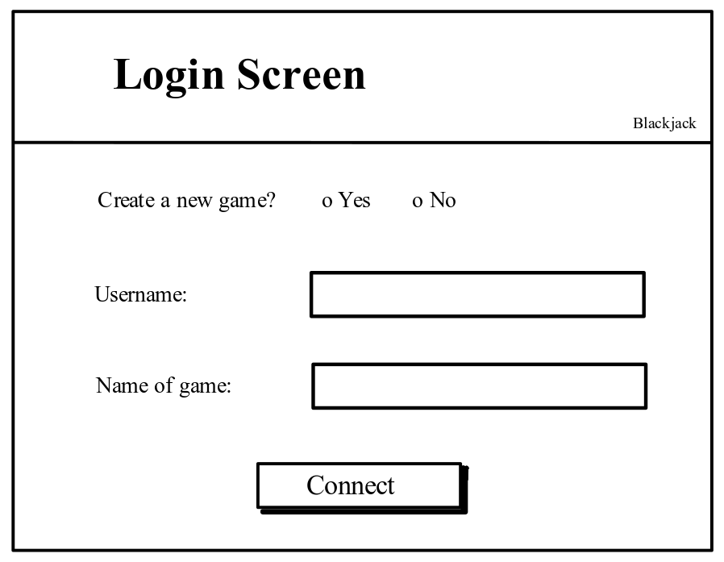
Figure 1: The login screen.

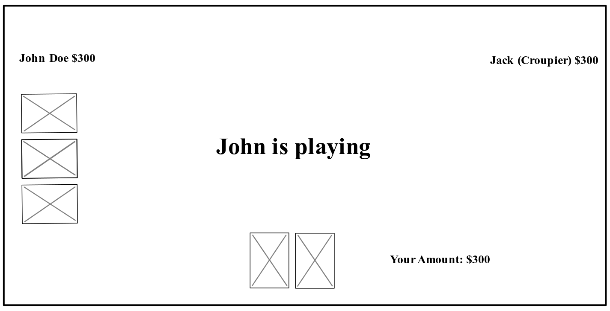
Figure 2: The match started and another person is currently playing

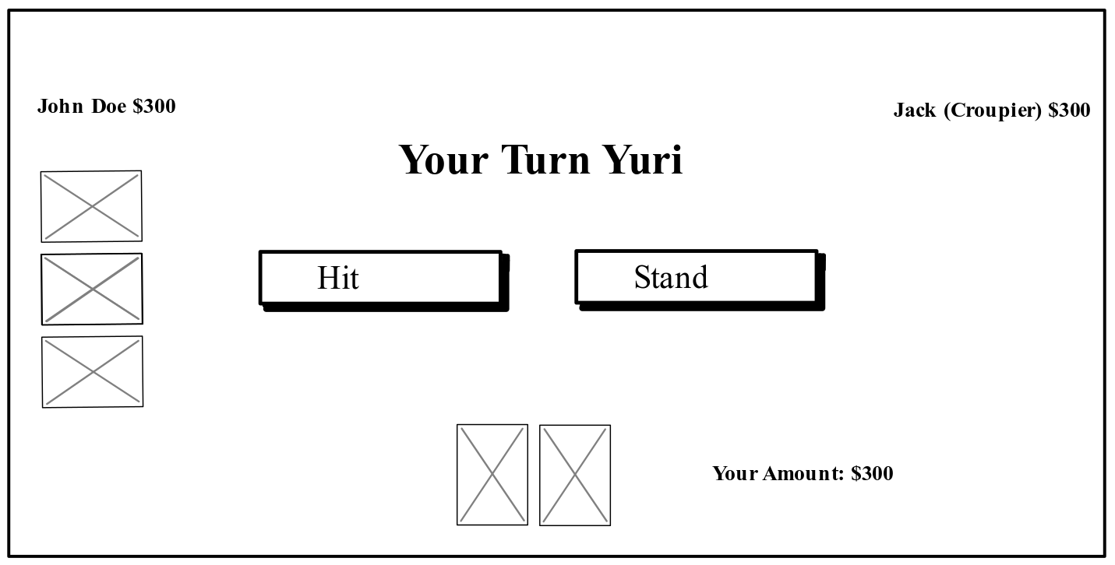
Figure 3: You are playing and it is your turn to decide.

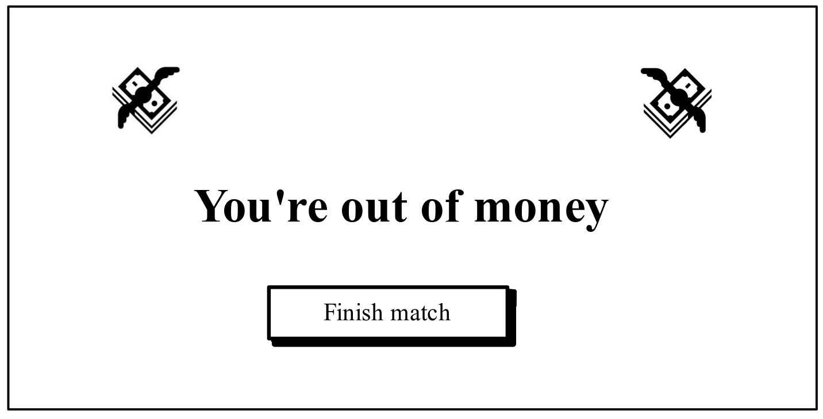
Figure 4: You lost and you’re all out of money. Your only option is to leave the game.

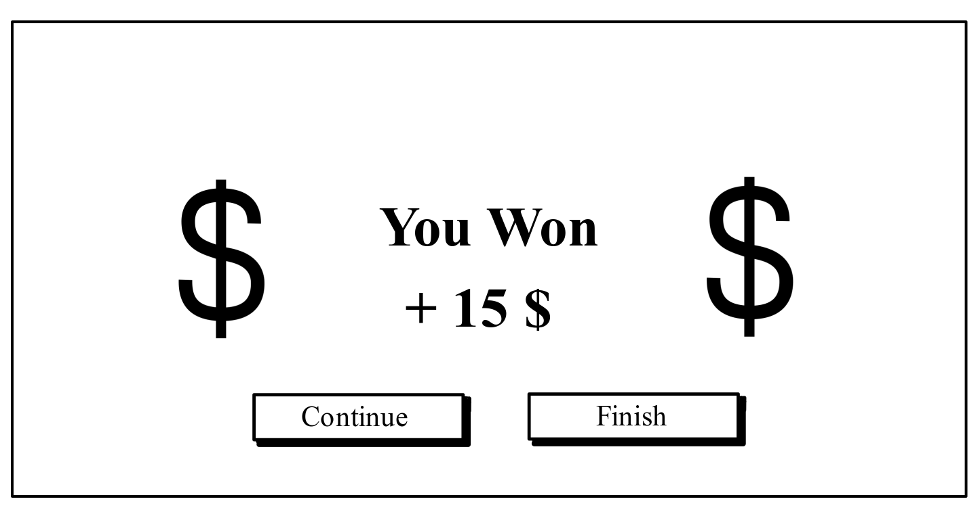
Figure 5: You won this round and receive the money. You can decide to leave.
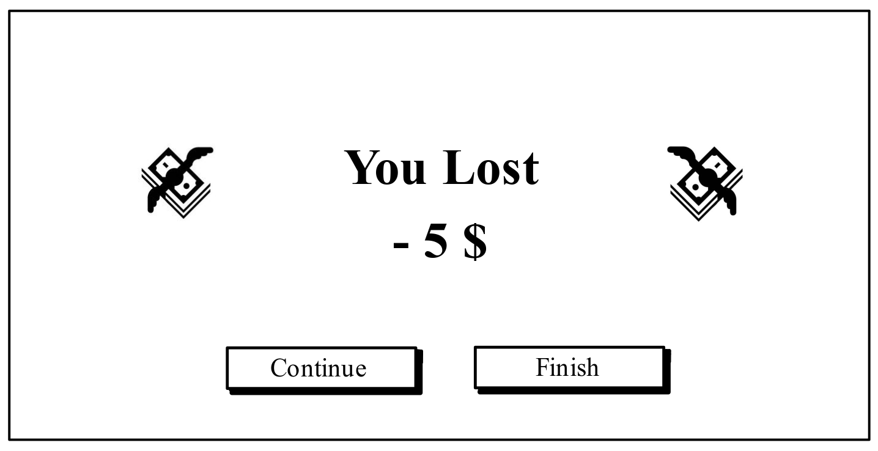
Figure 6: You lost this round. You can decide to leave the game

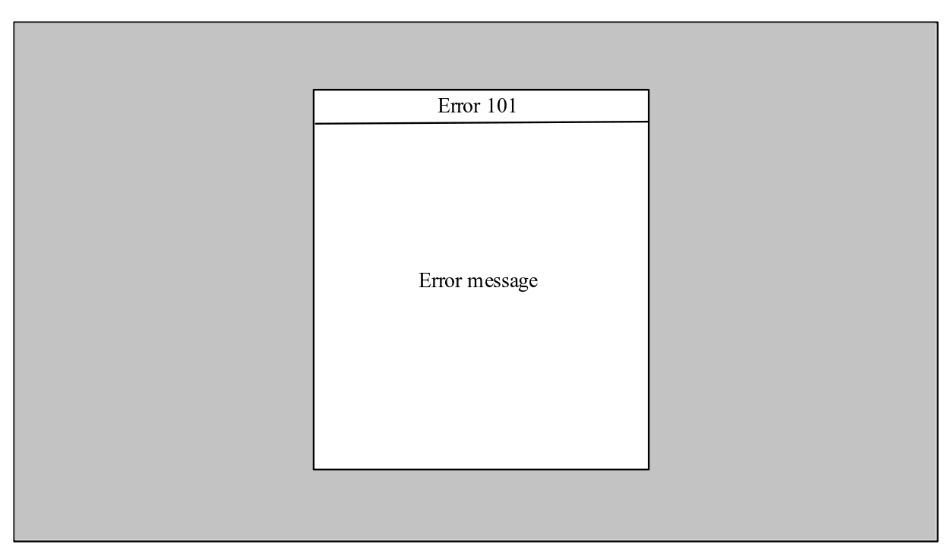
Figure 6: An example of an error.

Figure 1-6 are sketches of the different interfaces an user can have while playing the game. The different events which the user has to be made aware of, winning or losing a hand, playing and having the possibility to leave the game are all present. If a player loses all his money he cannot continue to play and has to leave the match.

Communications Interfaces

The interaction between the client and the server will be handled as follows: the communication will be of one server and multiple clients. Their communications will adhere to the TPC/IP protocol suite. The JSON format will be used to encode the data.

