  Checkpoint III | Checkpoint III: First Prototype
 | Group: | <GXX>
 | Date: | <YYYY/MM/DD>

Prototype Architecture
Our visualization prototype employs a modular, layered architecture designed for scalability and maintainability. The system consists of four main layers: Data Layer (asynchronous CSV loading with D3.js, handling three datasets: GDP/calories, obesity rates, and macronutrient distribution), Processing Layer (dynamic data integration that merges datasets based on country and year, supporting three visualization combinations), Interaction Layer (real-time filtering system with multi-select country interface and temporal controls), and Visualization Layer (D3.js-based scatter plot rendering with interactive elements). The architecture follows a unidirectional data flow: CSV Files → Data Loading → Integration → Filtering → Visualization, with user interactions triggering updates through event handlers. This design ensures extensibility for future chart additions while maintaining clear separation of concerns and efficient performance through optimized filtering algorithms.

Dashboard Layout
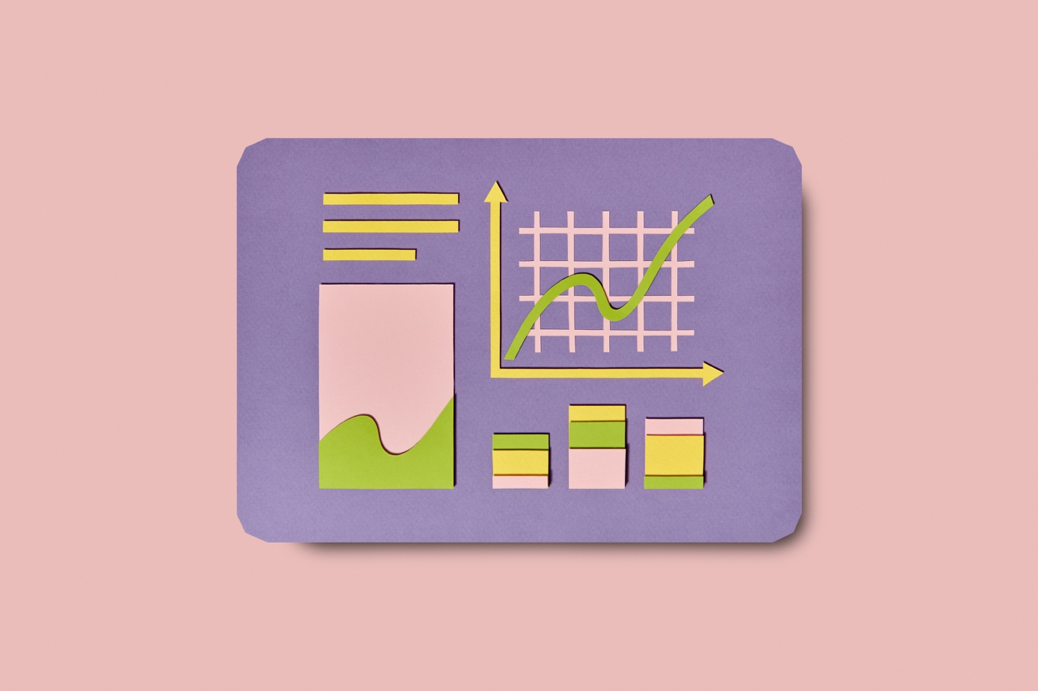The visualization interface is organized into three distinct functional areas optimized for user experience and data exploration. The top section contains centrally-positioned controls including a data dimension selector (GDP vs Calories, GDP vs Obesity, Calories vs Obesity) and year filter (All Years or specific year selection). The main content area uses a flexible layout with the scatter plot visualization on the left (800x600px SVG canvas with appropriate margins for axes and labels) and a fixed-width country selection sidebar on the right (300-350px). The scatter plot features interactive data points with hover effects, linear regression lines with R² display, and dynamic axis labels. The country filter sidebar includes search functionality, checkbox-based multi-selection, Select All/Clear All controls, and a scrollable interface for efficient country management. The design follows principles of consistency (uniform color scheme and typography), clarity (intuitive controls and clear labels), and accessibility (readable fonts and appropriate contrast ratios).

Data Processing

Beyond the initial preprocessing from Checkpoint I, our system performs additional real-time data transformations essential for visualization. Data type conversion transforms string values to numbers for all numerical fields, standardizes country names, and parses temporal data. The integration module dynamically merges datasets based on user selections: direct merging for GDP-calories data, left joins for obesity integration, and multi-dimensional combinations for comparative analysis. Data validation removes records with missing or invalid values, filters countries not present in required datasets, and ensures temporal consistency. Scale preparation includes GDP value capping at $160,000 for optimal visualization, domain calculations for appropriate axis scaling, and statistical computations for regression analysis. Real-time processing enables dynamic filtering based on country and year selections, on-demand statistical calculations, and performance-optimized algorithms ensuring responsive user interactions. This preprocessing pipeline maintains data integrity while providing flexible, efficient access to multi-dimensional country data across temporal ranges.

Chart Interaction

The scatter plot implementation provides rich interactivity designed to enhance data exploration and analysis. Visual encoding uses position (X,Y) for primary data variables, categorical colors for country identification, and consistent point sizing (5px radius) for clarity. Interactive features include sophisticated hover interactions with point highlighting (radius increases to 7px), contextual tooltips displaying country name, year, and exact values for both dimensions, and smooth CSS transitions for visual feedback. The filtering system enables real-time chart updates responding immediately to user selections, multi-dimensional data switching between GDP/calories/obesity combinations, multi-select country filtering with search capabilities, and temporal slicing by year. Statistical features include dynamic linear regression calculation using least squares method, R² coefficient display showing correlation strength, and automatic recalculation when data filters change. The system handles edge cases gracefully with empty data state management, performance optimization for smooth re-rendering, and clear visual indicators of data availability, ensuring robust user experience across all interaction scenarios.

Chart Integration
Although this prototype currently implements only the scatter plot idiom, the architecture is specifically designed for seamless multi-chart integration and extensibility. The integration system employs a shared data model where all datasets are globally accessible to chart components, unified filtering ensures selections affect all visualizations consistently, and centralized state management maintains coherent behavior across components. The event-driven architecture broadcasts filter changes to all chart instances, coordinates data loading and updates, and manages user interaction events for synchronized selection and highlighting. The modular design enables easy addition of new chart types following established patterns (createBarChart, createLineChart, createHeatmap functions), shared utilities for scale management, consistent color schemes, and common data processing functions. Future integration capabilities include brush-and-link functionality for cross-chart selections, coordinated view updates with shared filtering and highlighting, and state synchronization ensuring consistent data representation. This architecture provides low coupling between charts while maintaining high cohesion within functional groups, ensuring scalability for additional idioms while preserving the coordinated filtering, consistent styling, and synchronized interactions essential for effective multi-view visualization systems.

