Member1: Luca Marco Heitmann
Member2: Theodor Bogdan Dorotsky

Parameters to be set:
Dataset path:
Project directory:
what py-file to run to compute the prediction on the test data using the final model:
task2_reproduction.py with param generate_logits = True
what py-file to run the reproduction routine using the final model:
task2_reproduction.py with param generate_logits = False
it shows the validation performance graphs and the final performance number on test data using the saved selected model:
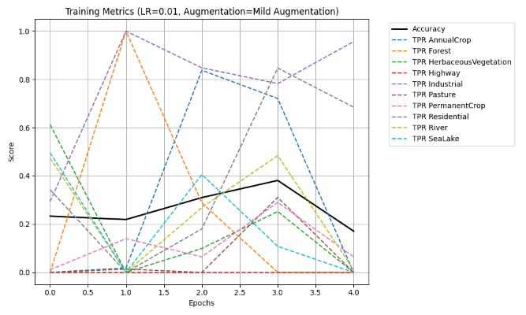
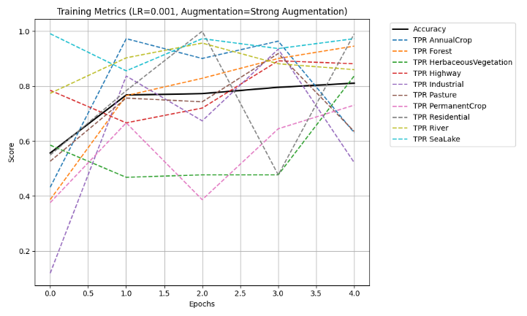
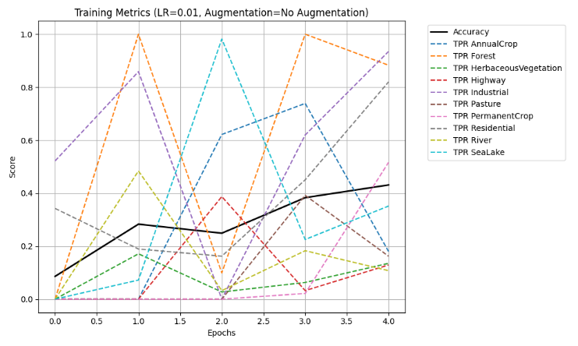
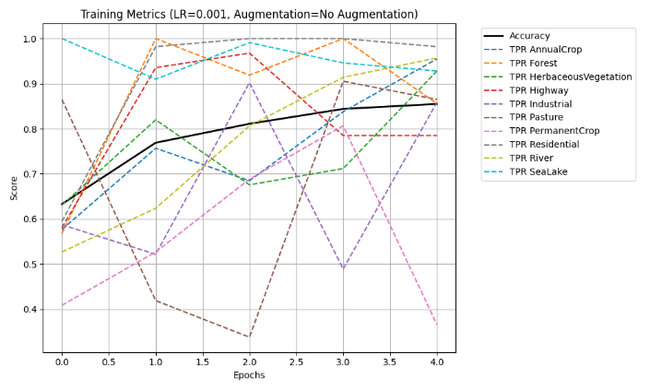
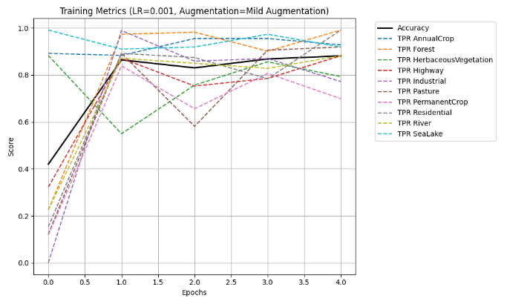

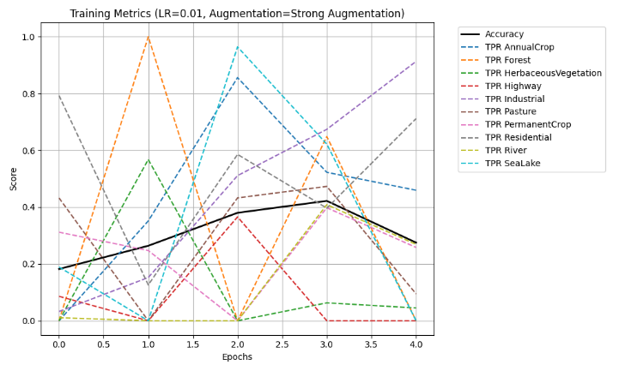

Final model performance on testset:
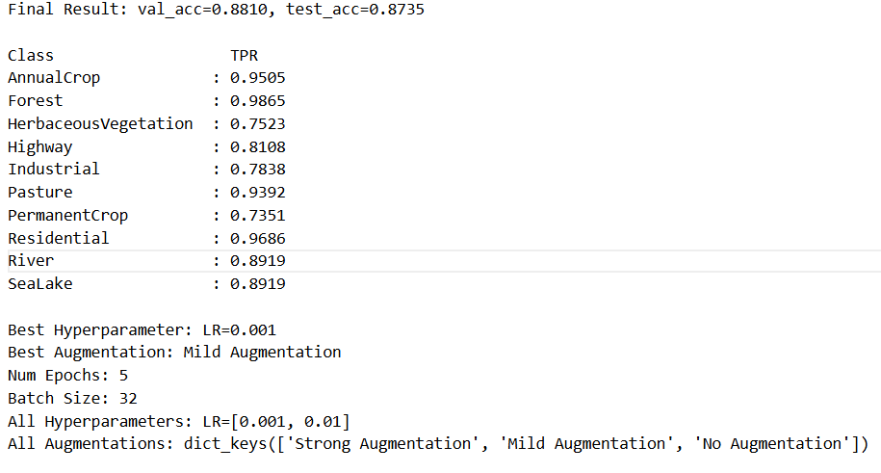

Top + Bottom 5 images for 3 Classes:
